A Comparative Study of Reliability-Calibrated QUBO Scheduling for Electric Vehicle Charging
Project Report submitted in the partial fulfillment of
Quantum Computing
by
Pratham Kapoor, A028
Ayaan Makhani, B056
Vinayak Rastogi, B078
Yashvardhan Wagh, B135
Samarendra Padaki, B067
Under the Guidance of
Dr. Sreemoyee Sarkar
SVKM's NMIMS University
(Deemed-to-be University)

Vile Parle (W), Mumbai – 56

A Comparative Study of Reliability-Calibrated QUBO Scheduling for Electric Vehicle Charging
Pratham Kapoor, Ayaan Makhani, Vinayak Rastogi, Yashvardhan Wagh, Samarendra Padaki
Mukesh Patel School of Technology Management & Engineering
SVKM's NMIMS University, Mumbai, India

Abstract
Limited connection time is a challenge for electric-vehicle charging schedules, which must meet the energy demand. site capacity. This exploratory study compares to nominal and scenario-averaged QUBOs, Calibration-dependent deadline buffers and/or earliest possible charging. Among 22,083 later This analysis takes place on public charging transactions where connection duration was observed, as these are used as counterfactuals. The 30-minute time limit and energy target, power and tariffs are assumed as available. Simulated Nominal and both earliest charging has a completion of 93.56% while the completion for the completion is 85.01% 90th-percentile buffer. A 95th percentile buffer is applied which does not leave a complete slot. The binding capacity limit (bcl) is added to a synthetic twoEV example: scenario, buffer and earliest policies select It's the same early allocation and it is a nominal-optimum tie as well. Explore the ways in which exact enumeration and Qiskit can be used. Aer simulations make a comparison between the QUBOs with six and eight logical qubits, where p=1 and p=2. across five seeds. The results reveal the critical nature of choice of baseline statistics, tie breaking, and demonstrate the... . Are not real-world deployment benefits or advantage for the quantum.
Here keywords: × in × + 1; uncertainty and × × × × × × reliability

Introduction
The process of charging a connected electric vehicle (EV) involves a decision on when the energy will be provided to the EV by the charging operator. Later charges are more likely to be lower but it leaves a request partially completed, and possibly dropped, if a connection ends early. Also electrical limits must be respected for multiple vehicle coordination. This All other things being equal and at a fixed state level, would a simple buffer based on a calibration on service completion alter service? vector is used to encode the solution.“Completion” and both cost value in a tiny modeled scheduling problem, and the binary vector that encodes the solution. optimization problem behaves on a quantum simulator.
In the contribution, we explore the issues of calibration, baseline selection, and tie-breaking through of a series of illustrative examples. Scheduling shared quanta and quantum sampling in a common formulation. A technique might look like it's better in situations where an alternative straightforward baseline is not provided. The multiple nominal optima are dealt with differently. The retail transactions through which customers are charged are: The tariffs and scheduling events used in this analysis are simulated, while the requests ares are real. The public-data experiment is limited to taking a single EV; they can't reasonably measure the performance of a fleet controller.

Related Work
SCENARIO BASED EV CHARGING UNDER UNCERTAIN AVAILABILITY AND DEMAND: Study of scenario based EV charging when the availability of charging stations and demand for EVs is uncertain. A method called stochastic programming (Wang et al., 2020) was used. Strong deadline and demand scheduling, as well as has prior work (Sone et al., 2024). Dalyac et al. (2021) studied quantum approaches for The idea of industrial smart charging was first proposed by the quantum approximate oxidation scheme and Farhi et al. (2014). optimization algorithm (QAOA). The penalties and slack encodings for QUBOs are defined.The penalties and slack encodings for the QUBOs are defined. The following tools should also be used for modeling (Glover et al., 2019): Our comparison is different, since we explicitly calibrated and evaluated, examined an overly conservative full-slot deadline, and . . . Simulated service-transparent quantum sampling. Those differences are not of concern. Create a new algorithm.

Methodology

Prior to any visit, information preparation, and decision-time assumptions, are taken into account.
Baek, et al. (2024) published charging-session records of both connecting and disconnecting. timestamps and given energy. Amid the lack of available information regarding families' connection durations, the study adopts the connection durations observed. counterfactual availability. The driver has not declared the time the driving duty is to be ended or a hasn't provided one in the file. RequiredDecisionTime requested energy from original ACN formulation. Therefore the nominal 'deadline' and 'Energy Request' are assumed in this experiment; Ah, J Consistent with its brothers and sisters, delG is not regarded as real demand.
Entries that lack a parseable date/time or have negative values for duration will be eliminated. For calibration, Sessions which began prior to July 1, 2022 and ended on or after the aforementioned date are also They were omitted, as the full lengths of their course is not yet known. Later sessions “form the” evaluation set. No timezone information is available for timestamp datatype and values are interpreted as naive.No timezone information is available for timestamp datatype and timestamp values are considered to be naive. local values. There are still 13 rows in the table which match and will be removed; a sensitivity check to remove rows that match is reported. below. The actual order of analysis is as shown in Figure 1.
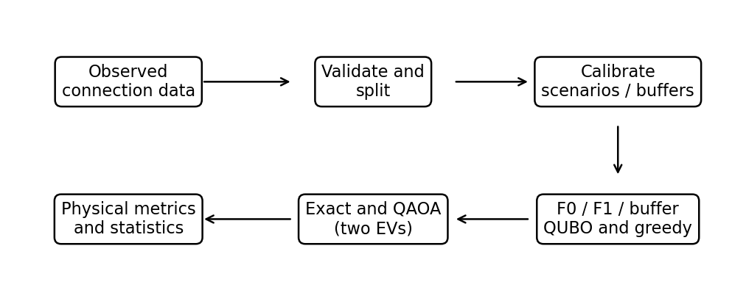
Figure 1. Data, calibration data processing and model building and assessment pipeline. The two-EV scenarios are simulated, not, reconstructed fleet sessions.
Table 1
Dataset accounting
Record group | Count
Downloaded | 72,856
Invalid duration | 547
Calibration crossing split | 41
Calibration | 50,185
Evaluation | 22,083

The number of junctions downloaded is compared with the totals of the two exclusions and retained junctions in Table 1. The dataset is a list of observed durations but not an observed application of the schedules constructed here.

Methods of calibration and scheduling
The nominal distance to the horizon D = 30minutes. amplitude of the electric force is: The difference between D and T is the difference in early-availability. Both b and are empirical quantiles of The nonnegative initial variations:
bτ = Qτ(max(0, D − T)) (1)
In this case, Qτ is the quantile of the sample calculated using linear interpolation and τ is some level. A conservative The times used for schedule is only 15 minutes per usage, ending when it reaches D − bτ. In F0 the window used is nominal; k=8, which is the minimum of the penalized objectives computed over k groups of equal size used for calibration. empirical weights. Buffer variants use τ = 0.80, 0.90 and 0.95. All participants will be asked to leave a session that ends after the The nominal horizon will not add any additional decision slots. The extra F_early policy fills: The slots are listed in chronological order from the point of view of how many are physically available; any relationships between EVs are stated.
The goal for F1 is to minimize min(x, s₁, …, sK) Σₛ pₛ fₛ(x, sₛ) where K is the number of calibrated. Let pₛ denote the empirical frequency of the groups, x the common schedule, and let sₛ be the scenario specific. capacity slack. Availability, delivered energy, cost and the capacity are changed in each scenario. residual. This is a risk neutral scenario averaging of the model and not a worst case guarantee.
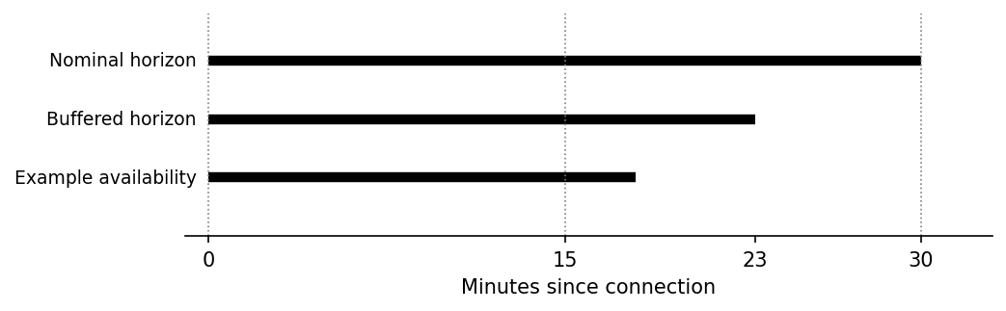
Figure 2. Illustrative timing: a 7-minute buffer moves the deadline to 23 minutes, leaving only the first complete slot. The example availability is 18 minutes.
The convention used for rounding is shown in figure 2. Energy is only added by a slot ending by the realized connection end. If all the complete slots are removed from the buffer, then the method is illegal charging opportunity, with the service objective not being tacitly waived.

System Architecture and Quantum Formulation

Physicals models and QUBO's
Let xᵢₜ = 1 if EV i is slotted to charge at time t, and xᵢₜ = 0 otherwise. Let Pᵢ be its The average charging speed required to power electric vehicles.The length of time required to charge an EV in hours. The tariff amount per kWh is designated as the tariff amount per unit, while the site limit set in the meter is designated as Pmax. With availability aᵢₜ equal to one for a fully available slot, delivered energy and cost are
The computation of the Edelivered,i is Σₜ aᵢₜ Pᵢ Δt xᵢₜ; the computation of the C is Σᵢ,ₜ cₜ aᵢₛ Pᵢ Δt xᵢₜ. (2)
Site loading Lₜ = Σᵢ aᵢₜ Pᵢxᵢₜ ought to be less than or equal to Pmax. The adopted model using integer power is this.This is the model adopted as integer-power model. represents unused capacity using nonnegative binary slack sₜ, and adds a squared penalty λc(Lₜ + sₜ − Pmax)². A squared penalty λe(|Rᵢ − |Σₜ aᵢₜxᵢₜ|)² is to be minimized, where aᵢₜ are the required slot counts.
One 1 kW EV will require R=1 slot, Δt=0.25 hours, Pmax=1 kW and both penalty coefficients are 5. The cost of electricity is $1.0 and $0.5 in arbitrary units per kWh. Thus the The energy target is 0.25kWh.
The model is expanded to become the quadratic unconstrained binary form, f(x) = xᵀQx + c. Both charging bits and auxiliary bits are included with the vector. To interpret the likelihood of a scenario to draw inferences. If finished availability will change unused capacity, then slack registers are used. Penalties are not Weak Conditional: Conditional statement that does not have to be true, but still contains a true statement within it. penalty allows to accept an unattainable optimum. An Exact Enumeration test checks instances selected; use doesn't imply common penalty restricting limit.

Ising mapping and QAOA
Set xᵢ = (1 − Zᵢ)/2 for every variable which is binary, where Zᵢ has computational-basis eigenvalues of +1. and −1. The symmetric QUBO takes the form: hc = ΣᵢhᵢZᵢ + Σᵢ<ⱼJᵢⱼZᵢZⱼ + c′. With the repository’s symmetric-matrix convention, hᵢ = −½ΣⱼQᵢⱼ, Jᵢⱼ = Qᵢⱼ/2 and c′ = c + [ΣᵢⱼQᵢⱼ + tr(Q)]/4. In xᵀQx, there are two offdiagonal entries for Q. Exhaustive tests confirm that QUBO and equalize. Calculates basis energies Ising, with the addition of c′.
Starting from an equal superposition, QAOA alternates a cost evolution and an X mixer. For The Aurea Garden was located in the state of ping's.
|ψ(γ, β)⟩ = ∏ℓ=1…p exp(−iβℓ ΣᵢXᵢ) exp(−iγℓ Hc) |+⟩⊗n. (3)
The last operation defined works first in each layer. Hadamards prepare initial unitary, the cost unitary imprints energy-dependent phases; the mixer changes amplitudes. A classical COBYLA optimizer iteratively updates values of γ and β based on circuit energies measured at a sample set. Measurements return bitstrings and decoding is done in the opposite direction to that displayed by Qiskit, with qubit zero being displayed on the right. the displayed order. This fifth figure is from the actual nominal circuit. Its first two bits The last two are used for encode charging decisions, while the remaining are used for encoding capacity slack.

Experimental Setup
An eligible session is either a calibration or an evaluation session and there are a total of 50,185 calibration and 22,083 evaluation sessions. Scenario centers (and buffers) are determined by calibration, not recorded. Observations do NOT occur during different observed durations; multiple observations on the same one-EV problem. Do not be considered reconstructed multi-EV site instances. The six methods are assessed with the same physical decoder. Service completed testing the modeled request is successful Respect the modeled capacity at the same time achieving realized availability within that capacity. Unmet energy includes its mean reduces to zero and hence the value of the Z score is zero.
This is compared to a 2000-replicate calendar day block when the paired 90% buffer comparison to F0 is used. Crossed into the Amish world on 92 dates.Crossed on 92 dates. However, a user-sensitivity and a charger-cluster sensitivity analysis are both included. reported separately. All these analyses are only partial cross-cluster dependent. The analysis is explorative in nature and is not a confirmative multiple comparison study because of the buffer levels. The A synthetic two-EV case (p=1) is utilized alongside the original one-EV QAOA for the test of p=1. and p=2 using five seeds and 128 shots for each of F0, F1 and the buffer.

Results and Discussion
Table 2
Simulated service outcomes
Method | Buffer (min) | Completion (%) | Mean unmet (kWh)
F0 nominal | — | 85.01 | 0.0375
F1 scenario | — | 85.01 | 0.0375
F_early | — | 93.56 | 0.0161
Buffer 80% | 0 | 85.01 | 0.0375
Buffer 90% | 7 | 93.56 | 0.0161
Buffer 95% | 18 | 0.00 | 0.2500

As low as you can see in Table 2 and in Figure 3, F0 and F1 choose the same latter slot in this particular case. The 90% buffer will move charging to first slot and find a model completion of 93.56%. Average 8.55 percentage points higher than F0 with 8.20 to 8.91 points between the days. F_early Selects the same initial credit slot and uses the same amount of energy and cost to complete the credit slot. Thus the Improvement is not improvement over an F0 baseline derived from cost, rather, improvement is over earliest feasible charging. The This is an idealized model, or a counterfactual, and is actually called an interval.
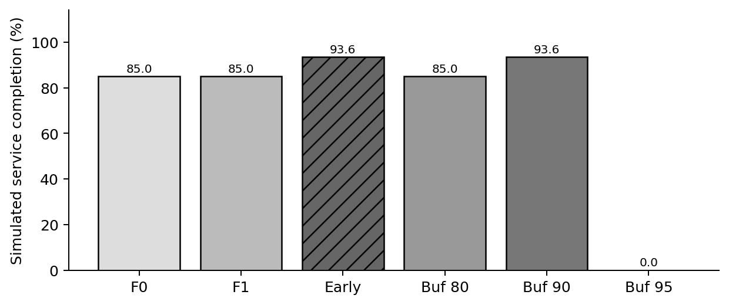
Figure 3. Female make-up percentage (completion rate of simulated observed not) 22,083 evaluation records deployed schedules.
Unconditional mean unmet energy is displayed in Figure 4. With 95% level, the buffer is 18 minutes. Changes the deadline to minute 12: neither of the 15 minute periods can be completed by this time. The resulting zero schedule leaves all the assumed 0.25 kWh request to be satisfied. This is a real repercussion of the event. The horizon is modeled with coarse refinement, as well as the strict complete-slot rule, and explains why a higher resolution for the horizon is warranted. The buffer should not be a quality improvement effort.
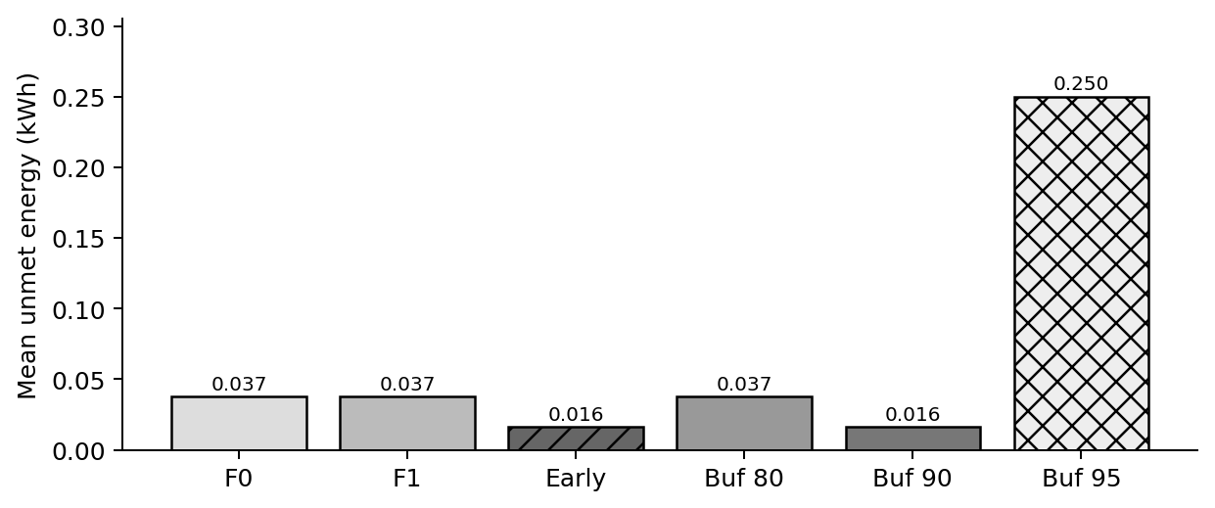
Figure 4. The MEANS is calculated using the average of the energy deficits of each YEP session, and includes value 0 for those sessions that do not have a deficit.
Note the means realized is a higher assumed tariff for the earlier 90% and the F_early schedules. The R&D spending ratio of 0.2339 is compared with the R&D spending ratio of 0.1063 for F0. These means use modeled energy not an equal amount of energy: F0 often results in less energy delivered: which reduces its costs. It is worth noting that the whole target nominal cost is 0.25 (early schedule). and Q125 at the later one. No bills or benefits observed of customers are inferred
Table 3
Quantum simulation on the selected QUBOs
Measure | F0 | 90% buffer
Logical qubits (slack) | 4 (2) | 4 (2)
Exact objective minimum | 0.125 | 0.250
Optimal-state probability | 23.83% | 36.72%
Best sampled gap | 0.000 | 0.000
Shots; depth p | 256; 1 | 256; 1

Table 3 differentiates between quantum sampling and service completion for a session. For F0, 86.72% 23.83% are optimal QUBO states, and of shots decode to a physically feasible nominal schedule. 92.97%Favor the conservative window in the buffer; 56.64%Favor both conservative window and writeback window in the buffer achieve the service model target. Alternative slack values and more expensive but feasible. The differences in the probabilities are explained by situations described in schedules. The nominal transpiled circuit is at level 16. and six CX gates. If a uniform random sampling is used, there would be 6.25% optimal vs 75% physically. feasible nominal states. The two values that are used for the quantum comparison are from a restricted second evaluation. No general superiority is to be drawn because budget will not necessarily equate to quality.
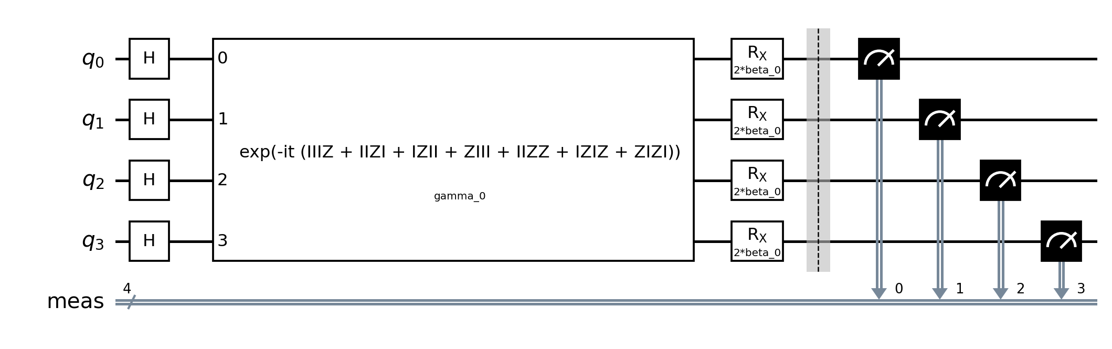
Figure 5. In the end, a physical circuit based on the parametersized model p = 1 QAOA circuit is generated for the nominal 4-variable QUBO. Qubits q0 and q1 q2 and q3 encode capacity slack; encode charging.

Capable of several electrical connections & detects a wide range of things.
For the separate synthetic instance, there are two EVs, two 15-Minute charging sessions, 1 kW charging power per EVs, ... The shared site limit is EV (1kW), as is the target for each of them (0.25kWh). The size of both EVs is the same. Arrival/departure time windows that are nominal, not specified. Two similarly weighted theoretical cases exist, one of them with a positive balance and the other with a negative balance. These are illustrative - allowances and not actually required. historical fleet schedules. Simultaneous charging cannot be achieved, due to site constraint. genuinely binds.
Table 4. Synthetic two-EV comparison (with two scenarios equally weighted)
Method | A takes out | B slots | Joint. completion | Unmet kWh | Mean cost
F0 | 01 | 10 | 50% | 0.125 | 0.3125
F1 | 10 | 01 | 100% | 0 | 0.3750
F_early | 10 | 01 | 100% | 0 | 0.3750
Buffer | 10 | 01 | 100% | 0 | 0.3750
In the two slot representation 10 means 1 is charged in the first slot, while 01 means 1 is charged in the second slot. The second slot is for charging the wheels of the car. These are not full QUBO bitstrings, but rather just bits for charging decisions. which includes capacity slack, too. Table 4 lists physical outcome under indistinguishable scenarios. F0's solution is displayed by lexicographic tie-breaking, an equally The other methods are matched by optimal nominal solution, which assigns EV A to an earlier position. Hence It is unclear to the orderers whether this difference of 50% versus 100% is attributable strictly to the buffer changes or to the changes in the scenario. optimization. A successful nominal schedule will actually buy 0.5 kWh for 0.375 arbitrary units. F0 was unable to provide 0.125 kWh in one case, thus the lower average realized cost.
Removing the 13 identical full rows had no effect on the buffer and the 22,083-record evaluation result. The 92 days will be used for the day-block interval. A charger-cluster interval is 7.78–9.45 percentage points over 1661 identifiable-user interval is 9.88–12.67 points over 1,254 nonzero user IDs and 13,684 records. These resampling units Different intervals are represented (overlap and the user subset differs, so the intervals are sensitivity analyses rather than interchangeable independent evidence.
Table 5. Four-EV QAOA: 101 seeds, 128 shots per run
Model | p | Qubits (slack) | Optimal % mean ± SD | Nominal feasible % | Depth / CX
F0 | 1 | 6 (2) | 9.38 ± 5.44 | 22.81 | 22 / 16
F0 | 2 | 6 (2) | 13.75 ± 5.84 | 25.47 | 37 / 32
F1 | 1 | 8 (4) | 2.19 ± 1.28 | 26.09 | 25 / 22
F1 | 2 | 8 (4) | 2.66 ± 0.43 | 29.22 | 43 / 44
F_buffer | 1 | 6 (2) | 8.28 ± 4.04 | 19.22 | 19 / 10
F_buffer | 2 | 6 (2) | 9.38 ± 3.03 | 21.72 | 34 / 20
Table 5 gives the average across five optimizer seeds (but not individual shots). independent optimization trials. The QUBOs have four qubits for making a charging decision. F1 adds four scenario-specific slack qubits add two, whereas F0 and the buffer add two. All small QUBO and Ising All of the basis energies were tested to completion. The necessary minimum of each of the tests objectives is The values obtained are used only in the context of the objective used; values from two different objectives are not used as physical-quality values. comparisons. Limited runs do not exhibit the quantum advantage.

Repeated results and model information.
We repeated the public-duration experiment and the synthetic two-EV study of the current repository. The first one observes the duration of connections and assumes requests, tariffs and scheduling decisions. The latter is a manmade miniature specimen. Neither represents observed Elwing can now be considered as the performance of a deployed controller.
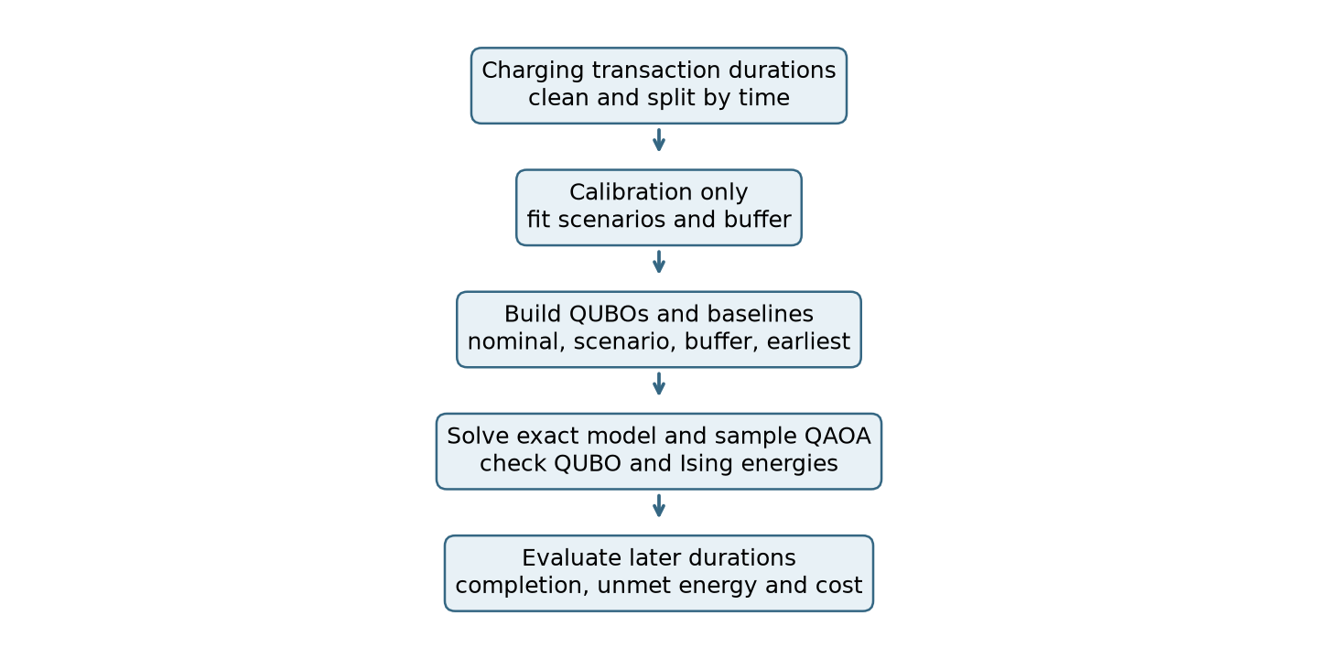
Figure 6. Observed durations, modeled evaluation, workflow. The two EV example going through an evaluation separately. Under the specified scenarios of availability.
There are 50185 sessions in the calibration set and 22083 sessions in the later evaluation set. The 90% buffer = 7 minutes and 95% buffer = 18 minutes. Only full 15min slots will count, Therefore, the latter is devoid of useful slot. Because of this, larger buffers will lead to lower readings. In this case, completion is extinguished towards zero.
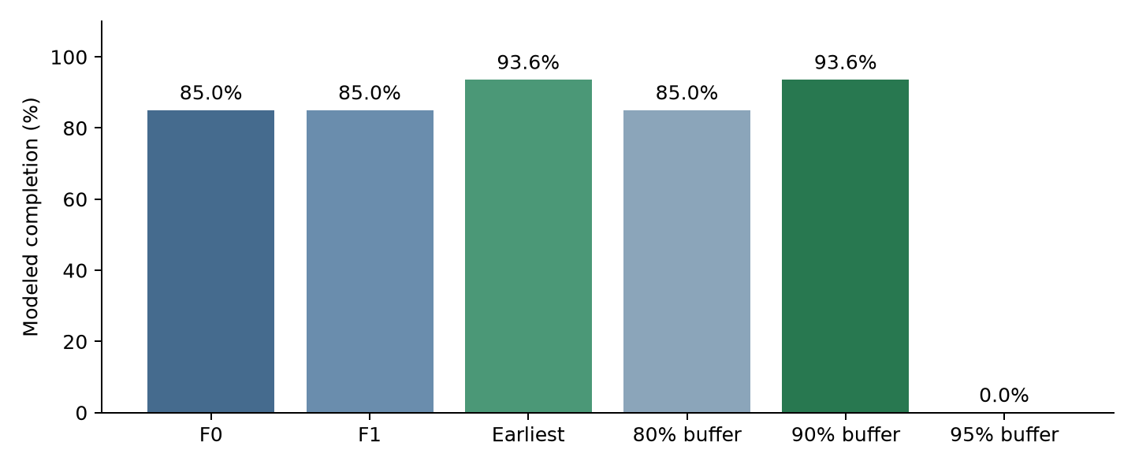
Figure 7. Completed modeled reproduction of later public-data sessions. The fastest charging and the 90% buffer option is selected. The same first position is used.
The 90% buffer achieves 93.56% completion which is 8.55% greater than the 85% completion achieved by F0. 8.55 percentage points. This fails when earliest charging is used, giving 93.56%. a benefit more than that minimum. These are outcomes that did not actually occur, but should have, they are not measured. The effects of past charging programs.

A matrix of problems based on the two EV QUBO model which is written in concrete.
For the nominal two-EV example, use z = [x₁₁, x₁₂, x₂₁, x₂₂, s₁, s₂]ᵀ, where x is a charging decision and s can be either capacity slack bit. The target objective is the one f(z) = zᵀQz + 20. The This Model generates a symmetric matrix below. Off-diagonal terms It was observed that when using relative energies, no constant is required, but there is a constant zᵀQz when using absolute energies.
 | x11 | x12 | x21 | x22 | s1 | s2
x11 | -9.75 | 5 | 5 | 0 | 5 | 0
x12 | 5 | -9.875 | 0 | 5 | 0 | 5
x21 | 5 | 0 | -9.75 | 5 | 5 | 0
x22 | 0 | 5 | 5 | -9.875 | 0 | 5
s1 | 5 | 0 | 5 | 0 | -5 | 0
s2 | 0 | 5 | 0 | 5 | 0 | -5
Each EV requests 0.25 kWh, charges at 1 kW, and shares a 1 kW site limit across two 15-minute slots. The two modeled availability cases have equal weight. Slack bits represent unused site capacity; they are not charging decisions.
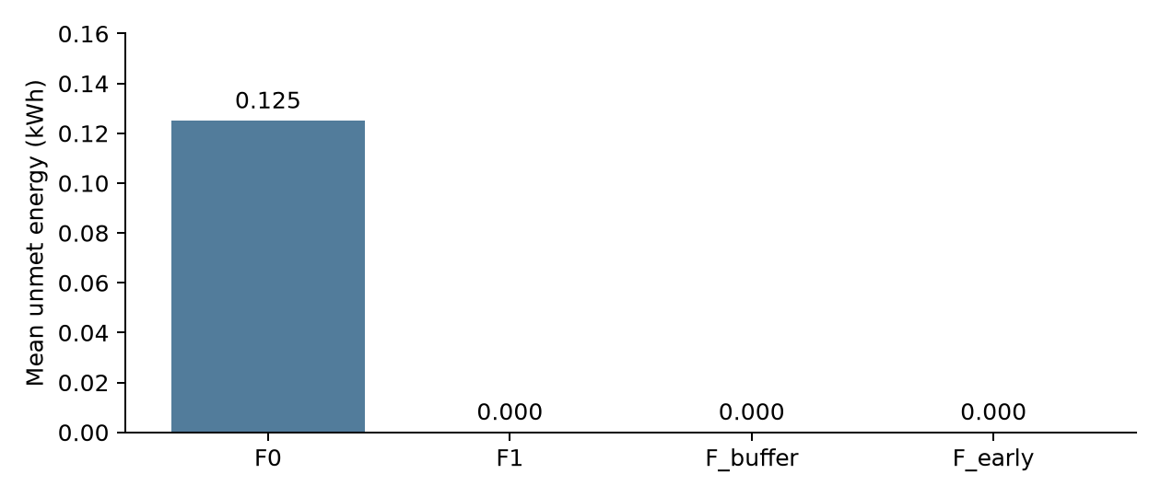
Figure 8. Mean unmet energy across the two equally weighted modeled scenarios. This is a synthetic example, not a fleet estimate.
The selected nominal schedule gives 0.125 kWh mean unmet energy; the scenario, buffer and earliest schedules give zero in these two cases. However, the nominal QUBO has another equally optimal schedule that makes the early allocation. The difference therefore depends on the selected tie and does not prove a unique advantage for scenario optimization. QAOA results remain simulator samples from short optimization runs, not evidence of quantum advantage.

Limitations
The public-data comparison models a single EV; requests, power, capacity, tariffs and Driver inputs are assumed – not observed, nominal deadlines. plus the two-EV experiment is also synthetic: Two equal scenarios are employed and a historical fleet is not developed. Its If a tie-breaker materially alters the reported comparison, then it is not considered a tie but instead results in a default rule that prevents the tie from being applied. Day-, charger- and user-cluster intervals are distinct measurements of sensitivity and their computation does not capture the full nature of dependence that exists due to overlaps. Aer is used to simulate QAOA with a finite number of seeds, shots and optimization budgets. No hardware There is a proof of concept of the execution system or a demonstration of noise resistance, industrial scaling or quantum advantage.

Conclusion
In the single-EV counterfactual, the 90% buffer improves modeled completion over the cost-oriented nominal schedule but exactly matches earliest feasible charging; the 95% buffer removes all usable full slots. In the synthetic two-EV case, capacity creates a meaningful scheduling conflict, yet an equally optimal nominal tie can match the scenario, buffer and greedy allocation. The findings demonstrate baseline and tie-breaking sensitivity rather than a unique benefit of calibration. Future work should validate on decision-time requests, independent multi-EV site data and broader quantum experiments.

References
Baek, K., Lee, E., & Kim, J. (2024). A dataset for multi-faceted analysis of electric vehicle charging transactions. Scientific Data, 11, Article 262. https://doi.org/10.1038/s41597-024-02942-9
Dalyac, C., Henriet, L., Jeandel, E., Lechner, W., Perdrix, S., Porcheron, M., & Veshchezerova, M. (2021). Qualifying quantum approaches for hard industrial optimization problems: A case study in the field of smart-charging of electric vehicles. EPJ Quantum Technology, 8, Article 12. https://doi.org/10.1140/epjqt/s40507-021-00100-3
Farhi, E., Goldstone, J., & Gutmann, S. (2014). A quantum approximate optimization algorithm. arXiv. https://arxiv.org/abs/1411.4028
Glover, F., Kochenberger, G., & Du, Y. (2019). A tutorial on formulating and using QUBO models. arXiv. https://doi.org/10.48550/arXiv.1811.11538
Sone, S. P., Lehtomäki, J. J., Khan, Z., Umebayashi, K., & Kim, K. S. (2024). Robust EV scheduling in charging stations under uncertain demands and deadlines. IEEE Transactions on Intelligent Transportation Systems, 25(12), 21484–21499. https://doi.org/10.1109/TITS.2024.3466514
Wang, Z., Jochem, P., & Fichtner, W. (2020). A scenario-based stochastic optimization model for charging scheduling of electric vehicles under uncertainties of vehicle availability and charging demand. Journal of Cleaner Production, 254, Article 119886. https://doi.org/10.1016/j.jclepro.2019.119886

