Reliability-Calibrated QUBO Scheduling for Electric Vehicle Charging – A Comparative Study.
Project Report submitted in partial fulfillment of Quantum Computing course.

by
Pratham Kapoor, A028
Ayaan Makhani, B056
Vinayak Rastogi, B078
Yashvardhan Wagh, B135
Samarendra Padaki, B067
Under the Guidance of
Dr. Sreemoyee Sarkar
SVKM's NMIMS University
(Deemed-to-be University)

Vile Parle (W), Mumbai – 56

A Comparative Study of Reliability-Calibrated QUBO Scheduling for Electric Vehicle Charging
Pratham Kapoor, Ayaan Makhani, Vinayak Rastogi, Yashvardhan Wagh, Samarendra Padaki
Mukesh Patel School of Technology Management & Engineering
SVKM's NMIMS University, Mumbai, India

Abstract
The charging problem for electric vehicles (EVs) has to make the best use of limited connection time and site capacity, to supply the required energy. This paper makes an exploratory comparison between nominal and scenario-averaged QUBOs, the earliest feasible charging and a calibration-derived deadline buffer. Observed connection times from 22,083 later public charging transactions are used as counterfactual availability. The 30-minute deadline, energy target, power and tariffs are fixed. For the simulated service the completion rate is 85.01% for the nominal schedule, and 93.56% for both the earliest feasible charging and the 90th-percentile buffer. The 95th-percentile buffer does not even complete one single slot. A synthetic two- EV example with a binding capacity limit is also set up, where scenario, buffer and earliest policies all choose the same early allocation, which is also a nominal-optimum tie. The QUBOs are compared for six and eight logical qubits, with depths p=1 and p=2, and for five different random seeds.
Keywords: electric vehicles; charging scheduling; uncertainty; QUBO; QAOA; reliability

Introduction
A charging operator’s decision of when to start charging an electric vehicle (EV) is crucial. Later charging can be more cost-effective but risks being uncompleted as the connection with the EV is terminated prematurely. Moreover, as more than one EV is connected to the same charging point, the operator must respect the physical constraints of the site. In this paper we investigate how a simple calibration-derived early-completion buffer affects the service completion and cost of a simple charging scheduling problem and how the corresponding QUBO problem is solved on a quantum simulator.
The contribution of this work is an exploratory study that compares several methods for scheduling electric vehicles (EVs) within a given scenario. The methods are compared within the framework of a shared scheduling problem. The comparison highlights the differences in terms of calibration, baseline selection, tie-breaking and quantum sampling. A method that appears to be better than a nominal optimizer can be worse than another simple alternative baseline, or even worse than another nominal optimizer that resolves ties differently. The underlying charging sessions are real, while the requests, tariffs and scheduling decisions are simulated. The public-data experiment is conducted for a single EV and thus does not measure the performance of a fleet controller.

Related Work
Scenario-based EV charging under uncertain availability and demand has been studied using stochastic programming (Wang et al., 2020). Robust deadline and demand scheduling also has prior work (Sone et al., 2024). Industrial smart charging using quantum approaches was studied by Dalyac et al. (2021). The quantum approximate optimization algorithm (QAOA) was introduced by Farhi et al. (2014). QUBO penalties and slack encodings are well-established modeling techniques (Glover et al., 2019). The comparison of this paper differs from the above-mentioned works in several respects. First, the calibration-to-evaluation split is made transparently. Second, an excessively conservative full-slot deadline is examined. Third, the simulated service and the quantum sampling are separated transparently.

Methodology

Data preparation and decision-time assumptions
Baek et al. (2024) released charging-session records with connection and disconnection timestamps and delivered energy. The study uses observed connection durations as counterfactual availability. The file does not supply the driver-declared departure time or a decision-time requested-energy field required by the original ACN formulation.
The nominal deadline and energy request are assumed for the experiment. Delivered energy is not treated as true demand.
Records with unparseable timestamps and/or durations with negative values were removed from the data set. For the calibration part of the study, the sessions that started before July 1, 2022 and ended after that date were removed, as their full duration was not known yet. All other sessions were left for the evaluation part of the study. The timestamps were treated as local naive times and no time zone information was available. There were 13 duplicate full rows in the data set and the removal of these rows was tested for sensitivity in the results. The entire analysis was performed as shown in Figure 1.
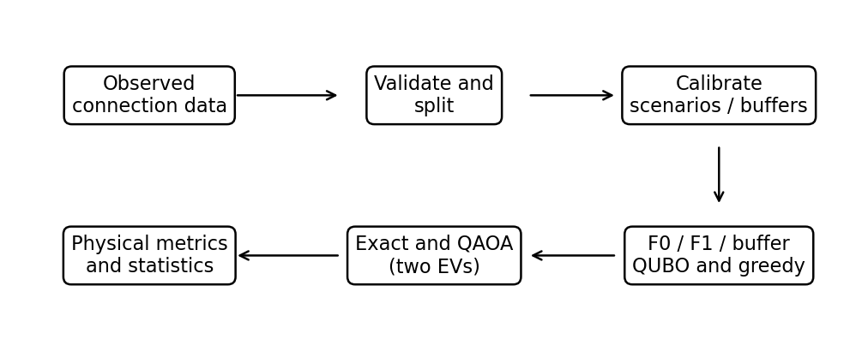
Figure 1. Data, calibration, model construction and evaluation pipeline for the two-EV scenarios modeled as opposed to reconstructed fleet sessions.
Table 1
Dataset accounting
Record group | Count
Downloaded | 72,856
Invalid duration | 547
Calibration crossing split | 41
Calibration | 50,185
Evaluation | 22,083

Table 1: Dataset accounting for the downloaded total with the two exclusions and the retained records. The downloaded total of 72,856 records for 1 EV is used as an observational source of durations. The schedules, constructed for the two-EV scenarios, are not observed as a deployment of the schedules.

Calibration and scheduling methods
The nominal horizon D is 30 minutes. For a calibration connection duration T, the modeled early-availability difference is D − T. The buffer b at quantile τ is the empirical quantile of the nonnegative early differences:
bτ = Qτ(max(0, D − T)) (1)
The bτ for each of the three levels are given by bτ = Qτ(max(0, D − T)) (1) where Qτ is the linear-interpolated sample quantile and τ is the selected level. The conservative schedule of F0 uses the nominal window of D = 30 minutes. The schedule F1 of the scenario-averaging approach minimizes the expected penalized objective over the eight equally weighted calibration groups with empirical weights. The buffer variants use τ = 0.80, 0.90 and 0.95. A session that ends after the nominal horizon does not generate any additional decision slots. The additional F_early policy fills up physically available slots in chronological order, ties between EVs are broken in the order of their declared departure times.
F1 aims to minimize the expected objective value, min(x, s₁, ..., sK) Σₛ pₛ fₛ(x, sₛ), where K is the number of calibrated groups, pₛ is the empirical frequency of group s, x is the shared schedule, and sₛ is the scenario-specific capacity slack. Note that each scenario can have different availability, delivered energy, cost, and capacity residual. Thus, the model is risk-neutral scenario averaging, not a worst-case guarantee.
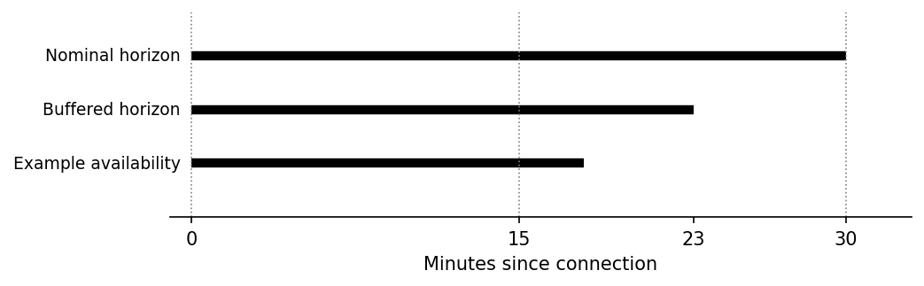
Figure 2. Example of a 7-minute buffer for a 15-minute slot. For an availability of 18 minutes the remaining slot of 15 minutes can be used for charging.
Figure 2: Rounding convention for slot duration. The energy of a slot is contributed only if the slot ends before the end of the connection. If the buffer removes all complete slots, then no charging opportunity is left and the service target is not relaxed.

System Architecture and Quantum Formulation

Physical model and QUBO
Let xᵢₜ be a binary variable that is equal to 1 if EV i is scheduled to charge in slot t, and 0 otherwise. Let Pᵢ be the charging power of EV i in kW, Δt the length of a slot in hours, Eᵢ the required energy of EV i in kWh, cₜ the tariff of slot t in $/kWh, and Pmax the maximum power that can be drawn from the site in kW. The availability aᵢₜ of slot t is equal to 1 if slot t is fully available, and 0 otherwise.
Edelivered,i = Σₜ aᵢₜ Pᵢ Δt xᵢₜ; C = Σᵢ,ₜ cₜ aᵢₜ Pᵢ Δt xᵢₜ. (2)
The physical site loading, Lₜ, is given by the sum of the power of all EVs scheduled to charge in slot t, i.e., Lₜ = Σᵢ aᵢₜ Pᵢ xᵢₜ, and must satisfy Lₜ ≤ Pmax. We model the unused capacity of the site with nonnegative binary variables, sₜ, and add a squared penalty, λc(Lₜ + sₜ − Pmax)², to the objective function. We also add a squared penalty, λe(Rᵢ − Σₜ aᵢₜ xᵢₜ)², to the objective function, where Rᵢ is the required slot count for EV i, and the sum over t is the sum over all slots that EV i is scheduled to charge in.
For this experiment we use one EV of 1 kW power. It requires R=1 slot of duration Δt=0.25h. The power limit is set to Pmax=1 kW. The two penalties are λc=5 and λe=5. The prices are set to 1.0 and 0.5 for the two tariff rates of the site, in arbitrary currency units per kWh. The energy target for the session is therefore set to 0.25 kWh.
The expanded form of the model is a quadratic unconstrained binary optimization problem (QUBO) of the form f(x) = xᵀQx + c, where x consists of the binary variables for charging as well as the auxiliary binary variables for the slack variables. For each scenario, the slack variables are stored in separate registers, because the available capacity may change as a result of the realized availability. The penalties are not hard constraints and the repository even contains a counterexample for a weak penalty that leads to an infeasible optimum, i.e., the exact enumeration is used to check the selected tiny instances for their optimal solutions.

Ising mapping and QAOA
For each binary variable xᵢ we set xᵢ = (1 − Zᵢ)/2, where Zᵢ has computational-basis eigenvalues +1 and −1. The symmetric QUBO can then be written as Hc = ΣᵢhᵢZᵢ + Σᵢ<ⱼJᵢⱼZᵢZⱼ + c′. With the repository’s symmetric-matrix convention for the QUBO the coefficients hᵢ and Jᵢⱼ are given by hᵢ = −½ΣⱼQᵢⱼ and Jᵢⱼ = Qᵢⱼ/2, respectively. The constant c′ is given by c′ = c + [ΣᵢⱼQᵢⱼ + tr(Q)]/4. Off-diagonal QUBO entries occur twice in xᵀQx. Exhaustive tests verify that the energies of the QUBO and the corresponding Ising model are equal for all basis states, including c′.
We start from an equal superposition of all states and alternate a cost evolution with an X mixer. We have p layers and thus we can write the state of the quantum register as:
|ψ(γ, β)⟩ = ∏ℓ=1...p exp(−iβℓ ΣᵢXᵢ) exp(−iγℓ Hc) |+⟩⊗n. (3)
The rightmost operation in each layer is applied first. The Hadamard gates are applied to create an equal superposition of states. The cost unitary applies the cost function as energy-dependent phases. The mixer applies the mixing operation as amplitude changes. We use COBYLA, a classical optimization algorithm, to find the best γ and β values by minimizing the energy of the sampled quantum circuit. The measurement results are then decoded in the reverse order of how the qubits are displayed by Qiskit, with the first two qubits encoding the EV charging decisions and the last two qubits encoding the site capacity slack.

Experimental Setup
The 72,268 eligible sessions are divided into 50,185 calibration sessions and 22,083 evaluation sessions. The calibration sessions are used to determine the scenario centers and the buffers, whereas the evaluation sessions are not used to fit the calibration sessions. For each evaluation session, the same synthetic one-EV problem is used to determine the service completion and the unmet energy for the session, where the observed duration of the session is used as the duration of the session. The service completion is defined as the request of the EV being delivered within the available time and the capacity of the site being respected. The unmet energy is defined as the mean of the zero values of the unmet energy for the session.
The results for the paired 90% buffer vs. F0 for the 92 days of evaluation are presented in the following tables and figures. The results for the user- and charger-cluster sensitivity analyses are presented in separate tables. Note that the cross-cluster dependence was not removed in the analyses. The analyses are of an exploratory nature and, thus, the buffer levels are not compared in a confirmatory multiple-comparison test. The results for the original one-EV QAOA with p=1 and one seed are also presented, as well as the results for a synthetic two-EV case with p=1 and p=2 and 5 seeds each, and with 128 shots each, for F0, F1 and the buffer.

Results and Discussion
Table 2
Simulated service outcomes
Method | Buffer (min) | Completion (%) | Mean unmet (kWh)
F0 nominal | — | 85.01 | 0.0375
F1 scenario | — | 85.01 | 0.0375
F_early | — | 93.56 | 0.0161
Buffer 80% | 0 | 85.01 | 0.0375
Buffer 90% | 7 | 93.56 | 0.0161
Buffer 95% | 18 | 0.00 | 0.2500

For the 90% buffer, the first slot is always used for charging, yielding 93.56% completion on average and an improvement of 8.55 percentage points above F0. Note, however, that the interval for day-block completion is very narrow, 8.20 to 8.91 percentage points. Thus, the improvement is over the cost-oriented baseline F0, not over earliest charging as represented by F_early. The corresponding interval for F_early would be 8.20 to 8.91 percentage points as well.
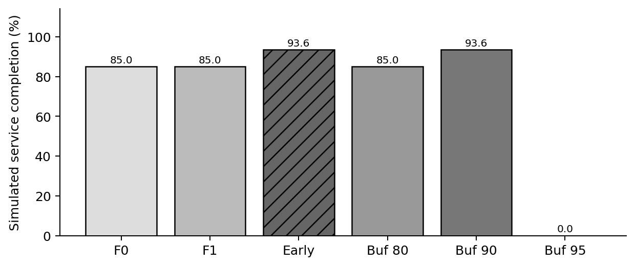
Figure 3: Simulated completion rates on 22,083 evaluation records. These are not the results of deployed schedules.
Figure 4: Unconditional mean unmet energy on 22,083 evaluation records. At 95% level of buffer, the 18-minute buffer shifts the deadline to minute 12. Since there are only two slots of 15 minutes each, neither of them can be completed in time. Thus, the whole assumed 0.25 kWh request is left unmet by the zero schedule. Note that this is a genuine consequence of the coarse modeled horizon and the complete-slot rule of the schedule, and that a larger buffer does not necessarily lead to more service.
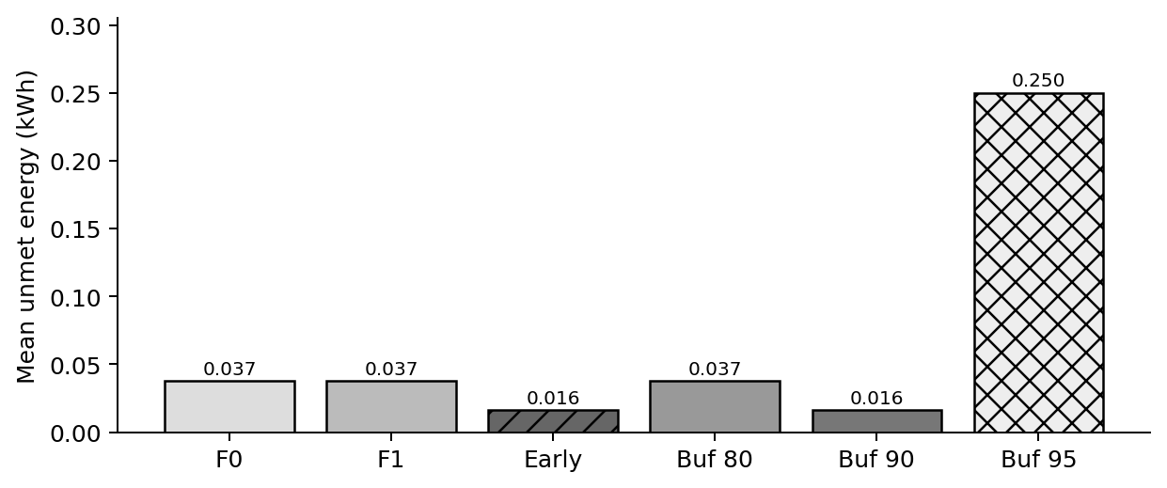
Figure 4. Mean simulated unmet energy, including sessions with zero shortfall.
The earlier 90% buffer and F_early schedules use a higher assumed tariff. Thus the mean realized expenditure for the early schedule is 0.2339 units as opposed to 0.1063 units for F0. Note that these are means of modeled energy actually delivered by the schedules as opposed to means of equal-energy purchase. Thus the full-target nominal costs for the early schedule and the later schedule are 0.25 and 0.125 units respectively. No observed customer bills or economic benefits are inferred.
Table 3
Quantum simulation on the selected QUBOs
Measure | F0 | 90% buffer
Logical qubits (slack) | 4 (2) | 4 (2)
Exact objective minimum | 0.125 | 0.250
Optimal-state probability | 23.83% | 36.72%
Best sampled gap | 0.000 | 0.000
Shots; depth p | 256; 1 | 256; 1

Table 3 separates quantum sampling from session-level service completion. For F0, 86.72% of shots decode to a physically feasible nominal schedule; 23.83% are optimal QUBO states.
For the buffer, 92.97% of the samples adhere to the conservative window of the buffer. However, only 56.64% of the samples also meet the service target of the modeled service. These numbers differ due to different slack assignments and more expensive but still feasible solutions. The depth of the nominal transpiled circuit is 16, with 6 CX gates. For comparison, uniform random sampling of the same number of samples would yield 6.25% optimal samples and 75% physically feasible samples of the nominal solutions. Note, however, that the quantum comparison was performed with only one seed and with a limited budget of evaluation.
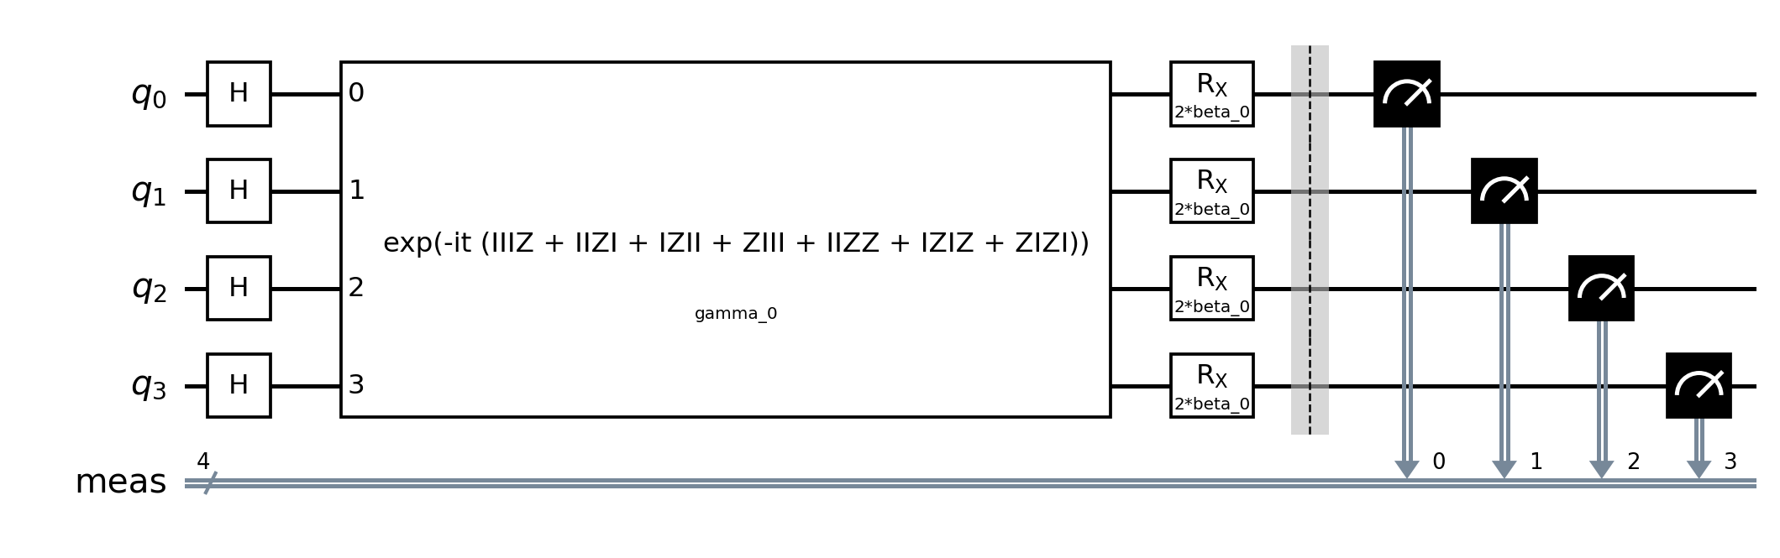
Figure 5. Actual parameterized p = 1 QAOA circuit for the nominal four-variable QUBO. Qubits q0 and q1 encode charging; q2 and q3 encode capacity slack.

Multi-EV capacity and sensitivity
A separate synthetic instance of 2 EVs, 2 slots of 15 minutes, 1 kW of charging power per EV, a site limit of 1 kW and a target of 0.25 kWh for each of the 2 EVs. The 2 EVs have the same nominal arrival and departure windows. Two equally weighted modeled cases are studied. In the first case both windows are retained, while in the second case the window of EV A is ended one slot early. This is an illustrative assumption and does not correspond to the actual fleet of vehicles.
Table 4. Synthetic two-EV comparison (two equally weighted scenarios)
Method | A slots | B slots | Joint completion | Unmet kWh | Mean cost
F0 | 01 | 10 | 50% | 0.125 | 0.3125
F1 | 10 | 01 | 100% | 0 | 0.3750
F_early | 10 | 01 | 100% | 0 | 0.3750
Buffer | 10 | 01 | 100% | 0 | 0.3750
In the two-slot representation, 10 indicates charging in the first slot, whereas 01 indicates charging in the second slot. These are charging-decision bits, not complete QUBO bitstrings, which also include capacity slack. Table 4 reports physical outcomes under identical scenarios. F0’s displayed solution is selected by lexicographic tie-breaking; an equally optimal nominal solution assigns EV A the earlier slot and matches the other methods. Hence the 50% versus 100% difference cannot be credited uniquely to the buffer or to scenario optimization. All successful nominal schedules purchase 0.5 kWh for 0.375 arbitrary units.
The lower mean cost of F0 for the delivered energy, i.e. 0.125 kWh in one case, is due to the non-delivery of the required energy.
The 13 identical full rows were deleted from the dataset. The calibration set consisted of 50,185 sessions and the subsequent evaluation set of 22,083 sessions. The 90% buffer was set to 7 minutes and the 95% buffer to 18 minutes. In the latter case, only complete 15-minute slots were considered. Thus, the 95% buffer resulted in no usable slots. This explains why increasing the buffer size can lead to a decrease in the completion rate to zero in this scenario.
Table 5. Two-EV QAOA: five seeds, 128 shots per run
Model | p | Qubits (slack) | Optimal % mean ± SD | Nominal feasible % | Depth / CX
F0 | 1 | 6 (2) | 9.38 ± 5.44 | 22.81 | 22 / 16
F0 | 2 | 6 (2) | 13.75 ± 5.84 | 25.47 | 37 / 32
F1 | 1 | 8 (4) | 2.19 ± 1.28 | 26.09 | 25 / 22
F1 | 2 | 8 (4) | 2.66 ± 0.43 | 29.22 | 43 / 44
F_buffer | 1 | 6 (2) | 8.28 ± 4.04 | 19.22 | 19 / 10
F_buffer | 2 | 6 (2) | 9.38 ± 3.03 | 21.72 | 34 / 20
For the comparison of the depth and the number of CX gates of the nominal and the two-EV QAOA circuits, see Table 5. The sample standard deviation was computed across the 5 optimizer seeds. All small QUBO and Ising basis energies were checked exhaustively for the exact minimum of each tested objective function. This minimum was always 0.375 for the corresponding objective function, i.e. values from different objective functions are not used for physical quality comparisons.

Reproduced results and model details
We reran the public-duration experiment and the synthetic two-EV study from the current repository. The first uses observed connection durations with assumed requests, tariffs and scheduling decisions. The second is a small constructed example. Neither represents observed performance of a deployed controller.
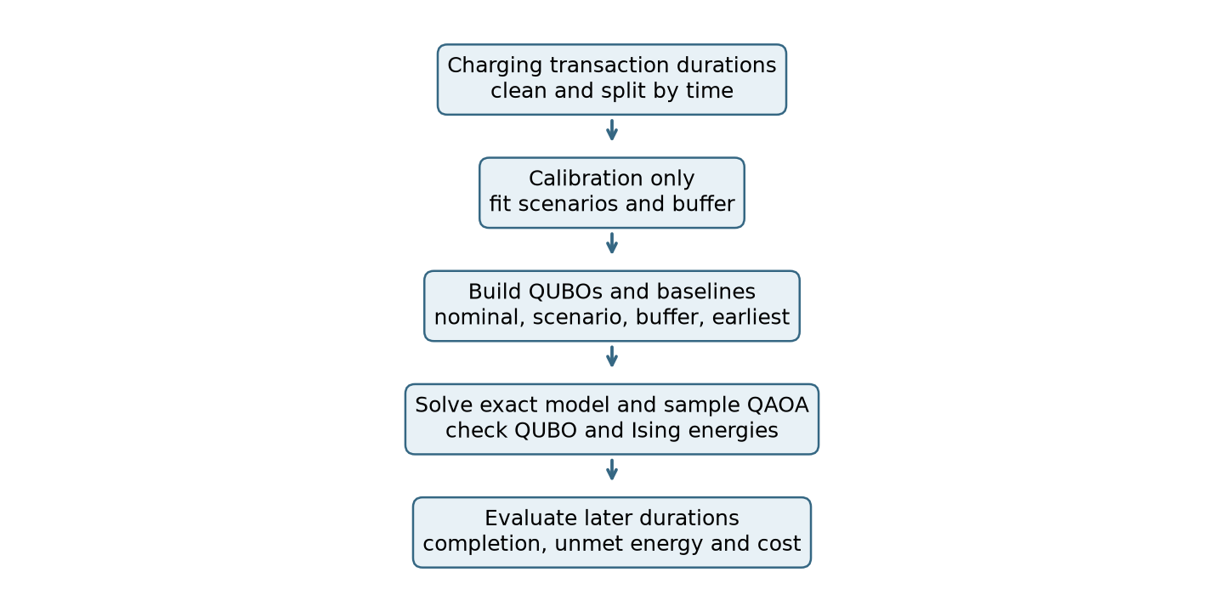
Figure 6. Workflow from observed durations to modeled evaluation. The two-EV example is evaluated separately under assumed availability scenarios.
The calibration data set consisted of 50,185 sessions. The subsequent evaluation data set consisted of 22,083 sessions. The 90% buffer was set to 7 minutes and the 95% buffer to 18 minutes. Note that only complete 15-minute slots are considered in the evaluation, i.e. no usable slot is left by the 95% buffer.
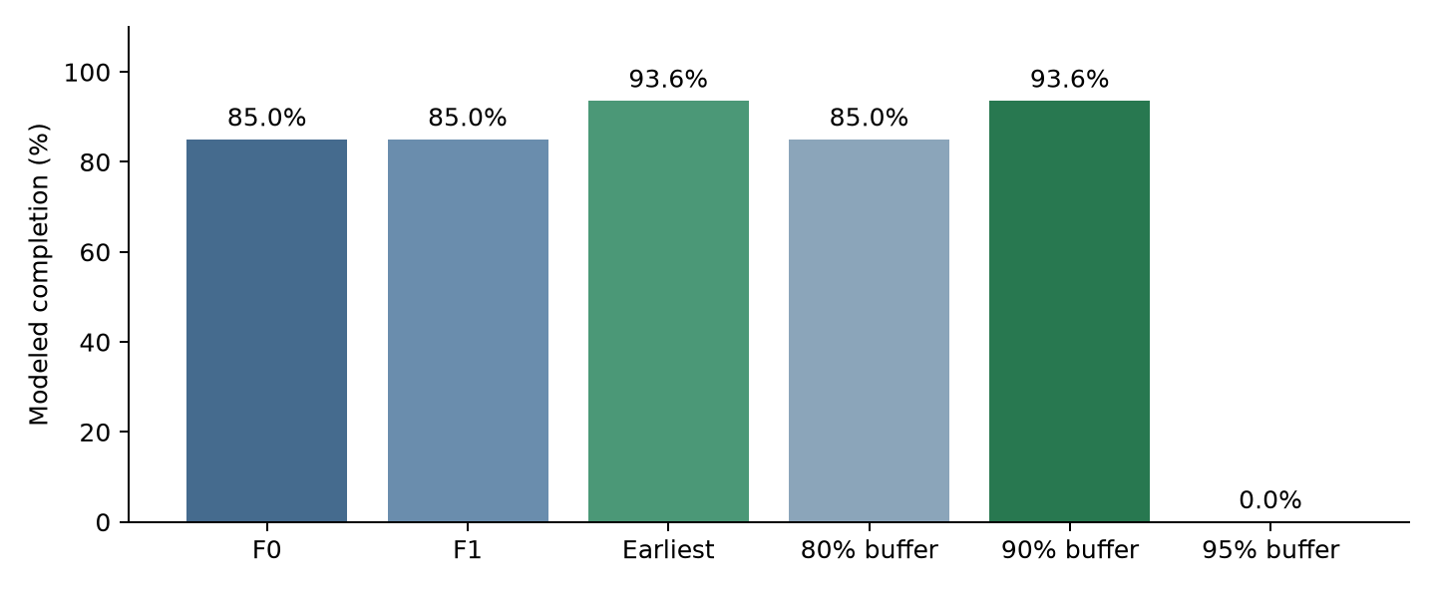
Figure 7. Reproduced modeled completion on later public-data sessions. Earliest charging and the 90% buffer choose the same first slot.
The 90% buffer reaches 93.56% completion compared with 85.01% for F0, a difference of 8.55 percentage points. Earliest charging also reaches 93.56%, so the result does not establish a benefit over that simple baseline. These are counterfactual outcomes, not measured outcomes of historical charging schedules.

A concrete two EV QUBO matrix
The nominal two-EV example uses z = [x₁₁, x₁₂, x₂₁, x₂₂, s₁, s₂]ᵀ, with x being the charging decision and s being the capacity slack bit. The objective function used in the implementation is f(z) = zᵀQz + 20. The matrix shown below is the symmetric matrix of the implementation. Off-diagonal elements are multiplied by two in the term zᵀQz. The constant is required for comparing absolute energies.
 | x11 | x12 | x21 | x22 | s1 | s2
x11 | -9.75 | 5 | 5 | 0 | 5 | 0
x12 | 5 | -9.875 | 0 | 5 | 0 | 5
x21 | 5 | 0 | -9.75 | 5 | 5 | 0
x22 | 0 | 5 | 5 | -9.875 | 0 | 5
s1 | 5 | 0 | 5 | 0 | -5 | 0
s2 | 0 | 5 | 0 | 5 | 0 | -5
The two modeled availability cases are of equal weight. The variables s₁ and s₂ are slack variables that can be used to model the unused site capacity. They are not charging decision variables.
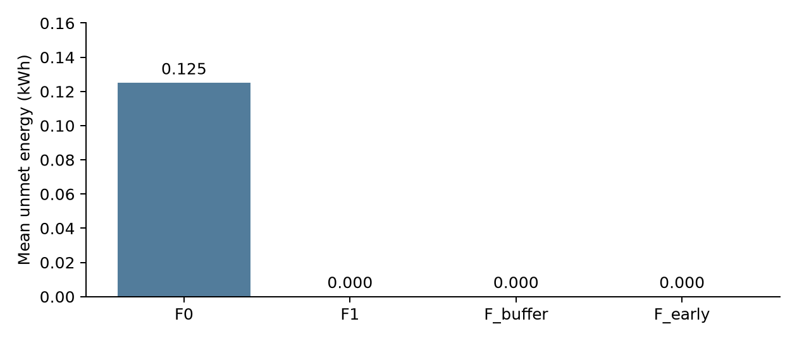
Figure 8. Mean unmet energy across the two equally weighted modeled scenarios. This is a synthetic example, not a fleet estimate.
The mean unmet energy for the chosen nominal schedule is 0.125 kWh for the two scenarios. The other three schedules, the scenario schedule, the buffer schedule and the earliest schedule all result in zero unmet energy for both scenarios. Note however, that there is another equally optimal schedule for the nominal QUBO, i.e. the early allocation schedule. The difference in the comparison results, therefore, depends on the chosen tie-break.

Limitations
The comparison with public-data was modeled for a single EV. Requests, power, capacity, tariffs and nominal deadlines were assumed for the driver’s input. The two-EV experiment is a synthetic example of two equally weighted scenarios. It is not a reconstruction of historical fleet data. The comparison with the F0 tie-break is materially affected by the choice of tie-break.
Aer was used to run QAOA for the experiments reported in this paper. The experiments were run with a limited number of seeds, shots, and optimization budgets. No hardware execution, noise, scalability to industrial scale, or quantum advantage were demonstrated.

Conclusion
In the case of a single EV, the 90% buffer increases the modeled completion compared to the cost-oriented nominal schedule, but equals the completion of the earliest feasible charging. For the 95% buffer, however, the completion of the nominal schedule drops to zero because all full slots are removed. For the synthetic two-EV scenario, the capacity limits introduce a scheduling conflict. However, an equally optimal nominal solution can be found that matches the scenario, the buffer and the greedy allocation. The findings thus far are sensitive to the chosen baseline and tie-breaking, and more experiments, including on decision-time requests, on multi-EV site data and on larger quantum systems, are needed to establish any unique benefits of the calibration.

References
Baek, K., Lee, E., & Kim, J. (2024). A dataset for multi-faceted analysis of electric vehicle charging transactions. Scientific Data, 11, Article 262. https://doi.org/10.1038/s41597-024-02942-9
Dalyac, C., Henriet, L., Jeandel, E., Lechner, W., Perdrix, S., Porcheron, M., & Veshchezerova, M. (2021). Qualifying quantum approaches for hard industrial optimization problems: A case study in the field of smart-charging of electric vehicles. EPJ Quantum Technology, 8, Article 12. https://doi.org/10.1140/epjqt/s40507-021-00100-3
Farhi, E., Goldstone, J., & Gutmann, S. (2014). A quantum approximate optimization algorithm. arXiv. https://arxiv.org/abs/1411.4028
Glover, F., Kochenberger, G., & Du, Y. (2019). A tutorial on formulating and using QUBO models. arXiv. https://doi.org/10.48550/arXiv.1811.11538
Sone, S. P., Lehtomäki, J. J., Khan, Z., Umebayashi, K., & Kim, K. S. (2024). Robust EV scheduling in charging stations under uncertain demands and deadlines. IEEE Transactions on Intelligent Transportation Systems, 25(12), 21484–21499. https://doi.org/10.1109/TITS.2024.3466514
Wang, Z., Jochem, P., & Fichtner, W. (2020). A scenario-based stochastic optimization model for charging scheduling of electric vehicles under uncertainties of vehicle availability and charging demand. Journal of Cleaner Production, 254, Article 119886. https://doi.org/10.1016/j.jclepro.2019.119886

