A Comparative Study of Reliability-Calibrated QUBO Scheduling for Electric Vehicle Charging
Project Report submitted in the partial fulfillment of
Quantum Computing
by
Pratham Kapoor, A028
Ayaan Makhani, B056
Vinayak Rastogi, B078
Yashvardhan Wagh, B135
Under the Guidance of
Dr. Sreemoyee Sarkar
SVKM's NMIMS University
(Deemed-to-be University)

Vile Parle (W), Mumbai – 56

A Comparative Study of Reliability-Calibrated QUBO Scheduling for Electric Vehicle Charging
Pratham Kapoor, Ayaan Makhani, Vinayak Rastogi, Yashvardhan Wagh
Mukesh Patel School of Technology Management & Engineering
SVKM's NMIMS University, Mumbai, India

Abstract
Electric-vehicle charging schedules must supply energy despite limited connection time and site capacity. This exploratory study compares nominal and scenario-averaged QUBOs, earliest feasible charging, and calibration-derived deadline buffers. Among 22,083 later public charging transactions, observed connection durations provide counterfactual availability; the 30-minute deadline, energy target, power and tariffs are assumed. Simulated completion is 85.01% for the nominal schedule and 93.56% for both earliest charging and the 90th-percentile buffer. The 95th-percentile buffer leaves no complete slot. A synthetic two-EV example introduces a binding capacity limit: scenario, buffer and earliest policies choose the same early allocation, which is also a nominal-optimum tie. Exact enumeration and Qiskit Aer simulations compare QUBOs with six or eight logical qubits, using depths p=1 and p=2 across five seeds. The results expose the importance of baseline choice and tie-breaking; they do not establish real-world deployment benefits or quantum advantage.
Keywords: electric vehicles; charging scheduling; uncertainty; QUBO; QAOA; reliability

Introduction
A charging operator must decide when a connected electric vehicle (EV) receives energy. Later charging may be cheaper, but it risks leaving a request unfinished when a connection ends early. Coordinating multiple vehicles also requires respect for electrical limits. This paper asks whether a simple calibration-derived early-completion buffer changes service completion and cost in a small modeled scheduling problem, and how a corresponding binary optimization problem behaves on a quantum simulator.
The contribution is an exploratory comparison of calibration, baseline selection, tie-breaking and quantum sampling under a shared scheduling formulation. A method can appear better than a nominal optimizer when a simple alternative baseline has been omitted or when multiple nominal optima are resolved differently. The underlying charging transactions are real, while the requests, tariffs and scheduling actions evaluated here are simulated. The public-data experiment uses one EV; it cannot establish the performance of a fleet controller.

Related Work
Scenario-based EV charging under uncertain availability and demand has been studied using stochastic programming (Wang et al., 2020). Robust deadline and demand scheduling also has prior work (Sone et al., 2024). Dalyac et al. (2021) examined quantum approaches for industrial smart charging, and Farhi et al. (2014) introduced the quantum approximate optimization algorithm (QAOA). QUBO penalties and slack encodings are established modeling tools (Glover et al., 2019). Our comparison differs in its explicit calibration-to-evaluation split, its examination of an excessively conservative full-slot deadline, and its transparent separation of simulated service from quantum sampling. Those differences do not establish a new algorithm.

Methodology

Data preparation and decision-time assumptions
Baek et al. (2024) released charging-session records with connection and disconnection timestamps and delivered energy. The study uses observed connection durations as counterfactual availability. The file does not supply the driver-declared departure time or a decision-time requested-energy field required by the original ACN formulation. Consequently, the nominal deadline and energy request in this experiment are assumed; delivered energy is not treated as true demand.
Records with unparseable timestamps or nonpositive durations are removed. For calibration, sessions beginning before July 1, 2022 but ending on or after that boundary are also excluded, because their full durations would not yet be known. Later sessions form the evaluation set. Timestamp timezone is not established and timestamps are treated as naive local values. Thirteen duplicate full rows remain; a removal sensitivity check is reported below. Figure 1 shows the actual sequence of analysis.
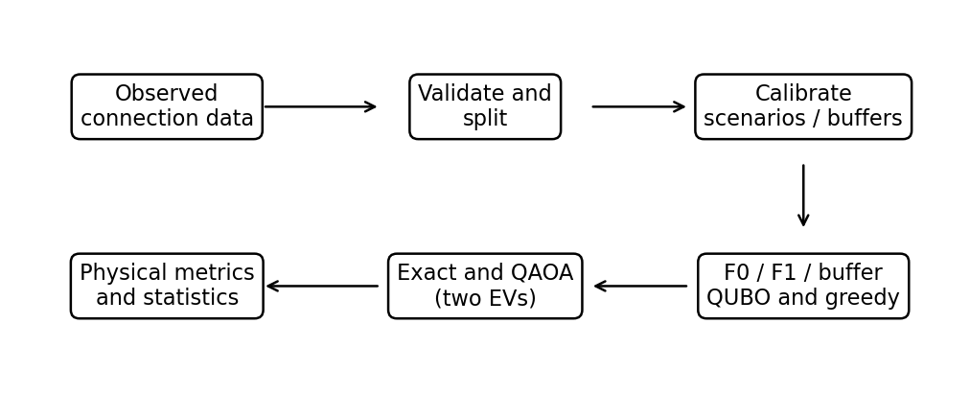
Figure 1. Data, calibration, model construction and evaluation pipeline. The two-EV scenarios are modeled, not reconstructed fleet sessions.
Table 1
Dataset accounting
Record group | Count
Downloaded | 72,856
Invalid duration | 547
Calibration crossing split | 41
Calibration | 50,185
Evaluation | 22,083

Table 1 reconciles the downloaded total with the two exclusions and retained records. The dataset is an observational source of durations, not an observed deployment of the schedules constructed here.

Calibration and scheduling methods
The nominal horizon D is 30 minutes. For a calibration connection duration T, the modeled early-availability difference is D − T. The buffer b at quantile τ is the empirical quantile of the nonnegative early differences:
bτ = Qτ(max(0, D − T)) (1)
Here Qτ is the linear-interpolated sample quantile and τ is a selected level. A conservative schedule uses only complete 15-minute slots ending by D − bτ. F0 uses the nominal window; F1 minimizes the expected penalized objective over eight equal-count calibration groups with empirical weights. Buffer variants use τ = 0.80, 0.90 and 0.95. A session ending later than the nominal horizon does not create extra decision slots. The additional F_early policy fills physically available slots chronologically; ties between EVs follow their declared order.
For F1, the objective is min(x, s₁,…,sK) Σₛ pₛ fₛ(x, sₛ), where K is the number of calibrated groups, pₛ is its empirical frequency, x is the shared schedule, and each sₛ is scenario-specific capacity slack. Each scenario changes availability, delivered energy, cost and the capacity residual. The model is risk-neutral scenario averaging, not a worst-case guarantee.
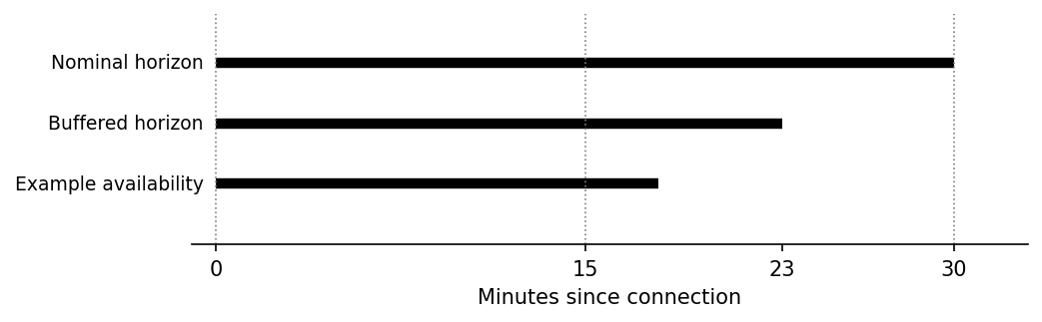
Figure 2. Illustrative timing: a 7-minute buffer moves the deadline to 23 minutes, leaving only the first complete slot. The example availability is 18 minutes.
Figure 2 illustrates the rounding convention. A slot contributes energy only if it ends by the realized connection end. If the buffer removes every complete slot, the method has no legal charging opportunity; the service target remains unmet rather than being silently relaxed.

System Architecture and Quantum Formulation

Physical model and QUBO
Let xᵢₜ be one when EV i is scheduled to charge in slot t, and zero otherwise. Let Pᵢ be its charging power in kW, Δt the slot length in hours, Eᵢ the assumed energy request in kWh, cₜ the tariff per kWh, and Pmax the site limit in kW. With availability aᵢₜ equal to one for a fully available slot, delivered energy and cost are
Edelivered,i = Σₜ aᵢₜ Pᵢ Δt xᵢₜ; C = Σᵢ,ₜ cₜ aᵢₜ Pᵢ Δt xᵢₜ. (2)
Site loading Lₜ = Σᵢ aᵢₜ Pᵢxᵢₜ should satisfy Lₜ ≤ Pmax. The implemented integer-power model represents unused capacity using nonnegative binary slack sₜ, and adds a squared penalty λc(Lₜ + sₜ − Pmax)². A separate squared penalty λe(Rᵢ − Σₜ aᵢₜxᵢₜ)² uses required slot count Rᵢ.
For this experiment, one 1 kW EV needs R=1 slot, Δt=0.25 hours, Pmax=1 kW, and both penalty coefficients are 5. Prices are 1.0 and 0.5 arbitrary currency units per kWh. Thus the energy target is 0.25 kWh.
After expansion, the model takes the quadratic unconstrained binary form f(x) = xᵀQx + c. The vector includes both charging and auxiliary slack bits. Scenario models use separate slack registers, because realized availability can change unused capacity. Penalties are not intrinsically hard constraints: the repository includes a counterexample in which a weak penalty admits an infeasible optimum. Exact enumeration checks the selected tiny instances; it does not prove a universal penalty bound.

Ising mapping and QAOA
For each binary variable, set xᵢ = (1 − Zᵢ)/2, where Zᵢ has computational-basis eigenvalues +1 and −1. The symmetric QUBO becomes Hc = ΣᵢhᵢZᵢ + Σᵢ<ⱼJᵢⱼZᵢZⱼ + c′. With the repository’s symmetric-matrix convention, hᵢ = −½ΣⱼQᵢⱼ, Jᵢⱼ = Qᵢⱼ/2 and c′ = c + [ΣᵢⱼQᵢⱼ + tr(Q)]/4. Off-diagonal QUBO entries occur twice in xᵀQx. Exhaustive tests verify equality of QUBO and Ising basis energies including c′.
Starting from an equal superposition, QAOA alternates a cost evolution and an X mixer. For p layers, the state is
|ψ(γ, β)⟩ = ∏ℓ=1…p exp(−iβℓ ΣᵢXᵢ) exp(−iγℓ Hc) |+⟩⊗n. (3)
The rightmost operation acts first within each layer. Hadamard gates prepare the initial superposition; the cost unitary imprints energy-dependent phases; the mixer changes amplitudes. A classical COBYLA optimizer adjusts γ and β using sampled circuit energies. Measurements yield bitstrings; Qiskit displays qubit zero on the right, so decoding reverses the displayed order. Figure 5 is drawn from the actual nominal circuit. Its first two qubits encode charging decisions, and the last two encode capacity slack.

Experimental Setup
The 72,268 eligible sessions are split into 50,185 calibration and 22,083 evaluation records. Calibration determines scenario centers and buffers; the later records are not used to fit them. Each observed duration is applied to the same synthetic one-EV problem, so observations do not constitute reconstructed multi-EV site instances. The six methods are evaluated with the same physical decoder. Service completion means that the modeled request is delivered within the realized availability while respecting the modeled capacity. Unmet energy includes zero values in its mean.
The paired 90% buffer versus F0 comparison uses a 2,000-replicate calendar-day block bootstrap across 92 evaluation days. User- and charger-cluster sensitivity analyses are reported separately. These analyses do not remove all cross-cluster dependence. The analysis is exploratory and the buffer levels are not a confirmatory multiple-comparison study. The original one-EV QAOA uses p=1 and one seed; a separate synthetic two-EV case tests p=1 and p=2 with five seeds and 128 shots each for F0, F1 and the buffer.

Results and Discussion
Table 2
Simulated service outcomes
Method | Buffer (min) | Completion (%) | Mean unmet (kWh)
F0 nominal | — | 85.01 | 0.0375
F1 scenario | — | 85.01 | 0.0375
F_early | — | 93.56 | 0.0161
Buffer 80% | 0 | 85.01 | 0.0375
Buffer 90% | 7 | 93.56 | 0.0161
Buffer 95% | 18 | 0.00 | 0.2500

As Table 2 and Figure 3 show, F0 and F1 select the same later slot in this particular instance. The 90% buffer moves charging to the first slot and achieves 93.56% modeled completion, 8.55 percentage points above F0; the day-block interval is 8.20 to 8.91 points. F_early chooses the identical first slot and has identical completion, unmet energy and cost. Thus the improvement is over the cost-oriented F0 baseline, not over earliest feasible charging. The interval describes this counterfactual model, not a real-world improvement.
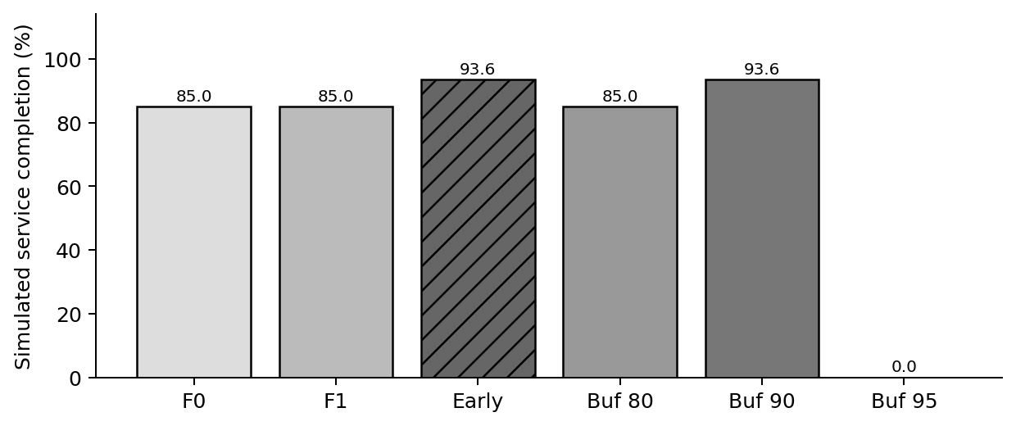
Figure 3. Simulated completion rates on 22,083 evaluation records; these are not observed outcomes of deployed schedules.
Figure 4 shows unconditional mean unmet energy. At the 95% level, the 18-minute buffer moves the deadline to minute 12: neither 15-minute slot can finish in time. The resulting zero schedule leaves the entire assumed 0.25 kWh request unmet. This is a genuine consequence of the coarse modeled horizon and strict complete-slot rule, and demonstrates why a larger buffer need not improve service.
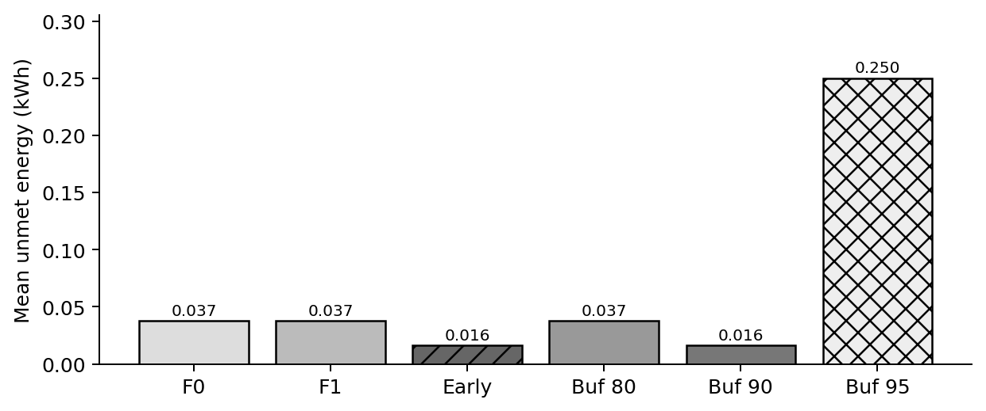
Figure 4. Mean simulated unmet energy, including sessions with zero shortfall.
The earlier 90% and F_early schedules use a higher assumed tariff: mean realized expenditure is 0.2339 arbitrary currency units versus 0.1063 for F0. These means use modeled energy actually delivered, not a fixed equal-energy purchase: F0 often delivers less, which lowers its expenditure. The full-target nominal costs are 0.25 for the early schedule and 0.125 for the later schedule. No observed customer bills or economic benefits are inferred.
Table 3
Quantum simulation on the selected QUBOs
Measure | F0 | 90% buffer
Logical qubits (slack) | 4 (2) | 4 (2)
Exact objective minimum | 0.125 | 0.250
Optimal-state probability | 23.83% | 36.72%
Best sampled gap | 0.000 | 0.000
Shots; depth p | 256; 1 | 256; 1

Table 3 separates quantum sampling from session-level service completion. For F0, 86.72% of shots decode to a physically feasible nominal schedule; 23.83% are optimal QUBO states. For the buffer, 92.97% obey its conservative window and 56.64% both obey the window and meet the modeled service target. Different slack assignments and feasible but more expensive schedules explain why the probabilities differ. The nominal transpiled circuit has depth 16 and six CX gates. Uniform random sampling would yield 6.25% optimal and 75% physically feasible nominal states. The quantum comparison uses one seed and a limited evaluation budget, so no general superiority can be inferred.
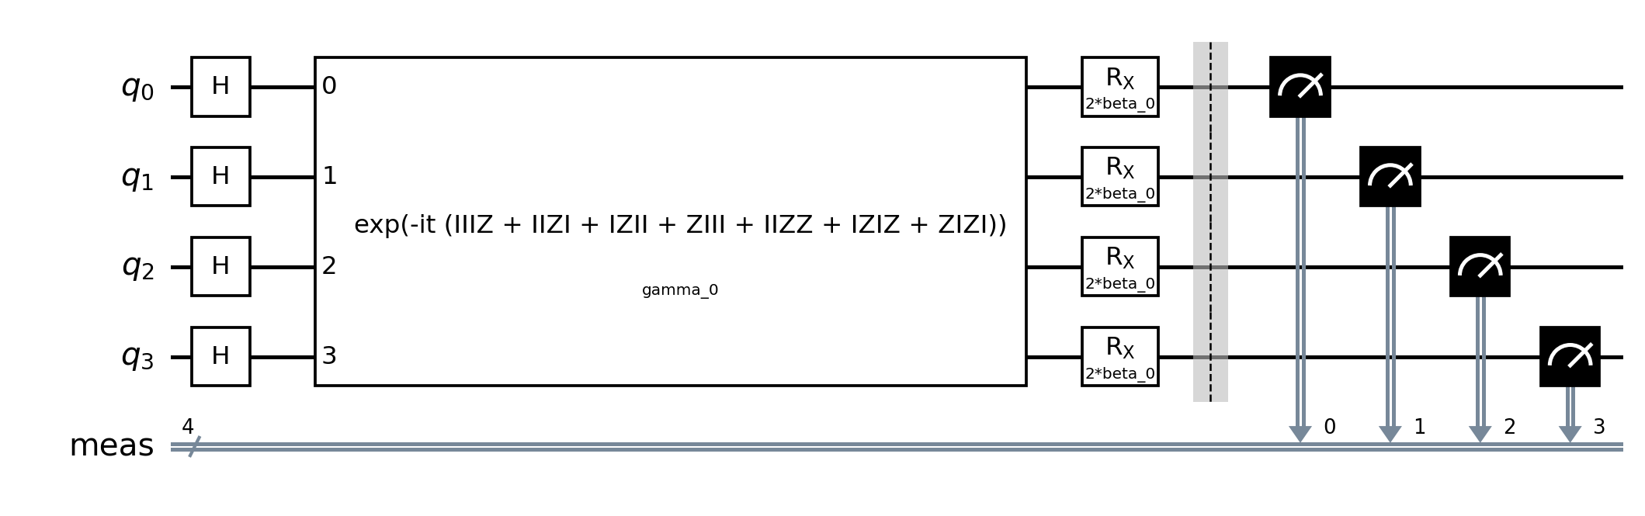
Figure 5. Actual parameterized p = 1 QAOA circuit for the nominal four-variable QUBO. Qubits q0 and q1 encode charging; q2 and q3 encode capacity slack.

Multi-EV capacity and sensitivity
A separate synthetic instance has two EVs, two 15-minute slots, 1 kW charging power per EV, a 1 kW shared site limit, and a 0.25 kWh target for each. Both EVs have the same nominal arrival and departure windows. Two equally weighted modeled cases either retain both windows or end EV A’s window one slot early; these are illustrative assumptions, not historical fleet schedules. Simultaneous charging exceeds capacity, so the site constraint genuinely binds.
Table 4. Synthetic two-EV comparison (two equally weighted scenarios)
Method | A slots | B slots | Joint completion | Unmet kWh | Mean cost
F0 | 01 | 10 | 50% | 0.125 | 0.3125
F1 | 10 | 01 | 100% | 0 | 0.3750
F_early | 10 | 01 | 100% | 0 | 0.3750
Buffer | 10 | 01 | 100% | 0 | 0.3750
In the two-slot representation, 10 indicates charging in the first slot, whereas 01 indicates charging in the second slot. These are charging-decision bits, not complete QUBO bitstrings, which also include capacity slack. Table 4 reports physical outcomes under identical scenarios. F0’s displayed solution is selected by lexicographic tie-breaking; an equally optimal nominal solution assigns EV A the earlier slot and matches the other methods. Hence the 50% versus 100% difference cannot be credited uniquely to the buffer or to scenario optimization. All successful nominal schedules purchase 0.5 kWh for 0.375 arbitrary units. F0’s lower average realized cost reflects its failure to deliver 0.125 kWh in one case.
Deleting the 13 identical full rows did not change the calibrated 7-minute buffer or the 22,083-record evaluation result. The day-block interval uses 92 days. A charger-cluster interval is 7.78–9.45 percentage points over 1,661 charger IDs; an identifiable-user interval is 9.88–12.67 points over 1,254 nonzero user IDs and 13,684 records. These resampling units overlap and the user subset differs, so the intervals are sensitivity analyses rather than interchangeable independent evidence.
Table 5. Two-EV QAOA: five seeds, 128 shots per run
Model | p | Qubits (slack) | Optimal % mean ± SD | Nominal feasible % | Depth / CX
F0 | 1 | 6 (2) | 9.38 ± 5.44 | 22.81 | 22 / 16
F0 | 2 | 6 (2) | 13.75 ± 5.84 | 25.47 | 37 / 32
F1 | 1 | 8 (4) | 2.19 ± 1.28 | 26.09 | 25 / 22
F1 | 2 | 8 (4) | 2.66 ± 0.43 | 29.22 | 43 / 44
F_buffer | 1 | 6 (2) | 8.28 ± 4.04 | 19.22 | 19 / 10
F_buffer | 2 | 6 (2) | 9.38 ± 3.03 | 21.72 | 34 / 20
Table 5 uses sample standard deviation across five optimizer seeds; individual shots are not independent optimization trials. Each QUBO has four charging-decision qubits. F1 adds four scenario-specific slack qubits, while F0 and the buffer add two. All small QUBO and Ising basis energies were checked exhaustively. The exact minimum of each tested objective is 0.375 in its own formulation; values from different objectives are not used as physical-quality comparisons. The limited runs do not show quantum advantage.

Limitations
The public-data comparison models a single EV; requests, power, capacity, tariffs and nominal deadlines are assumed, not observed driver inputs. The two-EV experiment is also synthetic, uses two equally weighted scenarios and does not reconstruct a historical fleet. Its F0 tie-breaking materially changes the reported comparison. Day-, charger- and user-cluster intervals are separate sensitivity checks and do not fully account for overlapping dependence. QAOA is simulated on Aer with limited seeds, shots and optimization budgets. No hardware execution, noise resilience, industrial scalability or quantum advantage is demonstrated.

Conclusion
In the single-EV counterfactual, the 90% buffer improves modeled completion over the cost-oriented nominal schedule but exactly matches earliest feasible charging; the 95% buffer removes all usable full slots. In the synthetic two-EV case, capacity creates a meaningful scheduling conflict, yet an equally optimal nominal tie can match the scenario, buffer and greedy allocation. The findings demonstrate baseline and tie-breaking sensitivity rather than a unique benefit of calibration. Future work should validate on decision-time requests, independent multi-EV site data and broader quantum experiments.

References
Baek, K., Lee, E., & Kim, J. (2024). A dataset for multi-faceted analysis of electric vehicle charging transactions. Scientific Data, 11, Article 262. https://doi.org/10.1038/s41597-024-02942-9
Dalyac, C., Henriet, L., Jeandel, E., Lechner, W., Perdrix, S., Porcheron, M., & Veshchezerova, M. (2021). Qualifying quantum approaches for hard industrial optimization problems: A case study in the field of smart-charging of electric vehicles. EPJ Quantum Technology, 8, Article 12. https://doi.org/10.1140/epjqt/s40507-021-00100-3
Farhi, E., Goldstone, J., & Gutmann, S. (2014). A quantum approximate optimization algorithm. arXiv. https://arxiv.org/abs/1411.4028
Glover, F., Kochenberger, G., & Du, Y. (2019). A tutorial on formulating and using QUBO models. arXiv. https://doi.org/10.48550/arXiv.1811.11538
Sone, S. P., Lehtomäki, J. J., Khan, Z., Umebayashi, K., & Kim, K. S. (2024). Robust EV scheduling in charging stations under uncertain demands and deadlines. IEEE Transactions on Intelligent Transportation Systems, 25(12), 21484–21499. https://doi.org/10.1109/TITS.2024.3466514
Wang, Z., Jochem, P., & Fichtner, W. (2020). A scenario-based stochastic optimization model for charging scheduling of electric vehicles under uncertainties of vehicle availability and charging demand. Journal of Cleaner Production, 254, Article 119886. https://doi.org/10.1016/j.jclepro.2019.119886

