Done By PRATHAM M

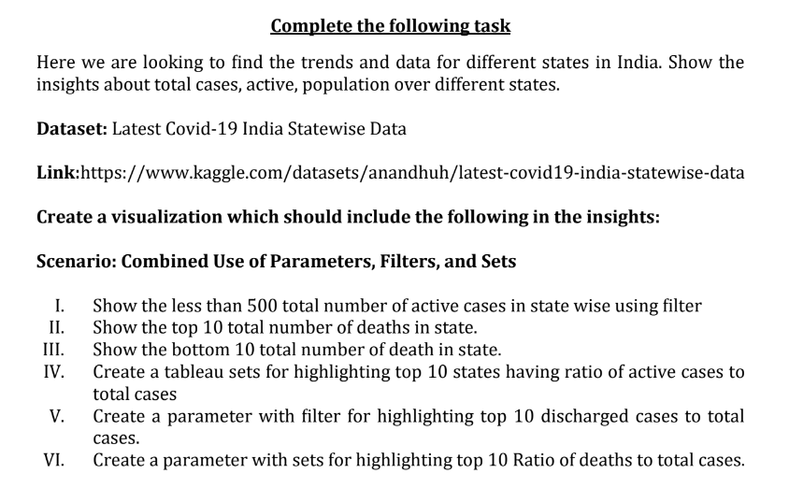

1. Show the less than 500 total number of active cases in state wise using filter

**I. Filter States with Less than 500 Active Cases**

* **Step 1:** Drag the State dimension to Rows.
* **Step 2:** Drag Active Cases to Columns.
* **Step 3:** Create a filter by dragging Active Cases to the Filters shelf.
* **Step 4:** In the filter dialog, set the condition to less than 500.
* **Step 5:** Adjust the visualization as a bar chart for better clarity.

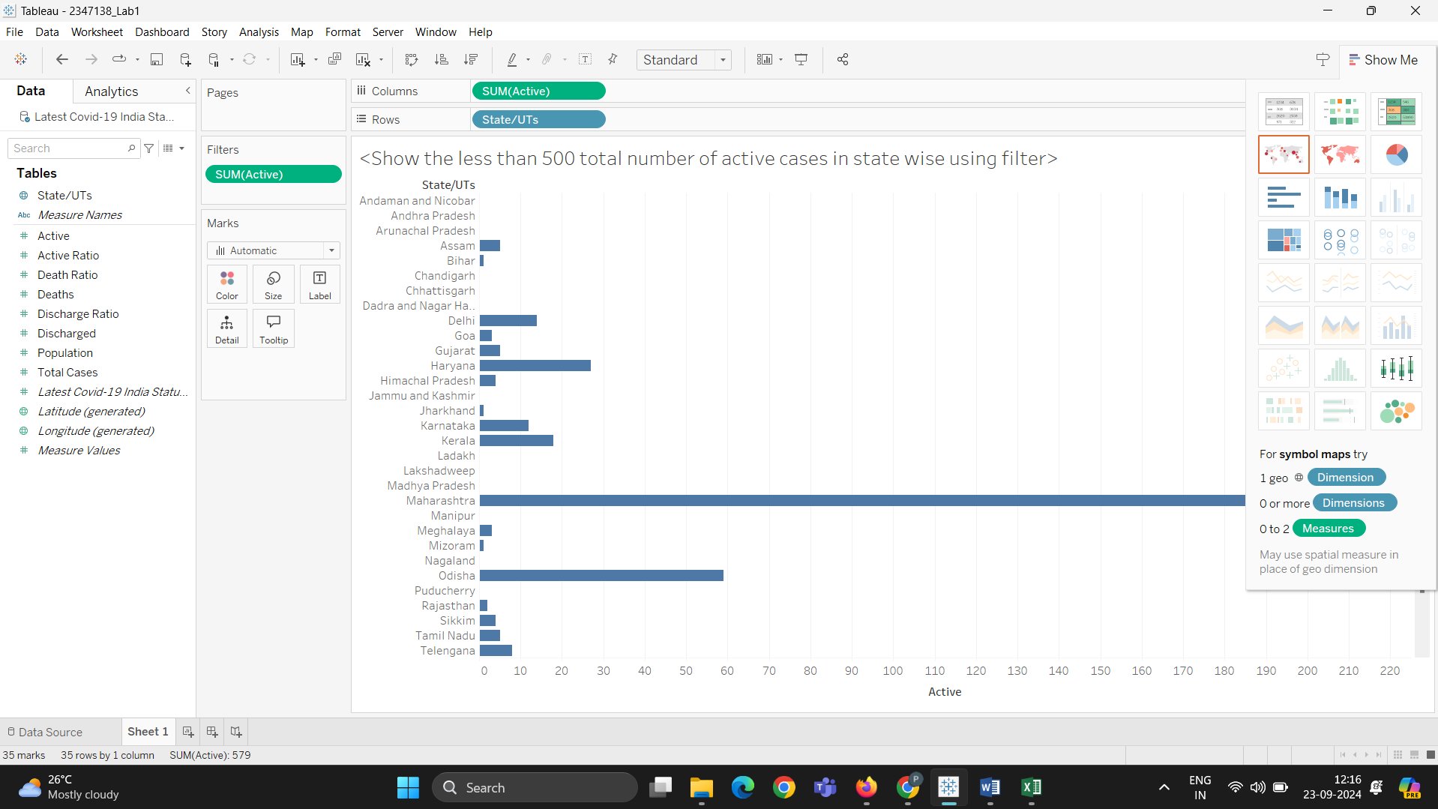

1. Show the top 10 total number of deaths in state.

**Show the Top 10 States with the Highest Number of Deaths**

* **Step 1:** Drag the State dimension to Rows.
* **Step 2:** Drag Deaths to Columns.
* **Step 3:** Sort the State by Deaths in descending order.
* **Step 4:** Limit the view to the top 10 by right-clicking on State, selecting Top, and choosing By Field with Top 10 by Deaths.

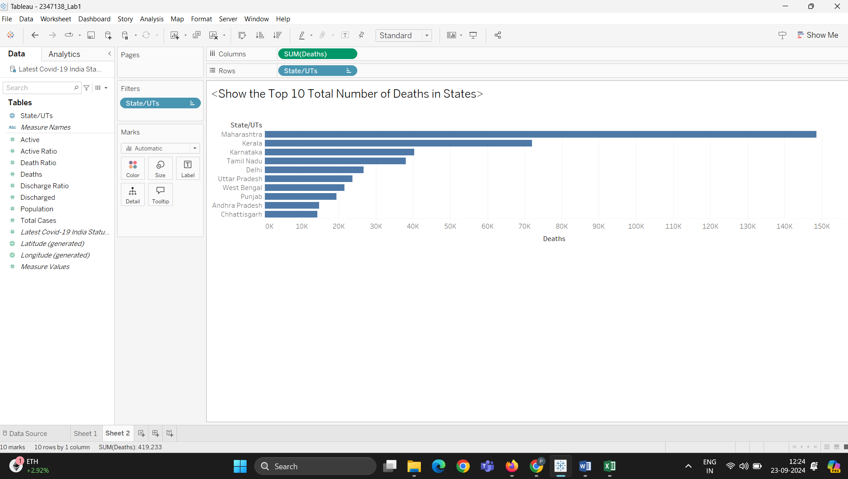

1. Show the bottom 10 total number of death in state.

#### ****III. Show the Bottom 10 States with the Lowest Number of Deaths****

* **Step 1:** Duplicate the previous sheet.
* **Step 2:** Modify the top filter to Bottom 10 by Deaths.

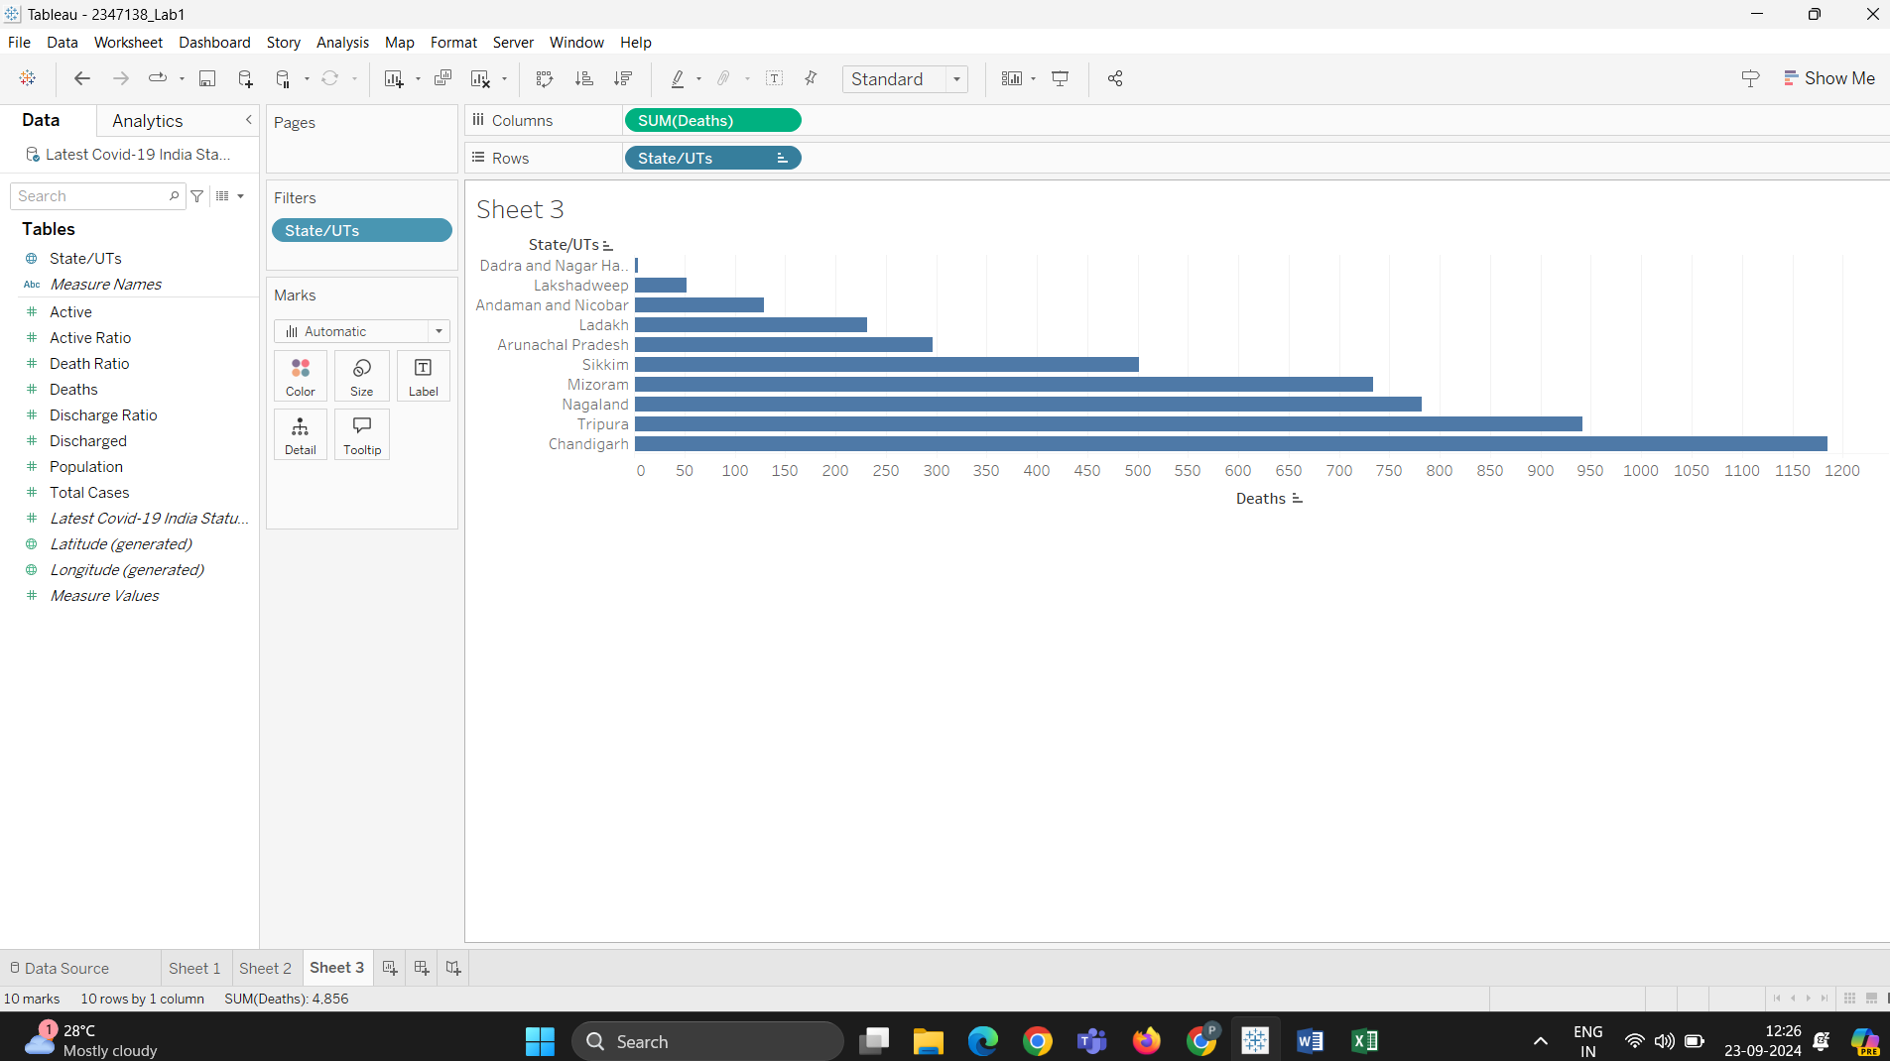

1. Create a tableau sets for highlighting top 10 states having ratio of active cases to total cases

#### ****IV. Create a Set for the Top 10 States by Ratio of Active Cases to Total Cases****

* **Step 1:** Create a calculated field: Active to Total Ratio as ([Active Cases] / [Total Cases]).
* **Step 2:** Right-click on State and create a set.
* **Step 3:** In the set dialog, choose Top by Field, and select Top 10 by Active to Total Ratio.

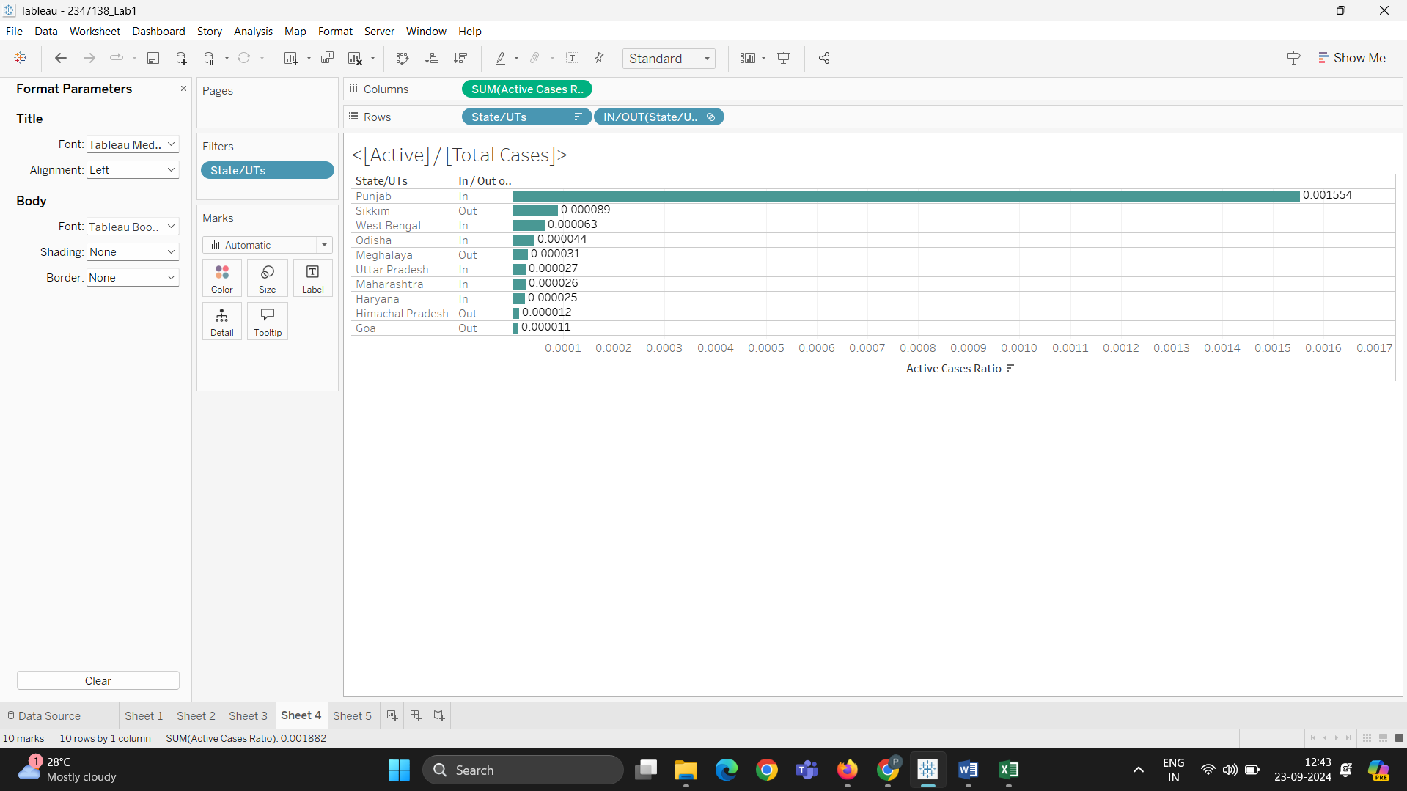

1. Create a parameter with filter for highlighting top 10 discharged cases to total cases.

#### ****Create a Parameter for Highlighting Top 10 Discharged to Total Cases****

* **Step 1:** Create a calculated field: Discharged to Total Ratio as ([Discharged] / [Total Cases]).
* **Step 2:** Create a parameter, name it Top Discharged Ratio.
* **Step 3:** Set the parameter data type to integer and set the range to 1 to 10.
* **Step 4:** Create a calculated field using this parameter to highlight the top states: IF RANK([Discharged to Total Ratio]) <= [Top Discharged Ratio] THEN 'Top' ELSE 'Others' END.

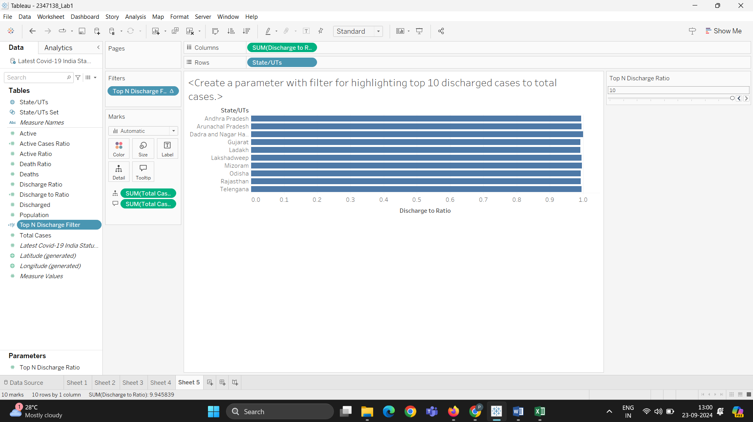

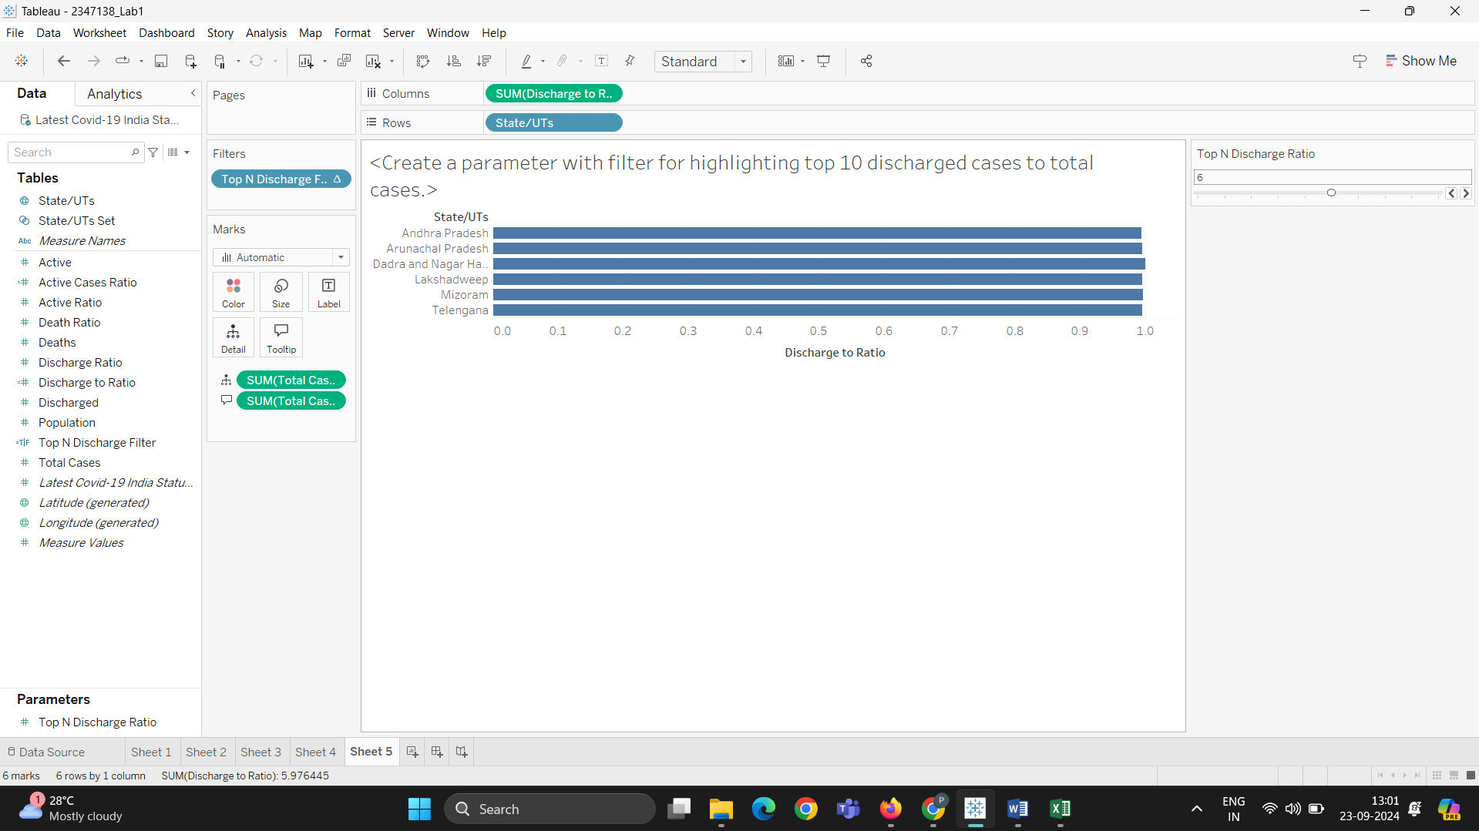

1. Create a parameter with sets for highlighting top 10 Ratio of deaths to total cases.

#### ****VI. Create a Parameter and Set for Highlighting the Top 10 Ratio of Deaths to Total Cases****

* **Step 1:** Create a calculated field: Deaths to Total Ratio as ([Deaths] / [Total Cases]).
* **Step 2:** Create a set similar to the Active Ratio set but based on Deaths to Total Ratio.
* **Step 3:** Create a parameter to dynamically filter or highlight these states, following the method used in the previous step for Discharged cases.

