Experiment – 1

**NAME : Madhuram Brijeshkumar Modi**

**ROLL NO. : 21BCP102**

**DIV, GROUP : 2,G3**

1. **Whoami**

Displays user, group and privileges information for the user who is currently logged on to the local system. If used without parameters, whoami displays the current domain and user name.

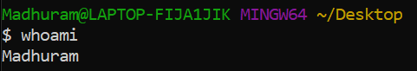

1. **–version**

Checks the version of a program or software.

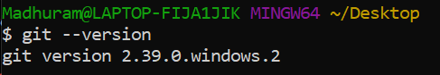

1. **pwd**

The pwd command writes to standard output the full path name of your current directory (from the root directory). All directories are separated by a / (slash).

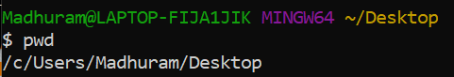

1. **ls**

The ls command is used to list files. "ls" on its own lists all files in the current

directory except for hidden files.



1. **-R**

The ls command lists the contents of your current working directory and

recurring files.

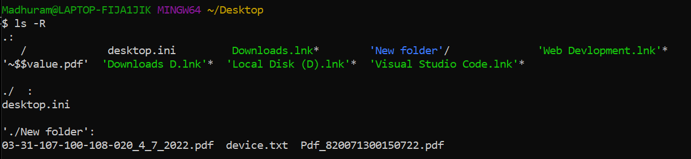

1. **-a**

The ls command is used to list hidden directories and files.



1. **history**

history command is used to view the previously executed command.

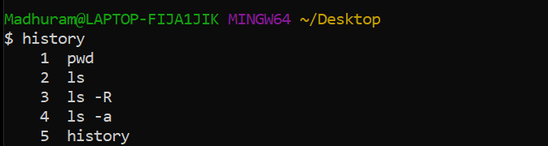

1. **clear**

The clear command clears your screen, if possible. The clear command first

checks the TERM environment variable for the terminal type.

1. **Echo**

In computing, echo is a command that outputs the strings that are passed to it as

arguments.

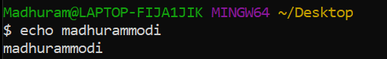

**10) touch**

The touch command updates the access and modification times of each file

specified by the File parameter of each directory specified by the Directory

parameter.

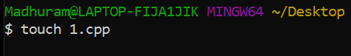

**11) rm**

The rm command is used to delete files. rm -i will ask before deleting each file.

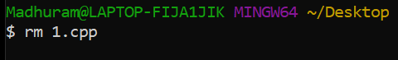

**12) mkdir**

The mkdir command in Linux/Unix allows users to create or make new

directories. mkdir stands for “make directory.”

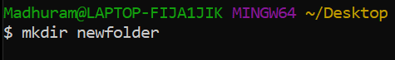

**13) rmdir**

The rmdir command removes the directory, specified by the Directory

parameter, from the system. The directory must be empty before you can

remove it, and you must have write permission in its parent directory.

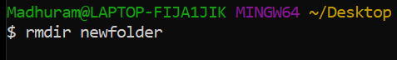

**14) –help**

The help command is a command that's used to provide more information on another

command.

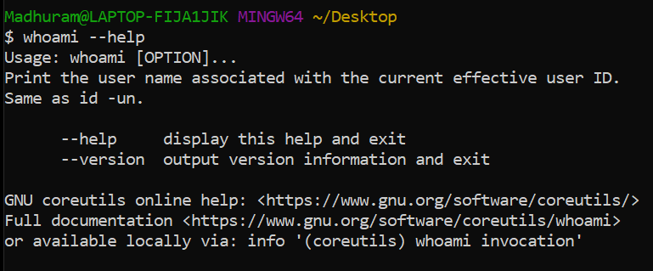

**15) mv**

The mv command moves files and directories from one directory to another or renames a file or directory. If you move a file or directory to a new directory, it retains the base file name.

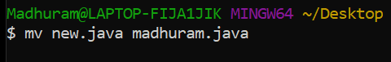

**16) date**

The date command shows the current day, date and time.

