Experiment – 2

**NAME : Madhuram Brijeshkumar Modi**

**ROLL NO. : 21BCP102**

**DIV, GROUP : 2,G3**

1. **cd Command**

cd stands for change directory

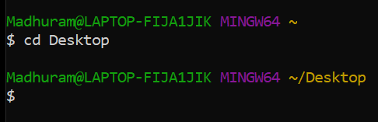

1. **cd ~ Command**

~ stands for home directory, this command will change current directory to home directory.

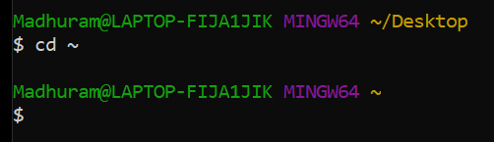

1. **cd .**

. stands for the current directory, it will stay in current directory

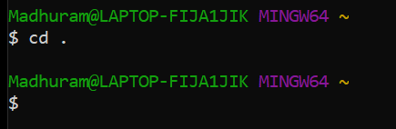

1. **cd ..**

.. stands for parent directory, It will change from current directory to parent directory

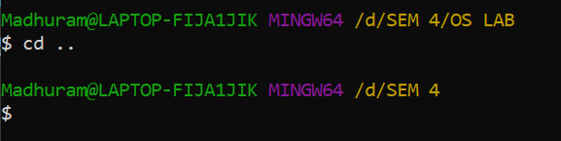

1. **cmp command**

cmp command is used to compare the two files byte by byte and helps you to find out whether the two files are identical or not.

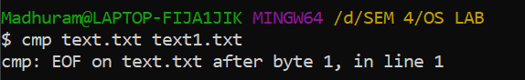

1. **cd / command**

/ It takes you to the system’s root directory.

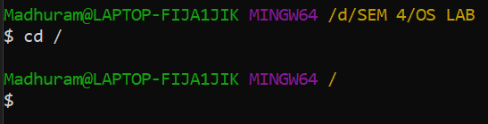

1. **cat command**

cat command reads data from the file and gives their content as output. It helps us to create, view, and concatenate files.

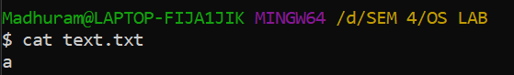

1. **cal -y command**

Shows the calendar of the complete current year with the current date highlighted.

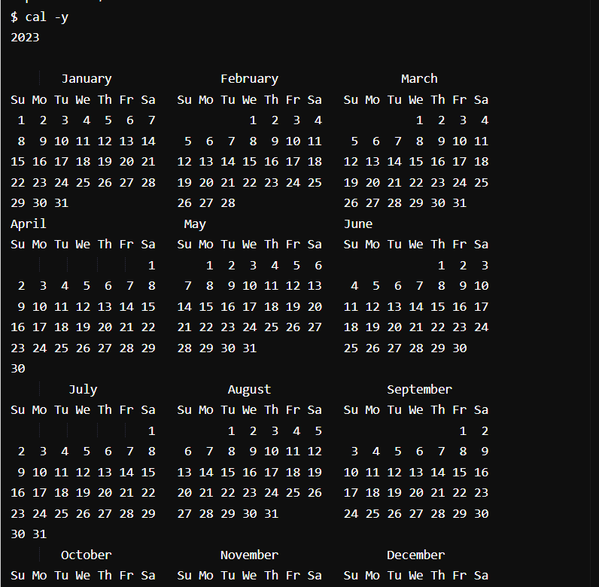

1. **grep command**

Grep command used to search for a string of characters in a specified file. The text search pattern is called a regular expression. When it finds a match, it prints the line with the result.

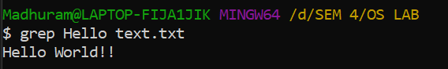

1. **uname, uname -a, uname -n, uname -s commands**

uname -a prints all the system information in the following order: Kernel name, network node hostname, kernel release date, kernel version, machine hardware name, hardware platform, operating system. Uname -s prints the kernel name. uname -n prints the hostname of the network node(current computer).

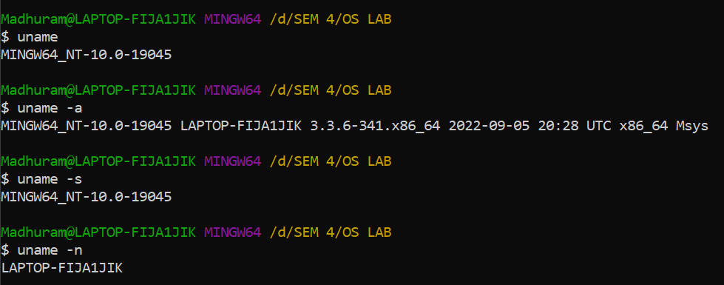

1. **free command**

free command outputs a summary of RAM usage, including total, used, free, shared, and available memory and swap space.

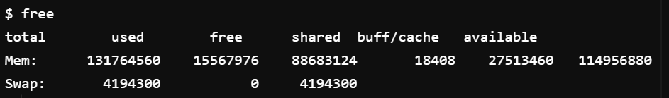

1. **date -d command**

This option allows user to operate on a specific date.

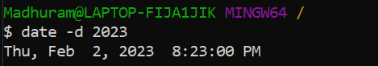

1. **passwd command**

passwd command is used to change the user account passwords.

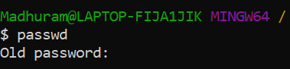

1. **comm command**

The 'comm' command compares two files or streams.

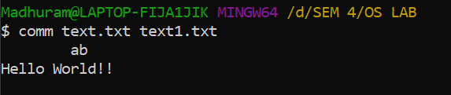

1. **cp**

Cp command copies one file’s content to another file.

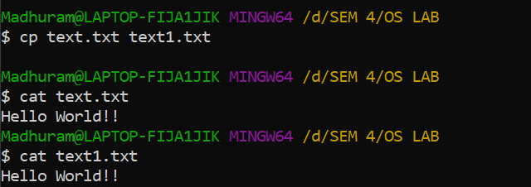

1. **ps command**

Ps command is used to list the currently running processes and their PIDs along with some other information depending on different options.

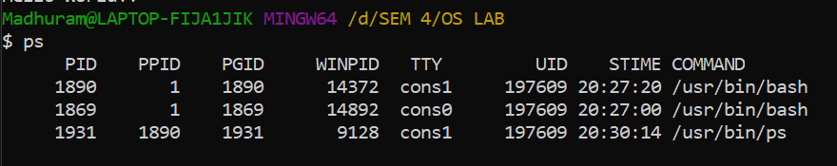

1. **top Command**

Top command is used to show the Linux processes. It provides a dynamic real-time view of the running system.

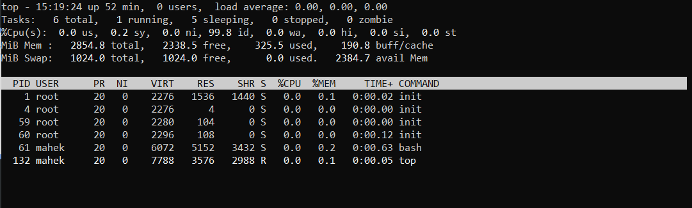

1. **date --date=”02/02/2023” command**

To display the given date string in the format of a date. This command does not affect the system’s actual date and time.



1. **wc -w command**

Gives the count of words in the given file.

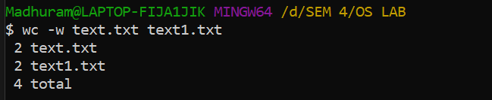

1. **wc -l command**

Gives the count of lines in the given file.

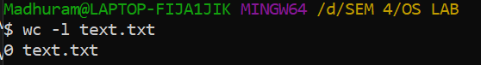

1. **wc -c command**

Gives the count of characters in the given file.

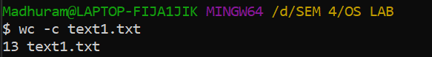

1. **chmod command**

Use to change permissions of a file or directory. (chmod -change mode) Syntax: ch mod category operation permission file. Assigns write & execute permissions for users ( - used to reduce power).

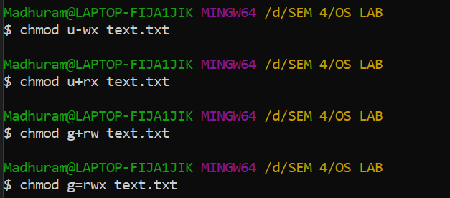

1. **kill pid command**

Kills the process with the given PID.

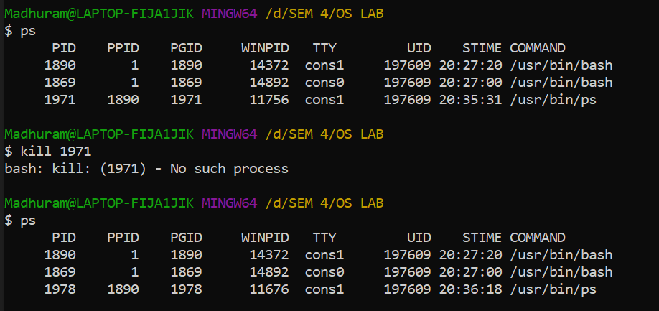

1. **killall proc command**

Kills all the processes running.

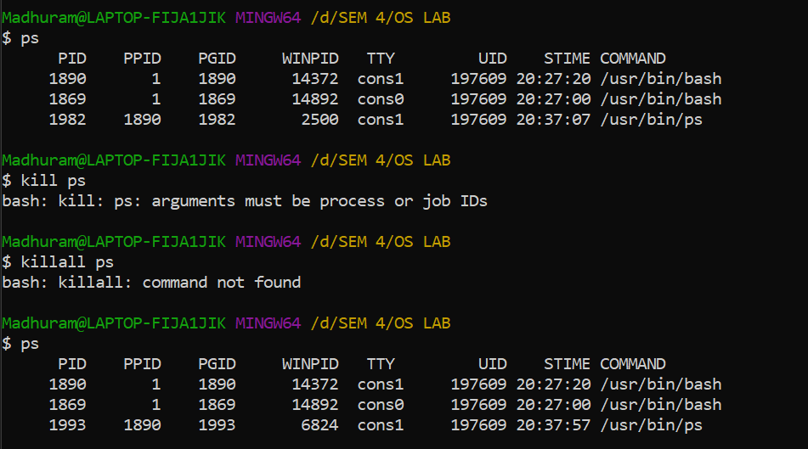

1. **find command**

The find command in UNIX is a command line utility for walking a file hierarchy. It can be used to find files and directories and perform subsequent operations on them.

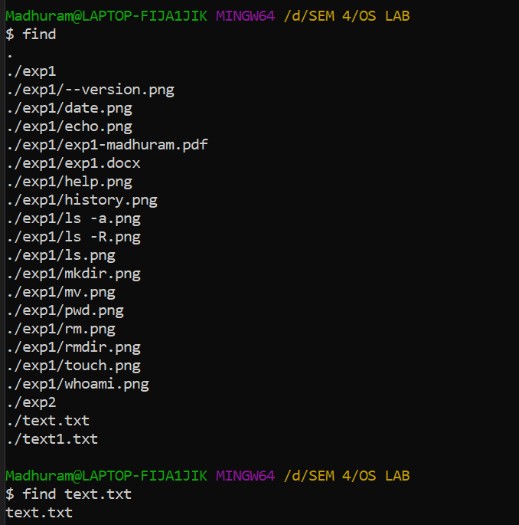

1. **Locate Command**

Locate command in Linux is used to find the files by name.

