Experiment – 3

**NAME : Madhuram Brijeshkumar Modi**

**ROLL NO. : 21BCP102**

**DIV, GROUP : 2,G3**

**Shell Scripting**

**Introduction:**

The shell is a command line interpreter. It translates the commands entered by the user and converts them into a language understood by the kernel. Kernel manages resource of Linux O/S. Kernel decides who will use this resource, for how long and when. It runs your programs (or set up to execute binary files).

Computer understand the language of 0's and 1's called binary language, In early days of computing, instruction are provided using binary language, which is difficult for all of us, to read and write. So in O/s there is special program called Shell. Shell accepts your instruction or commands in English and translate it into computers native binary language.



A shell script is a computer program designed to be run by the Unix/Linux shell which could be one of the following:

• The Bourne Shell

• The C Shell

• The Korn Shell

1. **Write a shell script to print your name.**

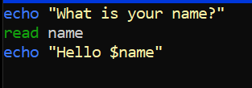

Output:

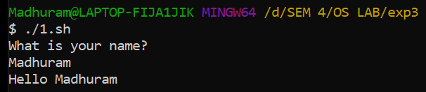

1. **Write a shell script to find whether a number is even or odd.**

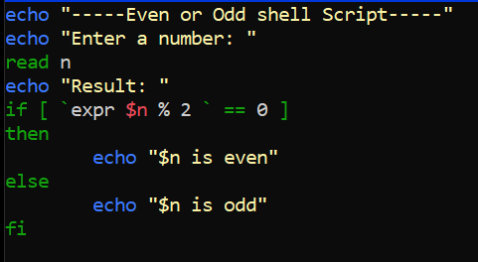

Output:

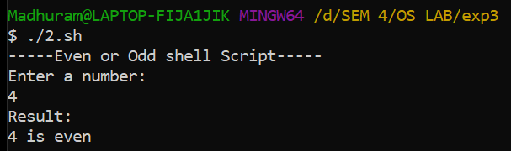

1. **Write a script to print a table of a given number.**

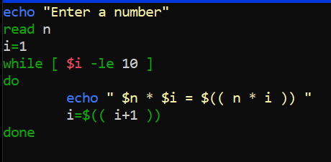

Output:

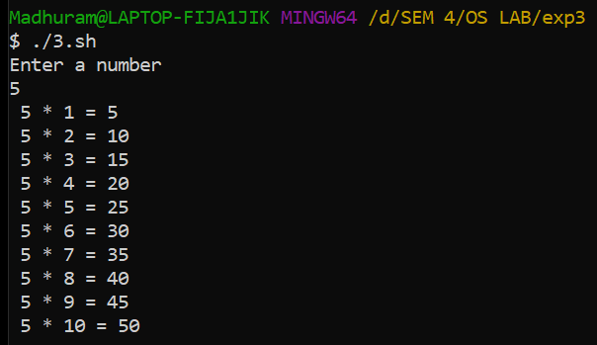

1. **Write a shell script to check whether a given no. is prime or not.**

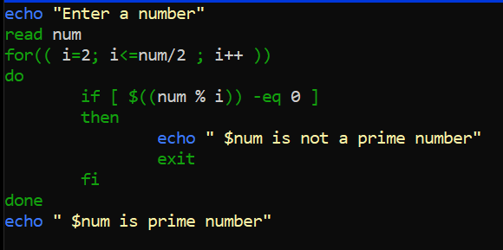

Output:

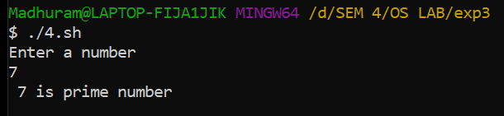

1. **Write a shell script to find the simple interest.**

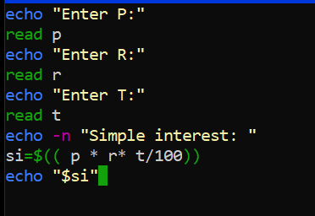

Output:

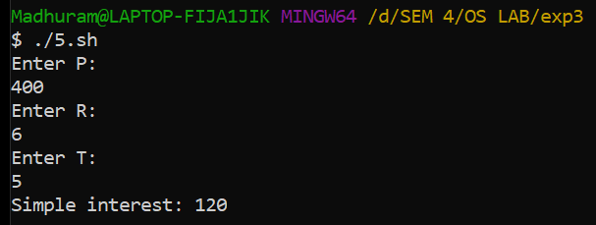

1. **Write a shell script to find sum of n numbers.**

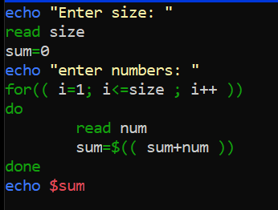

Output:

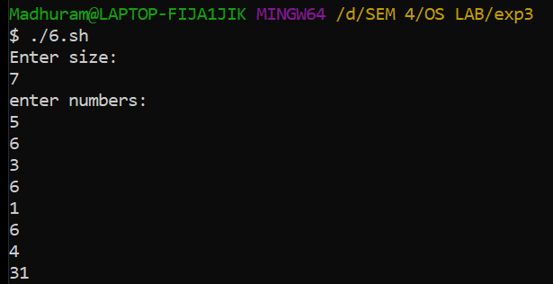

1. **Write a shell script to find the largest number of three numbers.**

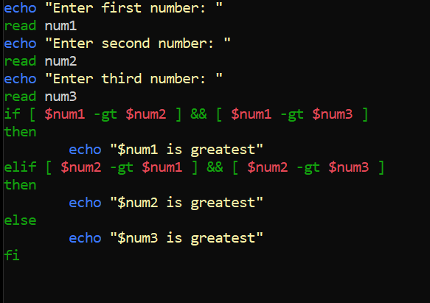

Output:

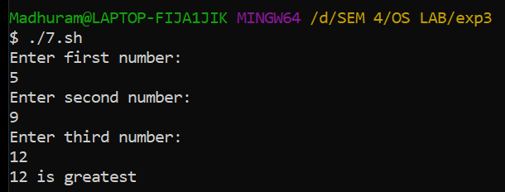

1. **Write a menu driven shell script will point thefollowing menu and execute the give task.**

**a. Display calender of current month**

**b. Display today’s date and time**

**c. Display username those are currently logged in thesystem**

**d. Display your name at given x,y position.**

**e. Display your terminal number.**

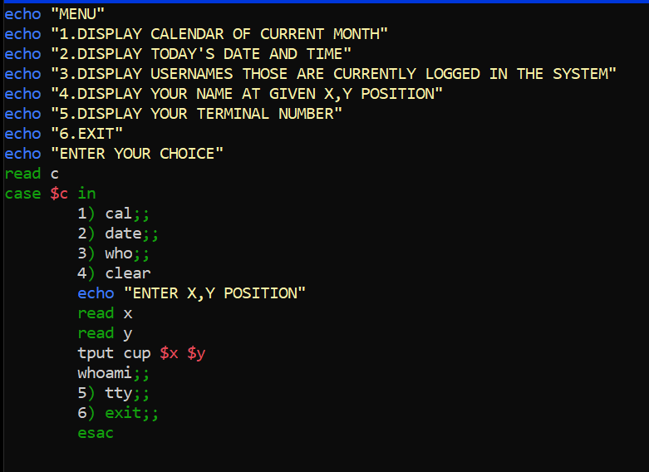

Output:

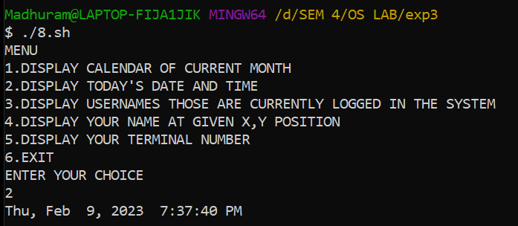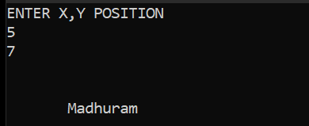

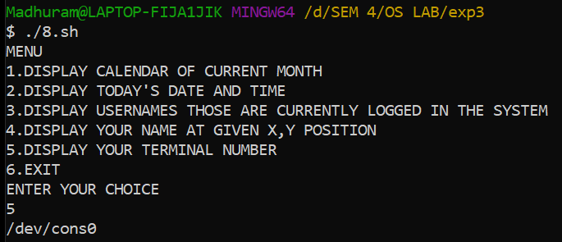

1. **Write a shell script which will generate first n Fibonacci numbers like :1,1,2,3,5,13,….\**

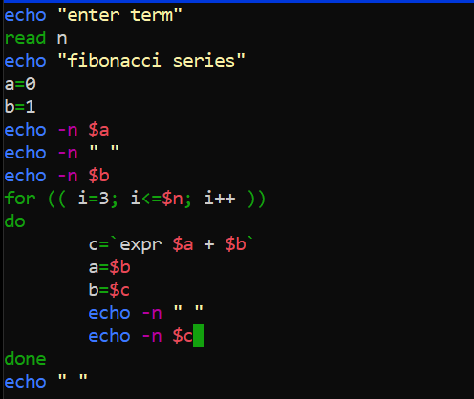

Output:

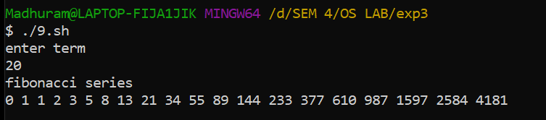

1. **Write a shell script to find whether a given year is leap year or not.**

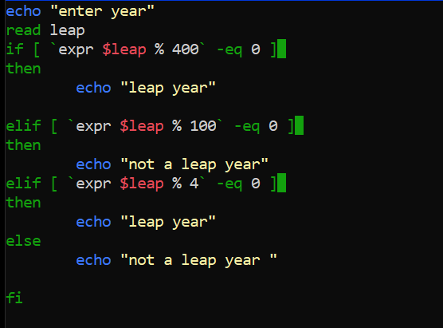

Output:

