Experiment – 3

**NAME : Madhuram Brijeshkumar Modi**

**ROLL NO. : 21BCP102**

**DIV, GROUP : 2,G3**

**11. Shell Script to print half pyramid using numbers.**

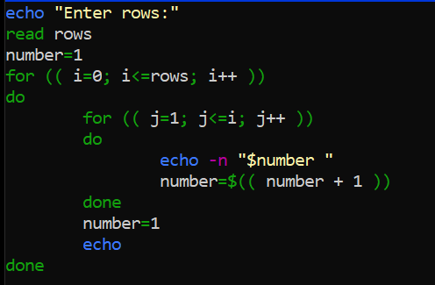

Output:

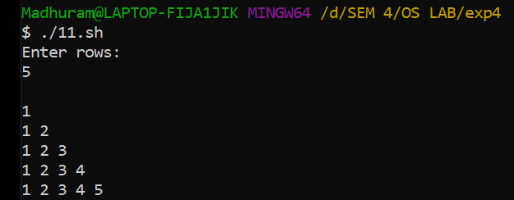

**12. Write a shell script that changes text to upper case**

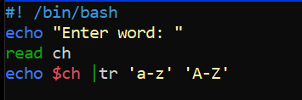

Output:

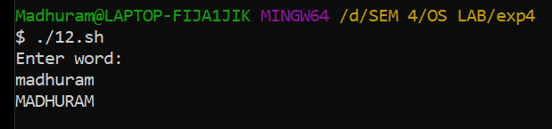

**13. Write a shell script to find reverse of given number.**

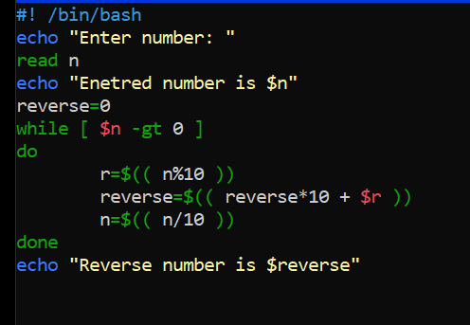

Output:

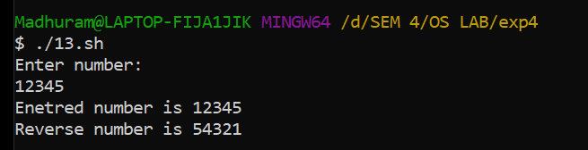

**14. Write a shell script to find sum of floating point numbers.**

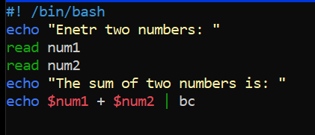

Output:

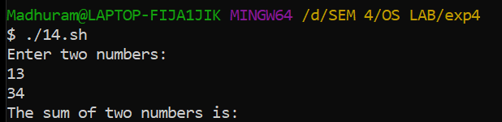

**15. Write a shell script to make the following operations menu based:**

**a) Addition**

**b) Subtraction**

**c) Multiplication**

**d) Division**

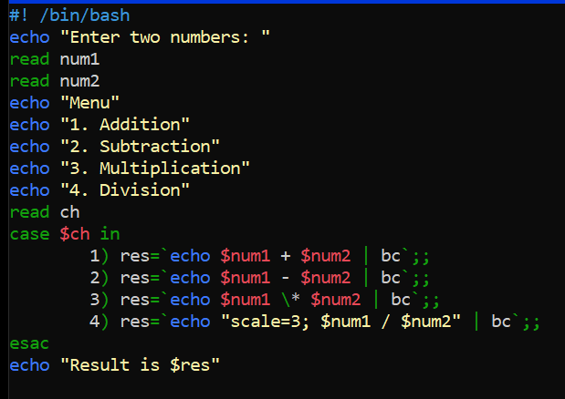

Output:

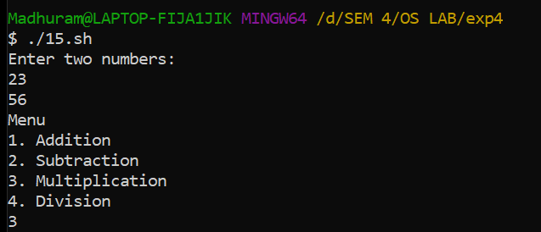

**16. Write a shell script to find sum of all digit for given number.**

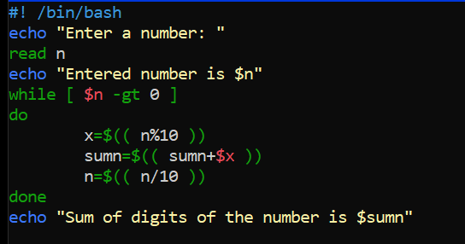

Output:

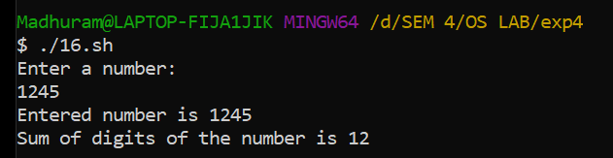

**17. Write a shell script to find the factorial of a given no.**

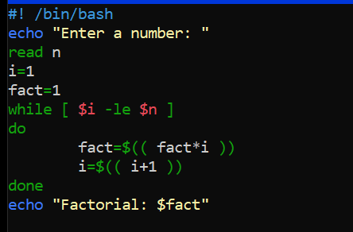

Output:

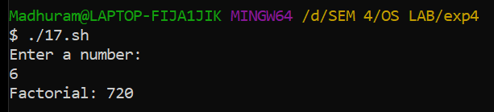

**18. Write a shell script to find the largest of three numbers and also find the total average.**

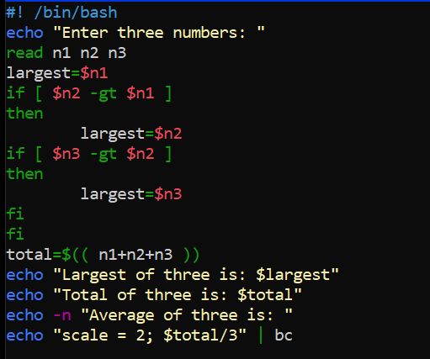

Output:

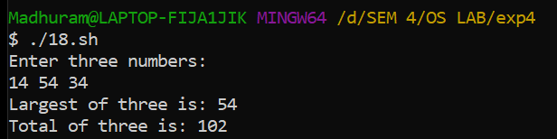

**19. Write a shell script which print “invalid no. of arguments” if more than 5 command line arguments otherwise print “valid no. of arguments”.**

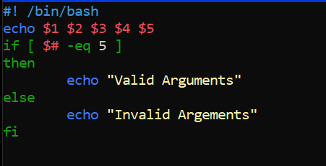

Output:

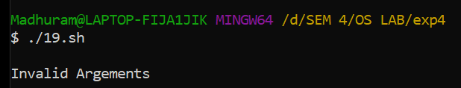

**20. Write a shell script to find the max. and min. number from the given data set passed by command line argument.**

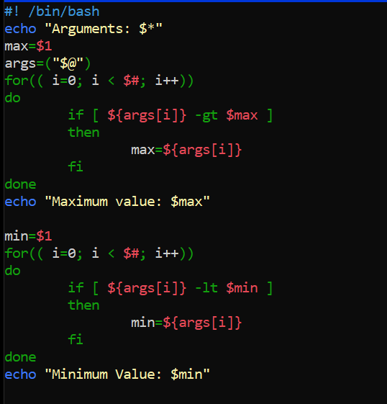

Output:

