Experiment – 6

**NAME : Madhuram Brijeshkumar Modi**

**ROLL NO. : 21BCP102**

**DIV, GROUP : 2,G3**

**Scheduling Algorithms**

**Scheduling Algorithms in OS:-**

There are various algorithms which are used by the Operating System to schedule the processes on the processor in an efficient way.

**The Purpose of a Scheduling algorithm:-**

**●** Maximum CPU utilization

● Fare allocation of CPU

● Maximum throughput

● Minimum turnaround time

● Minimum waiting time

● Minimum response time

**Different Type of algorithms: -**

**●** First Come First Serve

● Round Robin

● Shortest Job First

● Shortest remaining time first

● Priority based scheduling

● Highest Response Ratio Next

1. **First Come First Serve**

It is the simplest algorithm to implement. The process with the minimal arrival time will get the CPU first. The lesser the arrival time, the sooner will the process gets the CPU. It is the non-preemptive type of scheduling.

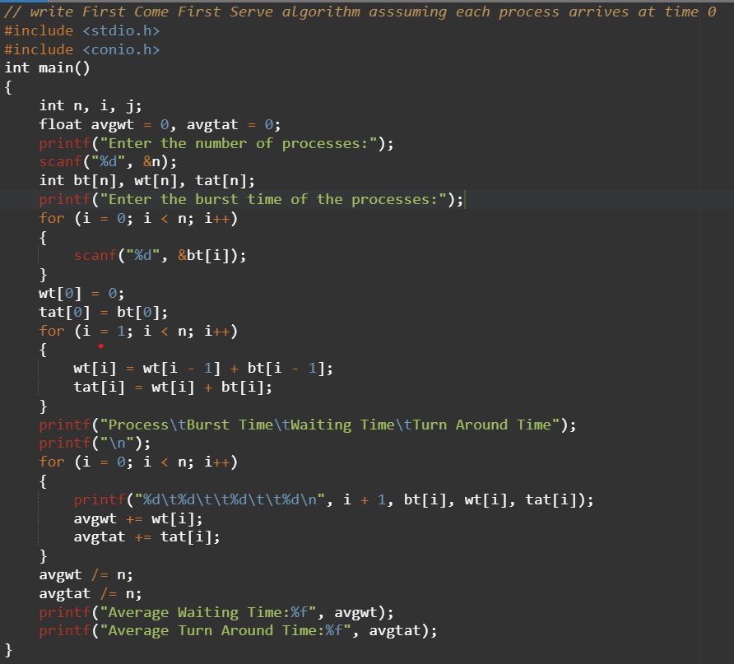

**OUTPUT**

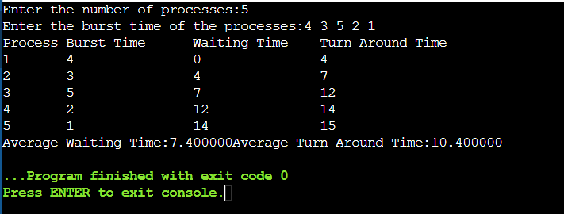

1. **Shortest Job First**

The job with the shortest burst time will get the CPU first. The lesser the burst time, the sooner will the process get the CPU. It is the non-preemptive type of scheduling.

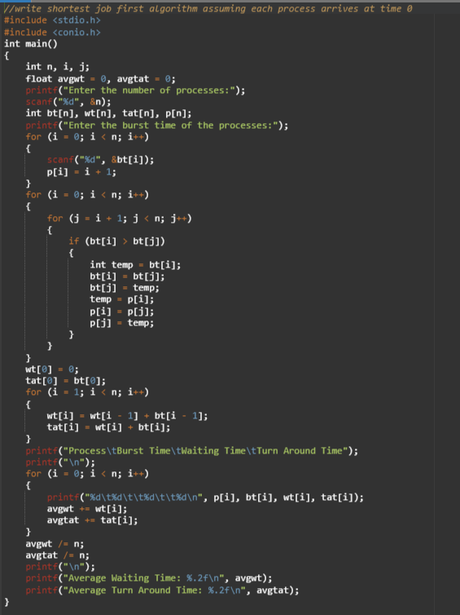

OUTPUT-

