Experiment – 7

**NAME : Madhuram Brijeshkumar Modi**

**ROLL NO. : 21BCP102**

**DIV, GROUP : 2,G3**

**Scheduling Algorithms -2**

**3. Shortest Remaining Time Next**

It is the preemptive form of SJF. In this algorithm, the OS schedules the Job according to the remaining time of the execution.

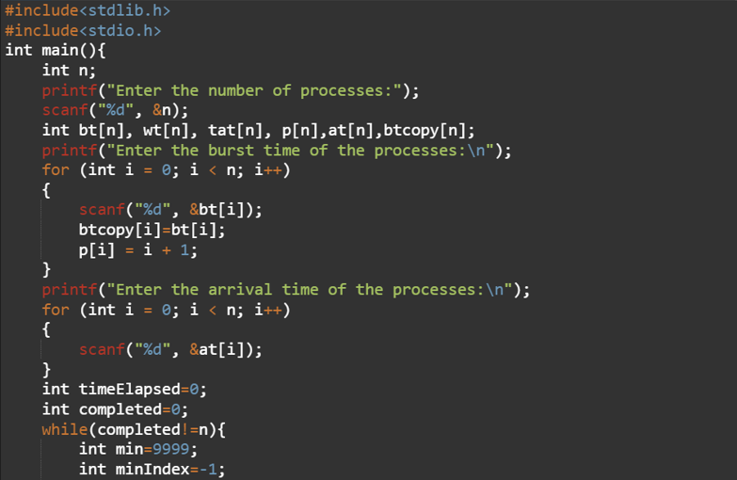

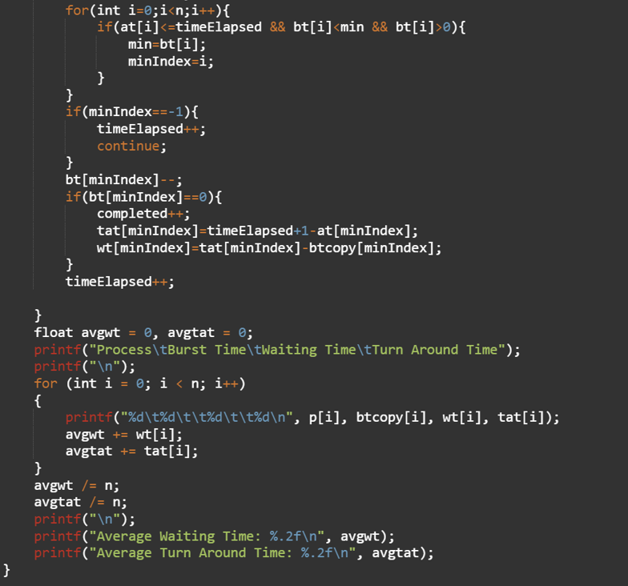

**OUTPUT**

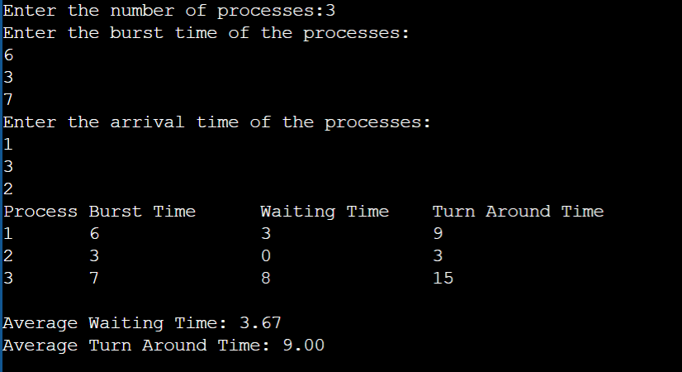

**4. Round Robin**

In the Round Robin scheduling algorithm, the OS defines a time quantum (slice). All the processes will get executed in the cyclic way. Each of the process will get the CPU for a small amount of time (called time quantum) and then get back to the ready queue to wait for its next turn. It is a preemptive type of scheduling.

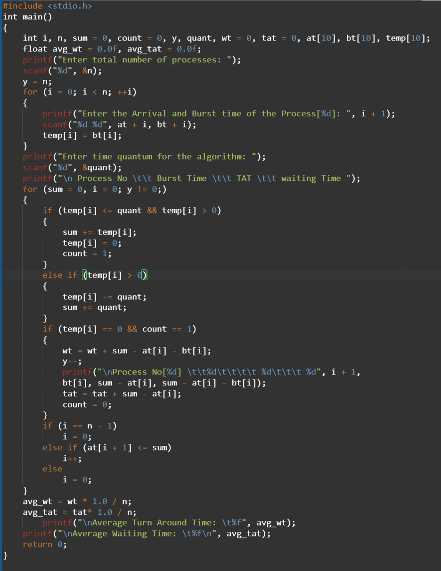

OUTPUT-

