Experiment – 8

**NAME : Madhuram Brijeshkumar Modi**

**ROLL NO. : 21BCP102**

**DIV, GROUP : 2,G3**

**Page Replacement Algorithm**

1. **First in First Out Page Replacement Algorithm**

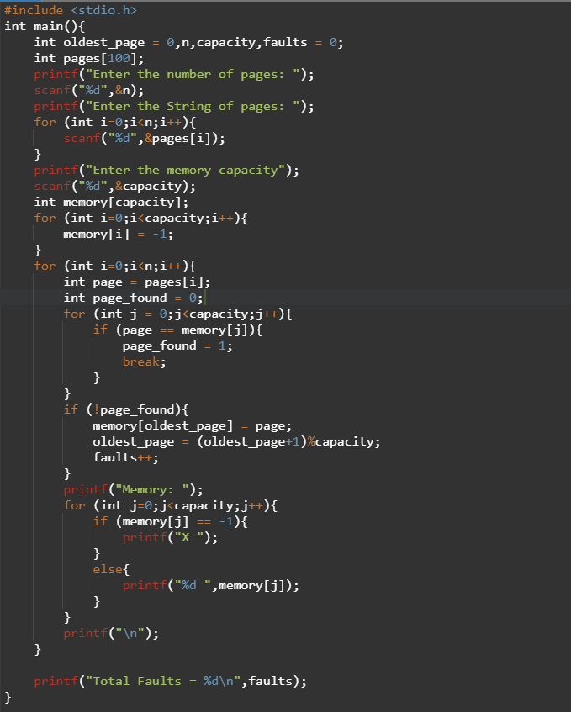

**OUTPUT**

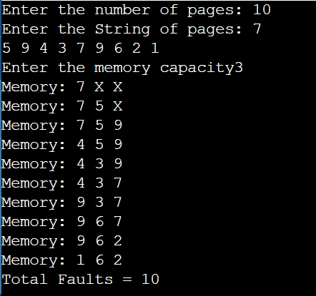

1. **Least Recently Used (LRU) Replacement Algorithm**

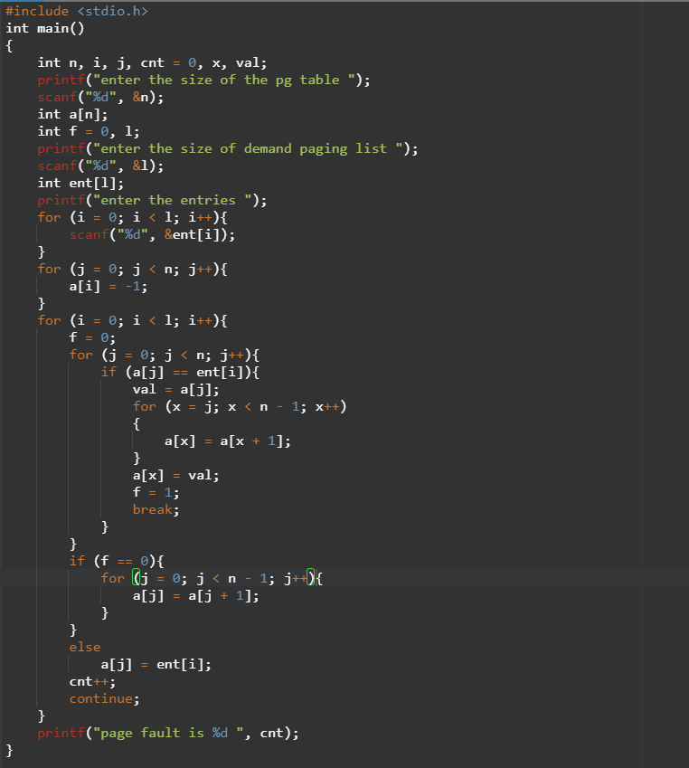

OUTPUT-

