Youtube Comment Sentiment Analysis
Pratham Pednekar – N134
Shravan Dige – N130

Introduction
The YouTube Comment Sentiment Analysis System is an intelligent application that analyzes viewer opinions and reactions posted as comments on YouTube videos. Since YouTube is one of the largest content-sharing platforms, understanding public feedback helps creators improve their content and marketing strategies.
However, with thousands of comments under popular videos, manual analysis becomes impossible. To solve this, the system automatically collects comments, cleans the data, applies Natural Language Processing (NLP) techniques, and uses Machine Learning algorithms to classify comments into Positive, Negative, or Neutral categories.
This automation helps Content Creators understand audience preferences instantly and allows Data Scientists to study real-world sentiment trends for better decision-making.

Images of UI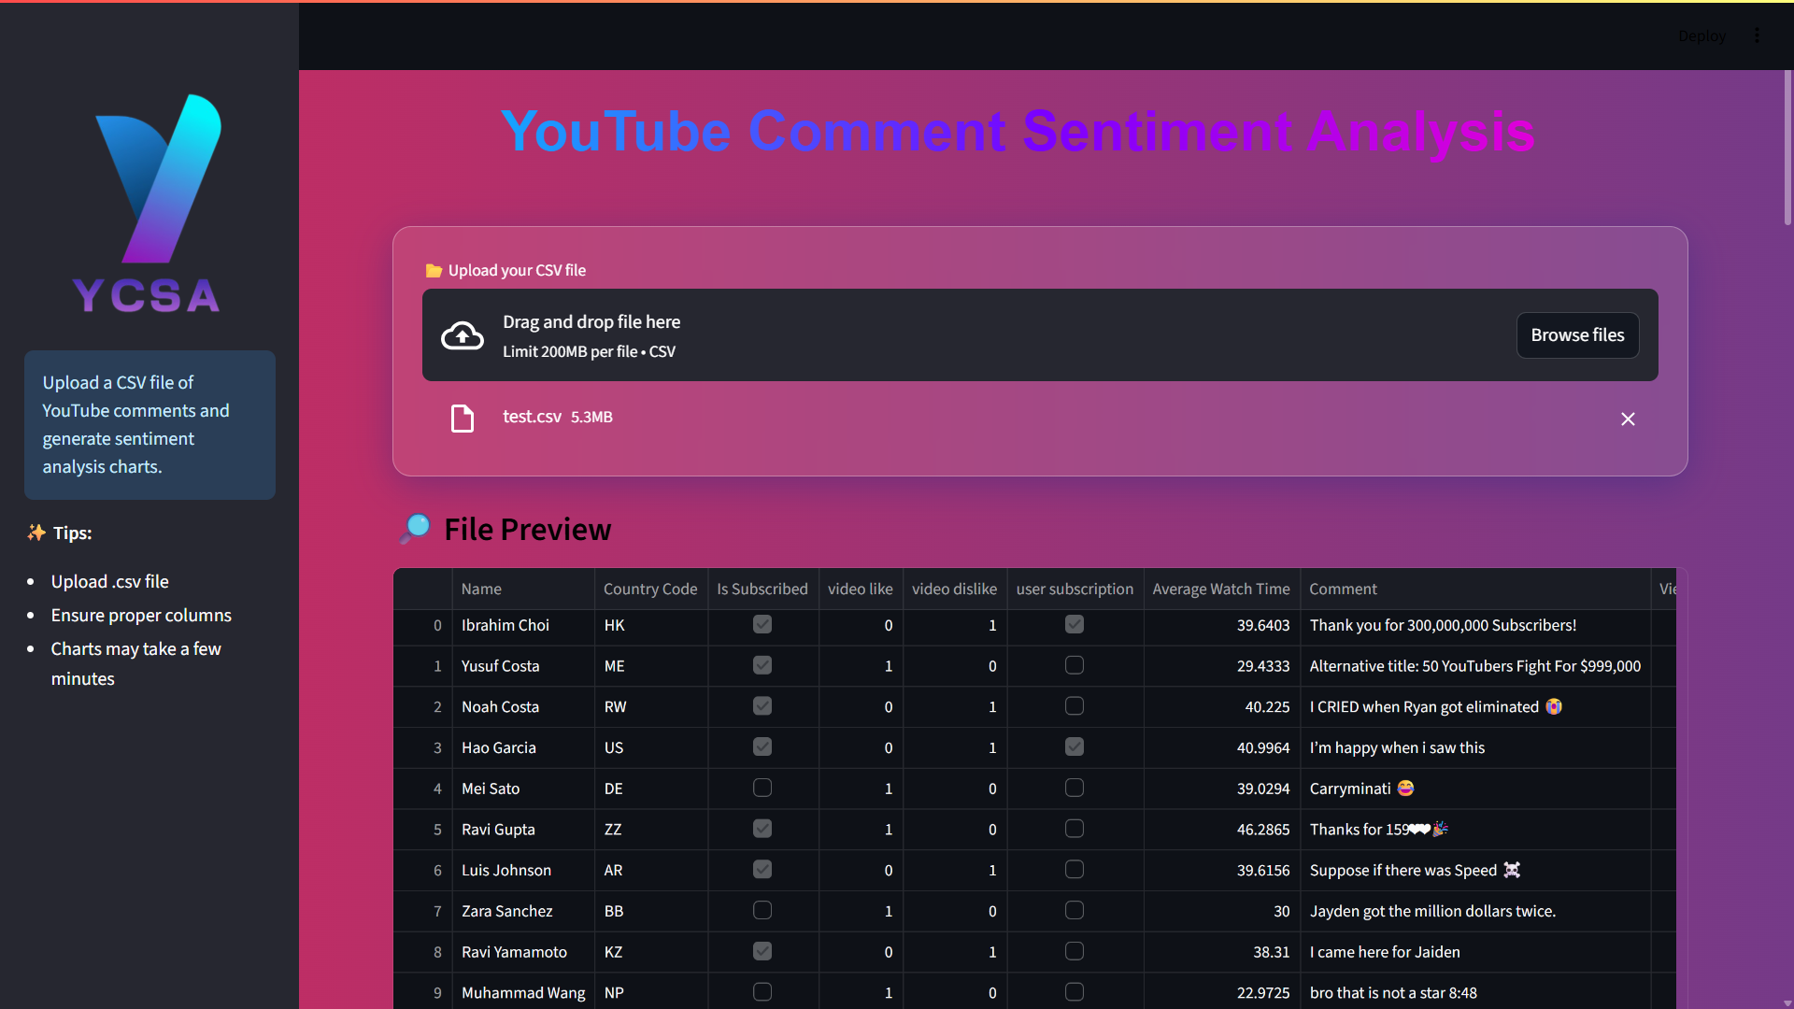
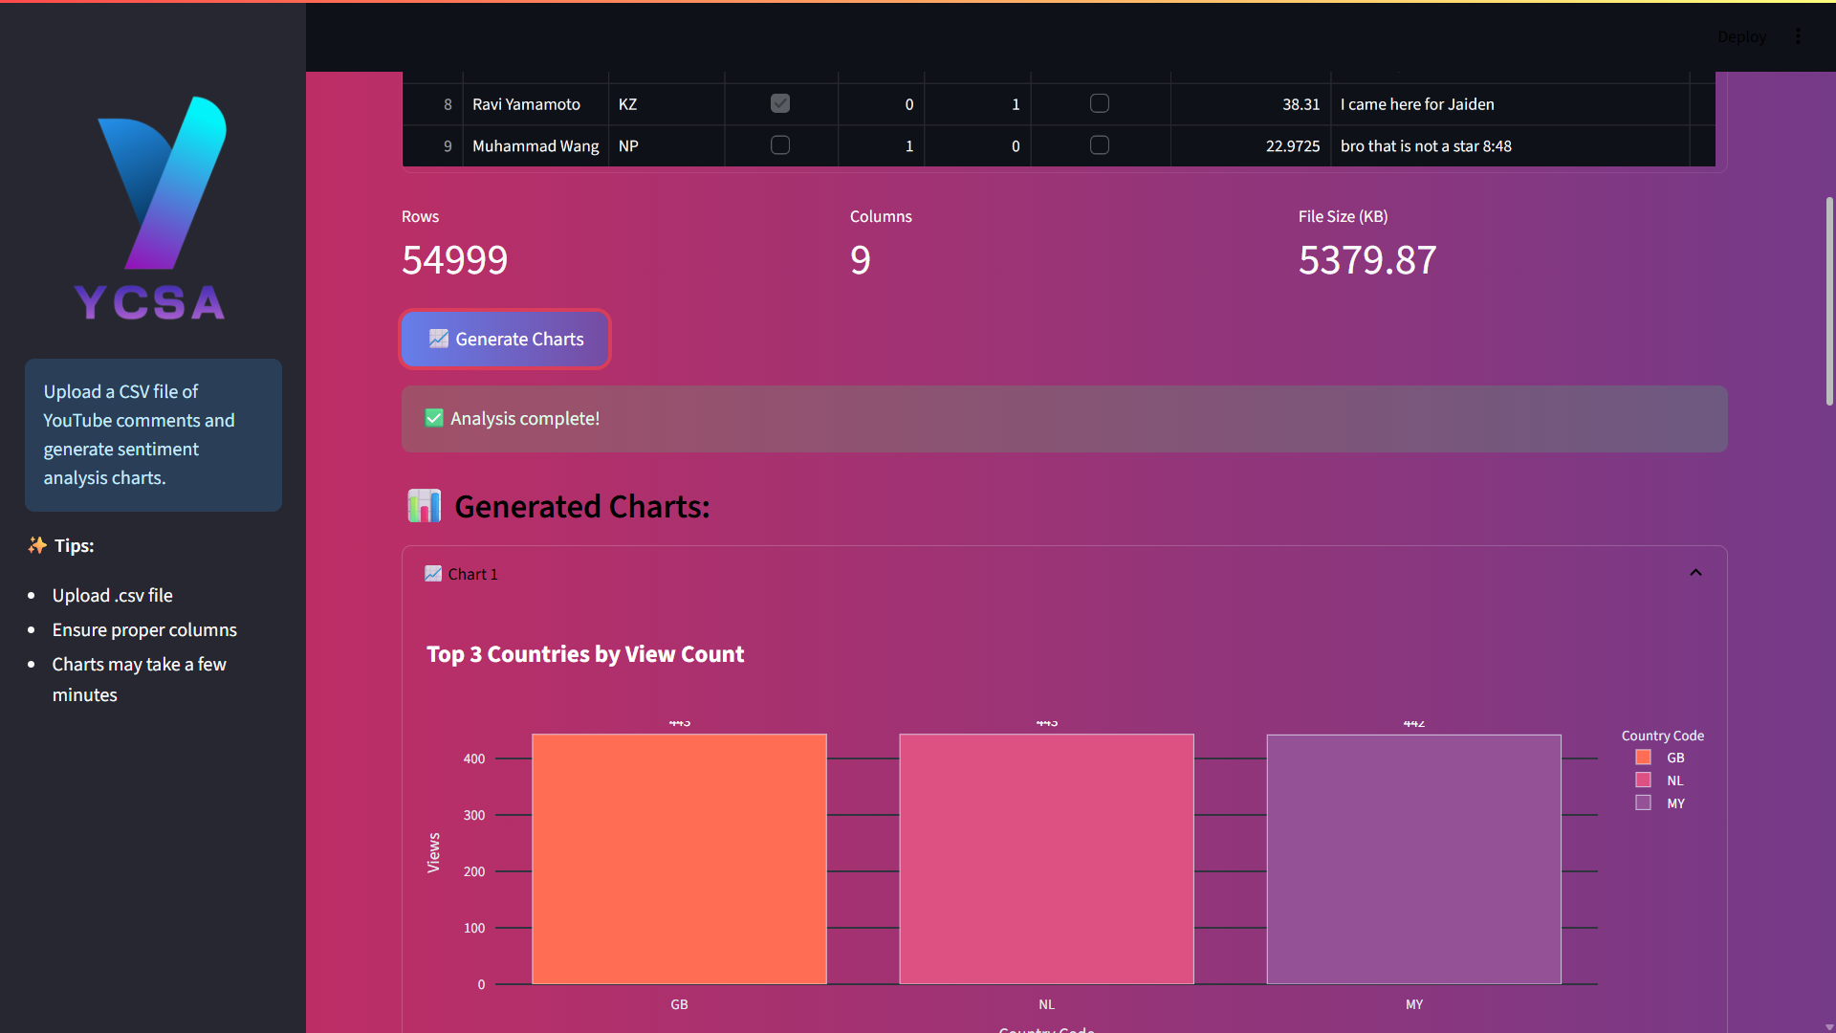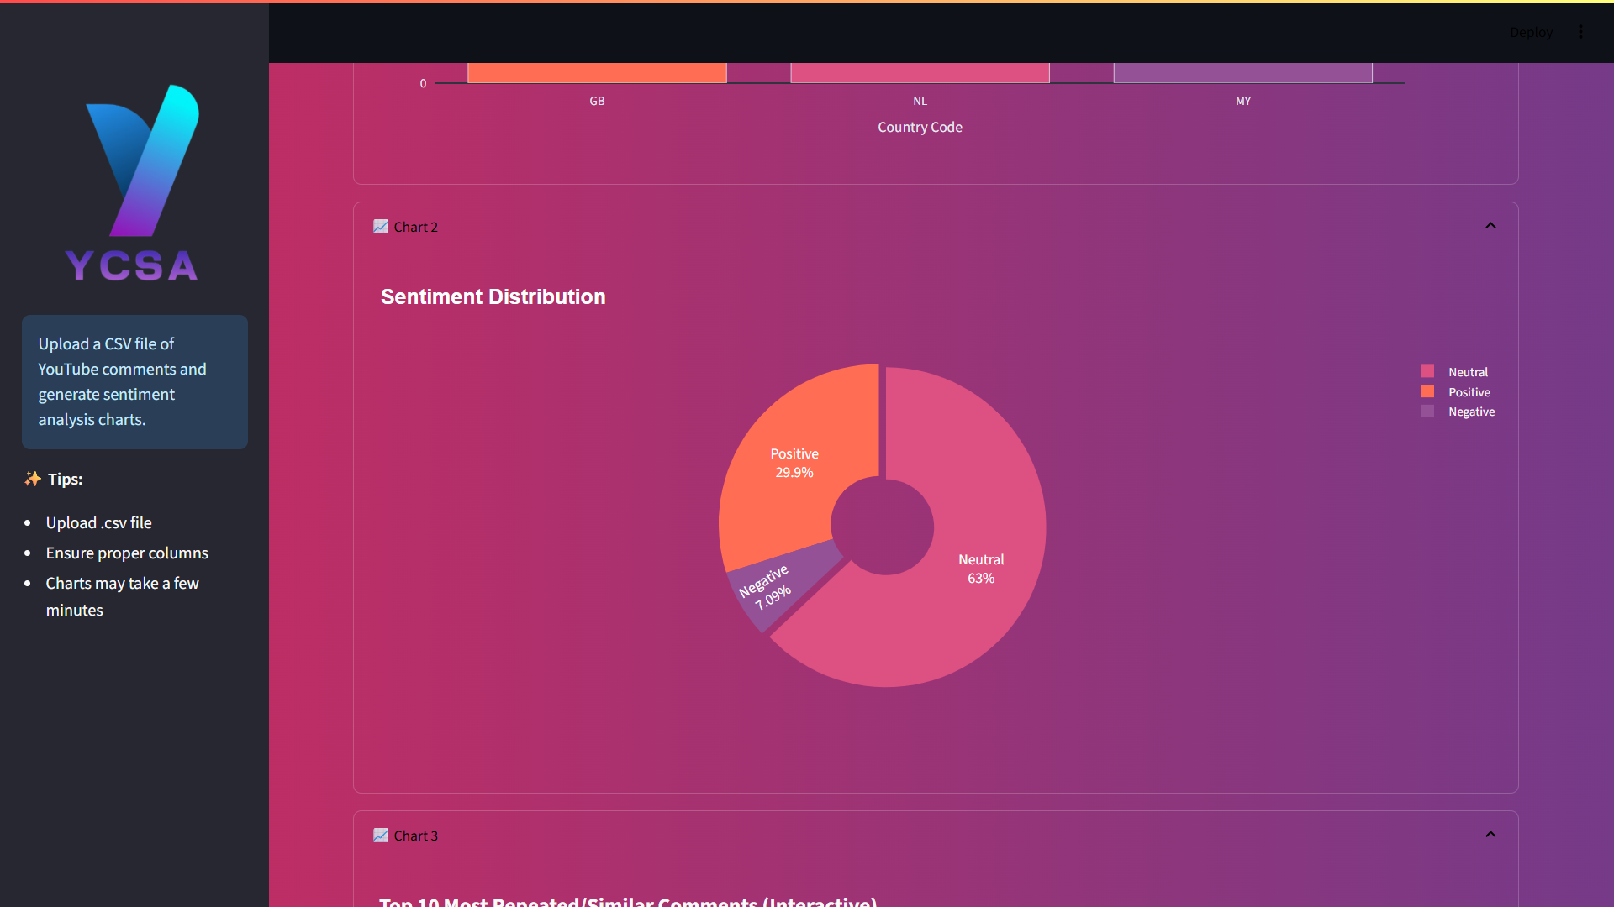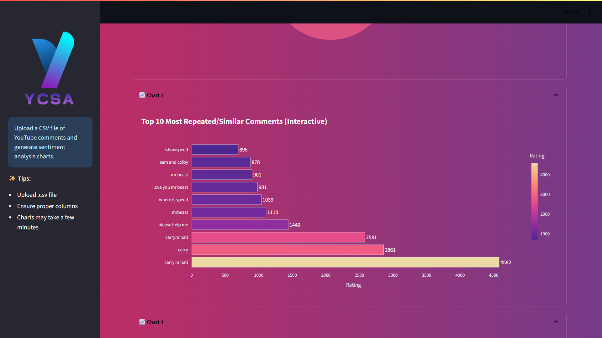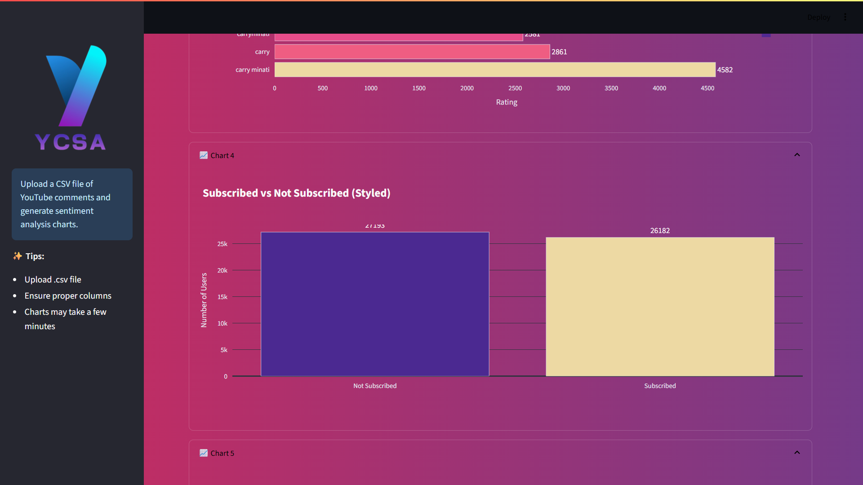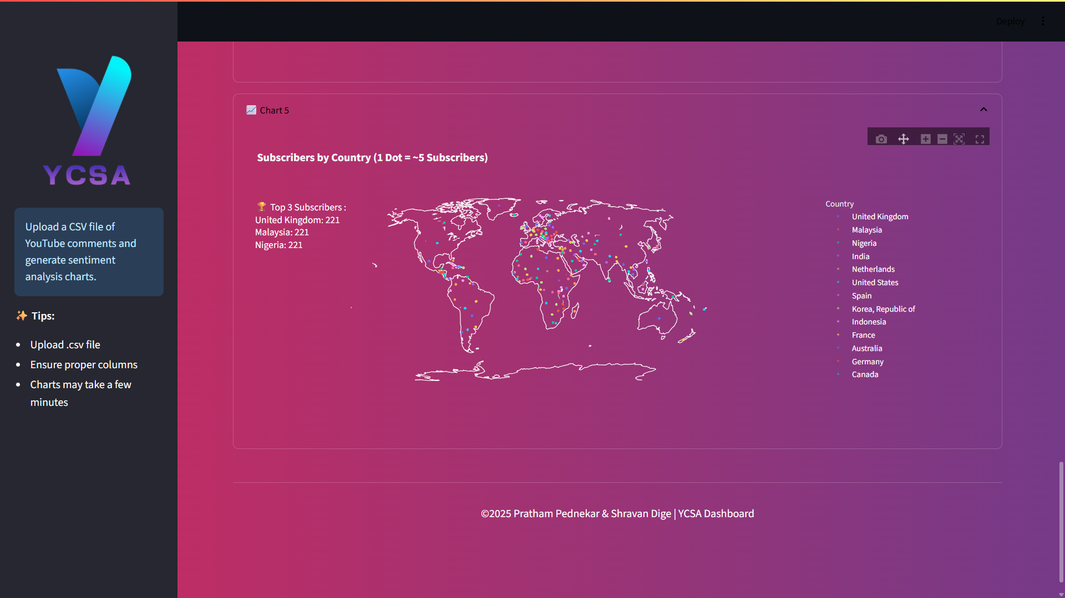
Diagram :- 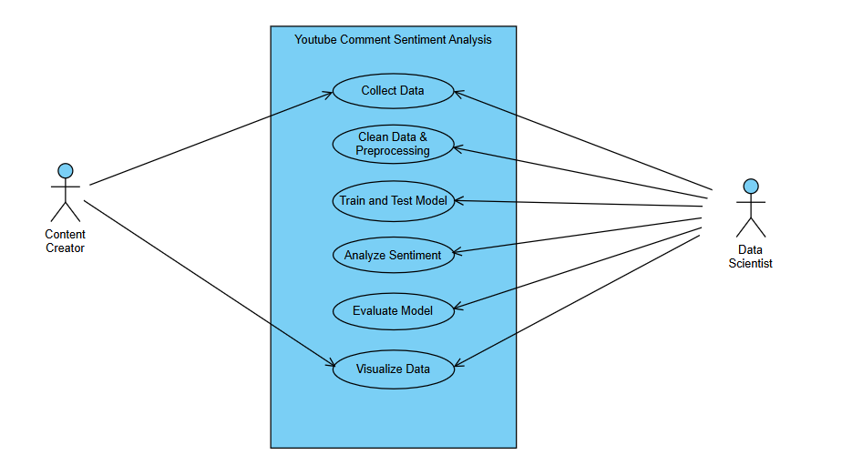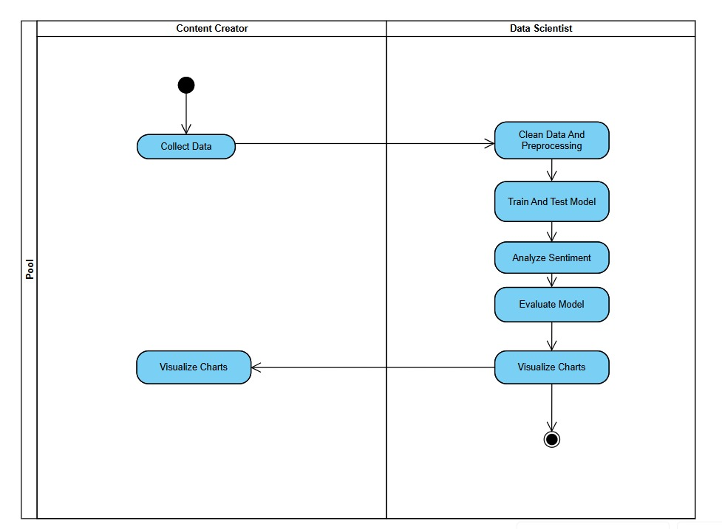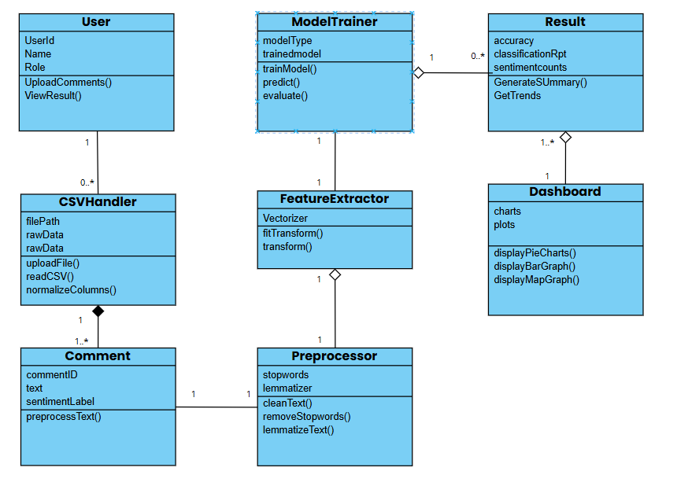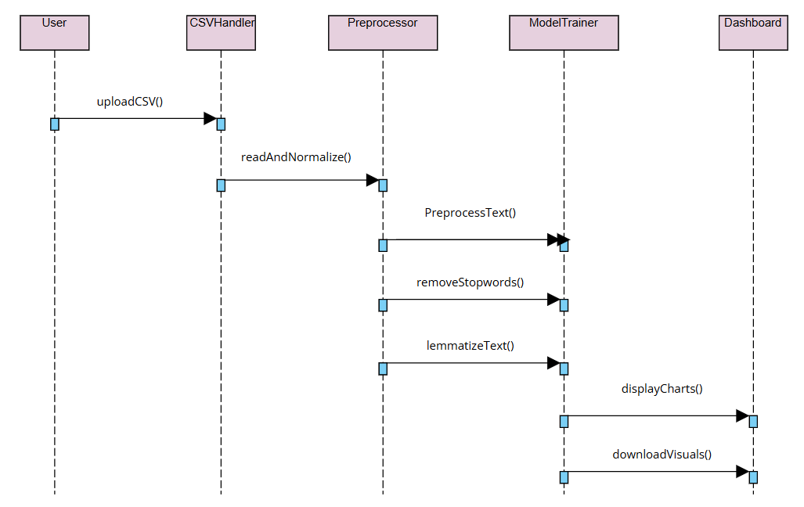
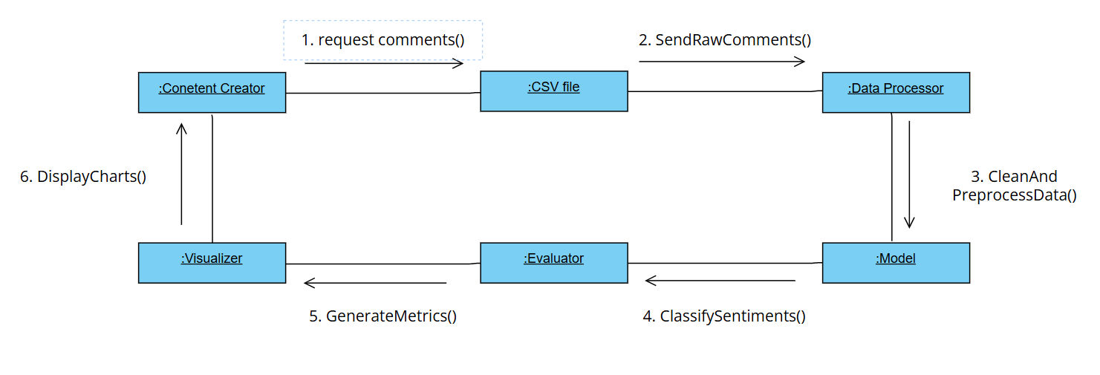

Description
The system is divided into several functional modules that work together to analyze sentiment effectively:
- Data Collection:
The system fetches YouTube comments using a video link or API. These comments are stored in a CSV file for analysis.
- Data Cleaning and Preprocessing:
The raw comments often contain emojis, URLs, punctuation, and other noise.
Preprocessing involves:
  - Removing special characters and links
  - Lowercasing text
  - Removing stopwords
  - Tokenizing sentences
  - Converting text into numerical features using TF-IDF or similar techniques.
- Model Training and Testing:
Machine Learning algorithms such as Logistic Regression, Naive Bayes, or Support Vector Machines (SVM) are used to train models on preprocessed data.
The dataset is divided into training and testing sets to evaluate model performance.
- Sentiment Analysis:
After training, the model classifies each comment as Positive, Negative, or Neutral based on its polarity.
For example:
  - “I love this video!” → Positive
  - “This is the worst content ever.” → Negative
  - “Okay video.” → Neutral
- Evaluation:
The system measures accuracy using metrics like:
  - Precision
  - Recall
  - F1-Score
  - Confusion Matrix
- Visualization:
Results are represented through bar graphs, pie charts, or word clouds, allowing users to understand the distribution of sentiments visually.
These insights help content creators easily interpret audience feedback without reading every comment.

