Youtube Comment Sentiment Analysis
Rochadiani, T. H, Khomsah, Siti, Aiswarya, A S; Haritha, Rajeev
MBATECH CE , NMIMS , Ville parle , Maharashtra , India

ABSTRACT

This project aim for looking at how the viewers react to YouTube videos by analyzing their comments. Comments usually show whether people liked, disliked, or felt neutral about a video. This system not only saves time but also helps to understand the human emotions towards the video, for making the content more better . Reading all comments by hand is not practical, so this system gathers them, organizes the text, and sorts reactions into positive, negative, or neutral categories. The results appear as charts and visuals, allowing creators and analysts to quickly grasp audience feedback also it helps in finding the major audience is from which country.

- INTRODUCTION

YouTube has become a daily part of how people watch, learn, and share ideas. Along with videos, the comment section is the main place where viewers share their opinions and their emotion . For a creator, these comments are very useful because they highlight what people enjoy or what needs to improve in their daily content , so too attract more viewers. But when videos receive hundreds or thousands of comments, it is not possible to read and analyze all of them one by one.
To solve this, the project introduces a Youtube comment sentiment analysis that automatically studies YouTube comments . For youtube comments it is preprocessing is very important because comments can have emoji’s and other special symbols . cleaning the data properly improves the accuracy of the system . Once the data is ready, machine learning models sort comments into positive, negative, or neutral categories.The machine learning models which is used is, Logistic Regression, which is too much helpful in sentiment analysis, compare to other machine learning algorithms . Even with these methods , there are some challenges facing during the project making, such as handling multiple languages and sarcasm . As youtube grows with their audieance and public support it is getting more important to understand the feedback for the creators and also for the businesses.The results appear in simple visuals like graphs, pie charts, and also in map view, making it easy to understand audience sentimentquickly.

- LITERATURE REVIEW

People often share their thoughts and feelings in online comments, which can give a clear idea of how an audience reacts. Going through all the comments by hand takes a lot of time, so automated systems have been created to handle this. These systems gather the comments, remove unnecessary or messy content, and then sort them into positive, negative, or neutral sentiments.
Different methods are used to classify sentiments, including simple rule-based approaches and machine learning techniques. Preprocessing the text is very important because online comments can be messy and informal. Previous studies shows that combining preprocessing with machine learning models improves accuracy , make it a better model .Visual tools like pie charts , bar charts and different other charts, are then used to present the results in an easy-to-understand way.
It is not only about understanding the sentiments of the people but also it’s about the thought process understanding , how the people are thinking now about the video or which type of content they need in this day’s, this system will help the most in understandingthisallthings.
This type of analysis helps content creators quickly see how viewers feel and allows researchers to test models on real-world data.

- METHODOLOGY

Sentiment Distribution

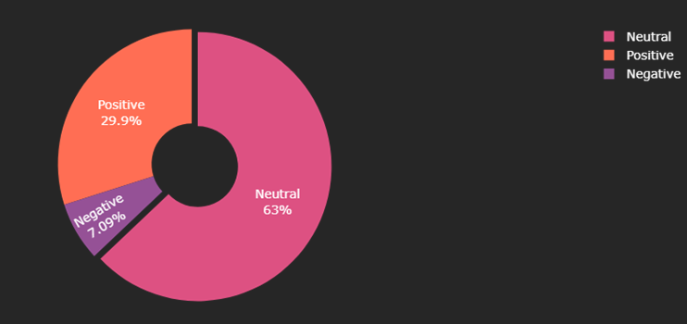
The sentiment distribution chart shows that the majority of YouTube comments are neutral (63%), meaning most viewers are simply sharing casual thoughts or general feedback without strong emotions. Around 29.9% of the comments are positive, reflecting a supportive and appreciative audience, while only 7.09% are negative, which is relatively low for public videos. Overall, this indicates that the audience response is balanced but leans more toward being encouraging and positive.

Top 10 most repeated comments
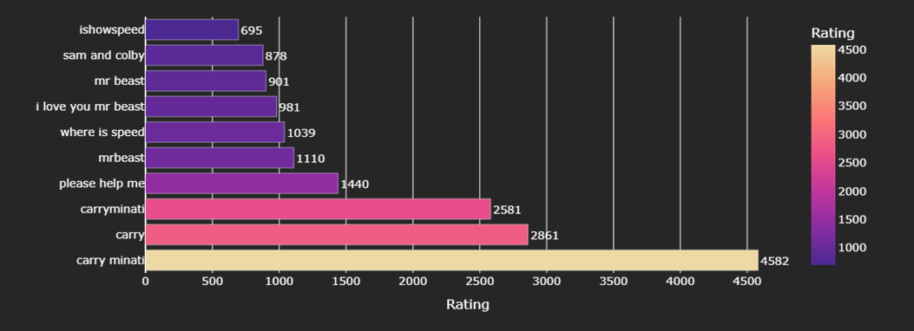
The chart of the top 10 most repeated or similar comments reveals that conversations are dominated by mentions of “Carry Minati,” with variations of his name appearing thousands of times and becoming the central focus of discussion. Other creators like MrBeast, IShowSpeed, and Sam and Colby are also repeatedly mentioned, along with emotional fan comments such as “I love you Mr Beast” and requests like “please help me.” This shows that while the sentiment remains largely neutral to positive, the comment section is strongly influenced by fans repeatedly discussing a handful of popular creators, especially Carry Minati.

- RESULTS

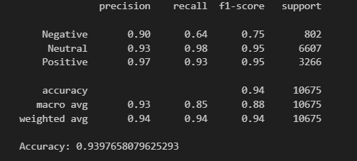
The classification report shows that the model is performing really well overall, with about 94% accuracy. It does an excellent job at detecting neutral and positive comments, with very high precision and recall, meaning it rarely misclassifies them. For negative comments, it’s still fairly accurate but sometimes misses them, which is why the recall is lower (0.64). In simple terms, the model is highly reliable in spotting positive and neutral feedback but could improve a bit in catching all the negative ones.

- REFERENCES

https://www.ijdm.latticescipub.com/portfolio-item/A163304010524/?utm_source
https://jurnal.upnyk.ac.id/index.php/telematika/article/view/4493?utm_source
https://zenodo.org/records/11278177?utm_source
chrome-extension://efaidnbmnnnibpcajpcglclefindmkaj/https://www.ijdm.latticescipub.com/wp-content/uploads/papers/v4i1/A163304010524.pdf?utm_source=chatgpt.com

