Youtube Comment Sentiment Analysis
Rochadiani, T. H, Khomsah, Siti, Aiswarya, A S; Haritha, Rajeev
MBATECH CE , NMIMS , Ville parle , Maharashtra , India
Pratham Pednekar Shravan Dige
Computer Department Computer Department
University of NMIMS University of NMIMS
Mumbai, India Mumbai, India
Pratham.pednekar33@nmims.in Shravan.dige75@nmims.in

ABSTRACT

This project aims to scrutinize the reception of YouTube videos through the comments. Comments generally express acceptance, rejection, or indifference toward a video. Such a system not only saves time but also allows for the analysis of sentiments toward the video, in making better content. Reading all the comments manually is something that cannot be done; so, the system aggregates comments, cleans the text, and sorts the reactions into positive, negative, or neutral classes. The results are then displayed as charts and visuals to provide content creators and analysts with an easy understanding of the feedback from the viewers, as well as the major countries of origin of those viewers.

- INTRODUCTION

YouTube has become an integral daily part for watching, learning, and sharing ideas. Besides videos, the comment box is the main area where viewers express their opinio Thanks to the excellent comments, creators can really know what people like and what they need to work on in their day-to-day content to attract more viewers. But when the number of comments reaches hundreds or thousands, it is too many to read and analyze individually. For this, the project introduces a YouTube comment sentiment analysis system that automatically studies YouTube comments. For YouTube comments, preprocessing is very important, because these comments can contain emoji's and other special symbols. Proper cleaning of data helps in improving system accuracyAfter the prepossessing of the data has been done, the model would sort comments into three sentiment classes (Positive, Negative, Neutral).Several machine learning models would be considered for these tasks, with Logistic Regression being very helpful for sentiment classification carrying out better than other machine learning algorithms. But, even with such methods in place, we face certain problems when developing this project, such as dealing with multiple languages and sarcasm. As YouTube grows, with an increasing audience and public support, it becomes quite important to understand reception for the creator as well as the business.The end result is shown in very simple visuals: those could be ordinary bar graphs, pie charts, or even map views just for that easy feel of reviewing 'audience sentiment' in no time.

- LITERATURE REVIEW

The feedback reveals individual opinions and emotions and more or less indicates the audience's response. A manual method of going through each comment would take a lot of time, thus the use of automated systems. Such systems collect the comments and discard the unimportant or messy content and finally classify the comments into positive, negative, or neutral sentiments. Numerous methods can be applied for sentiment classification, ranging from the rule-based ones to machine learning techniques. Text preprocessing plays a crucial role due to the fact that web comments are not always in accordance with the set rules and can be quite informal. The previous study suggests that preprocessing along with machine learning enhances accuracy and thus creates a better model. In the end, visualization tools such as pie charts, bar graphs, and a range of other types of charts are used to make the results very digestible to the audience. The situation is not just limited to understanding how the employees feel, but rather it is about identifying the creative thoughts of the people and knowing how it is going on very much deeper in today's days: Hence, the comprehension of all these matters will be aided by this system. This type of analysis facilitates the emotions of the viewers to be rapidly understood by the creators of the content, thus providing researchers the chance to test their models using real-world data.
- METHODOLOGY

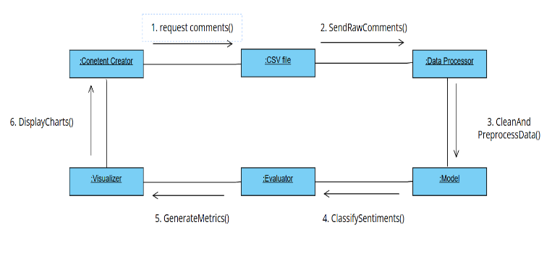
The whole thing starts with the content creator either asking for or collecting user comments that will be saved in a CSV file for later analysis. The subsequent action is the transferring of the data to the processor where the cleaning and preprocessing duty involves removing all unsuitable or contradictory information that is related to the comments. The cleaned and preprocessed data is then forwarded to the model which will either accomplish the classification or the sentiment analysis to spot the opposing views in the comments or the trends. The model outputs are then sent to the evaluator who is responsible for evaluating the model by calculating accuracy, precision, and other metrics. The evaluator will then forward these metrics to the visualizer who will convert them into charts and graphs that will visually represent the insights drawn from the data. The content creator will then look at these visual results to get a better understanding and to ease the decision-makingprocess.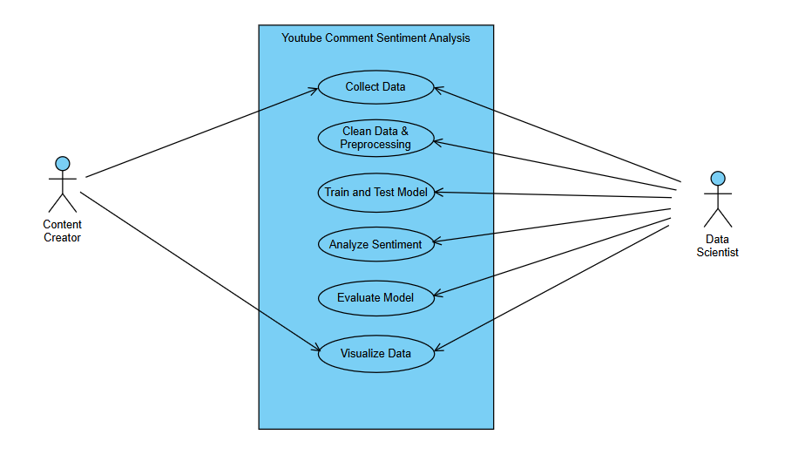
The flowchart depicts the **YouTube Comment Sentiment Analysis** process where a **Content Creator** and a **Data Scientist** are involved. First of all, the data containing YouTube comments is fetched, signifying that the comments are being cleaned and prepared for analysis by the preprocessing technique which transforms noise into something useful. The second operation is to carry out a machine learning model on this dataset to be able to always allocate the right sentiment (positive, negative, or neutral), which falls under the comments being processed (considered). Then, the model is used for sentiment analysis on the comments and the performance of the model is evaluated afterward to determine its reliability. Finally, the analyzed data visualization is given to both the content creator and the data scientist to be aware of what the audience, reacting to the feedback, is like and thus to make subsequent decisions on viewer feedback.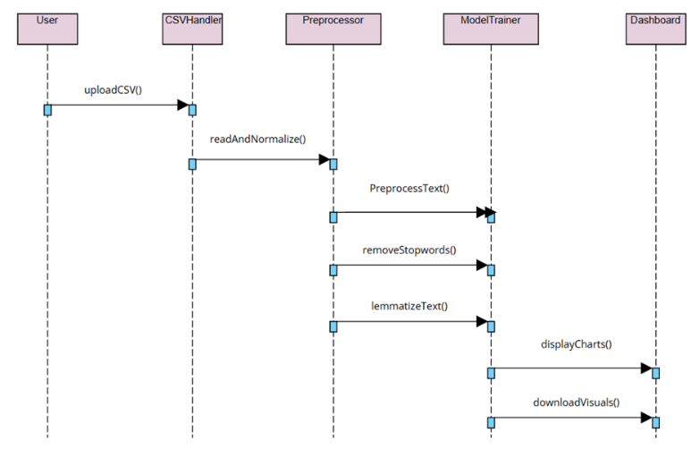

The sequence diagram that is presented illustrates the entire system process starting from data upload and ending with data visualization. The first step for the user is to upload a CSV file, which will be read and normalized by the CSVHandler. Data is then moved to the Preprocessor, where different procedures are taking place, such as text cleaning, removal of stopwords, and lemmatization. The ModelTrainer then receives the purified data and uses the pre-trained machine learning model to churn out the sentiments. Finally, the Dashboard converts the result into visual representations in the form of charts and graphs, which the user can easily interpret and download. This diagram acts as a map showing the complete interaction among different parts of the system that allows for the swift and dependable execution of the automated sentiment analysis process.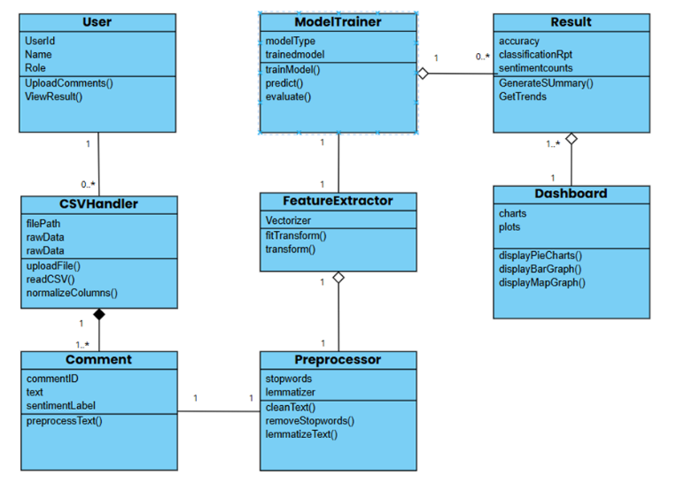
The class diagram showcases the architecture of the YouTube Comment Sentiment Analysis System. The user at the end of the line uploads the comments from YouTube and gets back the results of the analysis. The CSVHandler manages all file interactions, which include uploading, reading, and normalizing the dataset. Every record corresponds to an object of the Comment class, which works with the Preprocessor to eliminate stopwords, special symbols, and to conduct lemmatization on the text.The text cleaned up to standard is then handed over to the FeatureExtractor, who takes it to convert it into numerical features suitable for model training. The ModelTrainer takes care of the training and evaluation of the machine learning model, yielding the sentiment predictions. These are saved to the Result class and are accessible through the Dashboard, which illustrates the results with graphs and charts. The diagram simply indicates the various components that raw comment data has to go through in order to derive meaningful sentiment insights.
IV. RESULTS
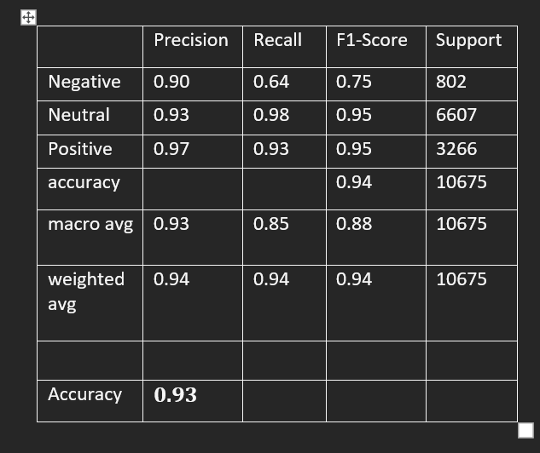
The table illustrates the results of a sentiment analysis model that classifies YouTube comments as Negative, Neutral, or Positive. The model got a great accuracy of 93.97% overall which means that it was performing well. The Neutral and Positive classes had very high recall and F1 scores which indicate that the model is very accurate in detecting these sentiments. The Negative class is associated with a slightly lower recall thus some negative comments were not detected. The macro average (0.88 F1) points to a balanced performance among all classes, while the weighted average (0.94 F1) conveys that the majority of the data is from the neutral and positive classes. To sum up, the model works effectively and can be relied on for sentiment analysis of comments.
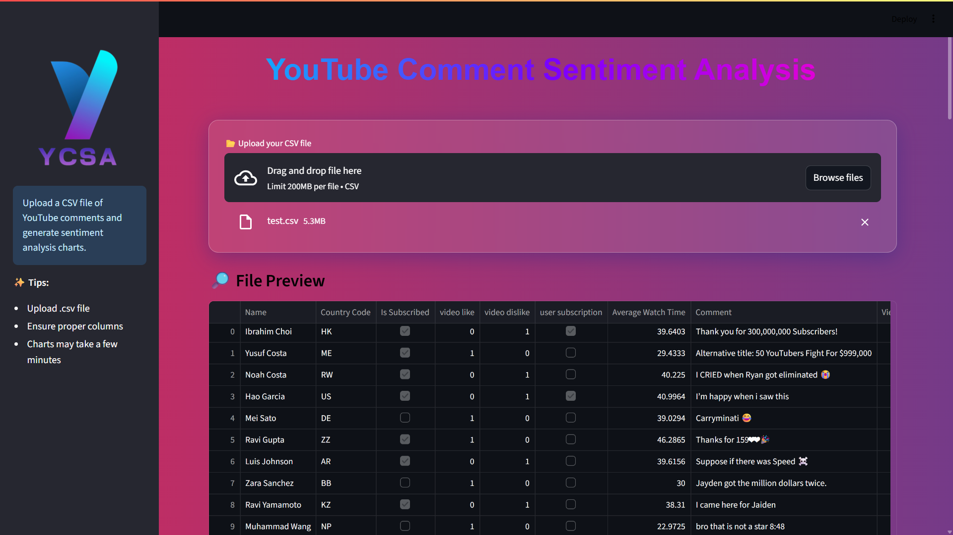

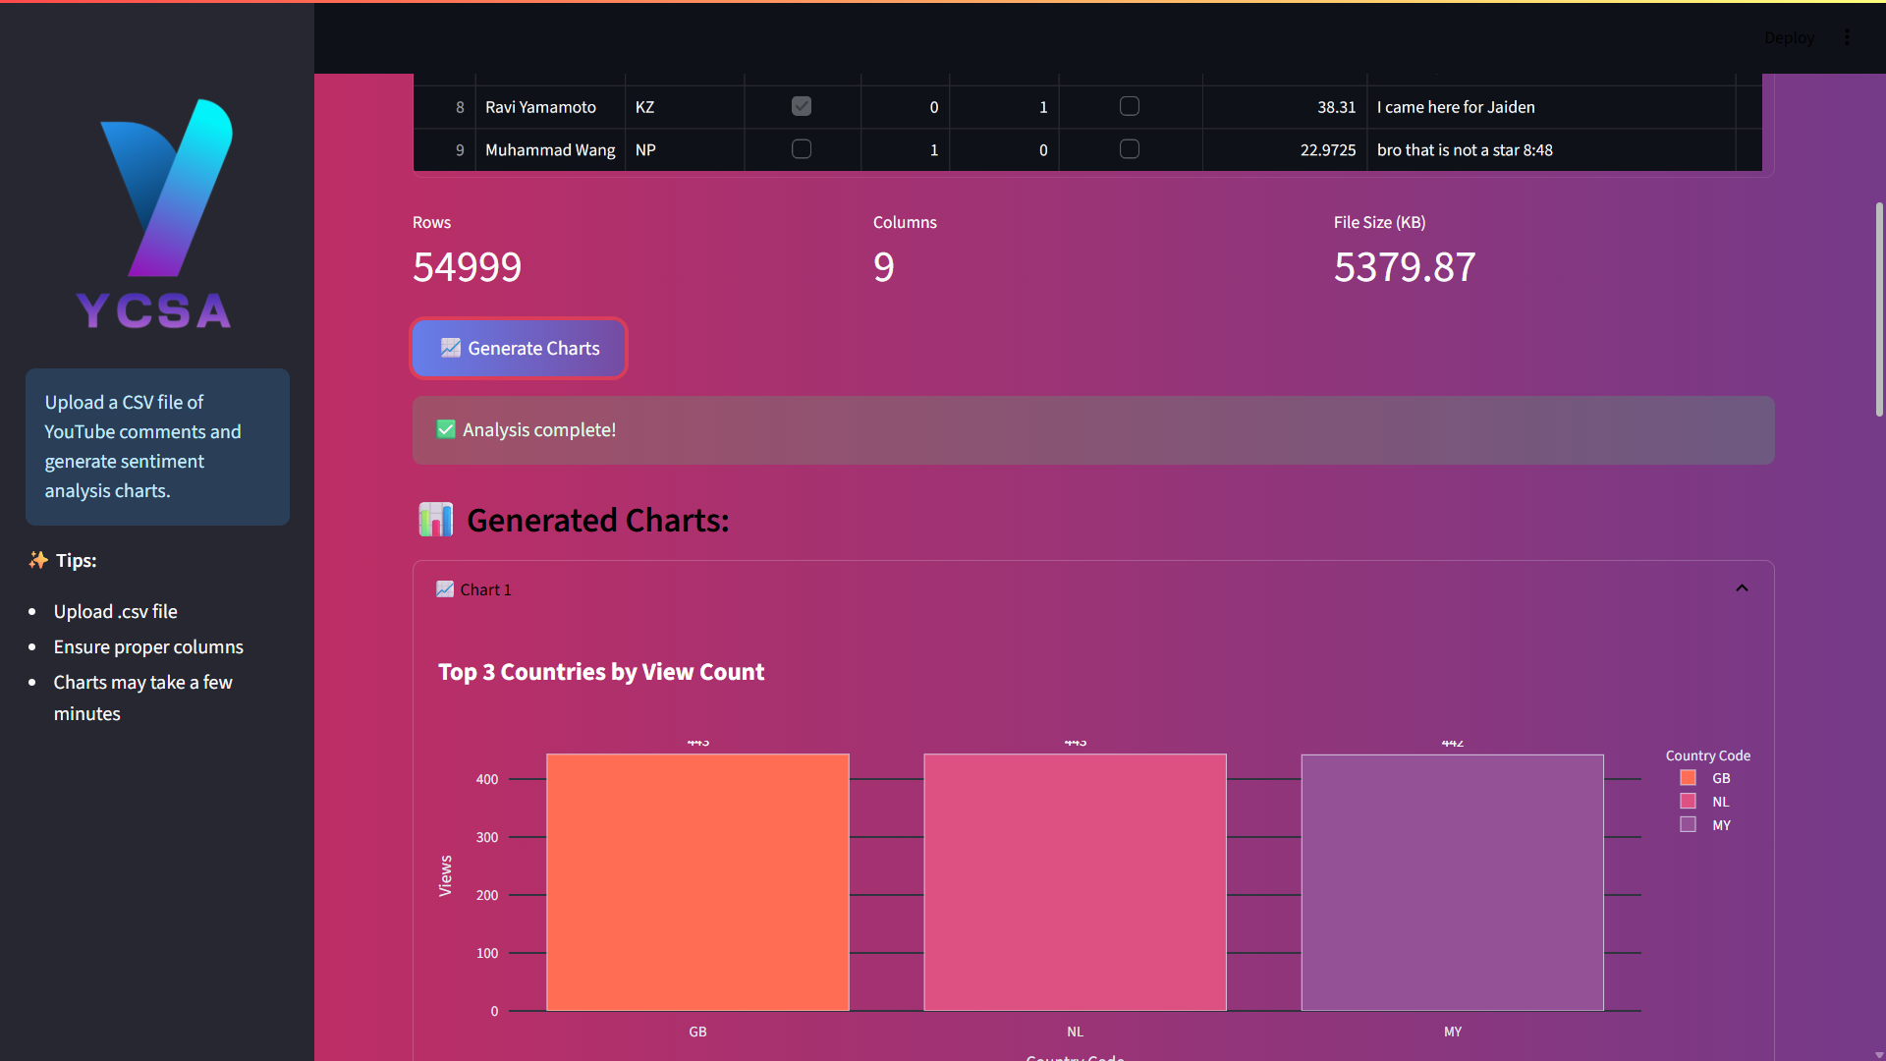
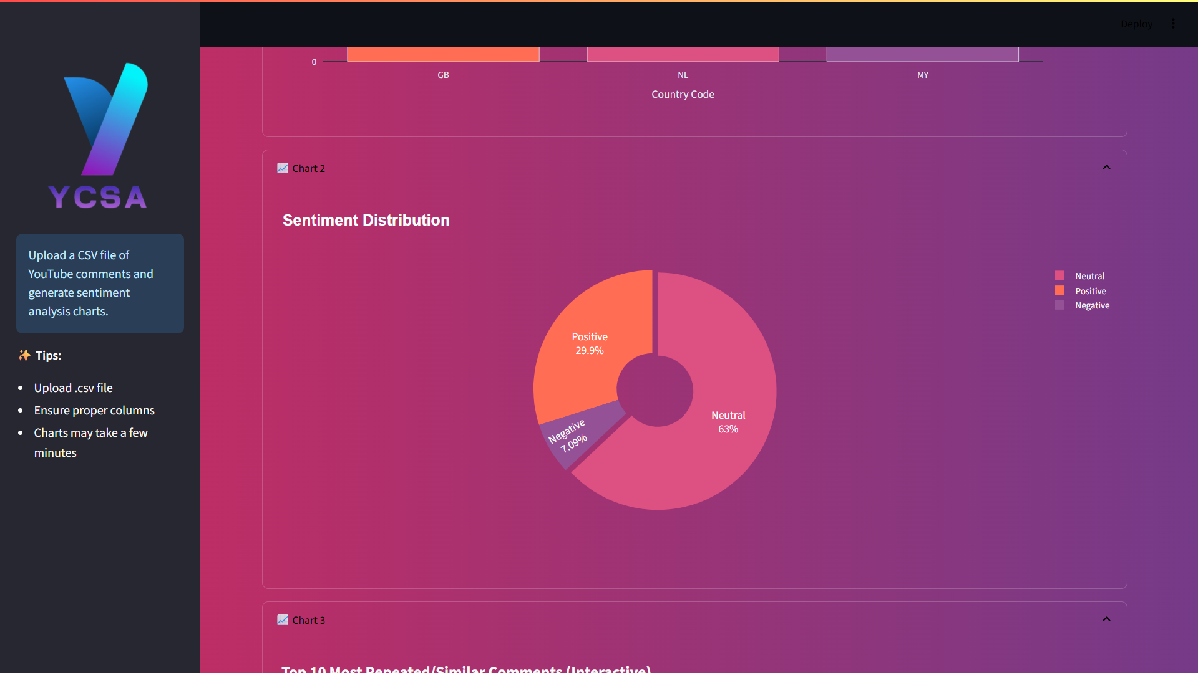
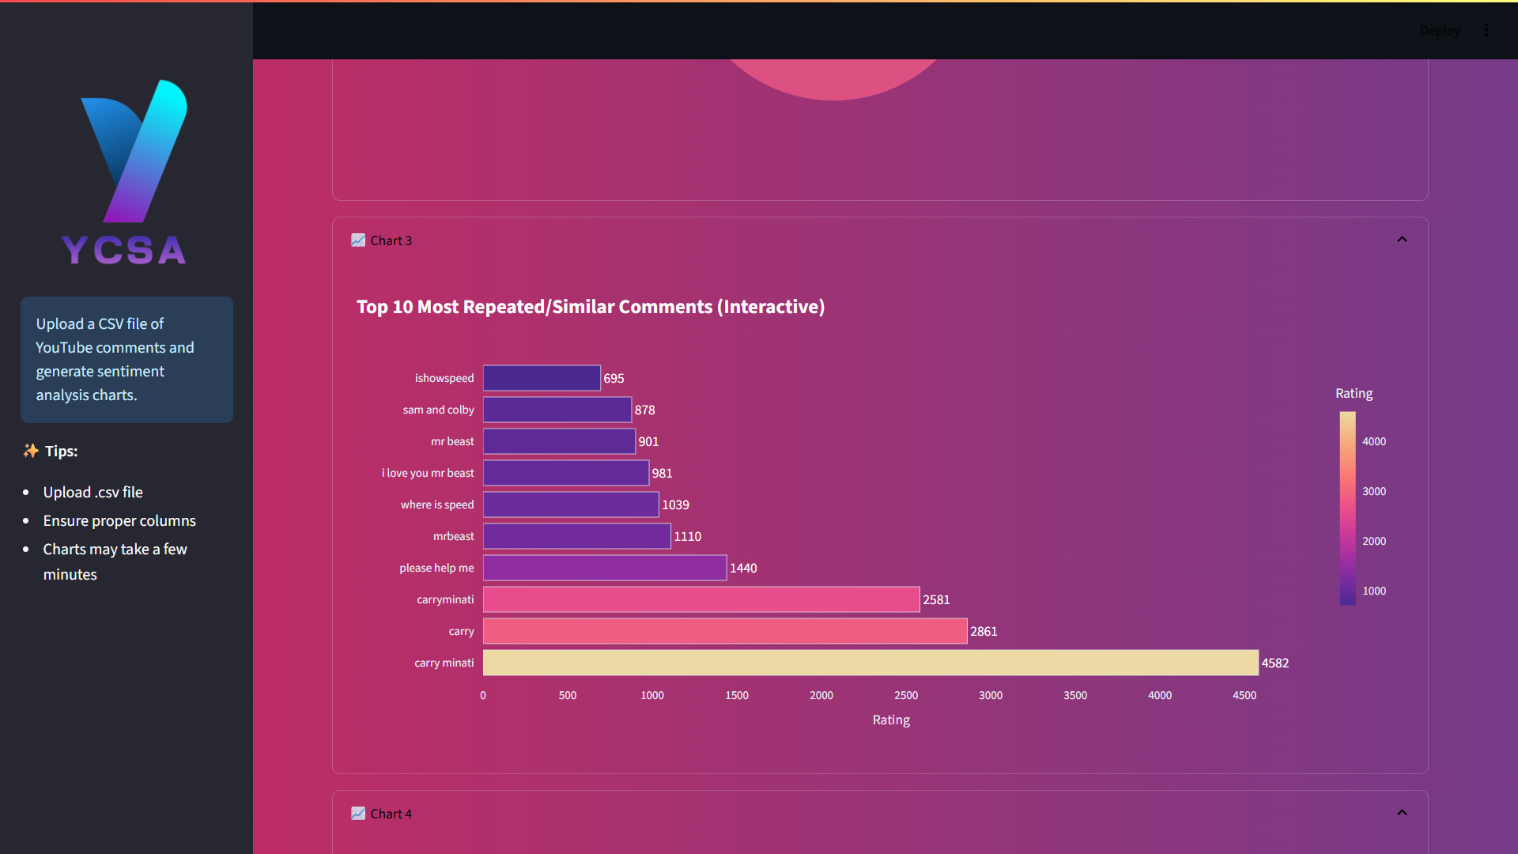
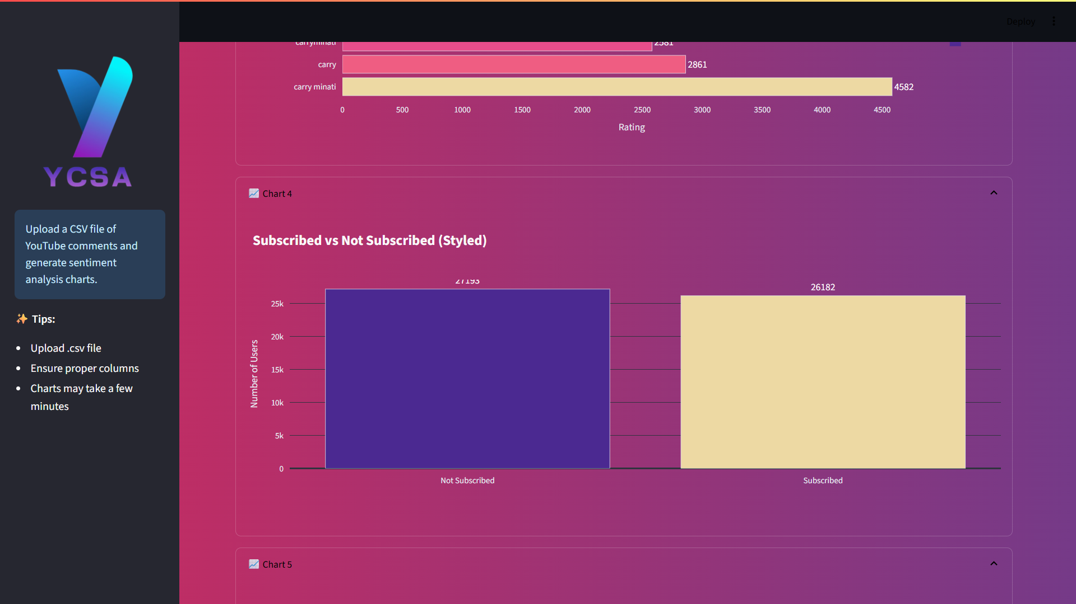
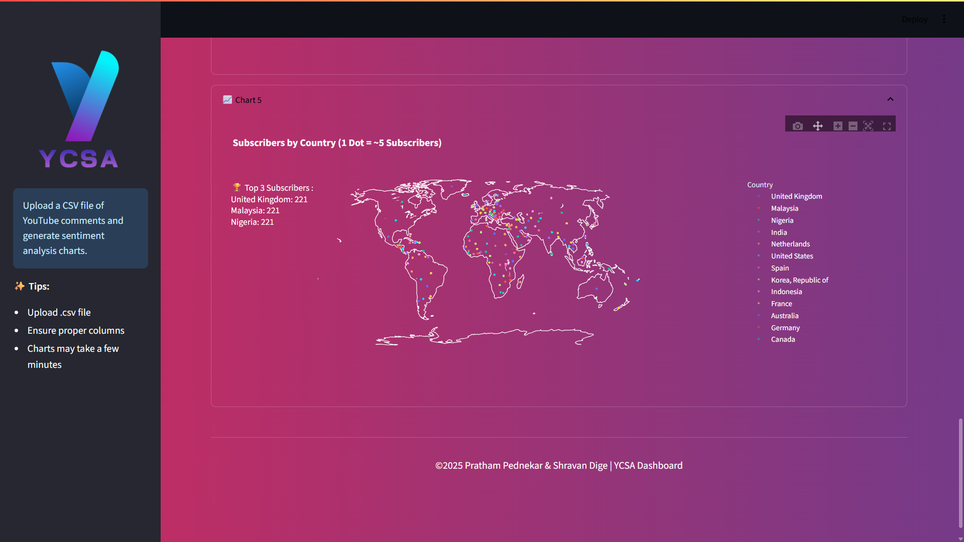
- REFERENCES

[1]https://www.ijdm.latticescipub.com/portfolio-item/A163304010524/?utm_source
[2]https://jurnal.upnyk.ac.id/index.php/telematika/article/view/4493?utm_source
[3]https://zenodo.org/records/11278177?utm_source
[4]chrome-extension://efaidnbmnnnibpcajpcglclefindmkaj/https://www.ijdm.latticescipub.com/wp-content/uploads/papers/v4i1/A163304010524.pdf?utm_source
[5]https://www.ijdm.latticescipub.com/portfolio-item/a163304010524/?utm_source
[6] https://arxiv.org/abs/2006.00206?utm_source
[7] https://arxiv.org/abs/2111.01908?utm_source

