Hospital Bed Allocation – Design Document
Oct 22, 2026 · @Nisarg
Group 7, scenario S7 (CS/SS G527 Cloud Computing): eight Python microservices allocate hospital beds so that no bed is ever given to two patients, using a ZooKeeper distributed lock with fencing tokens. Core services run on GKE in Google Cloud, notifications run as a Cloud Run function, and real-time analytics run as a Flink job on Dataproc.

System overview
The system admits patients, records their triage urgency, and allocates beds from pools such as WARDA-ICU, so that a bed is never given to two patients at once.
Admitting staff allocate and release beds, ward staff get a notification for every allocation, and administrators watch occupancy and contention on a dashboard. Beds are grouped into pools by ward and bed type (for example WARDA-ICU, WARDA-HDU, WARDB-GEN, WARDB-ISO), and urgency uses triage levels 1 (most urgent) to 5.
The hard part is concurrency. Bed Allocation runs as 2 to 10 replicas, and one allocation reads from three services and writes to three stores. Without coordination, two replicas working on the same pool can give one bed to two patients, or let a less urgent patient jump the waiting list. A ZooKeeper lock per pool turns each allocation into one critical section.
Allocation flow (POST /api/allocations):
- Bed Allocation checks the patient with Patient Registry (REST) and gets the triage level from Triage (gRPC).
- It asks Lock Coordinator (gRPC) for the pool's lock. Lock Coordinator queues the request in ZooKeeper and returns a 5-second lease and a fencing token once the request is first in line.
- Inside the lock, it lists the pool's free beds (Bed Registry, gRPC) and checks the pool's waiting list (Triage, gRPC).
- If a bed is free and no more urgent patient is waiting, it marks the bed occupied with the fencing token and assigns a nurse (Staff Scheduler, gRPC). Otherwise the patient joins the waiting list.
- It releases the lock, then publishes a bed event to Kafka for analytics and a message to Pub/Sub for the Notification function.
Releasing a bed (POST /api/allocations/{id}/release) takes the same lock, frees the bed, and hands it straight to the most urgent patient on that pool's waiting list.

Cloud deployment architecture
All 8 services, ZooKeeper, the data stores and the Flink job run in Google Cloud. The only outside piece is Kafka, hosted on Confluent Cloud.
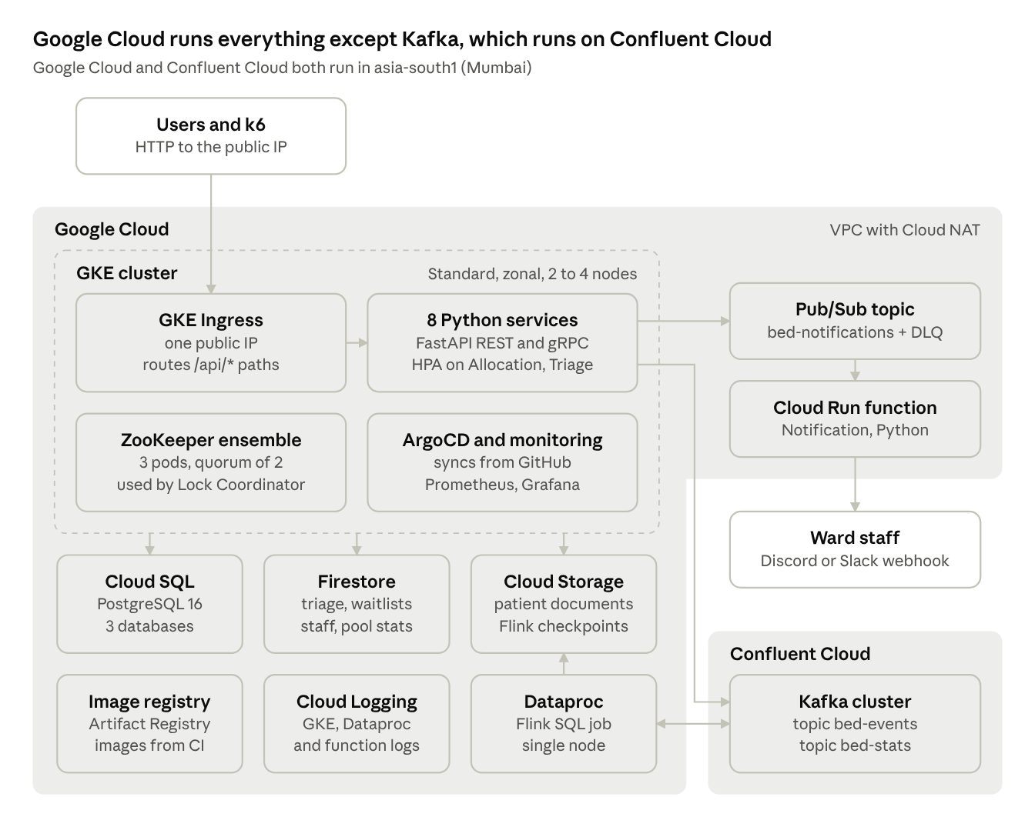
deployment · Google Cloud and Confluent Cloud
Only two links leave Google Cloud: the services and the Flink job reach Kafka over SASL_SSL through Cloud NAT, and the Notification function posts alerts to a Discord or Slack webhook.

Microservices architecture
Bed Allocation is the hub: it calls four services over gRPC and one over REST, then publishes to Pub/Sub and Kafka without waiting for either.
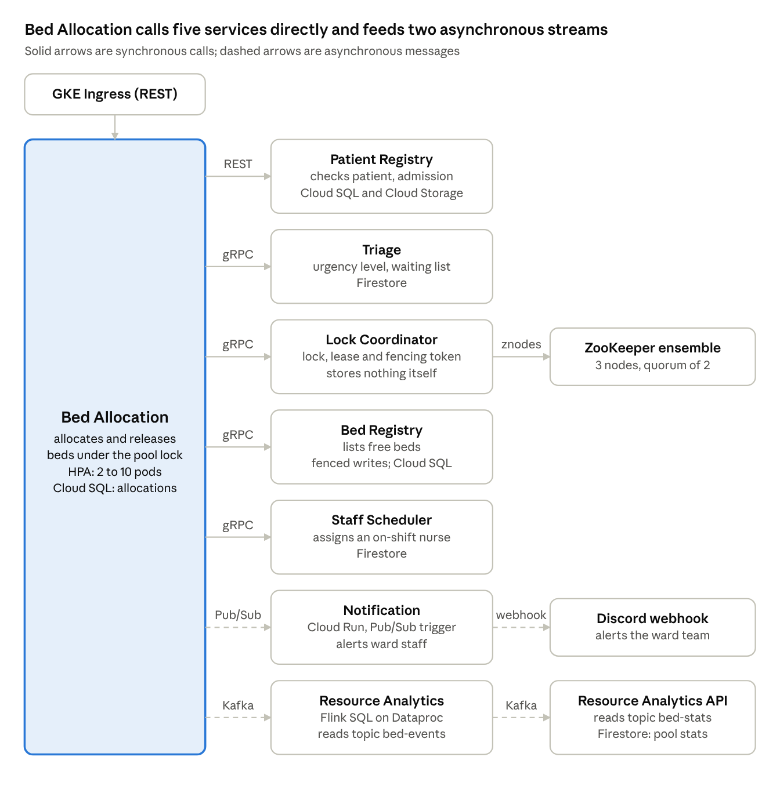
microservices · 8 services and their links
Every REST API is also exposed through the GKE Ingress, so users and k6 reach all services at one public IP.

Microservice responsibilities
Each of the 8 services owns one job and its own data; services never read another service's database.
Service | Responsibility | Interfaces | Data store | Scaling | Owner
Patient Registry | Patients, admissions and uploaded admission documents | REST (public URL) | Cloud SQL patients, Cloud Storage patient-docs | 2 replicas | A
Bed Registry | Bed identity, ward, type and status; rejects writes with stale fencing tokens | gRPC; REST for admin | Cloud SQL beds | 2 replicas | D
Bed Allocation | Allocates and releases beds inside the pool lock; publishes events | REST (public); gRPC client; Kafka and Pub/Sub producer | Cloud SQL allocations | HPA 2–10 pods | B
Lock Coordinator | Distributed locks with leases and fencing tokens on ZooKeeper | gRPC; REST lock inspector | ZooKeeper ensemble (3 nodes) | 2 replicas | C
Triage | Urgency levels 1–5 and each pool's priority waiting list | REST; gRPC | Firestore triage, waitlists | HPA 2–6 pods | B
Staff Scheduler | Staff shifts and nurse assignment per ward | REST; gRPC | Firestore staff | 2 replicas | A
Notification | Sends allocation, waitlist and conflict alerts to ward staff | Cloud Run function triggered by Pub/Sub; posts to a Discord or Slack webhook | None (stateless) | Scales to zero when idle | C
Resource Analytics | Flink job computing 1-minute occupancy, contention and wait-time windows; API serving the results | Kafka in and out; REST | Firestore pool_stats | Dataproc single node; API 1 replica | D

Interconnection mechanisms
REST is used at the edge, gRPC inside the allocation critical section, Pub/Sub for fire-and-forget notifications, and Kafka for the analytics stream.
Mechanism | Used between | Why it fits
REST (HTTP/JSON) | Clients and k6 → every public API through one GKE Ingress; Bed Allocation → Patient Registry | Easy to call from a browser, curl or k6; one public IP serves all routes
gRPC (HTTP/2, protobuf) | Bed Allocation → Lock Coordinator, Bed Registry, Triage, Staff Scheduler | Typed contracts in proto/, low latency, and a deadline on every call made while holding the lock
Message queue (Google Pub/Sub) | Bed Allocation → Notification function | Allocation never waits for the alert; Pub/Sub retries failed deliveries and moves poison messages to a dead-letter topic
Event streaming (Kafka on Confluent Cloud) | Bed Allocation → bed-events → Flink → bed-stats → Resource Analytics | Ordered per pool (message key = pool), replayable, and the input the stateful Flink job needs
A request ID created at the Ingress-facing service travels in HTTP headers, gRPC metadata, and Kafka and Pub/Sub messages, so one allocation can be traced across all services in the logs.

Required concept: ZooKeeper distributed lock
Every allocation or release for a pool runs while holding that pool's ZooKeeper lock, so only one replica changes a pool at a time and waiters are served in arrival order.
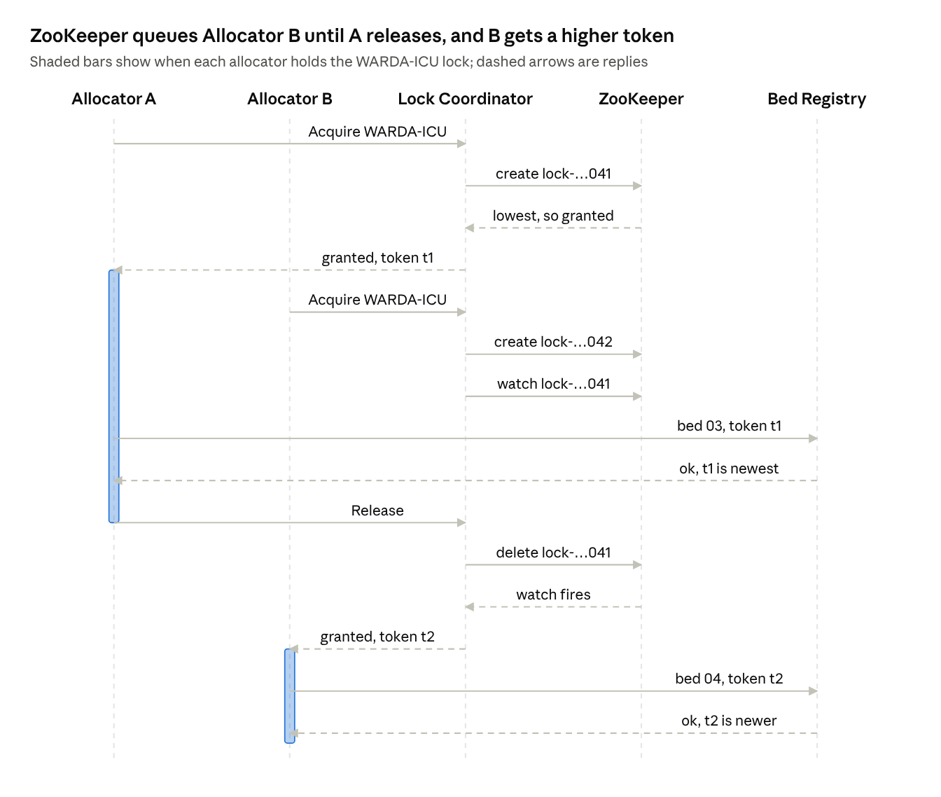
lock sequence · two allocators, one pool
Allocator B waits on a ZooKeeper watch instead of polling, and Bed Registry accepts B's write only because t2 is higher than any token it has seen for the pool.
How the lock works (implemented by hand on raw znodes, not with a library's lock recipe):
- Lock Coordinator creates an ephemeral, sequential znode such as /locks/WARDA-ICU/lock-0000000042, holding the owner and the lease expiry.
- If its znode has the lowest sequence number, the lock is granted. Otherwise it watches only the znode just before it, so a release wakes exactly one waiter (no herd effect).
- On grant it returns a fencing token: the znode's czxid, the ZooKeeper transaction ID that created it, which only ever increases.
- The holder does its work and calls Release, which deletes the znode. The watch fires and the next waiter takes the lock.
Leases: Bed Allocation asks for a 5-second lease and can renew it. A reaper in Lock Coordinator deletes any znode whose lease has run out, so a crashed or stuck allocator cannot block a pool forever. If a Lock Coordinator pod itself dies, its ZooKeeper session expires and ZooKeeper deletes all of that pod's ephemeral znodes.
Fencing tokens: Bed Registry stores the highest token seen for each pool and rejects any write that carries an older one. A holder that froze past its lease (a long GC pause or a network stall) therefore cannot overwrite the work of the holder that came after it.
ZooKeeper itself runs as a 3-node ensemble. Writes are ordered by the leader using the ZAB protocol, a quorum of 2 nodes must agree, and the ensemble keeps working if any one node fails.
Failure or test | What happens | How to show it in the demo
Many replicas request the same pool | Requests queue on znodes and run one at a time | k6 sends 50 simultaneous requests to a 10-bed pool: exactly 10 allocated, 40 waitlisted
Lock turned off (demo flag) | Replicas interleave and beds get double-allocated | Same k6 burst with lock=false: the audit endpoint shows more than 10 allocations
Allocator pod killed while holding the lock | Lease expires after 5 s and the reaper frees the lock | Delete the pod during a deliberately slow allocation
Holder freezes past its lease | The next holder gets a higher token; the stale write is rejected | pause_ms demo parameter returns 409 stale fencing token
Lock Coordinator pod dies | Its session expires and its znodes are deleted | Delete the pod; the lock frees within the session timeout
One ZooKeeper node dies | The other 2 nodes still form a quorum | Delete zookeeper-1 and keep allocating

Data storage
Three managed storage products each hold the data shape they fit: Cloud SQL for relational records, Firestore for high-write semi-structured documents, and Cloud Storage for files.
Store | Product | What it holds | Used by
Managed SQL | Cloud SQL for PostgreSQL 16, one instance with a database per service, private IP only | patients: patients, admissions, document metadata; beds: beds, per-pool fencing tokens; allocations: allocation history | Patient Registry, Bed Registry, Bed Allocation
Managed NoSQL | Firestore (native mode) | triage/{patient}, waitlists/{pool}/entries/{patient}, staff/{staffId}, pool_stats/{pool}_{windowStart} | Triage, Staff Scheduler, Resource Analytics
Object store | Cloud Storage | <project>-patient-docs: referral letters and ID scans; <project>-flink: the job JAR and Flink checkpoints | Patient Registry, Flink job
ZooKeeper holds only coordination state (lock znodes), not application data. A database per service keeps ownership clear, and sharing one Cloud SQL instance keeps the cost of three databases close to one.

Stream processing
Resource Analytics is a Flink SQL job on a single-node Dataproc cluster that turns raw bed events into per-pool statistics for every 1-minute window.
- Input: Kafka topic bed-events, keyed by pool. Event types are ALLOCATION_REQUESTED, BED_ALLOCATED, ALLOCATION_WAITLISTED and BED_RELEASED, each with the patient, the lock wait in milliseconds and the event time.
- Processing: event-time tumbling windows of 1 minute per pool, with a 5-second watermark for late events. Window state is checkpointed to Cloud Storage every 30 seconds, so the job resumes without losing counts after a restart.
- Output: Kafka topic bed-stats, one record per pool per window. The Resource Analytics API consumes it into Firestore and Prometheus gauges, which Grafana charts next to the service metrics.
INSERT INTO bed_stats
SELECT pool, window_start, window_end,
SUM(CASE WHEN event_type = 'ALLOCATION_REQUESTED' THEN 1 ELSE 0 END) AS requests,
SUM(CASE WHEN event_type = 'BED_ALLOCATED' THEN 1 ELSE 0 END) AS allocated,
SUM(CASE WHEN event_type = 'ALLOCATION_WAITLISTED' THEN 1 ELSE 0 END) AS waitlisted,
COUNT(DISTINCT patient_id) AS unique_patients,
AVG(CAST(lock_wait_ms AS DOUBLE)) AS avg_lock_wait_ms
FROM TABLE(TUMBLE(TABLE bed_events, DESCRIPTOR(event_time), INTERVAL '1' MINUTE))
GROUP BY pool, window_start, window_end;

Scaling and load testing
Bed Allocation and Triage carry the traffic of every allocation, so both scale horizontally on CPU, and k6 proves the scale-out and the lock's correctness under load.
Service | Min–max pods | Metric | Target | Why it is critical
Bed Allocation | 2–10 | CPU utilization | 60% | Every allocation and release passes through it
Triage | 2–6 | CPU utilization | 60% | Called on every allocation and for every waiting-list change
The GKE cluster autoscaler adds nodes (2 to 4) when new pods do not fit.
k6 tests in loadtest/:
- load.js (sustained load): ramps from 0 to 150 virtual users over 2 minutes, holds for 5 minutes, then ramps down, mixing allocations, releases and triage reads. Pass criteria: p95 latency under 800 ms and errors under 1%. During the run, Grafana and kubectl get hpa -w show both deployments scaling out, then back in after the test.
- contention.js (correctness under load): 50 virtual users allocate from the 10-bed WARDA-ICU pool at the same instant. Pass criteria: exactly 10 allocated, 40 waitlisted and zero beds with two active allocations. Run once with the lock and once with lock=false to show the difference.

Infrastructure as Code and GitOps
Terraform creates every cloud resource on both providers (Google Cloud and Confluent Cloud), and ArgoCD is the only thing that deploys to Kubernetes.
Terraform (infra/terraform/) has one root stack built from modules, with its state in a Cloud Storage bucket that a small bootstrap stack creates first:
Module | Creates
network | VPC, subnet with GKE pod and service ranges, Cloud Router and Cloud NAT, firewall rules
gke | Zonal GKE Standard cluster, autoscaling node pool, Workload Identity
cloudsql | PostgreSQL instance on private IP, the 3 databases and their users
firestore | Firestore database in native mode
storage | Cloud Storage buckets for patient documents and Flink
dataproc | Single-node Dataproc cluster with the Flink component
registry | Artifact Registry Docker repository, GitHub Actions workload identity federation
iam | Per-service IAM bindings for Kubernetes service accounts
serverless | Pub/Sub topic and dead-letter topic, the Notification Cloud Run function and its Pub/Sub trigger
confluent | Kafka cluster, bed-events and bed-stats topics, service accounts and API keys
bootstrap_k8s | Namespaces, Kubernetes secrets, ArgoCD (Helm) and the root ArgoCD application
Deployment flow, with no kubectl apply anywhere:
- A member pushes code to main.
- GitHub Actions builds the changed service's image and pushes it to Artifact Registry, tagged with the commit SHA.
- The workflow writes the new tag into k8s/overlays/gke/kustomization.yaml and commits it.
- ArgoCD, which tracks the repository with auto-sync, prune and self-heal, rolls out the new version.
ArgoCD uses an app-of-apps layout: a root application points at gitops/apps/, which defines the hospital (8 services, HPAs, Ingress), zookeeper and monitoring applications. Self-heal also reverts any manual change made in the cluster, which is easy to show live.

Observability
Prometheus and Grafana show service and cluster health on one dashboard, and Cloud Logging holds the logs of all 8 services, including the Flink job and the Notification function.
Metrics. kube-prometheus-stack (Prometheus, Grafana, node-exporter, kube-state-metrics) is deployed by ArgoCD. Every service exposes /metrics through a shared middleware, ServiceMonitors scrape them, and ZooKeeper exports its own metrics on port 7000. The Hospital – Services dashboard has these panels:
- Requests per second, per service
- Error rate (share of 5xx responses), per service
- p50 and p95 latency, per service
- HPA current and desired replicas for Bed Allocation and Triage
- Pod CPU and memory; node CPU, memory and readiness (cluster health)
- Lock acquisitions per second, lock wait p95 and lease expiries
- ZooKeeper quorum size, leader and outstanding requests
- Allocations, waitlisted requests and average lock wait per pool, from the Flink results
Logging. Cloud Logging is the single log store. GKE sends container logs automatically, and the Dataproc cluster is configured in Terraform to forward the Flink job's container logs. The Notification function's logs reach Cloud Logging automatically, like any other Google Cloud service. Every service writes one JSON line per event with service, severity and request_id, so a single Logs Explorer query follows one allocation across every service.

Design rationale
Most choices favour managed services the team does not have to operate, and everything except Kafka stays in one cloud.
Decision | Choice | Alternative considered | Why
Cloud provider | Google Cloud only | AWS, or Google Cloud plus AWS | Every member can use it; GKE, Dataproc and Cloud Logging work together with little setup; one bill and no keys crossing clouds
Serverless | Cloud Run function triggered by Pub/Sub | AWS Lambda with SQS | Logs land in Cloud Logging automatically, and nobody needs an AWS account
Kubernetes | GKE Standard, zonal, 2–4 nodes | GKE Autopilot | node-exporter needs host access that Autopilot restricts; the GKE free tier covers one zonal cluster's management fee
Coordination | ZooKeeper lock with leases and fencing tokens | Row lock or compare-and-set in PostgreSQL | One allocation spans 3 services and 3 stores, which a single row lock cannot cover; ZooKeeper also queues waiters fairly
Kafka | Confluent Cloud | Kafka on GKE | Fully managed with a Terraform provider; no brokers to run
Stream job | Flink SQL on a single-node Dataproc cluster | Flink DataStream API; Amazon EMR | The windowed aggregation is one SQL statement; Dataproc runs Flink as a built-in component in the same cloud
Relational database | One Cloud SQL instance, a database per service | One instance per service | Keeps data ownership per service at about a third of the cost
NoSQL database | Firestore | Bigtable, DynamoDB | Serverless with a free tier; fits per-patient and per-pool documents
GitOps controller | ArgoCD | Flux | Its UI shows sync status and diffs, which makes the demo clear
Logging | Cloud Logging | Loki, EFK | GKE and Dataproc ship logs with no extra agents to run
Language | Python: FastAPI, grpcio, kazoo | Java, Go | Fastest for the team to write and explain in the viva

Requirements coverage
Every assignment requirement maps to a specific component, and each task has one owner who demonstrates it.
Task | Requirement | How this design meets it | Owner
a | All infrastructure through IaC | Terraform for Google Cloud, Confluent Cloud and the ArgoCD bootstrap; nothing is created in a console | A
b | One serverless service; REST, gRPC and message queues all used | Notification is a Pub/Sub-triggered Cloud Run function; REST at the edge, gRPC inside, Pub/Sub and Kafka for asynchronous work | C
c | Managed Kubernetes, HPA on 2 services, load test | GKE; HPAs on Bed Allocation and Triage; k6 load and contention tests | B
d | GitOps controller, no direct kubectl apply | ArgoCD app-of-apps tracking the repository; CI only commits image tags | A
e | Flink on a managed cluster, Kafka in and out | Flink SQL job on Dataproc reads bed-events and writes 1-minute windows to bed-stats | D
f | Scenario concept: ZooKeeper | Lock Coordinator's hand-written ZooKeeper lock with leases and fencing tokens | C
g | Three distinct storage products | Cloud SQL, Firestore and Cloud Storage | D
h | Prometheus and Grafana; centralized logging | Hospital – Services dashboard; Cloud Logging for all services, Flink and the function | B
The public web service is the Ingress at http://<ingress-ip>/api/..., which serves Patient Registry and the other REST APIs.

Team and task division
Each member owns two tasks and two services and demonstrates them individually, as the assignment requires.
Member | Name | ID | Tasks | Services
A – platform | Ruchi Kumar | 2026H1030083P | a (Terraform), d (ArgoCD GitOps) | Patient Registry, Staff Scheduler
B – scaling | Pratham Soneja | 2026H1030055P | c (GKE, HPA, k6), h (Prometheus, Grafana, logging) | Bed Allocation, Triage
C – coordination | Nisarg Vagh | 2026H1030066P | f (ZooKeeper lock), b (Cloud Run function; REST, gRPC, Pub/Sub) | Lock Coordinator, Notification
D – data | Jay Patel | 2026H1030072P | e (Kafka, Flink), g (three storage products) | Resource Analytics, Bed Registry
The same table goes into task_division.txt in the repository.

