4

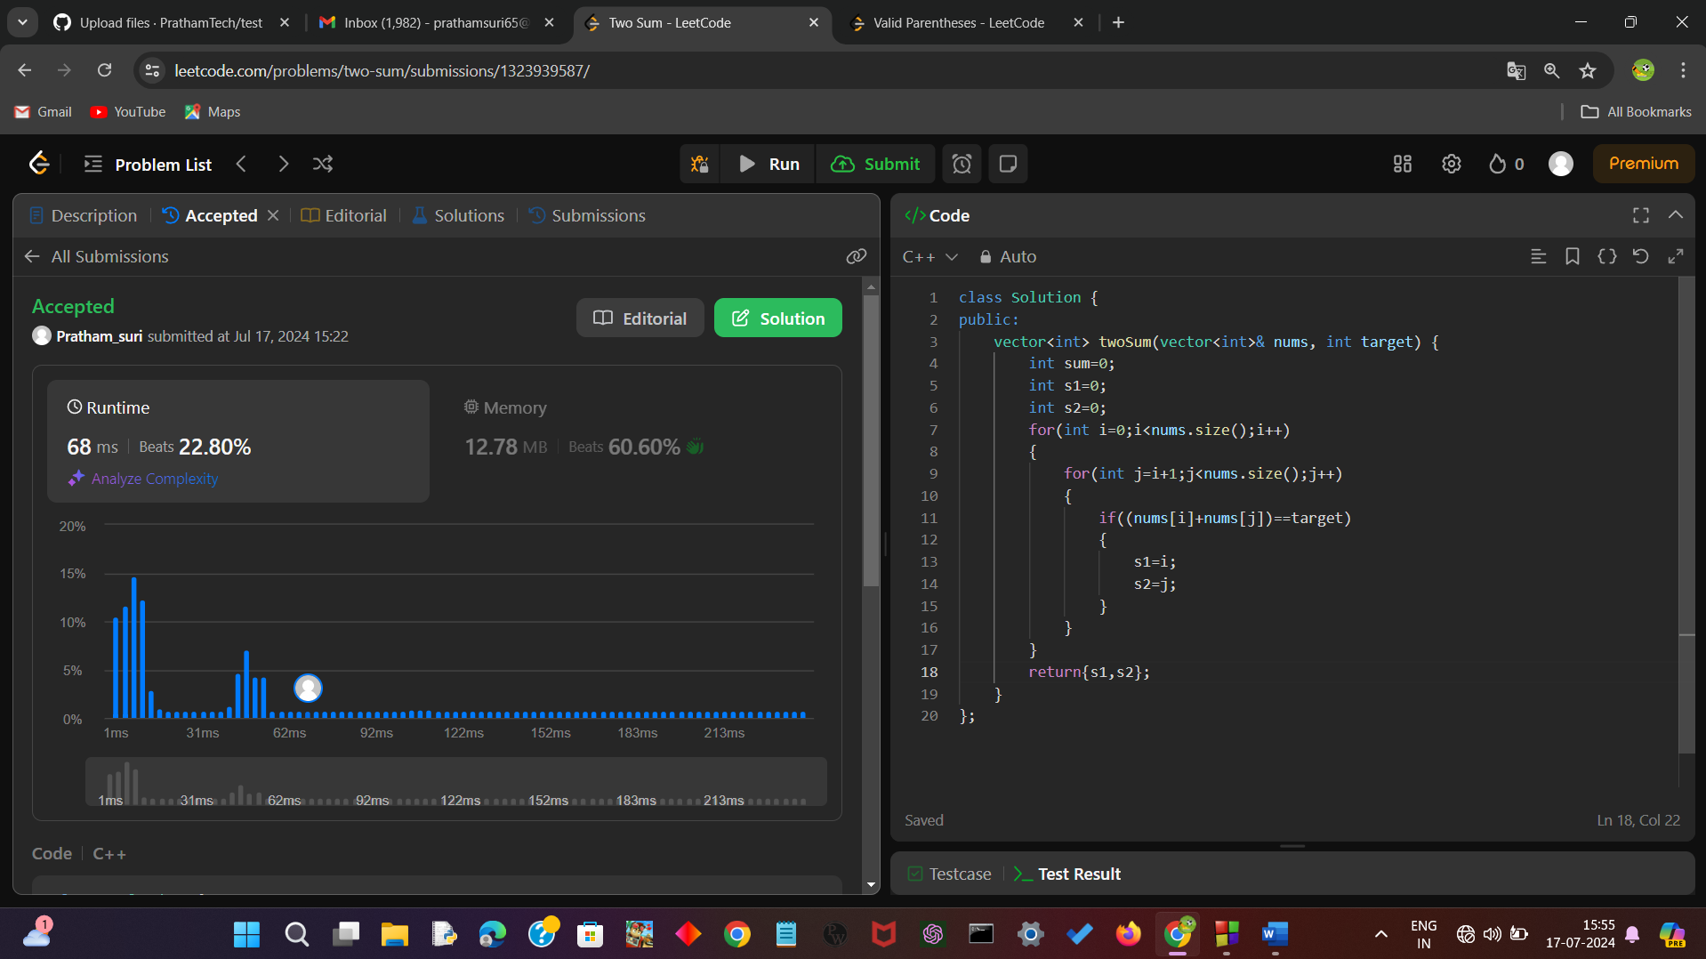

Pratham suri

2022a6r034