# ***Sweigart, "Automating Your Browser and Desktop Apps", PyBay2016***

https://www.youtube.com/watch?v=dZLyfbSQPXI

*Install Selenium:*

$ sudo pip install selenium

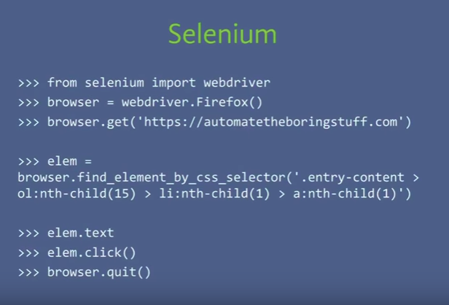

[Error](https://stackoverflow.com/questions/40555930/selenium-chromedriver-executable-needs-to-be-in-path)

*browser = webdriver.Chrome(executable_path='/home/samsung/Desktop/AutomationWithPython/chromedriver')*

*browser.get('https://google.com')*

*browser.get("http://karmic.co.in")*

***CSS Selector Syntax***

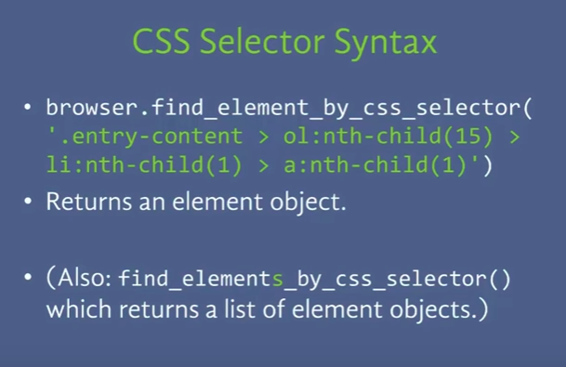

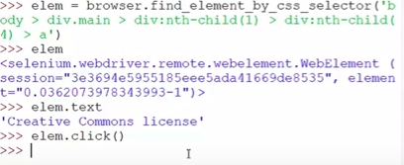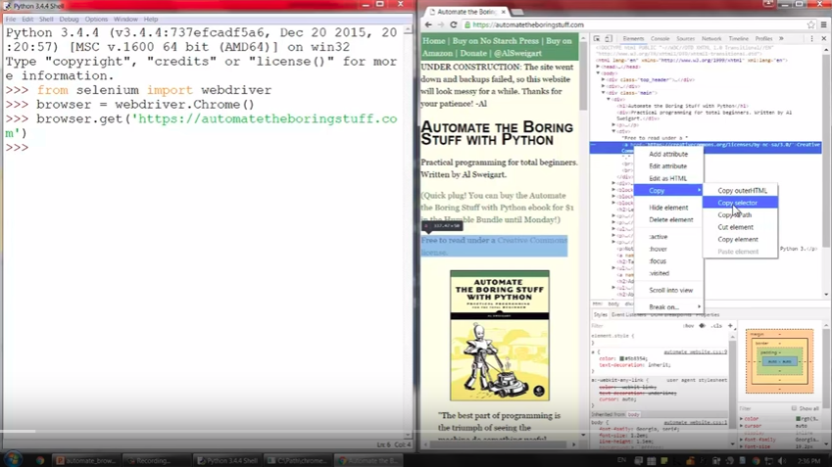

Element object method:

* click() - to click on a link
* send_keys() - to enter the keys
* submit()
* Browser Stuff’s
* - browser.back()
* - browser.refresh()
* - browser.forward()

