Make a circuit like this

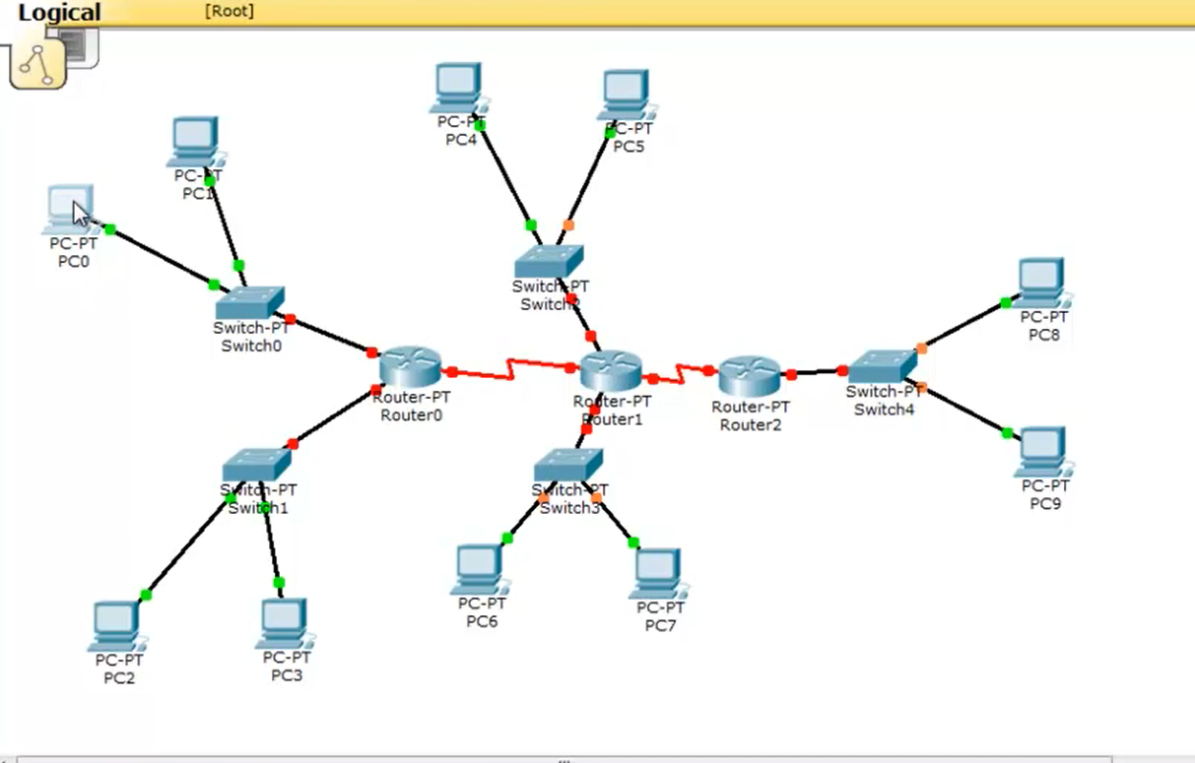

Click on PC >> Desktop(in dialogue box) >> IP Configurations

For pc0, IP = 1.168.0.2, Subnet Mask = 255.0.0.0, Default Gateway = 1.168.0.1

For pc1, IP = 1.168.0.3, Subnet Mask = 255.0.0.0, Default Gateway = 1.168.0.1

For pc2, IP = 128.168.0.2, Subnet Mask = 255.255.0.0, Default Gateway = 128.168.0.1

For pc3, IP = 128.168.0.3, Subnet Mask = 255.255.0.0, Default Gateway = 128.168.0.1

For pc4, IP = 192.168.0.2, Subnet Mask = 255.255.255.0, Default Gateway = 192.168.0.1

For pc5, IP = 192.168.0.3, Subnet Mask = 255.255.255.0, Default Gateway = 192.168.0.1

For pc6, IP = 126.168.1.2, Subnet Mask = 255.0.0.0, Default Gateway = 126.168.1.1

For pc7, IP = 126.168.1.3, Subnet Mask = 255.0.0.0, Default Gateway = 126.168.1.1

For pc8, IP = 191.168.1.2, Subnet Mask = 255.255.0.0, Default Gateway = 191.168.1.1

For pc9, IP = 191.168.1.3, Subnet Mask = 255.255.0.0, Default Gateway = 191.168.1.1

Click on Router >> Config(in dialogue box)

FastEthernet0/0

For Router0, Port Status (on), IP Address = 1.168.0.1, Subnet Mask = 255.0.0.0

For Router1, Port Status (on), IP Address = 192.168.0.1, Subnet Mask = 255.255.255.0

For Router2, Port Status (on), IP Address = 191.168.1.1, Subnet Mask = 255.255.0.0

FastEthernet1/0

For Router0, Port Status (on), IP Address = 128.168.0.1, Subnet Mask = 255.255.0.0

For Router1, Port Status (on), IP Address = 126.168.1.1, Subnet Mask = 255.0.0.0

For Router2, Port Status (on), IP Address = 192.168.0.1, Subnet Mask = 255.255.255.0

Serial2/0

For Router0, Port Status (on), IP Address = 10.0.0.1, Subnet Mask = 255.0.0.0

For Router1, Port Status (on), IP Address = 10.0.0.2, Subnet Mask = 255.0.0.0

For Router2, Port Status (on), IP Address = 128.0.0.3, Subnet Mask = 255.255.0.0

Serial3/0

For Router1, Port Status (on), IP Address = 128.0.0.1, Subnet Mask = 255.255.0.0

RIP

For Router0, Network = 1.168.0.1 >> Add, Network = 128.168.0.1 >> Add, Network = 10.0.0.1 >> Add

For Router1, Network = 192.168.0.1 >> Add, Network = 126.168.1.1 >> Add, Network = 10.0.0.2 >> Add, Network = 128.0.0.1 >> Add.

For Router2, Network = 191.168.1.1 >> Add, Network = 128.0.0.3 >> Add

* PC0 pe click krke 4th icon command prompt ka hoga, usko open krke type
  + Ping 128.168.0.2
  + Ping 128.169.0.3
  + Ping ……. (and so on)

IP dalna hai ping ke samne joh dusre pcs ka hai. Highlight kiya hai mein ips upr

**Neeche wala Step tab karna jab RIP krna ho**

This should Work and now right side pe envelope ka icon hoga first wala, uspe click krke select any 2 and bottom right pe last status should be successful.