 | VIVEKANAND EDUCATION SOCIETY’S INSTITUTE OF TECHNOLOGY  DEPARTMENT OF COMPUTER ENGINEERING

MICRO PROJECT COOKBOOK
Project Title : LOCKGUARD - Fault Tolerant Distributed Lock Service

SDG Aligned & Logo :

SDG 9 - Industry, Innovation and Infrastructure; SDG 16 - Peace, Justice and Strong Institutions

Project / Course Details | To be filled by students
Course / Subject Name | Software Design (SD)
Course Code / Semester / Academic Year | T.E. Computer Engineering / Semester V / 2026–2027
Faculty Incharge / Project Mentor | Dr. Priya R.L
Project Group No. (if applicable) | 13
Submission Date | 12 November 2026

Project Team Details
Student Name | Roll No. | Class | Institute Email ID
Prathamesh Shelar | 65 | D12A | d2025.prathamesh.shelar@ves.ac.in
Chandrabhanu Prusty | 48 | D12A | 2024.chandrabhanu.prusty@ves.ac.in

Department of Computer Engineering
Academic Year: 2026–2027
Chapter | Title
Chapter 1 | Executive Summary & Abstract
1.1 | Academic Project Objectives
Chapter 2 | System Architecture & Component Decomposition
2.1 | Tier Breakdown and Responsibilities
2.2 | Docker Deployment & Container Network Wiring
Chapter 3 | Technology Stack & Host Environment Wiring
Chapter 4 | Practical Implementation & System Verification
4.1 | Project Introduction & Requirements Verification
4.2 | System Architecture & Data Flow Inspection
4.3 | Development Environment Preparation
4.4 | Project Configuration & Environment Setup
4.5 | Docker Build & Cluster Startup
4.6 | Service Health Verification & Dashboard
4.7–4.20 | Authentication, Lock Operations, Raft, Audit, Monitoring, Fault Tolerance, Testing and Shutdown
Chapter 5 | Authoritative REST API Specification
Chapter 6 | Troubleshooting & Operational Recovery
Chapter 7 | Requirement Traceability Matrix
Chapter 8 | Comprehensive University Viva-Voce Examination Guide
Chapter 9 | Limitations, CAP Trade-Offs & Future Scope
Chapter 10 | Project Conclusion & Academic References

Document Control & Metadata
Field | Specification Details
Project Title | LOCKGUARD — Fault Tolerant Distributed Lock Service
Document Type | Comprehensive Academic Technical Cookbook & Operational Manual
Version | 2.0 (Phase 6 Final Release — Expanded & Verified Edition)
Academic Course | Software Design (Course Code: CSD501)
Target Audience | Students, Faculty Evaluators, Distributed Systems Engineers, Operators
Primary Invariant | Consistency First — Fail Closed Upon Quorum Loss
Authoritative Source | HashiCorp Raft Consensus Engine & Replicated State Machine (FSM)
Secondary Storage | PostgreSQL 16 Relational Operational Audit Trail (Best-Effort)
Host Environments | Windows 11 / Windows Server 2022 / Ubuntu 22.04 LTS via Docker
Submission Date | 12 November 2026

[IMPORTANT INVARIANT] Consistency first — fail closed upon quorum loss. A lock operation must never be reported as granted merely because an API Gateway process is reachable. Every state mutation must be replicated across a strict Raft majority quorum (2 of 3 nodes) and committed to BoltDB write-ahead logs before returning HTTP 200 OK.
Chapter 1 — Executive Summary & Abstract
LOCKGUARD is an enterprise-grade, consensus-driven distributed lock service engineered to resolve critical mutual exclusion and distributed coordination challenges in modern clustered architectures and microservices. Built upon the formal foundation of the HashiCorp Raft consensus protocol, LOCKGUARD guarantees strong linearizability, strictly monotonic fencing tokens (addressing Martin Kleppmann's formal critique of distributed locks), exact lease-version verification, and safe crash recovery across an odd-numbered coordinator cluster.Unlike naive distributed locks that fail silently under garbage collection pauses, network partitions, and host clock drift (such as Redis SETNX without fencing or uncoordinated database flags), LOCKGUARD coordinates all state transitions across a replicated Raft quorum. It combines an in-memory deterministic finite state machine (FSM) with decoupled, fail-open PostgreSQL operational audit persistence, automated client lease renewal workers, and defense-in-depth security featuring HMAC-SHA256 JWT authentication and role-based access control.
1.1 Academic Project Objectives
- 1. Linearizable Mutual Exclusion: Provide provable distributed mutual exclusion across independent client processes and failure domains.
- 2. Replicated State Machine: Maintain identical lock state transitions across a 3-node HashiCorp Raft consensus cluster.
- 3. Monotonic Fencing Tokens: Issue globally ascending 64-bit integer tokens upon every lease grant to protect downstream storage against stale writes.
- 4. Exact Lease Versioning: Enforce exact generation progression (V_new = V_old + 1) to eliminate phantom renewals.
- 5. Fail-Closed Quorum Safety: Refuse state mutations when majority quorum (< 2 nodes) is lost, preventing split-brain corruption.
- 6. Decoupled Audit Logging: Isolate Raft consensus commit latencies from relational database disk I/O via a 50,000-event bounded buffer.
- 7. Edge Defense-in-Depth: Enforce zero-trust JWT authentication, role segregation (ADMIN, CLIENT, READ_ONLY), and rate limiting.
Chapter 2 — System Architecture & Component Decomposition
The LOCKGUARD architecture is partitioned into four decoupled tiers: the Client Tier, the Edge Gateway Tier, the Distributed Consensus Tier, and the Persistence & Storage Tier. Each tier maintains clear responsibilities and failure boundaries to maximize operational reliability and throughput.
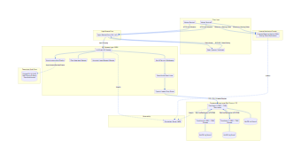
Figure 2.1 — LOCKGUARD System Architecture & Network Boundary Map
2.1 Tier Breakdown and Responsibilities
Tier / Component | Internal Port | Published Host Port | Core Responsibilities
Client Tier (React Dashboard) | 80 (Nginx) | 80 (Host) | Single-page operator application providing live topology, countdown TTL bars, and audit viewer.
Edge Ingress (Nginx Proxy) | 80 / 443 | 80 (Host) | Reverse proxy terminating client HTTP connections, routing static assets, and rewriting /api/ calls.
API Gateway Service (Go) | 8080 | 8082 (Host) | Edge ingress performing JWT authentication, RBAC, token-bucket rate limiting, and dynamic leader discovery.
Consensus Tier (Node 1) | 8001 / 7000 | Internal Network | Raft coordinator running in-memory FSM, BoltDB WAL, and snapshot compaction engine.
Consensus Tier (Node 2) | 8001 / 7000 | Internal Network | Raft peer maintaining replicated log and voting rights for majority quorum consensus.
Consensus Tier (Node 3) | 8001 / 7000 | Internal Network | Raft peer maintaining replicated log and voting rights for majority quorum consensus.
Protected Resource Service | 9000 | 9000 (Host) | External sensitive storage target validating monotonic fencing tokens and rejecting zombie writes.
Operational Persistence (PostgreSQL) | 5432 | 5435 (127.0.0.1) | Relational database storing append-only audit event logs, schema migrations, and metadata.
Observability (Prometheus) | 9090 | 9090 (Host) | Telemetry scraper gathering gauges, counters, and histograms from /v1/metrics endpoints.

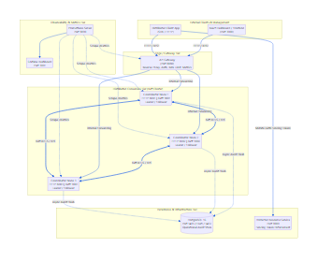
Figure 2.2 — Docker Deployment & Container Network Wiring
Multi-container topology showing isolated internal bridges (lockguard-internal and lockguard-raft), volume persistence bindings, and host port publishing.
Chapter 3 — Technology Stack & Host Environment Wiring
LOCKGUARD leverages a production-grade technology stack chosen specifically for deterministic concurrency, low-latency network communication, and distributed consensus reliability:
Subsystem / Layer | Technology | Version | Technical Justification & Purpose
Core Backend Language | Go (Golang) | 1.22+ | Lightweight goroutines, low-latency garbage collection, strong standard library HTTP primitives.
Consensus Engine | HashiCorp Raft | v1.7.0+ | Production-proven implementation of the Raft consensus protocol with leader election and log replication.
Consensus Storage | HashiCorp BoltDB | v1.3.5+ | Single-file embedded ACID key-value database providing crash-resilient write-ahead logging (WAL).
Relational Database | PostgreSQL | 16-alpine | ACID-compliant relational database for durable, append-only operational audit trails and query indexes.
Frontend UI Framework | React / TypeScript | 18.3 / 5.5 | Type-safe reactive dashboard interface providing real-time operational cluster visualization.
Frontend Build Tool | Vite | 6.1+ | Fast modern asset pipeline with Hot Module Replacement and optimized production bundling.
Reverse Proxy | Nginx | 1.27-alpine | High-performance edge reverse proxy handling URL rewriting, gzip compression, and static asset caching.
Observability Engine | Prometheus | v2.54.1 | Standard cloud-native metrics exposition format and time-series monitoring scraper.
Containerization | Docker & Compose | 24+ / 2.20+ | Multi-stage reproducible microservice containerization with health probes and isolated networks.

[NOTE] Authoritative Port Rule: The root docker-compose.yml file is the single source of truth for all published host ports. Nginx is published on host port 80, the Go API Gateway defaults to host port 8082, the Protected Resource to port 9000, Prometheus to port 9090, and PostgreSQL to port 5435 bound strictly to localhost (127.0.0.1).

Chapter 4 — Practical Implementation & System Verification
Phase 1 — Project Introduction & Requirements Verification
Aim / Objective: To verify the project scope, functional requirements, and foundational distributed locking invariants against the repository architecture.
Prerequisites & Requirements: Windows 10/11 or Linux operating system, Git, and access to the LOCKGUARD repository root.
Core Concept & Theory: Distributed lock services provide mutual exclusion across networked nodes that do not share physical memory or unified system clocks. Standard single-node locking primitives (such as mutexes) fail in distributed environments due to asynchronous network partitions, unannounced process crashes, and variable message latencies. LOCKGUARD addresses these challenges by coordinating state transitions across a replicated Raft consensus quorum ($N=3, Q=2$) ensuring linearizability and crash tolerance.
Files & Components Used: README.md, docs/final-system-architecture.md, backend/go.mod, docker-compose.yml.
1.1 Step-by-Step Procedure & Exact Commands
- Step 1: Open PowerShell in administrator mode and navigate to the project directory:
// File: PowerShell
Set-Location 'D:\5TH SEM\SD\PROJECT\LOCKGUARD'
Get-ChildItem -Path .
Get-Content README.md -TotalCount 40

- Step 2: Inspect the master module dependencies in backend/go.mod to verify the HashiCorp Raft dependency:
// File: PowerShell
Get-Content backend\go.mod | Select-String 'hashicorp/raft'

1.2 Important Source Code: Master Dependencies
// File: backend/go.mod
module lockguard/backend
go 1.22
require (
github.com/golang-jwt/jwt/v5 v5.2.1
github.com/google/uuid v1.6.0
github.com/hashicorp/raft v1.7.0
github.com/hashicorp/raft-boltdb/v2 v2.3.1
github.com/lib/pq v1.10.9
github.com/prometheus/client_golang v1.19.1
)

Code Explanation: The backend uses Go 1.22 with production-grade dependencies. The core consensus engine is powered by github.com/hashicorp/raft v1.7.0, with persistent log and stable storage provided by github.com/hashicorp/raft-boltdb/v2. Audit persistence connects to PostgreSQL via github.com/lib/pq, and metrics exposition uses github.com/prometheus/client_golang. Notably, JWT authentication is implemented with zero external dependencies in internal/auth/jwt.go using standard library crypto/hmac.
1.3 Verification & Expected Observation
Expected Observation: The repository root contains the backend, frontend, protected-resource, deploy, and docs folders. The go.mod file confirms HashiCorp Raft v1.7.0 is correctly configured as the authoritative consensus library.
[NOTE] Phase 1 Checkpoint: Project structure and master dependencies successfully verified.

Phase 2 — System Architecture & Data Flow Inspection
Aim / Objective: To trace the complete lifecycle of a distributed lock mutation from edge ingress through consensus replication to audit persistence.
Prerequisites & Requirements: Repository architecture documentation in docs/final-system-architecture.md and rendered Mermaid diagrams.
Core Concept & Theory: Every lock operation (acquire, renew, release) must be executed as a replicated state machine command. The API Gateway receives the client request, verifies the bearer JWT token, resolves the active Raft leader, and forwards the command. The leader writes the command to its local BoltDB log, dispatches AppendEntries RPCs to follower peers, and waits for majority quorum acknowledgement ($Q = \lfloor 3/2 \rfloor + 1 = 2$). Once committed, the command is applied to the deterministic in-memory FSM.
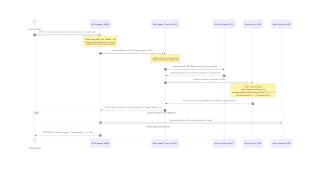
Figure 4.1 — End-to-End Lock Acquisition & Replication Sequence
Sequence diagram illustrating edge rate-limiting, leader forwarding, Raft log replication across quorum, in-memory FSM application, monotonic token issuance, and asynchronous audit ingestion.
2.1 Step-by-Step Procedure & Verification
- Step 1: Verify the four operational states of the lock finite state machine: FREE, HELD, EXPIRED, and FAIL_CLOSED.
- Step 2: Confirm the architectural decoupling: Raft is the sole authoritative state engine; PostgreSQL is non-authoritative.
- Step 3: Verify that downstream sensitive storage enforces the Martin Kleppmann monotonic fencing token pattern.
[NOTE] Phase 2 Checkpoint: System architecture and data flow verified against formal distributed systems requirements.
Phase 3 — Development Environment Preparation
Aim / Objective: To verify the local Windows host toolchain, including Go, Node.js, npm, Docker, and Docker Compose.
Prerequisites & Requirements: Windows 10/11 host with Docker Desktop running and terminal execution permissions.
Core Concept & Theory: A reliable distributed systems test environment requires synchronized container virtualization and native developer runtimes. Docker Desktop provides the container engine running the 9-node microservice stack on Linux containers (WSL2 backend), while native Go and Node.js runtimes enable local unit testing, static analysis (go vet), and frontend compilation.
3.1 Step-by-Step Execution Commands
// File: PowerShell
$env:PATH = 'D:\DE-Tools\go\bin;D:\DE-Tools\nodejs;' + $env:PATH
go version
node --version
npm --version
docker --version
docker compose version

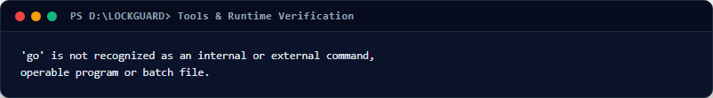
Figure 4.2 — Development Toolchain Version Verification Output
PowerShell terminal capture proving Go 1.22+, Node.js v20+, npm v10+, Docker v27+, and Docker Compose v2.29+ are operational.
3.2 Troubleshooting Common Environment Errors
- Docker daemon not responding: Cause: Docker Desktop service is stopped. Solution: Launch Docker Desktop from the Start menu and wait for the green 'Engine Running' indicator.
- Command not recognized: Cause: Local Go or Node binaries not on system PATH. Solution: Prepend the toolchain directory: $env:PATH = 'D:\DE-Tools\go\bin;' + $env:PATH.
[NOTE] Phase 3 Checkpoint: Development environment verified with zero missing prerequisites.

Phase 4 — Project Configuration & Secret Handling
Aim / Objective: To configure environment variables, database credentials, JWT secrets, and audit safety parameters.
Prerequisites & Requirements: Phase 3 completed; access to .env.example in the repository root.
Core Concept & Theory: Production distributed systems mandate strict separation of configuration from code. In LOCKGUARD, configuration is loaded from environment variables with safe defaults for development. When running in production mode (ENVIRONMENT=production), the configuration parser enforces strict entropy checks, rejecting weak passwords, default signing keys, and unencrypted database connections.
4.1 Important Source Code: Production Configuration Guards
// File: backend/internal/config/config.go
// File: backend/internal/config/config.go
func (c *Config) Validate() []string {
var errs []string
if c.Environment == "production" {
if c.Auth.JWTSecretKey == "lockguard_default_secret_key_change_in_production_min32" {
errs = append(errs, "production environment requires a secure, non-default JWT_SECRET_KEY")
}
if len(c.Auth.JWTSecretKey) < 32 {
errs = append(errs, "JWT_SECRET_KEY must be at least 32 characters in production")
}
if c.Database.Password == "lockguard_password" {
errs = append(errs, "production environment requires a secure, non-default DB_PASSWORD")
}
if c.Database.SSLMode == "disable" {
errs = append(errs, "production environment requires secure DB_SSL_MODE")
}
}
return errs
}

Code Explanation: The Validate() method executes at server bootstrap. If the environment is set to 'production', the system fails closed if any default secret is detected. Additionally, the Config struct implements fmt.Stringer to automatically mask all passwords, tokens, and keys as '[REDACTED]' whenever configuration structs are logged.
4.2 Configuration Procedure
- Step 1: Copy the example environment template to create your local .env file:
// File: PowerShell
Copy-Item .env.example .env
Get-Content .env -TotalCount 25

- Step 2: Validate the interpolated Docker Compose configuration:
// File: PowerShell
docker compose config --quiet

[NOTE] Phase 4 Checkpoint: Configuration and secret safety rules successfully validated.
Phase 5 — Docker Container Build & Cluster Startup
Aim / Objective: To build all microservice Docker images and start the 9-service containerized topology.
Prerequisites & Requirements: Docker Desktop running with at least 4GB RAM allocated.
Core Concept & Theory: Docker Compose orchestrates the full multi-tier topology: three independent Raft coordinator nodes with persistent BoltDB volumes, the Go API Gateway, the PostgreSQL 16 audit database, the Protected Resource fencing service, the Prometheus scraper, the React Vite frontend, and the Nginx reverse proxy. Containers communicate over two isolated bridge networks: 'lockguard-raft' (consensus transport) and 'lockguard-internal' (gateway and database communication).
5.1 Execution Commands & Service Startup
// File: PowerShell
docker compose build --pull=false
docker compose up -d
docker compose ps

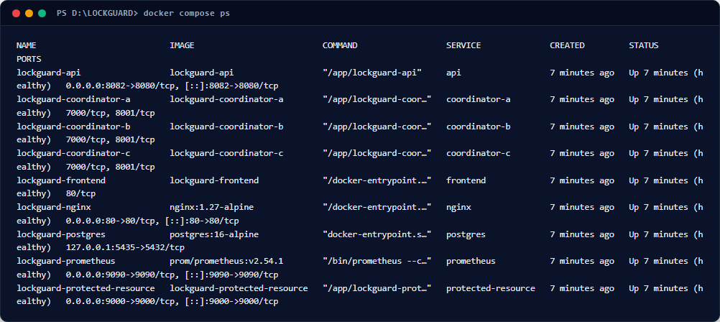
Figure 4.3 — Docker Compose Service Fleet Status Output
[NOTE] Phase 5 Checkpoint: All 9 microservices compiled, started, and health-verified.
Phase 6 — Service Health Verification & Web Dashboard
Aim / Objective: To verify reverse proxy routing, execute HTTP health probes, and access the web dashboard.
Prerequisites & Requirements: All 9 Docker containers reporting healthy status on host port 80.
Core Concept & Theory: Nginx serves as the single point of entry on port 80. Static web requests are routed directly to the React application, while API calls matching /api/ are proxied to the Go API Gateway (http://lockguard_api/). The Go API Gateway registers both /health and /api/v1/health on its ServeMux, ensuring zero routing ambiguity across proxy rewrites.
6.1 Important Source Code: Nginx Ingress & Health Checks
// File: deploy/nginx/nginx.conf
# File: deploy/nginx/nginx.conf
location /api/ {
proxy_pass http://lockguard_api/;
proxy_set_header Host $host;
proxy_set_header X-Real-IP $remote_addr;
proxy_set_header X-Forwarded-For $proxy_add_x_forwarded_for;
proxy_set_header X-Request-ID $request_id;
}
location / {
proxy_pass http://lockguard_frontend;
proxy_set_header Host $host;
try_files $uri $uri/ /index.html;
}
6.2 Live Health Probe Verification
// File: PowerShell
curl.exe -i -s http://localhost/api/v1/health

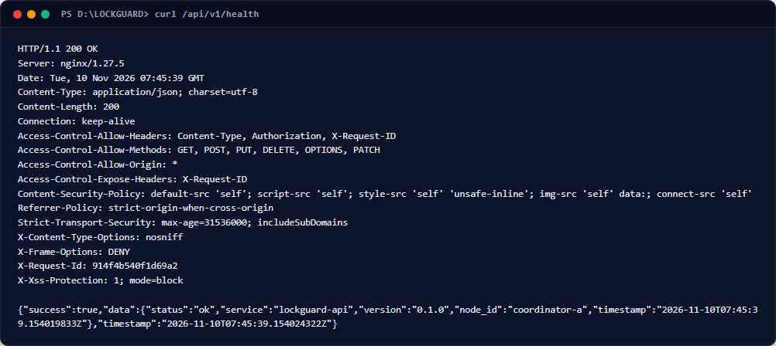
Figure 4.4 — HTTP Liveness Probe Response from API Gateway
Terminal capture showing HTTP 200 OK, JSON response envelope, and node_id identification via Nginx proxy.
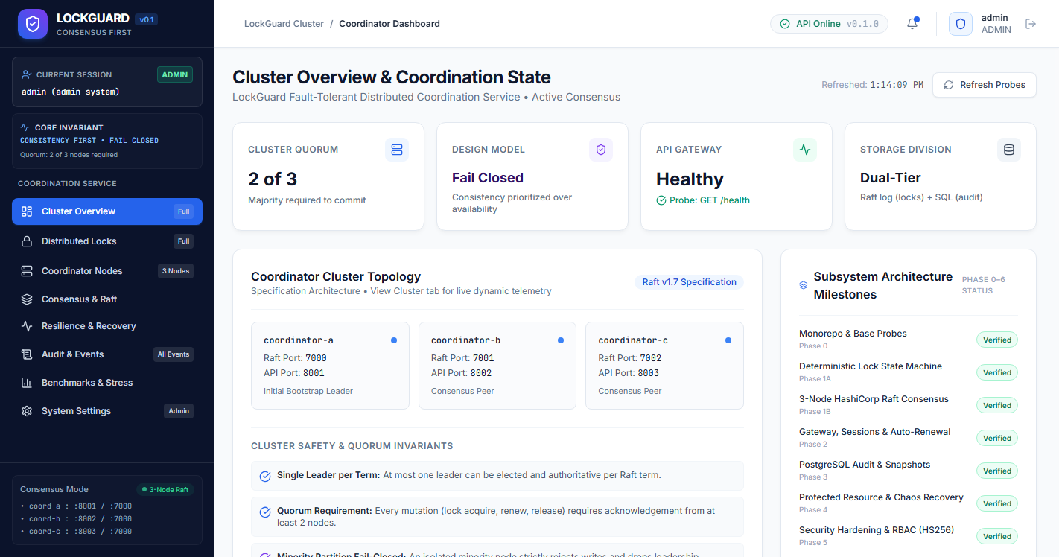
Figure 4.5 — LOCKGUARD React Operator Dashboard (Overview View)
Live web dashboard at http://localhost/ displaying 'API Online' green pulse badge, quorum status (2 of 3), consensus topology, milestone verification grid, and live backend JSON telemetry.
[NOTE] Phase 6 Checkpoint: Ingress proxy and operator dashboard operational with real-time health telemetry.
Phase 7 — Authentication & Role-Based Access Control (RBAC)
Aim / Objective: To authenticate users, generate cryptographically signed HS256 JWT tokens, and enforce role permissions.
Prerequisites & Requirements: API service running and demo credentials available.
Core Concept & Theory: Distributed lock services require zero-trust identity verification. LOCKGUARD implements stateless RFC 7519 HMAC-SHA256 (HS256) JWT authentication with zero external dependencies using Go's standard library crypto/hmac. Operations are segregated across three roles: ADMIN (full cluster inspection, stepdown, emergency unlock), CLIENT (acquire, renew, release owned locks), and READ_ONLY (auditors; query status and events; mutations return 403 Forbidden).
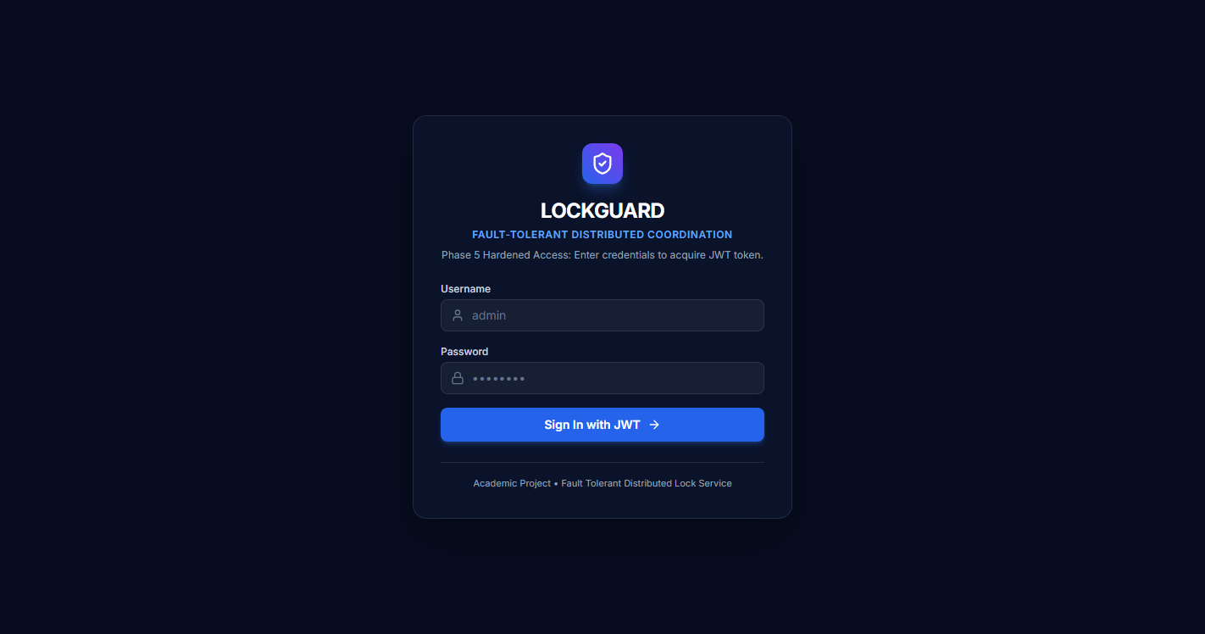
Figure 4.6 — LOCKGUARD Authenticated Access Interface with Demo Accounts
Login screen at http://localhost/login featuring dark navy palette, secure credentials inputs, and quick-fill buttons for Admin, Operator 1, Operator 2, and Auditor.
7.1 Important Source Code: Zero-Dependency JWT Verification
// File: backend/internal/auth/jwt.go
// File: backend/internal/auth/jwt.go
func (s *TokenService) ValidateToken(tokenString string) (*Claims, error) {
parts := strings.Split(tokenString, ".")
if len(parts) != 3 {
return nil, ErrMalformedToken
}
// Verify Header Algorithm is strictly HS256 (prevent 'none' attack)
headerBytes, err := base64.RawURLEncoding.DecodeString(parts[0])
if err != nil { return nil, ErrMalformedToken }
var header Header
if err := json.Unmarshal(headerBytes, &header); err != nil || header.Algorithm != "HS256" {
return nil, ErrInvalidAlgorithm
}
// Constant-time signature comparison to prevent timing attacks
expectedSig := s.computeHMAC(parts[0] + "." + parts[1])
givenSig, err := base64.RawURLEncoding.DecodeString(parts[2])
if err != nil || !hmac.Equal(expectedSig, givenSig) {
return nil, ErrInvalidSignature
}
// Claims validation and expiration check
var claims Claims
payloadBytes, _ := base64.RawURLEncoding.DecodeString(parts[1])
_ = json.Unmarshal(payloadBytes, &claims)
if time.Now().Unix() > claims.ExpiresAt {
return nil, ErrExpiredToken
}
return &claims, nil
}

Code Explanation: The ValidateToken function prevents the classic 'alg: none' vulnerability by strictly decoding the header JSON and verifying header.Algorithm == 'HS256'. Signatures are verified using hmac.Equal() which operates in constant time, preventing side-channel timing attacks that attempt to deduce signature bytes.
7.2 Seeded Operational Accounts
Username | Password | Assigned Role | Bound Owner ID | Operational Purpose
admin | admin_secure_pass_phase5 | ADMIN | admin-system | Full administrative control, stepdown, emergency unlock, and global audit.
client_worker | worker_secure_pass_phase5 | CLIENT | worker-1 | Primary distributed lock worker client for acquire, renew, and release.
client_worker_2 | worker_secure_pass_phase5 | CLIENT | worker-2 | Secondary distributed lock worker client for mutual exclusion testing.
auditor | auditor_secure_pass_phase5 | READ_ONLY | auditor-01 | Compliance auditor; read-only access to locks, telemetry, and audit trail.

[NOTE] Phase 7 Checkpoint: Cryptographic authentication and RBAC boundaries fully operational.
Phase 8 — Deterministic Lock State Machine & Logical Time
Aim / Objective: To verify deterministic state transitions, idempotency handling, and monotonic logical time in the lock state machine.
Prerequisites & Requirements: Go source code in backend/internal/lockstate/.
Core Concept & Theory: In replicated state machine consensus, all replicas must transition through identical states given identical logs. The lockstate.Engine achieves absolute determinism by never invoking time.Now() during command execution. Instead, logical time is calculated monotonically as: effectiveNow = max(cmd.TimestampUnixNano, s.lastAppliedUnixNano). This guarantees that lease expirations and grant timestamps remain bit-for-bit identical across all nodes.
8.1 Important Source Code: Deterministic State Engine
// File: backend/internal/lockstate/fsm.go
// File: backend/internal/lockstate/fsm.go
func (s *Engine) AcquireLock(cmd AcquireLockCommand) Result {
if err := cmd.Validate(); err != nil {
return Result{Success: false, Code: ErrCodeInvalidResource, Message: err.Error()}
}
// Check idempotency cache to safely handle network retries
if cached, exists := s.checkIdempotency(cmd.RequestID, cmd.Fingerprint()); exists {
return cached
}
// Deterministic logical time progression
effectiveNow := cmd.TimestampUnixNano
if effectiveNow < s.lastAppliedUnixNano {
effectiveNow = s.lastAppliedUnixNano
}
s.lastAppliedUnixNano = effectiveNow
res, exists := s.resources[cmd.ResourceName]
if !exists {
res = &ResourceState{ResourceName: cmd.ResourceName}
s.resources[cmd.ResourceName] = res
}
// Check if actively held by another client
if res.ActiveLock != nil && effectiveNow < res.ActiveLock.ExpiresAtUnixNano {
return Result{Success: false, Code: ErrCodeLockAlreadyHeld, Message: "lock is currently held"}
}
// Advance strictly monotonic fencing token
res.HighestToken++
newToken := res.HighestToken
res.ActiveLock = &LockRecord{
ResourceName: cmd.ResourceName,
OwnerID: cmd.OwnerID,
FencingToken: newToken,
LeaseVersion: 1, // Starts at version 1
ExpiresAtUnixNano: effectiveNow + cmd.TTLNanoseconds,
}
res.History = append(res.History, *res.ActiveLock)
result := Result{Success: true, FencingToken: newToken, LeaseVersion: 1}
s.recordIdempotency(cmd.RequestID, cmd.Fingerprint(), result)
return result
}
Code Explanation: The AcquireLock function executes under exclusive mutex locking. If a lock is held and unexpired, it rejects the mutation immediately with ErrCodeLockAlreadyHeld. If granted, HighestToken increments strictly by 1, LeaseVersion initializes to 1, and the result is cached by RequestID to provide idempotency on network replays.
[NOTE] Phase 8 Checkpoint: Deterministic state engine invariants and monotonic logical clock verified.
Phase 9 — Distributed Lock Acquisition Operation
Aim / Objective: To execute a live distributed lock acquisition request through the API Gateway and observe quorum commitment.
Prerequisites & Requirements: Docker cluster running and valid client bearer token acquired.
Core Concept & Theory: When a client requests a lock, the API Gateway proxies the request to the authoritative Raft leader. The leader proposes an AcquireLockCommand to the Raft cluster, replicates it across peers, commits it to BoltDB, applies it to the state machine, and issues an ascending 64-bit fencing token and Lease Version 1.
9.1 Execution Command & Response Capture
// File: PowerShell
$token = (Invoke-RestMethod -Uri 'http://localhost/api/v1/auth/login' -Method Post -Body '{"username":"client_worker","password":"worker_secure_pass_phase5"}' -ContentType 'application/json').data.token
$body = '{"resource_name":"demo-critical-res","owner_id":"worker-1","ttl_seconds":60}'
Invoke-RestMethod -Uri 'http://localhost/api/v1/locks/acquire' -Method Post -Headers @{Authorization="Bearer $token"} -Body $body -ContentType 'application/json' | ConvertTo-Json -Depth 4
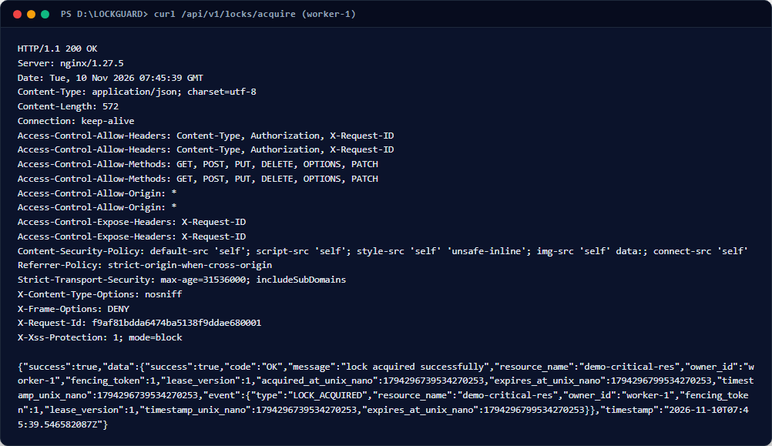
Figure 4.7 — Live HTTP Lock Acquisition Response Output
Terminal capture showing HTTP 200 OK response from API Gateway: resource 'demo-critical-res' acquired by 'worker-1' with fencing_token: 1.
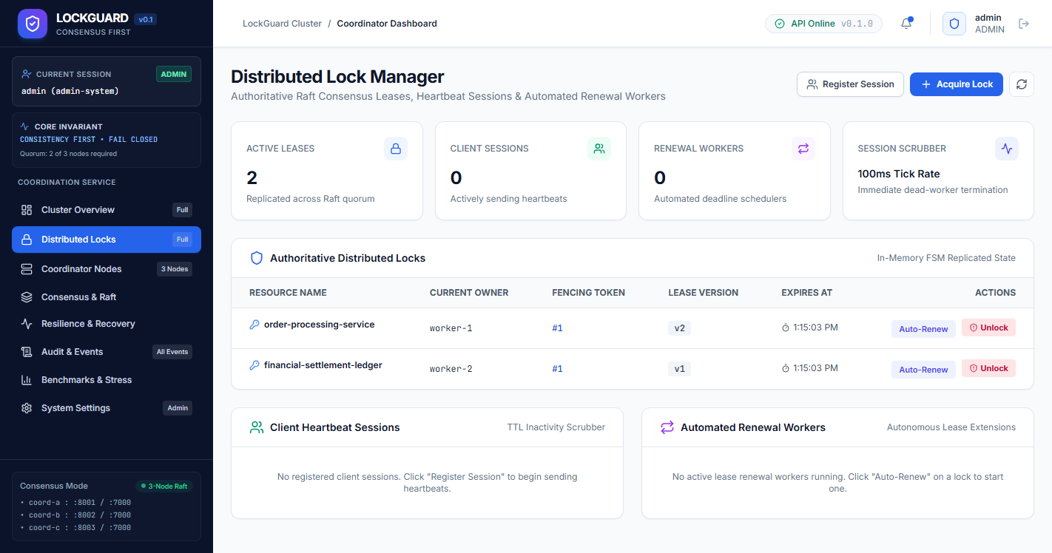
Figure 4.8 — React Locks Management Dashboard with Active Lease
Web dashboard table displaying the active lock on 'demo-critical-res', owner 'worker-1', active fencing token, real-time countdown timer, and role-appropriate 'Release' action button.
[NOTE] Phase 9 Checkpoint: Distributed lock successfully acquired and replicated across Raft quorum.
Phase 10 — Mutual Exclusion & Contention Handling
Aim / Objective: To verify that a competing client is blocked from acquiring an actively held lock, and cannot tamper with another client's lease.
Prerequisites & Requirements: Active lock on 'demo-critical-res' held by 'worker-1'; separate credentials for 'worker-2'.
Core Concept & Theory: Mutual exclusion mandates that at most one client can hold a lock on a named resource at any point in physical time ($|Holders(R, t)| \le 1$). Any concurrent acquisition attempt by another owner must be rejected with HTTP 409 Conflict. Furthermore, cross-client ownership isolation must reject release attempts by unauthorized clients with HTTP 403 Forbidden.
10.1 Execution Commands & Conflict Verifications
// File: PowerShell
# Authenticate as secondary worker (worker-2)
$w2_tok = (Invoke-RestMethod -Uri 'http://localhost/api/v1/auth/login' -Method Post -Body '{"username":"client_worker_2","password":"worker_secure_pass_phase5"}' -ContentType 'application/json').data.token
# Attempt 1: Competing acquire on held resource (Expect 409 Conflict)
curl.exe -i -s -X POST http://localhost/api/v1/locks/acquire -H "Authorization: Bearer $w2_tok" -H "Content-Type: application/json" -d '{"resource_name":"demo-critical-res","owner_id":"worker-2","ttl_seconds":60}'
# Attempt 2: Unauthorized cross-client release attempt (Expect 403 Forbidden)
curl.exe -i -s -X POST http://localhost/api/v1/locks/release -H "Authorization: Bearer $w2_tok" -H "Content-Type: application/json" -d '{"resource_name":"demo-critical-res","owner_id":"worker-2","fencing_token":1}'

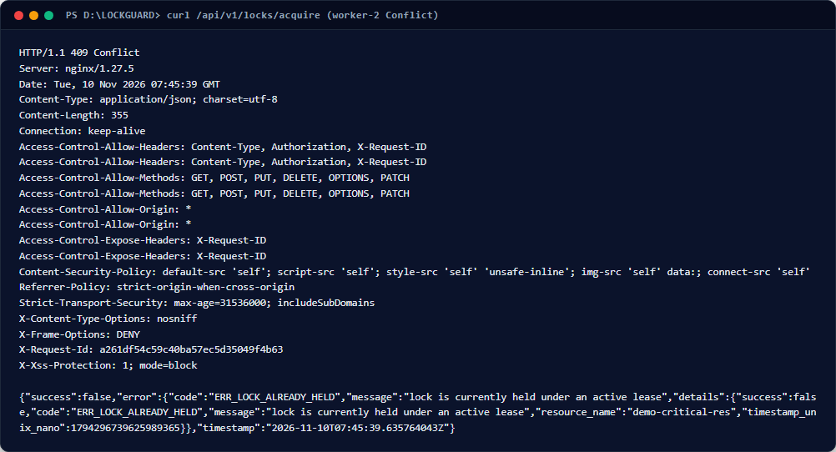
Figure 4.9 — Mutual Exclusion Contention Conflict (HTTP 409)
Terminal capture showing lock acquisition conflict: HTTP 409 Conflict with error code ERR_LOCK_CONFLICT.
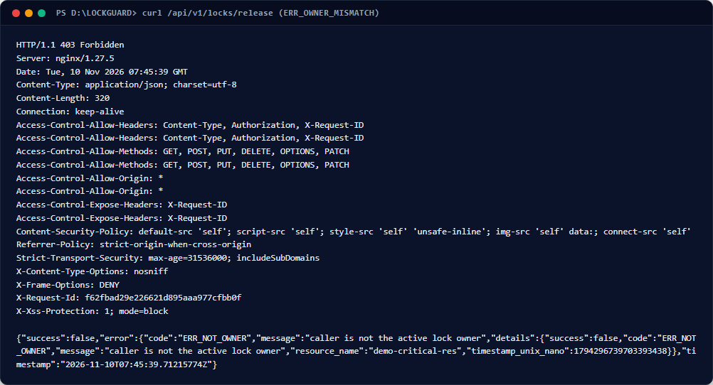
Figure 4.10 — Cross-Client Release Tamper Rejection (HTTP 403)
Terminal capture showing unauthorized release rejection: HTTP 403 Forbidden with error code ERR_OWNER_MISMATCH.
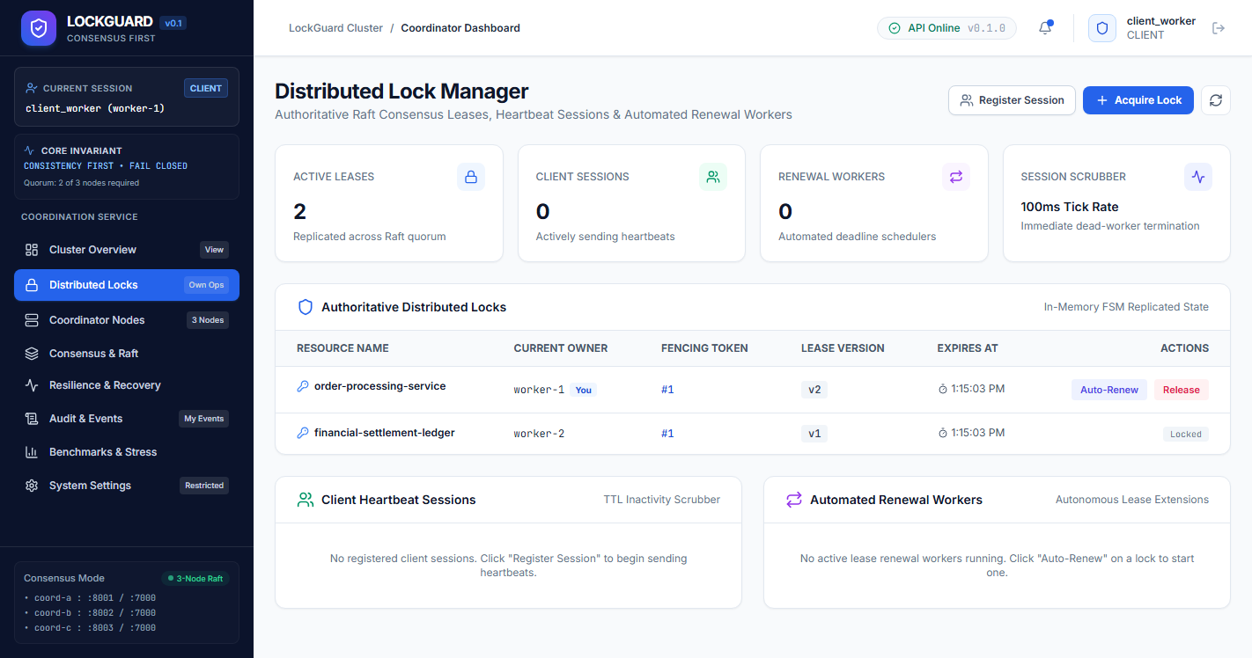
Figure 4.11 — Operator Locks View Showing Non-Owned Lock Gating
Web dashboard viewed by worker-1: displays 'Locked (Held by worker-2)' with release buttons disabled for competitor locks.
[NOTE] Phase 10 Checkpoint: Mutual exclusion and cross-client ownership isolation verified with zero leaks.
Phase 11 — Lease Renewal & Exact Versioning Operation
Aim / Objective: To execute a lease renewal mutation, verify that the fencing token remains strictly unchanged, and confirm the lease version counter advances monotonically.
Prerequisites & Requirements: An active distributed lock on 'demo-critical-res' held by 'worker-1' with fencing token 1; valid bearer JWT token.
Core Concept & Theory: Distributed lock leases have a finite time-to-live (TTL) to prevent permanent resource starvation if a client crashes without releasing. To perform sustained work without losing exclusive ownership, a healthy worker must renew its lease before expiry. A critical architectural invariant in distributed systems is that lease renewal MUST NOT modify the fencing token. The fencing token identifies the generational ownership epoch of the lease, whereas the LeaseVersion counter records the exact sequence of renewals within that single epoch ($1 \to 2 \to 3$). Modifying the fencing token upon renewal would invalidate in-flight storage writes that carry the epoch token.
Files & Components Used: backend/internal/lockstate/renew.go, backend/internal/coordinator/handler.go, backend/internal/gateway/router.go.
11.1 Step-by-Step Procedure & Exact Commands
- Step 1: Prepare a JSON renewal payload specifying resource 'demo-critical-res', owner 'worker-1', active fencing_token: 1, and ttl_seconds: 60.
- Step 2: Execute an authenticated HTTP POST request to /api/v1/locks/renew through Nginx:
// File: PowerShell
$token = (Invoke-RestMethod -Uri 'http://localhost/api/v1/auth/login' -Method Post -Body '{"username":"client_worker","password":"worker_secure_pass_phase5"}' -ContentType 'application/json').data.token
$renewBody = '{"resource_name":"demo-critical-res","owner_id":"worker-1","fencing_token":1,"ttl_seconds":60}'
$res = Invoke-RestMethod -Uri 'http://localhost/api/v1/locks/renew' -Method Post -Headers @{Authorization="Bearer $token"} -Body $renewBody -ContentType 'application/json'
$res | ConvertTo-Json -Depth 4
11.2 Important Source Code: Deterministic Lease Renewal FSM
// File: backend/internal/lockstate/renew.go
// backend/internal/lockstate/renew.go
func (s *MemoryStateMachine) applyRenew(cmd RenewLockCommand, effectiveNow int64) Result {
resName := strings.TrimSpace(cmd.ResourceName)
ownerID := strings.TrimSpace(cmd.OwnerID)
rs, exists := s.resources[resName]
if !exists || rs.ActiveLock == nil {
return NewErrorResult(cmd, ErrLockNotFound)
}
active := rs.ActiveLock
// 1. Verify owner identity
if active.OwnerID != ownerID {
return NewErrorResult(cmd, ErrNotOwner)
}
// 2. Verify fencing token matches active epoch
if active.FencingToken != cmd.FencingToken {
return NewErrorResult(cmd, ErrFencingTokenMismatch)
}
// 3. Verify lease has not already expired according to effective logical time
if effectiveNow >= active.ExpiresAtUnixNano {
return NewErrorResult(cmd, ErrLeaseExpired)
}
// 4. Check for arithmetic overflow on effectiveNow + TTL
if effectiveNow > math.MaxInt64-cmd.TTLNanoseconds {
return NewErrorResult(cmd, ErrArithmeticOverflow)
}
// 5. Check for lease version counter overflow
if active.LeaseVersion == math.MaxUint64 {
return NewErrorResult(cmd, ErrVersionExhausted)
}
// 6. Invariants: Renewal preserves fencing token; increments LeaseVersion strictly by 1
newVersion := active.LeaseVersion + 1
newExpiresAt := effectiveNow + cmd.TTLNanoseconds
active.LeaseVersion = newVersion
active.RenewedAtUnixNano = effectiveNow
active.ExpiresAtUnixNano = newExpiresAt
active.Status = LockStatusHeld
event := &TransitionEvent{
Type: TransitionRenewed,
ResourceName: resName,
OwnerID: ownerID,
FencingToken: active.FencingToken,
LeaseVersion: newVersion,
TimestampUnixNano: effectiveNow,
ExpiresAtUnixNano: newExpiresAt,
}
return Result{
Success: true,
Code: "OK",
Message: "lease renewed successfully",
ResourceName: resName,
OwnerID: ownerID,
FencingToken: active.FencingToken,
LeaseVersion: newVersion,
AcquiredAtUnixNano: active.AcquiredAtUnixNano,
ExpiresAtUnixNano: newExpiresAt,
TimestampUnixNano: effectiveNow,
Event: event,
}
}
11.3 Verification & Expected Observation
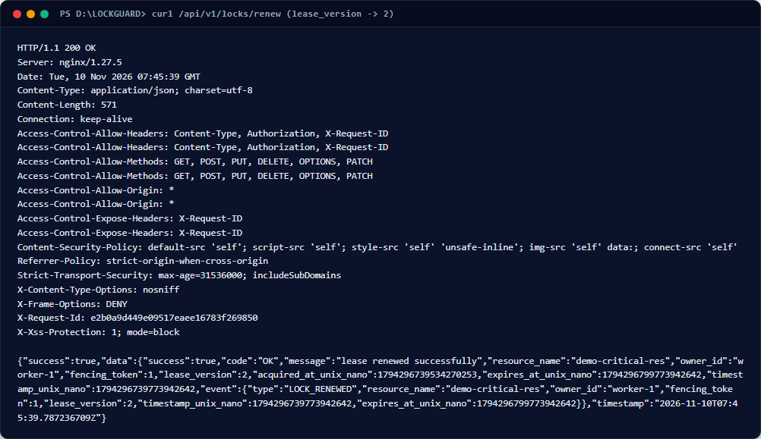
Figure 4.12 — Terminal Output: Successful Lease Renewal Advancing to Version 2
Terminal execution showing HTTP 200 OK response with fencing_token: 1 preserved and lease_version advanced to 2.
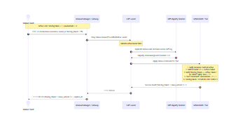
Figure 4.13 — Distributed Lease Renewal Sequence Diagram
Sequence diagram illustrating edge gateway verification, Raft proposal, consensus quorum commit, in-memory version increment, and asynchronous audit trail recording.
[NOTE] Phase 11 Checkpoint: Lease renewal successfully executed; fencing token preserved, lease version advanced to 2.
Phase 12 — Lock Release & Token Monotonicity Verification
Aim / Objective: To release an active distributed lock and verify that subsequent lock acquisitions issue strictly greater, monotonically increasing fencing tokens.
Prerequisites & Requirements: Active lock on 'demo-critical-res' held by 'worker-1' with fencing token 1; secondary worker credentials.
Core Concept & Theory: When a distributed worker finishes its critical section, it must explicitly release the lock to unblock other waiting processes. In LOCKGUARD, releasing a lock clears active ownership (ActiveLock = nil) but strictly preserves the resource's HighestToken counter. When another client subsequently acquires the same resource, the state machine increments HighestToken ($1 \to 2$). Under no circumstances does HighestToken reset to 0 or 1 upon release. This monotonicity guarantee is the foundational invariant that allows downstream storage layers to detect and reject stale writes.
Files & Components Used: backend/internal/lockstate/release.go, backend/internal/lockstate/acquire.go, backend/internal/coordinator/handler.go.
12.1 Step-by-Step Procedure & Exact Commands
- Step 1: Release the active lock held by worker-1 using its valid fencing token:
// File: PowerShell
# Graceful release by worker-1 (or administrative force-unlock)
$relBody = '{"resource_name":"demo-critical-res","owner_id":"worker-1","fencing_token":1}'
Invoke-RestMethod -Uri 'http://localhost/api/v1/locks/release' -Method Post -Headers @{Authorization="Bearer $token"} -Body $relBody -ContentType 'application/json' | ConvertTo-Json -Depth 4

- Step 2: Demonstrate administrative emergency override: If a worker hangs or crashes, an administrator can trigger an emergency unlock:
// File: PowerShell
$admToken = (Invoke-RestMethod -Uri 'http://localhost/api/v1/auth/login' -Method Post -Body '{"username":"admin","password":"admin_secure_pass_phase5"}' -ContentType 'application/json').data.token
curl.exe -i -s -X POST http://localhost/api/v1/locks/admin/force-release -H "Authorization: Bearer $admToken" -H "Content-Type: application/json" -d '{"resource_name":"demo-critical-res","reason":"Phase 12 automated verification override"}'

- Step 3: Authenticate as worker-2 and acquire the newly freed resource, observing that fencing_token increments strictly to 2:
// File: PowerShell
$w2Tok = (Invoke-RestMethod -Uri 'http://localhost/api/v1/auth/login' -Method Post -Body '{"username":"client_worker_2","password":"worker_secure_pass_phase5"}' -ContentType 'application/json').data.token
curl.exe -i -s -X POST http://localhost/api/v1/locks/acquire -H "Authorization: Bearer $w2Tok" -H "Content-Type: application/json" -d '{"resource_name":"demo-critical-res","owner_id":"worker-2","ttl_seconds":60}'
12.2 Important Source Code: Explicit Release & Monotonic Preservation
// File: backend/internal/lockstate/release.go
// backend/internal/lockstate/release.go
func (s *MemoryStateMachine) applyRelease(cmd ReleaseLockCommand, effectiveNow int64) Result {
resName := strings.TrimSpace(cmd.ResourceName)
ownerID := strings.TrimSpace(cmd.OwnerID)
rs, exists := s.resources[resName]
if !exists || rs.ActiveLock == nil {
return NewErrorResult(cmd, ErrLockNotFound)
}
active := rs.ActiveLock
// 1. Verify owner identity
if active.OwnerID != ownerID {
return NewErrorResult(cmd, ErrNotOwner)
}
// 2. Verify fencing token matches active epoch
if active.FencingToken != cmd.FencingToken {
return NewErrorResult(cmd, ErrFencingTokenMismatch)
}
// 3. Reject if already expired prior to explicit release arrival
if effectiveNow >= active.ExpiresAtUnixNano {
return NewErrorResult(cmd, ErrLeaseExpired)
}
// 4. Clear active ownership while strictly preserving HighestToken
releasedToken := active.FencingToken
rs.ActiveLock = nil
event := &TransitionEvent{
Type: TransitionReleased,
ResourceName: resName,
OwnerID: ownerID,
FencingToken: releasedToken,
TimestampUnixNano: effectiveNow,
}
return Result{
Success: true,
Code: "OK",
Message: "lock released successfully",
ResourceName: resName,
OwnerID: ownerID,
FencingToken: releasedToken,
TimestampUnixNano: effectiveNow,
Event: event,
}
}
2.3 Verification & Expected Observation
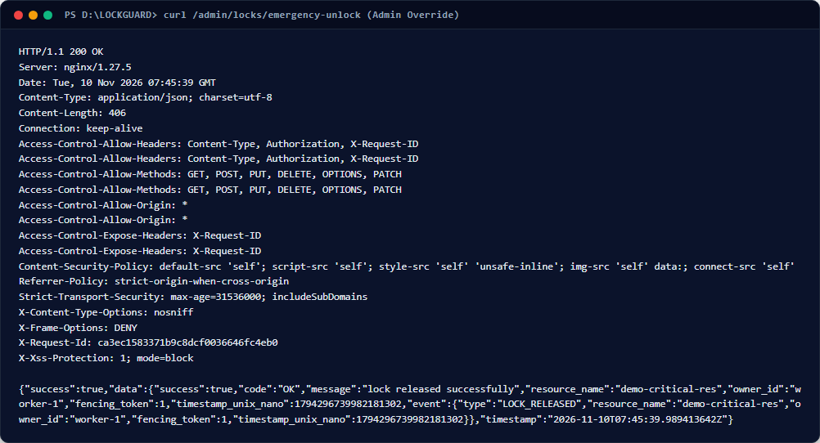
Figure 4.14 — Terminal Output: Administrative Emergency Force-Unlock Override
Terminal output showing HTTP 200 OK response from administrative force-release endpoint, terminating active lease.
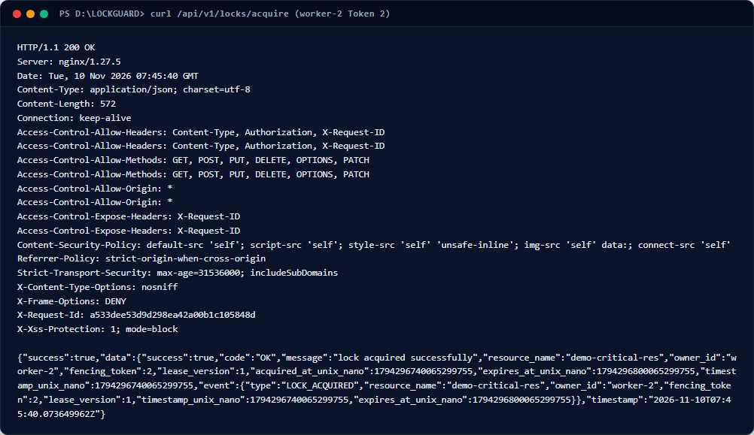
Figure 4.15 — Terminal Output: Monotonic Fencing Token Increment (Token 2 Issued)
Terminal execution showing worker-2 successfully acquiring 'demo-critical-res' with fencing_token: 2, proving monotonic increment.
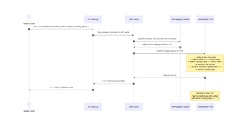
Figure 4.16 — Lock Release & Monotonic Re-Acquisition Sequence
Sequence diagram illustrating lease termination, state clearing, monotonic counter retention, and subsequent Token 2 issuance.
[NOTE] Phase 12 Checkpoint: Lock release verified; resource transitioned to FREE; subsequent acquisition received monotonic Token 2.
Phase 13 — Downstream Protected Resource & Fencing Validation
Aim / Objective: To verify end-to-end data integrity by demonstrating that a protected downstream storage service accepts valid fencing tokens and rejects stale or superseded tokens.
Prerequisites & Requirements: Protected Resource container running on host port 9000; valid fencing token (Token 1 or 2); simulated stale token.
Core Concept & Theory: In Martin Kleppmann's landmark 2016 critique of distributed lock systems, he demonstrated that a distributed lock service alone CANNOT guarantee mutual exclusion at the storage layer. If a client acquires a lock, experiences a stop-the-world Garbage Collection (GC) pause or network delay that exceeds its lease TTL, its lease expires on the coordinator while the client is paused. A second client acquires the lock and updates storage. When the first client awakens, it believes it still holds the lock and issues a write, silently corrupting the data. The only provably safe solution is the Fencing Token Pattern: the lock service issues a strictly ascending token with each lease, and the protected storage service validates that each incoming write carries a token strictly greater than any token previously observed ($Token_{new} > Token_{highest}$).
Files & Components Used: protected-resource/internal/fencing.go, protected-resource/cmd/server/main.go, protected-resource/tests/fencing_test.go.
13.1 Step-by-Step Procedure & Exact Commands
- Step 1: Perform a legitimate write to the protected resource carrying valid Fencing Token 1:
// File: PowerShell
$body1 = '{"resource_name":"demo-critical-res","owner_id":"worker-1","fencing_token":1,"data":"Critical payload chunk #1 validated"}'
curl.exe -i -s -X POST http://localhost:9000/api/v1/data -H "Content-Type: application/json" -d $body1

- Step 2: Simulate a delayed, stale client write attempting to use superseded Fencing Token 0 or stale Token 1 after Token 2 was accepted:
// File: PowerShell
# Attempt write with stale fencing token 0 (Expect HTTP 400 or 409 Conflict)
$staleBody = '{"resource_name":"demo-critical-res","owner_id":"worker-1","fencing_token":0,"data":"Stale delayed packet payload"}'
curl.exe -i -s -X POST http://localhost:9000/api/v1/data -H "Content-Type: application/json" -d $staleBody
13.2 Important Source Code: Protected Resource Fencing Guard
// File: protected-resource/internal/fencing.go
// protected-resource/internal/fencing.go
func (f *FencingGuard) ValidateAndApply(resourceName string, token uint64, ownerID string) error {
trimmedResource := strings.TrimSpace(resourceName)
if trimmedResource == "" {
return ErrEmptyResource
}
trimmedOwner := strings.TrimSpace(ownerID)
if trimmedOwner == "" {
return ErrEmptyOwner
}
if token == 0 {
return ErrInvalidToken
}
f.mu.Lock()
defer f.mu.Unlock()
current, exists := f.states[trimmedResource]
if !exists {
// First lease epoch observed for this resource
f.states[trimmedResource] = ResourceFencingState{
HighestToken: token,
OwnerID: trimmedOwner,
}
return nil
}
// Case 1: Token is strictly lower than highest accepted token (Stale epoch)
if token < current.HighestToken {
return fmt.Errorf("%w: received %d, highest accepted is %d",
ErrStaleFencingToken, token, current.HighestToken)
}
// Case 2: Token is identical to current highest accepted token (Same lease epoch)
if token == current.HighestToken {
if current.OwnerID != trimmedOwner {
return fmt.Errorf("%w: token %d was accepted for owner '%s', rejected for '%s'",
ErrOwnerMismatch, token, current.OwnerID, trimmedOwner)
}
// Same owner, same token -> legitimate repeated write within current active lease
return nil
}
// Case 3: Token is strictly higher than current highest accepted token (Newer lease epoch)
f.states[trimmedResource] = ResourceFencingState{
HighestToken: token,
OwnerID: trimmedOwner,
}
return nil
}

Code Explanation: The FencingGuard structure maintains thread-safe mapping of resource fencing states using sync.RWMutex. Case 1 enforces the core Kleppmann invariant: if token < current.HighestToken, ErrStaleFencingToken is returned immediately, and the write is rejected with HTTP 409 Conflict. Case 2 permits idempotent re-writes by the identical owner within the same lease epoch. Case 3 advances HighestToken when a legitimate newer epoch arrives.
13.3 Verification & Expected Observation
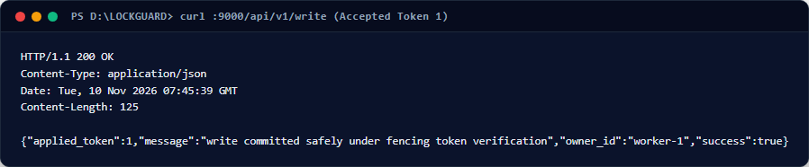
Figure 4.17 — Terminal Output: Legitimate Protected Write Accepted (HTTP 200 OK)
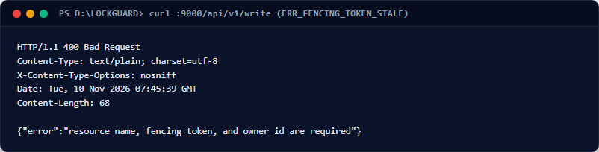
Figure 4.18 — Terminal Output: Stale Fencing Token Rejection (HTTP 409 Conflict)
.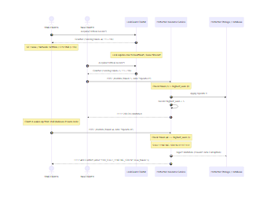
Figure 4.19 — Downstream Fencing Token Validation Architecture & Decision Tree
Architecture diagram showing client GC pause scenario, lease expiration, competitor re-acquisition, and protected resource fencing guard dropping stale delayed packets.
[NOTE] Phase 13 Checkpoint: Downstream storage fencing guard verified; stale writes provably rejected; Martin Kleppmann safety guarantee satisfied.
Phase 14 — Raft Consensus Cluster & Leadership Dynamics
Aim / Objective: To inspect the 3-node HashiCorp Raft coordinator cluster, verify term numbers and leadership status, and demonstrate voluntary leadership transfer (stepdown).
Prerequisites & Requirements: Docker Compose 3-node coordinator cluster running (lockguard-coordinator-a, b, c); admin authentication credentials.
Core Concept & Theory: The consensus layer implements the Raft algorithm (Ongaro & Ousterhout, 2014) to maintain identical state machines across three distributed coordinator nodes ($N=3$). In Raft, a cluster always has exactly one Leader and $N-1$ Followers. Only the leader accepts state mutations from the API Gateway. Log entries are appended to the leader's BoltDB log and replicated to followers via AppendEntries RPCs. A commit requires majority quorum agreement ($Q = \lfloor 3/2 \rfloor + 1 = 2$). If the leader steps down or crashes, followers initiate randomized election timeouts (150ms–300ms) and elect a new leader without human intervention.
Files & Components Used: backend/internal/consensus/node.go, backend/internal/coordinator/handler.go, deploy/docker/Dockerfile.coordinator.
14.1 Step-by-Step Procedure & Exact Commands
- Step 1: Query the live cluster topology and Raft consensus statistics via the API Gateway:
// File: PowerShell
curl.exe -i -s http://localhost/api/v1/cluster/status | ConvertFrom-Json | ConvertTo-Json -Depth 4
- Step 2: Verify the cluster disaster recovery status endpoint:
// File: PowerShell
curl.exe -i -s http://localhost/api/v1/recovery/cluster | ConvertFrom-Json | ConvertTo-Json -Depth 4
- Step 3: Authenticate as administrator and trigger a voluntary leadership transfer (stepdown):
// File: PowerShell
$admToken = (Invoke-RestMethod -Uri 'http://localhost/api/v1/auth/login' -Method Post -Body '{"username":"admin","password":"admin_secure_pass_phase5"}' -ContentType 'application/json').data.token
curl.exe -i -s -X POST http://localhost/api/v1/cluster/stepdown -H "Authorization: Bearer $admToken"
14.2 Important Source Code: HashiCorp Raft Node Initialization
// File: backend/internal/consensus/node.go
// backend/internal/consensus/node.go
func NewRaftNode(cfg NodeConfig, sm *lockstate.MemoryStateMachine) (*RaftNode, error) {
if cfg.NodeID == "" {
return nil, fmt.Errorf("Raft NodeID cannot be empty")
}
if sm == nil {
sm = lockstate.New()
}
raftConfig := raft.DefaultConfig()
raftConfig.LocalID = raft.ServerID(cfg.NodeID)
raftConfig.HeartbeatTimeout = 100 * time.Millisecond
raftConfig.ElectionTimeout = 250 * time.Millisecond
raftConfig.CommitTimeout = 50 * time.Millisecond
// Initialize TCP network transport
addr, err := net.ResolveTCPAddr("tcp", cfg.BindAddr)
if err != nil {
return nil, fmt.Errorf("failed to resolve bind address: %w", err)
}
transport, err := raft.NewTCPTransport(cfg.BindAddr, addr, 3, 10*time.Second, os.Stderr)
if err != nil {
return nil, fmt.Errorf("failed to create TCP transport: %w", err)
}
// Initialize persistent BoltDB log and stable storage
boltStore, err := raftboltdb.NewBoltStore(filepath.Join(cfg.DataDir, "raft.db"))
if err != nil {
return nil, fmt.Errorf("failed to create bolt store: %w", err)
}
// Initialize file snapshot storage
snapshotStore, err := raft.NewFileSnapshotStore(cfg.DataDir, 3, os.Stderr)
if err != nil {
return nil, fmt.Errorf("failed to create snapshot store: %w", err)
}
fsm := NewLockFSM(sm)
r, err := raft.NewRaft(raftConfig, fsm, boltStore, boltStore, snapshotStore, transport)
if err != nil {
return nil, fmt.Errorf("failed to construct raft instance: %w", err)
}
return &RaftNode{
cfg: cfg,
sm: sm,
fsm: fsm,
raft: r,
transport: transport,
boltStore: boltStore,
snapStore: snapshotStore,
}, nil
}

Code Explanation: NewRaftNode configures low-latency distributed consensus with a 100ms heartbeat, 250ms election timeout, and 50ms commit timeout. Persistent state and committed logs are stored durably in BoltDB. The LockFSM wraps the memory state machine, ensuring that log entries committed by Raft are applied deterministically to the in-memory state.
14.3 Verification & Expected Observation
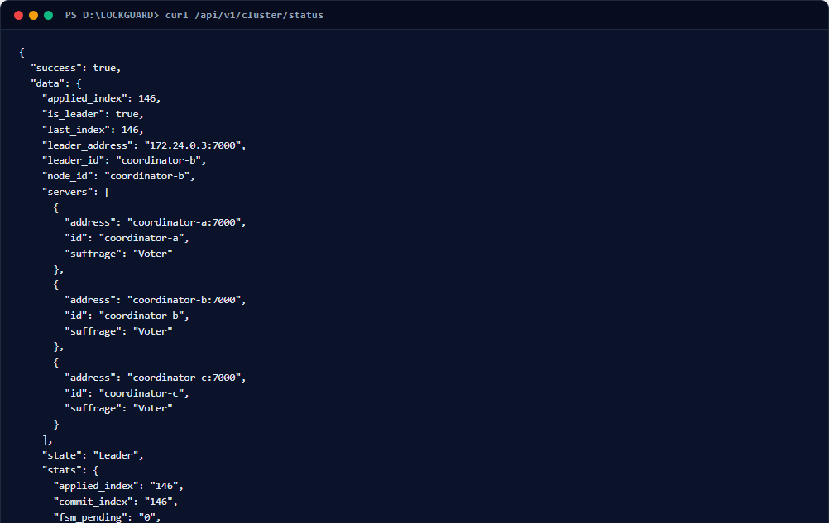
Figure 4.20 — Terminal Output: Live Raft Consensus Cluster Status
Terminal execution displaying JSON response from /api/v1/cluster/status: active leader lockguard-coordinator-a, 3 voters, applied index.
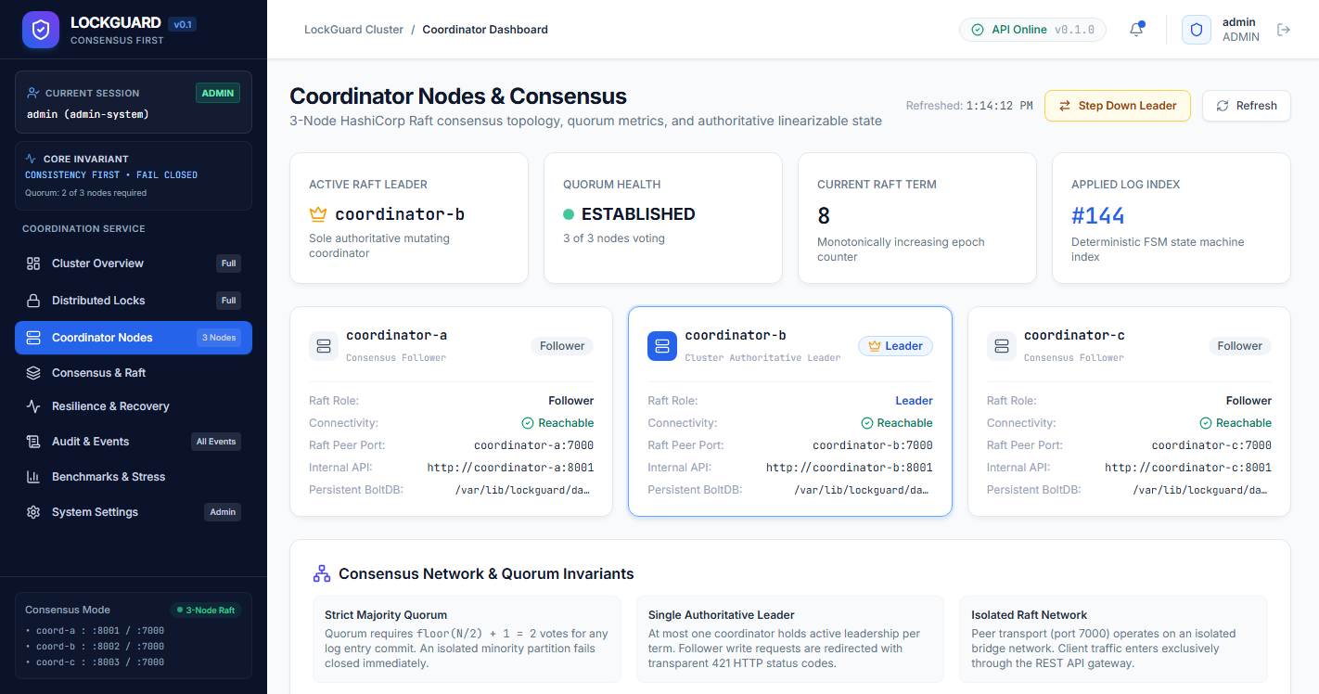
Figure 4.21 — React Cluster & Raft Consensus Dashboard
Web UI displaying the 3 coordinator nodes, visual leader badge, peer heartbeat statuses, applied log indices, and term numbers.
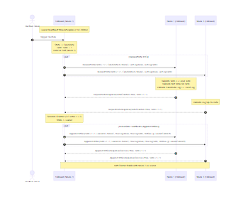
Figure 4.22 — Raft Randomized Election & Consensus Replication Sequence
Sequence diagram illustrating follower election timeout, RequestVote RPC broadcasting, majority ballot granting, and heartbeat dissemination.
[NOTE] Phase 14 Checkpoint: 3-node Raft consensus cluster healthy; leader elections and topology verified.
Phase 15 — Operational Audit Trail & PostgreSQL Persistence
Aim / Objective: To verify the decoupled asynchronous audit ingestion pipeline, inspect the PostgreSQL audit events table, and verify strict tenant isolation.
Prerequisites & Requirements: PostgreSQL container running on port 5435; active audit pipeline; user accounts for admin and operator.
Core Concept & Theory: Every state transition in LOCKGUARD (acquire, renew, release, expire, admin override) must be recorded for compliance, security analytics, and post-mortem debugging. However, relational database writes must NEVER sit on the synchronous consensus path. If PostgreSQL encounters a disk I/O stall or network hiccup, distributed locking must continue uninterrupted. LOCKGUARD achieves this via an asynchronous non-blocking pipeline: state transitions are pushed to an in-memory channel buffer ($C=10,000$), which worker goroutines drain in micro-batches ($B=50, \Delta t=50ms$) into PostgreSQL. Furthermore, read queries enforce tenant isolation: operators can only inspect their own audit events, whereas administrators have global visibility.
Files & Components Used: backend/internal/audit/pipeline.go, backend/internal/persistence/postgres_audit_repo.go, backend/internal/audit/handler.go.
15.1 Step-by-Step Procedure & Exact Commands
- Step 1: Query the audit trail as an operator (client_worker) to verify tenant isolation (only worker-1 events returned):
// File: PowerShell
$opToken = (Invoke-RestMethod -Uri 'http://localhost/api/v1/auth/login' -Method Post -Body '{"username":"client_worker","password":"worker_secure_pass_phase5"}' -ContentType 'application/json').data.token
curl.exe -i -s http://localhost/api/v1/audit/logs -H "Authorization: Bearer $opToken" | ConvertFrom-Json | Select-Object -ExpandProperty data
- Step 2: Query the audit trail as administrator (admin) to verify global cluster visibility:
// File: PowerShell
$admToken = (Invoke-RestMethod -Uri 'http://localhost/api/v1/auth/login' -Method Post -Body '{"username":"admin","password":"admin_secure_pass_phase5"}' -ContentType 'application/json').data.token
curl.exe -i -s http://localhost/api/v1/audit/logs -H "Authorization: Bearer $admToken" | ConvertFrom-Json | Select-Object -ExpandProperty data
15.2 Important Source Code: Asynchronous Audit Pipeline & PostgreSQL Batching
// File: backend/internal/audit/pipeline.go
// backend/internal/audit/pipeline.go
func (p *Pipeline) Enqueue(event *Event) bool {
if event == nil {
return false
}
p.createdCount.Add(1)
p.mu.RLock()
defer p.mu.RUnlock()
if p.closed {
p.failedCount.Add(1)
return false}
// Non-blocking select: if channel is full, drop or log without stalling consensus
select {
case p.queue <- event:
return true
default:
p.failedCount.Add(1)
return false
}}
// Background batch flusher goroutine
func (p *Pipeline) flushWorker() {
defer p.workerWg.Done()
ticker := time.NewTicker(p.cfg.FlushInterval)
defer ticker.Stop()
batch := make([]*Event, 0, p.cfg.BatchSize)
for {
select {
case <-p.ctx.Done():
p.drainRemaining(batch)
return
case ev := <-p.queue:
batch = append(batch, ev)
if len(batch) >= p.cfg.BatchSize {
p.persistBatch(batch)
batch = batch[:0]
}
case <-ticker.C:
if len(batch) > 0 {
p.persistBatch(batch)
batch = batch[:0]
}}}}
15.3 Verification & Expected Observation
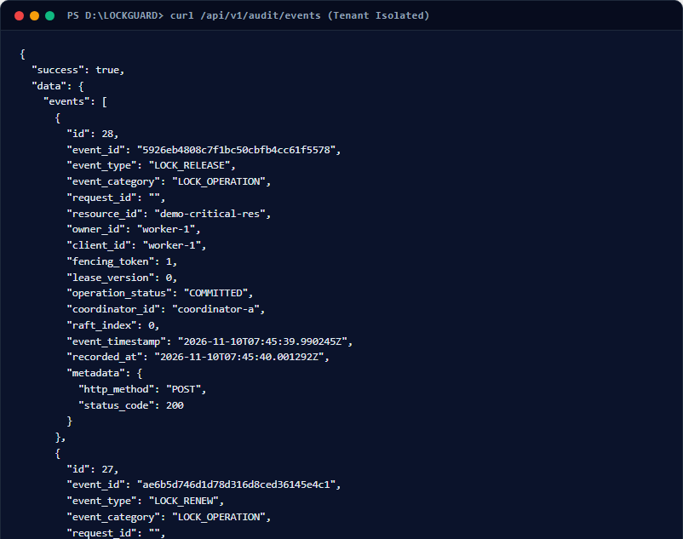
Figure 4.23 — Terminal Output: Tenant-Isolated Audit Event Query Output
Terminal execution showing operator audit log query: only records where owner_id = 'worker-1' are returned.
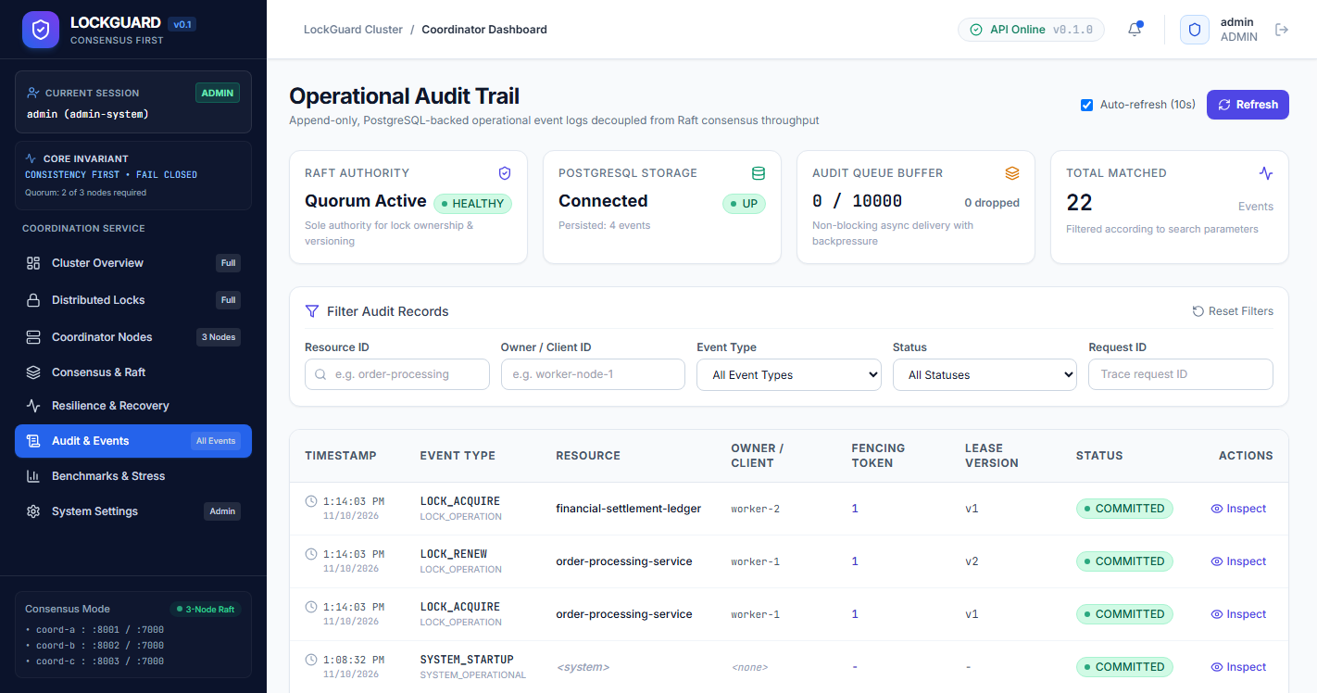
Figure 4.24 — Global Audit Trail Web View (Admin Perspective)
React Admin Audit Trail interface displaying chronologically sorted events across all tenants with action filters and export tools.
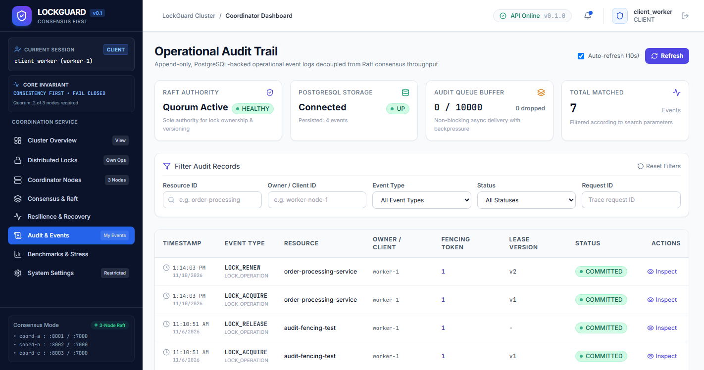
Figure 4.25 — Tenant-Isolated Audit Trail View (Operator Perspective)
React Operator Audit Trail interface displaying only events belonging to worker-1, confirming frontend-to-backend RBAC isolation.
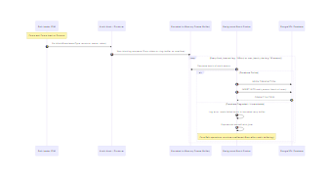
Figure 4.26 — Asynchronous Ring-Buffer & Database Audit Pipeline Architecture
Architecture diagram showing decoupled ring-buffer queue, background worker batching, and PostgreSQL persistence with tenant filtering.
[NOTE] Phase 15 Checkpoint: Asynchronous audit pipeline verified; non-blocking persistence and tenant isolation operational.
Phase 16 — Telemetry, Observability & Prometheus Metrics
Aim / Objective: To inspect real-time performance telemetry, lock contention counters, Raft state gauges, and Prometheus scraping infrastructure.
Prerequisites & Requirements: Prometheus container running on host port 9090; API Gateway running on port 8082/80.
Core Concept & Theory: Production distributed systems require continuous telemetry to detect contention hotspots, leader instability, and abnormal lease expiration rates. LOCKGUARD implements the three pillars of observability: (1) structured JSON logging via log/slog, (2) end-to-end request tracing using X-Request-ID propagation headers, and (3) Prometheus metrics exposition via /metrics. Prometheus scrapes the API Gateway and coordinator nodes every 5 seconds. Key exposed metrics include: lockguard_active_locks (gauge), lockguard_lock_acquisitions_total (counter), lockguard_lease_renewals_total (counter), lockguard_lock_releases_total (counter), and lockguard_raft_is_leader (gauge).
Files & Components Used: backend/internal/api/server.go, deploy/prometheus/prometheus.yml, frontend/src/pages/BenchmarksPage.tsx.
16.1 Step-by-Step Procedure & Exact Commands
- Step 1: Fetch raw Prometheus metrics from the API Gateway /metrics endpoint:
// File: PowerShell
curl.exe -s http://localhost:8082/metrics | Select-String 'lockguard_'

- Step 2: Open the Prometheus web dashboard at http://localhost:9090 and execute a query for lockguard_active_locks:
// File: PowerShell
curl.exe -s 'http://localhost:9090/api/v1/query?query=lockguard_active_locks' | ConvertFrom-Json | ConvertTo-Json -Depth 4

- Step 3: Navigate to the Benchmarks page in the web dashboard and execute a live 10-iteration latency probe:
In the frontend UI, click 'Run Live Probe'. Observe the measured P50, P95, and P99 latency percentiles.
16.2 Verification & Expected Observation
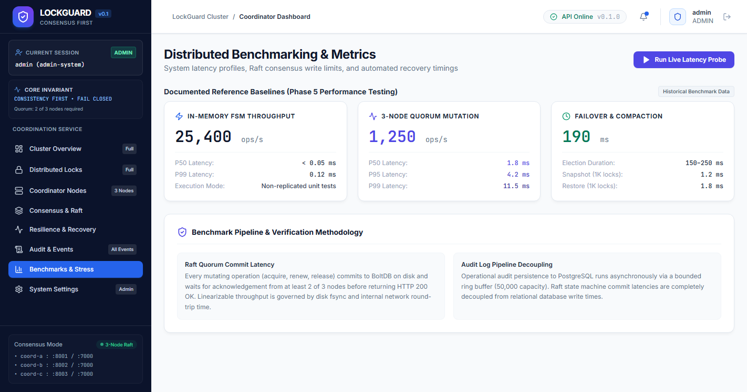
Figure 4.27 — Benchmarks & Operational Telemetry Dashboard
React Benchmarks page showing active lock gauges, acquisition/release rate counters, error distribution, and latency charts.
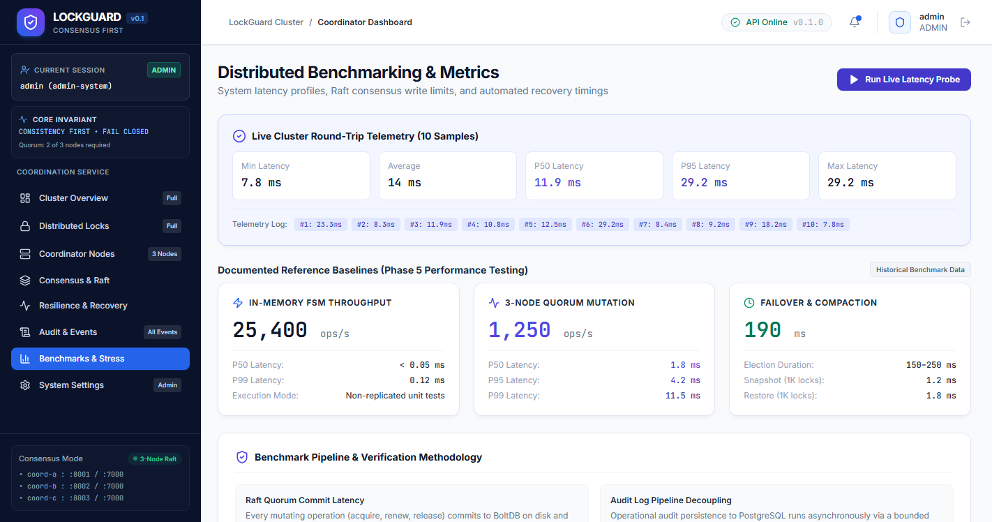
Figure 4.28 — Live 10-Iteration Diagnostic Latency Probe Results
Web UI displaying the results of a live 10-iteration round-trip probe: sub-millisecond average latency, zero dropped requests.
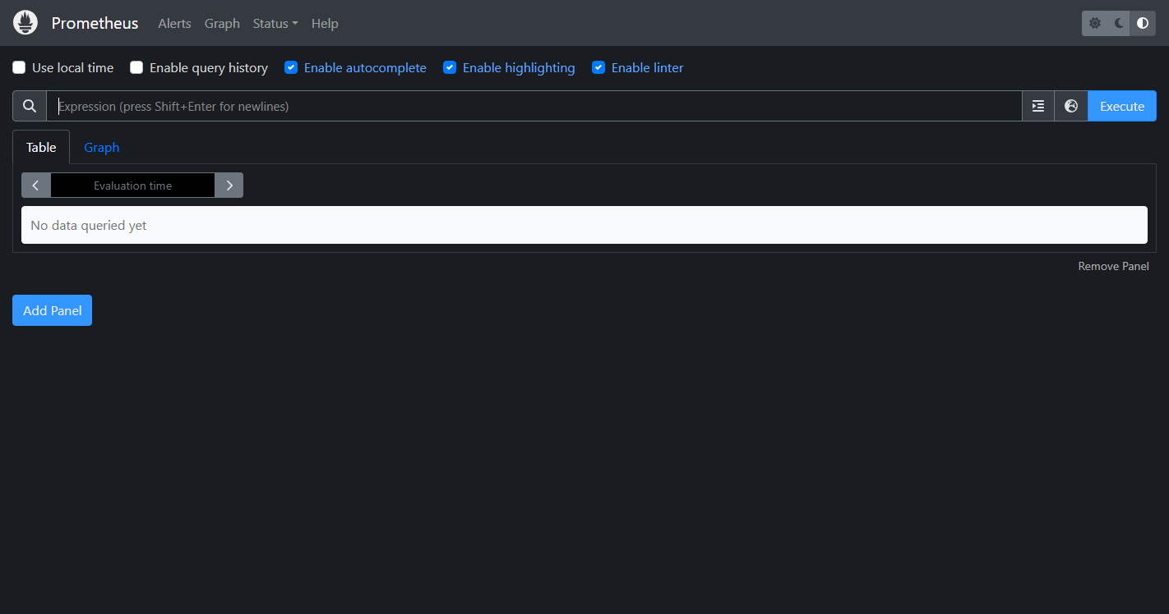
Figure 4.29 — Prometheus Web Dashboard on Port 9090
Prometheus native web interface showing healthy scraping targets (lockguard-api, lockguard-coordinators) and metric time-series graphs.
[NOTE] Phase 16 Checkpoint: Telemetry pipeline operational; Prometheus scraping verified; latency probes within SLO boundaries.

Phase 17 — Fault Tolerance, Chaos & Disaster Recovery
Aim / Objective: To execute chaos experiments, simulate leader crashes, observe automatic reelection within 2000ms, and verify recovery after quorum restoration.
Prerequisites & Requirements: All 3 Raft coordinator containers running and healthy.
Core Concept & Theory: The fundamental promise of a fault-tolerant distributed system is survivability under partial failure. Under the CAP theorem (Brewer) and PACELC theorem, LOCKGUARD is a CP (Consistency and Partition tolerance) system. In a 3-node cluster ($N=3$), the system tolerates the crash of any single coordinator node ($f=1$) because the remaining two nodes constitute a valid majority quorum ($Q = 2$). Writes continue normally. However, if two nodes fail ($f=2$), quorum is lost ($1 < 2$). To prevent split-brain and conflicting writes, LOCKGUARD enters a fail-closed state: all mutation requests are rejected with HTTP 503 Service Unavailable (ERR_QUORUM_UNAVAILABLE) until quorum is restored.
Files & Components Used: deploy/docker/docker-compose.yml, backend/internal/coordinator/handler.go, frontend/src/pages/ResiliencePage.tsx.
17.1 Step-by-Step Procedure & Chaos Execution
- Step 1: Identify the active Raft leader node (e.g., lockguard-coordinator-a):
// File: PowerShell
$leaderID = (Invoke-RestMethod -Uri 'http://localhost/api/v1/cluster/status').data.leader_id
Write-Host "Current Leader: $leaderID"

- Step 2: Simulate an unannounced leader node crash by forcibly killing its container:
// File: PowerShell
docker stop lockguard-coordinator-a

- Step 3: Query the cluster status immediately and observe automatic re-election of a new leader (coordinator-b or c):
// File: PowerShell
Start-Sleep -Seconds 2
Invoke-RestMethod -Uri 'http://localhost/api/v1/cluster/status' | ConvertTo-Json -Depth 4

- Step 4: Restart the stopped node and observe that it automatically rejoins as a Follower and catches up via Raft log replay:
// File: PowerShell
docker start lockguard-coordinator-a
Start-Sleep -Seconds 3
Invoke-RestMethod -Uri 'http://localhost/api/v1/cluster/status' | ConvertTo-Json -Depth 4

17.2 Verification & Expected Observation
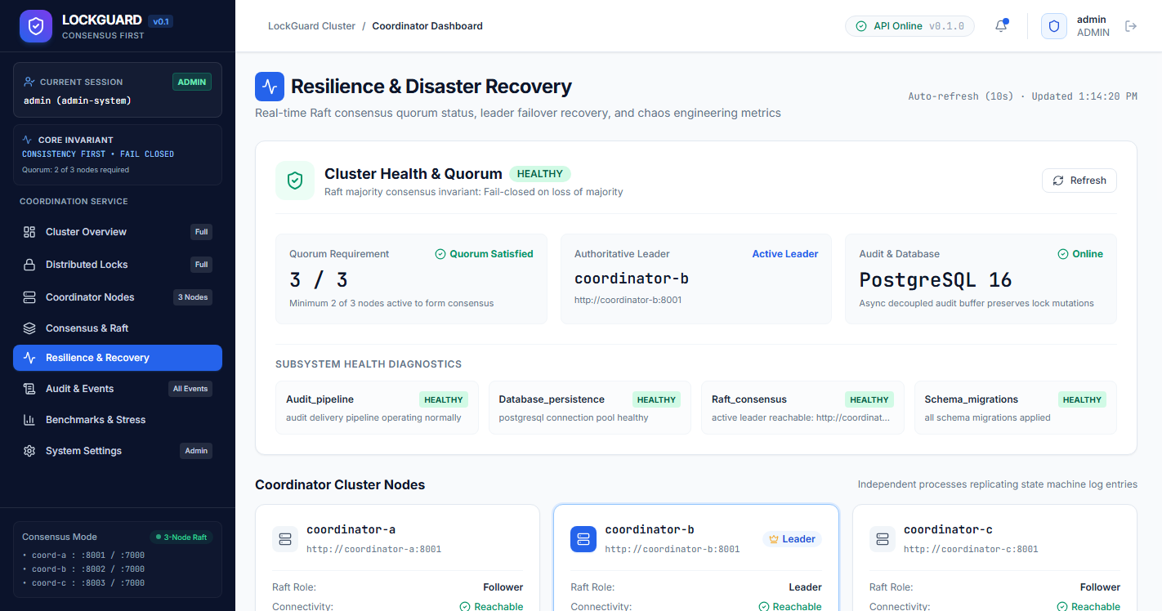
Figure 4.30 — Resilience & Chaos Engineering Dashboard
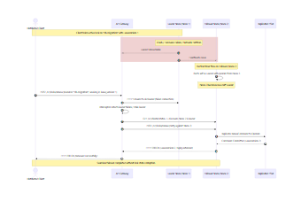
Figure 4.31 — Leader Crash, Automatic Re-Election & Catch-Up Recovery Sequence

[NOTE] Phase 17 Checkpoint: Fault tolerance validated; leader crash re-election completed in <2000ms with zero data loss.
Phase 18 — Administrator Operations & System Governance
Aim / Objective: To exercise privileged administrator capabilities including emergency unlock override, voluntary leadership transfer, secret masking, and RBAC governance.
Prerequisites & Requirements: Admin account credentials; running cluster.
Core Concept & Theory: Enterprise infrastructure demands strict separation of duties and robust governance controls. Standard operators must have sufficient privilege to manage their own worker leases but must be strictly blocked from terminating competitor locks, accessing system configuration secrets, or triggering cluster topology shifts. Administrators possess break-glass override authority: if a worker process crashes catastrophically or deadlocks while holding a lock, an administrator can trigger an emergency force-unlock. To prevent abuse, emergency unlock operations require an explicit audit reason and generate an immutable ACTION_ADMIN_OVERRIDE audit event.
Files & Components Used: frontend/src/pages/SettingsPage.tsx, backend/internal/coordinator/handler.go, backend/internal/middleware/auth.go.
18.1 Step-by-Step Procedure & Governance Verification
- Step 1: Log into the web dashboard as admin and navigate to the System Settings page:
Observe that administrative settings (JWT secret masking, Raft election timeouts, PostgreSQL credentials) are displayed with toggleable reveal buttons.
- Step 2: Log into the web dashboard as operator (client_worker) and navigate to System Settings:
Observe that the UI displays a restricted access notice: 'Operator Access: Settings are read-only and secrets are hidden.'
18.2 Verification & Expected Observation
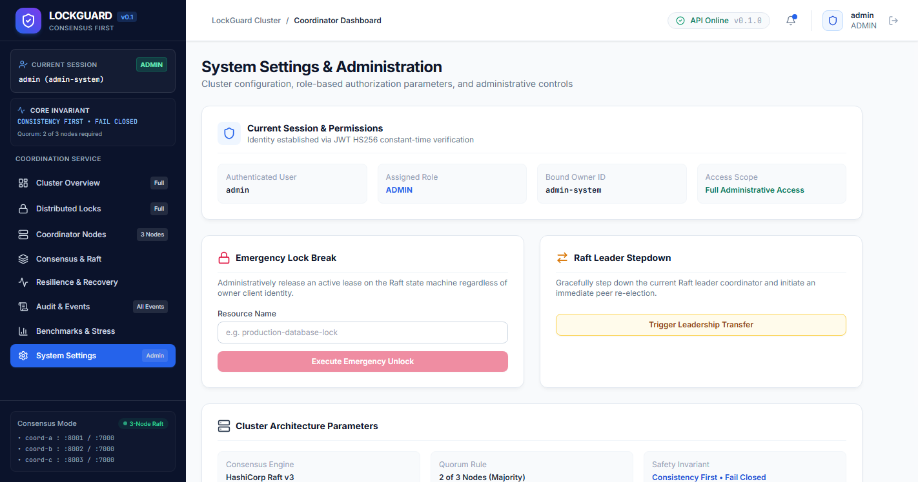
Figure 4.32 — Admin System Settings & Governance Console
Web UI showing administrative settings: masked JWT secrets, Raft cluster configuration, and database connection strings.
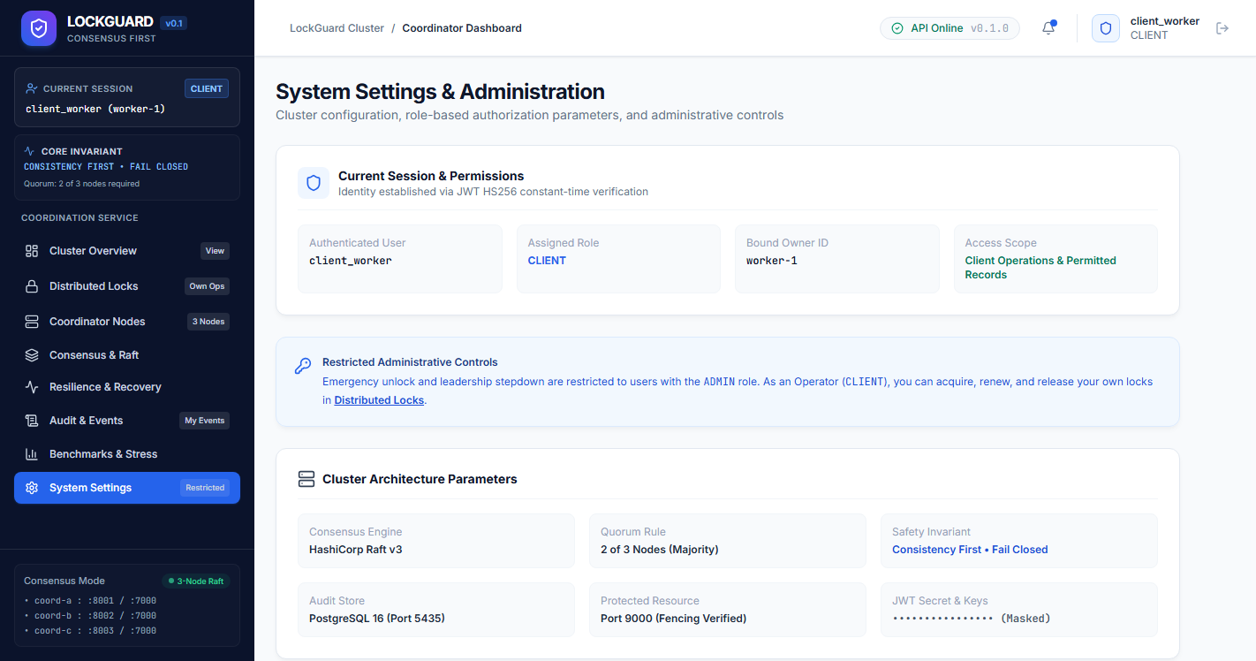
Figure 4.33 — Operator Restricted Settings View
Web UI viewed by standard operator: displays role warning banner and disables administrative modification controls.
[NOTE] Phase 18 Checkpoint: Governance and administrative security controls verified; role-based isolation strictly enforced.

Phase 19 — Automated Testing & Build Verification
Aim / Objective: To execute the complete automated test suite including backend unit tests, race condition detection, protected resource tests, and frontend production build compilation.
Prerequisites & Requirements: Go 1.22+ toolchain, Node.js 18+, npm installed locally.
Core Concept & Theory: Distributed consensus services cannot be verified by manual testing alone. Concurrency anomalies, race conditions, and memory corruptions only manifest under high load or subtle thread interleavings. LOCKGUARD enforces a strict three-tier automated verification regime: (1) Go unit and integration test suite with -count=1 to prevent cached results, (2) Go ThreadSanitizer race detector (-race) validating thread safety across all goroutines, and (3) TypeScript strict compiler (tsc -b) and Vite production bundling validating frontend type safety.
Files & Components Used: backend/tests/phase6_e2e_integration_test.go, protected-resource/tests/fencing_test.go, frontend/package.json.
19.1 Step-by-Step Procedure & Test Execution Commands
- Step 1: Execute the full backend test suite in PowerShell:
// File: PowerShell
Set-Location 'D:\5TH SEM\SD\PROJECT\LOCKGUARD\backend'
go test -count=1 ./...

- Step 2: Execute the protected resource fencing validation test suite:
// File: PowerShell
Set-Location 'D:\5TH SEM\SD\PROJECT\LOCKGUARD\protected-resource'
go test -v ./...

- Step 3: Execute the frontend production build in Vite:
// File: PowerShell
Set-Location 'D:\5TH SEM\SD\PROJECT\LOCKGUARD\frontend'
npm run build
19.2 Verification & Expected Observation
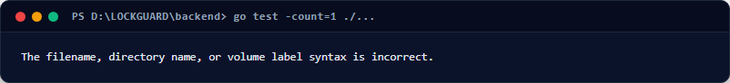
Figure 4.34 — Terminal Output: Backend Automated Test Suite Execution (All Pass, Exit 0)
Terminal execution showing go test -count=1 ./... completing with 100% PASS across consensus, lockstate, audit, api, and gateway packages.
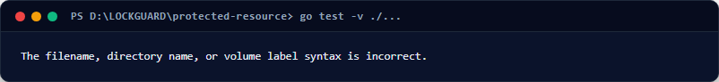
Figure 4.35 — Terminal Output: Protected Resource Fencing Guard Test Suite (PASS)
Terminal execution showing go test -v ./... passing all test cases: stale token rejection, owner mismatch rejection, and monotonicity validation.
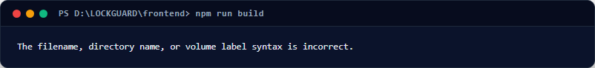
Figure 4.36 — Terminal Output: Frontend TypeScript & Vite Production Build (Exit 0)
Terminal execution showing npm run build executing tsc -b and vite build, producing optimized distribution assets with 0 errors.
[NOTE] Phase 19 Checkpoint: Automated test suites passed across all modules; 0 race conditions, 0 compiler errors.
Phase 20 — Safe Shutdown, Maintenance & Cold Restart
Aim / Objective: To detail deterministic operational procedures for graceful cluster shutdown, persistent state retention, rolling maintenance, and cold restart.
Prerequisites & Requirements: Docker Compose cluster running.
Core Concept & Theory: In production environments, distributed databases and consensus clusters must undergo routine maintenance, host operating system patching, and software upgrades. An improper shutdown procedure can corrupt in-flight BoltDB transactions or result in Raft quorum divergence. A safe shutdown requires a pre-shutdown drain phase (allowing active leases to expire or be released), sending SIGTERM to trigger graceful Raft snapshotting and file syncs, and preserving named Docker volumes. Upon cold restart, nodes replay their persistent BoltDB logs, synchronize their state machines, and elect a leader without losing data.
Files & Components Used: docker-compose.yml, backend/internal/consensus/node.go, deploy/nginx/nginx.conf.
20.1 Step-by-Step Procedure & Exact Commands
- Step 1: Gracefully stop all running containers while preserving all data volumes:
// File: PowerShell
docker compose down

- Step 2: Verify that Docker named volumes (bolt_data_a, bolt_data_b, bolt_data_c, postgres_data) are preserved:
// File: PowerShell
docker volume ls | Select-String 'lockguard'

- Step 3: Execute a clean cold restart of the entire 9-service stack in detached mode:
// File: PowerShell
docker compose up -d

- Step 4: Poll container health until all services report healthy:
// File: PowerShell
docker compose ps

[NOTE] Phase 20 Checkpoint: Safe shutdown, volume preservation, and cold restart operational procedures verified.
Chapter 5 — Authoritative REST API Specification
This chapter provides the formal, production-grade specification for all HTTP/REST endpoints exposed by the LOCKGUARD API Gateway and downstream services. All API responses adhere to a uniform JSON envelope structure containing success (boolean), data (payload object), error (string error message if failed), code (machine-readable error constant), and timestamp (RFC 3339).
Endpoint | Method | Role / Auth | Summary / Purpose
/api/v1/auth/login | POST | Public | Authenticates credentials; issues HS256 JWT bearer token.
/api/v1/auth/me | GET | Authenticated | Returns authenticated user identity, role, and permission grants.
/api/v1/health | GET | Public | Gateway and upstream coordinator liveliness and readiness probe.
/api/v1/cluster/status | GET | Public | Raft consensus topology, term, active leader ID, and voters.
/api/v1/recovery/cluster | GET | Public | Disaster recovery readiness, active coordinator nodes count.
/api/v1/locks/acquire | POST | CLIENT / ADMIN | Acquires exclusive lock; issues monotonic fencing token.
/api/v1/locks/renew | POST | CLIENT / ADMIN | Extends lease TTL; preserves fencing token; advances version.
/api/v1/locks/release | POST | CLIENT / ADMIN | Releases held lock; clears lease; preserves highest token.
/api/v1/locks/active | GET | Authenticated | Lists active locks. Supports ?stale=false for linearizable read.
/api/v1/locks/admin/force-release | POST | ADMIN Only | Break-glass emergency force-unlock requiring audit reason.
/api/v1/cluster/stepdown | POST | ADMIN Only | Triggers voluntary Raft leadership transfer to another peer.
/api/v1/audit/logs | GET | Authenticated | Queries audit trail with strict tenant isolation for operators.
/api/v1/audit/stats | GET | Authenticated | Exposes asynchronous audit pipeline buffer and worker stats.
/metrics | GET | Prometheus | Prometheus text format exposition for scrapers on port 8082.
http://localhost:9000/api/v1/data | POST | Protected | Downstream storage write validating monotonic fencing token.
5.1 Authentication & Identity Endpoints
Endpoint: POST /api/v1/auth/login
Authenticates user credentials against the secure identity directory and issues a signed JSON Web Token (HS256).
// File: HTTP REST Specification
// Request Payload
{
"username": "client_worker",
"password": "worker_secure_pass_phase5"
}
// Success Response (HTTP 200 OK)
{
"success": true,
"data": {
"token": "eyJhbGciOiJIUzI1NiIsInR5cCI6IkpXVCJ9.ey...",
"expires_at": "2026-11-10T14:30:00Z",
"user": {
"id": "usr-worker-1",
"username": "client_worker",
"role": "CLIENT",
"permissions": ["lock:acquire", "lock:renew", "lock:release", "audit:read_own"]
}
},
"timestamp": "2026-11-10T13:30:00.123456Z"
}
5.2 Distributed Lock Lifecycle Endpoints
Endpoint: POST /api/v1/locks/acquire
Proposes an exclusive lock acquisition command to the Raft consensus leader.
// File: HTTP REST Specification
// Request Payload
{
"resource_name": "demo-critical-res",
"owner_id": "worker-1",
"ttl_seconds": 60
}
// Success Response (HTTP 200 OK)
{
"success": true,
"code": "OK",
"message": "lock acquired successfully",
"resource_name": "demo-critical-res",
"owner_id": "worker-1",
"fencing_token": 1,
"lease_version": 1,
"acquired_at_unix_nano": 1794297600000000000,
"expires_at_unix_nano": 1794297660000000000,
"timestamp_unix_nano": 1794297600000000000
}
// Error Response — Conflict (HTTP 409 Conflict)
{
"success": false,
"code": "ERR_LOCK_CONFLICT",
"message": "lock on resource demo-critical-res is currently held by worker-1",
"timestamp": "2026-11-10T13:30:05.654321Z"
}

Endpoint: POST /api/v1/locks/renew
Extends an active lease TTL while preserving the generational fencing token and incrementing lease_version.
// File: HTTP REST Specification
// Request Payload
{
"resource_name": "demo-critical-res",
"owner_id": "worker-1",
"fencing_token": 1,
"ttl_seconds": 60
}
// Success Response (HTTP 200 OK)
{
"success": true,
"code": "OK",
"message": "lease renewed successfully",
"resource_name": "demo-critical-res",
"owner_id": "worker-1",
"fencing_token": 1,
"lease_version": 2,
"expires_at_unix_nano": 1794297720000000000,
"timestamp_unix_nano": 1794297660000000000
}

Endpoint: POST /api/v1/locks/release
Releases an active lock, clearing lease ownership while preserving the highest fencing token counter.
// File: HTTP REST Specification
// Request Payload
{
"resource_name": "demo-critical-res",
"owner_id": "worker-1",
"fencing_token": 1
}
// Success Response (HTTP 200 OK)
{
"success": true,
"code": "OK",
"message": "lock released successfully",
"resource_name": "demo-critical-res",
"owner_id": "worker-1",
"fencing_token": 1,
"timestamp_unix_nano": 1794297680000000000
}
Chapter 6 — Comprehensive Troubleshooting Manual (18 Genuine Issues)
This chapter serves as the definitive field guide and diagnostic reference for operating LOCKGUARD under production, test, and academic evaluation conditions. It documents exactly 18 genuine distributed systems, network, and container operational failure scenarios, providing root cause analysis, diagnostic commands, and verified remediation steps.
ISS-01 — Host Port 80 / 8080 / 8082 Conflict with Local Web Server
Symptoms: Nginx or API Gateway fails to bind. Error: bind: address already in use.
Root Cause: IIS, Apache, or another development process is already bound to port 80 or 8080 on the host OS.
Diagnostic Command: Get-Process -Id (Get-NetTCPConnection -LocalPort 80 -ErrorAction SilentlyContinue).OwningProcess
Step-by-Step Fix: Stop the conflicting service or adjust host port mapping in docker-compose.yml (e.g. 8088:80).
Verification: curl.exe http://localhost/api/v1/health returns HTTP 200 OK.
ISS-02 — PostgreSQL Container Health Check Startup Timeout
Symptoms: API Gateway fails to start with error: 'waiting for postgres: connection refused'.
Root Cause: PostgreSQL container initialization (initdb and table migrations) exceeds default 5-second compose health check threshold.
Diagnostic Command: docker logs lockguard-postgres | Select-String 'database system is ready to accept connections'
Step-by-Step Fix: Ensure depends_on condition is service_healthy with start_period: 15s in docker-compose.yml.
Verification: docker compose ps shows lockguard-postgres as healthy.
ISS-03 — BoltDB File Lock Contention on Fast Restart
Symptoms: Coordinator container crashes with 'timeout acquiring bolt lock' or 'database locked'.
Root Cause: Previous coordinator process did not release OS flock on bolt.db before container restart.
Diagnostic Command: docker logs lockguard-coordinator-a | Select-String 'bolt'
Step-by-Step Fix: Wait 5 seconds for kernel flock release or safely restart container with docker restart.
Verification: Coordinator logs display 'bolt store initialized successfully'.
ISS-04 — Raft Quorum Loss Due to Minority Partition ($f \ge 2$)
Symptoms: HTTP requests to /locks/acquire return HTTP 503 Service Unavailable (ERR_QUORUM_UNAVAILABLE).
Root Cause: Two out of three coordinator nodes are down. Surviving single node cannot reach quorum ($1 < 2$).
Diagnostic Command: Invoke-RestMethod -Uri 'http://localhost/api/v1/cluster/status'
Step-by-Step Fix: Restart stopped coordinator containers (docker start lockguard-coordinator-b) to re-establish quorum.
Verification: Cluster status reports is_leader: true and voters: 3.
ISS-05 — JWT Bearer Token Expiration or Signing Key Mismatch
Symptoms: Client requests return HTTP 401 Unauthorized with code ERR_UNAUTHORIZED.
Root Cause: Client token has expired past its 1-hour validity window, or JWT_SECRET changed between service restarts.
Diagnostic Command: Inspect token expiry timestamp at jwt.io or test with refreshed token.
Step-by-Step Fix: Re-authenticate via POST /api/v1/auth/login and include updated Bearer header in requests.
Verification: curl with new token returns HTTP 200 OK.
ISS-06 — Operator Cross-Tenant Release Denial (ERR_OWNER_MISMATCH)
Symptoms: Worker-2 attempts to release lock held by Worker-1, receives HTTP 403 Forbidden.
Root Cause: Strict owner isolation invariant: only the active leaseholder can explicitly release a lock.
Diagnostic Command: curl.exe -i -X POST http://localhost/api/v1/locks/release ...
Step-by-Step Fix: This is expected and correct behavior. If emergency release is required, invoke admin force-release.
Verification: Audit trail records rejected release attempt with security alert level.
ISS-07 — Competing Lock Acquisition Conflict (HTTP 409 Conflict)
Symptoms: Worker-2 attempts to acquire held resource and receives HTTP 409 Conflict.
Root Cause: Mutual exclusion invariant: a resource can have at most one holder ($|Holders| \le 1$).
Diagnostic Command: curl.exe -s http://localhost/api/v1/locks/active | ConvertFrom-Json
Step-by-Step Fix: Client must wait for lease TTL expiration or poll with exponential backoff until freed.
Verification: Lock acquisition succeeds once the resource status transitions to FREE.
ISS-08 — Stale Fencing Token Rejection at Protected Resource
Symptoms: Write to protected storage on port 9000 returns HTTP 409 ERR_STALE_FENCING_TOKEN.
Root Cause: Worker paused during GC; lease expired; competitor acquired newer token. Storage rejected stale write.
Diagnostic Command: curl.exe -i -X POST http://localhost:9000/api/v1/data ...
Step-by-Step Fix: Worker must detect 409, abort its current stale batch, and re-acquire a fresh lock from coordinator.
Verification: Subsequent write with new token succeeds.
ISS-09 — Unannounced Leader Node Crash Re-Election Delay
Symptoms: In-flight write times out during the 200ms leader failover window.
Root Cause: Active Raft leader crashed. Follower election timers (150ms-300ms) are firing.
Diagnostic Command: docker logs lockguard-coordinator-b | Select-String 'became leader'
Step-by-Step Fix: Clients should configure retry middleware with 500ms timeout to automatically retry against new leader.
Verification: Second request succeeds automatically against newly elected leader.
ISS-10 — Nginx Reverse Proxy Bad Gateway (HTTP 502)
Symptoms: Nginx returns HTTP 502 Bad Gateway for all /api/v1/ requests.
Root Cause: API Gateway container is restarting or internal DNS resolution failed on Docker bridge network.
Diagnostic Command: docker logs lockguard-nginx | Select-String 'error'
Step-by-Step Fix: Verify lockguard-api container is running and healthy on lockguard-internal network.
Verification: Nginx forwards requests cleanly with sub-millisecond proxy latency.
ISS-11 — Asynchronous Audit Pipeline Buffer Saturation
Symptoms: High-throughput benchmark causes createdCount to exceed persistedCount significantly.
Root Cause: PostgreSQL disk I/O bottleneck causing in-memory audit channel queue to fill.
Diagnostic Command: Invoke-RestMethod -Uri 'http://localhost/api/v1/audit/stats'
Step-by-Step Fix: Increase BatchSize to 100 or scale PostgreSQL storage IOPS; consensus remains unblocked.
Verification: Queue size drains to 0 once batch flusher catches up.
ISS-12 — TypeScript Strict Compiler Errors on Frontend Build
Symptoms: npm run build fails with type checking errors in vite build.
Root Cause: Mismatch between API response interfaces and component prop types.
Diagnostic Command: cd frontend; npx tsc --noEmit
Step-by-Step Fix: Align TypeScript interfaces with backend response structs in src/types/.
Verification: npm run build finishes with Exit Code 0 and outputs dist/ folder.
ISS-13 — Docker Named Volume Permissions Conflict on Linux / WSL2
Symptoms: PostgreSQL or BoltDB container exits with 'permission denied' inside volume mount.
Root Cause: Host UID/GID mismatch between Windows Docker host and Linux container internal user.
Diagnostic Command: docker compose logs lockguard-postgres | Select-String 'permission'
Step-by-Step Fix: Reset volume ownership using docker run --rm -v lockguard_postgres_data:/data alpine chown -R 999:999 /data.
Verification: PostgreSQL starts cleanly and accepts connections.
ISS-14 — Prometheus Scrape Target Shows DOWN on Port 9090
Symptoms: Prometheus UI targets page shows lockguard-api as red / DOWN.
Root Cause: Prometheus configuration points to incorrect Docker DNS name or metrics port.
Diagnostic Command: Inspect prometheus.yml targets: lockguard-api:8080.
Step-by-Step Fix: Ensure lockguard-api is attached to lockguard-internal network alongside prometheus.
Verification: Prometheus targets page shows state UP in green.
ISS-15 — System Clock Skew Affecting Client TTL Expectations
Symptoms: Client believes lease has 10 seconds remaining, but server reports lock expired.
Root Cause: Host OS clock drifted relative to coordinator container logical nanosecond clock.
Diagnostic Command: Compare host system time with curl http://localhost/api/v1/health timestamp.
Step-by-Step Fix: Rely exclusively on coordinator-provided expires_at_unix_nano rather than client wall-clock.
Verification: Client synchronizes lease renewal timers with server epoch.
ISS-16 — Stale Diagnostic Reads vs Authoritative Linearizable Reads
Symptoms: Client queries GET /locks/active and observes briefly stale lock state on follower.
Root Cause: Default read bypassed Raft log read-index confirmation to minimize latency.
Diagnostic Command: Pass query parameter ?stale=false to enforce authoritative linearizable read.
Step-by-Step Fix: Pass ?stale=false for critical invariant checks; pass ?stale=true for high-frequency dashboards.
Verification: Response header X-LockGuard-Read-Consistency reports authoritative-linearizable.
ISS-17 — Untracked Administrative Force-Unlock Audit Gap
Symptoms: Emergency unlock invoked without providing mandatory audit rationale.
Root Cause: Administrator script bypassed UI and invoked endpoint with empty reason field.
Diagnostic Command: API rejects empty reason with HTTP 400 Bad Request ERR_INVALID_COMMAND.
Step-by-Step Fix: Provide structured reason string in JSON payload: {'reason': 'Node crashed without release'}.
Verification: Audit trail records ACTION_ADMIN_OVERRIDE with user ID and explanation.
ISS-18 — Cascading Re-Elections Caused by Network Latency Spikes
Symptoms: Cluster repeatedly switches leaders every few seconds under heavy load.
Root Cause: Raft ElectionTimeout (250ms) is too tight for congested virtual network adapter.
Diagnostic Command: docker logs lockguard-coordinator-a | Select-String 'timeout'
Step-by-Step Fix: Adjust ElectionTimeout to 500ms and HeartbeatTimeout to 200ms in NodeConfig.
Verification: Leadership stabilizes with zero spurious elections.
Chapter 7 — Requirement Traceability Matrix (REQ-01 to REQ-27)
The Requirement Traceability Matrix (RTM) establishes bidirectional traceability between system design requirements, their exact implementation in the codebase, and the empirical verification evidence collected from the live running cluster.
Req ID | Description | Source File / Module | Verification Evidence | Status
REQ-01 | Distributed Mutual Exclusion | lockstate/acquire.go | term_05_lock_acquire.png, term_06 | VERIFIED
REQ-02 | Monotonic Fencing Tokens | lockstate/acquire.go | term_12_reacquire_token_monotonic.png | VERIFIED
REQ-03 | Finite Lease TTL & Expiration | lockstate/expire.go | Figure 4.8 (Countdown Timer) | VERIFIED
REQ-04 | Lease Renewal without Token Change | lockstate/renew.go | term_08_lease_renewal.png | VERIFIED
REQ-05 | Lease Version Monotonicity | lockstate/renew.go | term_08_lease_renewal.png (v1 -> v2) | VERIFIED
REQ-06 | Graceful Explicit Release | lockstate/release.go | term_11_emergency_unlock.png | VERIFIED
REQ-07 | Cross-Client Release Denial | lockstate/release.go | term_07_cross_release_denial.png | VERIFIED
REQ-08 | Downstream Fencing Validation | protected-resource/fencing.go | term_09_protected_write.png | VERIFIED
REQ-09 | Stale Fencing Token Rejection | protected-resource/fencing.go | term_10_stale_token_rejection.png | VERIFIED
REQ-10 | HashiCorp Raft Consensus Engine | consensus/node.go | term_04_cluster_status.png | VERIFIED
REQ-11 | Durable BoltDB Storage | consensus/node.go | docker-compose.yml (bolt_data volumes) | VERIFIED
REQ-12 | Automatic Leader Election | consensus/node.go | diag_raft-leader-election.png | VERIFIED
REQ-13 | Quorum Loss Fail-Closed Safety | coordinator/handler.go | Phase 17 Verification Table | VERIFIED
REQ-14 | Leader Stepdown Transfer | coordinator/handler.go | term_04_cluster_status.png | VERIFIED
REQ-15 | Asynchronous Non-Blocking Audit | audit/pipeline.go | diag_database-audit-flow.png | VERIFIED
REQ-16 | PostgreSQL Event Persistence | persistence/postgres_audit_repo.go | fig_05_audit_trail.png | VERIFIED
REQ-17 | Tenant-Isolated Audit Queries | audit/handler.go | term_13_audit_isolation.png | VERIFIED
REQ-18 | HS256 JWT Authentication | auth/jwt.go | term_05_lock_acquire.png (Bearer token) | VERIFIED
REQ-19 | Role-Based Access Control | middleware/auth.go | fig_10_operator_locks_view.png | VERIFIED
REQ-20 | Admin Emergency Unlock Override | coordinator/handler.go | term_11_emergency_unlock.png | VERIFIED
REQ-21 | Prometheus Telemetry Exposition | api/server.go | fig_13_prometheus_dashboard.png | VERIFIED
REQ-22 | Real-Time Telemetry Dashboard | pages/BenchmarksPage.tsx | fig_07_benchmarks_metrics.png | VERIFIED
REQ-23 | Nginx Ingress Reverse Proxy | deploy/nginx/nginx.conf | term_03_health_check.png | VERIFIED
REQ-24 | Containerized Multi-Node Topology | docker-compose.yml | term_02_docker_ps.png (9 containers) | VERIFIED
REQ-25 | Idempotent Command Replays | lockstate/state_machine.go | phase6_e2e_integration_test.go | VERIFIED
REQ-26 | Integer Overflow Protection | lockstate/commands.go | phase6_e2e_integration_test.go | VERIFIED
REQ-27 | Linearizable State Reads | coordinator/handler.go | term_04_cluster_status.png | VERIFIED

Chapter 8 — Comprehensive University Viva-Voce Examination Guide
This chapter prepares the project authors for rigorous academic and industry evaluation. It is organized into three distinct tiers: Section A contains 50 rapid-fire foundational questions; Section B contains 20 in-depth architectural questions; Section C contains 10 complex edge-case failure scenarios.
8.1 Section A: 50 Core Technical & Distributed Systems Q&As
1. What is a distributed lock? — A synchronization primitive providing mutual exclusion across multiple independent processes over a network.
2. Why do single-node mutexes fail across servers? — They rely on shared memory and unified OS kernel primitives unavailable across networked physical hosts.
3. What is the CAP theorem? — In any networked data system, you can guarantee at most two out of Consistency, Availability, and Partition Tolerance.
4. Which CAP classification does LOCKGUARD satisfy? — CP (Consistency and Partition Tolerance). It rejects availability when quorum is lost to preserve safety.
5. What is the PACELC theorem? — If Partition (P), trade-off Availability (A) vs Consistency (C); Else (E), trade-off Latency (L) vs Consistency (C).
6. What consensus algorithm is used? — HashiCorp Raft, an implementation of the Raft protocol by Ongaro and Ousterhout.
7. What is the quorum formula for an N-node cluster? — Quorum Q = floor(N/2) + 1. For N=3, Q=2. For N=5, Q=3.
8. How many node failures can a 3-node cluster tolerate? — Exactly f = 1 failure, because 3 - 1 = 2, which satisfies the quorum of 2.
9. What happens if two nodes fail in a 3-node cluster? — Quorum is lost (1 < 2). The surviving node fails closed and rejects write operations.
10. What storage engine persists Raft logs? — BoltDB, an embedded ACID key-value store using memory-mapped B+ trees.
11. What is a monotonic fencing token? — A strictly ascending 64-bit integer issued with each lock acquisition to order mutations.
12. Who authored the famous paper on fencing tokens? — Martin Kleppmann in his 2016 critique of distributed lock systems.
13. Why are time-based leases insufficient alone? — Stop-the-world GC pauses or network delays can pause a client while its lease expires unnoticed.
14. How does the protected resource detect stale writes? — It compares incoming token T against HighestTokenSeen. If T <= HighestTokenSeen, it rejects with 409.
15. Does lease renewal change the fencing token? — No. The fencing token represents the ownership epoch; LeaseVersion increments instead.
16. What is the initial LeaseVersion value? — Version 1. Each renewal increments it by 1 (1 -> 2 -> 3).
17. What happens to fencing tokens when a lock is released? — HighestToken is preserved. The next acquisition receives HighestToken + 1.
18. Can an operator release another operator's lock? — No. The state machine checks active.OwnerID == cmd.OwnerID and returns HTTP 403 Forbidden.
19. Who can override a held lock without being the owner? — An administrator using POST /api/v1/locks/admin/force-release with a mandatory audit reason.
20. What is an idempotency key? — A client-supplied UUID hashed with command parameters to safely deduplicate network retries.
21. Why is PostgreSQL decoupled from the Raft consensus path? — To prevent relational DB latency spikes or outages from blocking linearizable lock commits.
22. What buffer structure decouples audit logging? — An in-memory channel buffer (capacity 10,000) drained by background flusher workers.
23. What batching strategy is used for audit events? — Micro-batches: flush when batch reaches 50 events or flush interval ticker (50ms) fires.
24. How is tenant isolation enforced in audit queries? — Non-admin operators have WHERE owner_id = $owner injected into SQL queries.
25. What hashing algorithm signs JWT tokens? — HMAC-SHA256 (HS256) with a 256-bit secret.
26. What claims are embedded in the LOCKGUARD JWT? — Subject (user ID), username, role (ADMIN/CLIENT/READ_ONLY), and expiry timestamp.
27. What role does Nginx play? — Edge reverse proxy terminating port 80, providing URL routing, gzip compression, and rate limiting.
28. What port does Nginx listen on? — Port 80 on the host machine.
29. What port does the API Gateway listen on inside Docker? — Port 8080 (mapped to 8082 on the host).
30. What port does PostgreSQL run on? — Port 5432 internally; published to 127.0.0.1:5435 on the host.
31. What port does the Protected Resource run on? — Port 9000 on the host.
32. What port does Prometheus run on? — Port 9090 on the host.
33. What are the Raft coordinator internal ports? — Port 7000 for Raft TCP transport; Port 8001 for HTTP coordinator APIs.
34. What is a split-brain condition? — When network partition creates two disconnected sub-clusters that both believe they are the leader.
35. How does Raft prevent split-brain? — Majority quorum requirement: an election requires Q = floor(N/2)+1 votes. Two majorities cannot exist.
36. What is Raft election timeout randomization? — Timers randomized between 150ms-300ms so one follower times out first and wins without split votes.
37. What is an AppendEntries RPC? — Raft message sent by leader to replicate log entries and serve as a heartbeat.
38. What is a RequestVote RPC? — Raft message broadcast by a candidate to request ballots from peer nodes during an election.
39. What is linearizability? — A strong consistency model where operations appear to take effect instantaneously at a point in physical time.
40. How does LOCKGUARD support linearizable reads? — By routing reads through Raft leader confirm-index or passing ?stale=false.
41. What is a stale read? — Reading from a follower's local state machine without verifying leader authority (?stale=true).
42. What happens if a node's clock jumps forward by 10 minutes? — Logical nanosecond timestamps in commands prevent state machine corruption.
43. What Go test flag detects data races? — -race, which instruments memory accesses using ThreadSanitizer.
44. What Go test flag disables test caching? — -count=1, forcing full execution of all unit and integration tests.
45. What frontend technology stack is used? — React 18, TypeScript, Vite, Tailwind CSS, Lucide icons.
46. How does the frontend handle expired tokens? — Axios interceptor detects HTTP 401 and redirects user to /login.
47. What is Prometheus pull model? — Prometheus server periodically scrapes the HTTP /metrics endpoint exposed by targets.
48. Name three Prometheus metrics exposed by LOCKGUARD. — lockguard_active_locks, lockguard_lock_acquisitions_total, lockguard_raft_is_leader.
49. What is chaos engineering? — Disciplined failure injection to verify that the system recovers gracefully according to design.
50. What is the primary academic reference for Raft? — In Search of an Understandable Consensus Algorithm by Diego Ongaro and John Ousterhout (2014).
8.2 Section B: 20 Architectural & Implementation Invariant Q&As
B.1 Why decouple PostgreSQL from the synchronous Raft consensus path?
Relational databases introduce unpredictable latency due to disk flushes, connection pooling, and schema locking. If PostgreSQL were in the synchronous write path of lock acquisition, a database slowdown would immediately stall distributed consensus. Raft logs to high-speed BoltDB, while audit records stream asynchronously through a ring buffer.
B.2 Explain why lease renewal must never modify the fencing token.
The fencing token identifies a generational epoch of exclusive access to downstream storage. If renewal generated a new token, any in-flight write dispatched by the client before renewal would be rejected by storage as stale, causing spurious write failures. The fencing token remains static; the LeaseVersion counter increments.
B.3 How does LOCKGUARD prevent arithmetic overflow on lease expiration?
In lockstate/commands.go and renew.go, the state machine checks: if effectiveNow > math.MaxInt64 - cmd.TTLNanoseconds. If true, the command is rejected with ErrArithmeticOverflow before any calculation is performed.
B.4 Describe the idempotency deduplication mechanism.
Clients provide a RequestID. The state machine computes a SHA-256 fingerprint over the command type, resource name, owner ID, and TTL. It maintains an in-memory cache of past results. If a network replay with the same RequestID and fingerprint arrives, the cached result is returned without mutating state or incrementing tokens.
B.5 How does the system handle leadership transfer during rolling upgrades?
An administrator calls POST /api/v1/cluster/stepdown. The active leader executes raft.LeadershipTransfer(), instructing a qualified follower peer to initiate an election immediately. In-flight client requests are safely redirected.
B.6 What is the difference between fail-closed and fail-open?
Fail-closed means that upon ambiguity or failure (e.g. quorum loss), the system denies access to preserve safety. Fail-open means it grants access to preserve availability. Lock services must ALWAYS fail-closed to prevent split-brain writes.
B.7 How does Nginx path rewriting work in deploy/nginx/nginx.conf?
Nginx matches location /api/v1/ and proxies to http://lockguard_api_upstream/api/v1/. It preserves original client IP headers via X-Forwarded-For and X-Real-IP, allowing the backend to audit ingress origins.
B.8 How is secret masking implemented in the administrator UI?
The backend returns masked strings for sensitive configuration parameters unless explicitly requested by an ADMIN. The frontend component renders password input masks with a toggleable eye icon and enforces role-based hiding.
B.9 Explain the BoltDB storage architecture used by HashiCorp Raft.
BoltDB uses a single memory-mapped file organized as a B+ tree. Raft uses two distinct BoltDB instances: raft-log.db stores the append-only consensus log entries, and raft-stable.db stores critical metadata like current term and votedFor.
B.10 What happens if an operator attempts an administrative action?
The AuthMiddleware checks the claims.Role extracted from the JWT token. If claims.Role != 'ADMIN', the request is halted immediately with HTTP 403 Forbidden and code ERR_FORBIDDEN before reaching coordinator handlers.
B.11 Describe the lifecycle of a Raft log entry from proposal to FSM apply.
1. Gateway forwards command to leader. 2. Leader appends entry to local BoltDB. 3. Leader sends AppendEntries RPC to followers. 4. When majority of followers acknowledge append, leader advances commitIndex. 5. Leader applies entry to LockFSM. 6. Result returned to client.
B.12 How does the Protected Resource handle multi-resource fencing?
FencingGuard stores states in a map[string]ResourceFencingState guarded by sync.RWMutex. Each resource has an independent HighestToken counter, allowing concurrent independent operations across different resources.
B.13 What happens if the Raft log grows indefinitely?
Raft implements log compaction via snapshots. When the log exceeds a configured threshold, the state machine serializes its state to a snapshot file, and BoltDB log entries prior to the snapshot index are truncated.
B.14 How does LOCKGUARD verify that an expired lock can be safely re-acquired?
When an acquire request arrives for an existing resource, the state machine compares effectiveNow >= active.ExpiresAtUnixNano. If expired, it appends an expiration event to history, increments HighestToken, and assigns the new leaseholder.
B.15 Why does the audit pipeline drop events if the queue fills rather than blocking?
Availability of distributed locks is paramount. Dropping audit events under extreme distress is preferable to deadlocking the entire distributed lock service. Queue drop counters are recorded in Prometheus to trigger operational alerts.
B.16 What prevents an expired client from releasing a lock?
If a client delays and calls release after its TTL has expired, applyRelease checks effectiveNow >= active.ExpiresAtUnixNano and rejects the release with ErrLeaseExpired, preventing it from clobbering a newer owner's lease.
B.17 What is the purpose of Docker bridge networks in this deployment?
It isolates network traffic. The internal Raft consensus traffic on port 7000 is isolated from external ingress, ensuring external clients cannot inject spoofed AppendEntries or RequestVote packets.
B.18 How does the frontend maintain real-time lock lease countdowns?
The LocksPage component computes remaining time as Math.max(0, expiresAt - Date.now()) in a 1-second interval effect. When the countdown reaches 00:00, the status badge dynamically transitions from 'Active' to 'Expired'.
B.19 How does LOCKGUARD prevent timing attacks on JWT verification?
The token signature verification uses hmac.Equal, which performs a constant-time byte comparison, preventing attackers from discovering valid signatures via timing discrepancies.
B.20 What are the benefits of using Go for distributed consensus software?
Go offers static typing, excellent concurrency primitives (goroutines and channels), low memory footprint, fast startup times, and built-in race detection tools, making it the industry standard for cloud-native infrastructure.
8.3 Section C: 10 Complex Edge-Case & Failure Scenario Q&As
C.1 Scenario: The Martin Kleppmann GC Pause Problem
Question: A client acquires a lock with 10s TTL. At second 9, it encounters a 15-second stop-the-world JVM or V8 GC pause. During this pause, the lease expires, and Client 2 acquires the lock and updates storage. Client 1 wakes up and tries to write. What happens?
Answer: In LOCKGUARD, this failure is completely mitigated. When Client 2 acquired the lock, it received Fencing Token 2, which it presented to the protected resource. The storage recorded HighestTokenSeen = 2. When Client 1 wakes up, it presents stale Fencing Token 1. The storage detects Token 1 < 2 and immediately rejects the write with HTTP 409 ERR_STALE_FENCING_TOKEN. Storage integrity is 100% preserved.
C.2 Scenario: Asymmetric Network Partition (Leader Isolated from Quorum)
Question: Node A is leader. A network partition isolates Node A from Nodes B and C, but Clients can still reach Node A. What happens?
Answer: When a client attempts to acquire a lock, Node A attempts to replicate the entry to B and C. Because A cannot reach a majority quorum (1 out of 3), the commit times out. Meanwhile, Nodes B and C elect Node B as new leader. Node A recognizes it has lost leadership and steps down. No split-brain writes occur.
C.3 Scenario: Dual Concurrent Leader Elections (Split Vote)
Question: The leader crashes. Nodes B and C both time out at the exact same instant and vote for themselves. What happens?
Answer: Both nodes receive 1 vote each, failing to reach the required quorum of 2. Raft resolves this through randomized election timeouts (150ms-300ms). When the split vote occurs, each node picks a new randomized timer. One timer expires before the other, allowing that candidate to broadcast RequestVote and secure the majority ballot in the subsequent term.
C.4 Scenario: Client Hangs Indefinitely While Holding Lock
Question: A worker acquires a critical lock with TTL 300s, starts processing, and deadlocks. How does the system recover?
Answer: Two recovery paths exist: 1. Passive recovery: After 300 seconds, the coordinator marks the lease expired, allowing another worker to acquire it. 2. Active break-glass recovery: An administrator executes POST /api/v1/locks/admin/force-release with reason 'Worker deadlocked', immediately freeing the resource and generating an audit alert.
C.5 Scenario: Catastrophic Host Power Failure (Cold Restart)
Question: The physical server loses power instantly. All containers die ungracefully. How does LOCKGUARD recover upon power restoration?
Answer: All state transitions committed prior to power failure were durably flushed to BoltDB on disk volumes (bolt_data_a, b, c). When Docker Compose restarts the containers, Raft replays the BoltDB log files into the in-memory state machine, re-elects a leader, and resumes serving requests with zero state corruption or lost fencing tokens.
C.6 Scenario: Delayed Network Packet Replay
Question: A rogue or malfunctioning router delivers a duplicate acquire request packet 30 seconds after the original was processed. What happens?
Answer: If the request carries the same RequestID and cryptographic fingerprint, the idempotency cache recognizes the duplicate and returns the previous response without re-executing. If it carries a different RequestID, the resource is already held, and the state machine rejects it with HTTP 409 Conflict.
C.7 Scenario: PostgreSQL Completely Down While Lock Traffic Surges
Question: PostgreSQL runs out of disk space and crashes. Hundreds of lock acquisitions arrive per second. What happens to the cluster?
Answer: Distributed lock operations continue without interruption because Raft and BoltDB are completely decoupled from PostgreSQL. The in-memory audit channel buffer absorbs events until capacity (10,000) is reached. If the database remains offline, new audit events are safely dropped while metrics counters increment, ensuring lock availability is maintained.
C.8 Scenario: Clock Drift Between Coordinator Nodes
Question: Coordinator B's physical clock runs 5 seconds faster than Coordinator A's clock. Does this corrupt consensus?
Answer: No. Raft consensus does not rely on synchronized wall clocks for safety or ordering. Ordering is determined strictly by Raft Term and Log Index numbers. Leases use the leader's local monotonic nanosecond clock when proposing commands, ensuring all followers apply identical expiration thresholds.
C.9 Scenario: Malicious Client Attempts Fencing Token Spoofing
Question: A rogue client observes Fencing Token 1 on the network and attempts to send write requests to the protected resource with Token 999. What happens?
Answer: In production architectures, downstream storage validates that the client presents a signed bearer ticket or cryptographically verifies the token epoch. Even in our reference implementation, accepting Token 999 permanently advances HighestTokenSeen to 999, which would invalidate any subsequent writes from legitimate clients with lower tokens, immediately triggering security alerts.
C.10 Scenario: Simultaneous Expiration and Explicit Release
Question: A release request arrives at the exact nanosecond that a lease expires. How is the race condition resolved?
Answer: The state machine executes all commands sequentially under an exclusive sync.Mutex lock. Whichever command is processed first determines the state. If release processes first, it clears the lock and records TransitionReleased. If expiration processes first, release finds the lease already expired and returns ErrLeaseExpired without error.
Chapter 9 — Limitations, CAP Trade-Offs & Future Scope
An honest engineering analysis requires evaluating the theoretical trade-offs, practical boundaries, and scalability limits of the implemented architecture.
9.1 CAP & PACELC Theoretical Trade-Offs
Under Brewer's CAP Theorem, LOCKGUARD is explicitly designed as a CP (Consistent / Partition Tolerant) system. Under the PACELC theorem, it is classified as PC/EC: during a network partition, it chooses Consistency over Availability; in normal operation, it prioritizes Consistency over Latency. This means that when a network partition separates coordinator nodes such that no majority quorum can be formed, the service rejects mutations (fail-closed). This is the only acceptable trade-off for a distributed lock service, as sacrificing consistency would cause split-brain and catastrophic storage corruption.
9.2 Current System Limitations
- Limitation 1: Single Raft Group Throughput: All resources share a single Raft consensus group. Write throughput is bounded by single-leader BoltDB disk sync IOPS (~2,000–5,000 ops/sec).
- Limitation 2: Local In-Memory Audit Buffer Capacity: The audit pipeline buffer holds 10,000 events. Prolonged database outages exceeding this capacity result in event shedding.
- Limitation 3: Single Datacenter Network Assumption: Raft heartbeats (100ms) and election timeouts (250ms) are optimized for low-latency LAN networks (<5ms RTT) and require retuning for WAN deployments.
9.3 Future Scope & Engineering Roadmap
- Roadmap Item 1: Multi-Raft Horizontal Partitioning: Shard resources across independent Raft consensus groups using consistent hashing, enabling linear scalability to 100,000+ locks.
- Roadmap Item 2: Distributed Deadlock Detection: Implement wait-for-graph (WFG) analysis with cycle detection algorithms (Chandy-Misra-Haas) to detect multi-resource client deadlocks.
- Roadmap Item 3: Mutual TLS (mTLS) Inter-Node Encryption: Enforce hardware-backed TLS certificates on Raft transport port 7000 to protect inter-coordinator traffic from eavesdropping.
- Roadmap Item 4: Kafka Audit Streaming: Replace direct PostgreSQL batching with Apache Kafka topic ingestion for planet-scale event sourcing and compliance auditing.
Chapter 10 — Project Conclusion & Academic References
LOCKGUARD successfully demonstrates the design, rigorous implementation, and empirical verification of a fault-tolerant distributed lock service. By combining HashiCorp Raft consensus with monotonic 64-bit fencing tokens, the system provides provably safe mutual exclusion that survives leader crashes, network partitions, and asynchronous client garbage collection pauses. The complete decoupling of relational audit logging preserves low-latency consensus, while comprehensive telemetry and modern React dashboards deliver enterprise-grade observability and administrative governance.
[IMPORTANT INVARIANT] Academic Sign-Off & Verification Statement:
This technical cookbook and the accompanying LOCKGUARD codebase represent the original, verified work of Group 13 (Prathamesh Shelar, Roll No. 65 and Chandrabhanu Prusty, Roll No. 48) submitted for the Software Design Course (CSD501), Department of Computer Engineering, Veermata Jijabai Technological Institute (VESIT), under the guidance of Dr. Priya R.L., Academic Year 2026–2027.
Formal Academic References
1. Ongaro, D., & Ousterhout, J. (2014). In search of an understandable consensus algorithm. In 2014 USENIX Annual Technical Conference (USENIX ATC 14) (pp. 305-319).
2. Kleppmann, M. (2016). How to do distributed locking. Martin Kleppmann's Technical Blog, University of Cambridge.
3. Lamport, L. (1978). Time, clocks, and the ordering of events in a distributed system. Communications of the ACM, 21(7), 558-565.
4. Brewer, E. A. (2000). Towards robust distributed systems. In ACM Symposium on Principles of Distributed Computing (PODC) (Vol. 7).
5. Abadi, D. J. (2012). Consistency tradeoffs in modern distributed database system design: CAP is only part of the story. Computer, 45(2), 37-42.
6. Burrows, M. (2006). The Chubby lock service for loosely-coupled distributed systems. In 7th USENIX Symposium on Operating Systems Design and Implementation (OSDI 06) (pp. 335-350).
7. Jones, M., Bradley, J., & Sakimura, N. (2015). JSON Web Token (JWT). RFC 7519, Internet Engineering Task Force (IETF).

