E-Commerce Customer Intelligence & Sales Analytics

Executive Summary
This report summarizes the findings from the analysis of historical e-commerce transaction data. The analysis covers data quality, sales and revenue trends, geographic distribution, product performance, and customer segmentation via RFM and K-Means clustering.

Key Performance Indicators (KPIs)
A high-level summary of the yearly KPIs indicates significant transaction volume and revenue over the analyzed period.

Customer Segmentation (RFM + K-Means)
Customers were segmented using Recency, Frequency, and Monetary (RFM) analysis, followed by K-Means clustering to discover natural groupings. Four distinct clusters were identified, highlighting variations in customer lifetime value.
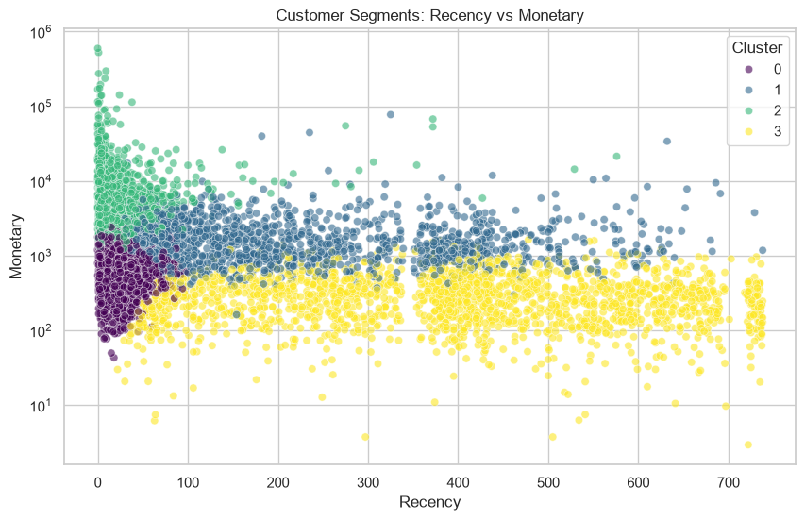
Figure: K-Means Customer Clusters (Recency vs Monetary)

Conclusions and Recommendations
- Increase targeted marketing toward high-value segments identified via RFM.
- Leverage geographic insights for targeted expansion (e.g., international markets with high AOV).
- Monitor return rates for high-volume products to reduce revenue leakage.

