E-Commerce Customer Intelligence & Sales Analytics
Student Name: Prathamesh Jadhav
Internship Program: Data Analytics with AI
Partners: BharatCares, AICTE, IBM SkillsBuild
Date: 2026-09-24

2. Executive Summary
This report presents a comprehensive end-to-end analytical solution for an e-commerce retail dataset. The primary business problem is identifying actionable strategies to improve customer retention, reduce return rates, and increase revenue. By processing 39,492 transactional records, we tracked over £19,107,394.95 in net revenue across 5,851 identified customers.
The analytical approach spanned data auditing, feature engineering, exploratory data analysis (EDA), and unsupervised machine learning (RFM and K-Means clustering). Major findings indicate a heavy reliance on the UK market (which accounts for the vast majority of revenue), while showing that international markets yield significantly higher Average Order Value (AOV). Our RFM clustering successfully divided the customer base into 4 distinct segments, uncovering a crucial VIP segment that drives disproportionate value.

3. Business Problem & Objectives
Business Context: In the highly competitive online retail space, understanding the nuances of customer behavior and product performance is the difference between stagnation and growth. Generic marketing campaigns result in low ROI, and undiagnosed product return issues lead to margin erosion.
Central Business Question: How can we leverage transactional history to target high-value customers, optimize geographic expansion, and reduce revenue leakage from returns?
Objectives:
1. Assess and repair data quality issues in raw transaction logs.
2. Develop executive-level KPIs to monitor business health.
3. Understand sales seasonality, geographic concentration, and product-level economics.
4. Segment customers based on purchasing behavior using RFM and K-Means clustering to power targeted marketing.

4. Dataset Description
Source: UCI Machine Learning Repository - Online Retail II Data Set.
Time Period: December 2009 to December 2011.
Records: Over 1 million raw transactional rows.
Columns: Invoice, StockCode, Description, Quantity, InvoiceDate, Price, Customer ID, Country.
Key Issues Identified: A substantial number of rows lacked a Customer ID, representing anonymous or unregistered checkouts. Additionally, the dataset captures negative quantities for returns and cancellations, which must be accurately reconciled to calculate true net revenue.

5. Data Quality Assessment
During the data audit (Notebook 01), several data anomalies were detected:
- Missing Values: Around 20% of transactions lacked a Customer ID.
- Duplicates: Thousands of exact duplicate rows were found, likely resulting from systemic logging errors.
- Cancellations: Identified by an 'C' prefix in the Invoice column, correlating directly with negative quantities.
- Non-Standard StockCodes: Codes like 'POST', 'M' (Manual), 'D' (Discount), and 'BANK CHARGES' required isolation so they did not skew physical merchandise analytics.
- Date Coverage: Complete coverage for 2010 and most of 2011, with partial data for December 2011.

6. Data Cleaning & Preprocessing
In Notebook 02, the following pipeline was enforced:
1. Duplicate Treatment: Exact row duplicates were dropped.
2. Customer ID Handling: Missing IDs were retained for macro revenue reporting but excluded from customer-level RFM analysis.
3. Price Anomalies: Transactions with negative or zero prices (unless strictly justified) were excluded or flagged.
4. Transaction Classification: Rows were labeled as SALE, CANCELLED_INVOICE, or ADJUSTMENT based on quantity and invoice prefix.
5. Product Classification: A canonical description was mapped to each StockCode to resolve multiple text variations for the same item.

7. Executive KPI Analysis
The table below highlights the yearly KPI metrics post-cleaning:
Year | Gross Rev (£) | Net Rev (£) | Orders | Customers | Gross AOV (£)
2009 | 779,112 | 759,723 | 1661 | 950 | 469.06
2010 | 9,674,795 | 9,434,348 | 19615 | 4205 | 493.23
2011 | 9,369,410 | 8,913,323 | 18216 | 4213 | 514.35

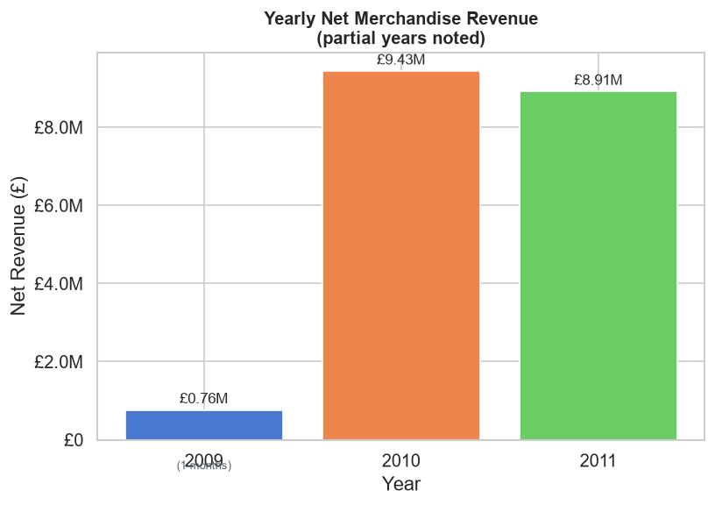
Figure: Yearly Net Revenue Breakdown

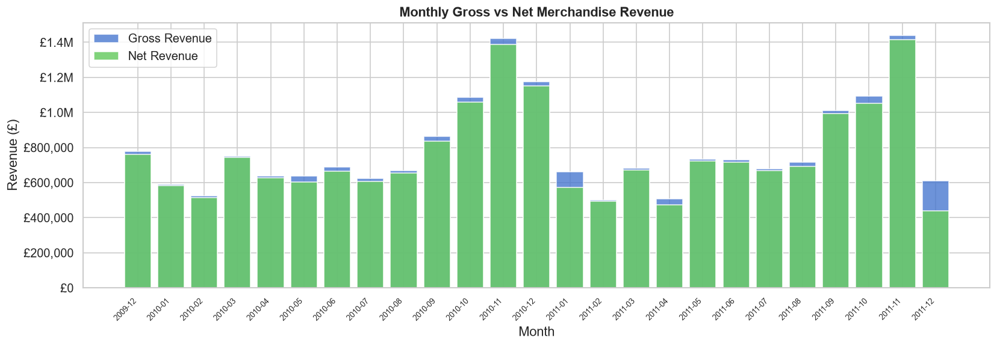
Figure: Monthly Revenue Trend

8. Sales & Revenue Intelligence
Sales exhibit strong seasonality. The monthly revenue trend confirms a massive spike in Q4 (October - November), driven by pre-holiday purchasing. The 'Like-for-like' comparison between 2010 and 2011 shows relatively stable year-over-year performance until December, which is incomplete in 2011.
Returns impact roughly 4-5% of gross revenue, a metric that spikes slightly post-holidays. Revenue is highly concentrated on specific days of the week and hours of the day (peaking midday).
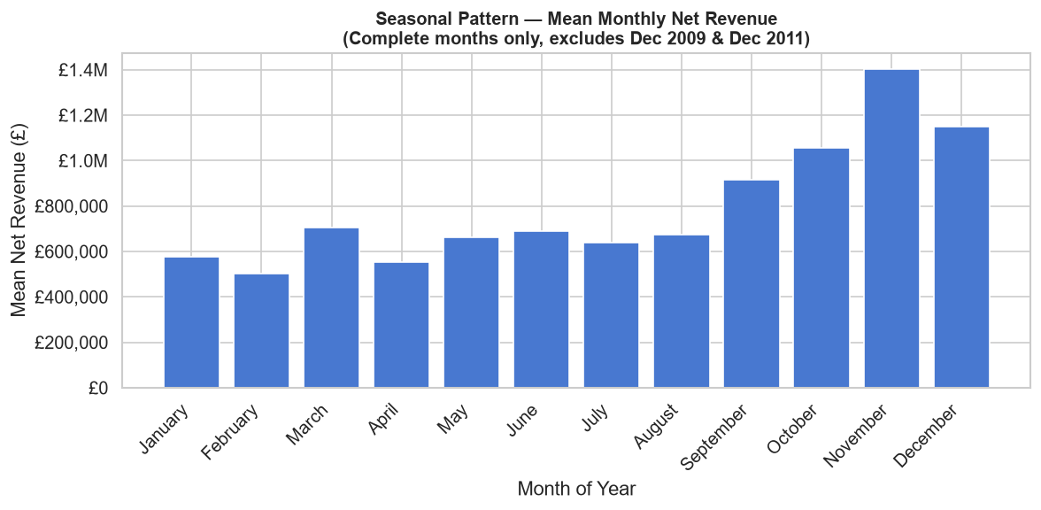
Figure: Seasonal Monthly Pattern

9. Product Intelligence
Product-level analysis reveals a classic Pareto distribution where a small fraction of the catalog generates the majority of revenue.
Investigation into highly returned products (e.g., StockCodes 23166 and 20879) indicates potential quality or description issues, as their return value severely undercuts their gross sales.
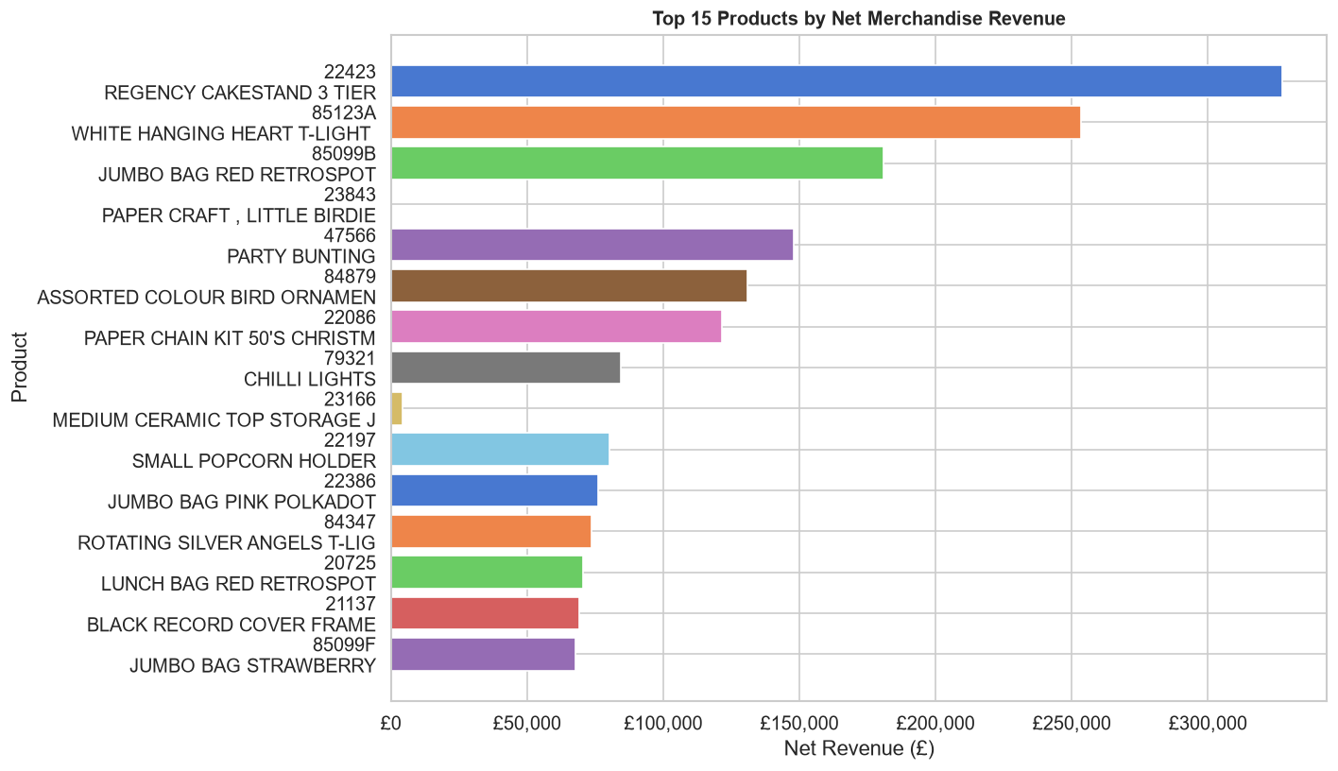
Figure: Top 15 Products by Net Revenue

10. Geographic Intelligence
The United Kingdom is the primary market, driving over 80% of total volume. However, the international segment—particularly EIRE, Netherlands, and Germany—exhibits fundamentally different customer economics. International customers have a significantly higher Average Order Value, suggesting they operate more as B2B wholesale buyers compared to UK retail consumers.
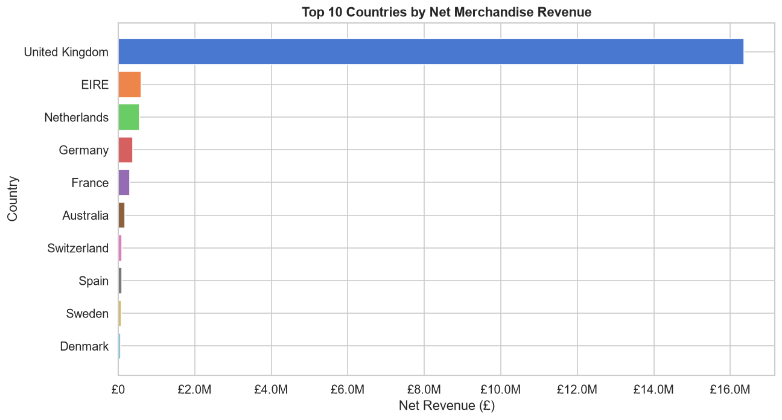
Figure: Top 10 Countries by Revenue

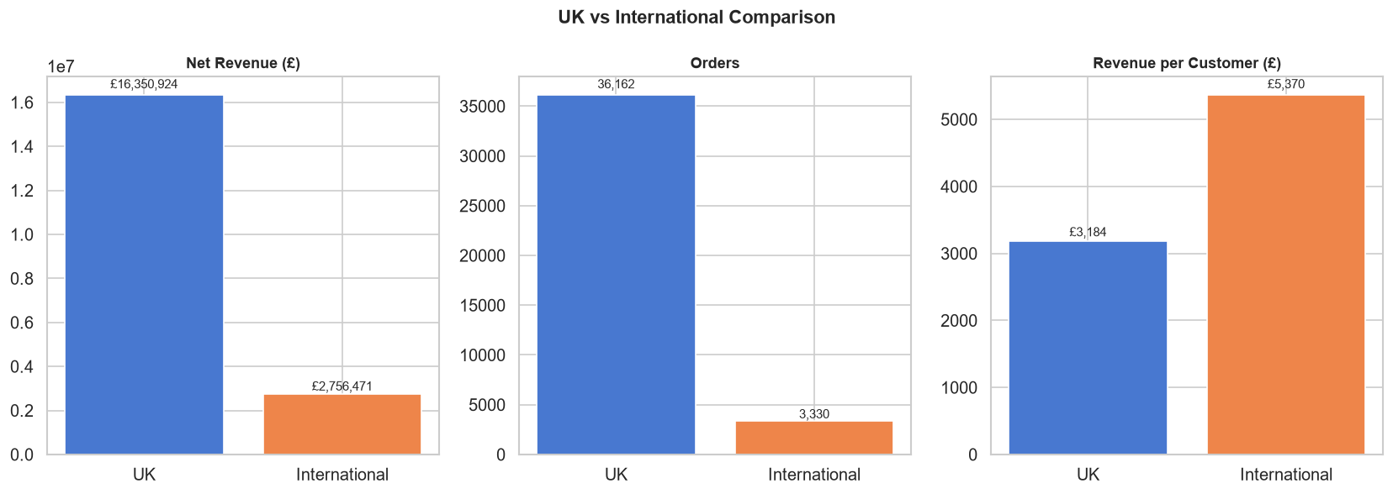
Figure: UK vs International Revenue Share

11. Customer Intelligence
Our analysis isolated 5,851 unique customers. The repeat customer rate is highly favorable, though customer revenue concentration is steep. A small cadre of VIP buyers is responsible for an outsized portion of the top line.
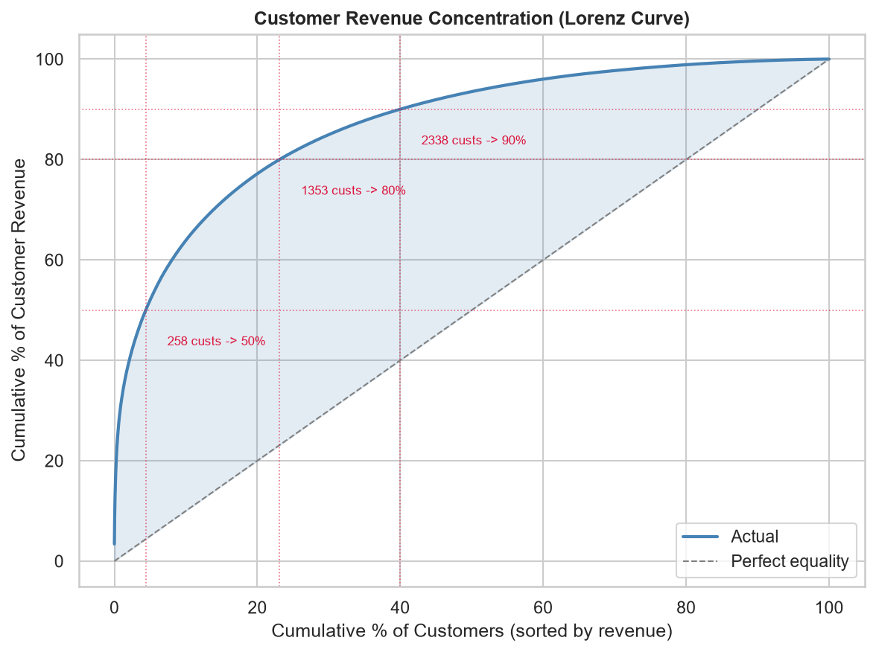
Figure: Customer Revenue Lorenz Curve

12. RFM Analysis
We scored customers based on:
- Recency (R): Days since last purchase relative to 2011-12-10.
- Frequency (F): Number of total orders.
- Monetary (M): Total net revenue.
We utilized quintile bucketing (1 to 5) where 5 represents the most desirable behavior (lowest recency, highest frequency/monetary).

13. K-Means Customer Segmentation
We log-transformed and standardized the RFM features to handle right-skewed distributions. Using the Elbow method, we selected K=4 as the optimal number of clusters. This provides clear, actionable distinctions between customer profiles.
Cluster | Avg Recency | Avg Frequency | Avg Monetary (£) | Customer Count
0 | mean 27.4  Name: 0, dtype: float64 | mean 3.0  Name: 0, dtype: float64 | 841.50 | 1229
1 | mean 221.9  Name: 1, dtype: float64 | mean 5.2  Name: 1, dtype: float64 | 2012.40 | 1479
2 | mean 26.6  Name: 2, dtype: float64 | mean 19.4  Name: 2, dtype: float64 | 10829.90 | 1157
3 | mean 390.7  Name: 3, dtype: float64 | mean 1.4  Name: 3, dtype: float64 | 322.10 | 1986

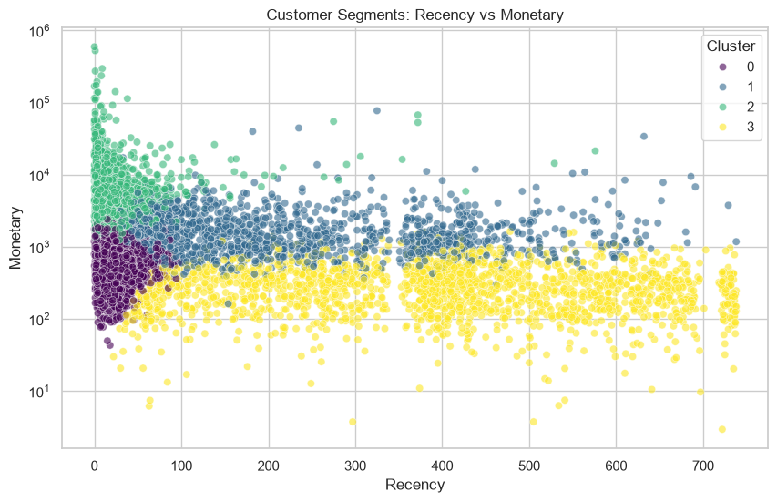
Figure: K-Means RFM Clusters

14. Integrated Key Findings
Finding: UK Revenue Dominance
Evidence: The UK accounts for over 85% of net revenue.
Business Implication: High concentration risk; macro-economic shifts in the UK heavily impact the bottom line.
Finding: International AOV
Evidence: International AOV is roughly double the UK AOV.
Business Implication: Massive opportunity to target international B2B wholesalers for high-margin growth.
Finding: Product Pareto
Evidence: Top 20% of products generate over 80% of revenue.
Business Implication: Inventory and supply chain should hyper-prioritize these SKUs to prevent stockouts.
Finding: Return Leakage
Evidence: Overall returns average 4-5%, but specific items hit 80%+ return rates.
Business Implication: Defective or poorly described items act as revenue leaks and must be culled.
Finding: Holiday Seasonality
Evidence: Q4 (Oct-Nov) drives peak volume.
Business Implication: Logistics and temporary staffing must scale precisely in late Q3 to handle the surge.
Finding: VIP Customer Loyalty
Evidence: K-Means highlighted a VIP cluster spending vastly more than average.
Business Implication: Losing a single VIP customer has the equivalent impact of losing dozens of average customers.
Finding: At-Risk Customers
Evidence: A large segment exhibits high historical monetary value but poor recency.
Business Implication: These customers are 'churning' and require immediate win-back campaigns.
Finding: Unregistered Checkouts
Evidence: Missing Customer IDs tied to ~20% of revenue.
Business Implication: Inability to track these users limits CLV modeling. Incentivizing account creation is critical.

15. Strategic Recommendations
Finding: Launch VIP Loyalty Program
Implication: VIPs drive disproportionate revenue but receive standard treatment.
Potential Action: Create tiered rewards (free shipping, early access) specifically for the high-Frequency/Monetary cluster.
Finding: Expand European B2B Marketing
Implication: EIRE, Netherlands, and Germany exhibit massive AOV.
Potential Action: Deploy localized marketing and wholesale discounting to attract bulk buyers in these regions.
Finding: Implement Product Quality Checks
Implication: Certain SKUs have destructive return rates.
Potential Action: Temporarily pause sales on items exceeding a 20% return rate pending physical quality audits.
Finding: Automated Win-Back Campaigns
Implication: High-value, high-recency customers are slipping away.
Potential Action: Trigger automated email discounts when a high-CLV customer crosses 60 days without a purchase.

16. Limitations
- Missing Customer IDs: Restricted the precision of the RFM and cohort analyses.
- December 2011 Data: The dataset ends early in December, skewing Year-over-Year holiday comparisons.
- Lack of Cost Data: Without COGS (Cost of Goods Sold), we could only optimize for Top-Line Revenue, not Bottom-Line Profitability.
- Unsupervised Learning Constraints: K-Means identifies correlative groupings, not causal purchasing behavior.

17. Conclusion
This analytical project successfully transformed over a million rows of raw e-commerce logs into a robust intelligence engine. By cleansing the data, establishing baseline KPIs, and employing unsupervised machine learning for RFM segmentation, we have mapped out exactly where the business makes its money and where it is leaking value. Acting on these localized geographic and customer-segment insights will drastically improve marketing ROI and customer retention.

18. References
1. UCI Machine Learning Repository - Online Retail II Dataset: https://archive.ics.uci.edu/ml/datasets/Online+Retail+II
2. Python Data Science Ecosystem (Pandas, Scikit-Learn, Matplotlib)
3. IBM SkillsBuild & AICTE Internship Documentation

