**Assignment No. 2**

Name : Tejas K. Pulli.

Roll No. 65

**Aim : Problem Statement**

Perform the following operations on Git and GitHub.

* Create a Repository/Project

Create a local repository on the github. Also create local repository on the system . Initialize the repository

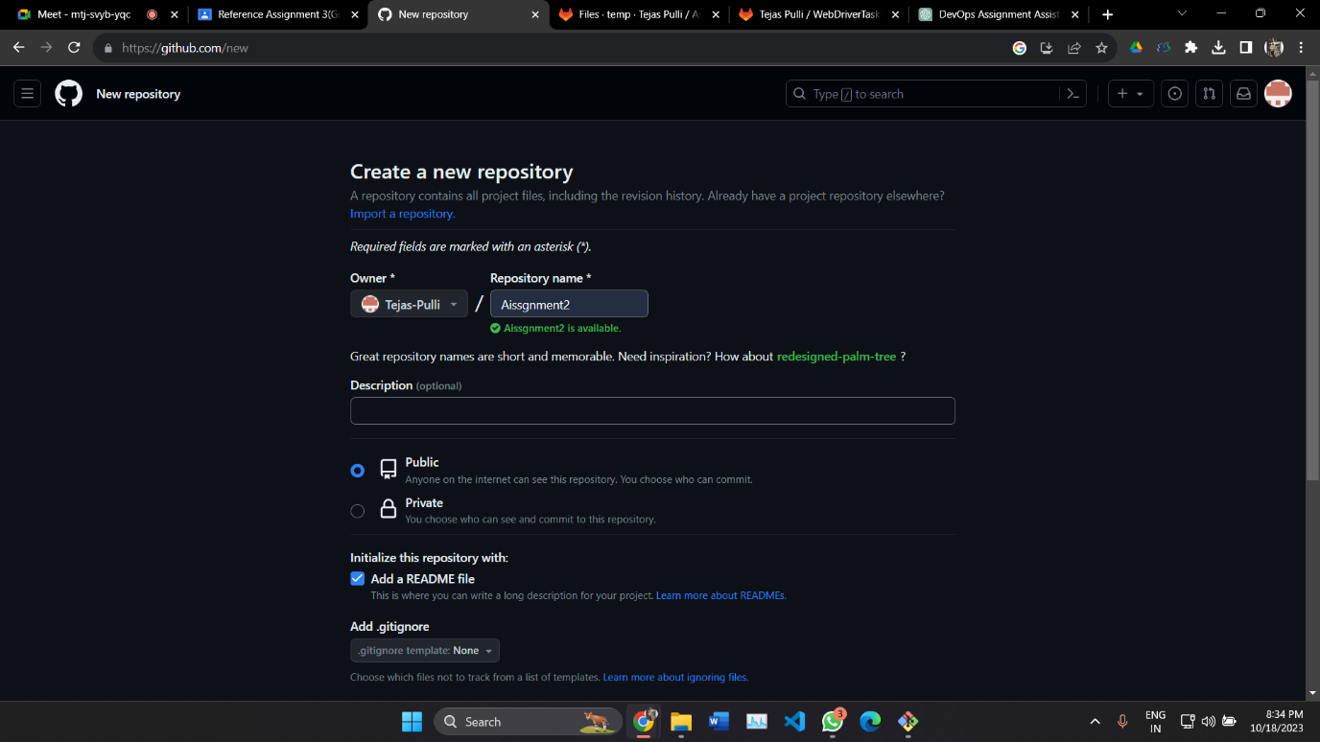

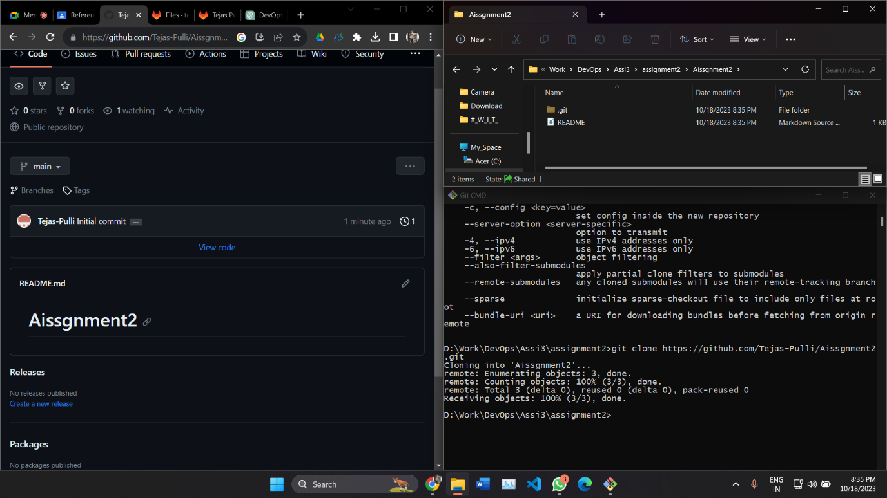

* Clone Repository

After the project is created, the next step is to open a cmd and issue the ‘git clone’ command. But first, you will need the URL of the repository. We can find the URL by clicking on the big blue clone button on the landing page for the repository in the GitHub GUI. Copy the HTTP URL and then open a cmd.

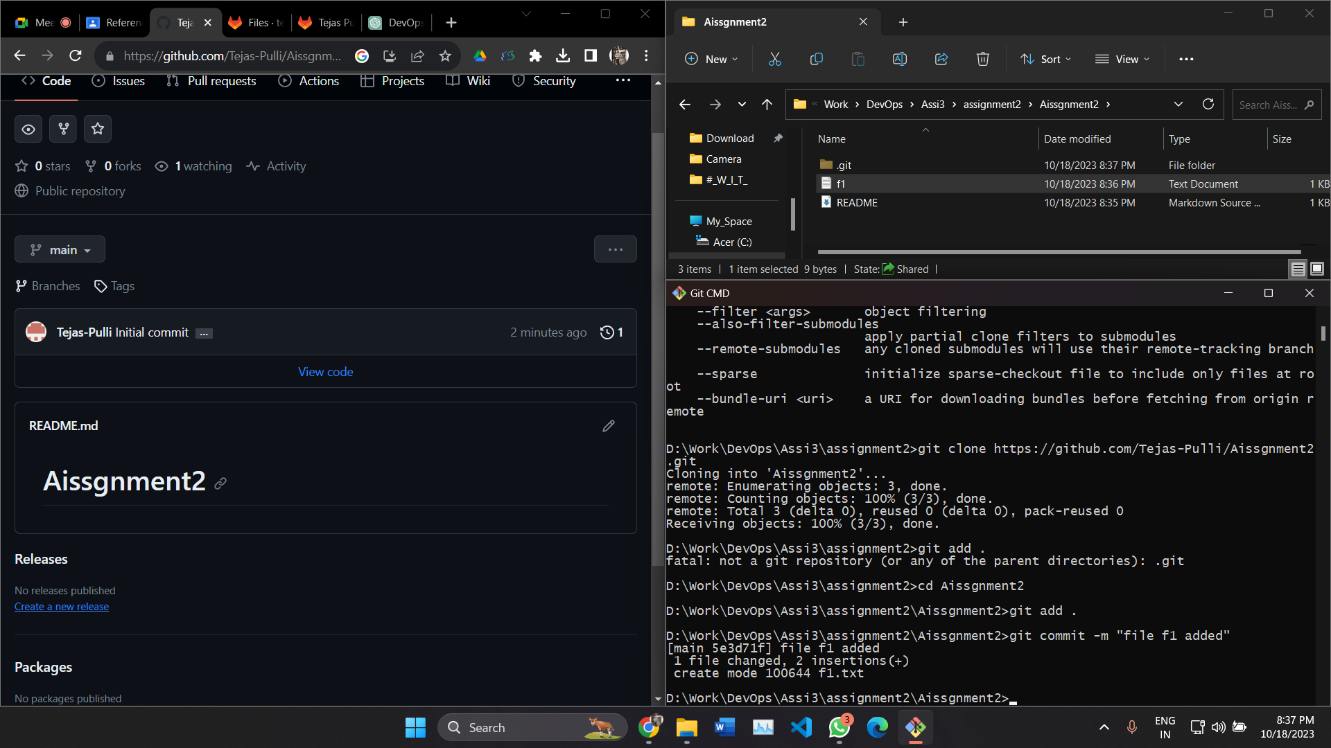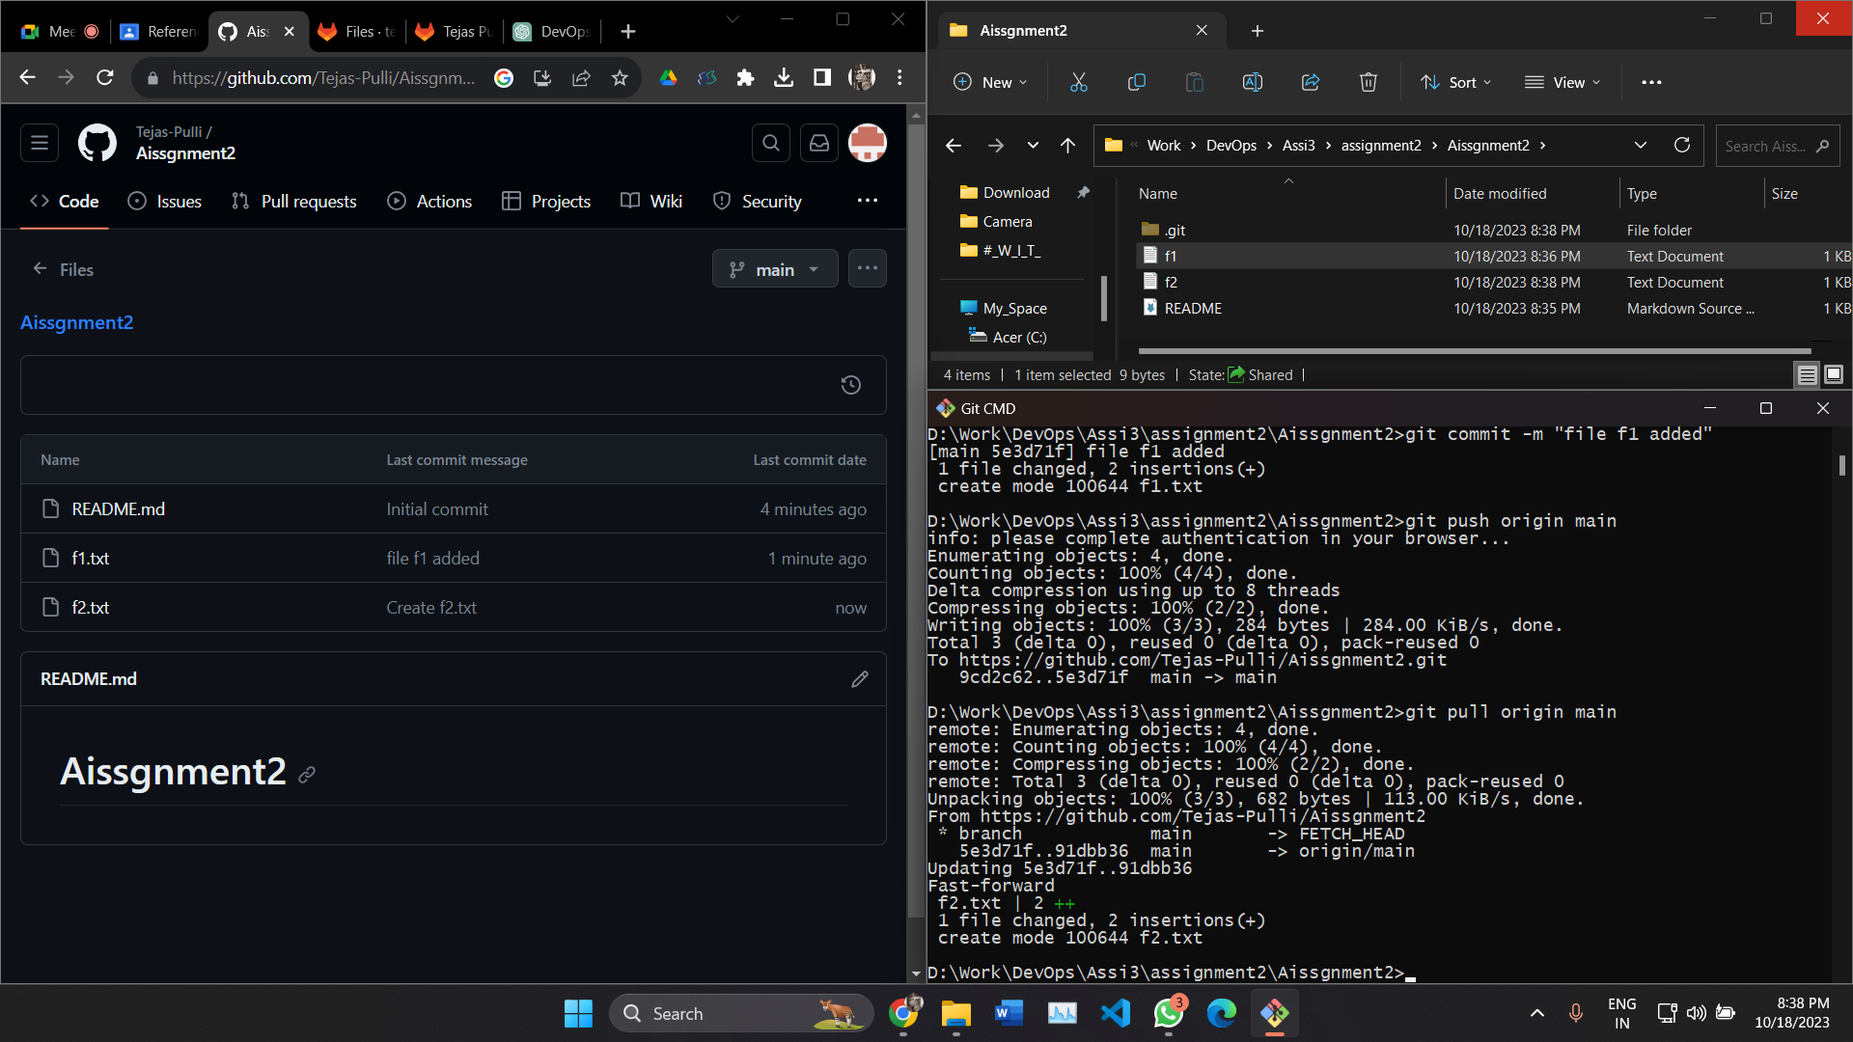

Create a file f1.txt add this file to the repository folder and commit the changes Push the changes from the local to remote

* Create Branches

create branches using the git branch and git checkout commands.

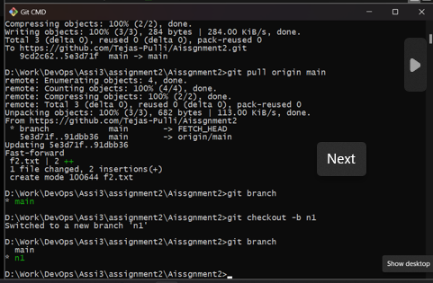

* Perform Add, Commit, Push, Pull

Create a file f1.txt add this file to the repository folder and commit the changes Push the changes from the local to remote

Create a file f2.txt add this file to the repository folder and commit the changes and create new branch. Pull the changes from remote to local repository so that all the changes will be pulled to local respository. 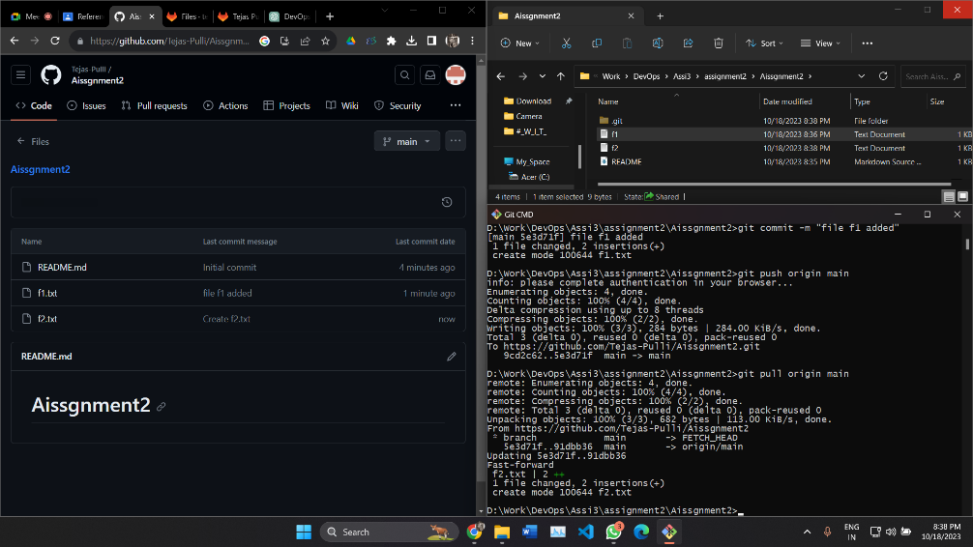

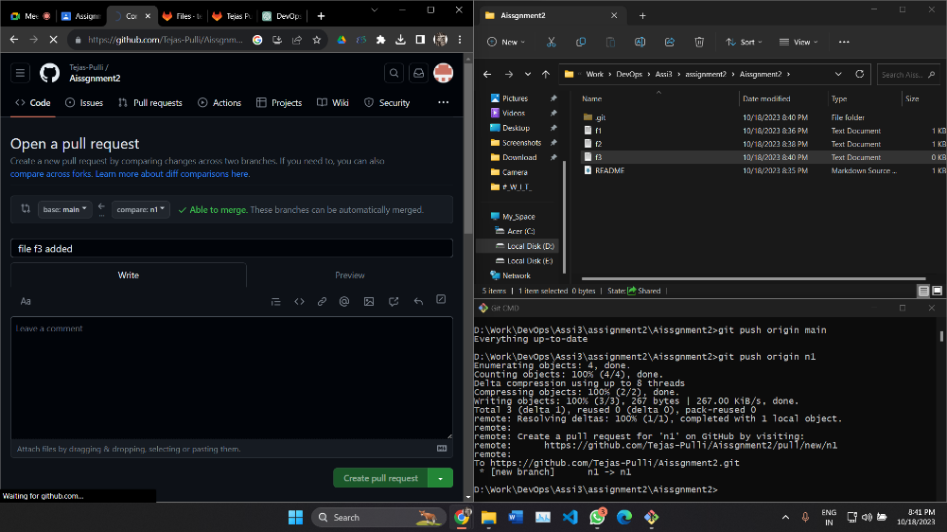

* Undo commits

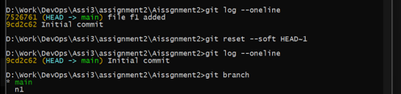

* Fork a project, Open and merge Pull request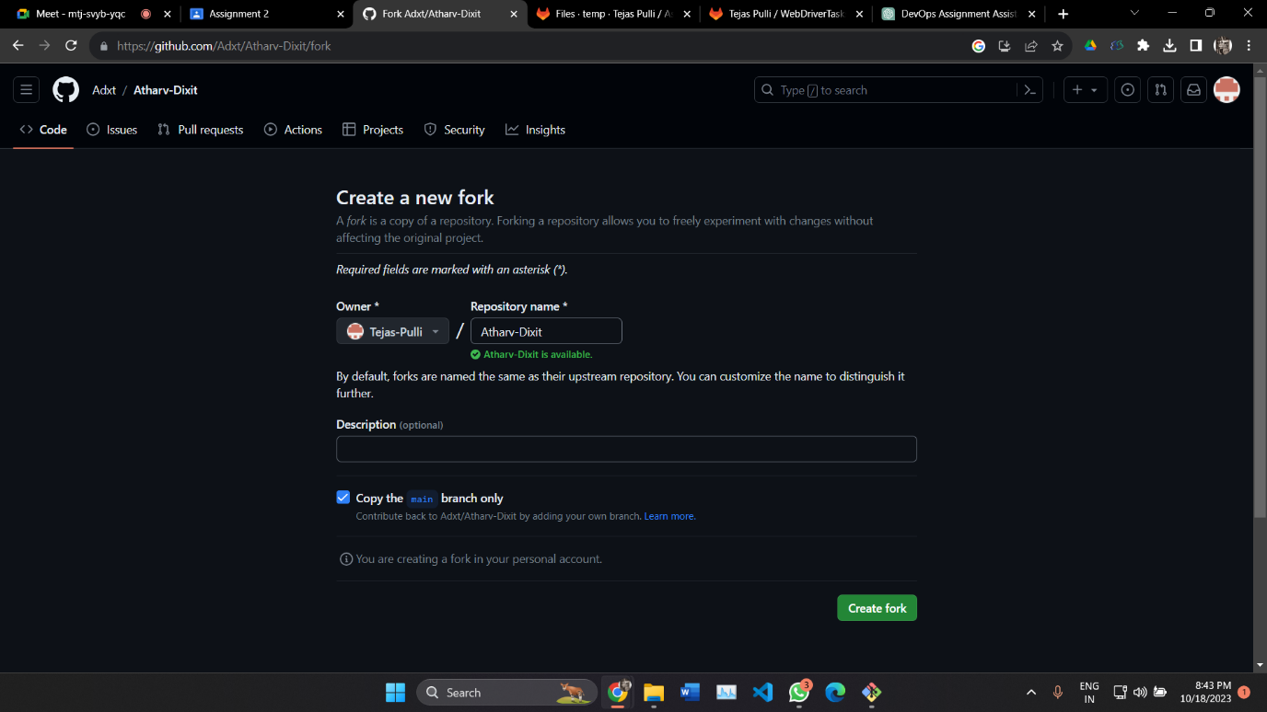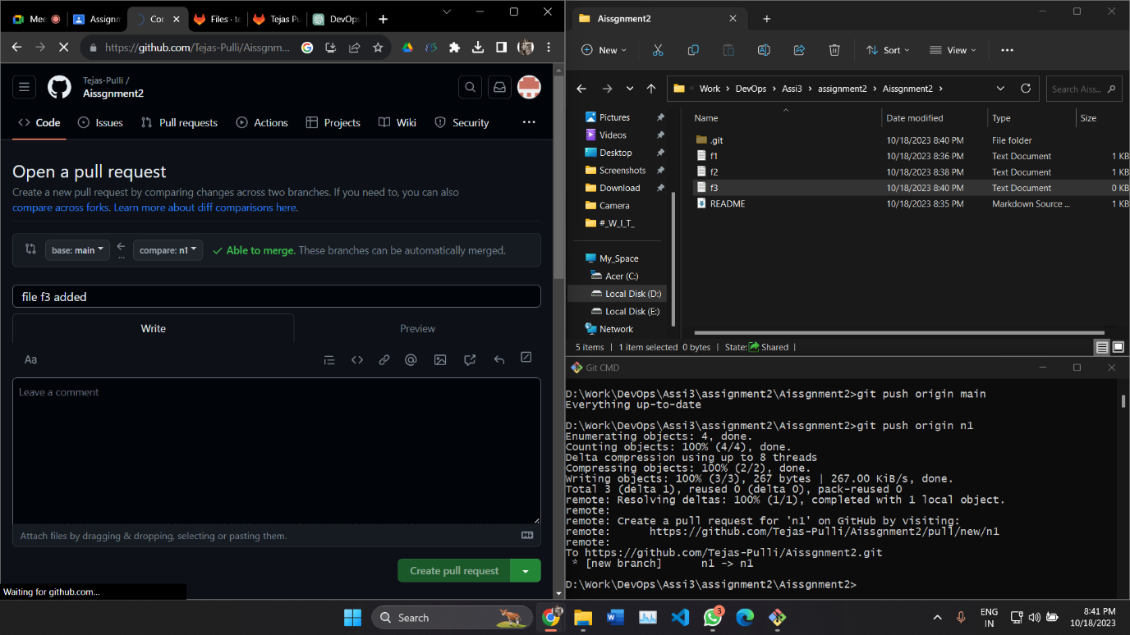
* Merge and Rebase

Merge feature branch with main branch using command git merge feature. To merge branches the command is git merge <branch name>. Once the branches are merged we can see new commit on merged branches.

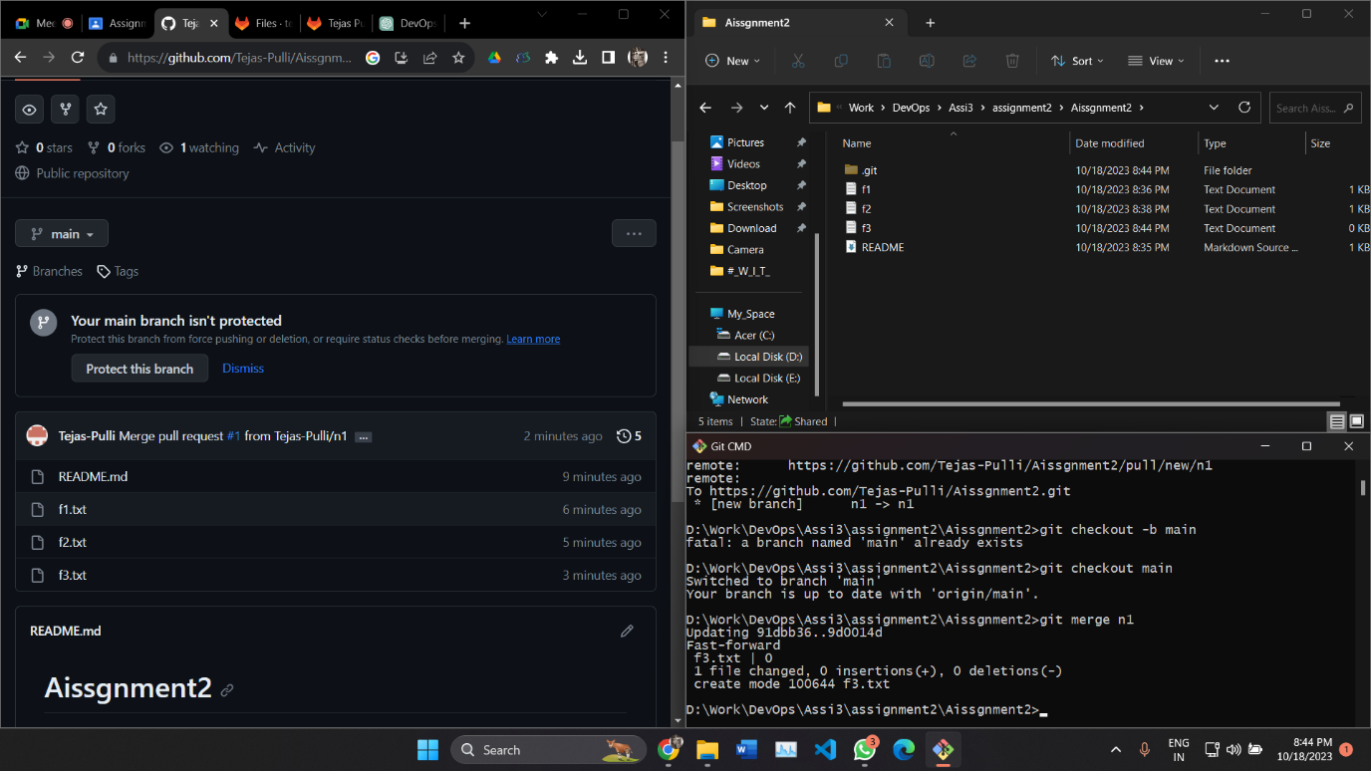

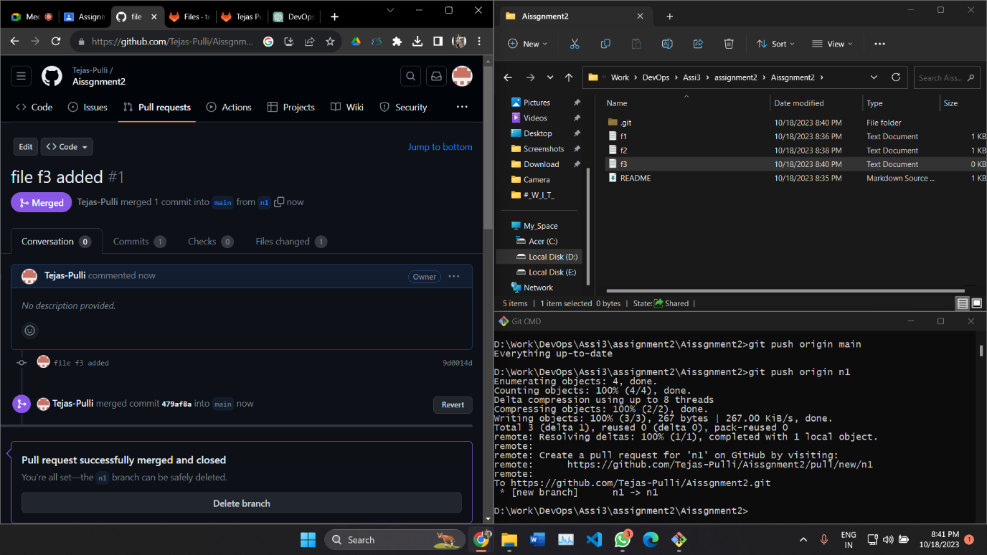Rebase two branches i.e. feature and main here. The Git rebase command moves a branch to a new location at the head of another branch. The Git rebase command combines two source code branches into one.

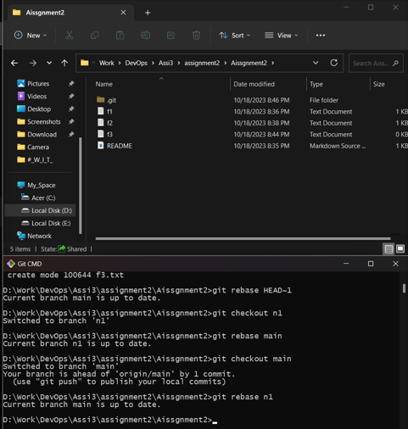

* Squashing Commits

GitLab squashing is achieved with a Rebase, of a special form called Interactive Rebase.To "squash" in Git meansto combine multiple commitsinto one. You can do thisat any point in time (by using Git's "Interactive Rebase" feature), though it is most oftendone when merging branches.

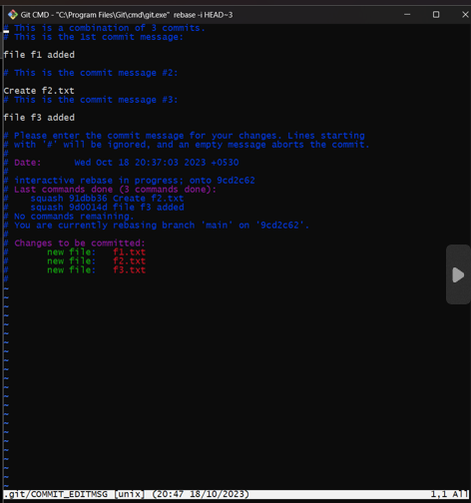

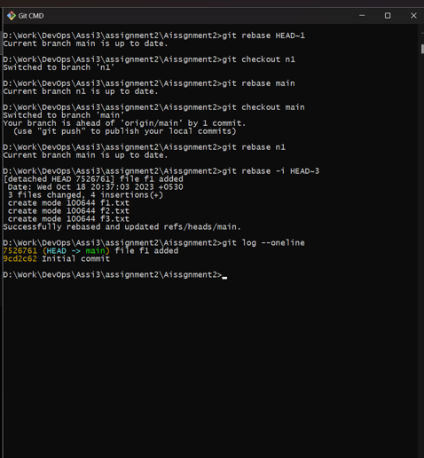

* Delete local & remote branches

