**Assignment No. 3**

Name : Tejas K. Pulli.

Roll No. 65

**Aim : Problem Statement**

Perform the following operations on Git and GitLab.

* Create a Repository/Project

From the Blank project tab, give the project a name and add a description. If you want it

to be a public repository, click the Public option. Make sure the Initialize repository with

README option is left unchecked. Then click the Create project button.

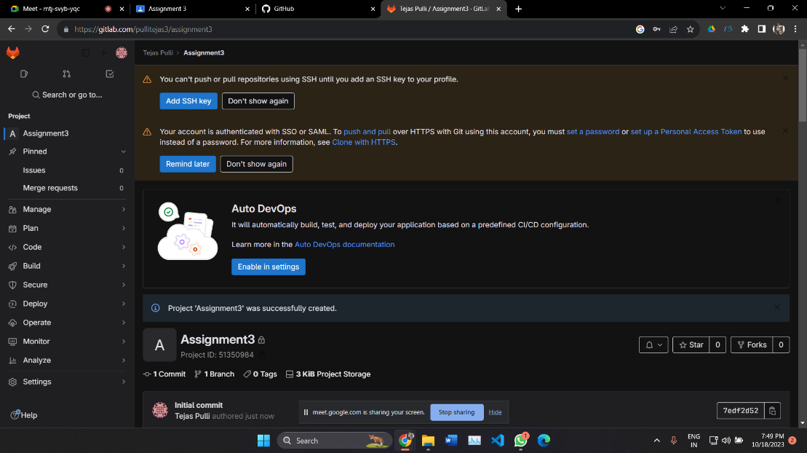

* Clone the Project

After the project is created, the next step is to open a cmd and issue the ‘git clone’

command. But first, you will need the URL of the repository.We can find the URL by

clicking on the big blue clone button on the landing page for the repository in the GitLab

GUI. Copy the HTTP URL and then open a cmd.

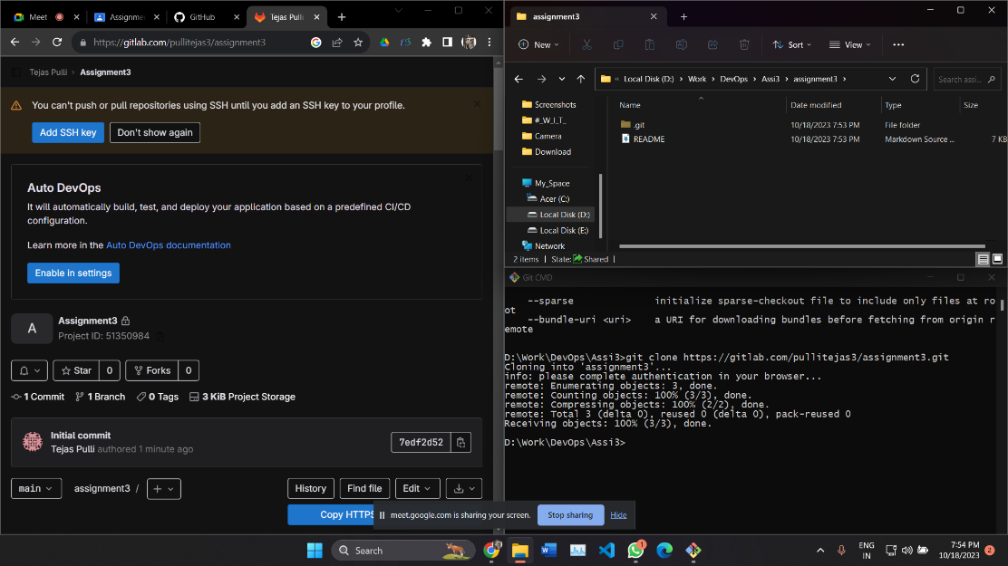

* Create Branches

Create a file file1.txt add this file to staging area and and then commit the changes

Create file M2.txt and add this file tu staging area and commit the changes

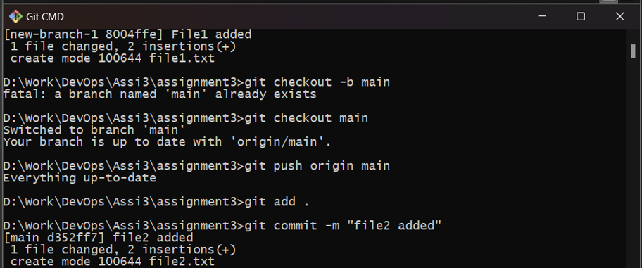

* Perform Add, Commit, Push, Pull

Now push these changes from local to remote repository.

The Command is git push origin main

Create a new branch with a name feature. We can create a branch using git branch

<branchname> or by git checkout -b <branch name>.

Now, switch the branch using the git checkout feature add file1.txt locally in the feature

branch.

Add and commit the changes in the feature branch.

In main, Create a new file file3.txt at a remote repository.

Here, new file file3.txt pulls the changes from remote to local repository so that all the

changes will be pulled to local respository.

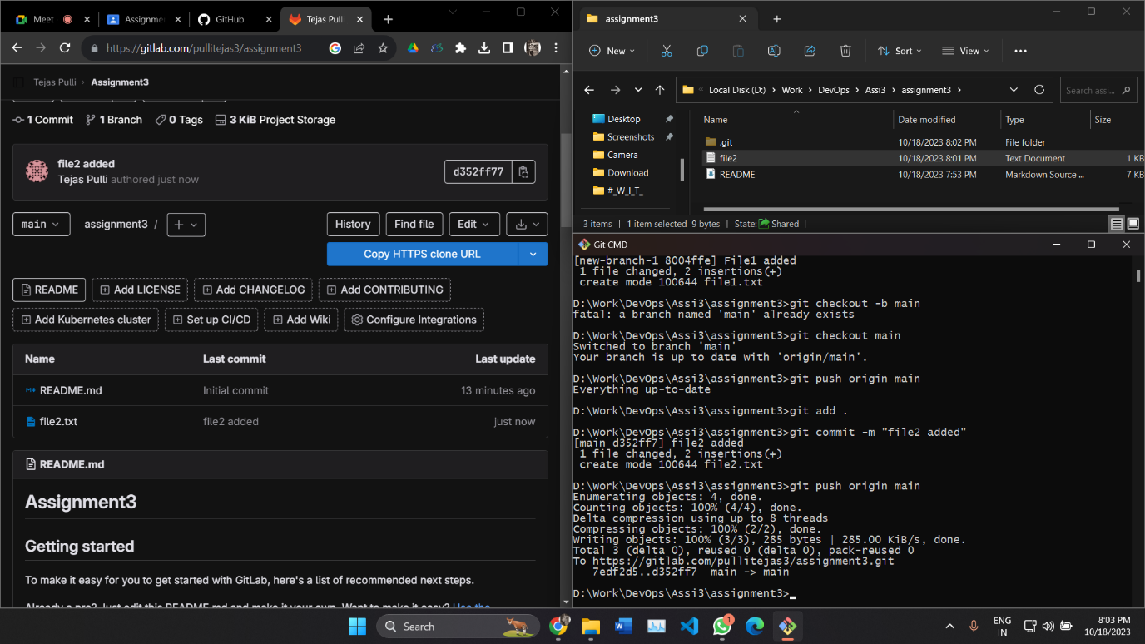

* Undo commits
* Fork a project, Open and merge Pull request

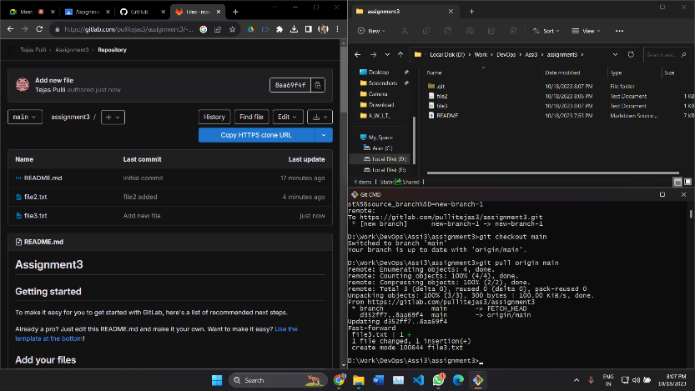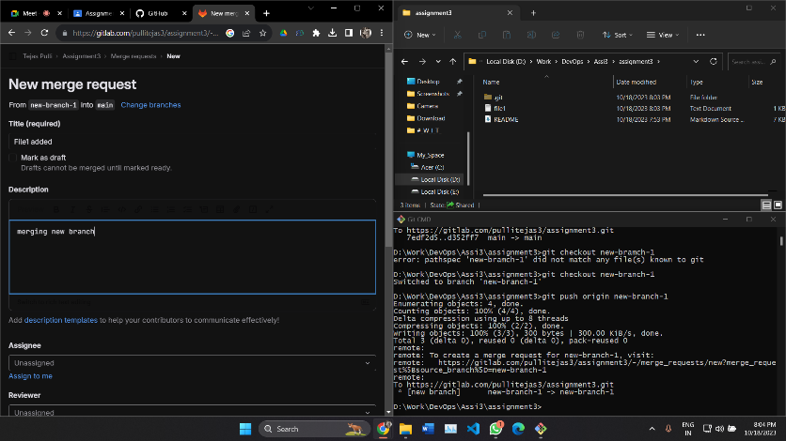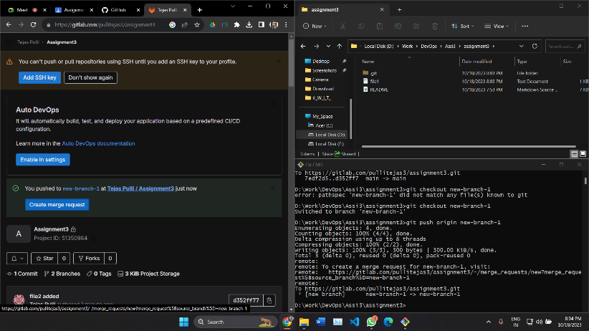

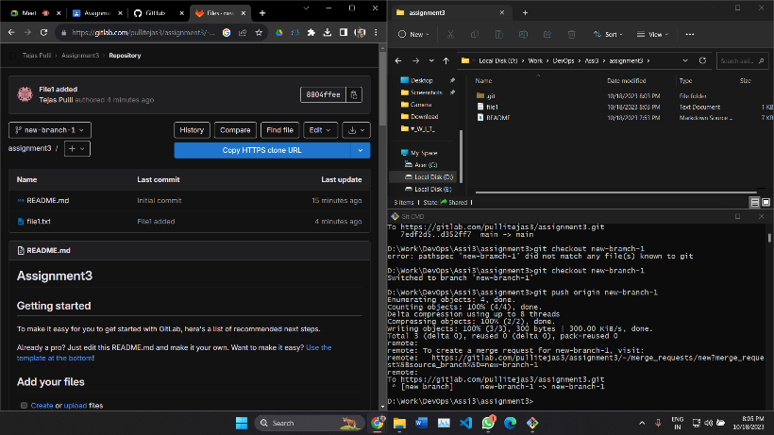

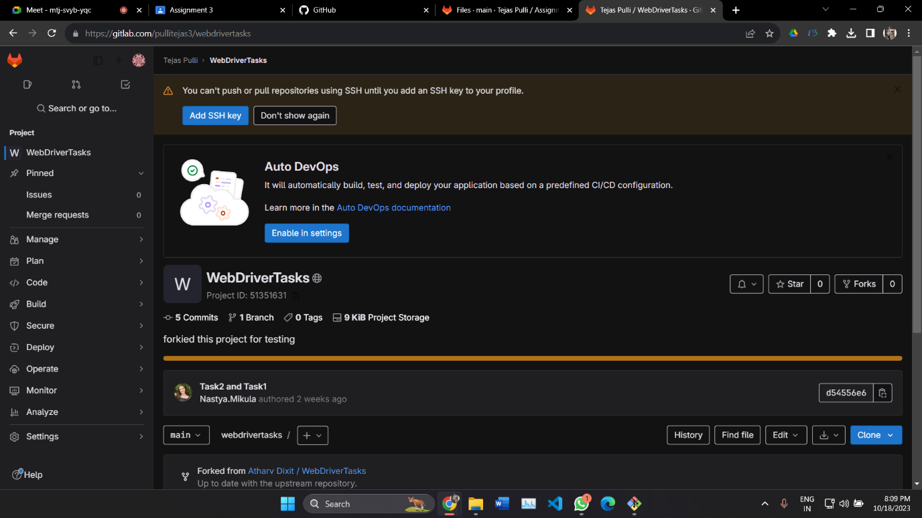

* Merge and Rebase

Merge feature branch with main branch using command git merge feature. To merge

branches the command is git merge <branch name>. Once the branches are merged

we can see new commit on merged branches.

Rebase two branches ie feature and main here. The Git rebase command moves a branch to a new location at the head of another branch. The Git rebase command combines

two source code branches into one

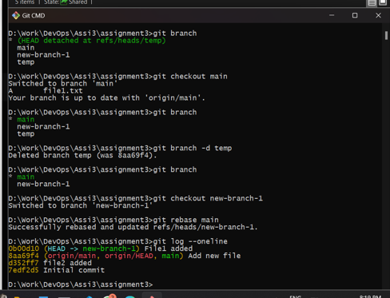

* Squashing Commits

In GitLab squashing is achieved with a Rebase, of a special form called Interactive

Rebase. To "squash" in Git means to combine multiple commits into one. You can do this at any point in time (by using Git's "Interactive Rebase" feature), though it is most often done when merging branches

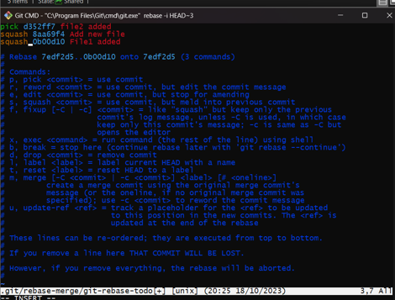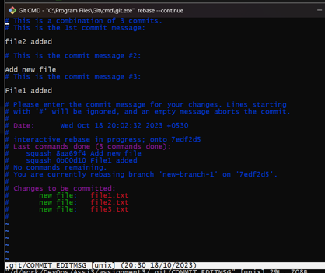

* Delete local & remote branches

To delete a local branch Command is :

Git branch -D <branch name>

To delete Remote branch command is :

Git push –delete <remote name> <branch name>

