**Assignment No. 6**

Name : Tejas K. Pulli.

Roll No. 65

**Aim : Problem Statement**

Use Jenkins “Deploy to Container Plugin” and "Build Pipeline Plugin”.

* Install the Plugins:

Install “Deploy to container” and “Build Pipeline” plugins in the Jenkins instance from Dashboard -> Manage Jenkins -> Available Plugins search and install.

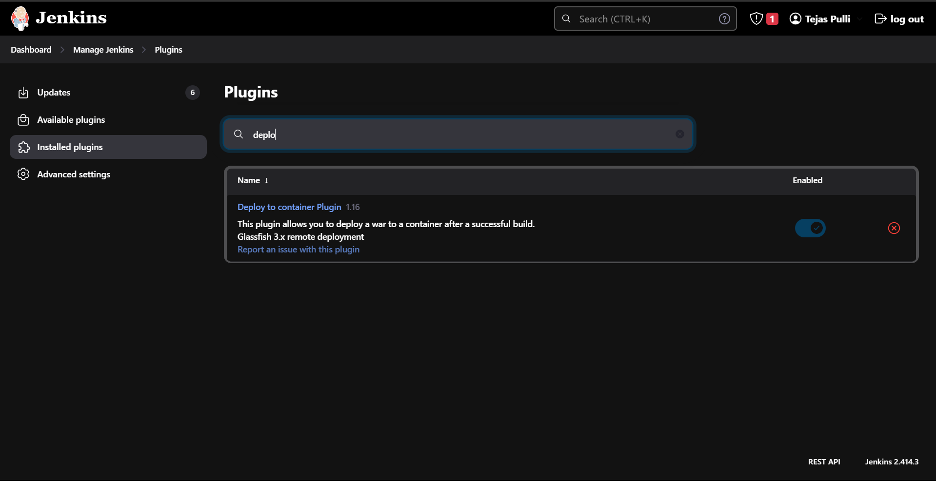

* Create a Jenkins Job:

Create a new job from the dashboard select New Item to create a new job , name it and choose Pipeline project.

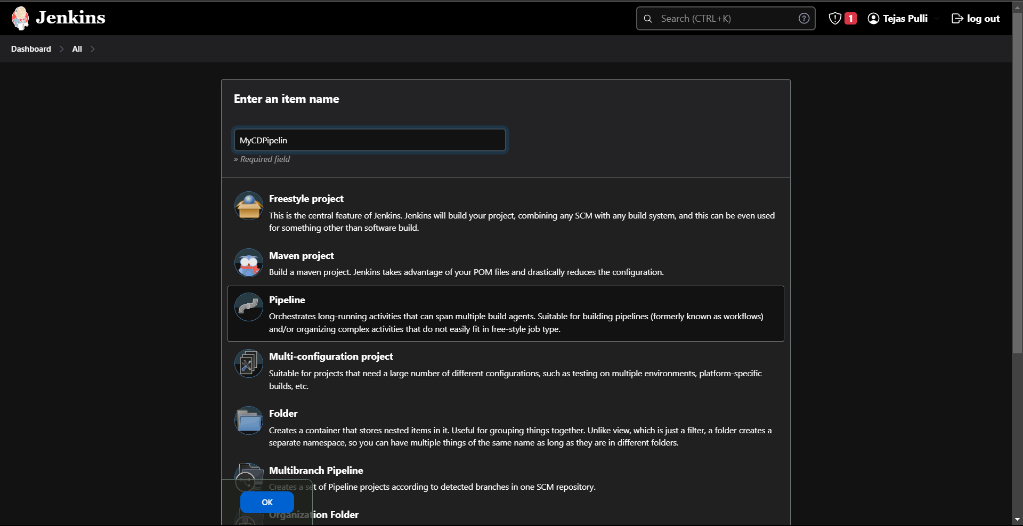

* Configure Project :

In Source Code Management choose Git and add github repository link

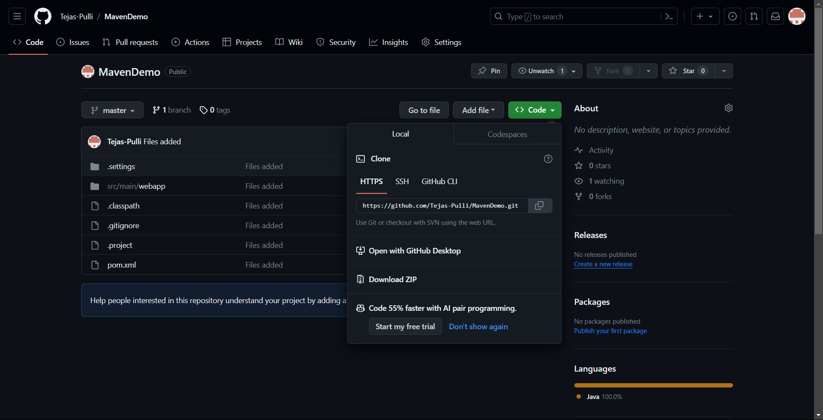

* Build Steps:

Generate a pipeline script:

Using pipeline syntax easily generate pipeline script

To Build :

In the seps choose build: Build a Job choose the project and generate the script and paste it in the project script

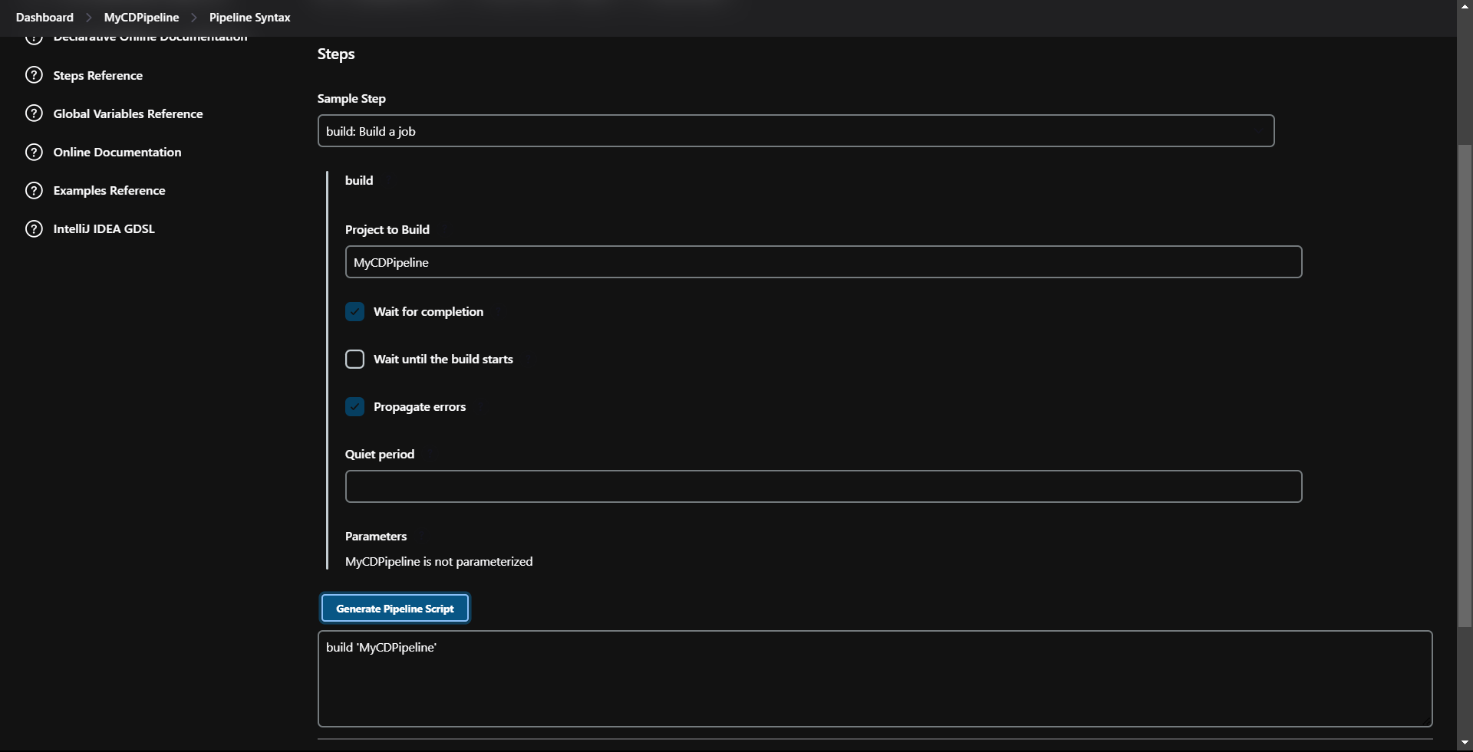

To Checkout:

Select the checkout and paste the github repository link in the text box

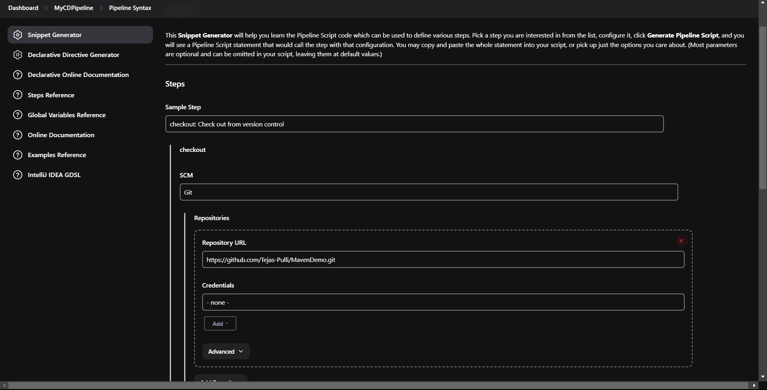

Click on generate script and generate the script and paste in the main project script

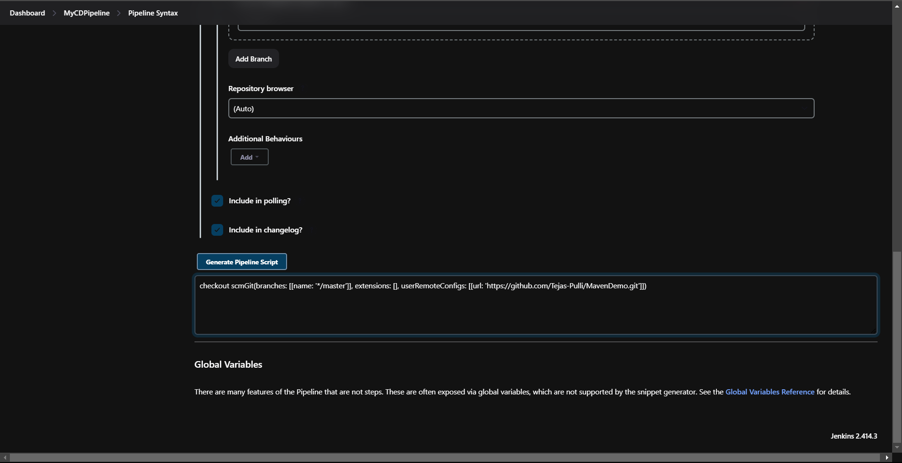

Similarly for the deploy the job generate the script

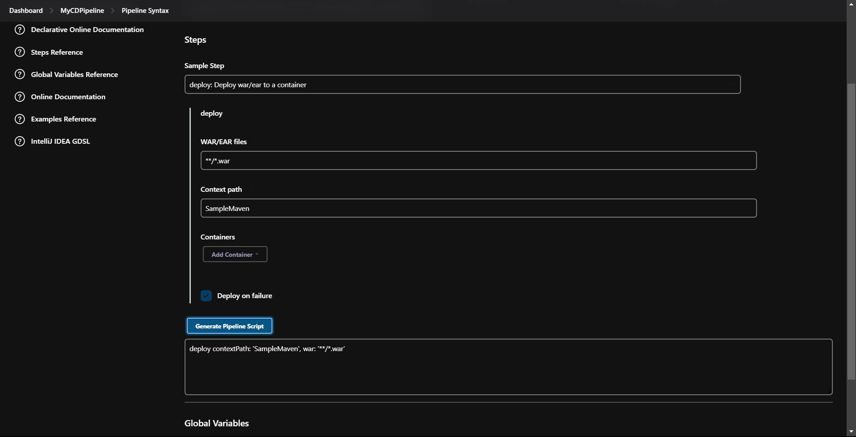

The final script of the project will be like

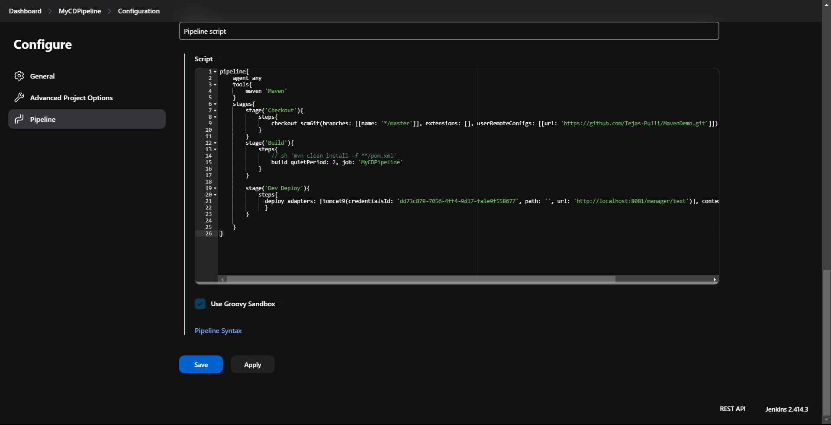

Now Build the project

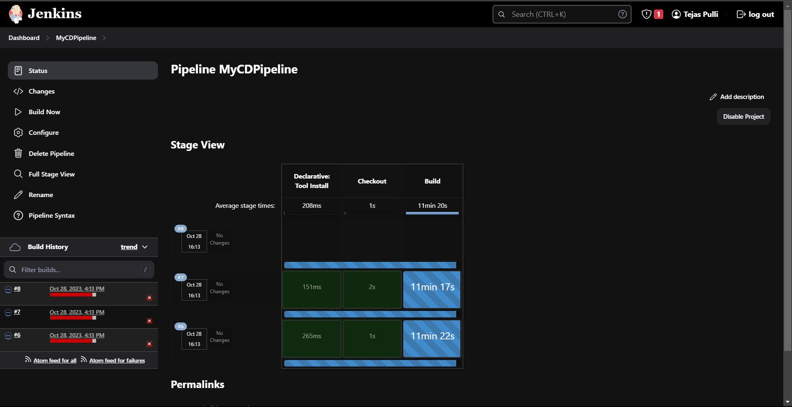

View the pipeline in the Full Stage View

