**Assignment No. 7**

Name : Tejas K. Pulli.

Roll No. 65

**Aim : Problem Statement**

Build a Docker image and push it to Docker Hub. Pull it on another system. Create and run a

new container from an image.

* Install and Setup Docker Hub:

Download Docker Desktop for Windows from the Docker website.

Create an account on Docker Hub and use this account to store your Docker images.

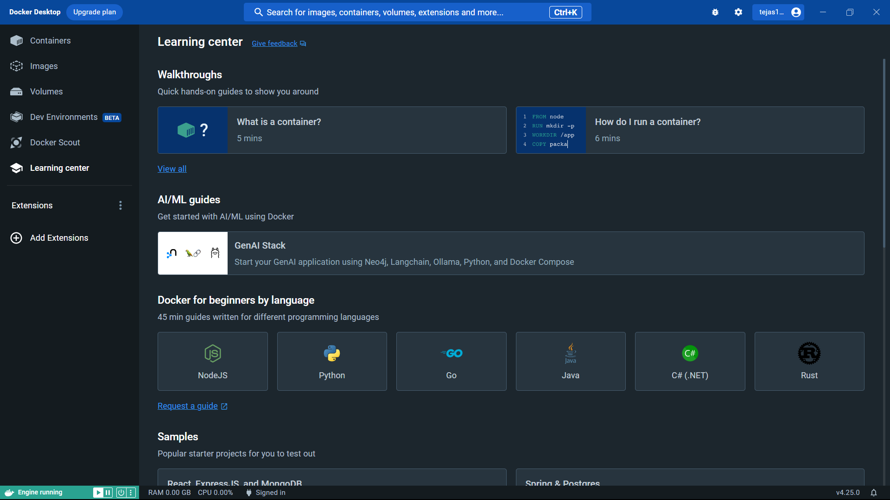

* Build a Docker Image:

Create a directory for the docker project and add all the required files inside the directory.

Add Dockerfile in the project directory, which is used to define how image is built.

Here is a sample java application and Dockerfile

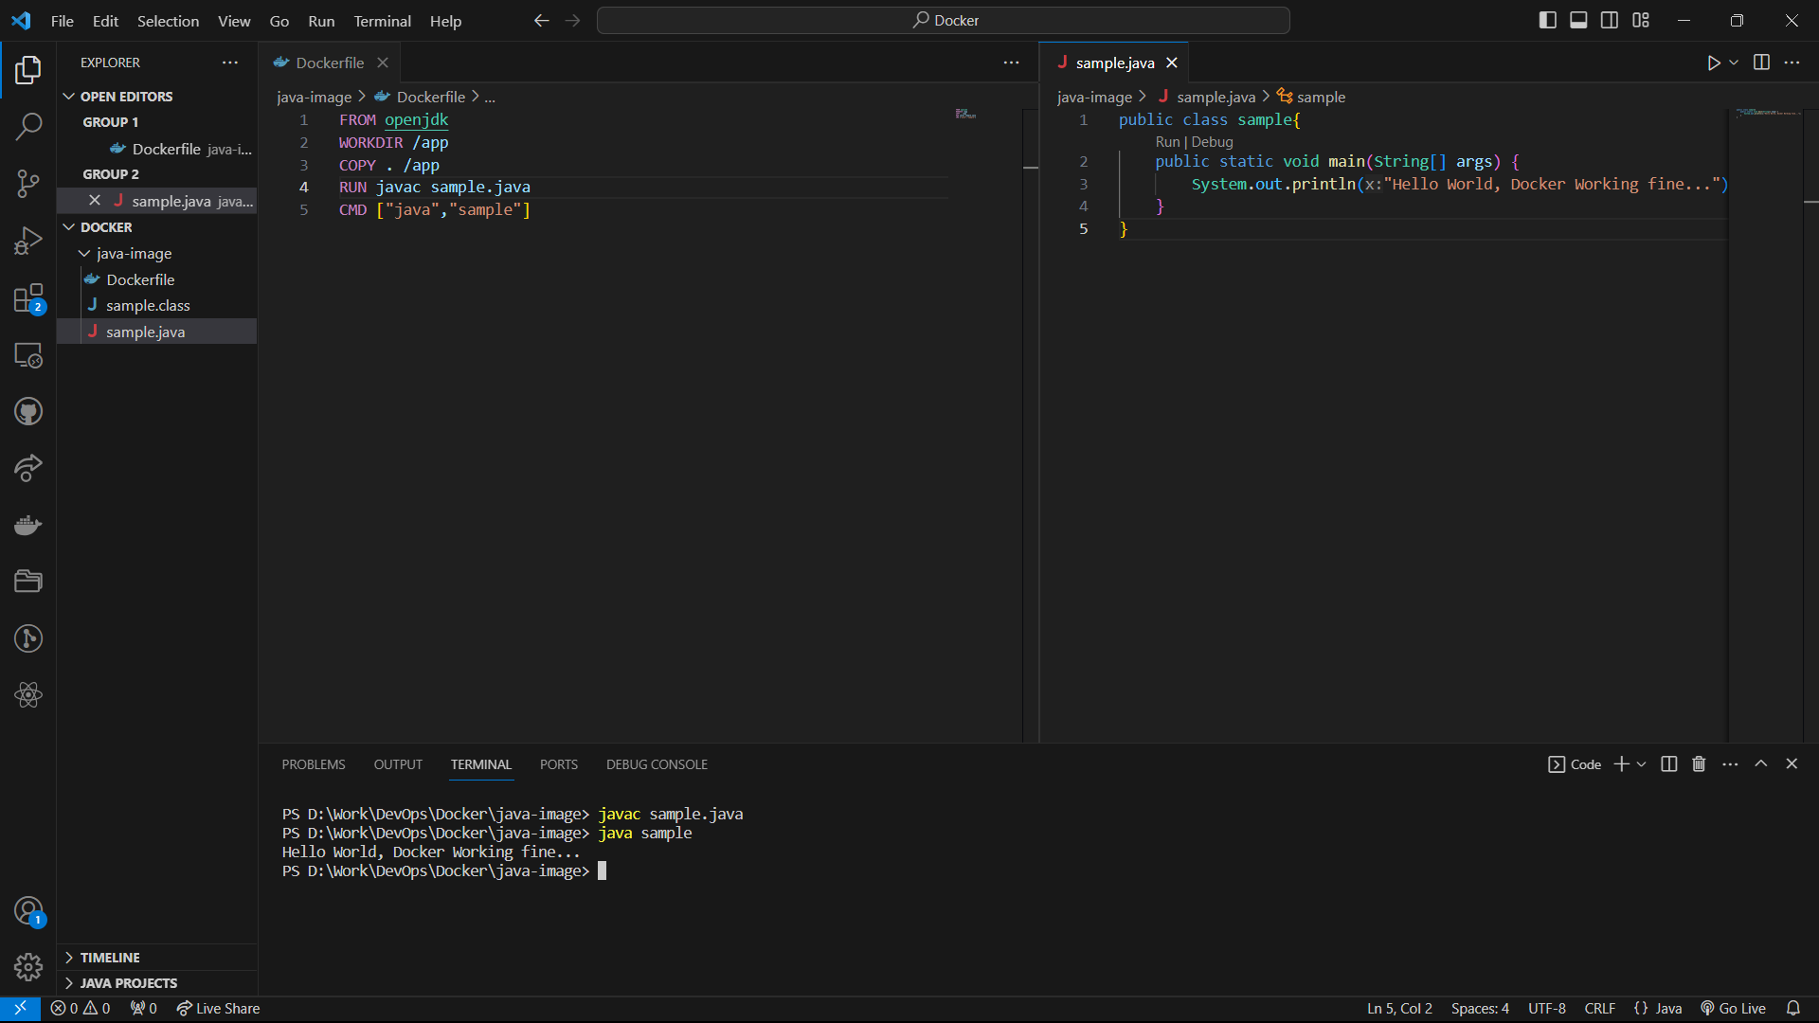

Build the docker image using the ‘docker build -t image-name .’ command.

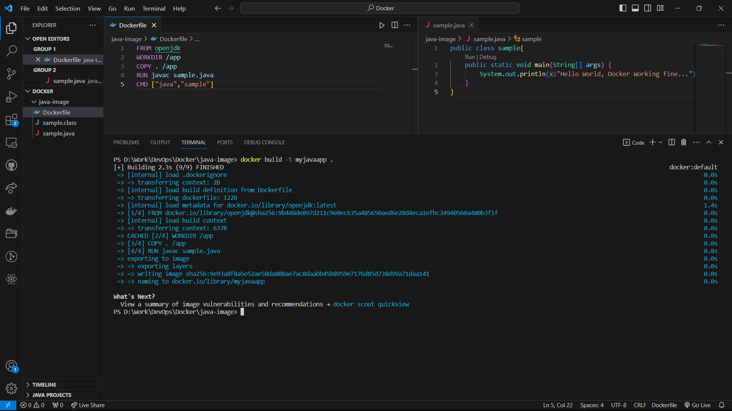

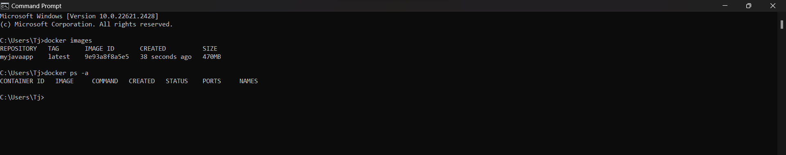

* Push to Docker Hub:

Login to your DockerHub account using the ‘docker login’ command then enter login credentials.



To push Docker image to Docker Hub use ‘docker push user-name/image-name:tag’ command  
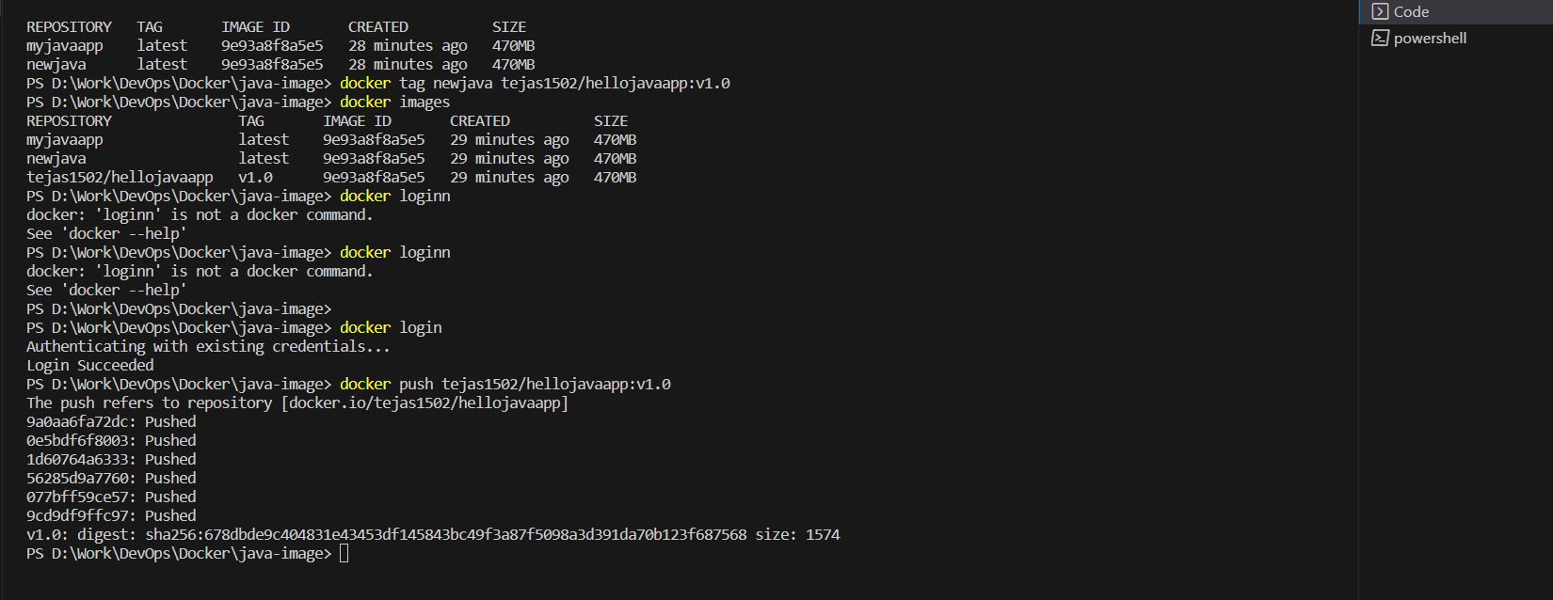

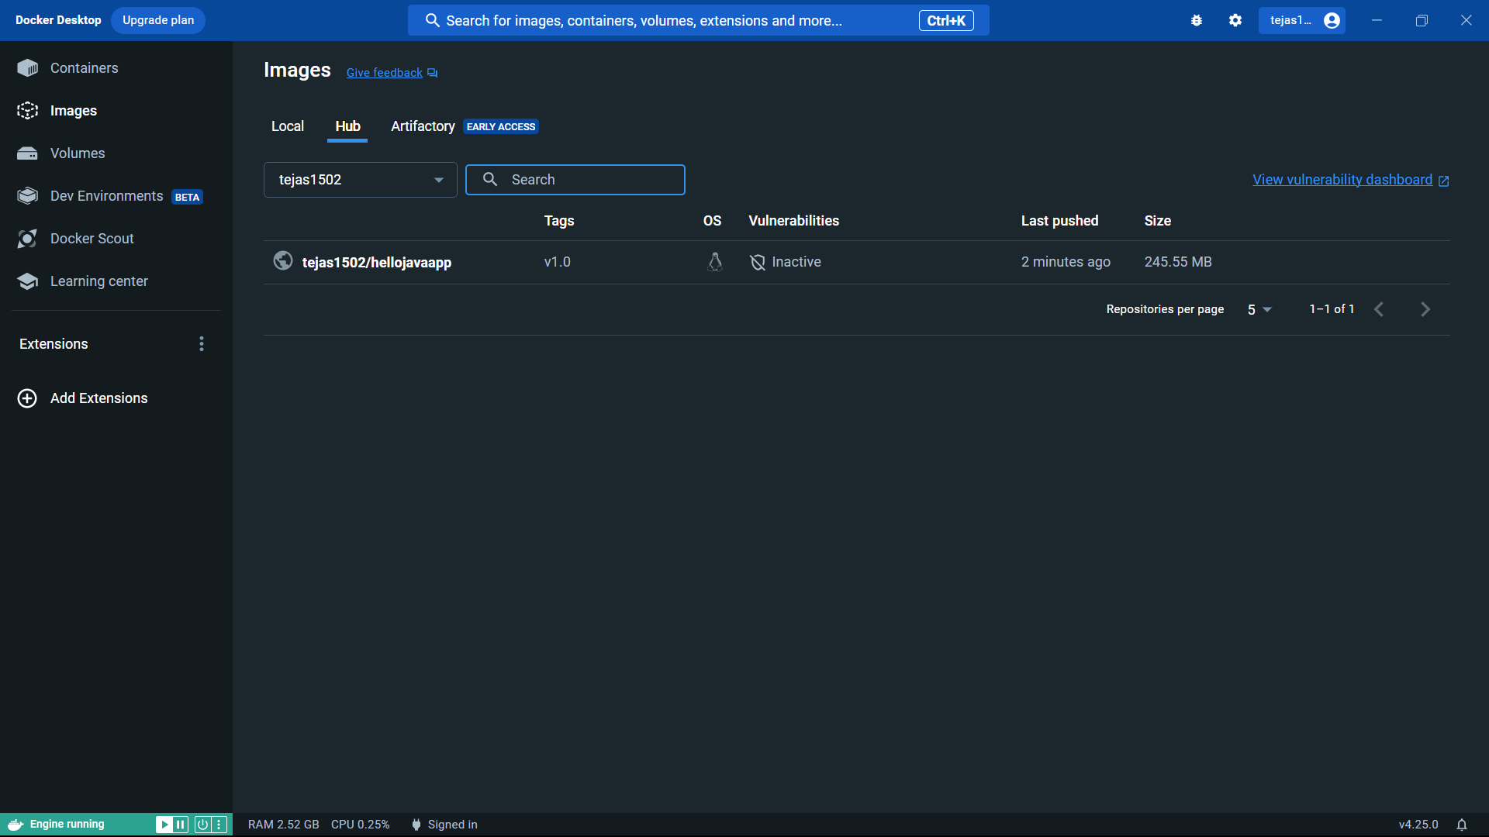

* Pull on another system:

On the other windows system where Docker is installed follow these steps to pull the image from Docker Hub :

Login to your DockerHub account using the ‘docker login’ command then enter login credentials

Pull the Docker image from Docker Hub using ‘docker pull user-name/image-name:tag’ command.

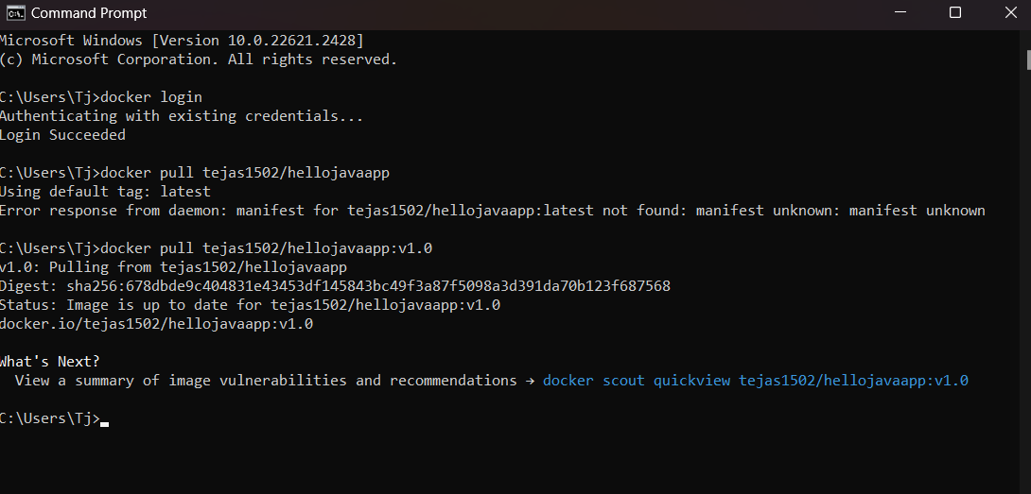

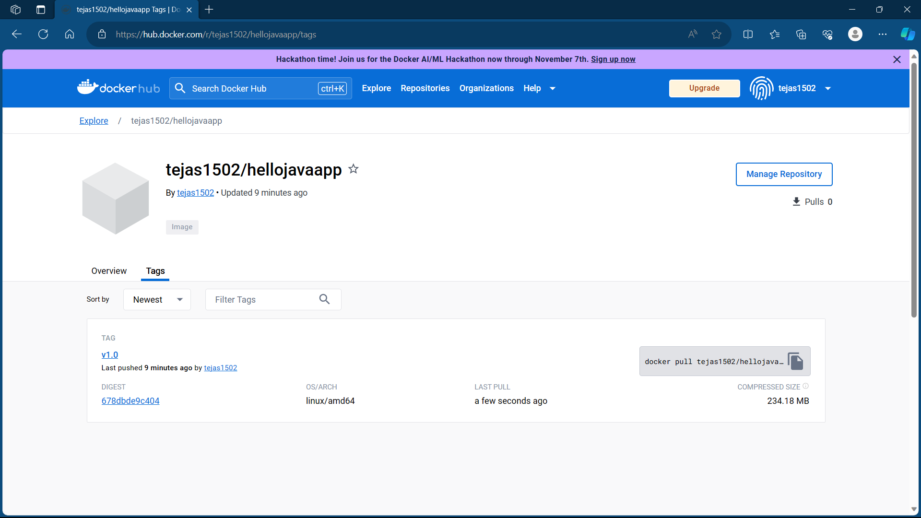

* Create and Run new Container:

Check the available images using ‘docker images’ command. Run the application using ‘docker run -name container-name imagename’

