**Assignment No. 1**

Name : Tejas K. Pulli.

Roll No. 65

**Aim : Problem Statement**

Set up the Git Server and perform the following operations:

* Create a Repository :

Create a local repository on thee system. Initialize the git using git init command

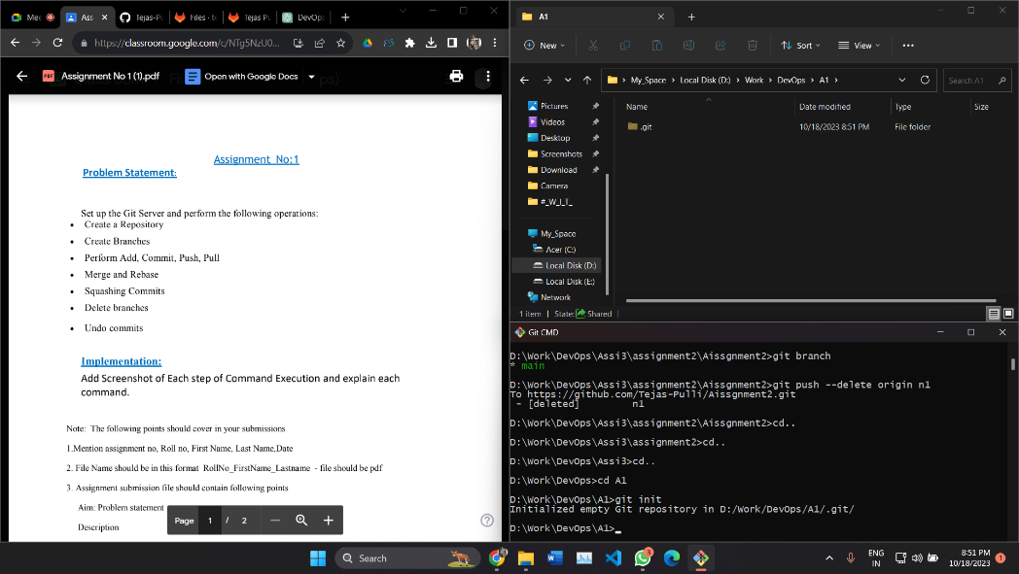

* Create Branches

create branches using the git branch and git checkout commands.

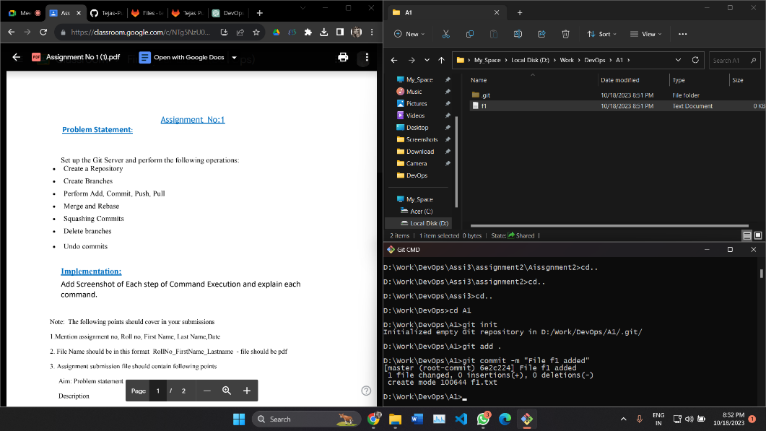

* Perform Add, Commit, Push, Pull :

Create a file f1.txt add this file to the repository folder and commit the changes Push the changes from the local to remote

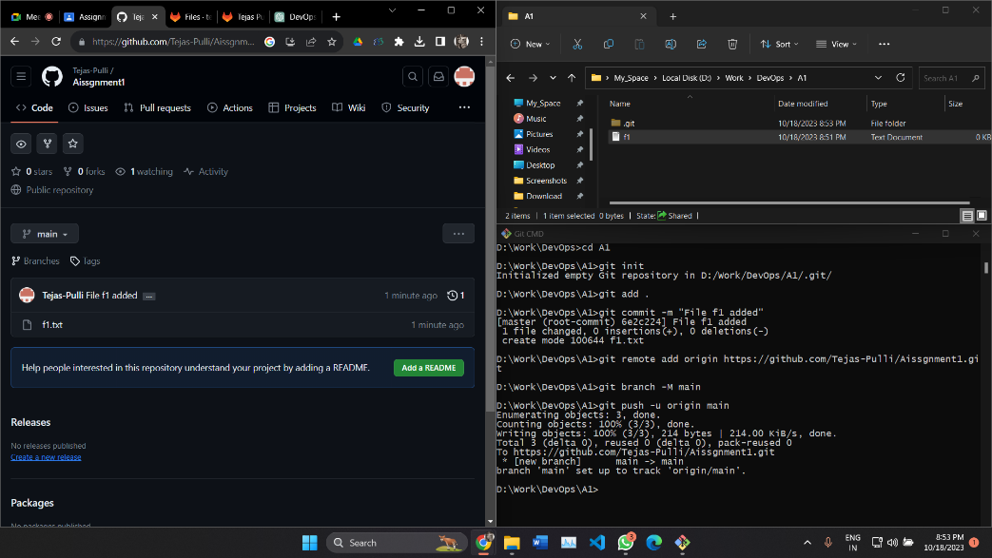

Create a file f2.txt add this file to the repository folder and commit the changes and create new branch. Pull the changes from remote to local repository so that all the changes will be pulled to local respository.

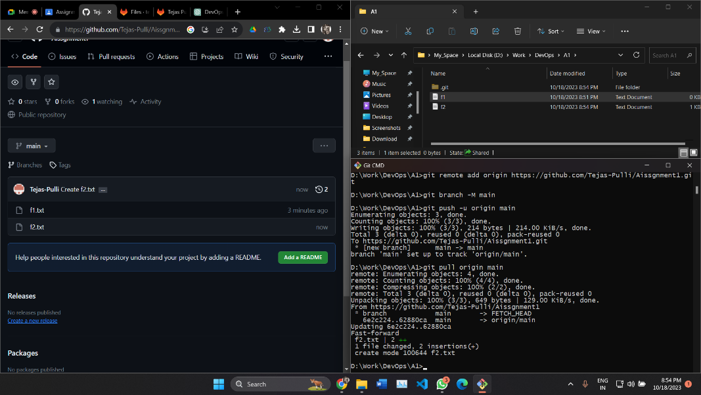

* Merge and Rebase

Merge feature branch with main branch using command git merge feature. To merge branches the command is git merge <branch name>. Once the branches are merged we can see new commit on merged branches.

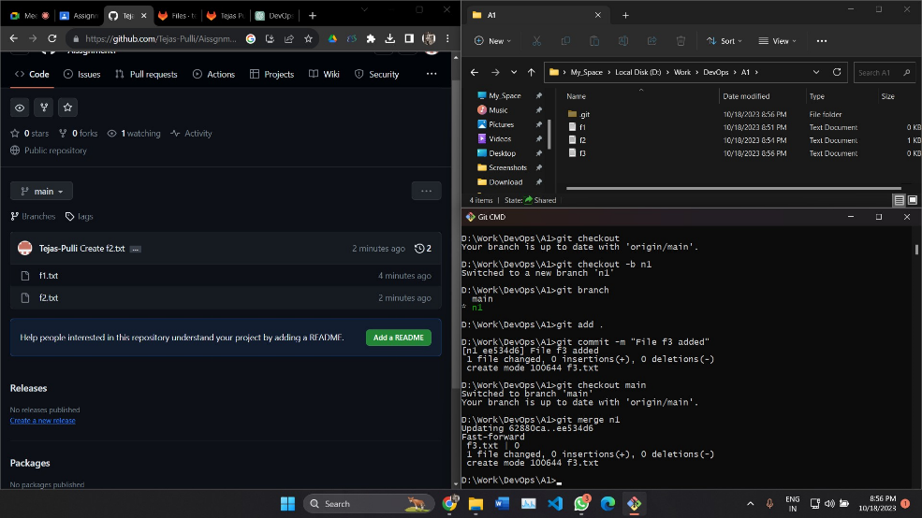

Rebase two branches i.e. feature and main here. The Git rebase command moves a branch to a new location at the head of another branch. The Git rebase command combines two source code branches into one.

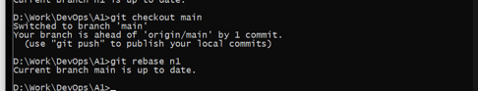

* Squashing Commits

GitLab squashing is achieved with a Rebase, of a special form called Interactive Rebase.To "squash" in Git meansto combine multiple commitsinto one. You can do thisat any point in time (by using Git's "Interactive Rebase" feature), though it is most oftendone when merging branches.

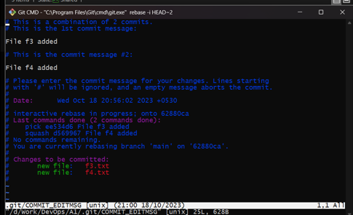

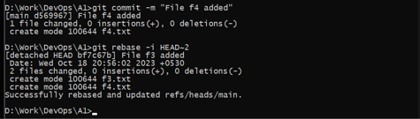

* Undo commits

