Product Management API
Open Api document
Swagger UI
http://localhost:8080/q/swagger-ui
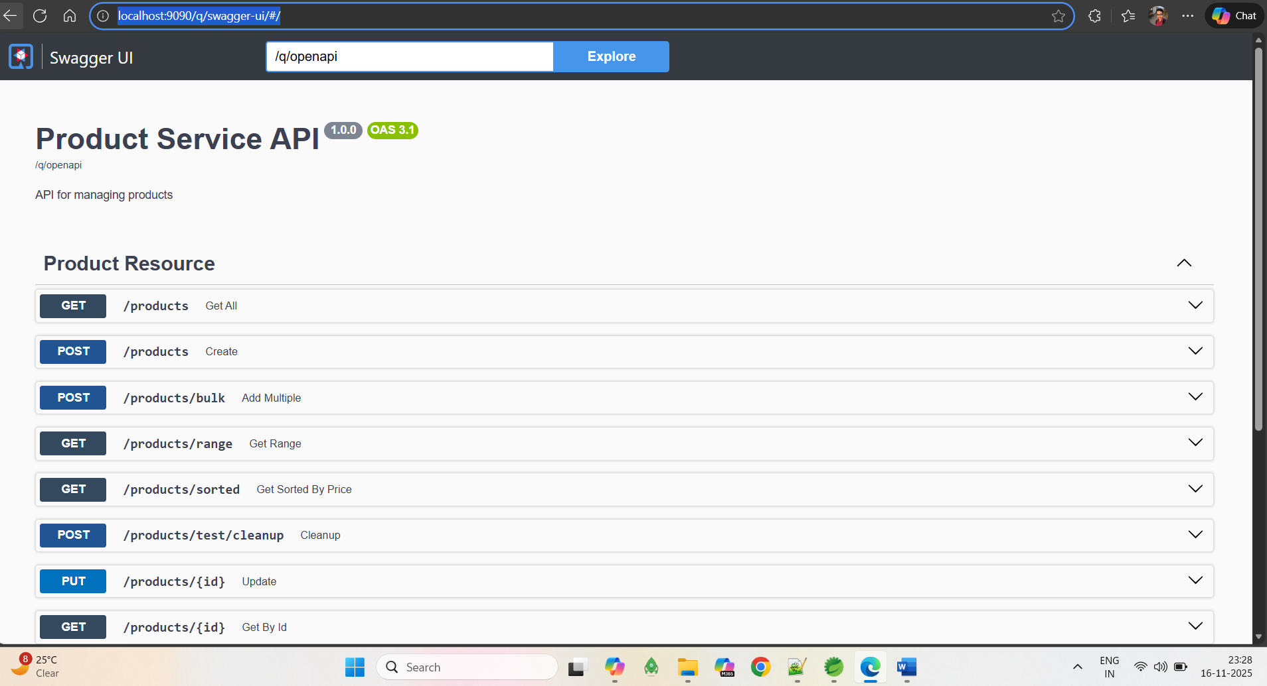
Code Coverage
