Question 1:

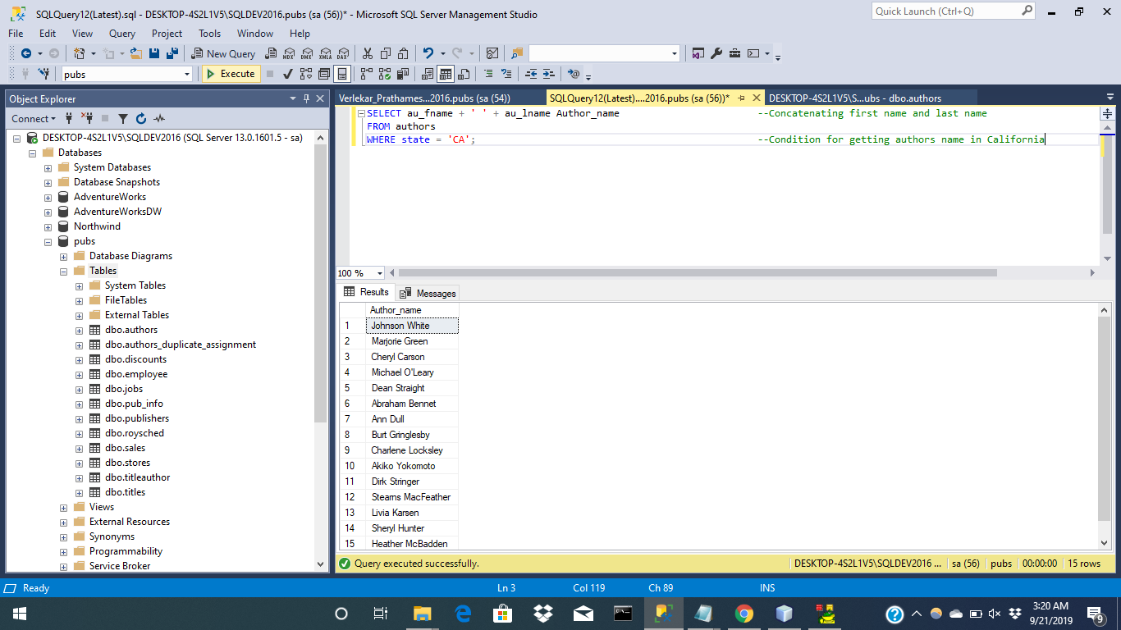

Question 2:

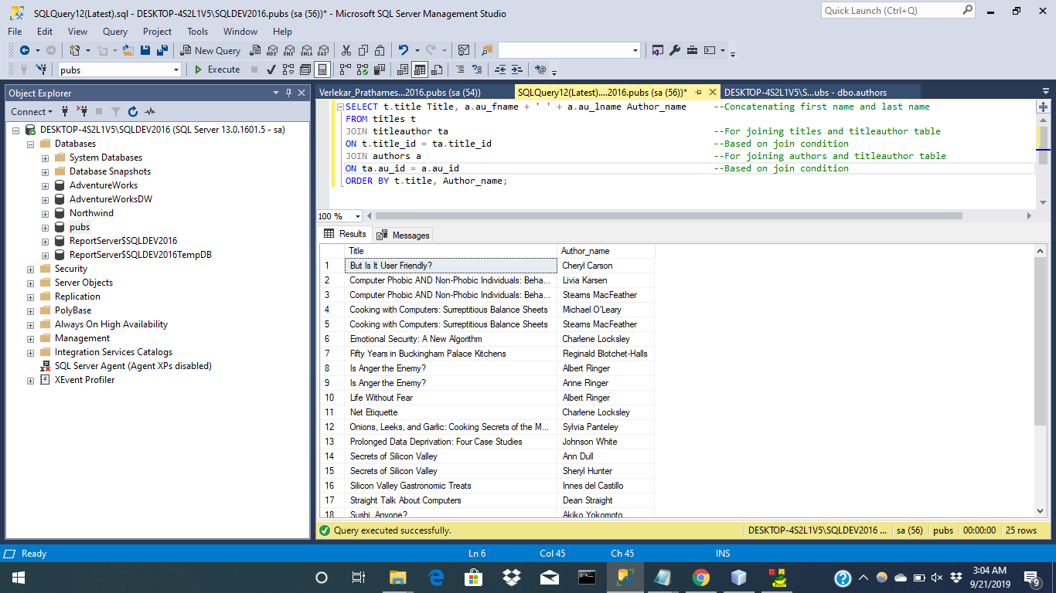

Question 3:

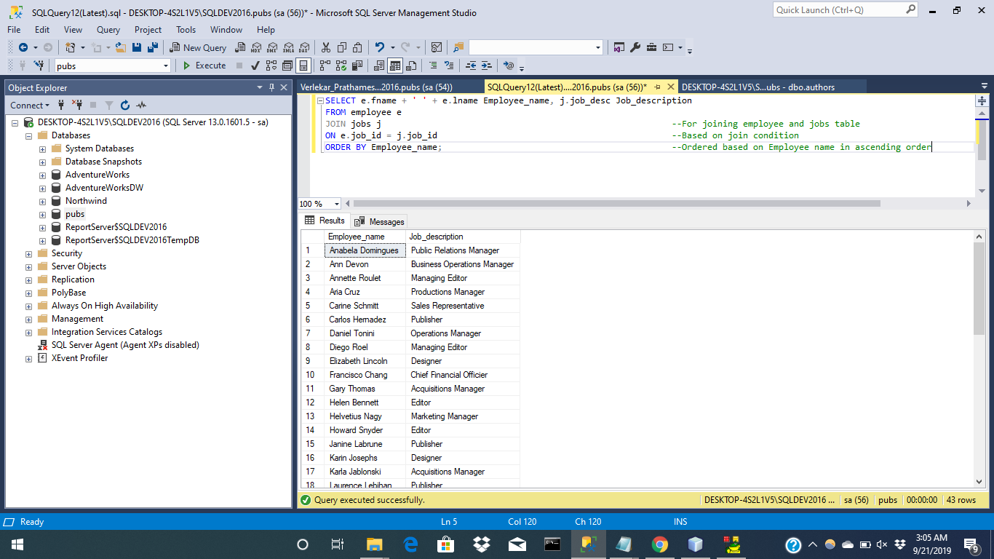

Question 4:

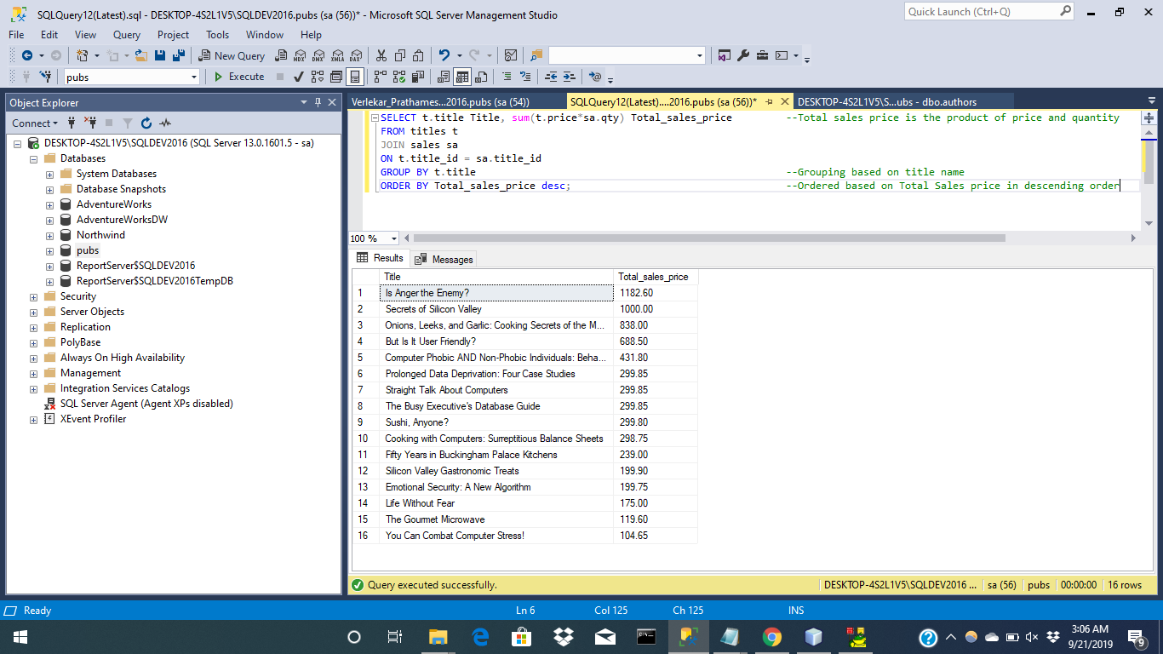

Question 5:

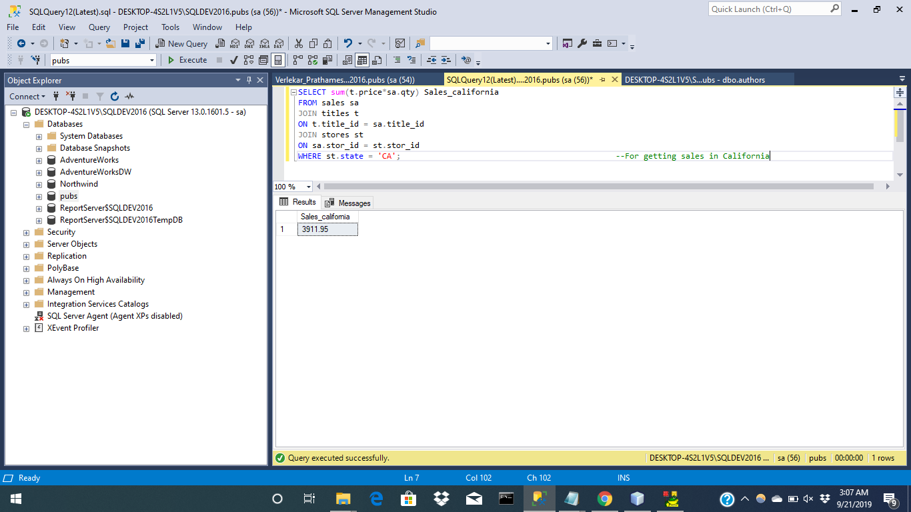

Question 6:

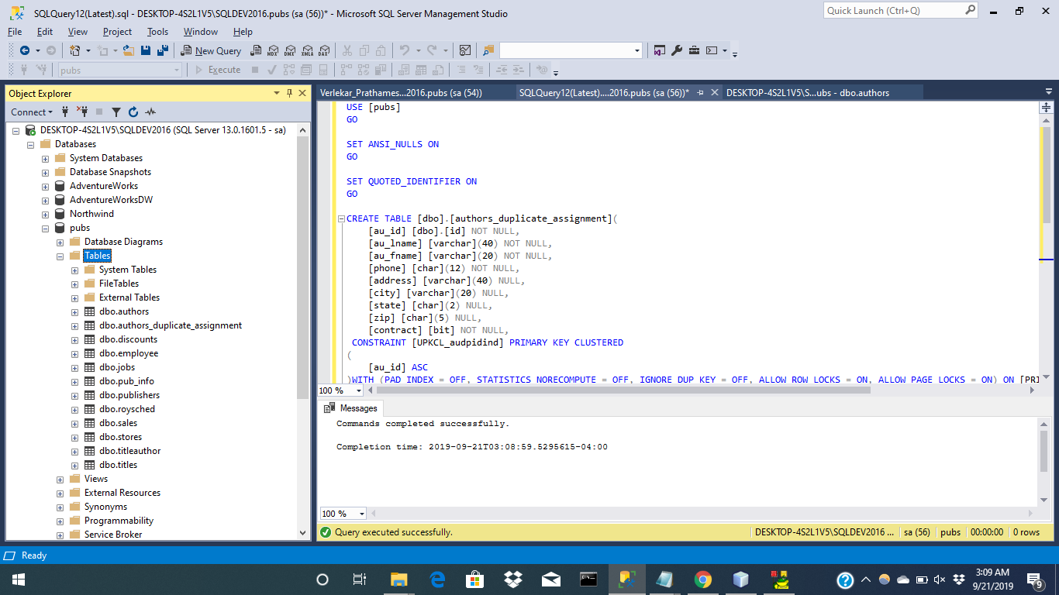

Question 7:

The au_id in the authors table is using a User Defined DataType(Id) which is varchar with length as 11, which means it can store a variable-sized data up to 11 bytes out of which 2 bytes will hold the length information and remaining will store the characters.

For Example: If au_id is of 4 bytes, then the varchar data type will use 4 bytes for the characters and 2 bytes for the length information and will save remaining spaces.

Question 8:

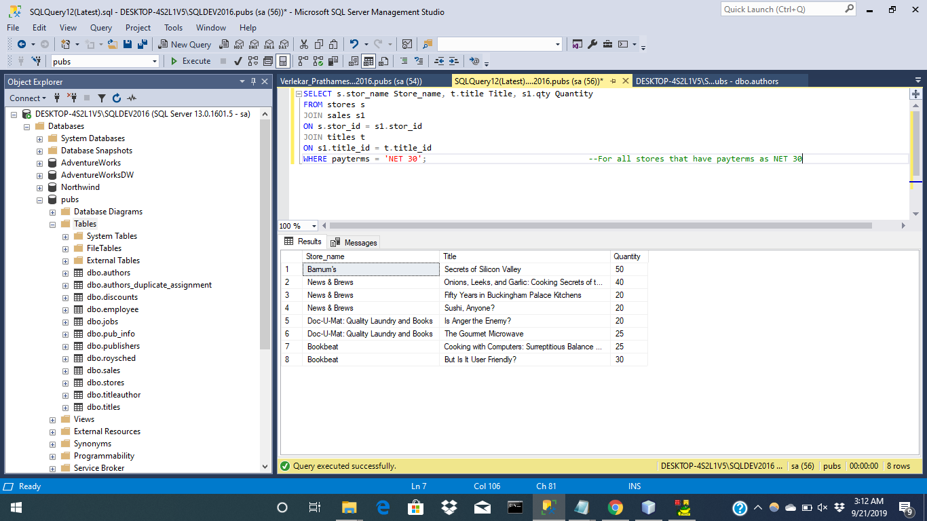

Question 9:

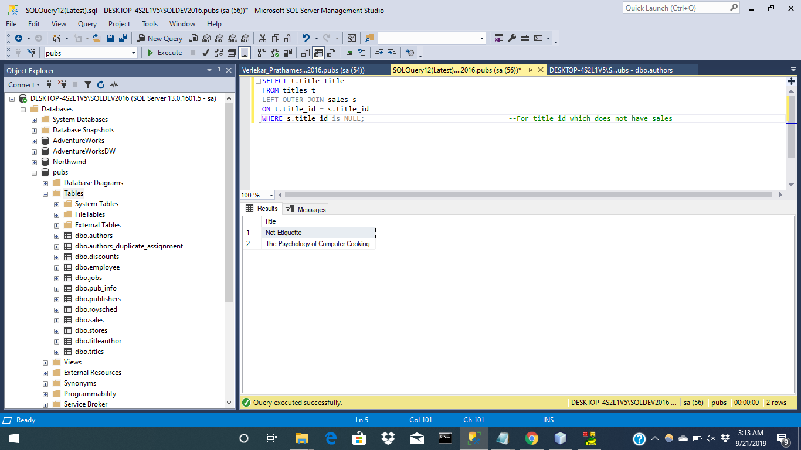

Question 10:

