Game Design Document

Fill up the following document

1. Write the title of your project.

The title of the project is “THE DINO GAME”

1. What is the goal of the game?

The goal of the project is the main character of game

Dino has to protect himself from the ice blocks falling from upper side and meet his mom again.

1. Write a brief story of your game.

The story of the game- Once upon a time there was a baby dino and his mother was going to diffrent place in search of food.Then suddenly they come to a cold area where they were standing upon the big ice block and ice

block broken down into two pieces.

Both were seprated from each other and baby dino came to a diffrent land in which ice blocks were falling from the upper side.So he has to defend him and meet his mom again.But it is not easy he has to also defend from dealy ice and stingy thorn and there is skull food which gives him energy and makes him faster and ice and other obstacles will not able to hurt dino.There are three lives too for making the game and the dino have a power of fire

through which he can melt ice.

1. Which are the playing characters of this game?

* Playing characters are the ones who respond to the user based on the input from the user.
* Cars, monkeys, dinos, wizards, etc., are the playing characters in the game.

|  |  |  |
| --- | --- | --- |
| Number | Character Name | What can this character do? |
| 1 | Dino | Running and defending from the obstacles. |
| 2 | Fire | Power = Fire |
| 3 | Jumping | To defend from obstacles. |
| 4 |  |  |
| 5 |  |  |
| 6 |  |  |
| 7 |  |  |
| 8 |  |  |

1. Which are the Non-Playing Characters of this game?

* Non-Playing characters are the ones that don't have an action or behavior when the user interacts with the game.
* Hurdles, stones, bananas, coins, etc., are non-playing characters in the game.

|  |  |  |
| --- | --- | --- |
| Number | Character Name | What can this character do? |
| 1 | Ice | It can hit dino and kill his one live. |
| 2 | Stingy Thorn | It can hit dino and kill his one live. |
| 3 | Ground | For jumping and Moving Dino. |
| 4 | Moving Small lands | To jump and land on it. |
| 5 | Skull | The power of dino. |
| 6 | Dino Mother | Mother of baby dino |
| 7 |  |  |
| 8 |  |  |

Draw your imagination of this game. What does this game look like?

* Draw the game either on your computer or on paper.
* Add images of the game scenes to show each of the playing and non-playing characters at least once.

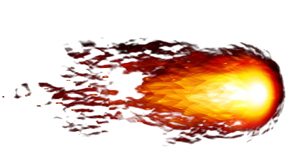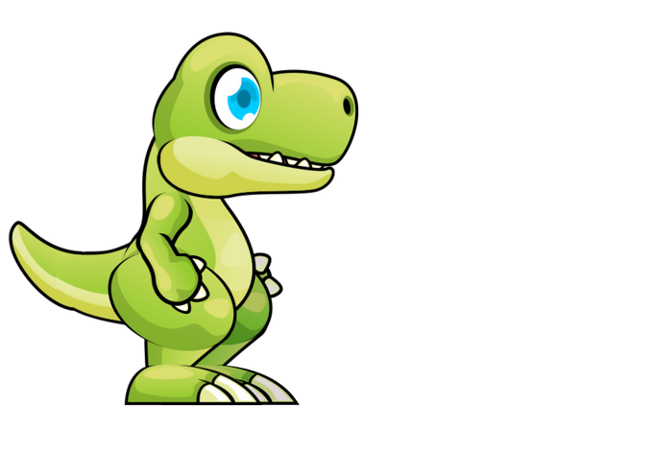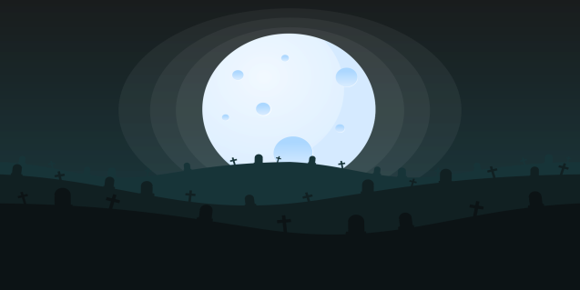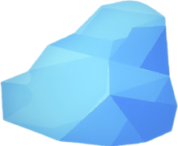

Ice Block = The main obstacle of this game.

Fire = Power of the Dino.

Dino = Main character of dino.

Stingy thorn = Main obstacle of the game

Background = For running the dino.

How do you plan to make your game engaging?

I am using the VSC studio to create my game.