**D.Y.PATIL COLLEGE OF ENGINEERING &TECHNOLOGY,**

**KASABA BAWADA, KOLHAPUR**

DEPARTMENT OF COMPUTER SCIENCE & ENGINEERING

(Academic Year: 2024-25)



**Project-III Synopsis**

On

**"Zerodha Stock Broker"`**

Submitted By

|  |  |
| --- | --- |
| **Roll no.** | **Student Name** |
| 3. | Sahil Vilas Gawade |
| 6. | Prathamesh Sachin Pawar |
| 8. | Saurabh Laxman Karande. |
| 9. | Aditya Raghunath Kakade. |

**Under the guidance**

Miss. Meghana Bandiwadekar

Class: TY (CSE) Div: C Batch: T1

Index:

|  |  |  |
| --- | --- | --- |
| **Sr no.** | **Topic Name** | **Page no.** |
| **1.** | **Abstract** | **3** |
| **2.** | **Introduction** | **4** |
| **3.** | **Literature Review** | **5** |
| **4.** | **Problem Statement** | **7** |
| **5.** | **Objective** | **8** |
| **6.** | **Proposed System Architecture Diagram** | **9** |
| **7.** | **Modules** | **10** |
| **8.** | **System Requirements** | **11** |
| **9.** | **Conclusion** | **12** |
| **10.** | **References** | **13** |

**Abstract:**

The Zerodha Clone project is a web-based stock trading platform designed to emulate the core functionalities of Zerodha, one of India's leading stock trading platforms. Built using the MERN stack (MongoDB, Express.js, React.js, and Node.js), the application provides users with a seamless and intuitive interface to manage their investments. Key features include secure user authentication, real-time stock data fetching through third-party APIs, and a comprehensive dashboard that displays holdings, positions, funds, and graphical analytics. The frontend is designed using Material-UI and Bootstrap to ensure a modern, responsive, and visually appealing user experience. The backend is powered by Node.js and Express.js, with MongoDB serving as the database for storing user and stock-related data. Testing is performed using Jest to ensure code reliability and functionality. This project demonstrates the integration of modern web technologies to create a robust and scalable stock trading platform, with potential for future enhancements such as trading functionality, advanced analytics, and AI-based recommendations.

**Introduction**:

The stock market has become an integral part of the global economy, enabling individuals and institutions to invest, trade, and grow their wealth. With the rise of online trading platforms, users now have access to real-time market data, advanced analytics, and seamless trading experiences from the comfort of their homes. Zerodha, one of India's most popular stock trading platforms, has revolutionized the industry by offering a user-friendly interface, low brokerage fees, and a wide range of features for both beginners and experienced traders.

The Zerodha Clone project aims to replicate the core functionalities of Zerodha, providing users with a similar experience through a web-based application. The project is built using the MERN stack, a powerful combination of technologies that includes MongoDB for database management, Express.js for backend development, React.js for frontend development, and Node.js for server-side logic. Additionally, the project leverages Material-UI and Bootstrap for designing a responsive and visually appealing user interface. Real-time stock data is fetched using third-party APIs, ensuring that users have access to accurate and up-to-date market information.

**Literature Review:**

The study explores the transformation of stock trading in India, focusing on how digital trading apps like Zerodha's Kite, Angel Broking, Motilal Oswal's MO Investor, and IIFL Markets have revolutionized consumer behavior, particularly among millennials aged 20-35. Before the mid-2010s, trading relied on stockbrokers and traditional information sources like newspapers and television, but the advent of trading apps has empowered individuals to trade independently, with real-time updates and advice from social media platforms and advisory apps like Upstox and Smallcase. The research identifies key parameters influencing consumer decisions in online trading and conducts a competitive analysis of leading apps with over ten lakh downloads, aiming to determine which app is closest to becoming an ideal product. Using secondary data from journals, articles, and publications, the study contextualizes the evolution of stock trading in India, from the establishment of the Bombay Stock Exchange in 1855 to the digital disruptions driven by internet-enabled platforms. It highlights how firms like Zerodha have disrupted the traditional brokerage model by targeting retail customers, shifting the focus from high-net-worth clients to a broader, tech-savvy audience. However, the study is limited by its reliance on secondary data, exclusion of smaller apps, and focus on millennials, which may not fully capture the diverse trading landscape.[1]

The value of U.S. corporate equities relative to gross national income (GNI) has risen significantly, reaching 1.8 times GNI in the first half of 2000, a level well above the post-World War II average of 0.67. While some, like Glassman and Hassett (1999), argue the market is undervalued, others, including Federal Reserve Chairman Alan Greenspan and Shiller (2000), express concerns about overvaluation, citing "irrational exuberance" and the potential for a 50% market decline, drawing parallels to Japan's 1990s equity crash and economic stagnation. Using standard economic theory, which posits that corporate equity value should align with the value of productive assets in the corporate sector, the analysis finds that a valuation of 1.8 times GNP is justified. By applying deterministic and stochastic models consistent with U.S. economic behavior, the study demonstrates that this valuation is consistent with theoretical predictions, supporting the conclusion that the market is not overvalued.[2]

This paper examines stock market manipulation and its impact on market efficiency, highlighting how manipulators can distort stock prices for profit, even in the presence of informed traders like arbitrageurs. Surprisingly, increasing the number of informed traders can worsen market efficiency by raising manipulators' profits, making manipulation more likely and undermining the effectiveness of arbitrage. This underscores the need for robust government regulation, such as enforcing anti-manipulation rules, to restore market efficiency. The study analyzes U.S. manipulation cases, finding that manipulated stocks experience significant price increases during the manipulation period, followed by sharp declines afterward, with manipulators achieving high returns in short periods. The findings are particularly relevant for emerging markets, where manipulation is more prevalent, and for understanding financial fraud cases like Enron. The paper also discusses how the internet has facilitated manipulation, as seen in cases like Jonathan Lebed, who profited by spreading misinformation online. Overall, the research demonstrates that manipulation poses a significant threat to market efficiency and highlights the importance of regulatory intervention to mitigate its effects.[3]

During recent times,Changes in stock prices have substantial explanatory power for U.S. investment, particularly over long-term samples, and this relationship holds even when controlling for cash flow variables. The stock market significantly outperforms traditional measures like Tobin's q, as the market-equity component of q is only a rough approximation of true stock market value. While the stock market's predictive accuracy weakened following the October 1987 crash, the errors were not statistically significant, suggesting that its overall reliability remains robust. A puzzling finding emerges when examining Canadian investment, which appears to be more responsive to U.S. stock market movements than to its own domestic market. This raises questions about the extent of cross-border economic influences and the interconnectedness of North American financial markets. The study highlights the importance of stock market valuations in understanding investment behavior, emphasizing their unique insights beyond traditional financial metrics. Overall, the research underscores the critical role of stock markets in shaping investment decisions and calls for further exploration of cross-border financial dynamics.[4]

**Problem Statement:**

The increasing popularity of stock trading has highlighted the need for user-friendly, cost-effective, and feature-rich platforms. Many existing solutions lack intuitive interfaces, real-time data access, or comprehensive investment tools, making it challenging for users to manage their portfolios effectively. The Zerodha Clone project addresses these issues by developing a web-based platform using the MERN stack. It provides secure authentication, real-time stock data via APIs, and an interactive dashboard for holdings, positions, funds, and graphical analytics. The project aims to deliver a seamless, responsive, and scalable trading experience for modern investors

**Objectives:**

1. **To create a user-friendly stock trading platform similar to Zerodha.**
2. **To implement secure user authentication and authorization.**
3. **To fetch and display real-time stock data using APIs.**
4. **To provide a dashboard for users to view their holdings, positions, funds, and graphical analytics.**

**System Architecture:**

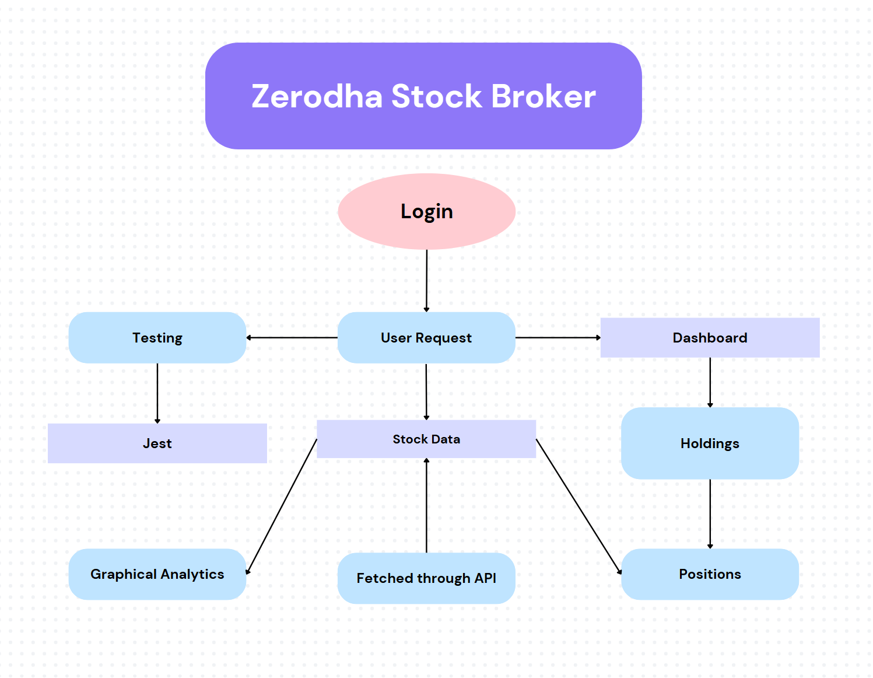

**Modules:**

1. ****User Authentication Module:****

* **Functionality: Handles user registration, login, and password management.**

****Features:****

* **Signup with email and password.**
* **Login with JWT-based authentication.**

****2. Stock Data Module****

* **Functionality: Fetches and displays real-time stock data.**

****Features:****

* **Search functionality for stocks by symbol or name.**
* **Display stock details (price, volume, historical data).**
* **Interactive stock charts using libraries like Chart.js or Recharts.**

****3. Dashboard Module****

* **Functionality: Provides an overview of the user’s portfolio and trading activities.**

****Features:****

* **Holdings: Displays stocks owned by the user.**
* **Positions: Shows open positions and profit/loss.**
* **Funds: Displays available balance and transaction history.**
* **Graphical Analytics: Visualizes portfolio performance using charts.**

****4. Testing Module****

* **Functionality: Ensures the application is reliable and bug-free.**

****Features:****

* **Unit testing for components and functions using Jest.**
* **Integration testing for APIs and third-party services.**

**Requirement:**

**Software Requirements:**

* **Programming Languages:** JavaScript,React, Node JS, Express Js, Jest.
* **Database:** MongoDB.
* **IDE**: Visual Studio Code.

**Hardware Requirements:**

* **RAM**: Minimum 8GB, Recommended 16GB.
* **Processor**: Intel i5/i7 or equivalent.
* **Storage**: Minimum 20GB (SSD recommended).

**Conclusion:**

The Zerodha Clone project successfully replicates the core functionalities of a stock trading platform using the MERN stack. The application provides a seamless user experience with features like secure authentication, real-time stock data, and an interactive dashboard. The use of modern frameworks like Material-UI and Bootstrap ensures a visually appealing and responsive design. With further enhancements, the application can evolve into a fully functional trading platform .

The Zerodha Clone project also emphasizes scalability and performance, ensuring that the platform can handle a growing number of users and real-time data demands efficiently. By leveraging third-party APIs for stock data and integrating robust backend systems, the application delivers accurate and up-to-date market information, empowering users to make informed investment decisions. Additionally, the project’s modular architecture and comprehensive testing using tools like Jest ensure reliability and maintainability, making it easier to add new features or scale the system in the future. With its user-centric design and cutting-edge technology stack, the Zerodha Clone project lays a strong foundation for a modern, feature-rich trading platform that can adapt to the evolving needs of investors.

**References:**

1. The Institute of Management and Economy Research, J.-H. Lee, S.-H. Son, and S.-K. Park, “Analyzing asset growth factors in the Korean stock market: A representativeness heuristics approach,” *The Institute Manag Econ Research*, vol. 15, no. 3, pp. 431–448, 2024.
2. E. R. McGrattan and E. C. Prescott, “Is the stock market overvalued?,” Q. Rev. - Fed. Reserve Bank Minneap., vol. 24, no. 4, 2024.
3. R. K. Aggarwal and G. Wu, “Stock Market Manipulations,” J. Bus., vol. 79, no. 4, pp. 1915–1953, 2023.
4. P. Manuel Nogueira Reis, A. Pedro Soares Pinto, and A. Guimaraes, “The influence of consumer, manager, and investor sentiment on US stock market returns,” Invest. Manag. Fin. Innov., vol. 22, no. 1, pp. 231–256, 2025.

**Online Links:**

* **React.js Documentation:** https://react.dev/
* **Material-UI Documentation**: https://mui.com/materialui/?srsltid=AfmBOoomQA9Wb7NM2XfOlEGBZvjBJJMvRaaKXMp_VneTEMxKc_Jc9BnK
* **Bootstrap Documentation:** https://getbootstrap.com/docs/5.3/getting-started/introduction/

**Class:** TY **Div:C**

**Group Member Names:** **Sign**

1. Sahil Vilas Gawade.

2. Prathamesh Sachin Pawar.

3. Saurabh Laxman Karande.

4. Aditya Raghunath Kakade.

**Date:**

**Place:**

Miss. Meghana Bandiwadekar Miss Meghna Bandiwadekar Miss Raddheka Dhanall

**Sign of Guide Sign of Project Coordinator Sign of HOD(CSE)**