**Sort 0,1,2**

A1 : Sort the array

A2 : take 0 1 2 count and create array according to counts O(2N)

A3 :

**Dutch National Flag Algo**

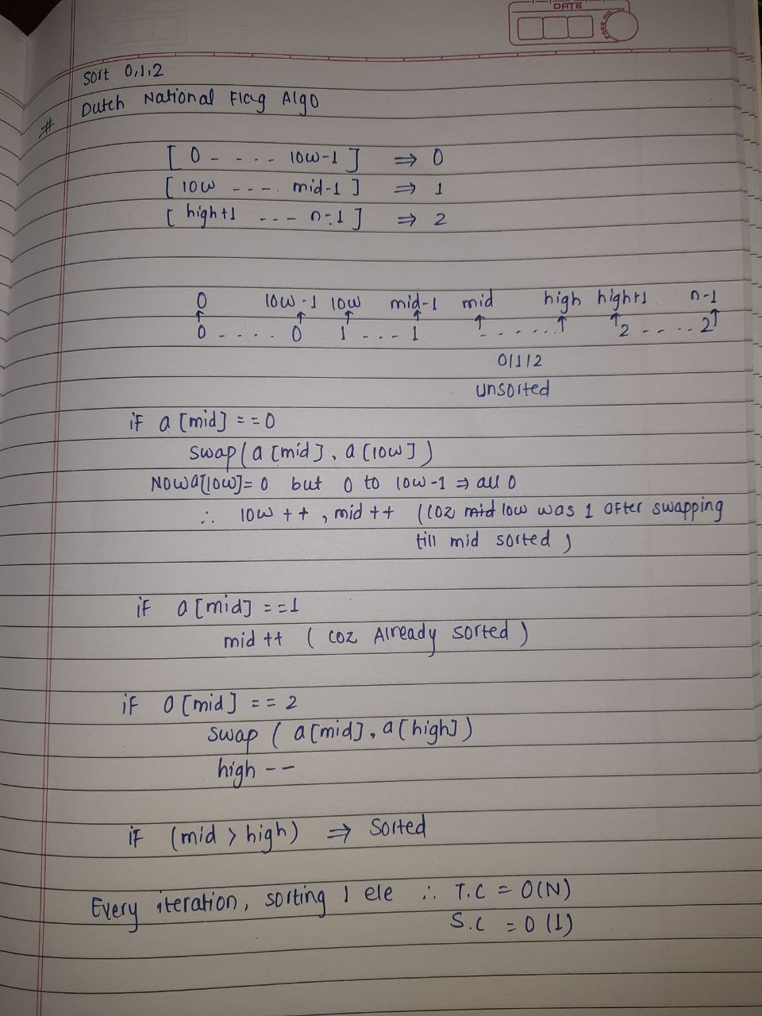

**Majority Elements ( freq of ele > n/2 )**

A1 : Direct compare O(**N2**)

A2 : store freq in map and compare TC : NlogN + N SC N

A3:

**Moore's Voting Algorithm**

Take the element if matches c++ if not c—if c=0 start with new element

And the last element will be your majority element

TC : O(N+N) another N is for checking if not N only

**Maximum SubArray Sum**

A1 : Traverse thro all subarrays and find max sum O(N3) and to O(N2)

A2 :

**Kadane's Algorithm**

If sum<0 sum=0 if sum>0 add the elements and keep tracking maximum