DD-Airline Booking System  
BACKEND

Objective:  
We need to build a backend system that can support diff features for an airline booking system. Our end user is going to be someone who can book flights and query about the flights so we need to robust system to actually help the best experience possible   
we will mainly focus on the backend. We want to prepare the whole backend keeping in the mind that code base should be as maintainable as possible

Requirements :

Functional Requirements:

-User should be able to search for the flights from one place to another

-User should be able to mention the src and dest details   
 -User should be able to select the date of the journey

-[V2] User should be able to search for the return flights and

Multicity flights   
 -User should be able to select the class of the flight

-User should be able to select the no of seats they want to book

-Now based on above data we will list down the flights

-We should show our users the best available flights on the top based on duration and price .

- We need to support the pagination

-we should support the filters based on the price , duration , airlines , etc.

-A User should be able to book a flight considering that user is registered on the platform

-[V2]Seat slection

-User should be cancel the booking   
 -there should be return of money with some deductions

-User should be able to book for the excess luggage for every flight

-Tracking flight prices should be possible. User should be notified about any price drops or delays

- For making the booking , payment should be there which will be dummy in this project

-User should be able to list the prev and upcoming flights

-User should be able to download boarding pass if they have the booking

-Online checkin mechanism should be there

-Notifications via email for completing online check in before 3 hours of departure

-Notifications about any delays

-User should be able to review the flight journey if and only if they have booking in that flight

-Revies mechanism -> star rating , comments

-While displaying the list of the flights show them with the reviews by the other ones

-Authentication using email and pass

-FAQ with static data

-Person can reserve more than one seats .

Non-Functional Requirements:

-We can expect that we are going to have more flight searches than flight bookings

-System needs to be accurate in terms of booking

-Expect that we will be having approx. 1 lakh total users , 2 lakh bookings may come up in one quarter

-So in one day we can expect 2000 bookings

-System should be capable of scaling up 3x of the current estimated traffic

-Real time updates for the flight bookings in the price and duration

-Concurrency should be handled , using RDBMS

Capacity Estimations :

-Storage Estimation:

-For upcoming 5 yrs , 40 lakh bookings , 2 lakh users   
 (overall 1 TB of data may require )

-Traffic Estimations:

-consider the search : booking ration be 10:1 (at max)

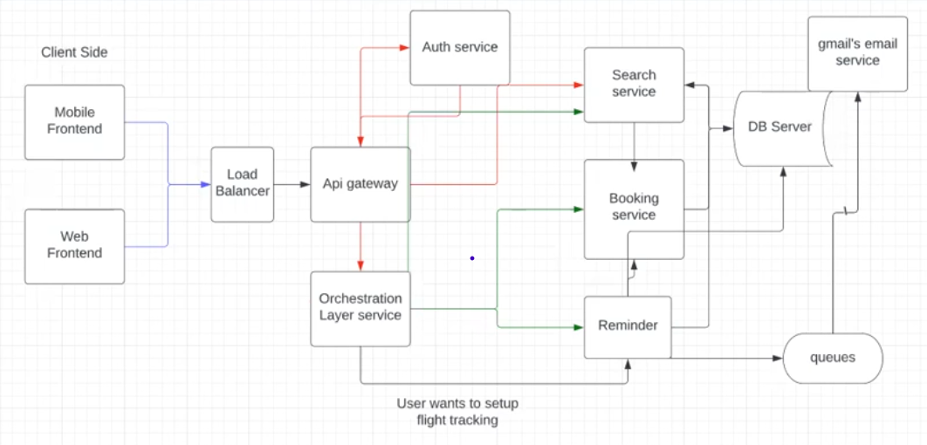

Search and Flights Services:

-Create Flights   
 -Delete Flights

-Search Flights

-pagination

-based on multiple criteria

-update flights

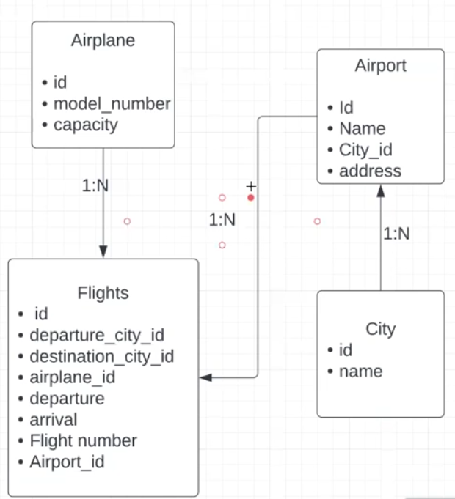

Flight Search Database