Hive

Question 1:

Q1)

Select distinct(src_airport_iata) from routes where src_airport_iata not in (select distinct(dest_airport_iata) from routes)

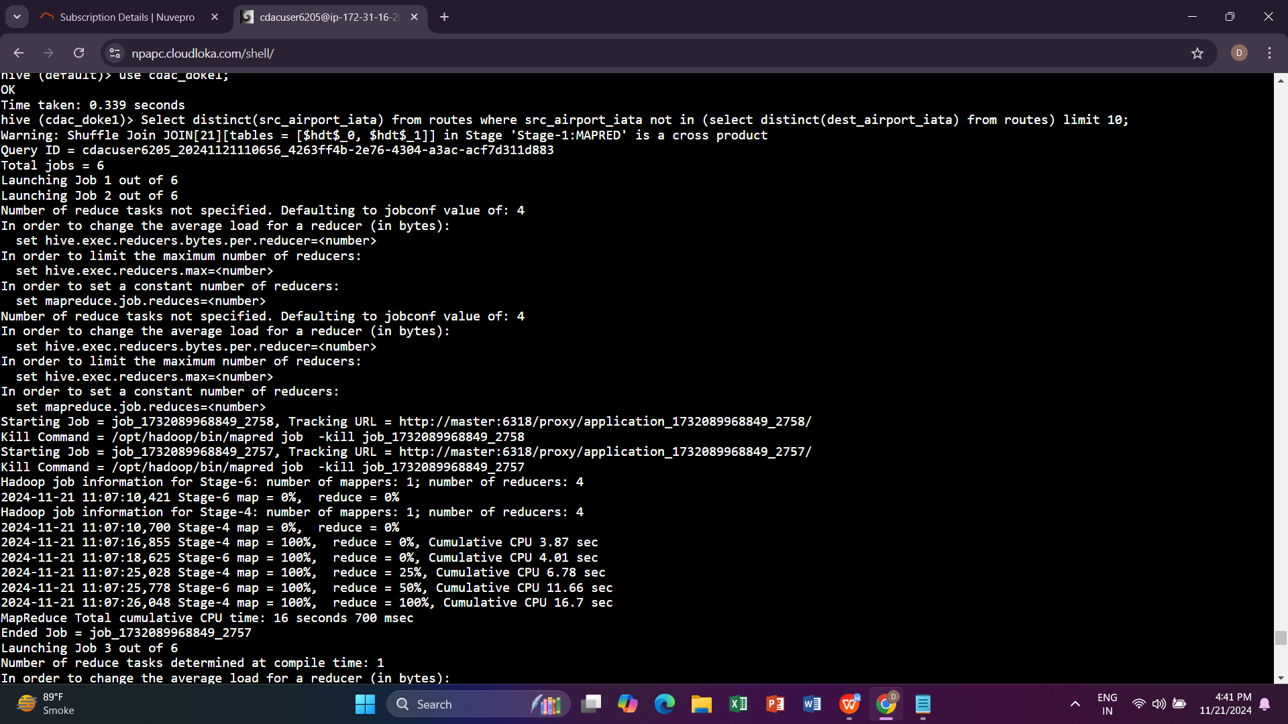

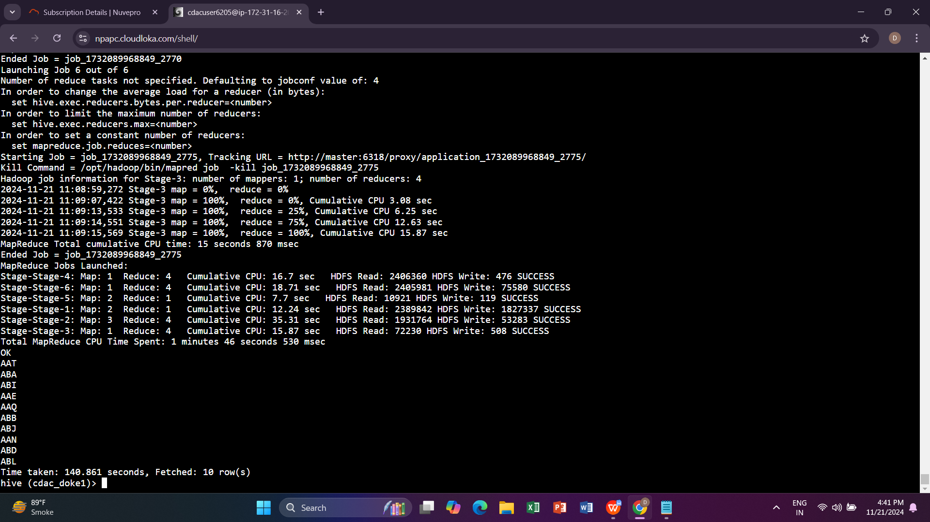

Q2)

Select count(distinct(airline_id) from airlines a join routes r on a.airline_id=r.airline_id;

Q3)

Select count(distinct(equipment)) from routes

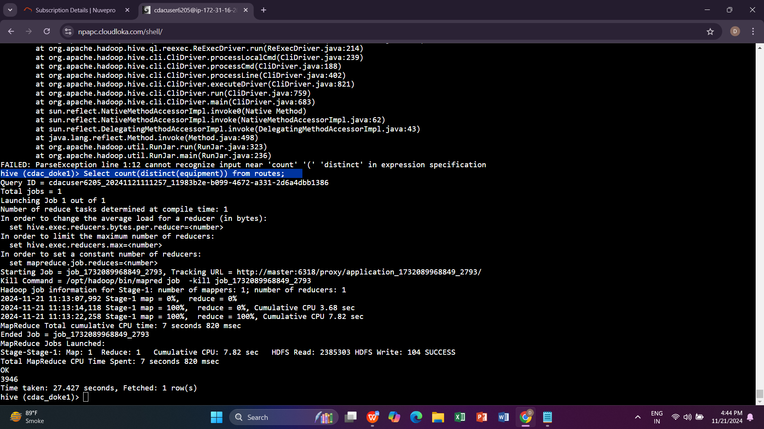

Question2:

Q1)

Create table routes_partitioned (airline_iata string, airline_id int ,src_airport_iata string, src_airport_id int ,dest_airport_iata string ,dest_airport_id int , codeshare string ,stops int,equipment string)

PARTITION (dest_airport_iata string)

row format delimited

Fields terminated by ‘,’

Stored as textFile;

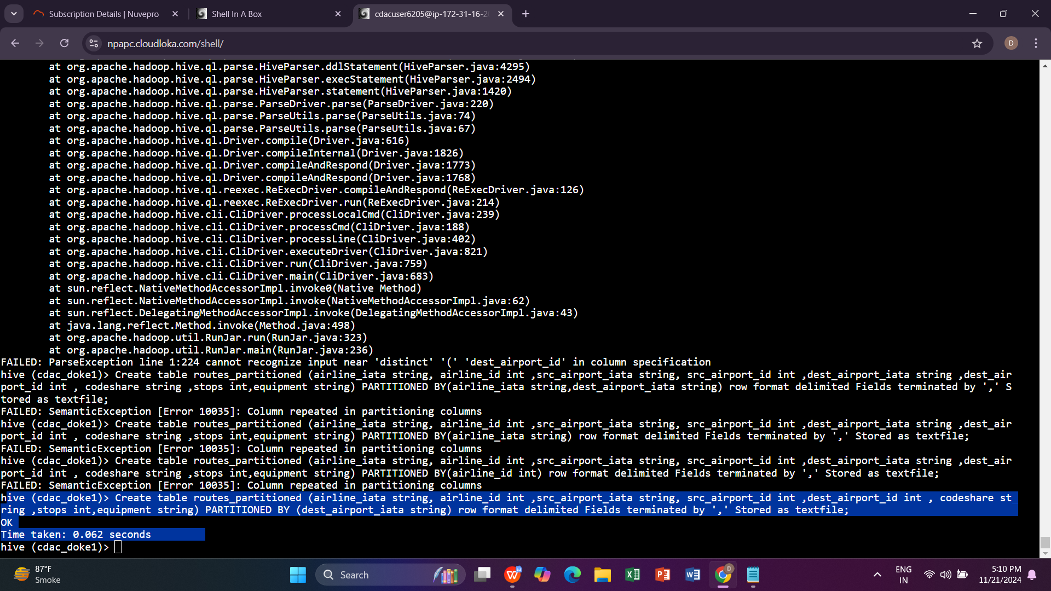

2)

insert overwrite table routes_partitioned partition(dest_airport_iata) select r.airline_iata ,r.airline_id r.,src_airport_iata, r.src_airport_id r.,d

esinsert overwrite table routes_partitioned partition(dest_airport_iata) select r.airline_iata ,r.airline_id r.,src_airport_iata, r.src_airport_id r.,d

est_airport_id ,r.codeshare ,r.stops,r.equipment ,r.dest_airport_iata from routes r where upper(r.dest_airport_iata)="ORD";

Q3)

Select * from routes_partitioned where dest_airport_iata=”ORD”

Q4)

Pyspqrk

Q1)

1.

>>> df.filter(df.booked_seats>20000 & df.booked_seats < 50000 ).show()

Server error

2.

Q2) DF

1. df.groupBy("Year","Quarter").agg(min(df.booked_seats)).limit(1).show()

>>> df.groupBy("Year","Quarter").agg(max(df.booked_seats)).limit(1).show()

>>> df.groupBy("Year","Quarter").agg(avg(df.booked_seats)).show()

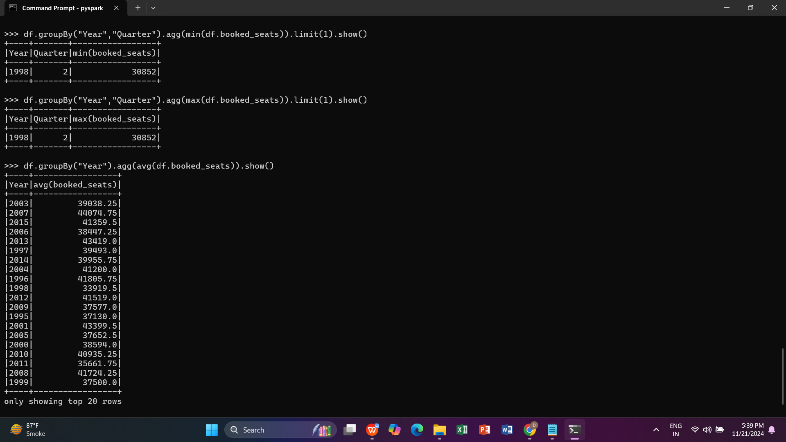

Q2)>>> df.where(df.Avg_rev_per_seat<290).count()

>>> df.where(df.Avg_rev_per_seat<290).show()

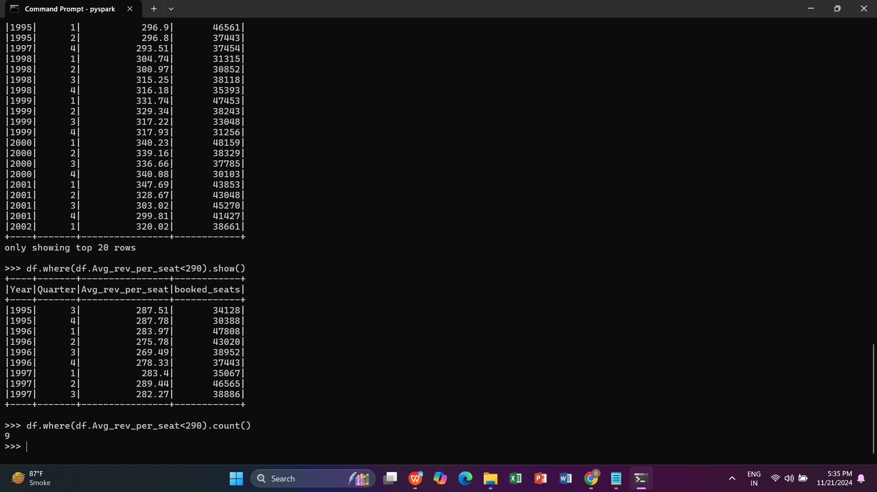

Q 3)

>>> df.groupBy("Year","Quarter").agg(avg(df.booked_seats)).show()

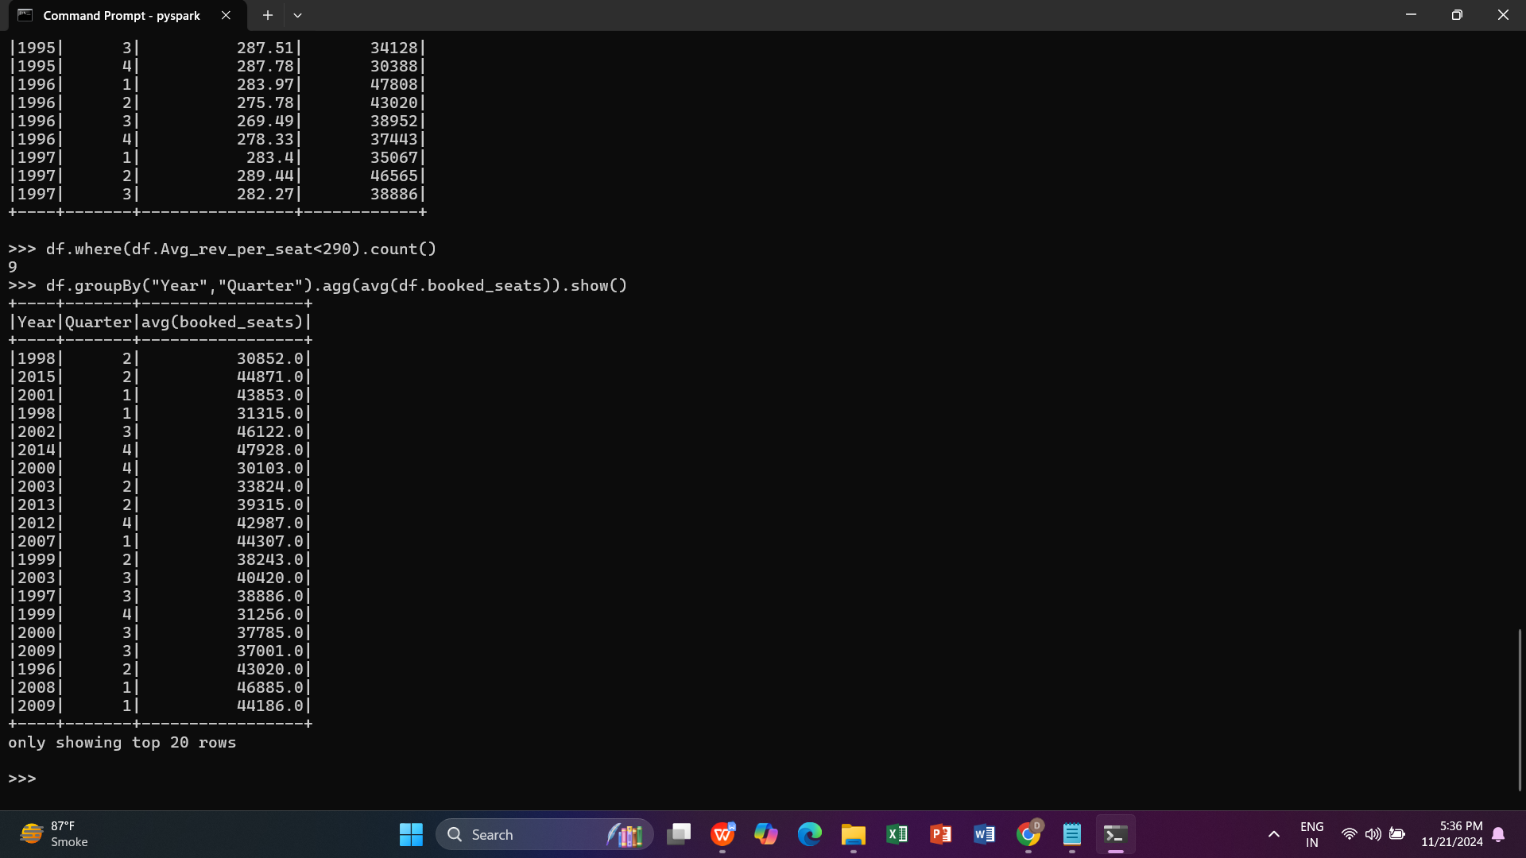

4)

>>> df.groupBy("Year").agg(count("Quarter")).show()

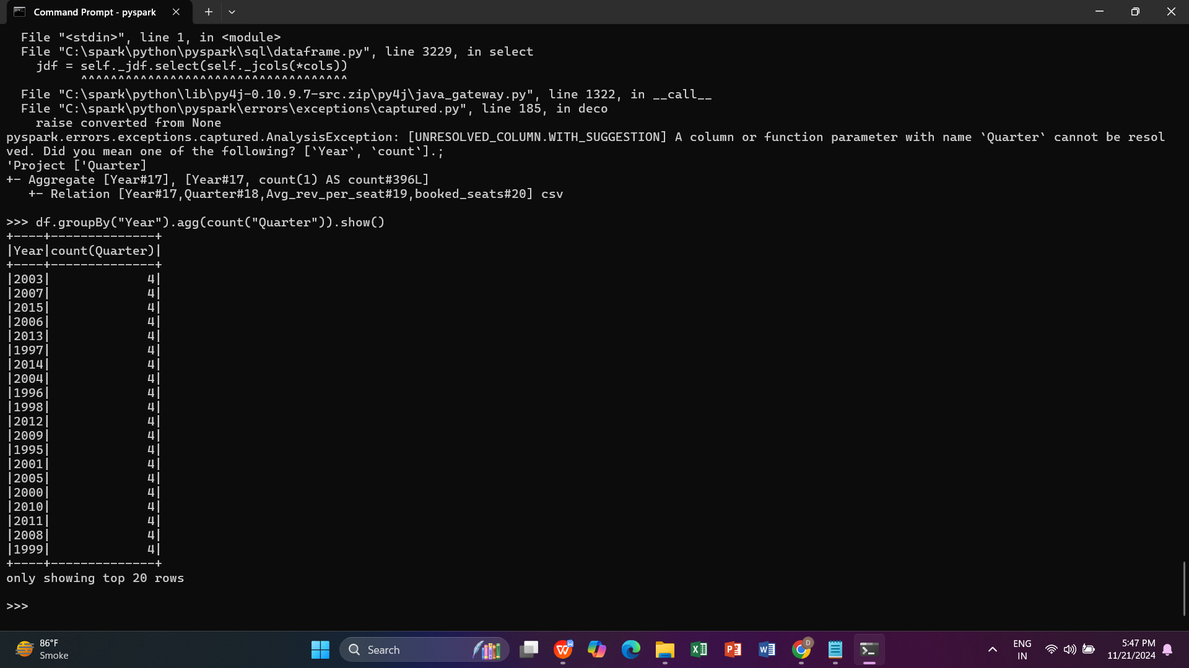

Q5)

>>> df.groupBy("Year""Quarter").agg(max(booked_seats * Avg_rev_per_seat)).alias("highest_revenue").show()