**Login and register. Done.**

1. **Login:** [**http://localhost:3000/users/signin**](http://localhost:3000/users/signin)

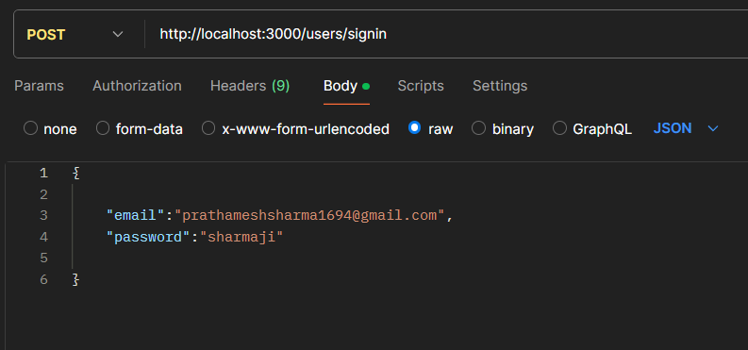

1. **Register: http://localhost:3000/users/signup**

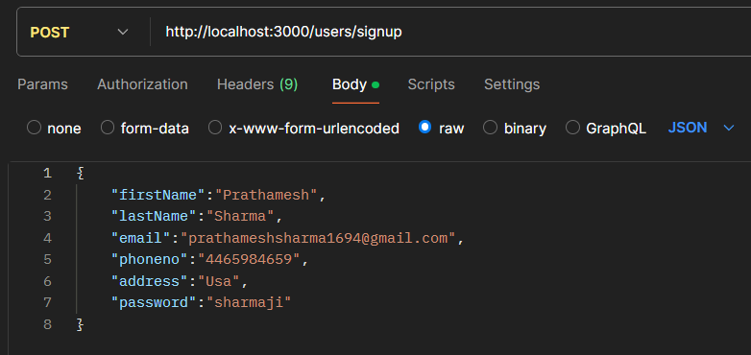

1. **Get All Quotes:** [**http://localhost:3000/quote**](http://localhost:3000/quote)