**Synopsis**

-Prathamesh Patil

SAI&D02

**Title:** “**Automated Term work Assessment**” using C++

**Data Structure Used :**  Hash table, Arrays

**Introduction:**

Automated term work assessment is a system where teachers can enter all the academic activities held during the semester such as lecture attendance, unit tests, assignments submission, mock practical, prelims for the student. In this system, all the data related to student is entered and on the basis of that term work for the student for that respective semester is calculated automatically and stored in hash table on the basis of roll number. In this system, teacher can calculate and store data of whole class of all subjects at a time and retrieve it anytime easily to check the performance.

**Description:**

The coding language used to execute the system is c++ and the data structure used is Hash table and the hashing method used is direct hashing.

* **C++: -** C++ is a s a general-purpose programming language created by Bjarne Stroustrup as an extension of the C programming language, or "C with Classes". The language has expanded significantly over time, and modern C++ now has object-oriented, generic, and functional features in addition to facilities for low-level memory manipulation.
* **Hash table: -** Hash table (Hash map) is a data structure that implements an associative array abstract data type, a structure that can map keys to values. A hash table uses a hash function to compute an index, also called a hash code, into an array of buckets or slots, from which the desired value can be found.
* **Direct Hashing:** - In direct hashing the key is the address without any algorithmic manipulation and the key is directly considered index of the array.

**Algorithm:**

1. **Start.**
2. **Initialize Hash Table with NULL values: -**  As Hash Table is implemented using arrays. At the beginning all the hash table slots are initialized to NULL values for easier manipulation in the runtime of the program.
3. **Select operation:-** A set of operations are given among which user can select the required one and the system throughout its runtime iterates through this loop.
4. **Input basic information about all subjects for the semester :-** Here all the information related to subject throughout the semester is taken from teacher like the number of lectures conducted, assignments given, unit test conducted. Go to step 3.
5. **Inserting student data for the subjects *: -*** In this part all the student information like name, roll number, and subject related information like marks obtained in prelims, number of lectures attended for all the subjects is taken and the term work is calculated accordingly and stored in the hash table to the corresponding roll number of the student using direct hashing. Go to step 3.
6. **Display data of a particular student:-**  Here if the data of particular student is required, roll number of the student can be taken as an input and if the data is present corresponding data is displayed on the screen else if not present “Data not present ” is displayed. Go to step 3.
7. **Display all student data:-** The data of the whole class can be displayed using this function, if the data is not present “Data not available is displayed”. Go to step 3.
8. **Delete records of student :-** If the records of a particular student are to be deleted from the hash table, the data at that position of hash table is set to NULL. Go to step 3.
9. **Quit:** To exit the system, this option can be selected.
10. **End**

**Flowchart:**

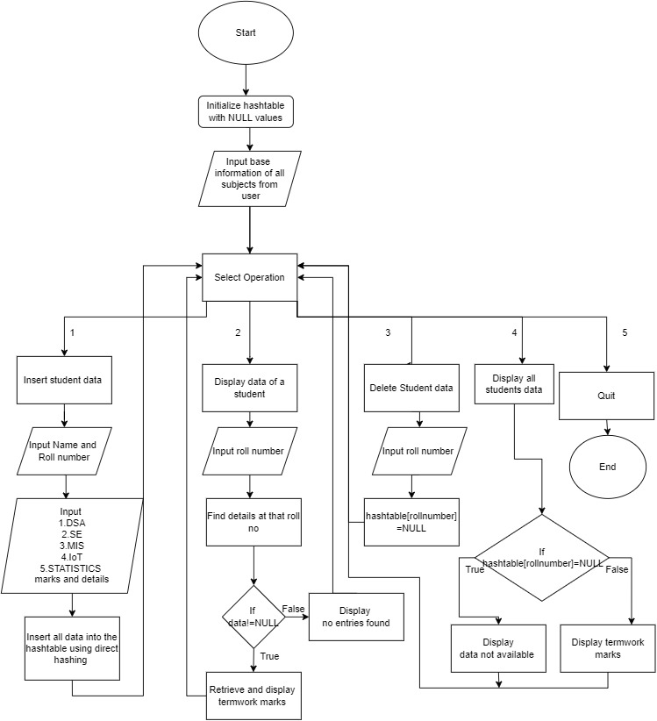

**Conclusion:**

This system can be used by any teacher of any college/school for automatic term work assessment of a student’s performance for a particular semester without performing any calculations manually. Teacher just has input student performance and the term work will be calculated and stored. The added benefit of using this automated system is that the performance of the whole can be stored at a single place and accessed directly without going through bunch of papers.

**References:**

[**https://www.w3schools.com/**](https://www.w3schools.com/)

**https://www.geeksforgeeks.org/**

**Source Code/Github link of the project: -**

https://github.com/Prathamesh2642/DSA-MINI-PROJECT/blob/main/Automated_termwork_assessment.cpp