Results:

I have compiled the results I got after at certain number of epochs.

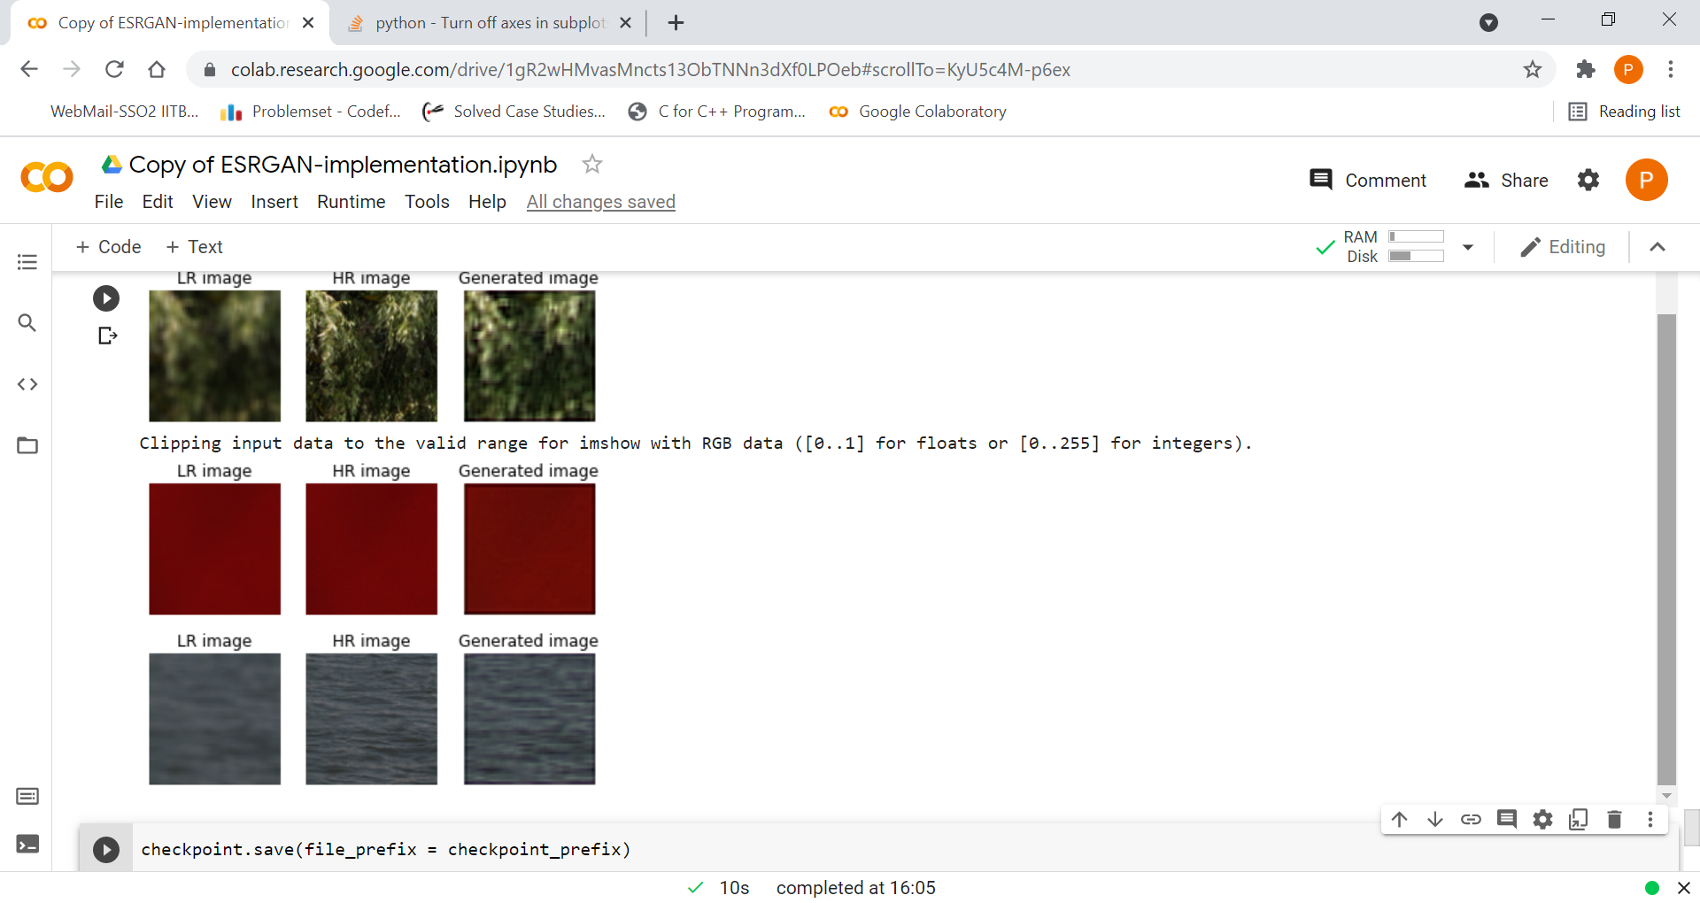After about 10 epochs or so (lines started becoming prominent)

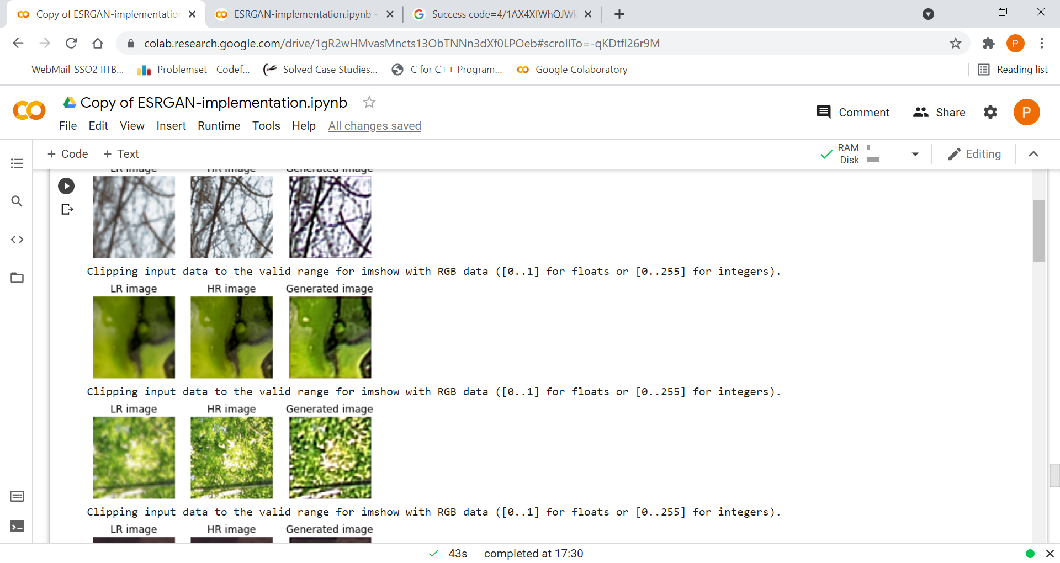After many epochs:

Some nice results I got on the way of training , though not all images were as clear:

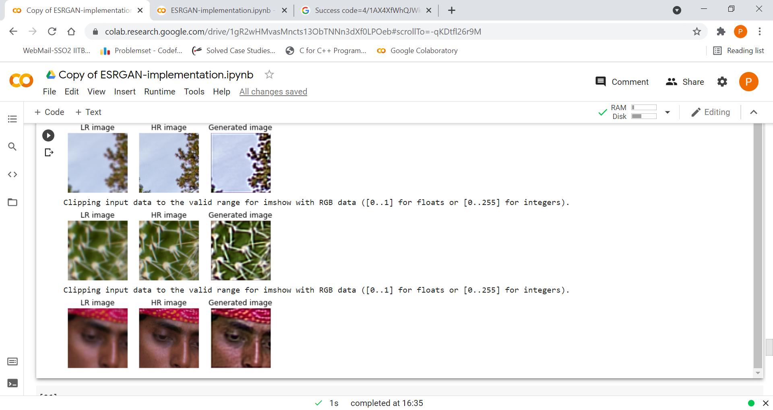The highly clear(seeming) image

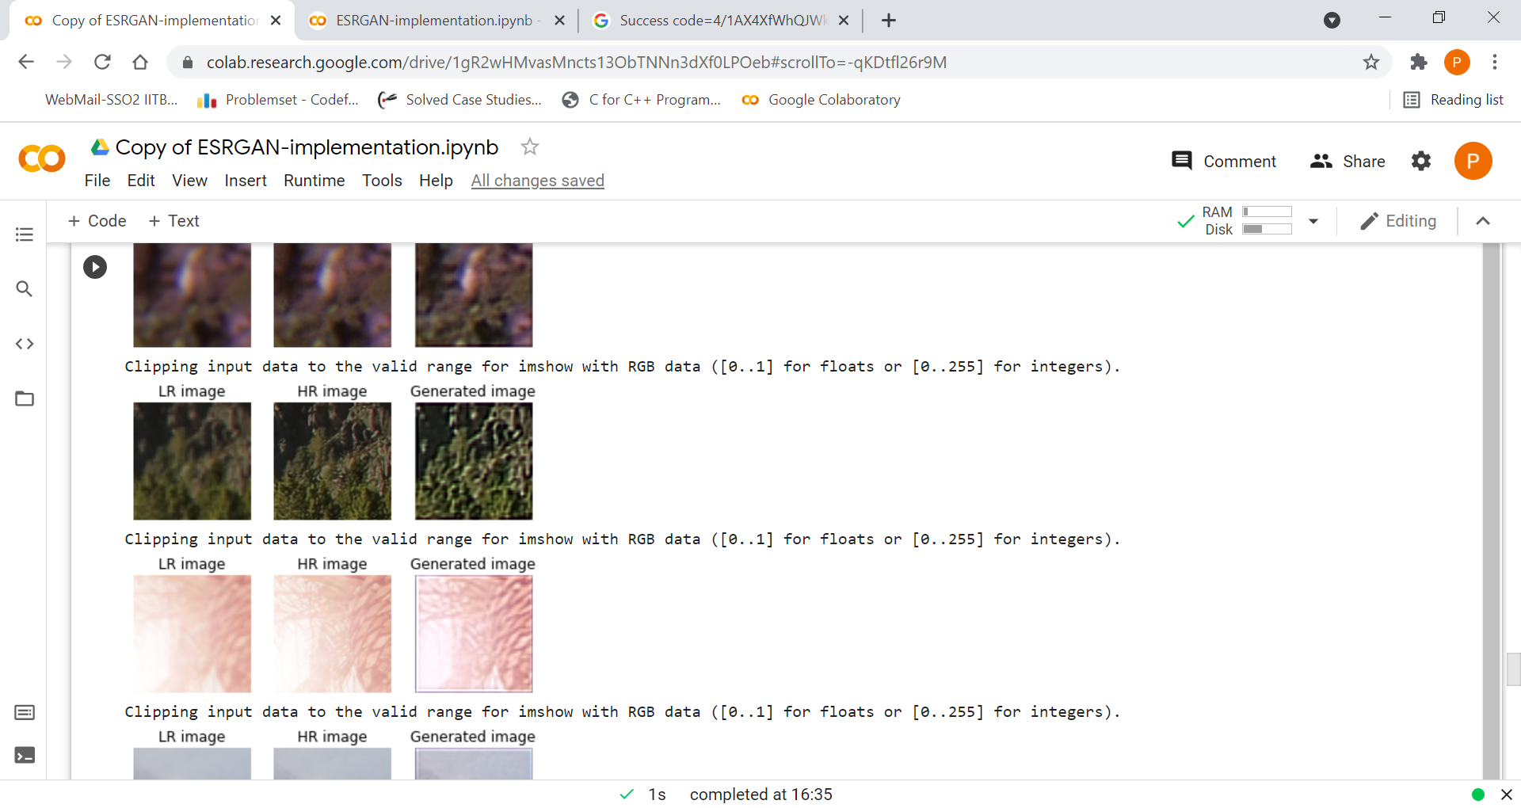Not always had the clarity as much as above: