FOR CLIENTS AND PARTNERS
Resort OS — Product Overview
One system to run an Indian resort: rooms and dormitory beds, bookings, front desk, GST billing, restaurant, staff and more.

Edition | Version 1.10
Date | 20 October 2026
Covers | Sprints 01, 02, 03, 04, 05, 06, 07, 08, 09, 10 accepted · Sprint 11 Razorpay in progress
Prepared by | Prathamesh, product owner, Resort OS
Classification | Confidential

Features marked as planned are part of the agreed roadmap and are delivered sprint by sprint; the roadmap section shows the status of each.

Document control
Version | Date | Change
1.10 | 2026-10-20 | Sprint 10 (Payments, refunds, cash drawer) accepted: cash, UPI, card and bank payments on the bill or on account, refunds with a reason that can never exceed the payment, voids, the cash drawer opened and closed against a count with manager approval of a shortfall, no card data stored, real balances at check-out. Payment flow diagram. Sprint 11 (Razorpay) started.
1.9 | 2026-10-20 | Sprint 09 (GST configuration and tax engine) accepted: GST worked out on every charge (CGST + SGST or IGST), rates kept as rules with dates that an accountant changes from next month without a software update, room GST by the price per room per night, posted charges keep their GST. Tax flow diagram. Sprint 10 (Payments, refunds, cash drawer) started.
1.8 | 2026-10-18 | Sprint 08 (Folio) accepted: a running bill for every stay with room nights, meals, transport, activities and packages; nothing can be edited or deleted, a manager reverses a line with a reason; bills can be split; the front desk shows the real balance. Folio flow diagram. Sprint 09 (GST configuration and tax engine) started.
1.7 | 2026-10-18 | Sprint 07 (Front desk) accepted: arrivals, departures and in-house lists, check-in and check-out in a few clicks, walk-ins on one screen, early departures with a reason, rooms marked dirty and ready. Check-in flow diagram. Sprint 08 (Folio) started.
1.6 | 2026-10-17 | Sprint 06 (Reservation calendar) accepted: day, week and month calendar of rooms and dorm beds, moving a guest by drag-and-drop with a reason, list by day on phones. Room-move flow diagram. Sprint 07 (Front desk) started.
1.5 | 2026-10-15 | Sprint 05 (Availability engine and reservations) accepted: race-free booking, booking wizard, booking history, date pickers. Diagrams of the reservation tables and the booking flow. Sprint 06 (Reservation calendar) started.
1.4 | 2026-10-14 | Sprint 04 (Rate plans and packages) accepted: nightly price grid, quotes, packages with revenue split. Sprint 05 (Availability engine and reservations) started.
1.3 | 2026-10-11 | Sprint 03 (Guests) accepted, with review fixes: Aadhaar number check and error messages that say why. Sprint 04 (Rate plans and packages) started.
1.2.1 | 2026-10-10 | Sprint 03 (Guests) built and in review: guest profiles, encrypted ID documents, duplicates, merge, anonymise, consent.
1.2 | 2026-10-10 | First edition. Sprints 01 (Foundation) and 02 (Accommodation) accepted; Sprint 03 (Guests) started.

Document | Resort OS — Product Overview
Audience | Resort owners and managers, prospective clients, partners and investors. No technical knowledge needed.
Status | Living document, rebuilt at the end of every sprint. This edition reflects Sprint 10 accepted and Sprint 11 in progress.
Owner | Prathamesh, product owner
Distribution | May be shared with clients and partners. Contains no passwords, keys or personal data.

Contents
1 Executive summary
2 Why Resort OS
3 What Resort OS does
3.1 Foundation
3.2 Rooms and reservations
3.3 Front desk and guests
3.4 Billing, GST and payments
3.5 Housekeeping and maintenance
3.6 Restaurant, stock and purchasing
3.7 Staff and attendance
3.8 Guest experiences
3.9 Control and reports
3.10 Connections
4 A guest's journey through Resort OS
5 Who uses it
6 Built for India
7 Security and data protection
8 Technology in brief
9 Available today
9.1 Sprint 01 — Foundation
9.2 Sprint 02 — Accommodation
9.3 Sprint 03 — Guests
9.4 Sprint 04 — Rate plans and packages
9.5 Sprint 05 — Availability engine and reservations core
9.6 Sprint 06 — Reservation calendar
9.7 Sprint 07 — Front desk
9.8 Sprint 08 — Folio
9.9 Sprint 09 — GST configuration and tax engine
9.10 Sprint 10 — Payments, refunds, cash drawer
9.11 In progress: Sprint 11 — Razorpay
10 Delivery roadmap
10.1 Every sprint
11 How we deliver
12 Running costs
13 Glossary

1 Executive summary
Resort OS is a complete operating system for a resort in India. It brings reservations, rooms and dormitory beds, the front desk, guest billing with GST, payments, housekeeping, the restaurant and kitchen, stock and purchasing, staff and attendance, activities, the beach shuttle, expenses and reports into one application with one database, used by every member of staff on a computer, tablet or phone.
It is designed around how an Indian resort actually works: GST with CGST/SGST and IGST, UPI and Razorpay payments, WhatsApp messages to guests, guests who book a whole room or a single dormitory bed, ID rules for foreign nationals, and accounts that end up in Zoho Books or Tally.

32  modules in one system | 17  ready-made staff roles | 10 of 29  build sprints delivered | ₹0  running cost while in development

Who it is for | Resort owners, general managers and every staff role: reception, housekeeping, kitchen and restaurant, stores, accounts, HR, drivers and activity staff.
How staff use it | In a web browser on any computer, tablet or phone. No installation; it can be added to a phone's home screen like an app.
What makes it different | One guest record, one bill and one audit trail across every department, and the rules (GST, no double-booking, who may see ID documents) enforced by the system rather than by memory.
Where it stands today | Sprints 01 and 02 and 03 and 04 and 05 and 06 and 07 and 08 and 09 and 10 are delivered and accepted. Sprint 11 (Razorpay) is in progress.

In one sentence
A resort team should be able to run the whole property, from the first booking enquiry to the GST invoice and the month-end report, without re-typing anything into a second system.

2 Why Resort OS
Most small and mid-sized resorts run on a patchwork: a booking register or spreadsheet, the OTA extranets, a separate restaurant billing machine, invoices typed by hand, staff attendance on paper and guest communication on personal WhatsApp. Each tool works on its own; the trouble is in the gaps between them.
Today, typically | With Resort OS
The same booking is typed into the register, the OTA extranet and the invoice | A booking is entered once; the bill, the room calendar, housekeeping and the invoice all use it
Two people sell the last room at the same moment | The system refuses the second booking; a room or a dorm bed can never be double-sold
Restaurant bills for in-house guests are carried to reception on paper | Orders are charged straight to the guest's room bill
GST rates and invoice numbers are worked out by hand | GST is calculated per line from the configured rules; invoice numbers follow the legal series
Guest ID copies sit in a drawer or on a phone | ID documents are stored encrypted and only permitted roles can open them
Nobody can say who changed a price or cancelled a booking | Every change is recorded: who, when, from which device, what changed and why
Month-end numbers take days to put together | Occupancy, revenue, GST, food cost and staff hours are reports, not projects

3 What Resort OS does
Resort OS is organised in ten areas that share one foundation. The picture shows them all, with when each arrives; the pages that follow describe what each area gives the resort.
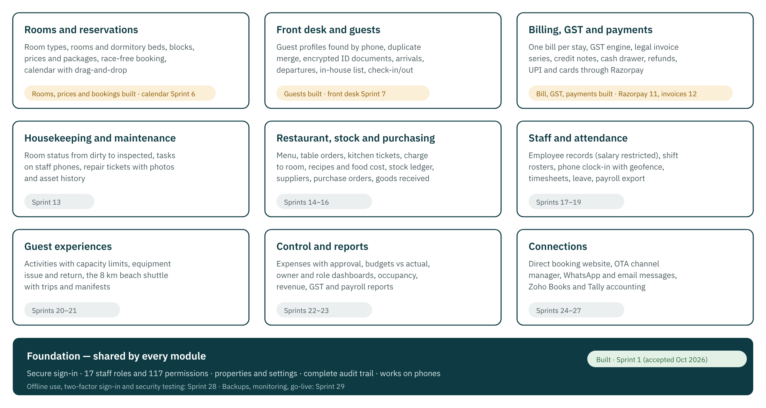
The ten areas of Resort OS and when each is delivered

3.1 Foundation
Everything else is built on this: who can sign in, what each person may do, which properties exist, and a permanent record of every change.
Sprint | What it gives the resort | Status
01 | Staff sign in securely, each person sees only what their role allows, the owner manages properties and staff accounts, and every change is recorded in an audit trail. | Done
28 | The staff app keeps working through poor connectivity, managers use two-factor sign-in, and the system passes an OWASP security check. | Planned
29 | The system goes live with backups, monitoring, alerts and a tested recovery plan, and passes the final acceptance tests. | Planned

3.2 Rooms and reservations
The resort's inventory (rooms and individual dormitory beds), its prices, and bookings that can never double-sell a room or a bed.
Sprint | What it gives the resort | Status
02 | The resort's rooms and dormitory beds are set up in the system, can be taken out of sale for repairs or owner use, and their status is visible at a glance. | Done
04 | Managers set room and bed prices by date, weekend rates and packages (for example room + breakfast), and get an instant price quote for any stay. | Done
05 | Bookings for rooms and dorm beds are taken without double-booking, even when two people book the last room at the same moment. | Done
06 | A calendar shows every room and bed with its bookings by day, week or month; bookings can be moved by drag-and-drop with safety checks. | Done

3.3 Front desk and guests
One record per guest, fast look-up by phone, and check-in and check-out in a few clicks.
Sprint | What it gives the resort | Status
03 | Reception keeps one clean record per guest, finds returning guests by phone in one search, and stores ID documents encrypted and visible only to permitted staff. | Done
07 | Reception checks guests in and out in a few clicks, with today's arrivals, departures and in-house guests on one screen. | Done

3.4 Billing, GST and payments
One running bill per stay, GST worked out correctly for every line, payments by any method, and legally numbered invoices.
Sprint | What it gives the resort | Status
08 | Every stay has one running bill (folio) that collects room charges, meals, activities and transport. | Done
09 | GST is calculated automatically and correctly for each item (CGST/SGST or IGST), with rates kept up to date by configuration, not code. | Done
10 | Cash, UPI, card and bank payments are recorded against the bill, refunds are controlled, and the cash drawer balances at shift end. | Done
11 | Guests pay online with UPI and cards through Razorpay; payment links can be sent before arrival. | In progress
12 | Legally numbered GST invoices are produced from the bill; corrections are made only through credit and debit notes. | Planned

3.5 Housekeeping and maintenance
Room readiness and repairs managed from staff phones.
Sprint | What it gives the resort | Status
13 | Housekeeping and maintenance staff see their tasks on their phones, update room status, and report repairs with photos. | Planned

3.6 Restaurant, stock and purchasing
Food and beverage from order to kitchen to the guest's bill, with stock and food cost under control.
Sprint | What it gives the resort | Status
14 | The restaurant takes orders by table, sends tickets to the kitchen, and charges in-house guests directly to their room. | Planned
15 | Stock is tracked as it is used, recipes give the real food cost per dish, and wastage is recorded. | Planned
16 | Purchasing runs from request to purchase order, goods received, supplier invoice and payment. | Planned

3.7 Staff and attendance
Employee records, rosters, phone clock-in at the resort, leave and payroll input.
Sprint | What it gives the resort | Status
17 | Staff records (with salaries visible only to authorised people) and weekly shift rosters with clash warnings. | Planned
18 | Staff clock in and out on their phones at the resort, and timesheets are approved by managers. | Planned
19 | Leave requests check balances and cover; holidays and approved hours flow into a payroll export file. | Planned

3.8 Guest experiences
Activities, equipment and the beach shuttle, booked within real capacity.
Sprint | What it gives the resort | Status
20 | Activities are booked within capacity, and equipment (kayaks, snorkels, bicycles) is issued and returned with a record. | Planned
21 | The beach shuttle runs on scheduled trips with seat limits, drivers and passenger lists. | Planned

3.9 Control and reports
Spending under approval and budget, and the numbers owners and managers need every day.
Sprint | What it gives the resort | Status
22 | Expenses are captured with receipts and approval, and spending is compared with the budget. | Planned
23 | Owners and managers get dashboards and reports: occupancy, revenue, GST, food cost, staff hours and more. | Planned

3.10 Connections
The outside world: WhatsApp and email, accounting, online travel agents and the resort's own booking website.
Sprint | What it gives the resort | Status
24 | Guests and staff receive WhatsApp and email messages from templates (confirmations, reminders, invoices) with delivery tracking. | Planned
25 | Accounts sync automatically to Zoho Books, with a Tally export option, without duplicate entries. | Planned
26 | Bookings from Booking.com, MakeMyTrip and other channels arrive automatically through a channel manager, and availability is pushed back. | Planned
27 | Guests book and pay directly on the resort's own website, saving OTA commission. | Planned

4 A guest's journey through Resort OS
The best way to see how the modules fit together is to follow one guest from booking to invoice. Every step below reads from and writes to the same guest record and the same bill.
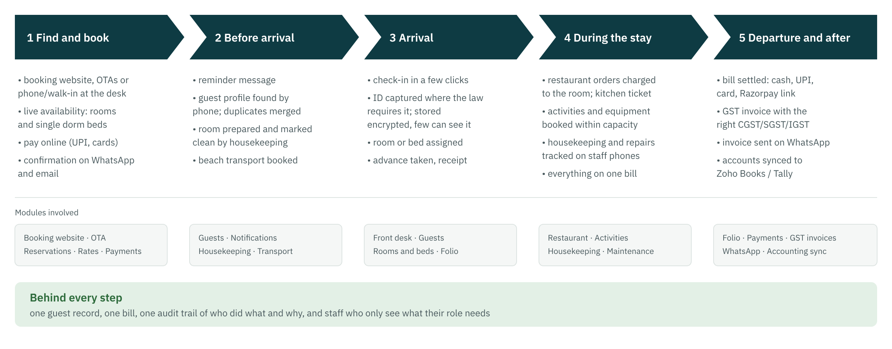
One stay, end to end
Moment | What the staff do | What Resort OS does for them
Booking | Take a phone booking, or receive one from the website or an OTA | Shows live availability, prices the stay, holds the room or bed, takes an advance, sends confirmation
Before arrival | Prepare the room, arrange the shuttle | Gives housekeeping the room list, books transport seats, sends a reminder
Check-in | Greet the guest, record ID where required | Finds the guest by phone, stores ID encrypted, assigns the room or bed, opens the bill
During the stay | Serve meals, run activities, fix problems | Charges orders and activities to the room, tracks housekeeping and repairs
Check-out | Settle the bill | Totals every charge, applies GST correctly, takes payment, issues the invoice and sends it on WhatsApp
After the stay | Close the day and the month | Balances the cash drawer, syncs accounts to Zoho Books or Tally, updates reports

5 Who uses it
Resort OS ships with 17 staff roles. Each role is a bundle of permissions (there are 117), and a person can hold a role for every property or for one property only. Screens and buttons a person is not allowed to use are simply not shown, and the server checks every request again, so a hidden button can never be a back door.
Role | What they do in Resort OS
Owner | Full access to the organisation
General Manager | Runs the property; no platform/integration settings
Manager | Duty manager across front office and operations
Receptionist | Front desk: bookings, check-in/out, payments
Housekeeping Supervisor | Assigns and inspects housekeeping
Housekeeper | Cleans rooms, reports issues
Restaurant Manager | Menu, POS, kitchen, F&B stock
Waiter | Takes orders, posts room charges
Kitchen | Kitchen display / KOT
Inventory Manager | Stock control
Purchasing | Suppliers and purchase orders
Accountant | Invoices, payments, expenses, financial reports
HR | Employees, attendance, leave, roster
Maintenance | Works maintenance tickets
Driver | Operates beach transfers
Activity Manager | Activities and equipment
Employee | Self-service only

Sensitive information stays with the right people
Guest ID documents, staff salaries, refunds, tax rules and the audit trail each need a dedicated permission. A waiter or a housekeeper cannot open a guest's ID scan; only the owner and HR see salaries.

6 Built for India
This is how the finished system handles each need. The roadmap section shows which sprint delivers each one.
Need | How Resort OS handles it
GST | CGST + SGST within the state and IGST across states, chosen per line from the property's GST state. Rates are configuration with effective dates, so a rate change does not need new software. Invoice numbers follow a legal series per financial year; cancellations go through credit notes.
Payments | Cash, UPI, card and bank transfer at the desk; online UPI and cards through Razorpay, where the payment confirmation from Razorpay's server, not the browser, is what counts.
Guest messages | WhatsApp Business and email from approved templates: confirmations, reminders, invoices, with delivery tracking.
Rooms and dormitory beds | A room type is sold either as a whole room or bed by bed, so a hostel-style dormitory and private rooms live side by side.
Guest identification | ID details are captured only where the law requires it (for example Form-C for foreign nationals), stored encrypted and deleted after the retention period the owner sets.
Local time and currency | All business dates follow the property's time zone (IST) and amounts are in rupees, stored exactly (no rounding drift).
Accounting | Invoices, payments and expenses sync to Zoho Books; a Tally export is available for accountants who use Tally.
Online travel agents | Booking.com, MakeMyTrip, Goibibo, Airbnb and others through one Indian channel manager.
Connectivity | The staff app is designed to keep working through a poor connection and catch up when it returns; money actions wait until it is back online.

7 Security and data protection
Security is built into every layer rather than added at the end. Nobody can honestly promise a system that cannot be attacked; what Resort OS does is make each layer hard to get past, keep any attempt visible, and test the controls on every change.
Protection | In practice
Sign-in | Strong password hashing, lock-out after 5 wrong attempts, temporary passwords that must be changed, and immediate sign-out when an account is deactivated or a password changes. Two-factor sign-in for owners, managers and accountants follows in Sprint 28.
Least access | Every action needs a specific permission; access can be limited to one property; nobody can give themselves more access than they hold.
Separation of resorts | Each organisation's data is invisible to every other, enforced on every database query.
Encryption | HTTPS everywhere; guest ID numbers and other sensitive fields are additionally encrypted inside the database (from Sprint 03).
Audit trail | Every change records who, when, from which device and IP address, the old and new values, and the reason. The trail cannot be edited or deleted, even directly in the database.
Money and bookings | Invoices, payments and stock movements are never edited or deleted; corrections are new entries. Repeated clicks or network retries never create duplicate bookings or payments.
Secrets | Passwords and service keys are never stored in the source code; they are held in the hosting provider's secret store and shared only with the people who run the system.
Backups | A managed database with point-in-time recovery, and a tested restore procedure, before the resort goes live.

8 Technology in brief
Resort OS uses mainstream, long-term-supported technology that many developers in India know, so the resort is never dependent on one person or one vendor.
Part | Technology | Why it matters to the resort
Server | Microsoft .NET 10 (long-term support) | Fast, secure, supported by Microsoft for years; runs on low-cost Linux servers
Database | PostgreSQL 16 | Open-source and free; the database itself enforces the rules that protect money and bookings
Staff app | Angular 20 with Material Design | One app for desktop, tablet and phone; installable like an app; clear, consistent screens
Payments | Razorpay | India's widely used gateway for UPI, cards and netbanking
Accounting | Zoho Books (Tally export) | Fits how Indian accountants already work
Messages | WhatsApp Business Platform, email | Reaches guests where they already are
Hosting | A small cloud server in an Indian region, managed database, Cloudflare in front | Data can stay in India; low monthly cost; protection against attacks
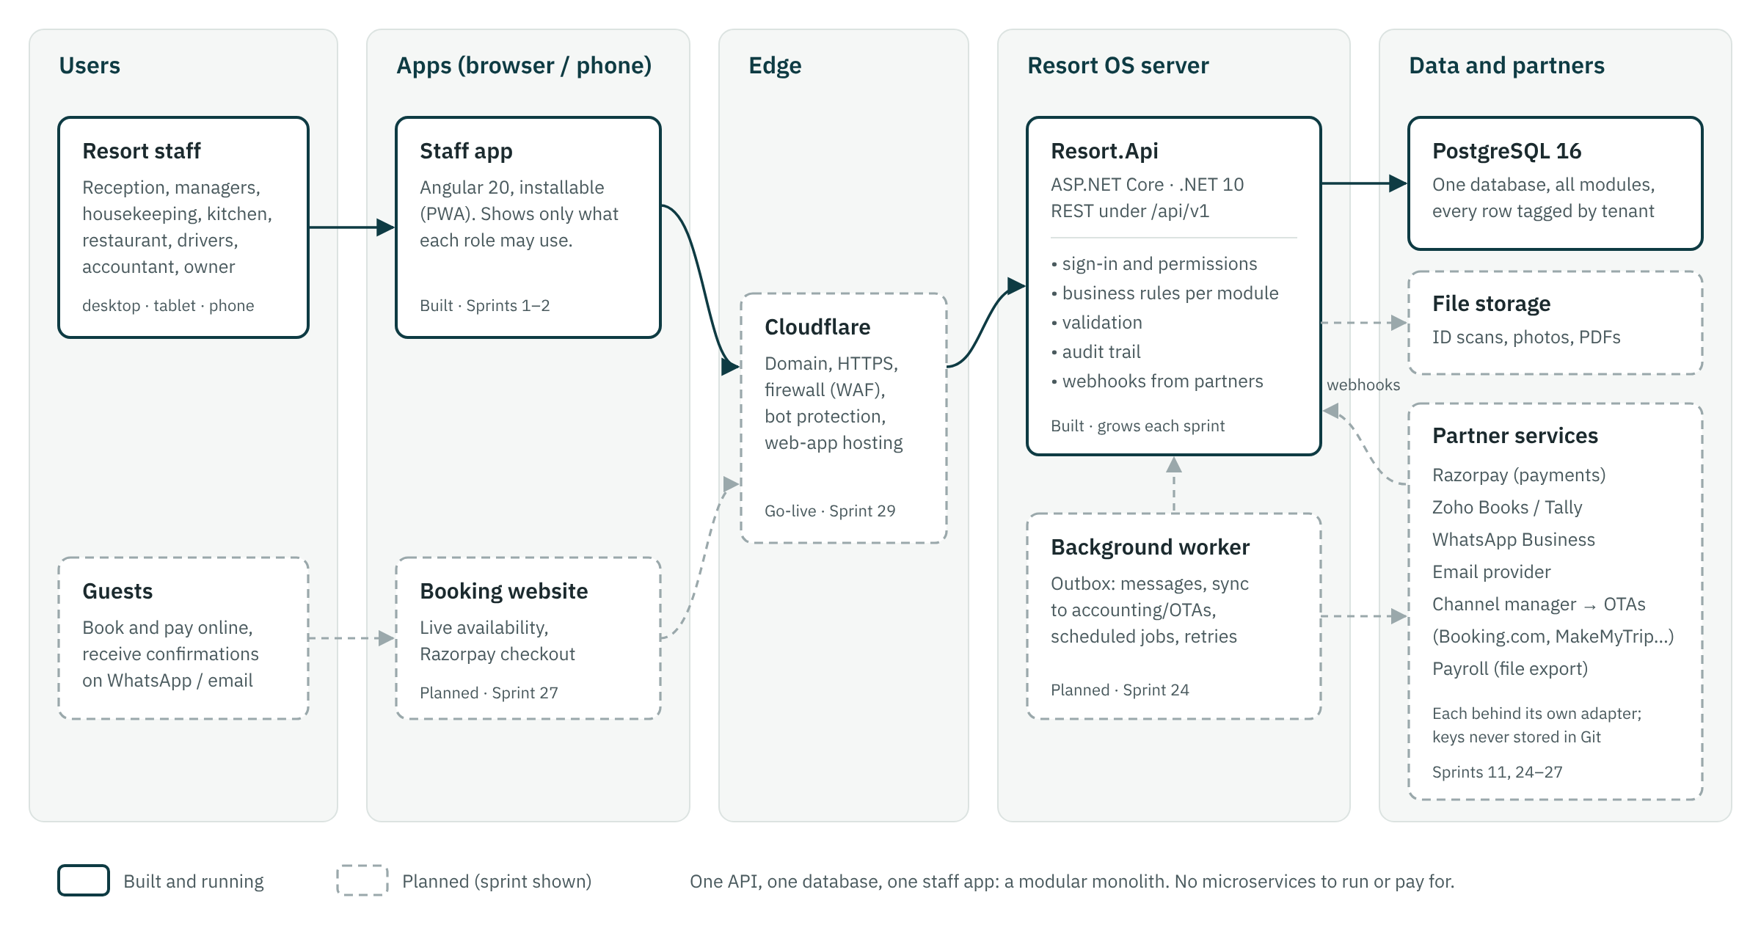
How the parts connect

9 Available today
Work is delivered in short sprints, and each one ends with the owner trying the new screens and accepting them. These are the parts that are built, tested and accepted as of Sprint 10.

9.1 Sprint 01 — Foundation
Staff sign in securely, each person sees only what their role allows, the owner manages properties and staff accounts, and every change is recorded in an audit trail.
- Secure sign-in with lockout after 5 wrong passwords and forced change of temporary passwords
- 17 ready-made staff roles (Owner, General Manager, Receptionist, Housekeeper, Kitchen, Driver…) and 117 permissions
- Staff accounts limited to one property or all properties; deactivating someone signs them out at once
- Property details, GST state, time zone and check-in/out times
- Audit trail: who changed what, when, from which device, and why
- Works on desktop and phone
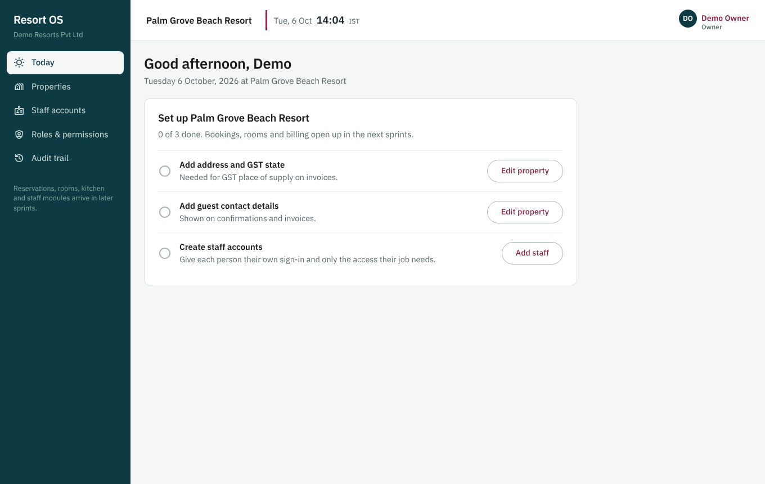
Today: the owner's setup checklist
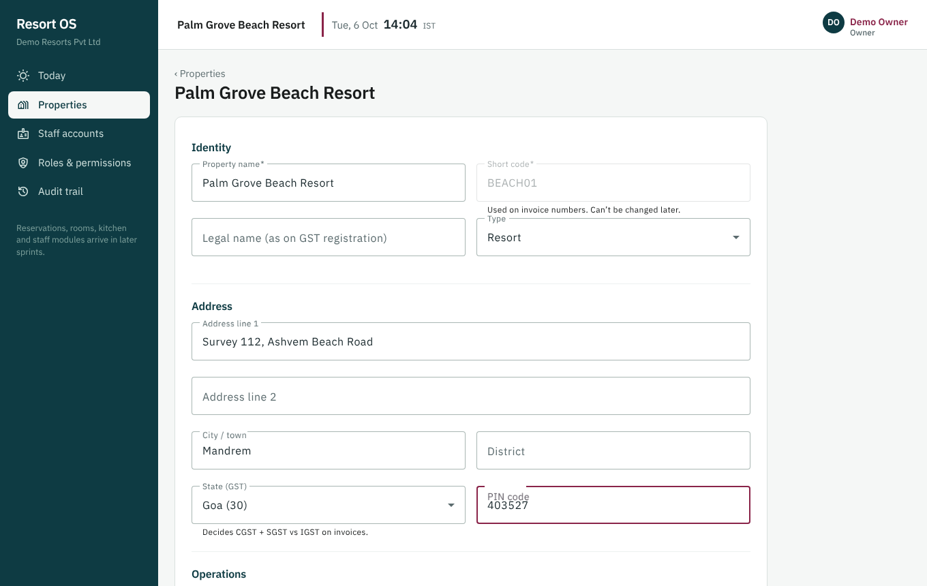
Property editor: address, GST state, time zone, check-in/out times
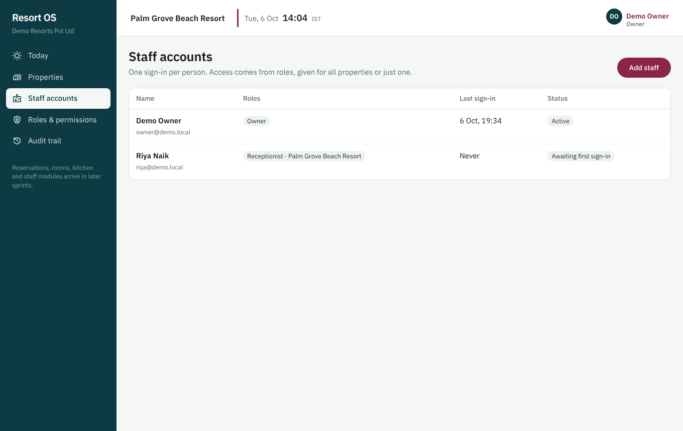
Staff accounts with role and status

9.2 Sprint 02 — Accommodation
The resort's rooms and dormitory beds are set up in the system, can be taken out of sale for repairs or owner use, and their status is visible at a glance.
- Room types with amenities, rooms, and a dormitory sold bed by bed
- Rooms or single beds blocked for maintenance, owner use or a hold, with a reason; overlapping blocks are refused
- Room status board: available, blocked, inactive, at a glance
- Demo property ready to try: Deluxe 101–102, Standard 103–106, a 10-bed dormitory
- Reception can see rooms; only the owner and general manager can change them
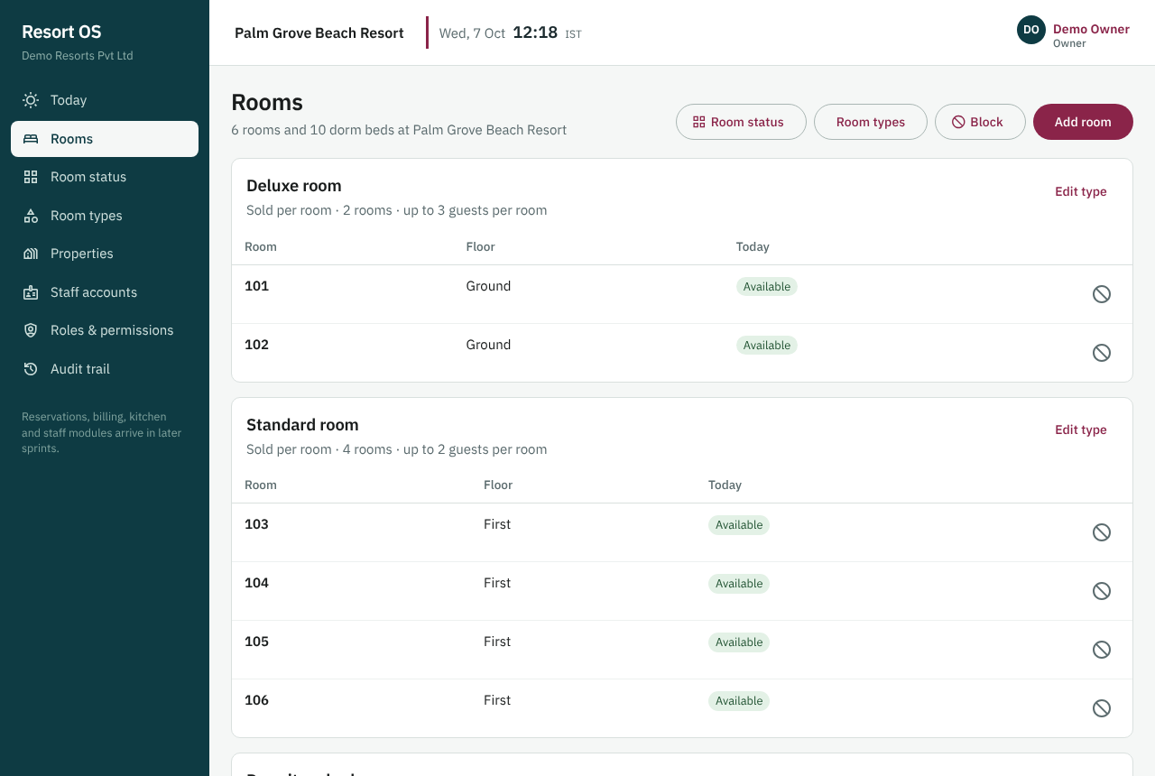
Rooms grouped by type with today's status
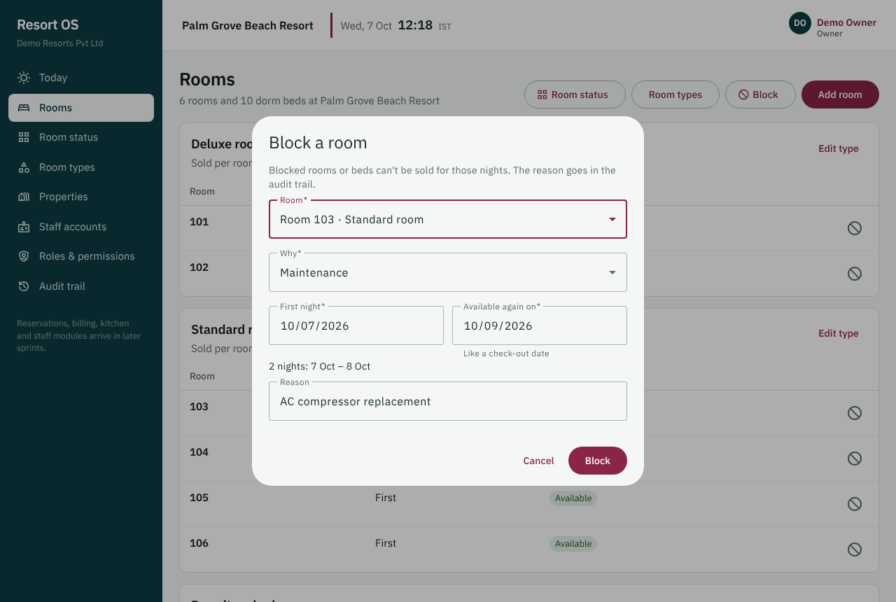
Blocking a room: dates, type and a reason
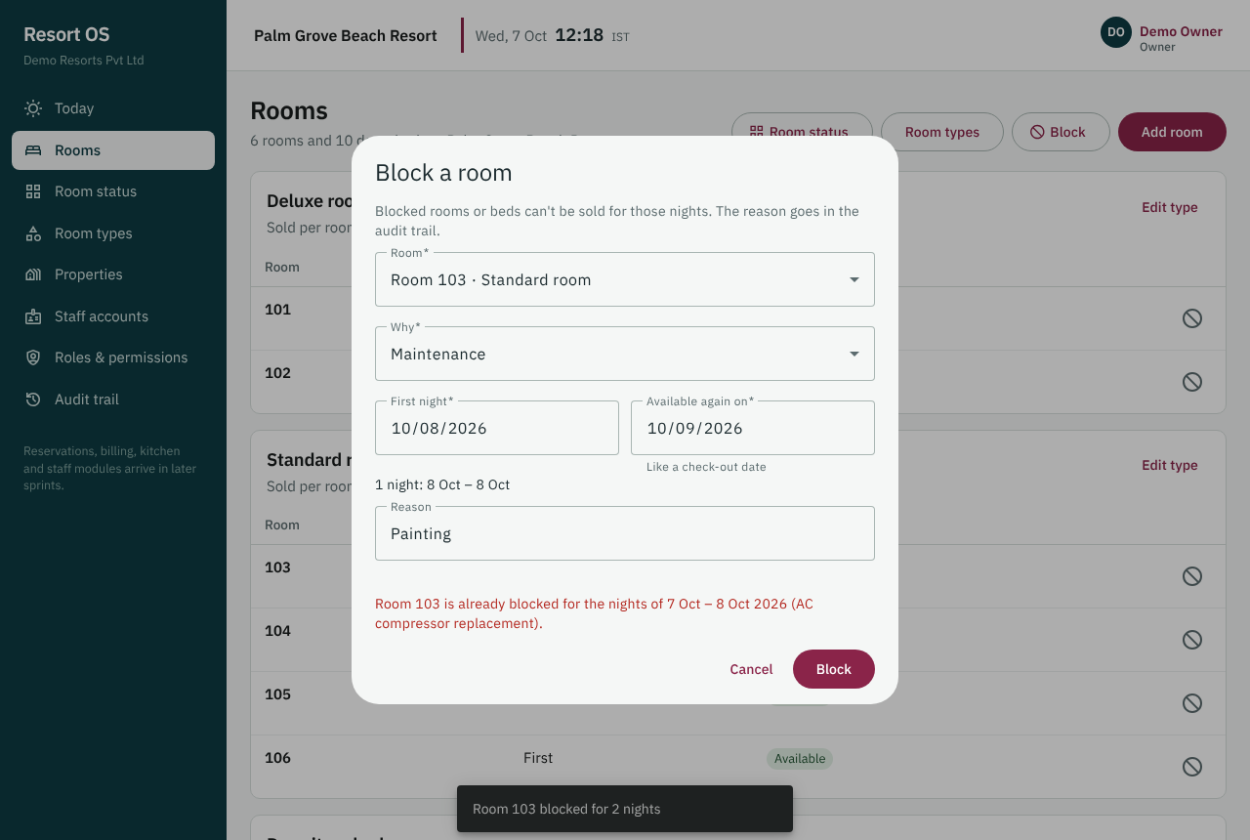
An overlapping block is refused with a clear message

9.3 Sprint 03 — Guests
Reception keeps one clean record per guest, finds returning guests by phone in one search, and stores ID documents encrypted and visible only to permitted staff.
- One profile per guest, shared by every property; returning guests found by phone in one search
- A warning before creating a second profile for the same person, and a merge for duplicates that slip through
- ID documents (passport, Aadhaar, visa…) stored encrypted; only reception, managers and owners can open them, and every view is recorded
- Aadhaar: only the last 4 digits are ever kept
- Consent for WhatsApp and email offers recorded with time and staff member
- Anonymise on request: personal data and documents removed, accounts still add up
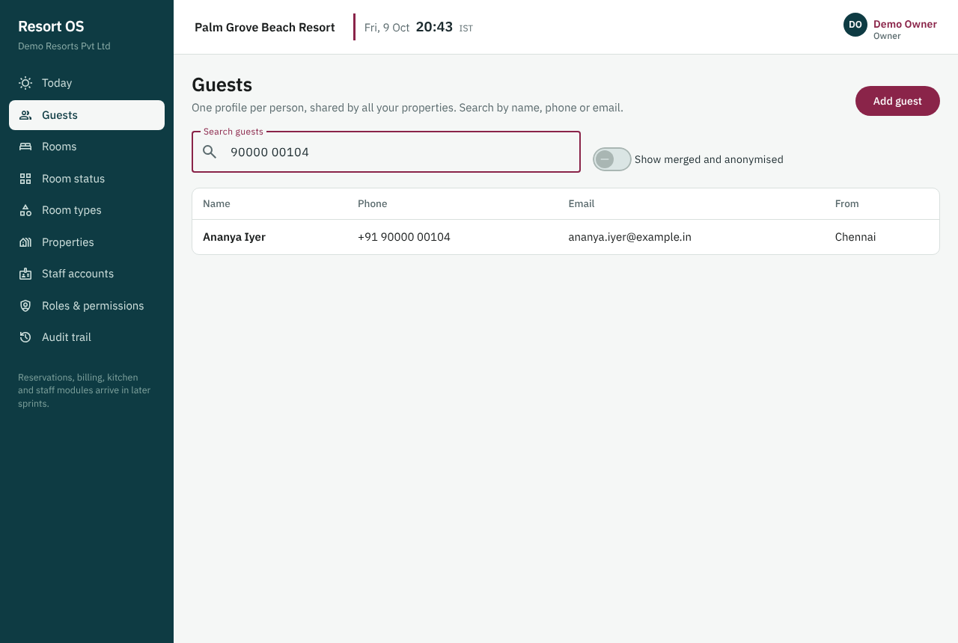
A returning guest found by phone in one search
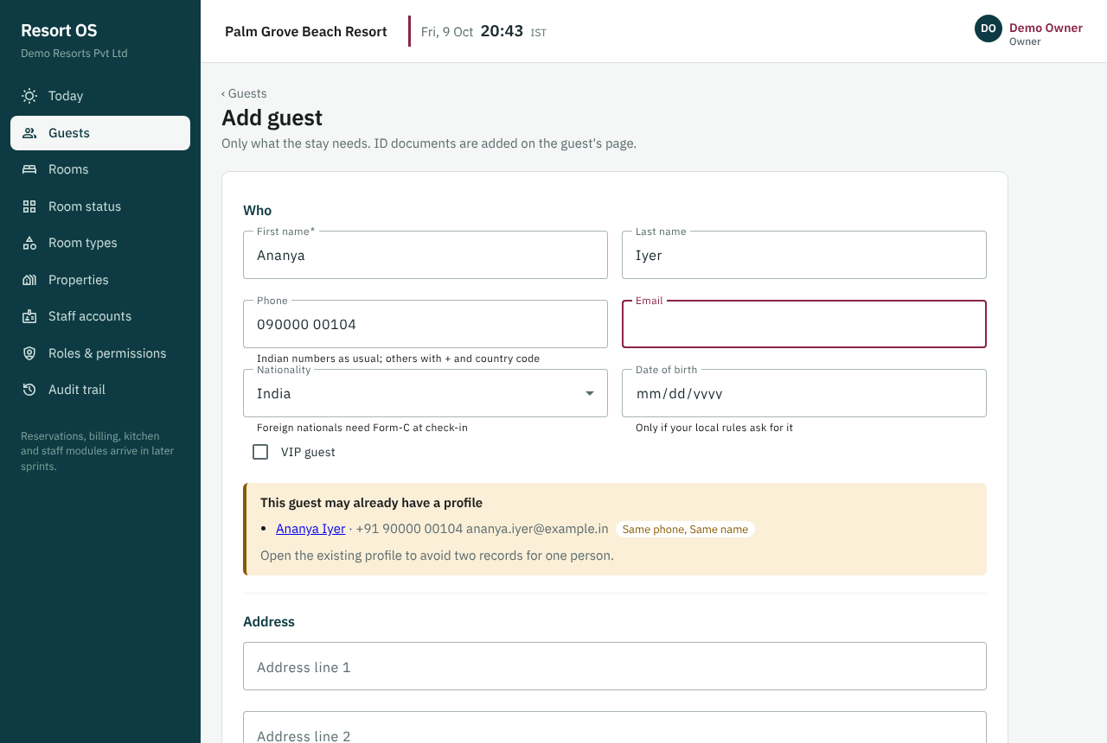
Warning before creating a second profile for the same person
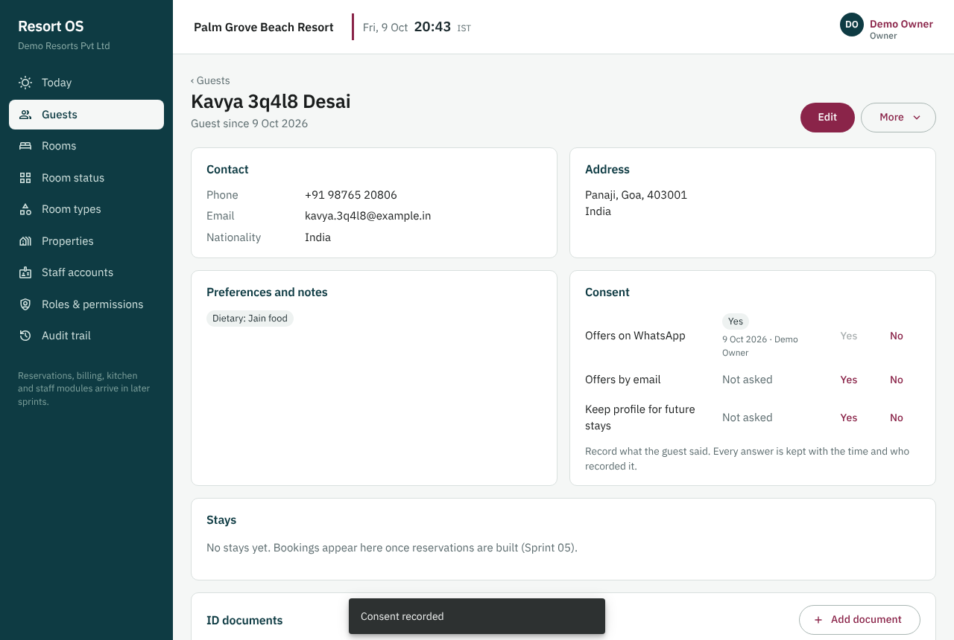
Guest profile: contact, address, preferences and consent

9.4 Sprint 04 — Rate plans and packages
Managers set room and bed prices by date, weekend rates and packages (for example room + breakfast), and get an instant price quote for any stay.
- Prices for every room type and every night, set by date range in a few clicks, with weekend rates
- Rate plans such as Best available rate, room only or with meals; one is the default
- Dormitories priced per bed; extra adults and children priced above the room's standard occupancy
- An instant quote for any room or room type, night by night, matching the price grid
- Packages such as a Couple getaway at one price, split into room, food, transport and activity to the paisa, ready for accounting
- Every price change recorded with the old and new price, and every error explains exactly what to fix
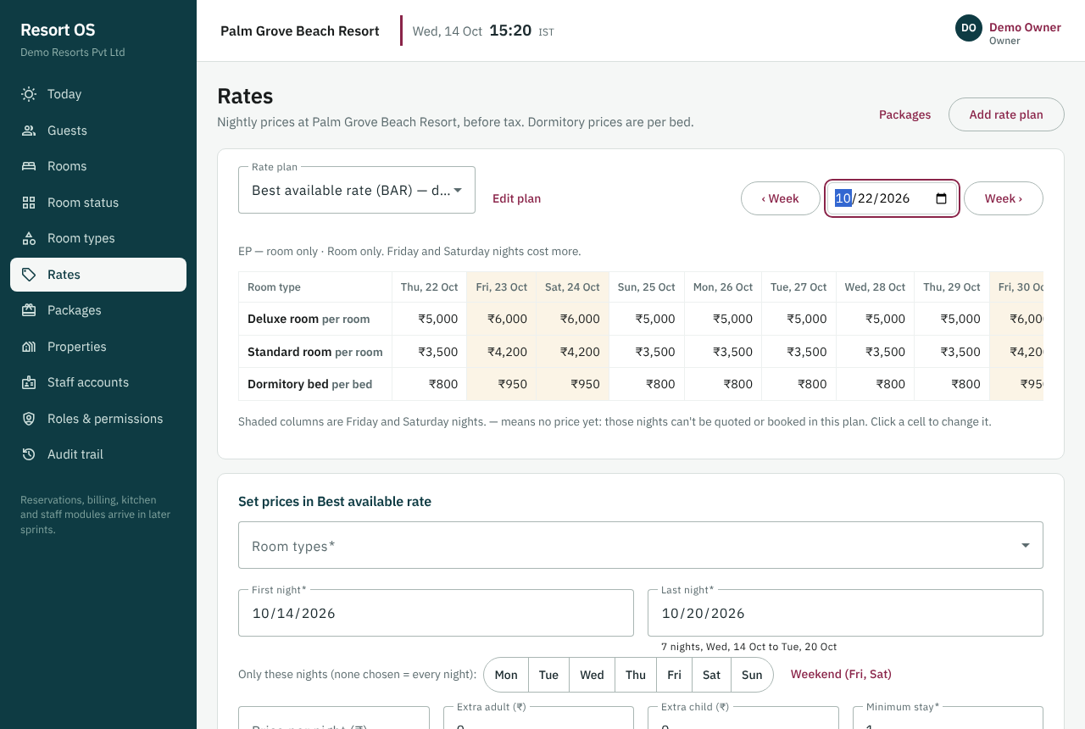
The rate grid: room types × nights, weekends shaded
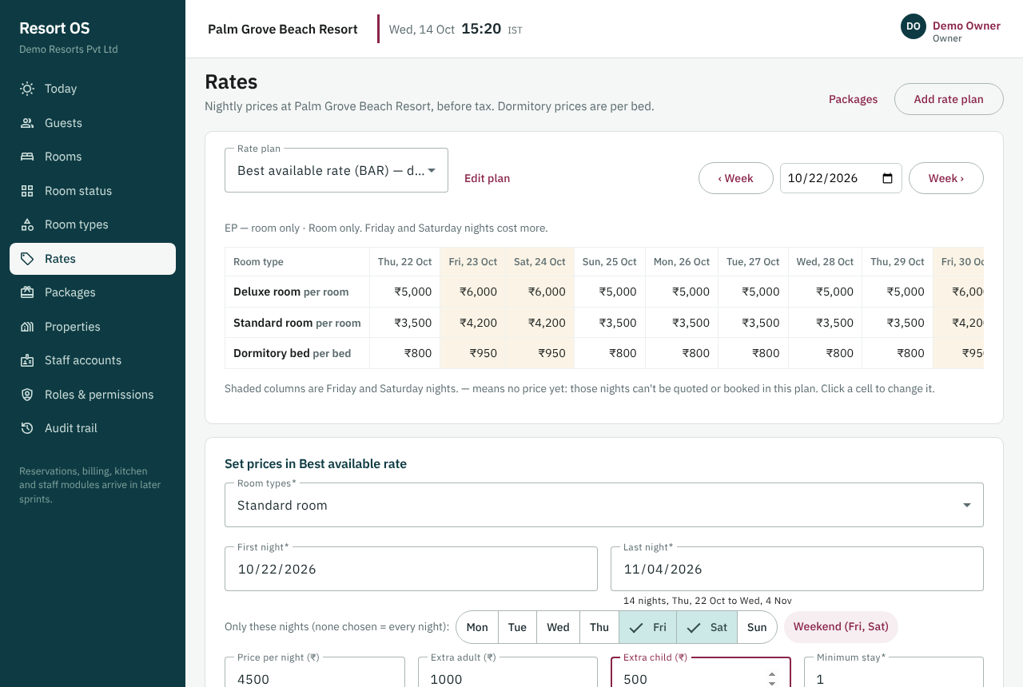
Setting weekend prices for a date range
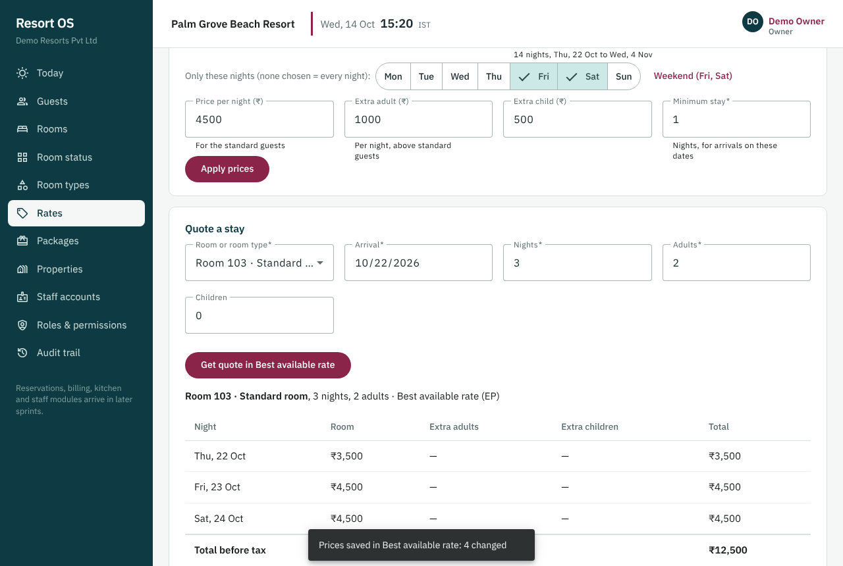
A quote for Room 103, night by night, matching the grid

9.5 Sprint 05 — Availability engine and reservations core
Bookings for rooms and dorm beds are taken without double-booking, even when two people book the last room at the same moment.
- See which rooms and dorm beds are free for any dates, with the price, before booking
- Book a walk-in in five steps: dates, room, guest (find or add), rate, confirm
- No double booking: when two people book the last room at the same moment, one gets it and the other is told why
- Every booking keeps its nightly prices, notes and a full history of who confirmed, changed or cancelled it and why
- Enquiries are saved without holding a room; cancelling frees the room at once
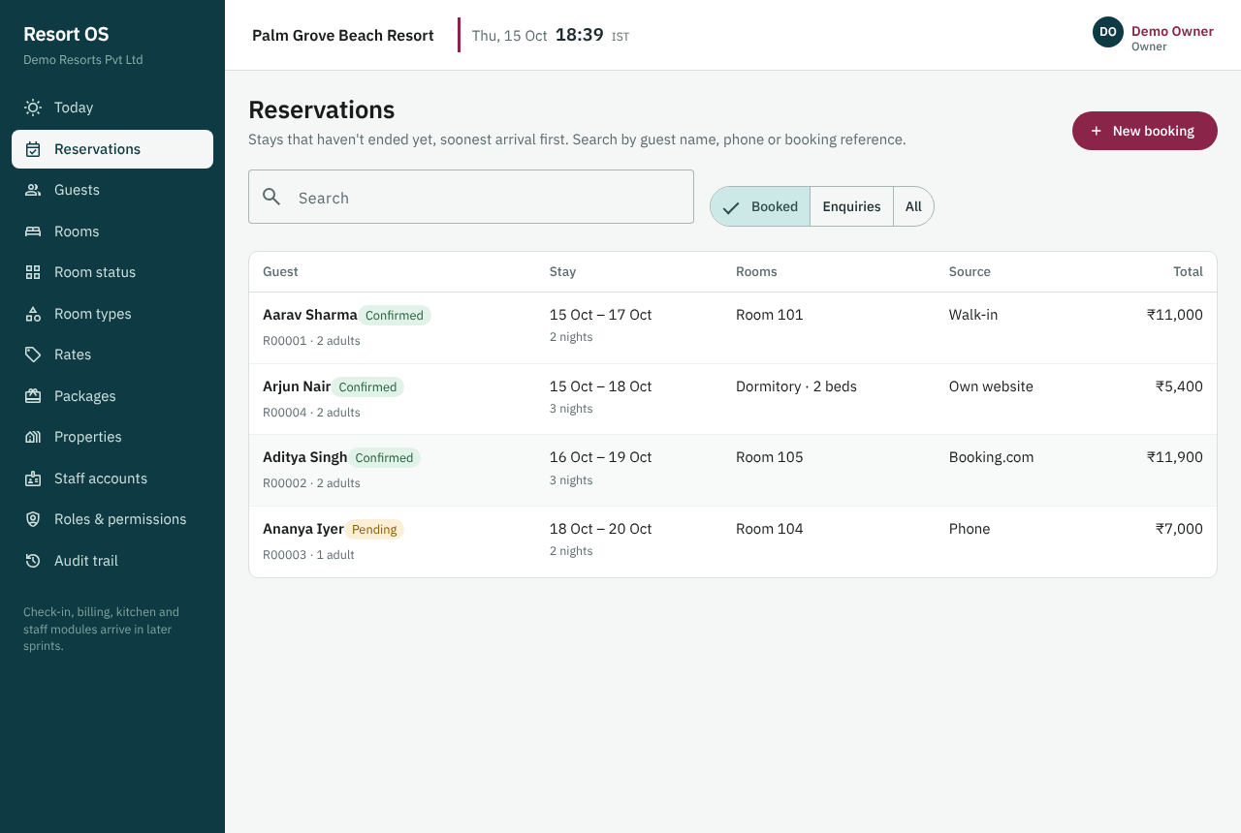
Reservations: stays that haven't ended, soonest first
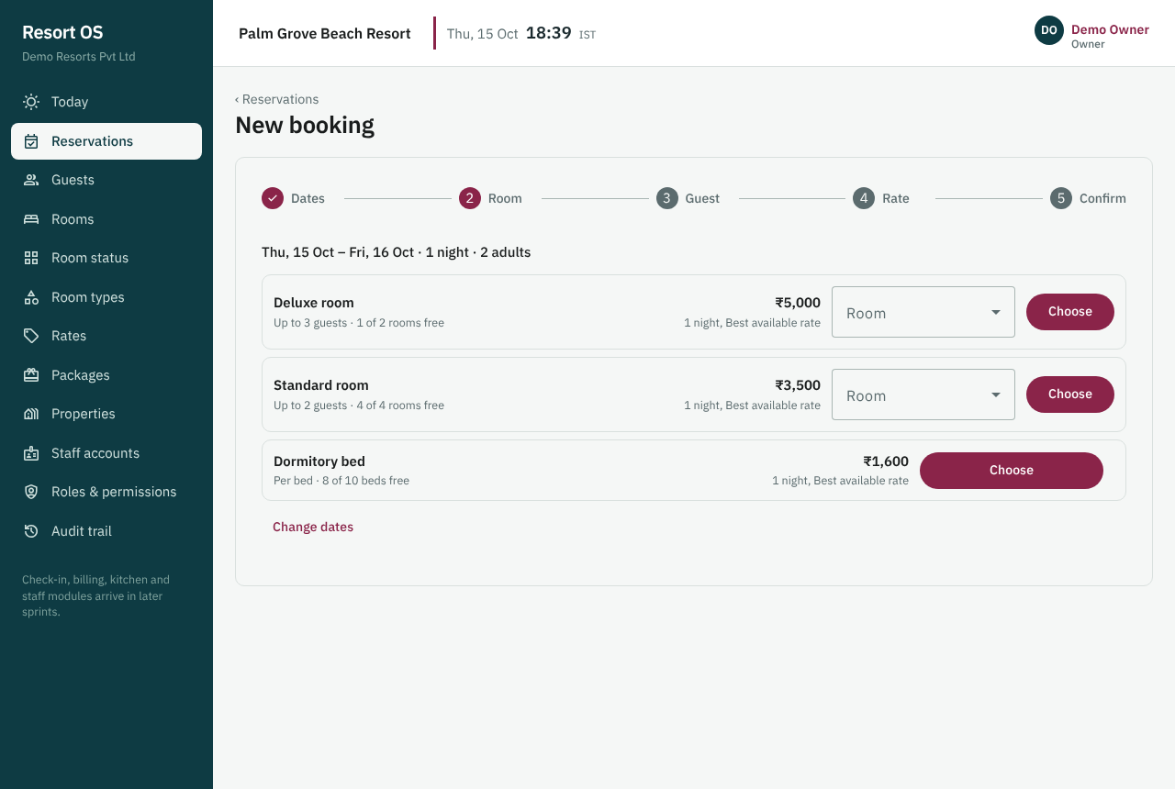
Availability: free rooms and beds per type, with the price
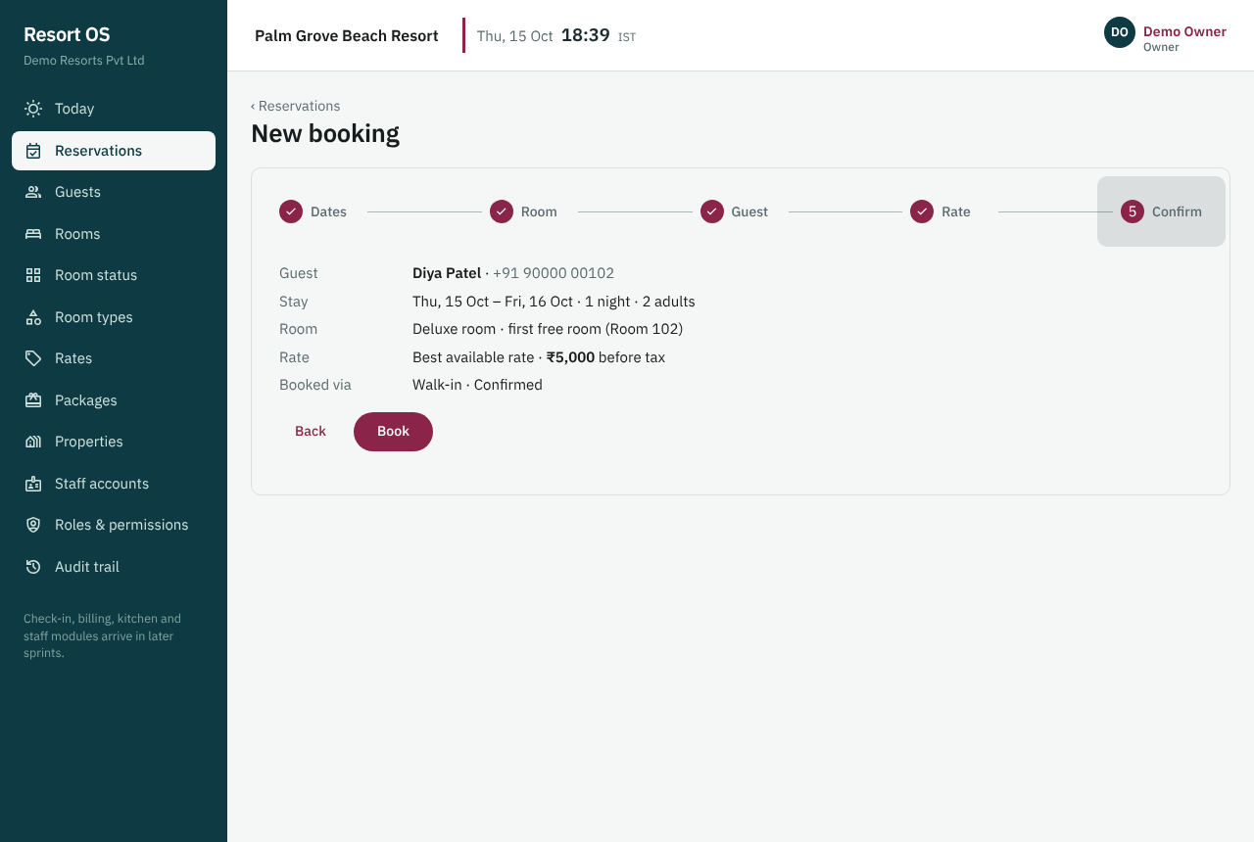
The last step of a new booking

9.6 Sprint 06 — Reservation calendar
A calendar shows every room and bed with its bookings by day, week or month; bookings can be moved by drag-and-drop with safety checks.
- See every room and dorm bed with its bookings and blocks by day, week or month on one calendar
- Move a guest to another room by dragging the booking and giving a reason: two actions
- A move onto a blocked or booked room is refused at once, with the reason
- The price stays the same after a move, and the booking and audit trail show who moved it and why
- On a phone the calendar becomes a list by day: arrivals, in house, departures and blocked rooms
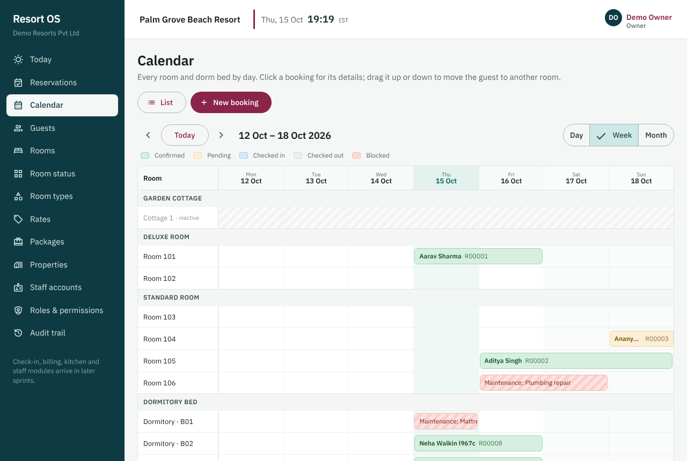
Calendar, week view: bookings by room and a maintenance block
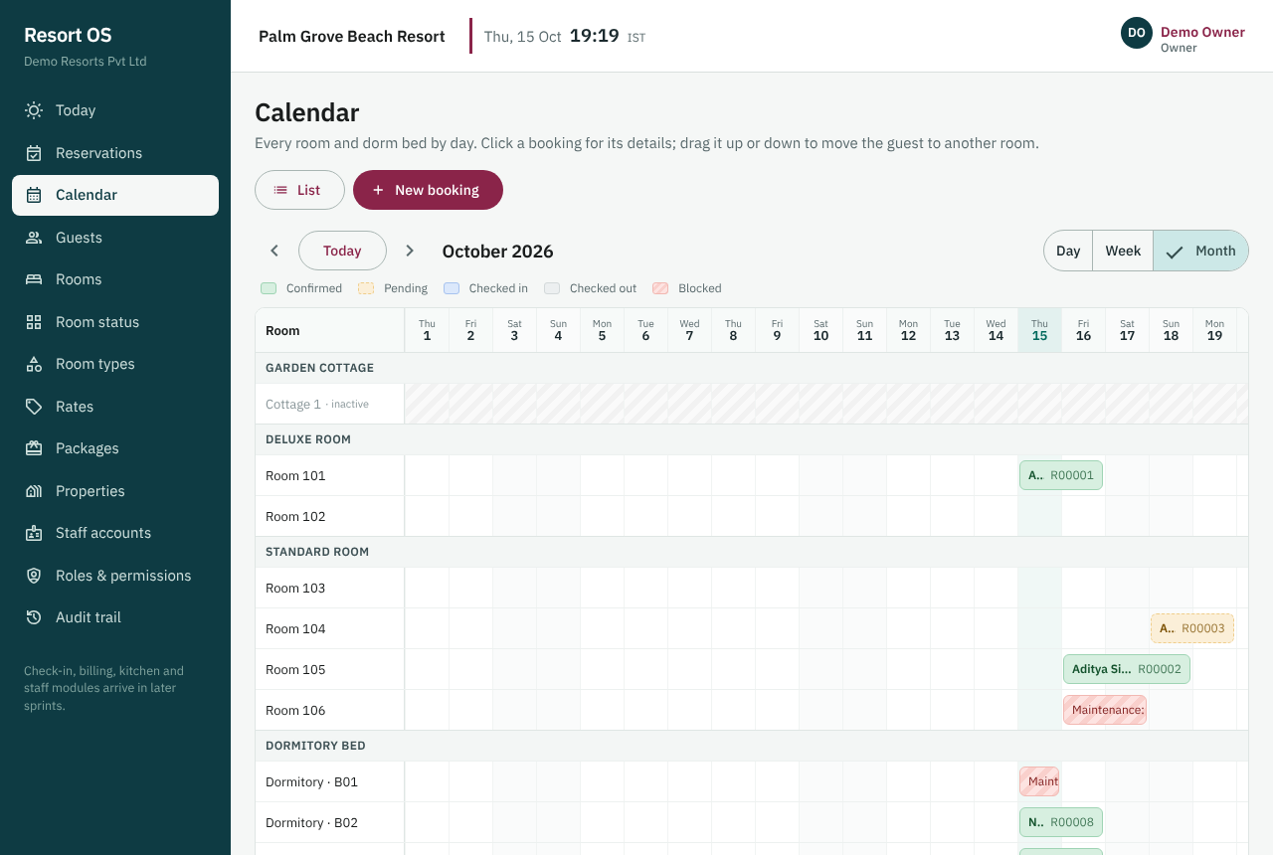
Calendar, month view
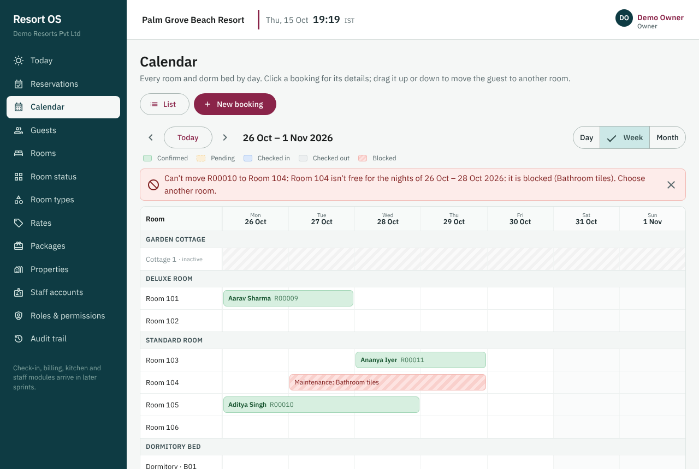
A drop onto a blocked room is refused with the reason

9.7 Sprint 07 — Front desk
Reception checks guests in and out in a few clicks, with today's arrivals, departures and in-house guests on one screen.
- Today's arrivals, departures and in-house guests on one Front desk screen, with each room's cleaning state
- Check a guest in or out in a few clicks; a room that isn't ready can still be used with a reason
- A walk-in guest is booked and checked in from one screen
- A guest leaving early gives a reason and the nights left are released for sale
- Rooms become dirty at check-out and are marked ready again from the rooms board
- 'Today' is always the resort's own date (India time), never the server's
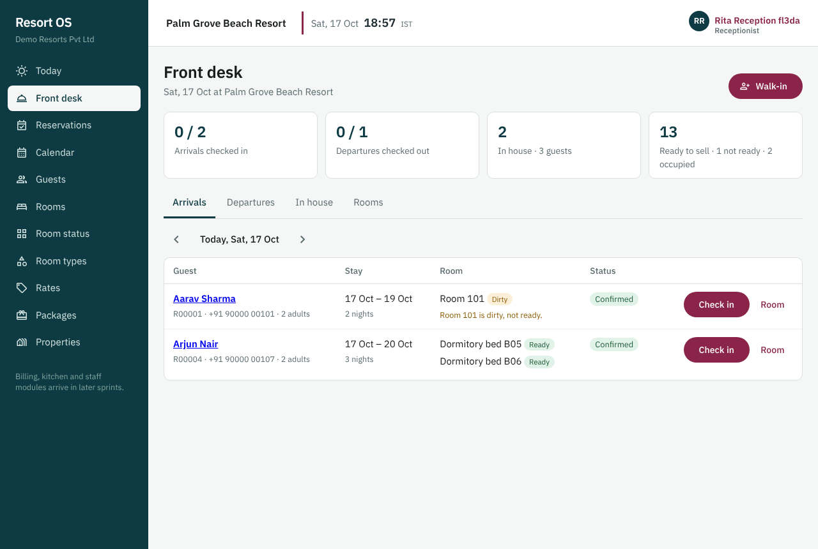
Front desk: today's arrivals with room and cleaning state
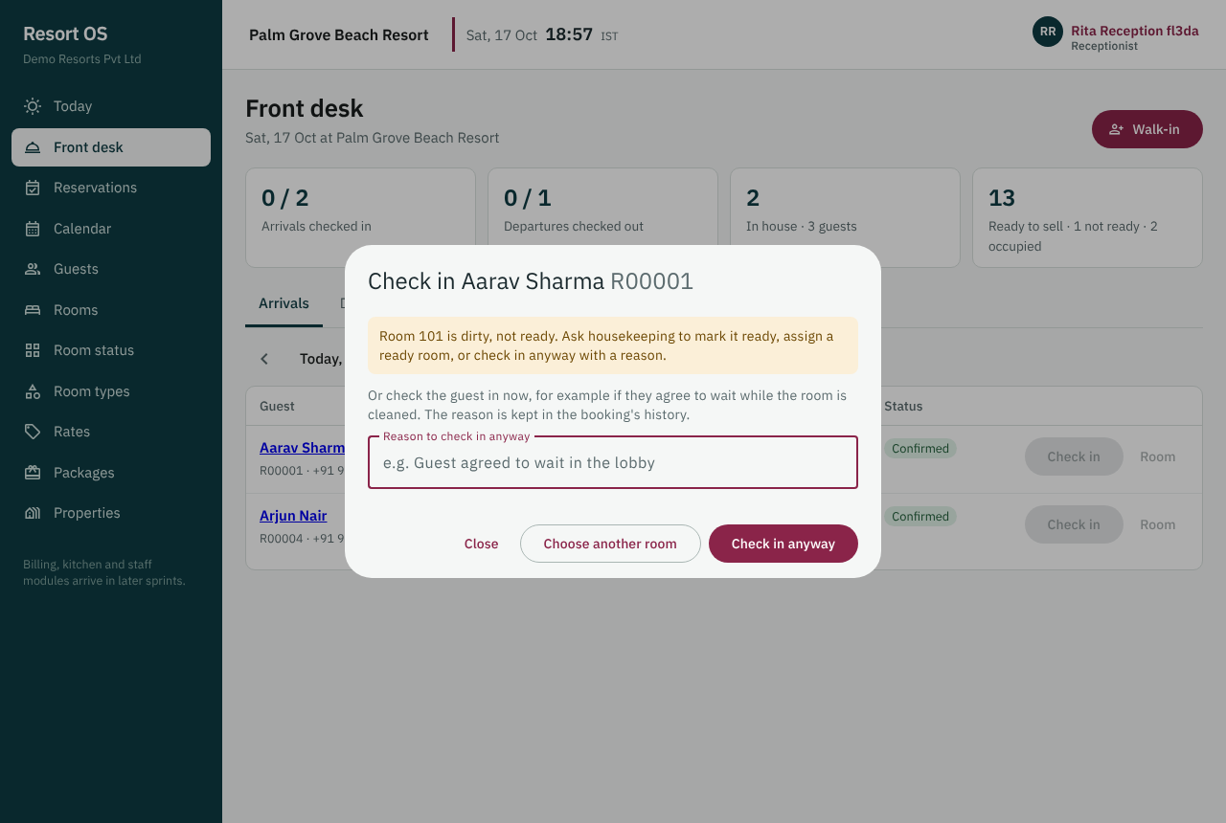
A room that isn't ready needs a reason to check in
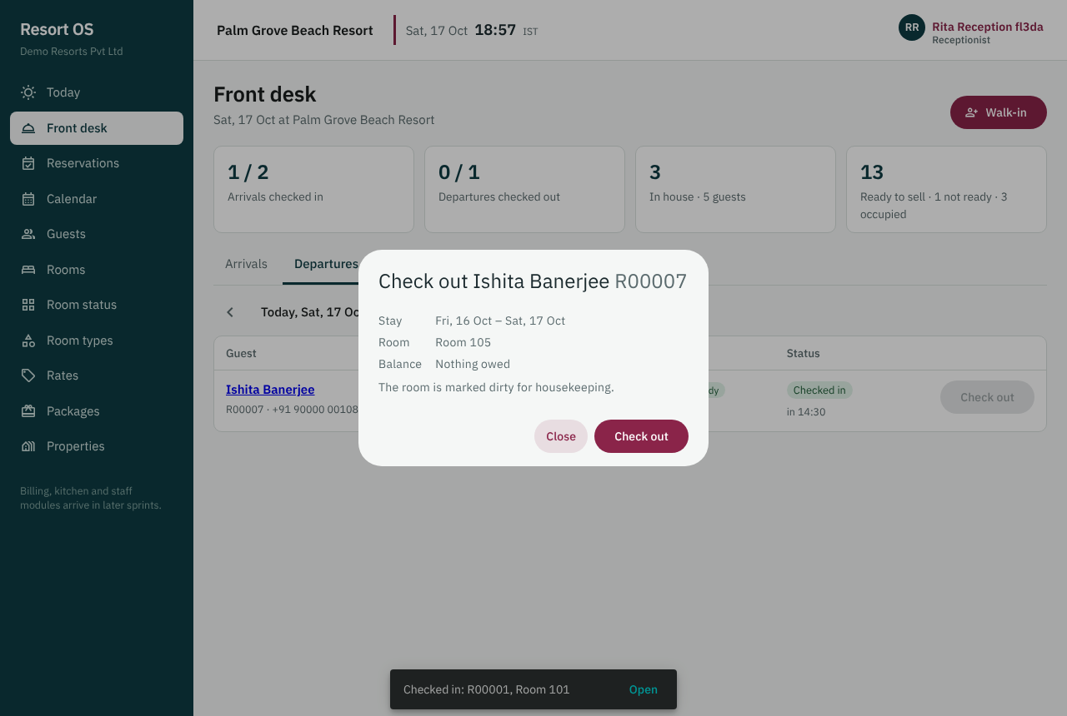
Checking a guest out

9.8 Sprint 08 — Folio
Every stay has one running bill (folio) that collects room charges, meals, activities and transport.
- Every stay has a running bill (folio) with room nights, meals, transport and activities
- Staff post charges in a few clicks; a package becomes one line per part
- Nothing on a bill can be edited or deleted: a manager reverses a line with a reason and both stay visible
- Room nights go on the bill by themselves, and a guest leaving early isn't charged for the nights given back
- A bill can be split, e.g. a friend or the company pays part of it
- The front desk shows what each guest owes
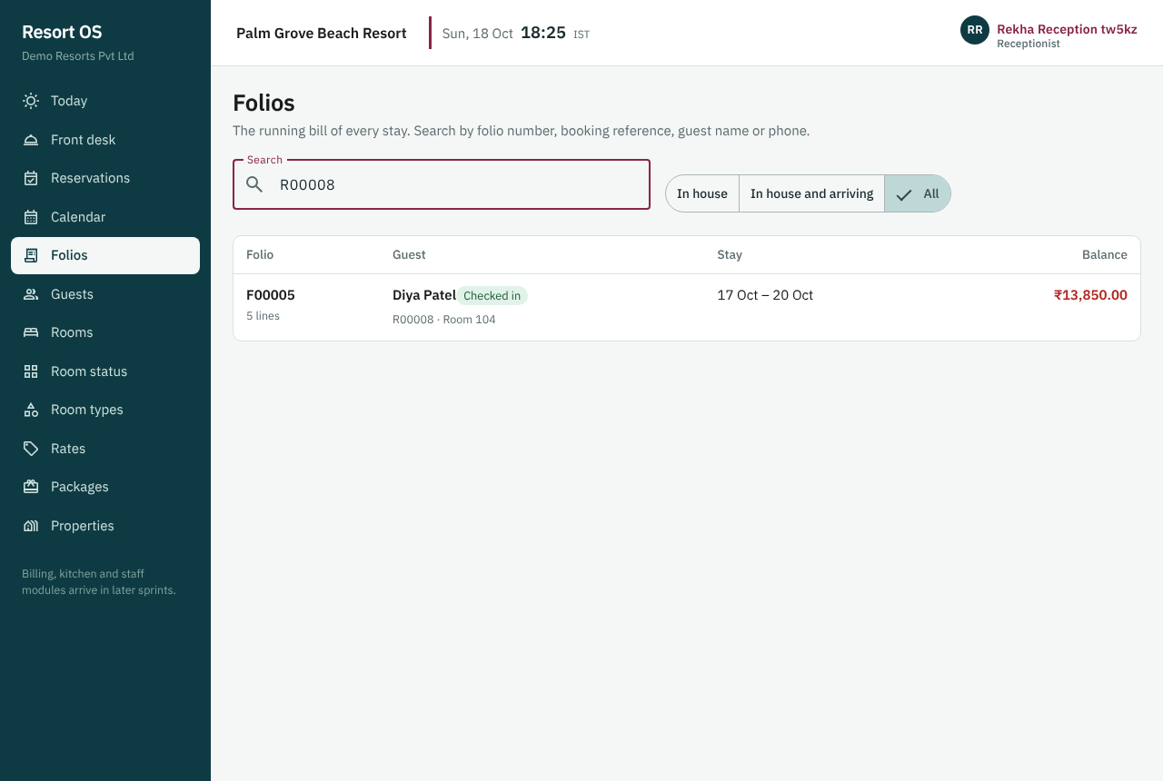
Folios: the bills of the stays
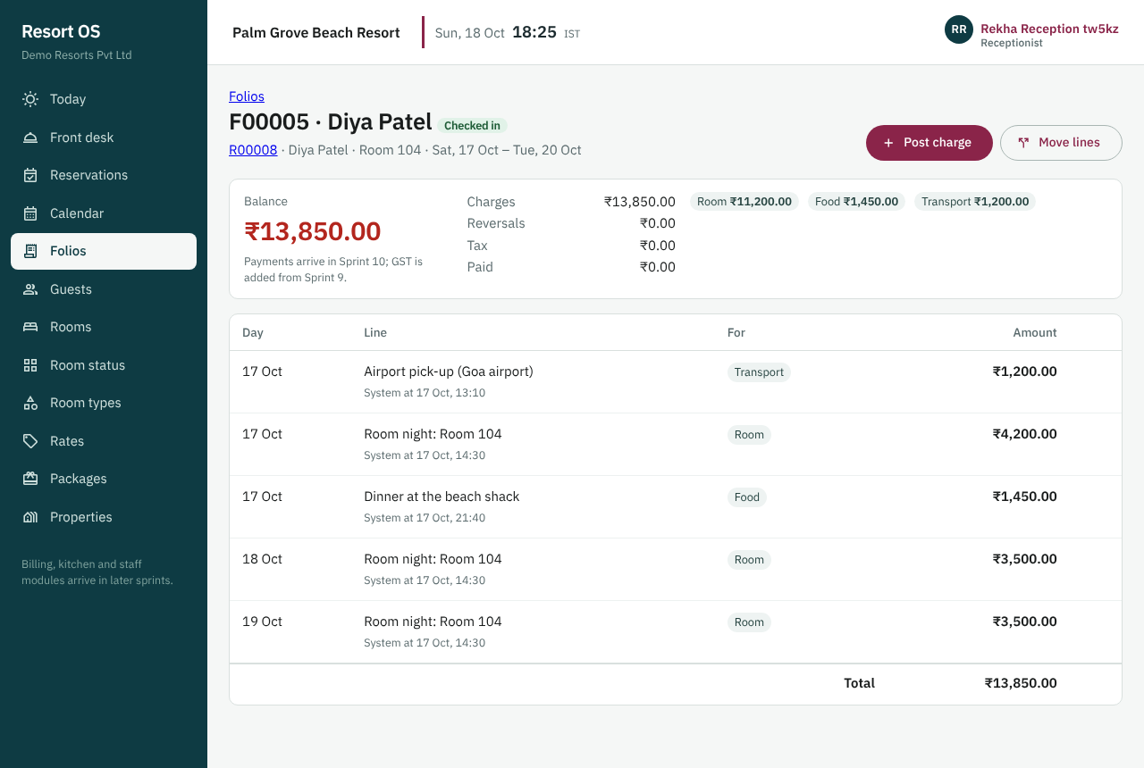
A bill: balance, sums by category and every line
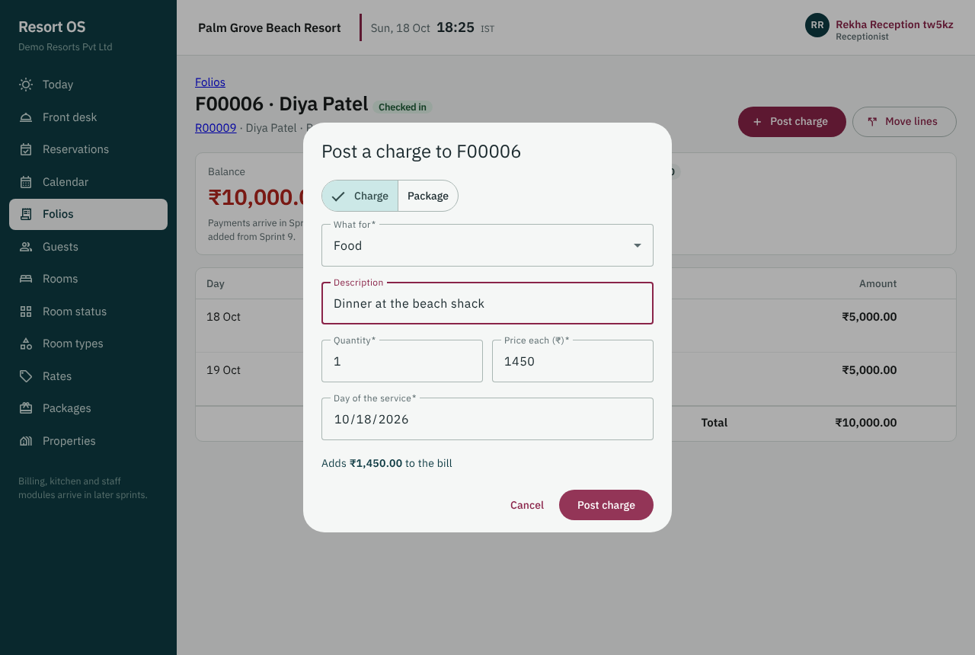
Posting a charge

9.9 Sprint 09 — GST configuration and tax engine
GST is calculated automatically and correctly for each item (CGST/SGST or IGST), with rates kept up to date by configuration, not code.
- GST is worked out automatically on every charge: CGST + SGST inside the state, IGST across states
- No GST rate is built into the software: rates are rules with dates, kept up to date by your accountant
- Your accountant adds next month's rate on the GST page, with no software update; the old rate ends the day before
- Room GST follows the price of each room per night (₹7,500 limit), as the law requires
- A posted charge keeps the GST it was charged with, even if the rate changes later
- The rules shipped with Resort OS are marked unverified until your accountant checks them
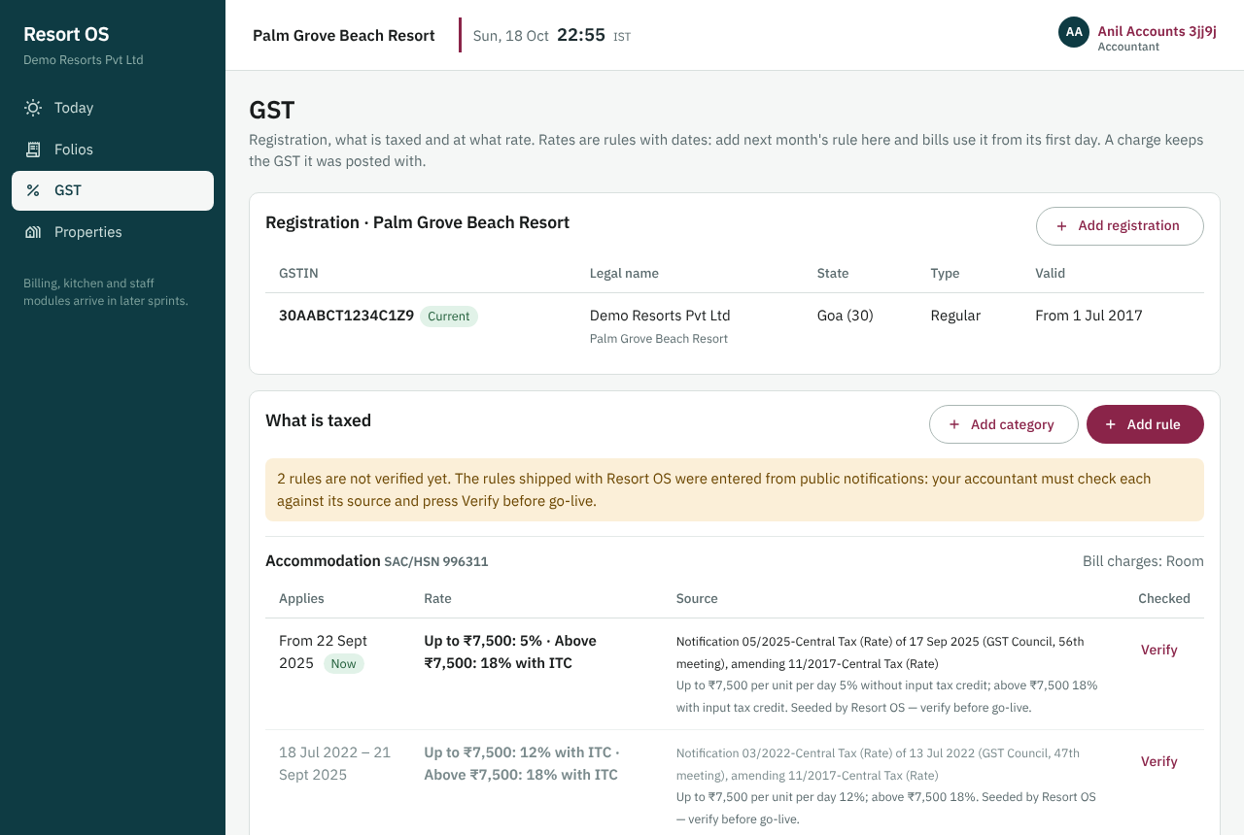
GST: the registration and the rules with their sources
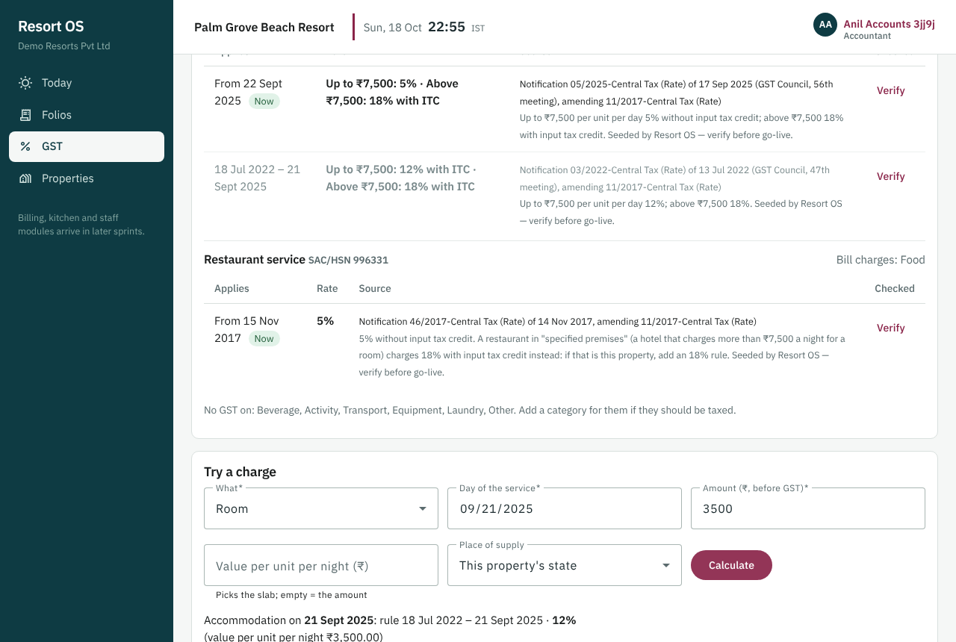
A room night on 21 Sep 2025: 12% GST
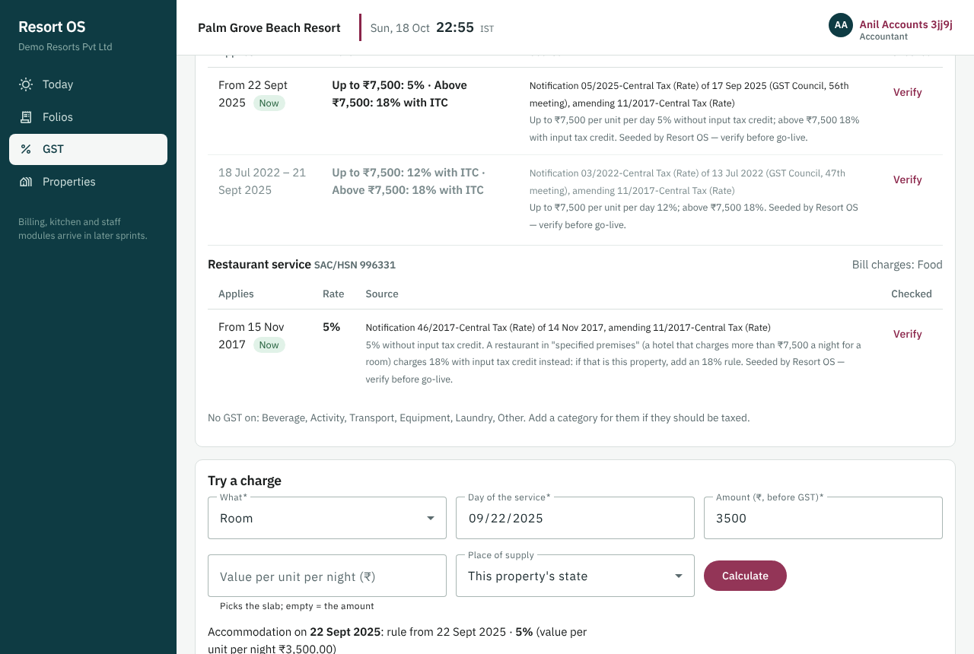
The same room night on 22 Sep 2025: 5% GST

9.10 Sprint 10 — Payments, refunds, cash drawer
Cash, UPI, card and bank payments are recorded against the bill, refunds are controlled, and the cash drawer balances at shift end.
- Cash, UPI, card and bank transfer payments are recorded on the guest's bill, or taken in advance on account
- Refunds need a reason and a manager or accountant, and can never give back more than was paid
- The cash drawer is opened with the cash counted in it and closed against a count; a shortfall needs a reason and a manager's approval
- Card numbers are never stored: anything that looks like one is refused
- Payments, refunds and drawer shifts are never deleted; every change is in the audit trail
- Bill balances, check-out and the calendar now show what has really been paid
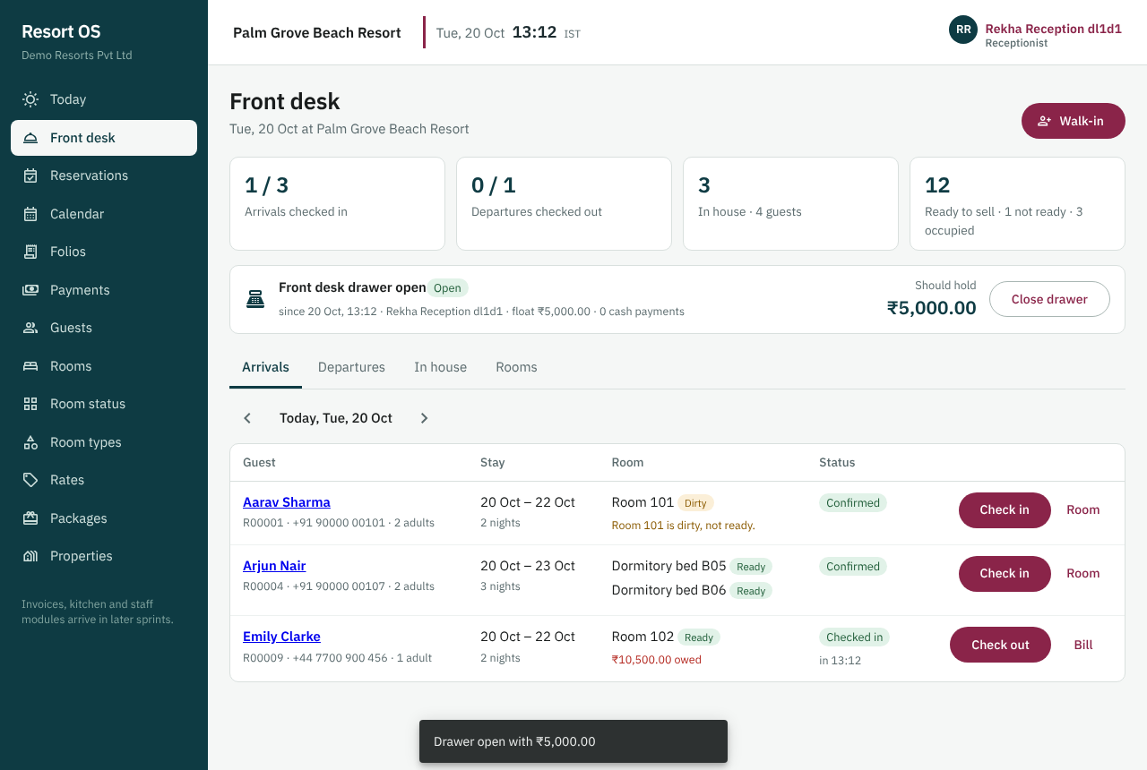
The cash drawer on the front desk, opened with ₹5,000
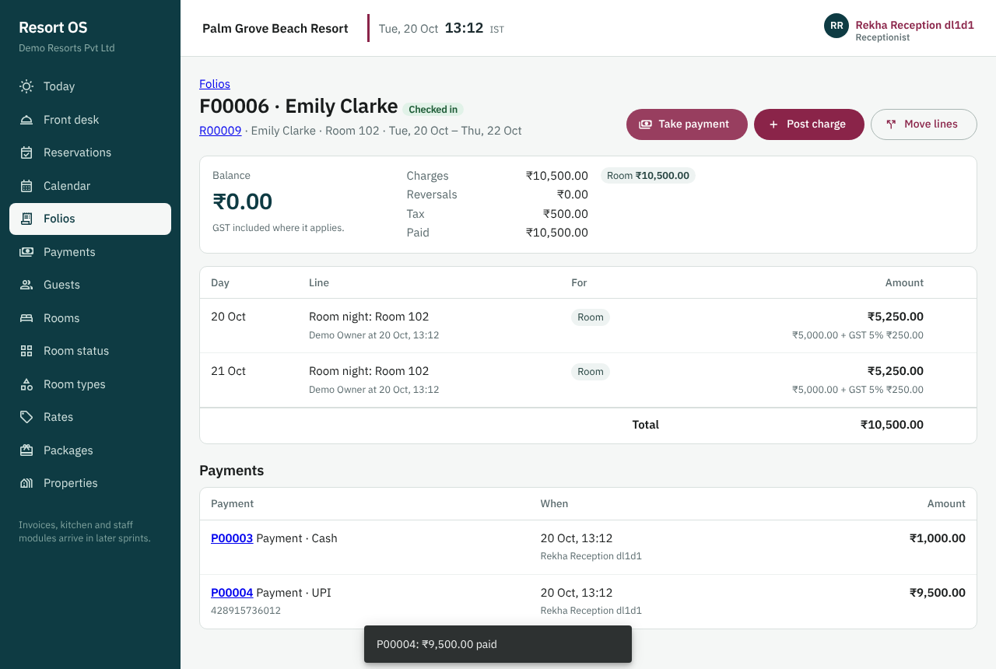
A bill paid in cash and UPI: the balance is nil
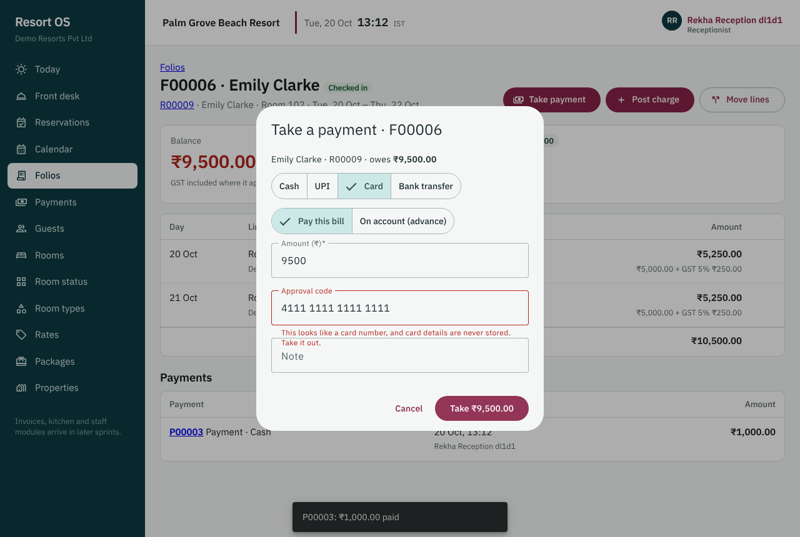
A card number is refused: card details are never stored

9.11 In progress: Sprint 11 — Razorpay
Guests pay online with UPI and cards through Razorpay; payment links can be sent before arrival.
It will be accepted when: Test-mode payment in Razorpay dashboard confirms the reservation via webhook.

10 Delivery roadmap
The plan has 30 sprints in 11 phases. Each sprint is about two weeks of work and ends with a review. The order follows what the resort needs first: rooms and bookings, then money, then operations, then connections and go-live.
Phase | Sprints | What it brings | Status
0 | 00 | Requirements and architecture | In progress
1 | 01, 02 | Foundation, property, rooms, beds | Done
2 | 03, 04, 05, 06, 07 | Guests, reservations, availability, calendar, front desk | Done
3 | 08, 09, 10, 11, 12 | Folio, payments, Razorpay, GST, invoices | In progress
4 | 13 | Housekeeping and maintenance | Planned
5 | 14, 15, 16 | Restaurant, kitchen, menu, inventory, purchasing | Planned
6 | 17, 18, 19 | Employees, attendance, timesheets, leave, roster | Planned
7 | 20, 21 | Activities, transport, equipment | Planned
8 | 22, 23 | Expenses, budgets, reports | Planned
9 | 24, 25, 26, 27 | Notifications, accounting, OTA, booking website | Planned
10 | 28, 29 | Offline use, security hardening, go-live | Planned

10.1 Every sprint
# | Sprint | What the resort gets | Status
00 | Architecture and requirements | We agreed how the whole system fits together, what data it keeps, who may do what, and the order of work, before writing code. | In review
01 | Foundation | Staff sign in securely, each person sees only what their role allows, the owner manages properties and staff accounts, and every change is recorded in an audit trail. | Done
02 | Accommodation | The resort's rooms and dormitory beds are set up in the system, can be taken out of sale for repairs or owner use, and their status is visible at a glance. | Done
03 | Guests | Reception keeps one clean record per guest, finds returning guests by phone in one search, and stores ID documents encrypted and visible only to permitted staff. | Done
04 | Rate plans and packages | Managers set room and bed prices by date, weekend rates and packages (for example room + breakfast), and get an instant price quote for any stay. | Done
05 | Availability engine and reservations core | Bookings for rooms and dorm beds are taken without double-booking, even when two people book the last room at the same moment. | Done
06 | Reservation calendar | A calendar shows every room and bed with its bookings by day, week or month; bookings can be moved by drag-and-drop with safety checks. | Done
07 | Front desk | Reception checks guests in and out in a few clicks, with today's arrivals, departures and in-house guests on one screen. | Done
08 | Folio | Every stay has one running bill (folio) that collects room charges, meals, activities and transport. | Done
09 | GST configuration and tax engine | GST is calculated automatically and correctly for each item (CGST/SGST or IGST), with rates kept up to date by configuration, not code. | Done
10 | Payments, refunds, cash drawer | Cash, UPI, card and bank payments are recorded against the bill, refunds are controlled, and the cash drawer balances at shift end. | Done
11 | Razorpay | Guests pay online with UPI and cards through Razorpay; payment links can be sent before arrival. | In progress
12 | GST invoices, credit/debit notes, receipts | Legally numbered GST invoices are produced from the bill; corrections are made only through credit and debit notes. | Planned
13 | Housekeeping and maintenance (mobile-first) | Housekeeping and maintenance staff see their tasks on their phones, update room status, and report repairs with photos. | Planned
14 | Menu, restaurant POS and KOT | The restaurant takes orders by table, sends tickets to the kitchen, and charges in-house guests directly to their room. | Planned
15 | Inventory and recipe costing | Stock is tracked as it is used, recipes give the real food cost per dish, and wastage is recorded. | Planned
16 | Suppliers and purchasing | Purchasing runs from request to purchase order, goods received, supplier invoice and payment. | Planned
17 | Employees and roster | Staff records (with salaries visible only to authorised people) and weekly shift rosters with clash warnings. | Planned
18 | Attendance and timesheets (PWA) | Staff clock in and out on their phones at the resort, and timesheets are approved by managers. | Planned
19 | Leave, holidays and payroll export | Leave requests check balances and cover; holidays and approved hours flow into a payroll export file. | Planned
20 | Activities and equipment | Activities are booked within capacity, and equipment (kayaks, snorkels, bicycles) is issued and returned with a record. | Planned
21 | Beach transport | The beach shuttle runs on scheduled trips with seat limits, drivers and passenger lists. | Planned
22 | Expenses and budgets | Expenses are captured with receipts and approval, and spending is compared with the budget. | Planned
23 | Reports and dashboards | Owners and managers get dashboards and reports: occupancy, revenue, GST, food cost, staff hours and more. | Planned
24 | Notification engine, WhatsApp, email, background jobs | Guests and staff receive WhatsApp and email messages from templates (confirmations, reminders, invoices) with delivery tracking. | Planned
25 | Zoho Books, Tally export, e-invoice reconciliation | Accounts sync automatically to Zoho Books, with a Tally export option, without duplicate entries. | Planned
26 | OTA / channel manager | Bookings from Booking.com, MakeMyTrip and other channels arrive automatically through a channel manager, and availability is pushed back. | Planned
27 | Direct booking website | Guests book and pay directly on the resort's own website, saving OTA commission. | Planned
28 | Offline PWA and security hardening | The staff app keeps working through poor connectivity, managers use two-factor sign-in, and the system passes an OWASP security check. | Planned
29 | Backups, monitoring, CI/CD to production, acceptance | The system goes live with backups, monitoring, alerts and a tested recovery plan, and passes the final acceptance tests. | Planned
Dates depend on team size and on decisions the owner still has to make (for example the channel manager and the payroll provider). The order and scope are agreed; each sprint is confirmed at its planning meeting.

11 How we deliver
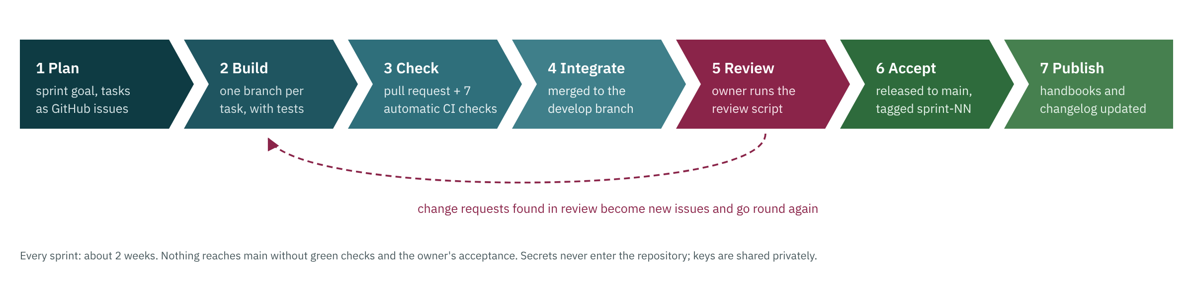
One sprint, from plan to published
- Small, reviewable steps. Every sprint has a written goal, a list of tasks and the tests that prove it works.
- You see it before it counts. At the end of each sprint the owner follows a step-by-step review script on the real screens. Nothing is released until it is accepted.
- Automatic checks on every change. Each change runs through automatic checks before it can be merged: it builds, its tests pass on a real database on both Linux and Windows, the screens are clicked through in a real browser, and it contains no passwords or known-vulnerable components.
- Tests that grow with the system. As of Sprint 10: 216 server test methods, 72 screen tests and 90 end-to-end browser steps, all passing.
- Everything is recorded. Each sprint has a written guide, a changelog entry and a tagged release, so anyone can see what changed and when.

12 Running costs
Resort OS is built on free tools and free tiers while it is being developed. Paid services start only when the resort goes live, and most of them are charged per use.
Stage | When | Monthly cost
Development | Now, until about Sprint 28 | ₹0
Online demo / test environment (optional) | From about Sprint 11, to test payments and messages | ₹0 on free tiers
Live operation | From go-live (Sprint 29) | About ₹2,500–₹6,000 per month (estimate) plus per-transaction fees

Per-use charge | Typical rate (verify before go-live)
Razorpay online payments | About 2% per domestic payment (3% international), plus 18% GST on the fee; nothing for cash or UPI taken at the desk
WhatsApp messages | Roughly ₹0.12 per utility message (confirmations, invoices) in India, plus GST
Zoho Books | A paid plan is needed for the automatic sync (from about ₹749 per month)
Channel manager for OTAs | Quoted by the provider; typically under ₹5,000 per month for a small property
Prices were checked in October 2026 and change over time; they are planning figures, not quotes.

13 Glossary
Term | Meaning
Audit trail | A permanent record of every change: who, when, what and why
Block | Taking a room or bed out of sale for some nights (repairs, owner use, a hold)
Channel manager | A service that keeps availability and bookings in step across OTAs
CGST / SGST / IGST | Central and State GST for sales within a state; Integrated GST for sales across states
Credit note | The legal way to reduce or cancel an invoice that has been issued
Dormitory (bed-based) room | A room sold bed by bed rather than as a whole
Folio | The running bill for a stay, collecting every charge and payment
Form-C | The report of a foreign national's stay that Indian accommodation providers must file
KOT | Kitchen order ticket: the restaurant order as the kitchen sees it
OTA | Online travel agent, for example Booking.com or MakeMyTrip
PWA | Progressive web app: a website that can be installed and used like a phone app
Role / permission | A role (Receptionist) is a named bundle of permissions (view rooms, take payments…)
Sprint | A short, fixed period of work (about two weeks) that ends with a review and acceptance

