TECHNICAL HANDBOOK
Resort OS — Software Documentation
Architecture, technology, design of the UI, API and database, the sprint-by-sprint record, code and test results.

Edition | Version 1.5
Date | 15 October 2026
Covers | Sprints 01, 02, 03, 04, 05 accepted · Sprint 06 Reservation calendar in progress
Prepared by | Prathamesh, product owner, Resort OS
Classification | Confidential

Document control
Version | Date | Change
1.5 | 2026-10-15 | Sprint 05 (Availability engine and reservations) accepted: race-free booking, booking wizard, booking history, date pickers. Diagrams of the reservation tables and the booking flow. Sprint 06 (Reservation calendar) started.
1.4 | 2026-10-14 | Sprint 04 (Rate plans and packages) accepted: nightly price grid, quotes, packages with revenue split. Sprint 05 (Availability engine and reservations) started.
1.3 | 2026-10-11 | Sprint 03 (Guests) accepted, with review fixes: Aadhaar number check and error messages that say why. Sprint 04 (Rate plans and packages) started.
1.2.1 | 2026-10-10 | Sprint 03 (Guests) built and in review: guest profiles, encrypted ID documents, duplicates, merge, anonymise, consent.
1.2 | 2026-10-10 | First edition. Sprints 01 (Foundation) and 02 (Accommodation) accepted; Sprint 03 (Guests) started.

Document | Resort OS — Software Documentation
Audience | Developers, technical reviewers and auditors, and the product owner.
Status | Living document, rebuilt at the end of every sprint. This edition reflects Sprint 05 accepted and Sprint 06 in progress.
Owner | Prathamesh, product owner
Distribution | Internal and technical reviewers under confidentiality. Contains no passwords or keys; it names repository paths and internal design details.

Contents
1 Introduction
1.1 Purpose and audience
1.2 How this document is produced
1.3 Related documents in the repository
2 Project summary
3 Technology stack
4 Architecture
4.1 System context
4.2 Backend structure
4.3 Request pipeline
4.4 Cross-cutting rules
4.5 Module map
5 Security architecture
5.1 Authentication (built)
5.2 Authorisation (built)
5.3 Data classification
5.4 OWASP Top 10 (2021) mapping
6 Data architecture
6.1 Conventions
6.2 Migrations
7 API design
7.1 Conventions
7.2 Error format
7.3 Endpoint catalogue (built)
8 Frontend design
8.1 UI conventions
9 Engineering process
9.1 Sprint lifecycle
9.2 Branching
9.3 Definition of Done
9.4 Secrets and configuration
9.5 Continuous integration
10 Sprint record
10.1 Sprint 01 — Foundation — identity, RBAC, organisation, properties, audit
10.2 Sprint 02 — Accommodation — room types, rooms, dormitory beds, blocks
10.3 Sprint 03 — Guests
10.4 Sprint 04 — Rate plans and packages
10.5 Sprint 05 — Availability engine and reservations core
10.6 Sprint 06 — Reservation calendar (in progress)
11 Quality report
11.1 Latest recorded results (Sprint 05)
11.2 Code size
12 Roadmap
13 Appendices
13.1 A. Roles
13.2 B. Permissions by module
13.3 C. Glossary
13.4 D. Rebuilding this document

1 Introduction

1.1 Purpose and audience
This document describes how Resort OS is built: its technology, architecture, security and data design, the engineering process, and a sprint-by-sprint record of what was delivered, how each screen, API and table is designed, which code changed and how it was tested. It is written for developers joining the project, technical reviewers, auditors and the owner.
A companion document, Resort OS — Product Overview, explains the system in plain language for clients.

1.2 How this document is produced
It is generated from the repository by tools/handbooks (npm run build), reading the sprint plan (docs/sprints/sprints.yml), the SQL migrations, the OpenAPI snapshot, the source tree and the CI workflow. This edition was built from commit 5e821f9 (2026-10-16). When a sprint is accepted the plan is updated and the document rebuilt, so it always matches the code.

1.3 Related documents in the repository
Document | What it covers
README.md | Project summary, quick start, current sprint
docs/GETTING_STARTED.md | Tools to install, clone, run and test, step by step (Windows first)
docs/ONBOARDING.md | How a new developer joins and how two developers collaborate
docs/ARCHITECTURE.md, docs/architecture/* | Architecture, module map, lifecycles, frontend, decisions, risks
docs/DATABASE.md, docs/database/* | Conventions, migrations, schema per sprint, tables by sprint
docs/API.md, docs/api/* | API conventions, error format, endpoint specs, OpenAPI snapshot
docs/SECURITY.md, docs/security/* | Security architecture, OWASP mapping, permission matrix
docs/TESTING.md, docs/testing/VERIFYING.md | Test strategy; UI → API → database checks per feature
docs/sprints/* | The plan, process, review scripts and one guide per sprint
docs/COSTS.md, DEPLOYMENT.md, OPERATIONS.md | Costs, environments, operations and backups
CHANGELOG.md | What changed in each accepted sprint

2 Project summary
Resort OS is an India-first resort management system delivered as a modular monolith: one ASP.NET Core API, one PostgreSQL database and one Angular staff app (an installable PWA), with a separate public booking site later. External specialists (payments, accounting, payroll, OTAs, messaging) are reached only through adapters. There are no microservices, message brokers, Redis or Kubernetes: the system is sized for a resort, cheap to run and simple to operate.

5/29  build sprints accepted | 38  database tables built | 54  API operations | 225  automated test methods | 14,549  lines of app code

Repository | github.com/Prathamesh27702/resort-os (private). Branches: main (released, tagged sprint-NN), develop (integration), feature/* and fix/*
Current sprint | Sprint 06 — Reservation calendar (in progress)
Last accepted | Sprint 05 — Availability engine and reservations core.
Target property | A beach resort in India with 6 rooms (2 deluxe, 4 standard) and a 10-bed dormitory; multi-property and multi-organisation by design
Cost so far | ₹0: free tools and free tiers only (docs/COSTS.md)

3 Technology stack
Layer | Technology | Version | Why this choice
Runtime | .NET SDK (LTS) | 10.0.100 | Long-term support, high performance, one language across API and tests
API | ASP.NET Core minimal APIs | 10 | Thin endpoints, built-in auth, rate limiting, OpenAPI
Data access | EF Core + Npgsql | 10.0.0 | Typed queries, global tenant filters, xmin concurrency; schema owned by SQL migrations
Validation | FluentValidation | 12.1.1 | One validator per request; field-level messages
Auth | JWT bearer + rotating refresh cookie | 10.0.12 | Short-lived tokens in memory; HttpOnly refresh with reuse detection
Logging / tracing | Serilog, OpenTelemetry | 10.0.0 / 1.19.0 | Structured logs with correlation ids; vendor-neutral tracing
API docs | Microsoft.AspNetCore.OpenApi + Swagger UI | 10.0.12 | Live spec in Development; snapshot committed
Database | PostgreSQL | 16 | Exclusion constraints, ranges, triggers, JSONB; free and managed everywhere
Frontend | Angular (standalone, signals) | 20.3.0 | Typed, structured, long-lived; strong forms and routing
UI kit | Angular Material + Tailwind CSS | 20.2.14 / 4.3.3 | Accessible components; utilities for layout
Language | TypeScript | 5.9.2 | Strict typing in the browser code
Backend tests | xUnit + WebApplicationFactory | 2.9.3 | Integration tests against a real PostgreSQL 16
Frontend tests | Jasmine + Karma | 5.9.0 | Component and service unit tests
Browser tests | Playwright | 1.64.0 | The sprint review scripts, automated, in Chromium
Lint / format | dotnet format, ESLint (angular-eslint) | 9.39.1 | Consistent code; enforced in CI
CI | GitHub Actions | — | 6 jobs on every pull request (section 9.5)
Local environment | Docker Desktop (PostgreSQL), VS Code | — | Same database version as production; free for small teams
Production (Sprint 29) | Linux VM in an Indian region, managed PostgreSQL with PITR, blob storage, Cloudflare | — | Low cost, data residency, point-in-time recovery

4 Architecture

4.1 System context
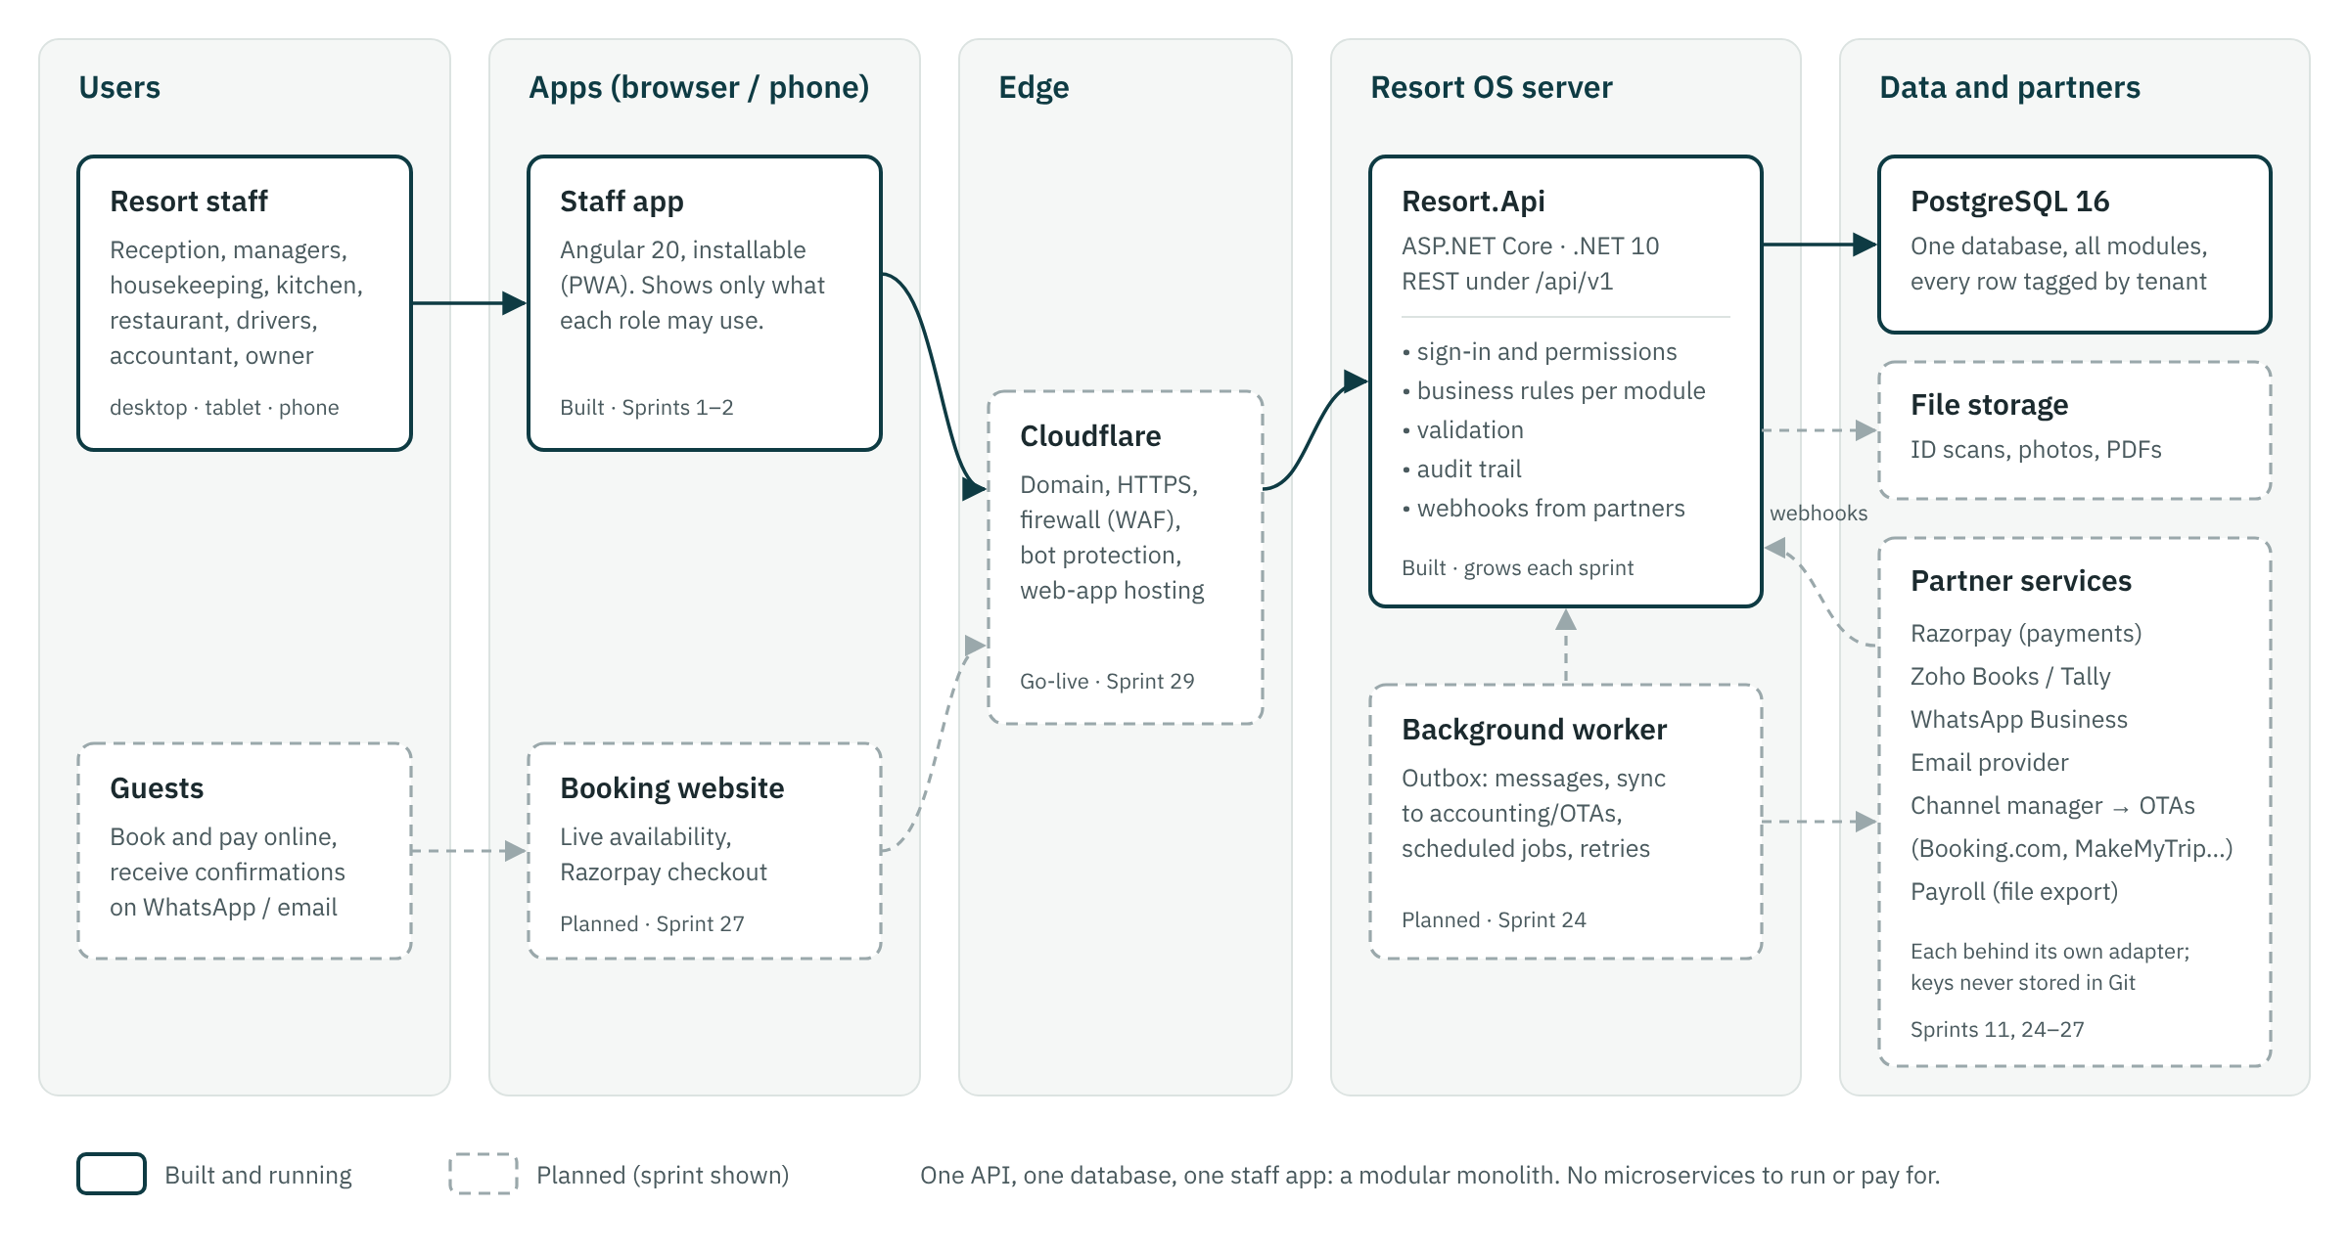
System architecture: built parts in solid boxes, planned parts dashed
- One deployable API (Resort.Api) serves the staff app, later the public booking site, and partner webhooks.
- One PostgreSQL database holds every module's tables. Every business row carries organization_id (and property_id where it belongs to a property).
- A background worker (Sprint 24) delivers outbound work from an outbox table: messages, accounting and OTA sync, scheduled jobs, with retries and idempotency.
- Adapters per capability (IPaymentGateway, IAccountingProvider, IChannelManager, IMessageSender, IFileStore) keep vendors replaceable.

4.2 Backend structure
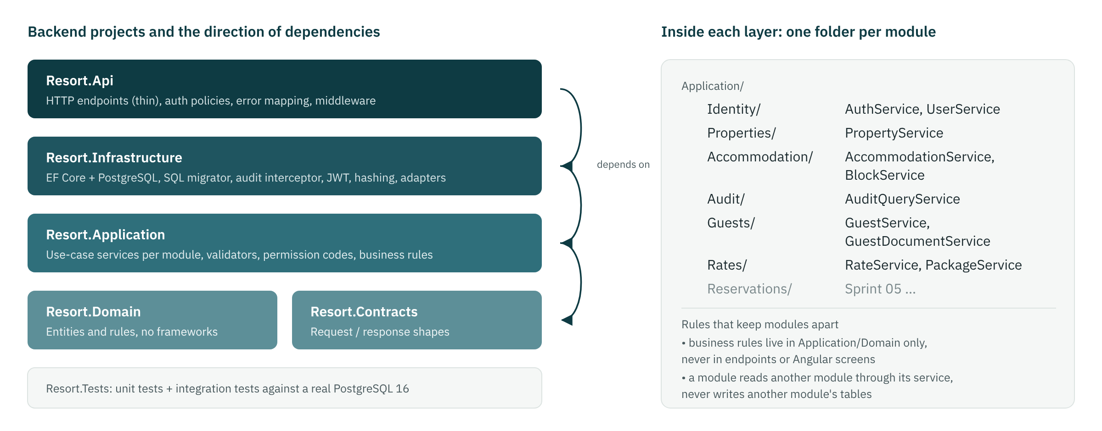
Projects, dependency direction and module folders
Projects: Resort.Api, Resort.Application, Resort.Contracts, Resort.Domain, Resort.Infrastructure, Resort.Tests. Dependencies point inwards: Api → Infrastructure → Application → Domain/Contracts. Business rules live in Application and Domain, never in endpoints or Angular components. Each module is a folder in every layer, and modules talk to each other through application services, never by writing another module's tables.

4.3 Request pipeline
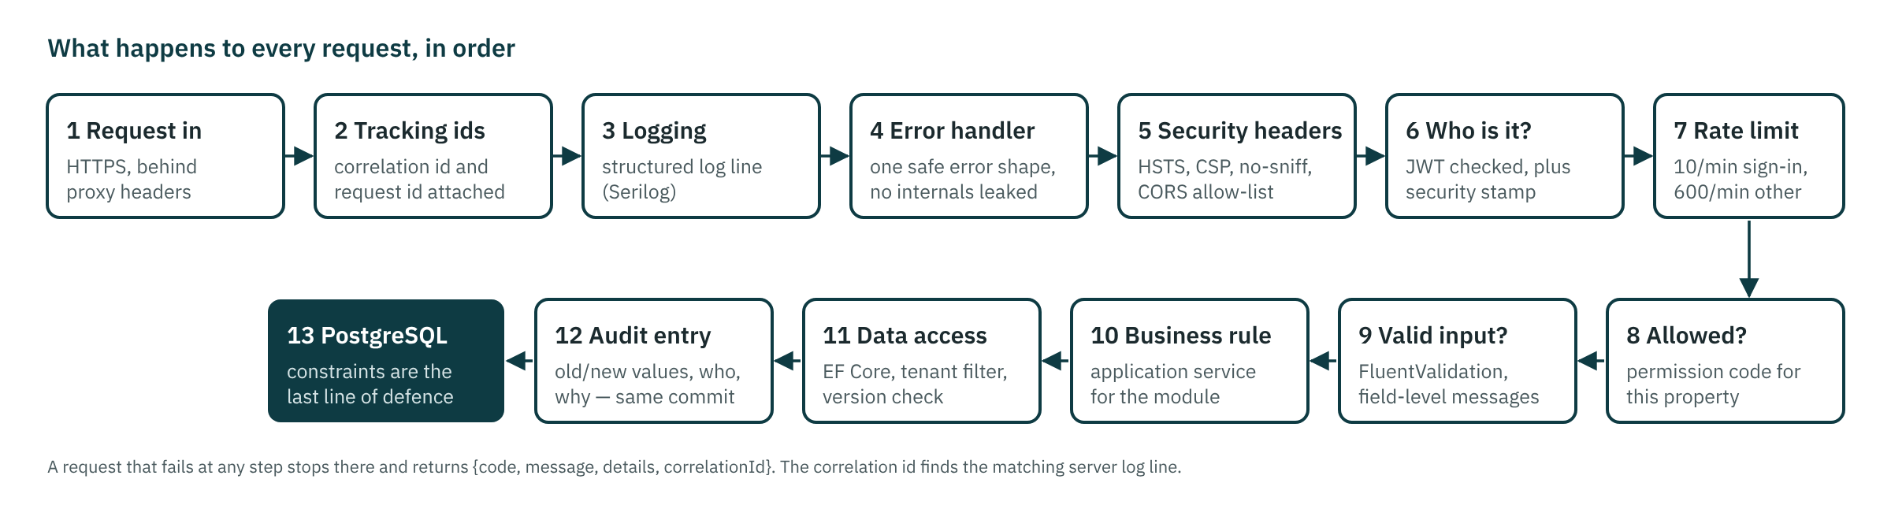
Middleware and checks applied to every request

4.4 Cross-cutting rules
Concern | Rule
Tenancy | Global EF Core query filter on organization_id; anonymous queries see nothing; another tenant's id returns 404, never 403
Time | Instants stored as UTC timestamptz. Business dates (stays, blocks, shifts) are date values in the property's time zone (Asia/Kolkata), never the server clock
Money | decimal in C#, numeric(12,2) in SQL, never float. Tax rule id and rate stored on every taxed line (Sprints 8–12)
Concurrency | Optimistic: PostgreSQL xmin exposed as version, 409 on stale edits. Inventory: row locks plus EXCLUDE constraints
Idempotency | Idempotency-Key header on booking and money POSTs; webhook event-id de-duplication (Sprints 5, 11)
Audit | EF interceptor writes old/new values, user, IP, device, reason, correlation and request id in the same transaction; append-only by trigger
Errors | {code, message, details, correlationId}; no stack traces, SQL or infrastructure details ever returned
Secrets | Only in environment variables / secret stores; .env is gitignored; gitleaks scans every pull request

4.5 Module map
The 32 modules, the tables each owns, and the sprint that builds it. Status is computed from the sprint plan.
# | Module | Owns (main tables) | Sprint | Status
1 | Identity | users, roles, permissions, user_roles, refresh_tokens, login_events | 1 | Done
2 | Property management | organizations, properties, property_settings | 1 | Done
3 | Accommodation | accommodation_types, accommodation_units, beds, unit_blocks | 2 | Done
4 | Reservations | reservations, reservation_units, idempotency_keys, rate_plans, packages | 4–6 | In progress
5 | Guests | guests, guest_documents, guest_preferences | 3 | Done
6 | Front desk | (uses reservations, folios) | 7 | Planned
7 | Folio | folios, folio_items, folio_item_taxes | 8 | Planned
8 | Payments | payments, payment_allocations, refunds, cash_drawer_* | 10–11 | Planned
9 | GST / invoicing | gst_registrations, tax_rules, invoices, credit_notes, receipts | 9, 12 | Planned
10 | Housekeeping | housekeeping_tasks, unit_housekeeping_status | 13 | Planned
11 | Maintenance | maintenance_assets, maintenance_tickets | 13 | Planned
12 | Restaurant / POS | restaurant_tables, orders, order_items, kots | 14 | Planned
13 | Menu | menu_categories, menu_items, modifiers | 14 | Planned
14 | Inventory | inventory_items, stock_movements, recipes | 15 | Planned
15 | Purchasing | purchase_orders, goods_received_notes, supplier_invoices | 16 | Planned
16 | Suppliers | suppliers | 16 | Planned
17 | Employees | employees, employee_compensation, departments | 17 | Planned
18 | Attendance | attendance_events, geofences, timesheets | 18 | Planned
19 | Roster | shift_templates, roster_shifts | 17 | Planned
20 | Leave | leave_types, leave_balances, leave_requests, holidays | 19 | Planned
21 | Activities | activities, activity_schedules, activity_bookings | 20 | Planned
22 | Transport | vehicles, vehicle_trips, trip_passengers | 21 | Planned
23 | Equipment | equipment, equipment_assignments | 20 | Planned
24 | Expenses | expenses, expense_categories, cost_centres | 22 | Planned
25 | Budgeting | budgets, budget_lines | 22 | Planned
26 | Accounting integration | accounting_sync_records | 25 | Planned
27 | OTA integration | ota_channels, ota_reservations, ota_events | 26 | Planned
28 | WhatsApp | whatsapp_messages, message_templates | 24 | Planned
29 | Notifications | notifications, outbox_messages | 24 | Planned
30 | Reports | reporting.* views | 23 | Planned
31 | Audit | audit_logs | 1 | Done
32 | System administration | system_settings, schema_migrations | 1 | Done

5 Security architecture

5.1 Authentication (built)
- Passwords hashed with PBKDF2-HMAC-SHA512 (100,000 iterations, per-hash salt); minimum 10 characters with letters and digits.
- Lock-out after 5 failures for 15 minutes; the same error for an unknown email and a wrong password, with equalised timing.
- Access token: JWT HS256, 15 minutes, kept in memory by the app (never localStorage).
- Refresh token: 32 random bytes stored only as a SHA-256 hash, in an HttpOnly, Secure, SameSite=Strict cookie scoped to /api/v1/auth, rotated on every use. Reuse of a rotated token revokes the whole session family and is audited.
- Cookie endpoints require the X-Resort-Client header (CSRF defence on top of SameSite).
- A security stamp in every token is checked on every request: deactivation, password change and admin reset sign the user out at once.
- Temporary passwords: every endpoint except change-password returns 403 PASSWORD_CHANGE_REQUIRED. MFA (TOTP) for owner, GM and accountant arrives in Sprint 28.

5.2 Authorisation (built)
- Permission codes, never role names, in code: .RequirePermission("unit_block.manage"). 117 permissions (23 flagged sensitive) and 17 system roles are seeded by migration V002.
- A grant is organisation-wide or limited to one property; property endpoints check the {propertyId} route value.
- Escalation guard: a user can only grant or remove roles whose permissions they hold in that scope; no self role changes or self-deactivation; at least one active owner always remains.
- Resource-level checks in services (CallerAccess) cover anything the route cannot express.

5.3 Data classification
Class | Examples | Controls
Public | Property name, room types, menu | None
Internal | Reservations, room status, rosters | Authenticated + permission
Confidential | Guest contact details, invoices, payments, staff records | Permission + audit of bulk export reads (Sprint 23)
Sensitive | Guest ID numbers and scans, salaries, bank details | Dedicated permission, AES-GCM field encryption, separate endpoints, never in lists or message bodies

5.4 OWASP Top 10 (2021) mapping
Risk | Controls | Tested by
A01 Broken access control | Permission policies, property scoping, tenant filters, escalation guard | AccessControlTests (built)
A02 Cryptographic failures | PBKDF2, SHA-256 token hashes, AES-GCM for sensitive fields, TLS | Cookie flags, masked audit values (built); encrypted column (Sprint 3)
A03 Injection | Parameterised EF Core queries only; Angular escaping | Injection payload suite (Sprint 28)
A04 Insecure design | Exclusion constraints and idempotency for bookings and money | Concurrency tests (built for blocks; Sprint 5 for bookings)
A05 Security misconfiguration | Secure headers, Swagger only in Development, least-privilege DB role | Security_headers_are_present (built)
A06 Vulnerable components | Dependabot; CI fails on known-vulnerable packages | CI security job (built)
A07 Authentication failures | Lock-out, rate limit, rotation + reuse detection, security stamp, MFA | AuthTests (built)
A08 Integrity failures | Migration checksums, signed webhooks, CI-built artefacts | Migrator tamper test (built); webhook signatures (Sprint 11)
A09 Logging failures | Structured logs, append-only audit, login events, alerts | Audit append-only test (built)
A10 SSRF | No user-supplied URLs fetched; allow-listed outbound hosts | Sprint 28

6 Data architecture

6.1 Conventions
Rule | Detail
Names | snake_case, plural tables; ix_ / ux_ / ck_ prefixes
Keys | uuid primary keys generated by the API as UUIDv7 (time-ordered); append-only logs use bigint identity
Tenancy | organization_id NOT NULL on every business table; property_id where the row belongs to one property; composite FKs keep children inside one property
Time | timestamptz in UTC; business dates as date in the property's time zone; ranges are [start, end) like check-in/check-out
Money | numeric(12,2); quantities numeric(12,3); never float or money
Audit columns | created_at, updated_at, created_by, updated_by on mutable tables
Deletion | Master data is deactivated; financial rows and history are never updated in place or deleted (enforced by triggers)
Enums | text + CHECK constraint, easy to extend in a migration
Classification | Personal-data columns carry COMMENT ON COLUMN … 'class: sensitive'

6.2 Migrations
The schema is owned by plain SQL migrations in database/migrations, applied in order at API start-up (in production, as a separate pipeline step). Each file runs in one transaction under an advisory lock. The API stores a SHA-256 checksum of every applied file and refuses to start if a merged migration is edited, so fixes always go forward in a new file.
Migration | Lines | Tables created
V001__foundation.sql | 273 | organizations, properties, property_settings, system_settings, users, permissions, roles, role_permissions, user_roles, refresh_tokens, login_events, audit_logs
V002__seed_permissions_roles.sql | 279 | none (seed data / columns)
V003__audit_request_context.sql | 12 | none (seed data / columns)
V004__accommodation.sql | 300 | amenities, accommodation_types, accommodation_type_amenities, accommodation_units, beds, unit_images, unit_blocks
V005__guests.sql | 265 | guests, guest_addresses, guest_documents, guest_preferences, guest_consents
V006__rates.sql | 243 | reservation_sources, rate_plans, rate_plan_prices, packages, package_components
V007__reservations.sql | 375 | property_counters, reservation_status_transitions, reservations, reservation_units, reservation_guests, reservation_rate_breakdowns, reservation_notes, reservation_status_history, idempotency_keys
Total: 38 tables in 7 migrations. Development demo data lives in database/seed/dev and runs only in Development.
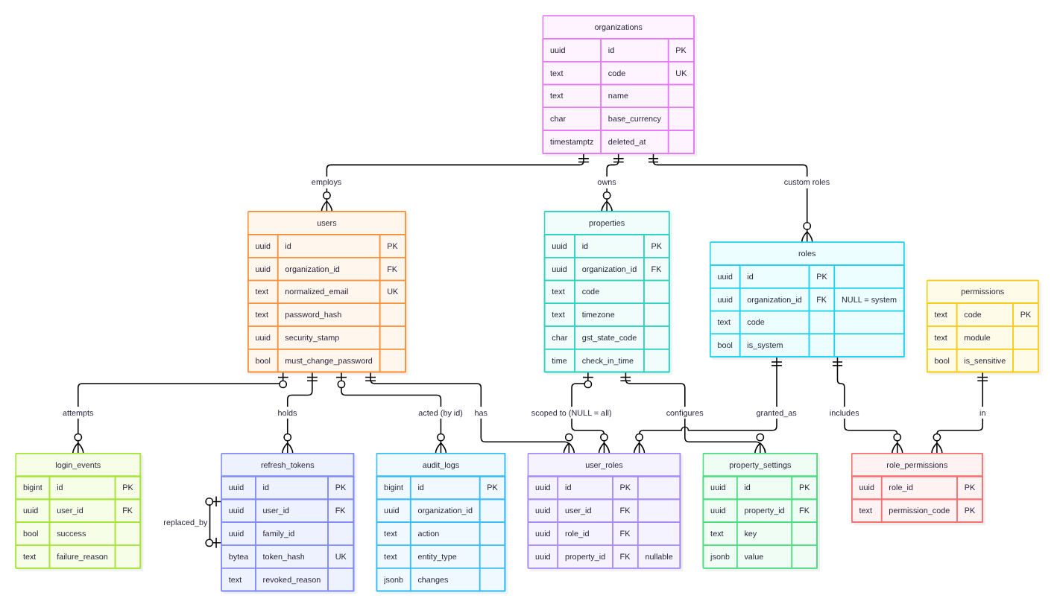
Sprint 01 tables: identity, organisation, properties and audit

7 API design

7.1 Conventions
Topic | Rule
Base path | /api/v1/<group>; property-specific resources under /api/v1/properties/{propertyId}/…
Auth | Authorization: Bearer <access token> (15 min); refresh via HttpOnly cookie on /api/v1/auth/refresh with X-Resort-Client: web
Permissions | Each endpoint requires one permission code; under /properties/{propertyId} the grant must be org-wide or for that property
Time | ISO-8601 UTC instants; business dates as YYYY-MM-DD in property local time
Concurrency | Mutable resources return version; send it back on PUT; stale → 409 CONCURRENCY_CONFLICT
Idempotency | Booking and money POSTs require Idempotency-Key; retries return the original response (Sprint 5+)
Reason | X-Change-Reason header (or a reason field in the body) on sensitive changes; stored in the audit log
Tracing | Optional X-Correlation-Id; every response returns X-Correlation-Id and X-Request-Id
Paging | ?page=1&pageSize=50 (max 200) → { items, page, pageSize, total }
Rate limits | Sign-in and password change 10/min/IP; everything else 600/min per user

7.2 Error format
Every non-2xx response has the body { code, message, details, correlationId }. Stack traces, SQL and exception types are never returned; the correlation id finds the server log line.
HTTP | Codes | When
400 | VALIDATION_FAILED, BAD_REQUEST, MISSING_CLIENT_HEADER | Invalid input (details = field → messages)
401 | UNAUTHORIZED, INVALID_CREDENTIALS, ACCOUNT_LOCKED, INVALID_REFRESH_TOKEN | Not signed in or bad credentials
403 | FORBIDDEN, PASSWORD_CHANGE_REQUIRED | Missing permission or temporary password
404 | NOT_FOUND | Missing or in another tenant (never says which)
409 | CONCURRENCY_CONFLICT, DUPLICATE, OVERLAP, EMAIL_TAKEN … | State conflict
422 | LAST_OWNER, SELF_ROLE_CHANGE, CONSTRAINT_VIOLATION … | Valid request that a business rule refuses
429 | RATE_LIMITED | Too many requests
500 | INTERNAL_ERROR | A bug; details only in the server log

7.3 Endpoint catalogue (built)
54 operations on 40 paths, from the committed OpenAPI snapshot (docs/api/openapi-v1.json). Full request and response specifications are in docs/API.md and in Swagger UI at /swagger when the API runs in Development.
Method | Path | Group
GET | /roles | Roles
GET | /permissions | Roles
GET | /audit-logs | Audit
POST | /auth/login | Auth
POST | /auth/refresh | Auth
POST | /auth/logout | Auth
GET | /auth/me | Auth
POST | /auth/change-password | Auth
GET | /organization | Organization
PUT | /organization | Organization
GET | /properties | Properties
POST | /properties | Properties
GET | /properties/{propertyId} | Properties
PUT | /properties/{propertyId} | Properties
GET | /properties/{propertyId}/settings | Properties
PUT | /properties/{propertyId}/settings/{key} | Properties
GET | /users | Users
POST | /users | Users
GET | /users/{id} | Users
PUT | /users/{id} | Users
PUT | /users/{id}/roles | Users
POST | /users/{id}/deactivate | Users
POST | /users/{id}/activate | Users
POST | /users/{id}/reset-password | Users
GET | /properties/{propertyId}/amenities | Rooms
PUT | /properties/{propertyId}/beds/{id} | Rooms
GET | /properties/{propertyId}/accommodation-types | Room types
POST | /properties/{propertyId}/accommodation-types | Room types
GET | /properties/{propertyId}/accommodation-types/{id} | Room types
PUT | /properties/{propertyId}/accommodation-types/{id} | Room types
GET | /properties/{propertyId}/rooms | Rooms
POST | /properties/{propertyId}/rooms | Rooms
GET | /properties/{propertyId}/rooms/status | Rooms
GET | /properties/{propertyId}/rooms/{id} | Rooms
PUT | /properties/{propertyId}/rooms/{id} | Rooms
GET | /properties/{propertyId}/rooms/{id}/beds | Rooms
POST | /properties/{propertyId}/rooms/{id}/beds | Rooms
GET | /properties/{propertyId}/blocks | Blocks
POST | /properties/{propertyId}/blocks | Blocks
POST | /properties/{propertyId}/blocks/{id}/release | Blocks
GET | /guests | Guests
POST | /guests | Guests
GET | /guests/possible-duplicates | Guests
POST | /guests/merge | Guests
GET | /guests/retention/dry-run | Guests
GET | /guests/{id} | Guests
PUT | /guests/{id} | Guests
GET | /guests/{id}/stays | Guests
POST | /guests/{id}/consents | Guests
POST | /guests/{id}/anonymise | Guests
GET | /guests/{id}/documents | Guest documents
POST | /guests/{id}/documents | Guest documents
GET | /guests/{id}/documents/{docId} | Guest documents
GET | /guests/{id}/documents/{docId}/file | Guest documents
Paths are shown without the /api/v1 prefix.

8 Frontend design
Angular 20 with standalone components, signals, reactive forms and lazy-loaded routes; Angular Material components with Tailwind utilities. Components render and collect input; business logic lives in the API. Each feature talks to the API through its own typed service.
Folder | Contents
core/ | Auth service (token in memory, silent refresh), HTTP interceptor and error mapping, guards, property context, models
shared/ | Reusable pieces such as the *appCan permission directive
layout/ | Shell: side navigation filtered by permission, top bar with property clock (IST), user menu
features/ | One folder per module: auth, dashboard, settings, users, audit, rooms … (added by their sprints)

8.1 UI conventions
Element | Convention
Layout | Page head (title, one-line purpose, one primary action) above panels
Forms | Reactive forms, outline fields, two columns collapsing to one at 640 px; server field errors mapped onto controls
Lists | Loading, empty (with the next action) and error states on every list; secondary columns hidden on phones
Feedback | Snack bar for 2.5 s in the past tense ("Changes saved"); errors show the API message
Time | Always shown in the property's time zone
Access | Guards and *appCan hide what a user cannot use; the API checks every request again
Phones | Menu behind a button below 900 px; touch targets ≥ 44 px on staff-mobile screens
Palette and type | Tide #0E3B43, kokum #8A2449, palm #2E6B3C on lime-wash #F5F7F6; IBM Plex Sans (self-hosted)

9 Engineering process

9.1 Sprint lifecycle
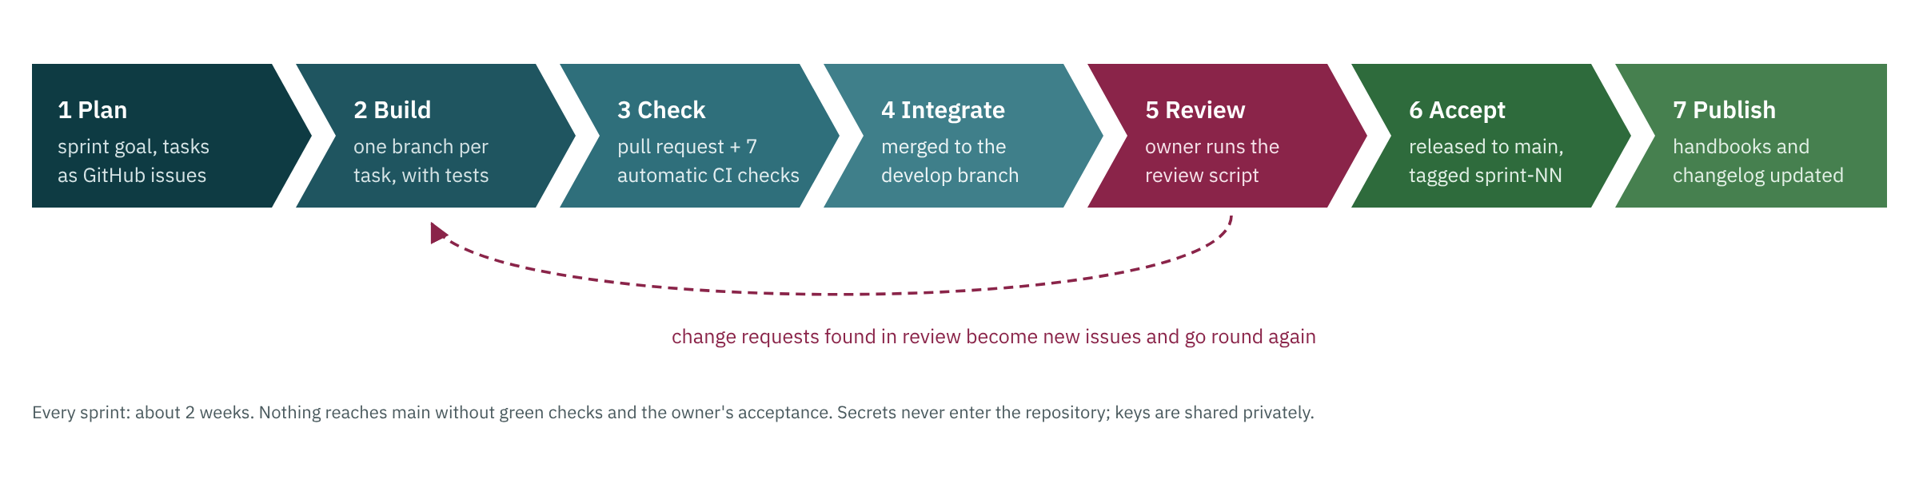
From plan to published
When | Event | Output
Day 1 | Sprint planning (60 min) | Goal agreed; issues in the sprint milestone; current: set in sprints.yml
Daily | Stand-up (15 min) | Yesterday / today / blockers
Day 9 | Code freeze | Only fixes merged; acceptance checks run
Day 10 | Sprint review (45 min) | Owner runs the REVIEWING.md script; accepts or files issues
Day 10 | Retro (30 min) | One or two process changes written into PROCESS.md
On acceptance | Release | develop → main (merge commit), tag sprint-NN, CHANGELOG dated, handbooks rebuilt

9.2 Branching
- main: production-ready, one tagged release per accepted sprint.
- develop: integration branch; every feature pull request targets it.
- feature/S03-12-guest-search, fix/S03-20-…: one branch per issue, squash-merged with a conventional title such as feat(guests): search by phone (#12).
- hotfix/…: from main for production incidents only; merged back to develop.

9.3 Definition of Done
- Merged to develop through a pull request with green CI (and one approving review once the team has two developers).
- Tests written for the behaviour, including the sprint guide's required tests.
- State-changing endpoints have a permission check, a validator, an audit entry, and idempotency where money or bookings are involved.
- No secrets, keys or personal data committed.
- docs/API.md and docs/DATABASE.md updated when endpoints or tables change.
- Screens have loading, empty and error states and work at 360 px width.

9.4 Secrets and configuration
Configuration comes from appsettings files (no secrets), then environment variables. Locally, scripts/setup-dev writes a gitignored .env at the repository root with throwaway values (database password, JWT signing key, encryption key, first owner password). Integration test keys (Razorpay, WhatsApp, Zoho) are handed out privately by the owner; .env.example lists the variable names with blank values. CI runs gitleaks on every pull request.

9.5 Continuous integration
Job | What it checks
Backend — build, lint, test | Restore, build with warnings as errors, dotnet format check, all backend tests against PostgreSQL 16 on Linux
Frontend — lint, test, build | npm ci, ESLint, unit tests in headless Chrome, production build
Backend — tests on Windows | All backend tests on a Windows runner with PostgreSQL (catches platform differences such as time-zone lookup)
Browser tests — sprint review scripts | Starts its own API, web app and throwaway database; runs the sprint review scripts in Chromium; uploads the report
Migrations — immutable and ordered | Merged migration files unchanged; numbering continuous
Security — secrets and vulnerable packages | gitleaks over the history; known-vulnerable NuGet and npm packages fail the build
An Onboarding workflow (Linux and Windows) also runs the setup scripts from scratch whenever they change.

10 Sprint record
One section per sprint that has been accepted or is built and waiting for review, then the plan of the sprint in progress. Each lists its outcome, the UI, API and database design, the code that changed, the tests and their results, and the behaviours a developer should know about.
# | Sprint | Size | Status | Outcome
00 | Architecture and requirements | M | In review | Pending: owner approval recorded as ADR-0000 in docs/architecture/decisions.md.
01 | Foundation — identity, RBAC, organisation, properties, audit | L | Done | Accepted 10 Oct 2026. On main as tag sprint-01.
02 | Accommodation — room types, rooms, dormitory beds, blocks | M | Done | Accepted 10 Oct 2026. On main as tag sprint-02. Sprint 03 (guests) started.
03 | Guests | M | Done | Accepted 11 Oct 2026. On main as tag sprint-03. Sprint 04 (rate plans and packages) started.
04 | Rate plans and packages | M | Done | Accepted 14 Oct 2026. A quote for Room 103, 2 adults, 3 nights returns a nightly breakdown matching the rate grid (checked by DevSeedTests, check-api.mjs and browser step S04-03). On main as tag sprint-04. Sprint 05 (availability engine and reservations) started.
05 | Availability engine and reservations core | L | Done | Accepted by the owner on 15 Oct 2026 and released to main (tag sprint-05). Review fixes: every date field shows 15 Oct 2026 with a calendar, field labels no longer cut off, finished wizard steps show a tick, Back beside Continue. New guide for joiners: docs/architecture/system-design.md.
06 | Reservation calendar | M | In progress

10.1 Sprint 01 — Foundation — identity, RBAC, organisation, properties, audit
Goal | A secure, multi-tenant base that every later module plugs into.
In plain words | Staff sign in securely, each person sees only what their role allows, the owner manages properties and staff accounts, and every change is recorded in an audit trail.
Phase / size | 1 — Foundation, property, rooms, beds · L
Depends on | Sprint 00
Status | Done
Outcome | Accepted 10 Oct 2026. On main as tag sprint-01.

10.1.1 What was delivered
- Solution: Resort.Api / Application / Domain / Infrastructure / Contracts / Tests on .NET 10
- Migrations V001 (13 tables, append-only triggers), V002 (117 permissions, 17 roles, default matrix), V003 (audit device/reason/request id)
- Sign-in, rotating refresh cookie with theft detection, lockout, forced password change, sign-out everywhere on deactivation
- Organisation, properties, property settings; staff accounts with property-scoped roles; escalation and last-owner guards
- Audit trail written in the same transaction; reason via X-Change-Reason; correlation and request ids
- /api/v1 routes, standard error body, security headers, rate limits, health checks, OpenAPI/Swagger
- Angular 20 staff app: sign-in, Today checklist, properties, staff accounts, roles matrix, audit trail, change password
- CI on GitHub (build, lint, tests on PostgreSQL 16, secret and dependency scans); onboarding scripts for Windows/macOS/Linux

10.1.2 UI design
An Angular 20 staff app with a left navigation that shows only the screens a person's permissions allow, and a top bar with the property name and its local clock (IST). Screens: Sign in, Today (a setup checklist that ticks itself off), Properties (list and editor), Staff accounts (list, create, edit roles, deactivate, reset password), Roles & permissions (a read-only matrix of 17 roles × 117 permissions), Audit trail (filterable history) and Change password. Every list has loading, empty and error states; forms show the server's field-level messages; the layout collapses behind a menu button below 900 px.
Screens (routes)
/login
/dashboard
/account/password
/settings/properties
/users
/roles
/audit
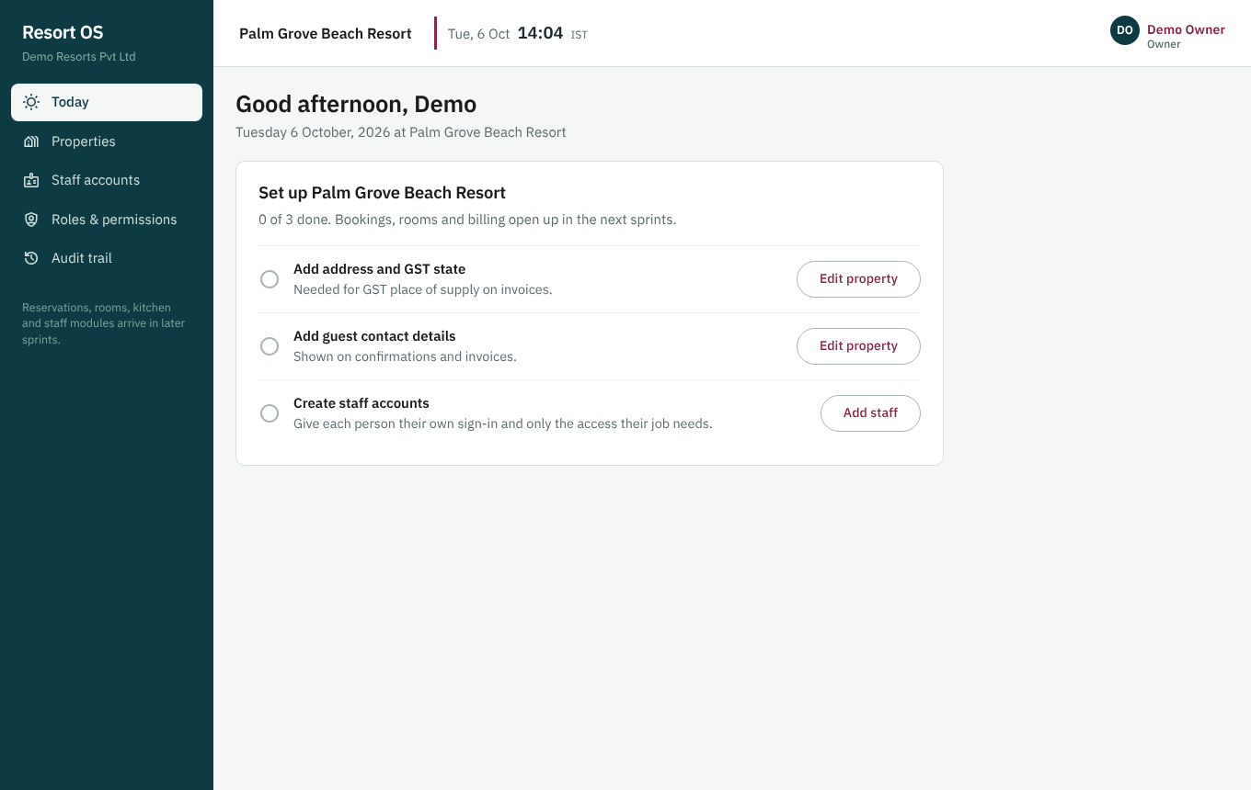
Today: the owner's setup checklist
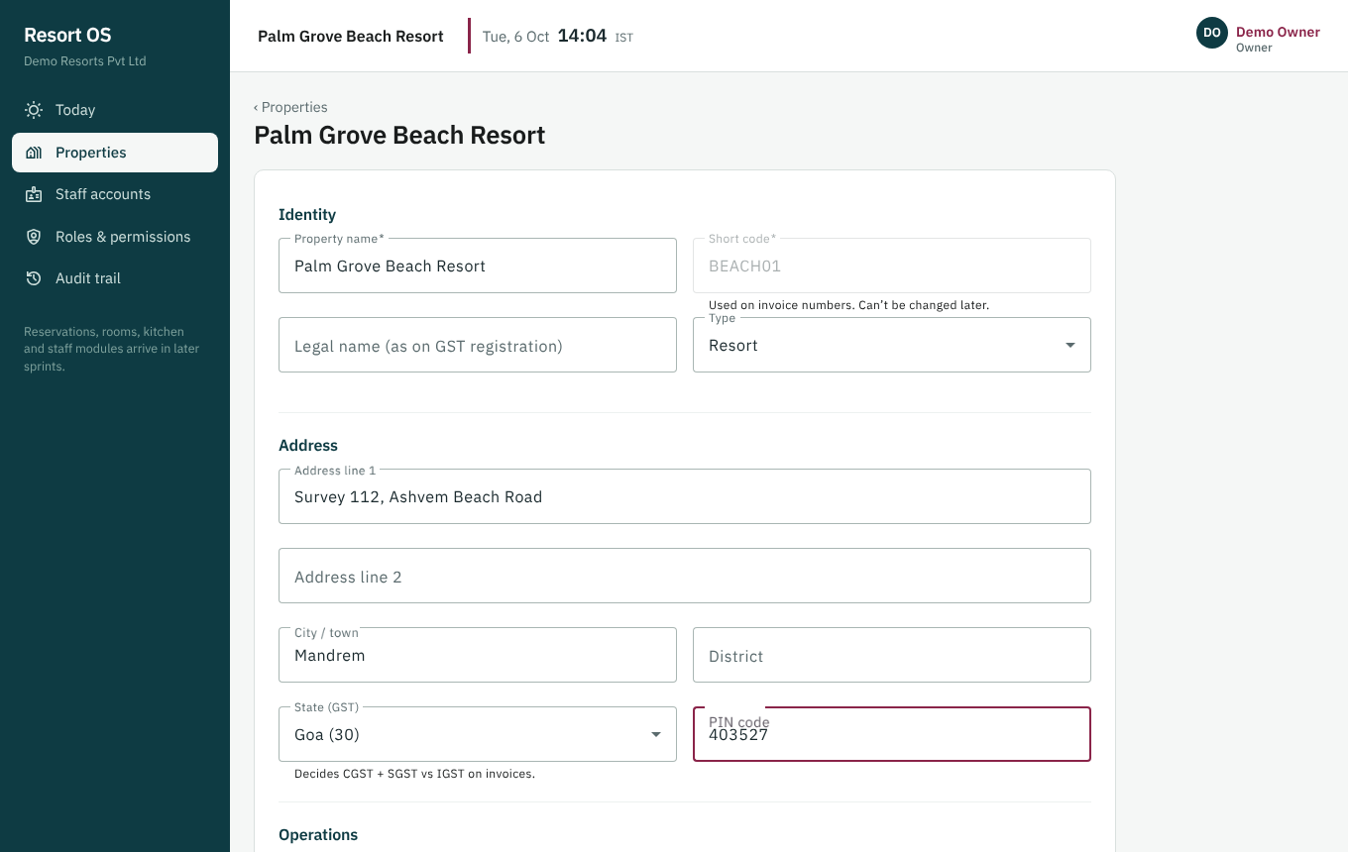
Property editor: address, GST state, time zone, check-in/out times
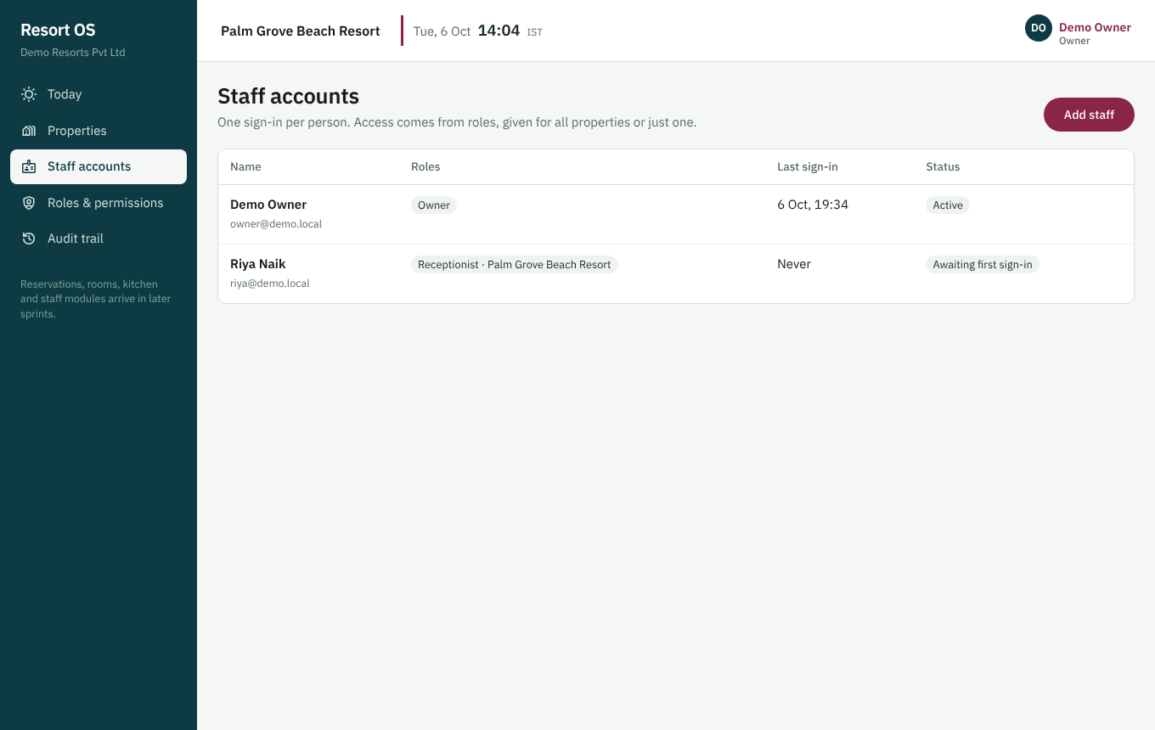
Staff accounts with role and status
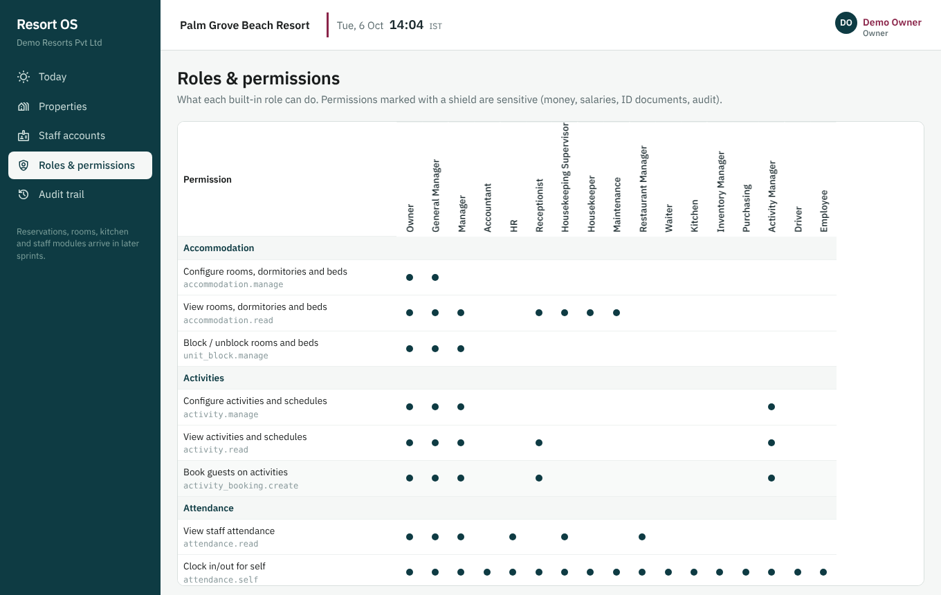
Roles and permissions matrix (17 roles × 117 permissions)
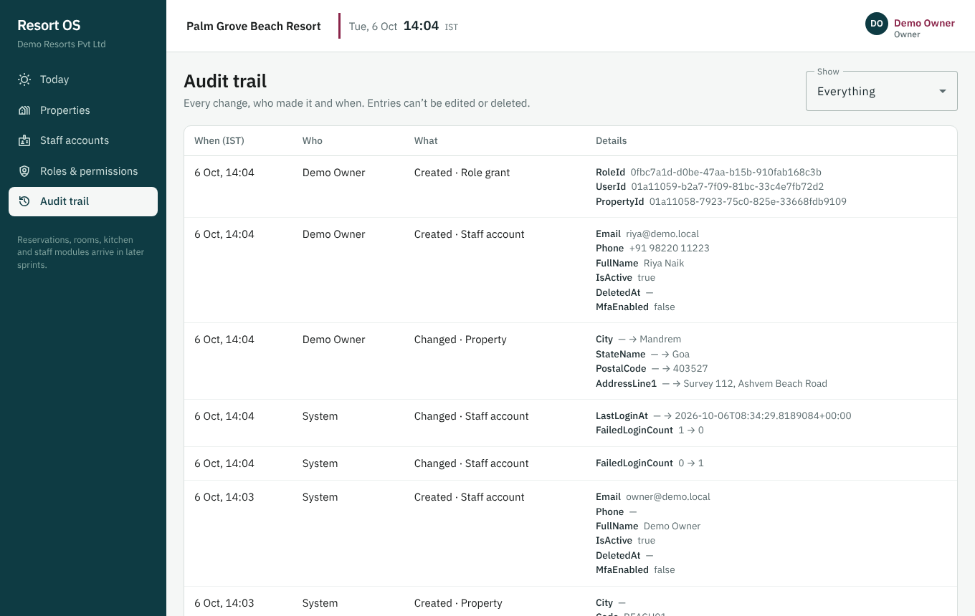
Audit trail: who changed what, when and why
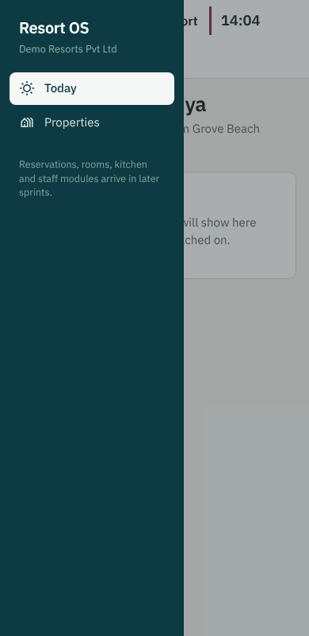
Phone width: the menu folds behind a button

10.1.3 API design
REST endpoints under /api/v1 for auth (login, refresh, logout, me, change-password), organisation, properties and property settings, users and their roles, roles, permissions and audit logs. Each endpoint requires one permission code, checked against the property in the route. Access tokens last 15 minutes and live in memory; the refresh token is an HttpOnly cookie that rotates on every use, and reusing an old one revokes the whole session family. Edits send back a version number (optimistic concurrency, 409 on a stale edit). Errors always come back as {code, message, details, correlationId}.
Endpoints
POST /auth/login
POST /auth/refresh
POST /auth/logout
GET /auth/me
POST /auth/change-password
GET|PUT /organization
GET|POST /properties
GET|PUT /properties/{propertyId}
GET /properties/{propertyId}/settings
PUT /properties/{propertyId}/settings/{key}
GET|POST /users
GET|PUT /users/{id}
PUT /users/{id}/roles
POST /users/{id}/deactivate | activate | reset-password
GET /roles
GET /permissions
GET /audit-logs

10.1.4 Database design
Migrations V001–V003 create 13 tables: organisations, properties and settings; users, roles, permissions, role_permissions and user_roles (a grant can be organisation-wide or for one property); refresh_tokens and login_events; audit_logs; system_settings and schema_migrations. V002 seeds the 117 permissions and 17 system roles. Database triggers make audit_logs and login_events append-only. The migrator records a SHA-256 checksum per file and refuses to start if a merged migration is edited.
Tables | organizations, properties, property_settings, system_settings, users, roles, permissions, role_permissions, user_roles, refresh_tokens, login_events, audit_logs, schema_migrations
Migrations | V001__foundation, V002__seed_permissions_roles, V003__audit_request_context

10.1.5 Code changed
Files and folders
database/migrations/V001__foundation.sql, V002__seed_permissions_roles.sql, V003__audit_request_context.sql
backend/Resort.Domain/ — Common/Entity.cs, Identity/Identity.cs, Organizations/Organization.cs, Audit/AuditLog.cs
backend/Resort.Contracts/Contracts.cs
backend/Resort.Application/ — Identity/AuthService.cs, Identity/UserService.cs, Properties/PropertyService.cs, Audit/AuditQueryService.cs, Common/*, Validation/Validators.cs
backend/Resort.Infrastructure/ — Persistence/AppDbContext.cs, AuditInterceptor.cs, DatabaseMigrator.cs, Bootstrapper.cs; Identity/Security.cs
backend/Resort.Api/ — Program.cs, Endpoints/AuthEndpoints.cs, Endpoints/AdminEndpoints.cs, Infrastructure/* (auth, errors, request context, .env loader)
backend/Resort.Tests/ — Integration/AuthTests.cs, Integration/AccessControlTests.cs, Unit/UnitTests.cs, Support/ResortApiFactory.cs
frontend/src/app/ — core/*, shared/can.directive.ts, layout/shell.ts, features/{auth,dashboard,settings/properties,users,audit}
scripts/*, .github/workflows/*, .vscode/*, .env.example

10.1.6 Tests and results
Required test
Login, lockout, same error for unknown email vs wrong password
Refresh rotation and reuse detection revoking the family
Permission denial (403) and property scoping
Tenant isolation (404 across tenants)
Escalation guard (GM cannot grant OWNER)
Optimistic concurrency (409)
Audit with masked secrets, reason, device, request id; append-only at DB level
Migrator idempotent; edited migration refused

Results
Backend: 30 passed, 0 failed (GitHub CI, real PostgreSQL 16)
Frontend: 6 of 6 passed; ESLint clean; production build OK
Build warnings: 0; dotnet format clean; gitleaks: no secrets in history
Manual walkthrough as owner and receptionist on desktop and 390 px phone width (screenshots; step-by-step script in REVIEWING.md)

10.1.7 Acceptance criteria
- Owner signs in, creates a property, creates a receptionist limited to one property, and sees both actions in the audit trail
- Receptionist sees only Today and Properties; /users redirects
- Deactivating a user signs them out immediately

10.1.8 Behaviours to know when debugging
- 401 on every call after a password change is expected: the security stamp rotated. Sign in again.
- 403 PASSWORD_CHANGE_REQUIRED: the account still has a temporary password.
- Access is cached for 30 s per user; restart the API if you edit user_roles directly in SQL.

10.2 Sprint 02 — Accommodation — room types, rooms, dormitory beds, blocks
Goal | Model the 6 rooms and the dormitory correctly (room-based vs bed-based inventory) and let managers block units.
In plain words | The resort's rooms and dormitory beds are set up in the system, can be taken out of sale for repairs or owner use, and their status is visible at a glance.
Phase / size | 1 — Foundation, property, rooms, beds · M
Depends on | Sprint 01
Status | Done
Outcome | Accepted 10 Oct 2026. On main as tag sprint-02. Sprint 03 (guests) started.

10.2.1 What was delivered
- Migration V004: 7 tables, 22 built-in amenities, btree_gist EXCLUDE constraints for overlapping blocks, triggers that keep beds under bed-based rooms only
- Room-based (UNIT) and bed-based (BED) inventory with a capacity calculation the availability engine (Sprint 05) will reuse
- APIs: room types with amenities, rooms, dorm beds, room status board, blocks with reason and release — all permission-checked, validated and audited
- Blocks: property-local dates, end date not included, row lock + database guard so 10 simultaneous requests give exactly one block
- Rooms are deactivated, never deleted; blocks are released, never deleted
- Development seed runner (database/seed/dev) + demo data: 2 deluxe, 4 standard, a 10-bed dormitory
- Angular screens: Rooms (grouped by type, today's status, blocks list), room editor with dorm bed editor and bulk-add, block dialog, release with reason, Room status board, Room types list and editor with amenities
- Today checklist gains a *Set up rooms* step; menu gains Rooms, Room status, Room types

10.2.2 UI design
Rooms (grouped by type with today's status and a list of current and upcoming blocks), the room editor (with a dormitory bed editor and bulk add), the block dialog (dates, type, reason), release with a reason, the Room status board, and Room types (list and editor with amenities grouped by category). The Today checklist gains a Set up rooms step. Receptionists get read-only views; buttons they cannot use are hidden.
Screens (routes)
/rooms
/rooms/new, /rooms/{id}
/rooms/status (read-only for now)
/settings/room-types, /settings/room-types/new, /settings/room-types/{id}
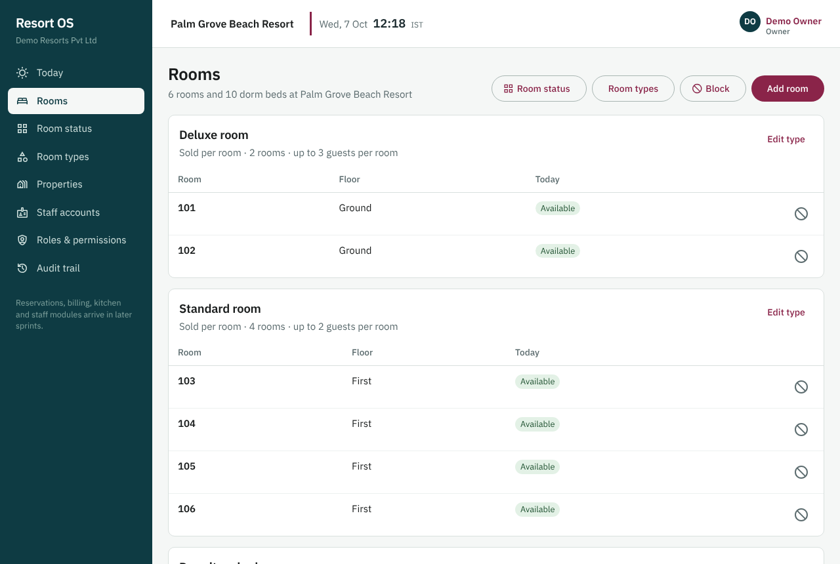
Rooms grouped by type with today's status
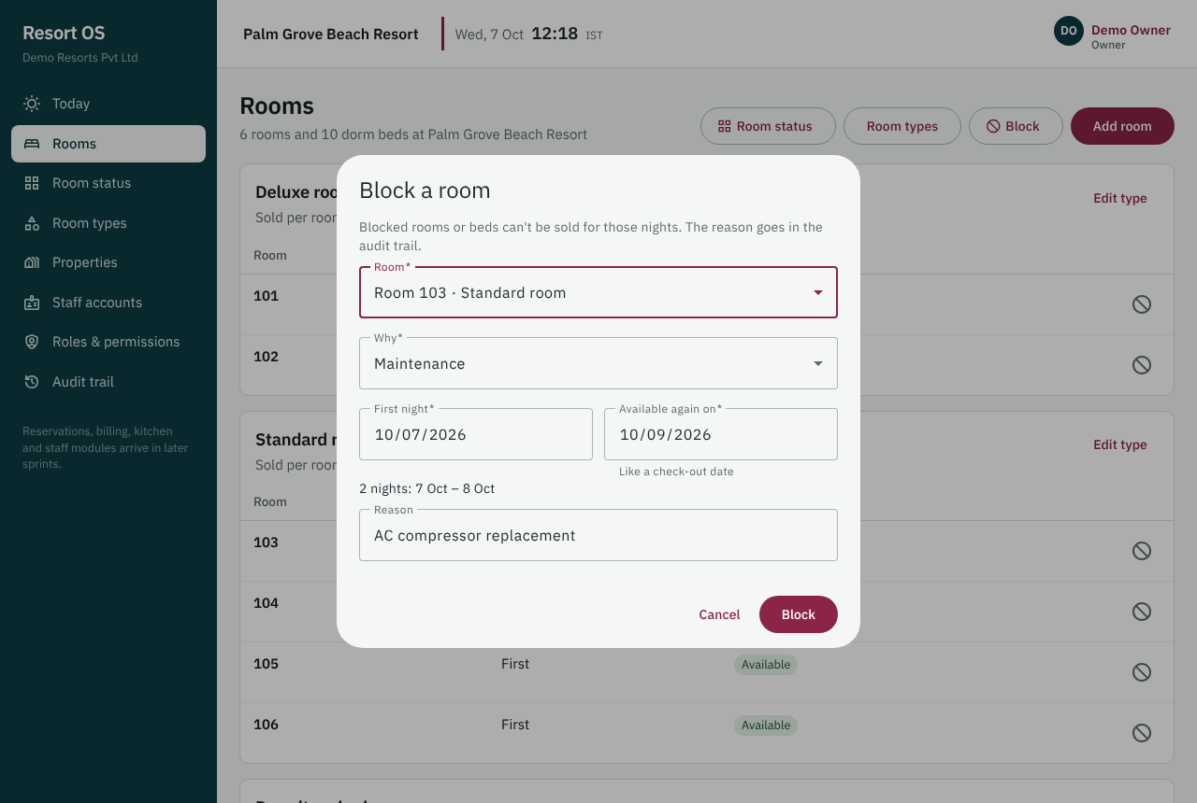
Blocking a room: dates, type and a reason
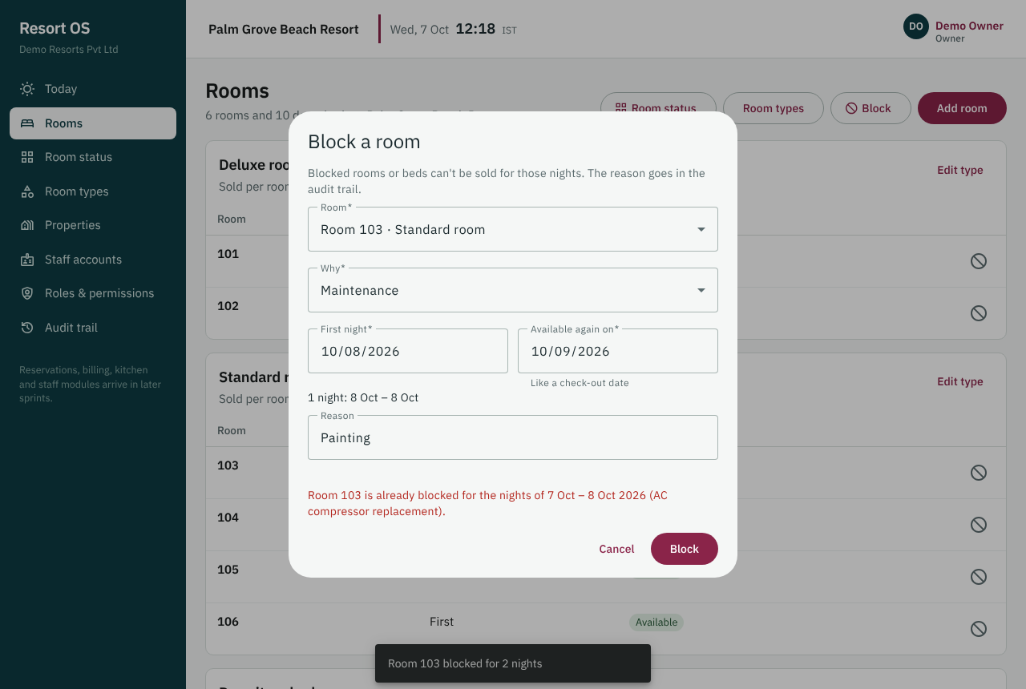
An overlapping block is refused with a clear message
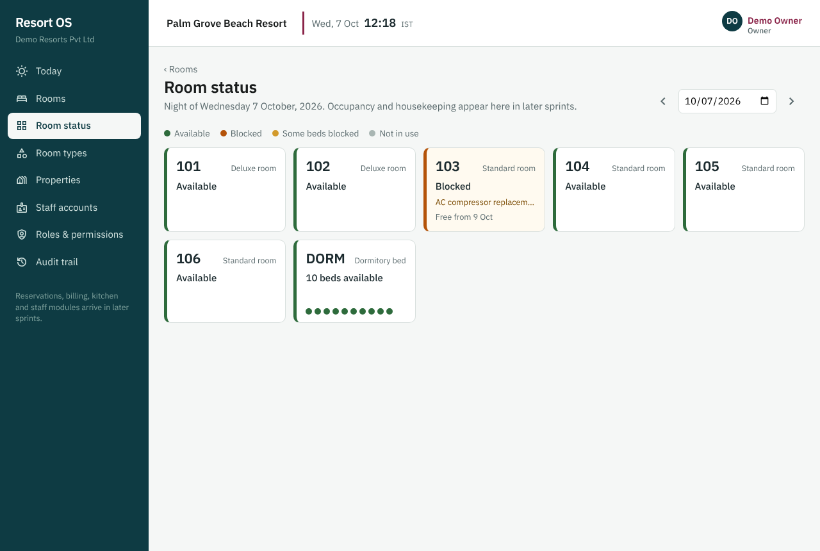
Room status board
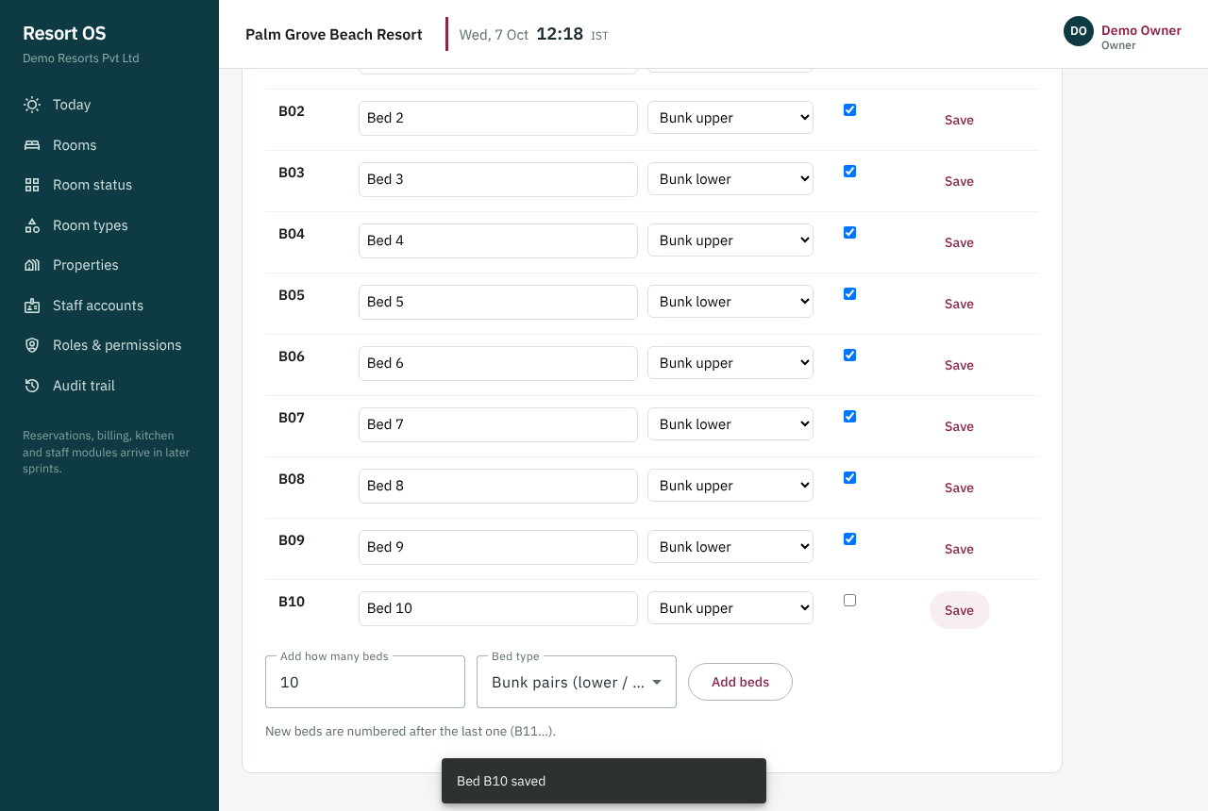
Dormitory: beds B01–B10 managed one by one
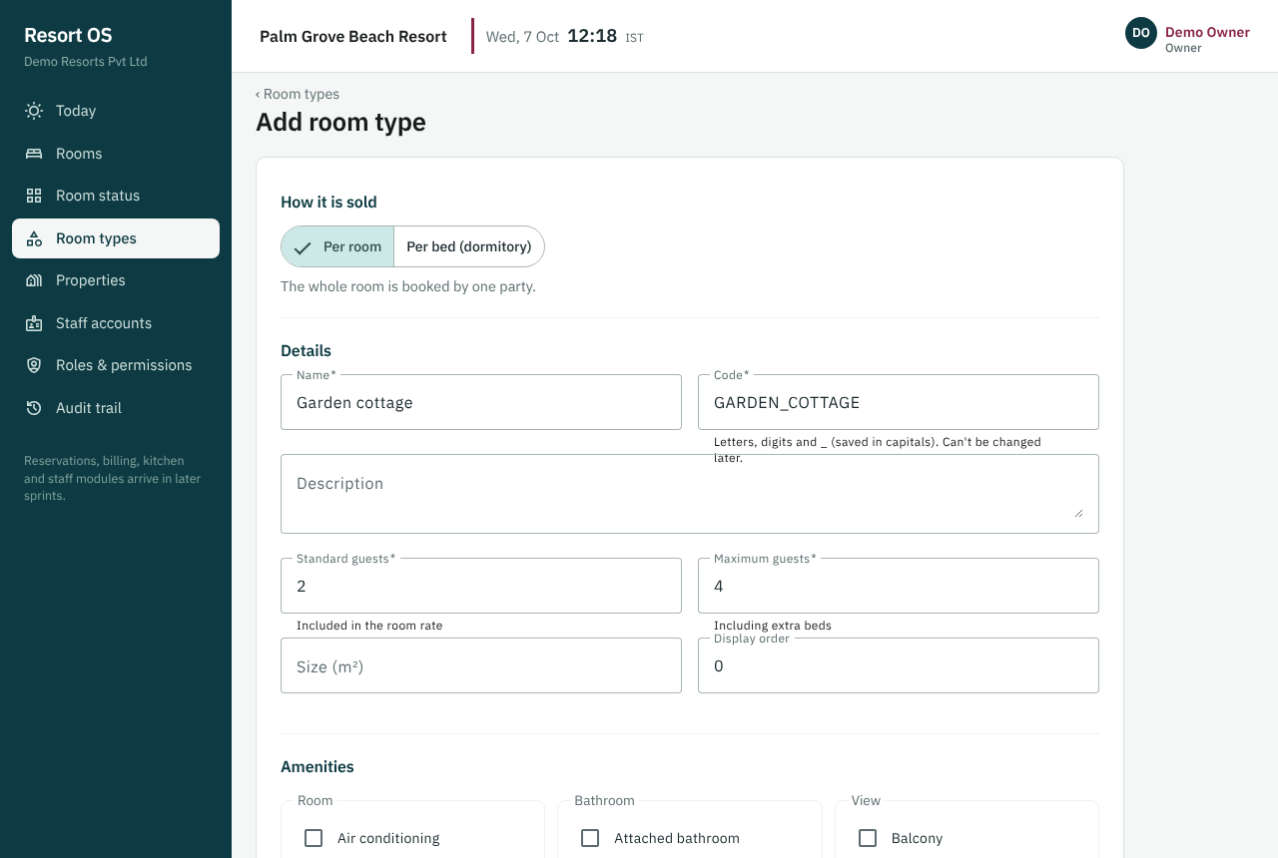
Room type editor with amenities
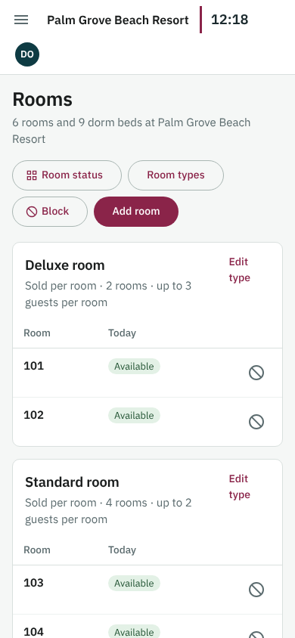
Rooms at phone width

10.2.3 API design
Endpoints under /api/v1/properties/{propertyId}: amenities, accommodation types, rooms, room status, dormitory beds, blocks and block release. Configuration needs accommodation.manage; blocking needs unit_block.manage; reading needs accommodation.read. Blocks use property-local dates with the end date not included (like a check-out date). The overlap check runs under a row lock, and the database is the final guard: 10 simultaneous block requests on one room give exactly one block and nine 409 OVERLAP answers.
Endpoints
GET|POST /properties/{propertyId}/accommodation-types
GET|PUT /properties/{propertyId}/accommodation-types/{id}
GET|POST /properties/{propertyId}/rooms
GET /properties/{propertyId}/rooms/status
GET|PUT /properties/{propertyId}/rooms/{id}
GET|POST /properties/{propertyId}/rooms/{id}/beds
PUT /properties/{propertyId}/beds/{id}
GET|POST /properties/{propertyId}/blocks
POST /properties/{propertyId}/blocks/{id}/release
GET /properties/{propertyId}/amenities

10.2.4 Database design
Migration V004 adds 7 tables: accommodation_types (inventory_mode UNIT or BED), accommodation_type_amenities, amenities (22 built in), accommodation_units, beds, unit_images and unit_blocks. btree_gist EXCLUDE constraints stop two active blocks overlapping on one room or one bed; a trigger stops a whole-dorm block overlapping a single-bed block; other triggers keep beds only under bed-based rooms and refuse deleting blocks. Composite foreign keys keep every row inside one property. A development-only seed runner (database/seed/dev) loads the demo rooms once.
Tables | accommodation_types, accommodation_units, beds, amenities, accommodation_type_amenities, unit_images, unit_blocks
Migrations | V004__accommodation
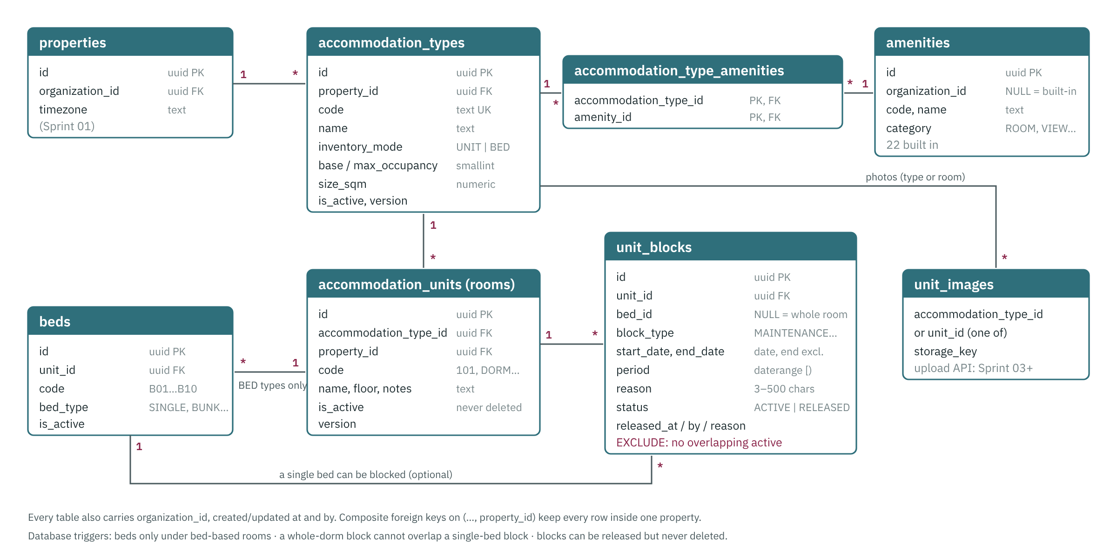
Accommodation tables and how they relate

10.2.5 Code changed
Files and folders
database/migrations/V004__accommodation.sql; database/seed/dev/S001__accommodation.sql
backend/Resort.Domain/Accommodation/Accommodation.cs
backend/Resort.Contracts/AccommodationContracts.cs
backend/Resort.Application/ — Accommodation/AccommodationService.cs, Accommodation/BlockService.cs, Validation/AccommodationValidators.cs, Common/AuditContext.cs, Common/Permissions.cs
backend/Resort.Infrastructure/ — Persistence/AppDbContext.cs, AuditInterceptor.cs (reason from the request body), DevSeeder.cs
backend/Resort.Api/ — Endpoints/AccommodationEndpoints.cs, Program.cs, appsettings.Development.json (DevSeed)
backend/Resort.Tests/ — Integration/AccommodationTests.cs, Integration/DevSeedTests.cs, Unit/AccommodationUnitTests.cs
frontend/src/app/ — features/rooms/*, features/settings/room-types/*, core/models.ts, app.routes.ts, layout/shell.ts, features/dashboard
docs/API.md, docs/DATABASE.md, docs/database/schema-sprint-02.md, docs/GETTING_STARTED.md, docs/sprints/REVIEWING.md, sprint-02-screens/

10.2.6 Tests and results
Required test
Integration — cannot add beds to a UNIT-mode room (422)
Integration — overlapping blocks on the same unit rejected by the DB (409 OVERLAP)
Integration — receptionist can read rooms but not create them (403)
Integration — block create/release audited with reason
Unit — inventory capacity calculation (room = 1 sellable unit, dorm = N beds)
Frontend — room editor form validation
Integration — 10 concurrent blocks on one room: exactly one wins
Integration — whole-dorm block vs single-bed block conflict, both directions
Integration — tenant isolation (404) and stale version (409)
Integration — dev seed creates the demo rooms once and skips on restart
Unit — overlap message names the blocked nights, not the day the room is free again

Results
Backend: 58 passed, 0 failed, real PostgreSQL 16, on Linux and Windows (incl. the IST time-zone fix found in review)
Concurrency: 10 simultaneous block requests on one room → exactly 1 created, 9 × 409; repeated 20 times, no flakes
Frontend: 14 of 14 unit tests passed; 26 of 26 browser tests (Sprint 01 + 02 review scripts, automated); ESLint clean; production build OK
All 14 steps of the REVIEWING.md Sprint 02 script run in Chromium as owner and receptionist, desktop and 390 px phone width, no page errors (screenshots)

10.2.7 Acceptance criteria
- A manager configures 6 rooms and a 10-bed dorm from the UI in under 10 minutes
- Blocking Room 103 for 2 nights shows it as blocked; a second overlapping block is refused

10.2.8 Behaviours to know when debugging
- EXCLUDE constraints need the btree_gist extension: the migration must CREATE EXTENSION IF NOT EXISTS btree_gist.
- Date ranges are [check-in, check-out) in the property's local dates — never convert to UTC for availability.
- No demo rooms after pulling? The seed only fills a property that has no room types. Reset the database and restart the API.
- 409 OVERLAP (not BLOCK_OVERLAP) means two requests raced and the database guard caught the second one. That's correct behaviour.
- Configuring rooms needs accommodation.manage (Owner, GM). A Manager can block rooms but not edit them; a Receptionist can only view.

10.3 Sprint 03 — Guests
Goal | Guest profiles with only the data that is needed, encrypted sensitive fields, de-duplication and retention.
In plain words | Reception keeps one clean record per guest, finds returning guests by phone in one search, and stores ID documents encrypted and visible only to permitted staff.
Phase / size | 2 — Guests, reservations, availability, calendar, front desk · M
Depends on | Sprint 01
Status | Done
Outcome | Accepted 11 Oct 2026. On main as tag sprint-03. Sprint 04 (rate plans and packages) started.

10.3.1 What was delivered
- Migration V005: 5 tables with a data classification on every column; pg_trgm indexes for contains-search on name, email, company and phone digits; database guards (never delete guests, anonymised rows empty, Aadhaar never in full, consent history append-only)
- Field-level encryption (AES-256-GCM, HKDF-derived keys, key id per row, row-bound associated data) for ID numbers, document details and scans; key rotation design and steps in SECURITY.md
- File storage abstraction (IFileStore) with a local-disk implementation; scans checked by their bytes (JPEG/PNG/PDF), ≤ 5 MB, stored encrypted
- Guest APIs: search by any part of a phone number typed any way, or name/email/company; duplicate warning on create (phone, email, full name, same ID document); edit with optimistic concurrency; consent history; merge with reason; anonymise with reason; retention dry-run report
- Phone numbers normalised to E.164 (Indian numbers typed locally, international with + or 00)
- Audit trail names changed guest fields but never stores personal values; opening an ID number or scan is a SENSITIVE_READ audit row
- Dev seed S002: 20 invented guests (14 Indian, 6 international) with addresses, preferences and consents
- Angular screens: Guests list with search-as-you-type, add/edit guest with duplicate warning, GST state and preferences, guest profile with consent, stays and ID documents (only with guest_document.read), add-document dialog, merge dialog, anonymise

10.3.2 UI design
Guests (menu) lists profiles with search-as-you-type: any part of a phone number in any format, or name, email or company. Add/edit guest checks for duplicates as soon as the phone or email is entered and shows matches with their reasons; saving again creates the profile anyway. The form covers contact details, nationality (Form-C hint for foreign nationals), address with the GST state for Indian addresses, company and GSTIN, preferences as chips, and team notes. The profile page shows contact, address, preferences, consent (Yes/No per purpose with who and when), stays (empty until Sprint 05) and, only for users with guest_document.read, ID documents with masked numbers, Show number, View scan and an Add document dialog (camera capture on phones). More → Merge folds a duplicate in; More → Anonymise (owner/GM) asks for a reason.
Screens (routes)
/guests
/guests/new
/guests/:id
/guests/:id/edit
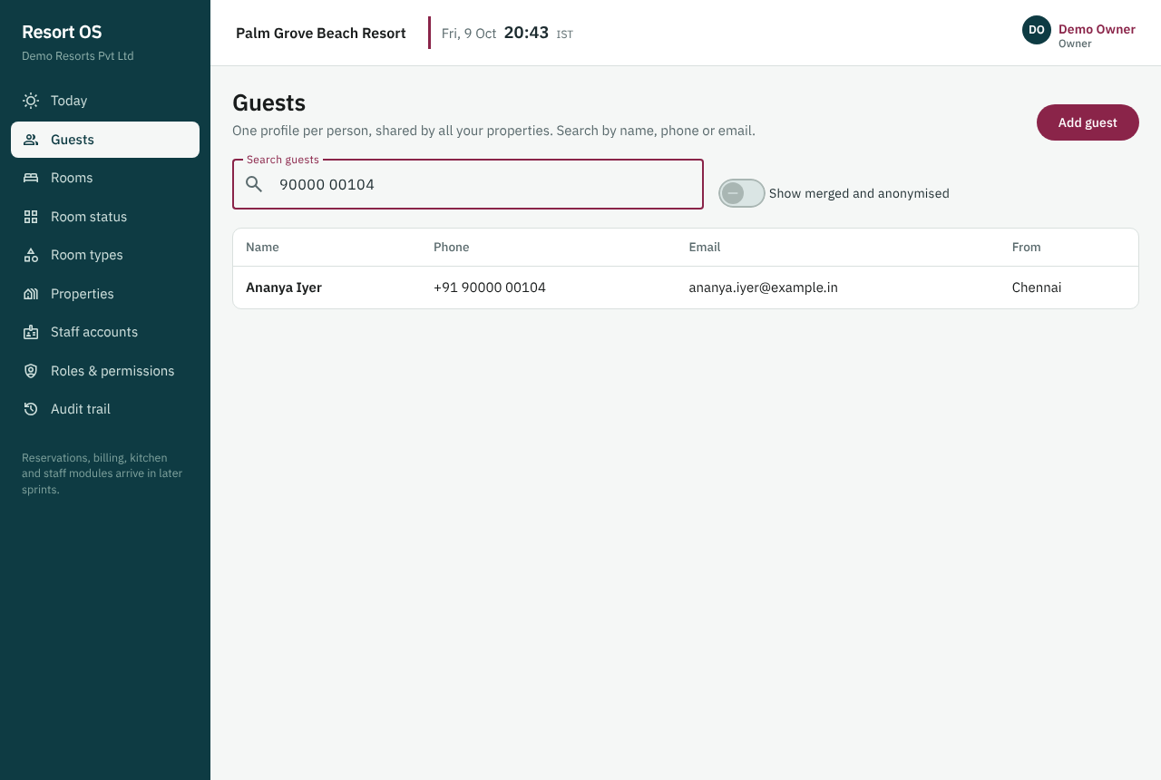
A returning guest found by phone in one search
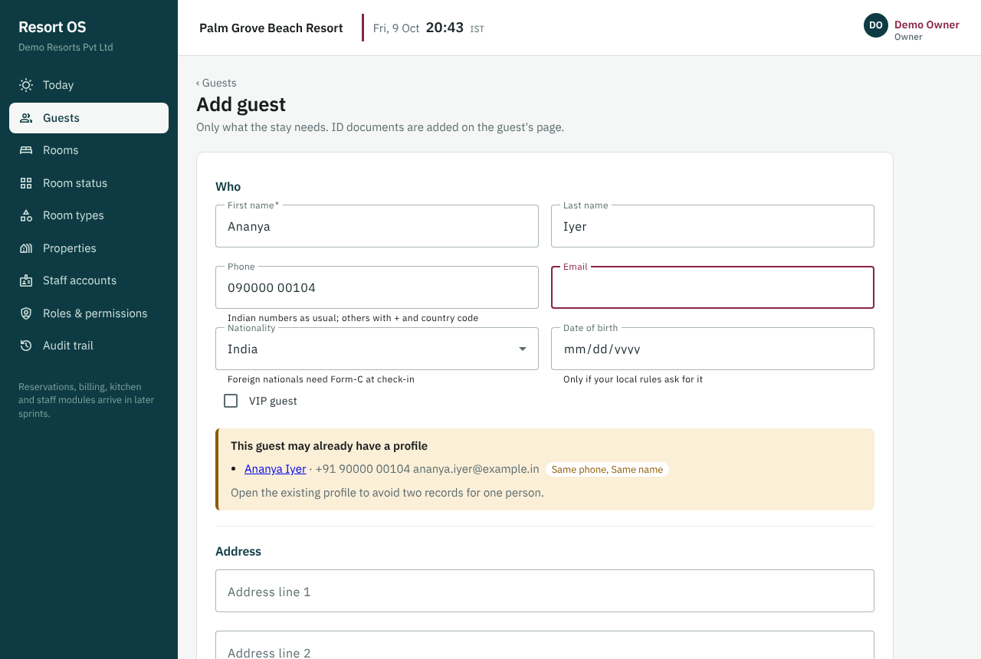
Warning before creating a second profile for the same person
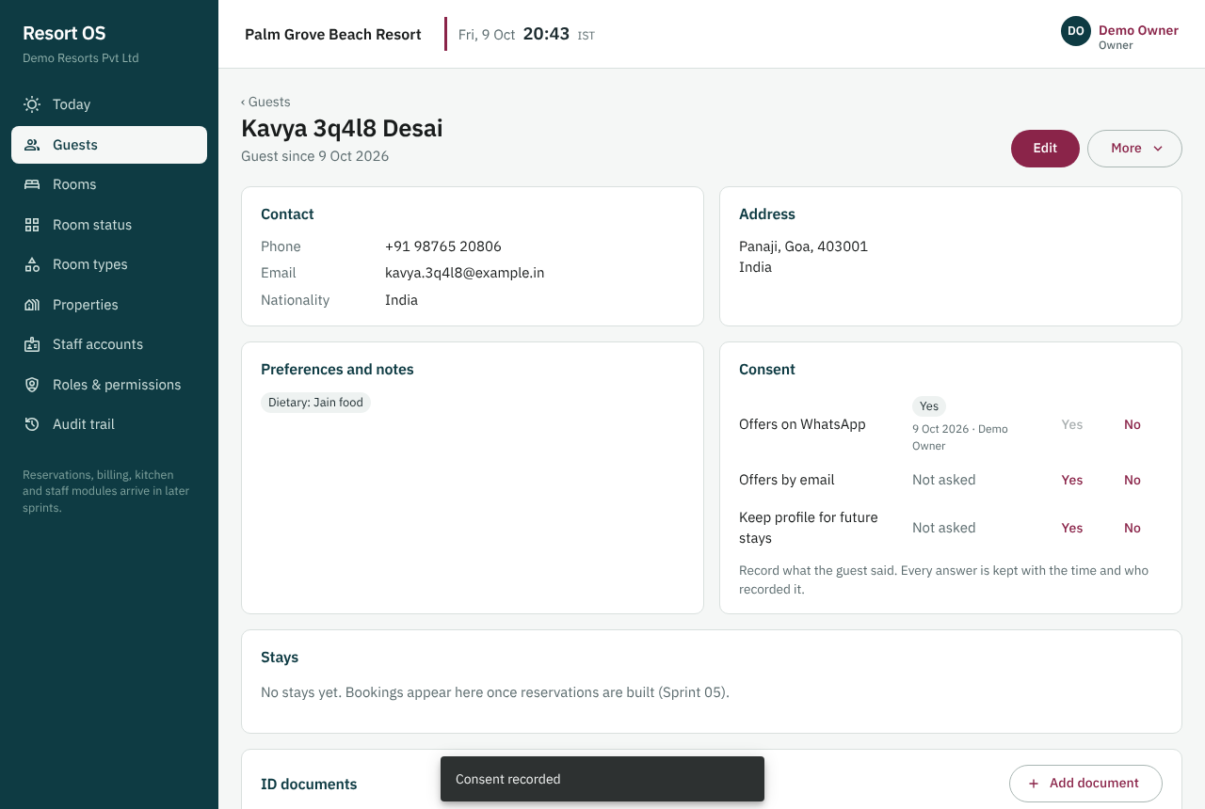
Guest profile: contact, address, preferences and consent
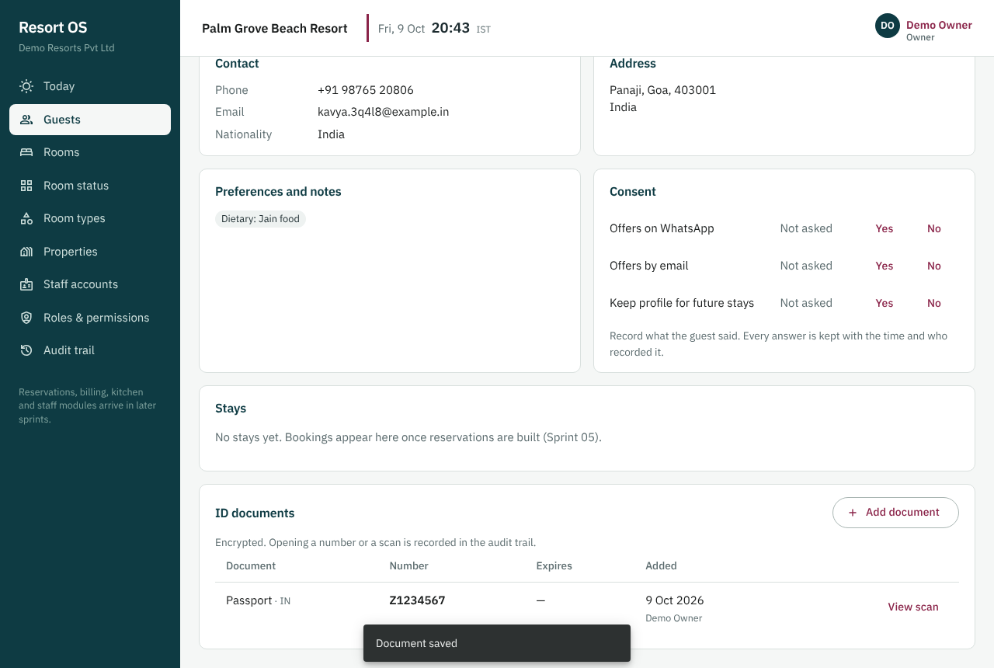
ID documents: masked until opened; every view is recorded
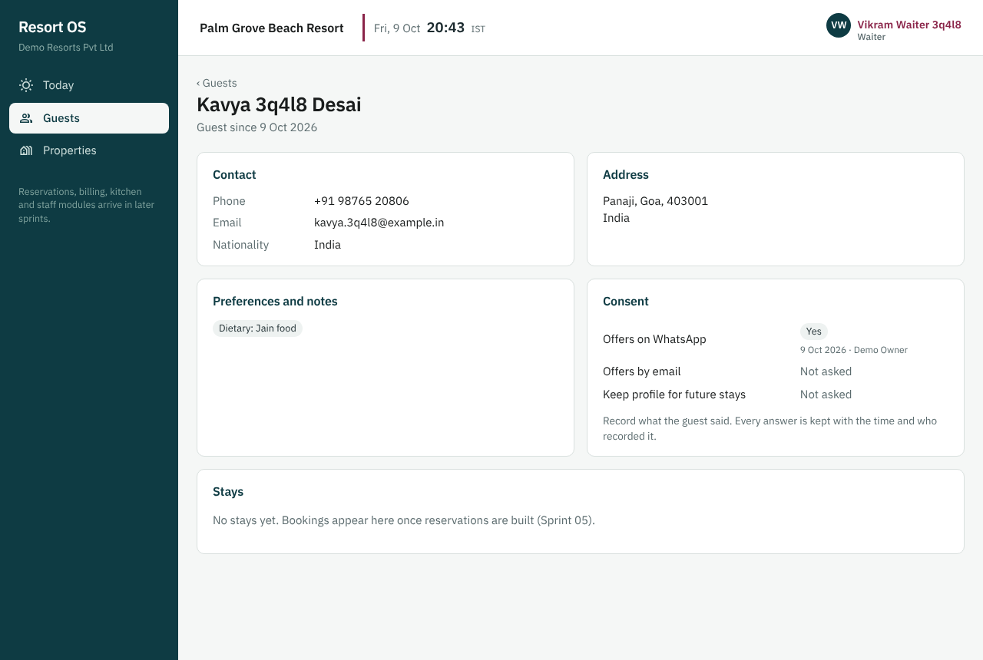
A waiter sees the guest but no ID documents
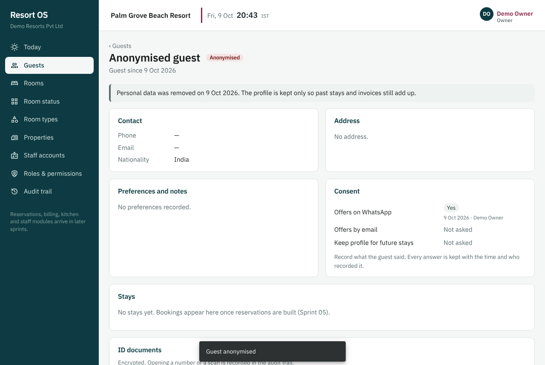
After anonymising: personal data and documents removed
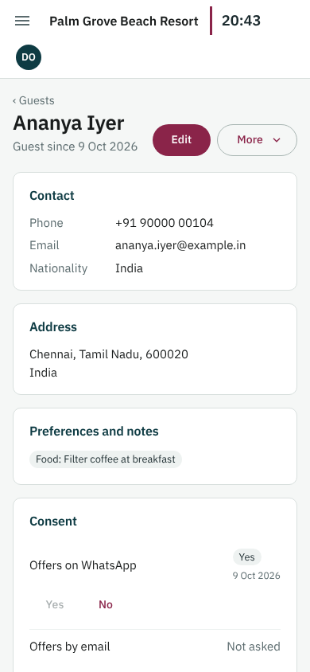
Guest profile at phone width

10.3.3 API design
Endpoints under /api/v1/guests. Guests belong to the organisation, so a grant for any property is enough; anonymise and the retention report need guest.delete organisation-wide. Create returns 409 POSSIBLE_DUPLICATE with the matches until ignoreDuplicates is set. Documents are uploaded as multipart/form-data; the API sniffs the file type from its bytes, encrypts the number, details and scan, and returns only a masked number. Opening a document (number or scan) is a separate call that is audited as SENSITIVE_READ. Edits and merges carry the version the user saw (409 on a stale edit).
Endpoints
GET|POST /guests
GET /guests/possible-duplicates
GET|PUT /guests/{id}
GET /guests/{id}/stays
POST /guests/{id}/consents
POST /guests/merge
POST /guests/{id}/anonymise
GET /guests/retention/dry-run
GET|POST /guests/{id}/documents
GET /guests/{id}/documents/{docId}
GET /guests/{id}/documents/{docId}/file

10.3.4 Database design
Migration V005 adds guests, guest_addresses, guest_documents, guest_preferences and guest_consents, with a data classification comment on every column. Generated search_text and phone_digits columns with pg_trgm GIN indexes keep contains-search fast. Document numbers and details are bytea ciphertext with a key_id for rotation and an HMAC lookup hash; Aadhaar rows may not hold an encrypted number. Constraints guarantee anonymised rows hold no personal data and purged documents keep nothing identifying; triggers forbid deleting guests and rewriting consent history.
Tables | guests, guest_addresses, guest_documents, guest_preferences, guest_consents
Migrations | V005__guests
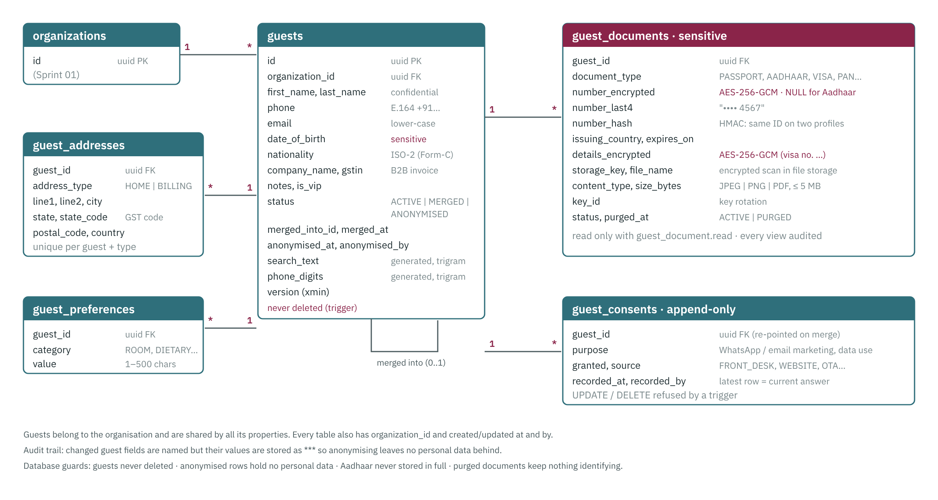
Guest tables and how they relate

10.3.5 Code changed
Files and folders
database/migrations/V005__guests.sql; database/seed/dev/S002__guests.sql; database/queries/check-sprint-03.sql
backend/Resort.Domain/Guests/Guests.cs
backend/Resort.Contracts/GuestContracts.cs
backend/Resort.Application/ — Guests/GuestService.cs, Guests/GuestDocumentService.cs, Validation/GuestValidators.cs, Common/Protection.cs, Common/Permissions.cs, Common/Errors.cs
backend/Resort.Infrastructure/ — Protection/FieldEncryption.cs, Protection/LocalDiskFileStore.cs, Persistence/AppDbContext.cs, Persistence/AuditInterceptor.cs (personal-data masking)
backend/Resort.Api/ — Endpoints/GuestEndpoints.cs, Program.cs (key check at start-up), appsettings.json (Guests, FileStore)
backend/Resort.Tests/ — Integration/GuestTests.cs, Unit/GuestUnitTests.cs, Support/ResortApiFactory.cs
frontend/src/app/ — features/guests/*, core/models.ts, app.routes.ts, layout/shell.ts, features/audit (labels)
frontend/e2e/sprint-03.spec.ts, e2e/helpers.ts (optional screenshots); scripts/check-api.mjs (Sprint 03 checks)
docs/API.md, docs/DATABASE.md, docs/database/schema-sprint-03.md, docs/SECURITY.md, docs/GETTING_STARTED.md, docs/sprints/REVIEWING.md, docs/testing/VERIFYING.md, sprint-03-screens/

10.3.6 Tests and results
Required test
Integration — WAITER and HOUSEKEEPER cannot read guest documents (403) — brief §59
Integration — ID number stored encrypted (raw column is not plaintext)
Integration — anonymise keeps stays, removes PII, audited with reason
Unit — phone normalisation (+91 and international)
Integration — returning guest found by any part of the phone, typed any way
Integration — duplicate warning (409 POSSIBLE_DUPLICATE) until confirmed
Integration — Aadhaar keeps only the last 4 digits
Integration — scans: file type from the bytes, ≤ 5 MB, stored encrypted, every view audited
Integration — merge moves documents, consents, preferences; duplicate hidden
Integration — personal data never written to the audit trail; stale edit → 409; tenant isolation (404)
Integration — retention dry run deletes nothing; database refuses deleting guests and rewriting consents
Unit — AES-256-GCM: tampering and wrong row detected, rotation keeps old data readable, missing key fails fast

Results
Backend: 102 passed, 0 failed on real PostgreSQL 16 (44 new: 13 integration, 31 unit including phone and encryption cases)
Frontend: 20 of 20 unit tests passed; ESLint clean; production build OK
Browser tests: 39 of 39 passed (Sprint 01 + 02 + the 13 new Sprint 03 review steps)
Review fixes (#105): Aadhaar takes 12 digits or the last 4 with the reason under the field; first sign-in password page shows why a password is refused; API validation messages list the reasons instead of a generic line
API checks: 46 of 46 passed on a fresh database (45 on later runs); SQL checks: all 14 Sprint 03 queries as expected

10.3.7 Acceptance criteria
- Reception finds a returning guest by phone in one search

10.3.8 Behaviours to know when debugging
- Lost the encryption key = lost ID data. Dev key lives in .env (Encryption__Key); never reuse across environments.
- API won't start: 'Encryption:Key (Encryption__Key) is not set' or 'must be 32 bytes' → run scripts/setup-dev, or set a base64 32-byte key.
- CryptographicException when opening a document: the key changed since it was saved. Put the old key back (or add it as Encryption__PreviousKeys__k1).
- 409 POSSIBLE_DUPLICATE is expected the first time; the UI's 'Create a new profile anyway' resends with ignoreDuplicates.
- No demo guests? The seed only fills an organisation with no guests. Reset the database and restart the API.
- Scans live in backend/Resort.Api/App_Data/files (encrypted). A database reset doesn't delete them.

10.4 Sprint 04 — Rate plans and packages
Goal | Configurable prices per type/date and packages whose revenue is split into room/food/transport/activity.
In plain words | Managers set room and bed prices by date, weekend rates and packages (for example room + breakfast), and get an instant price quote for any stay.
Phase / size | 2 — Guests, reservations, availability, calendar, front desk · M
Depends on | Sprint 02
Status | Done
Outcome | Accepted 14 Oct 2026. A quote for Room 103, 2 adults, 3 nights returns a nightly breakdown matching the rate grid (checked by DevSeedTests, check-api.mjs and browser step S04-03). On main as tag sprint-04. Sprint 05 (availability engine and reservations) started.

10.4.1 What was delivered
- Migration V006: rate_plans, rate_plan_prices (one row per plan × room type × night, numeric(12,2), per-bed prices for dormitories), packages, package_components, reservation_sources (14 built-in channels); one default plan per property; a deferred trigger refuses any package whose split doesn't add up to its price
- Quote engine (pure, unit-tested): nightly breakdown, extra adults and children above standard occupancy, per-bed dormitory pricing, minimum stay on the arrival night, maximum occupancy; every refusal says exactly why (which nights have no price, how many guests the room sleeps)
- Package revenue split by percent with the largest-remainder rule: amounts always add up to exactly the price, to the paisa (rule in DATABASE.md → Money and rounding)
- Rate APIs: plans, grid read, bulk edit by date range and days of the week, quote by room or type (id or code), packages, reservation sources. Every price change audited with old and new values
- Dev seed S003: BAR with Friday/Saturday uplift for a year, Couple getaway and Room + breakfast packages
- Screens: Rates (plan picker, room type × 14-night grid, click a cell to edit, bulk edit with weekend shortcut, quote panel) and Packages (list with revenue chips, editor with live split preview). Every error is shown under its field with the reason

10.4.2 UI design
Rates (menu) shows the chosen rate plan as a grid of room types × 14 nights, with weekend columns shaded and nights without a price marked; arrows move a week and a date picks the first night. Clicking a cell edits that night. Set prices applies a price, extra adult and child rates and a minimum stay to chosen room types over a date range, on all nights or only chosen weekdays (a Weekend button picks Friday and Saturday), and reports how many nights changed. Quote a stay takes a room or room type, arrival, nights and guests and shows each night with extras and the total before tax. Packages lists packages with their revenue split as chips; the editor shows each part's amount live as shares are typed and refuses a split that doesn't add up to 100 %, with the reason under the parts. Receptionists see rates and can quote but can't change anything.
Screens (routes)
/settings/rates
/settings/packages
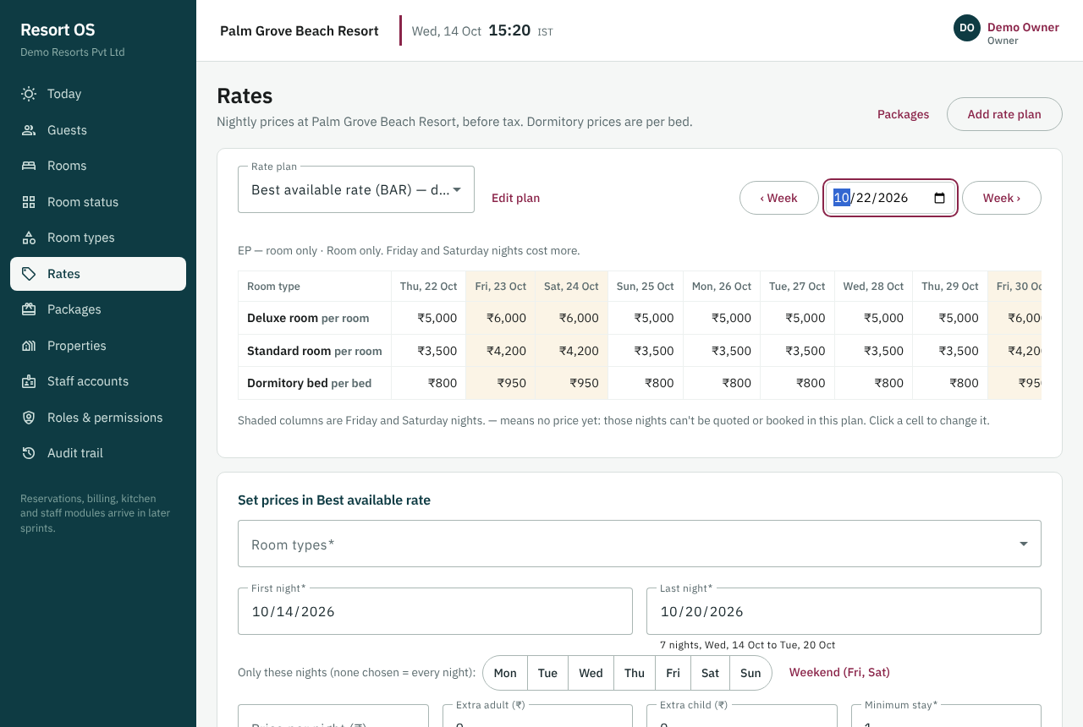
The rate grid: room types × nights, weekends shaded
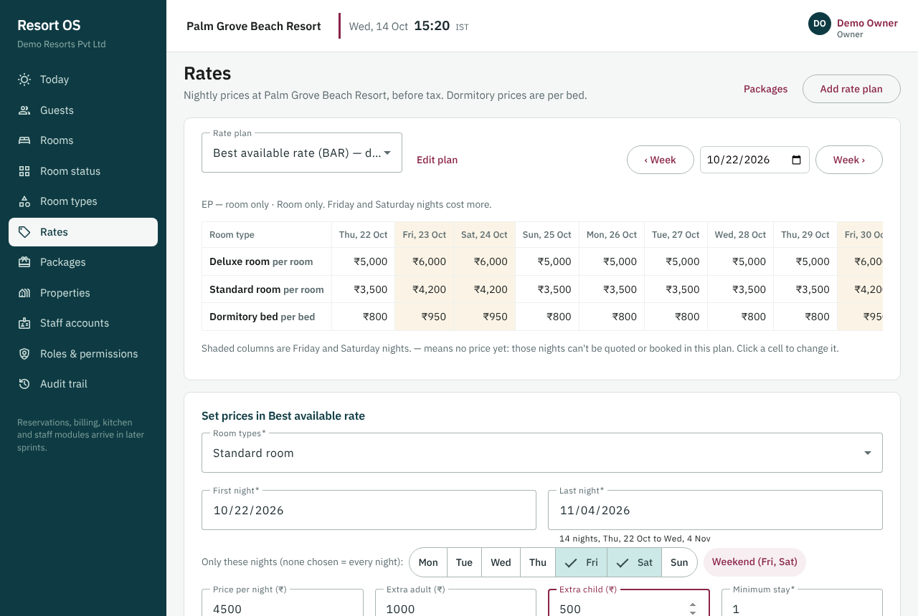
Setting weekend prices for a date range
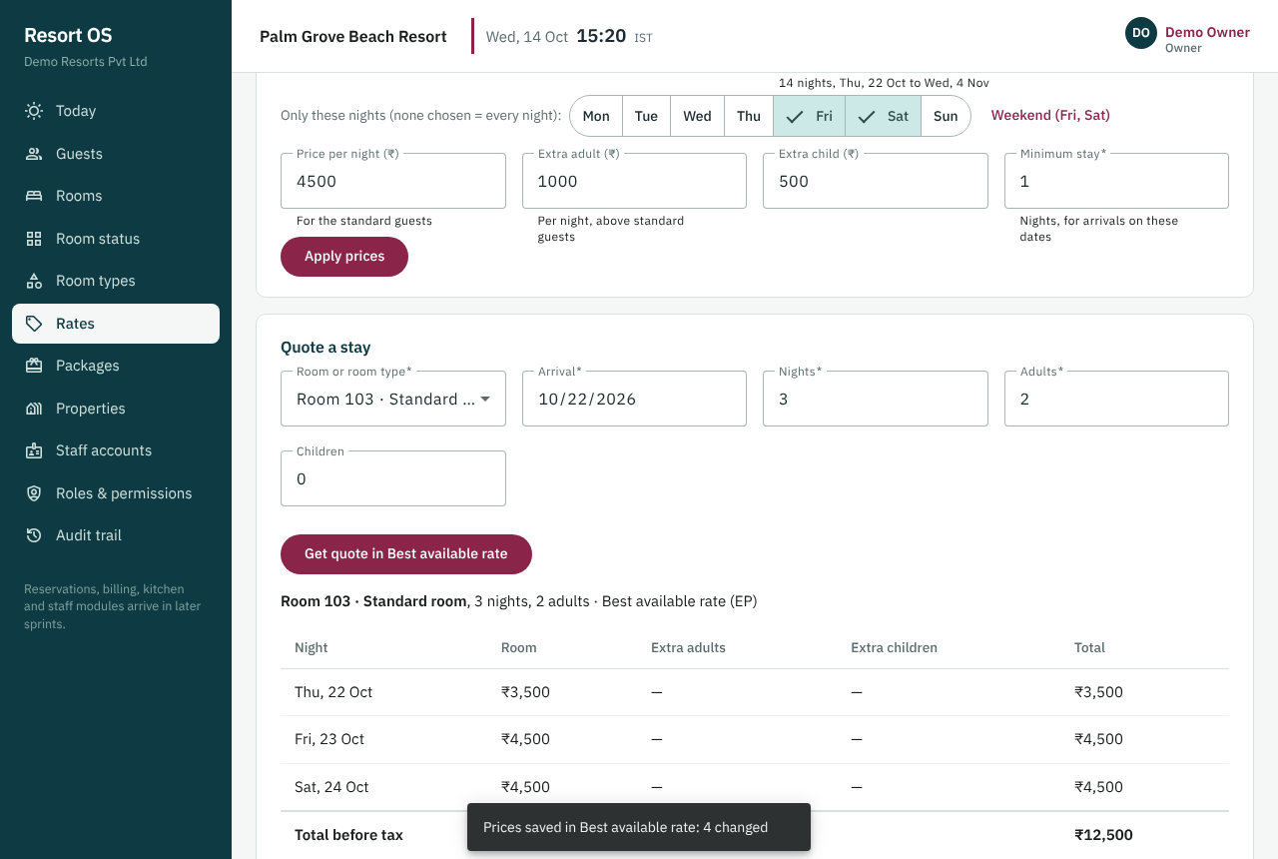
A quote for Room 103, night by night, matching the grid
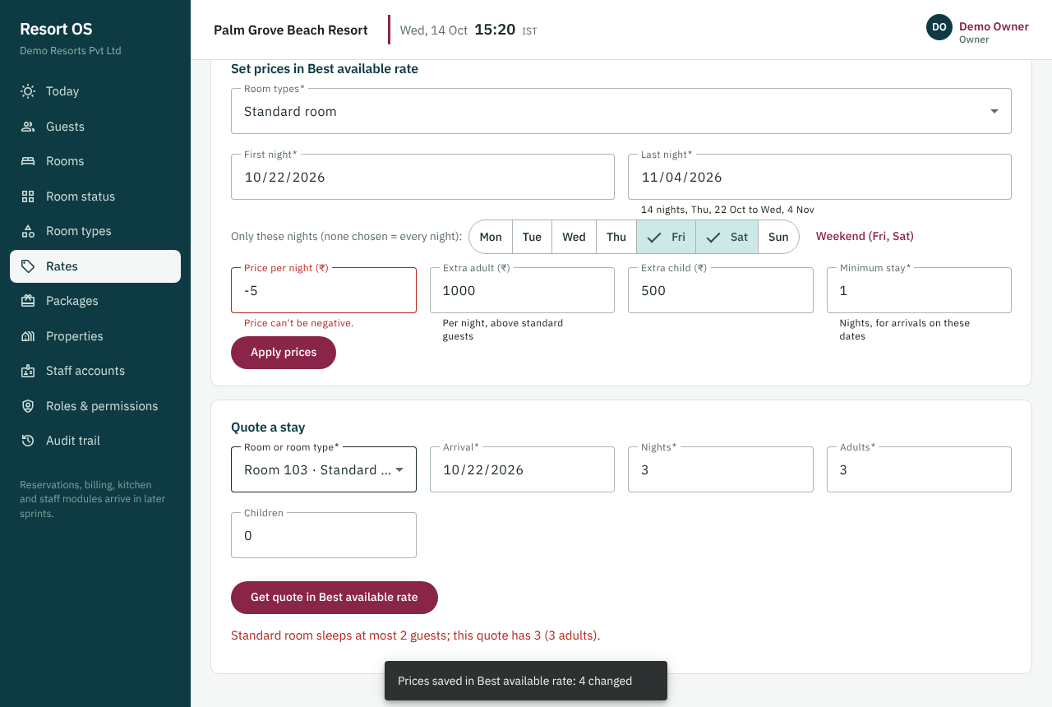
Errors say why, under the field they concern
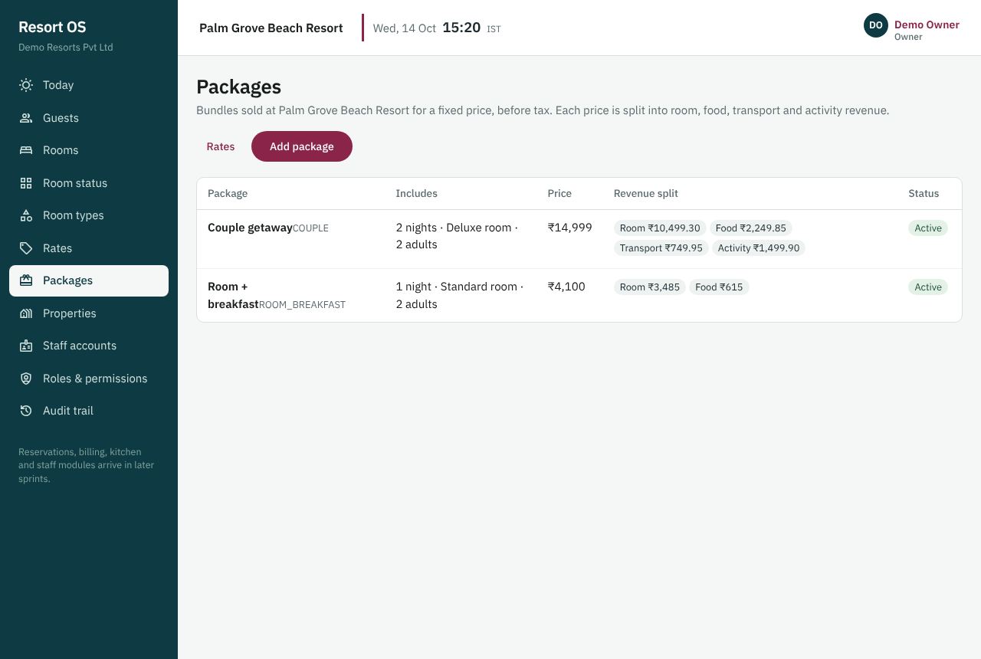
Packages with their revenue split
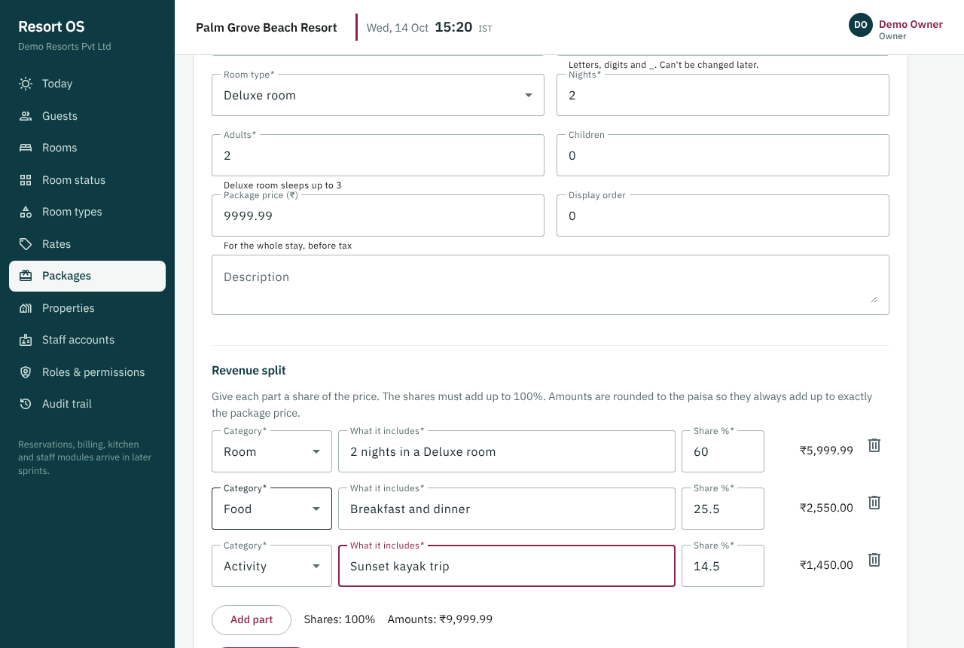
Package editor: each part's amount, adding up to the price exactly

10.4.3 API design
Endpoints under /api/v1/properties/{propertyId}: rate-plans (list, create, edit; the first plan becomes the default and only one plan is default), rate-plans/{id}/prices (read a date range; PUT applies a bulk edit and returns created, changed and unchanged counts), rates/quote (by room or room type, id or code; 422 with the reason and, for missing prices, the nights concerned), packages (list, create, edit) and reservation-sources. rate.read lets staff view and quote, rate.manage lets managers change. Edits carry the version the user saw (409 on a stale edit). Validation errors name the field and the reason.
Endpoints
GET|POST /properties/{propertyId}/rate-plans
PUT /properties/{propertyId}/rate-plans/{id}
PUT /properties/{propertyId}/rate-plans/{id}/prices (bulk date range)
GET /properties/{propertyId}/rates/quote?type&from&to&adults&children
GET|POST /properties/{propertyId}/packages

10.4.4 Database design
Migration V006 adds rate_plans, rate_plan_prices (one row per plan × room type × night, numeric(12,2), unique per cell), packages, package_components and reservation_sources (14 built-in channels). A partial unique index allows one default plan per property. Deferred constraint triggers check at commit that a package's shares add up to 100 %, its amounts add up to its price exactly and it has a ROOM part. Plans and packages are never deleted (deactivated instead). Amounts are split with the largest-remainder rule so no paisa is lost or gained.
Tables | rate_plans, rate_plan_prices, packages, package_components, reservation_sources
Migrations | —
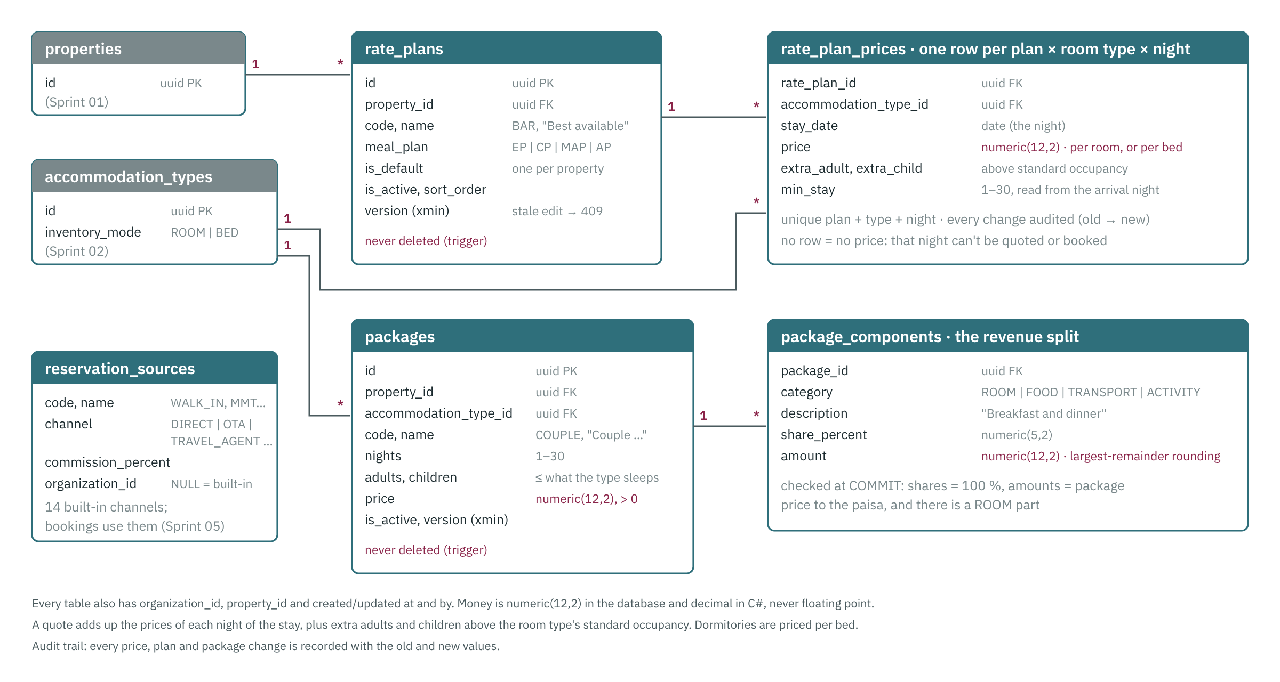
Rate and package tables and how they relate

10.4.5 Code changed
Files and folders
database/migrations/V006__rates.sql; database/seed/dev/S003__rates.sql; database/queries/check-sprint-04.sql
backend/Resort.Domain/Rates/Rates.cs, Rates/QuoteEngine.cs (QuoteEngine, MoneySplit)
backend/Resort.Contracts/RateContracts.cs
backend/Resort.Application/ — Rates/RateService.cs, Rates/PackageService.cs, Validation/RateValidators.cs, Common/Permissions.cs, Common/Errors.cs
backend/Resort.Infrastructure/Persistence/AppDbContext.cs; backend/Resort.Api/ — Endpoints/RateEndpoints.cs, Program.cs, Infrastructure/Problems.cs
backend/Resort.Tests/ — Integration/RateTests.cs, Integration/DevSeedTests.cs, Unit/RateUnitTests.cs
frontend/src/app/ — features/settings/rates/*, features/settings/packages/*, core/models.ts, core/http.ts (nested field errors), app.routes.ts, layout/shell.ts, features/audit (labels)
frontend/e2e/sprint-04.spec.ts; scripts/check-api.mjs (Sprint 04 checks)
docs/API.md, docs/DATABASE.md, docs/database/schema-sprint-04.md, docs/sprints/REVIEWING.md, sprint-04-screens/

10.4.6 Tests and results
Required test
Unit — quote for 3 nights across a weekend boundary
Unit — package split rounding never loses or gains a paisa
Integration — price change audited

Results
Backend: 138 passed, 0 failed on real PostgreSQL 16 (29 new: 11 integration, 18 unit including the weekend-boundary quote and 5,000 random package splits)
Frontend: 31 of 31 unit tests passed; ESLint clean; production build OK
Browser tests: 45 of 45 passed (Sprint 01–03 steps plus the 6 new Sprint 04 review steps); screenshots in docs/sprints/sprint-04-screens
Review fix: the rate grid's prices sat one column right of their dates (the table's style name clashed with a layout style). Fixed, and browser step S04-01 now checks every price sits under its date
Run-and-test handbook docs/RUN_AND_TEST.md: every command to run the app and test it, sprint by sprint and all sprints together

10.4.7 Acceptance criteria
- A quote for Room 103, 2 adults, 3 nights returns a nightly breakdown matching the rate grid

10.4.8 Behaviours to know when debugging
- Money is decimal in C# and numeric in SQL. Never float/double.

10.5 Sprint 05 — Availability engine and reservations core
Goal | Race-free booking of rooms and dorm beds with idempotent create and full status history (brief §14–16).
In plain words | Bookings for rooms and dorm beds are taken without double-booking, even when two people book the last room at the same moment.
Phase / size | 2 — Guests, reservations, availability, calendar, front desk · L
Depends on | Sprint 02, Sprint 03, Sprint 04
Status | Done
Outcome

10.5.1 What was delivered
- Migration V007: reservations, reservation_units (rooms and dorm beds held, EXCLUDE USING gist on room and on bed over the stay), reservation_guests, reservation_rate_breakdowns, reservation_notes, reservation_status_history, reservation_status_transitions (status graph enforced by a trigger), idempotency_keys, property_counters (references R00001 …). Nothing is ever deleted; blocks and bookings can't cover the same room and night
- Availability engine (pure, unit-tested): free rooms and beds for every night, allocation of rooms and one bed per dorm guest, and the exact reason when something doesn't fit (which room, which nights, which booking or block holds it)
- Booking algorithm in one transaction: claim the Idempotency-Key, lock the rooms of the requested types in id order, allocate, price every night from the rate grid, store the response. The exclusion constraints are the final guard (23P01 → 409 ROOM_UNAVAILABLE). Written up in docs/architecture/booking-algorithm.md
- APIs: availability; reservations list, get, create (Idempotency-Key, replay header), change dates or guests (re-checks and re-prices), confirm, cancel and no-show with a reason, notes. Permissions reservation.read/create/update/cancel
- Dev seed S004: six demo bookings from today; Room 102 is the last Deluxe room tonight for the two-browser demo
- Owner review fixes (15 Oct 2026): date fields across the app show 15 Oct 2026 with a calendar and accept typed dates; first-row field labels in dialogs and wizard steps no longer clipped; change-booking dialog lines rooms up under the dates; finished steps show a tick; Back sits next to each step's main button
- Architecture and system design guide for new joiners (docs/architecture/system-design.md) with diagrams per sprint; updating it is now a step of closing every sprint
- Screens: Reservations list (search, Booked / Enquiries / All), New booking wizard (dates → room → guest → rate → confirm, quick-add of a walk-in guest), booking page (rooms, nightly prices, guests, notes, history, confirm, change, cancel, no-show). Guest profiles list stays with their reference. Every error is shown under its field or next to its button with the reason

10.5.2 UI design
Reservations (menu) lists stays that haven't ended, soonest arrival first, with search by guest, phone or booking reference and Booked / Enquiries / All. New booking is a five-step wizard: dates and guests; free room types with prices and the free rooms; find a returning guest or add a new one (with a duplicate check); rate plan, source, status, requests and the nightly price; confirm and book. A booking page shows rooms, the price night by night, guests, notes and history, with Confirm, Change dates or guests, No-show and Cancel (a reason is required). Every error appears under its field or next to its button with the reason.
Screens (routes)
/reservations
/reservations/new
/reservations/:id
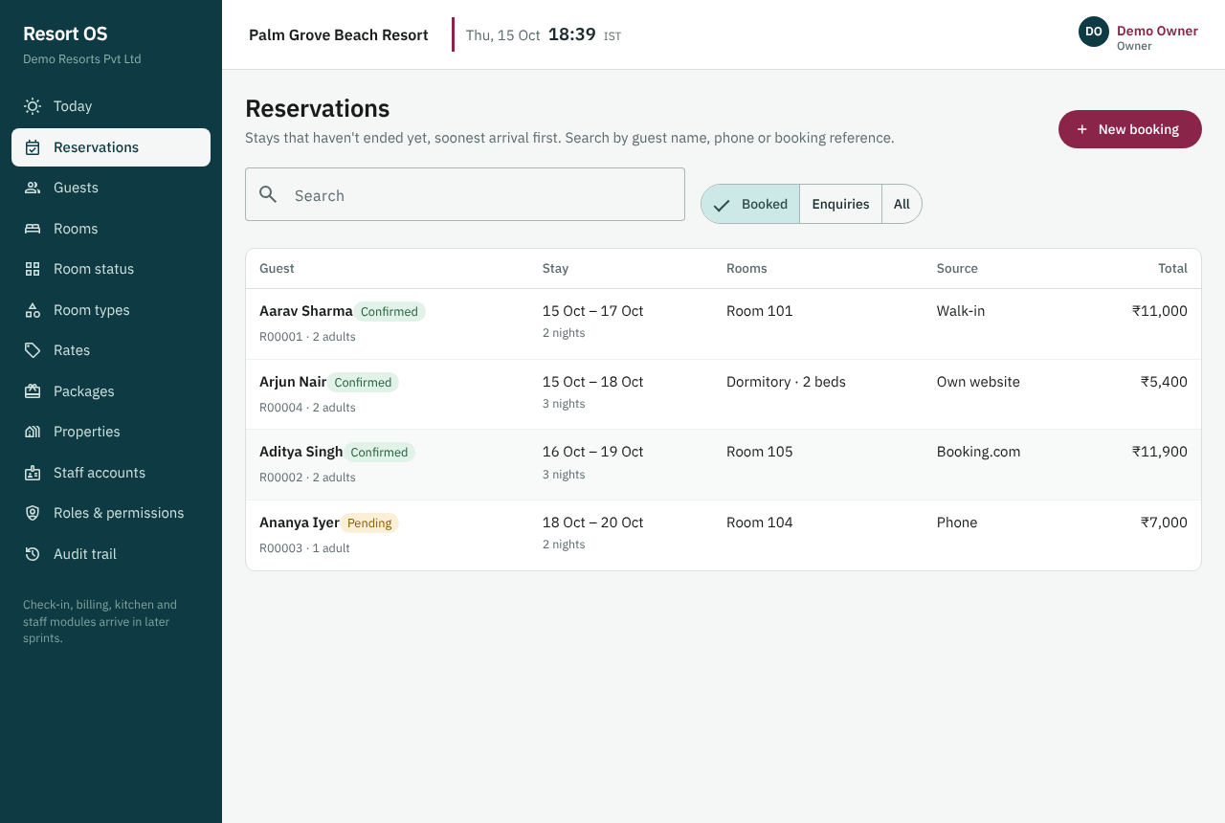
Reservations: stays that haven't ended, soonest first
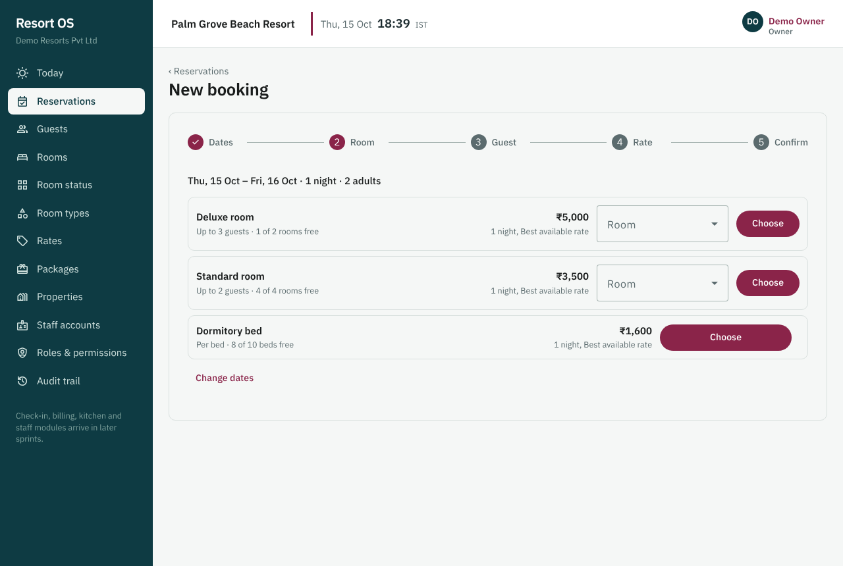
Availability: free rooms and beds per type, with the price
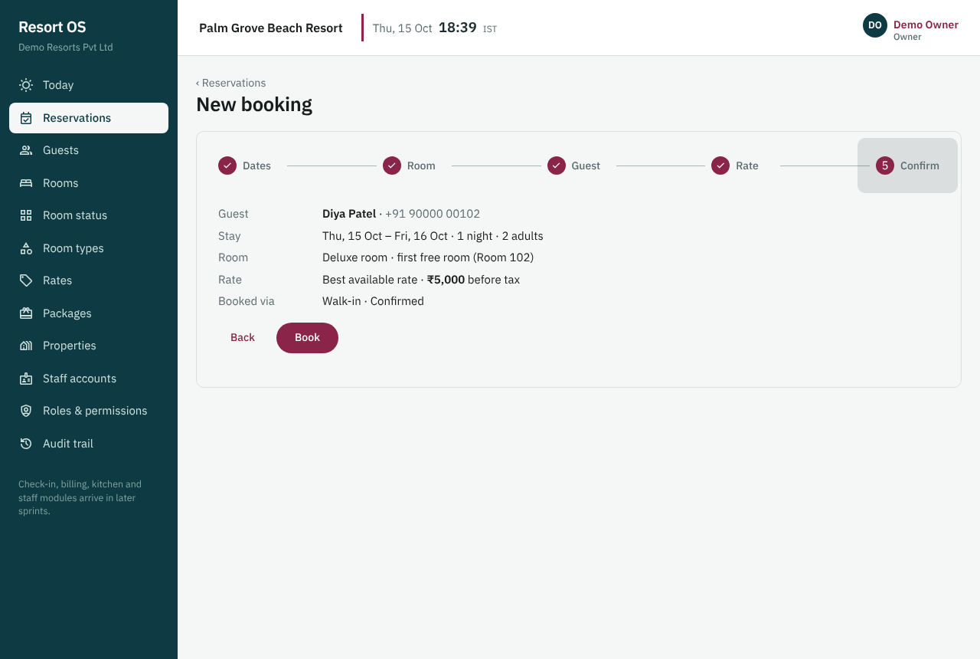
The last step of a new booking
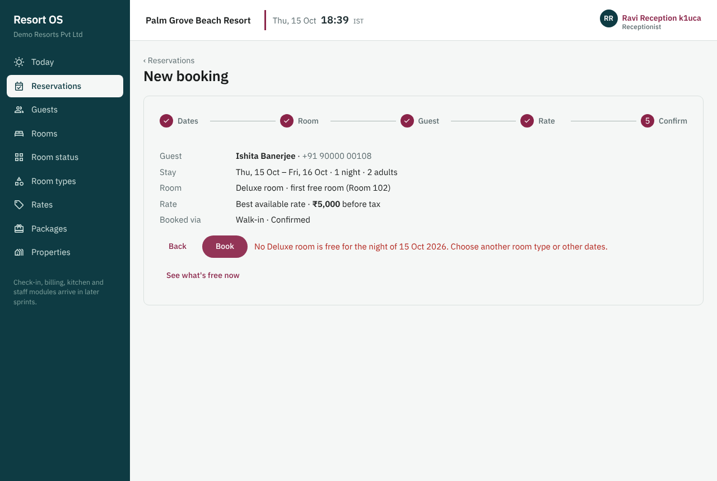
The second person to book the last room is told why
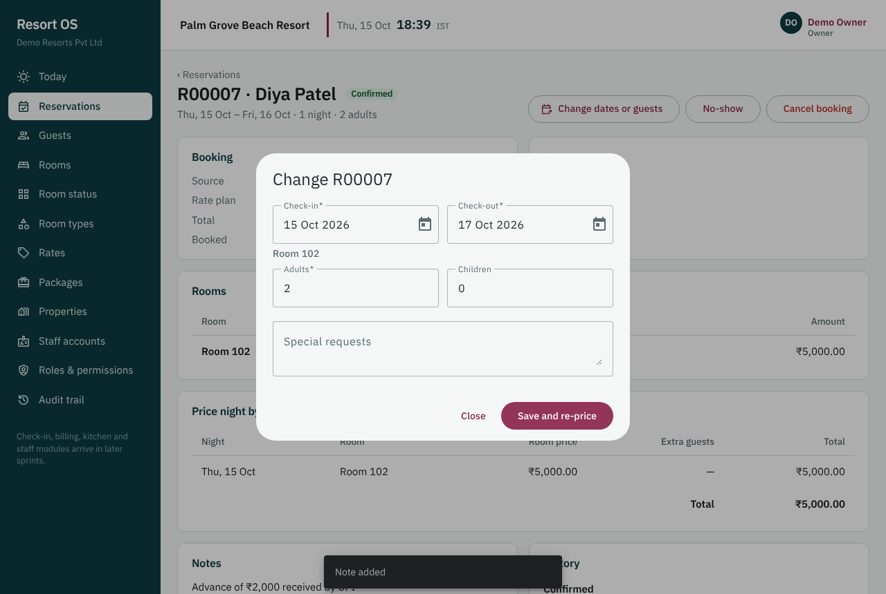
Changing the dates re-checks the room and re-prices
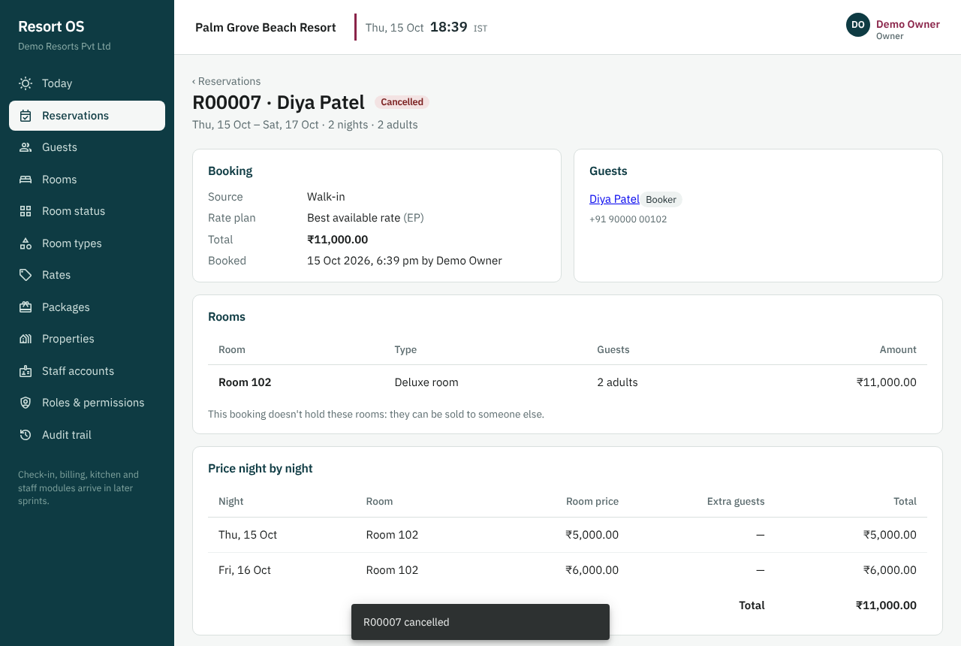
A cancelled booking with its nightly prices and history

10.5.3 API design
Endpoints under /api/v1/properties/{propertyId}: availability (free rooms and beds per type for a stay, with the default price), reservations (list, get, create with an Idempotency-Key header, change dates or guests, confirm, cancel and no-show with a reason, notes). reservation.read, .create, .update and .cancel decide who may do what. A retried create with the same key returns the same booking; a taken room is 409 ROOM_UNAVAILABLE naming what holds it.
Endpoints
GET /properties/{propertyId}/availability?from&to&adults
POST /properties/{propertyId}/reservations (Idempotency-Key header required)
GET /properties/{propertyId}/reservations
GET /properties/{propertyId}/reservations/{id}
POST /properties/{propertyId}/reservations/{id}/confirm | cancel | no-show
PUT /properties/{propertyId}/reservations/{id} (dates/guests; re-checks availability)
POST /properties/{propertyId}/reservations/{id}/notes

10.5.4 Database design
Migration V007 adds reservations, reservation_units (rooms and dorm beds held, with exclusion constraints so the same room or bed can't be held twice on a night), reservation_guests, reservation_rate_breakdowns, reservation_notes, reservation_status_history, reservation_status_transitions (the allowed status graph, enforced by a trigger), idempotency_keys and property_counters. Nothing is deleted; changes of dates supersede old rows. Triggers stop a block and a booking covering the same room and night.
Tables | reservations, reservation_units, reservation_guests, reservation_rate_breakdowns, reservation_notes, reservation_status_history, idempotency_keys
Migrations | —
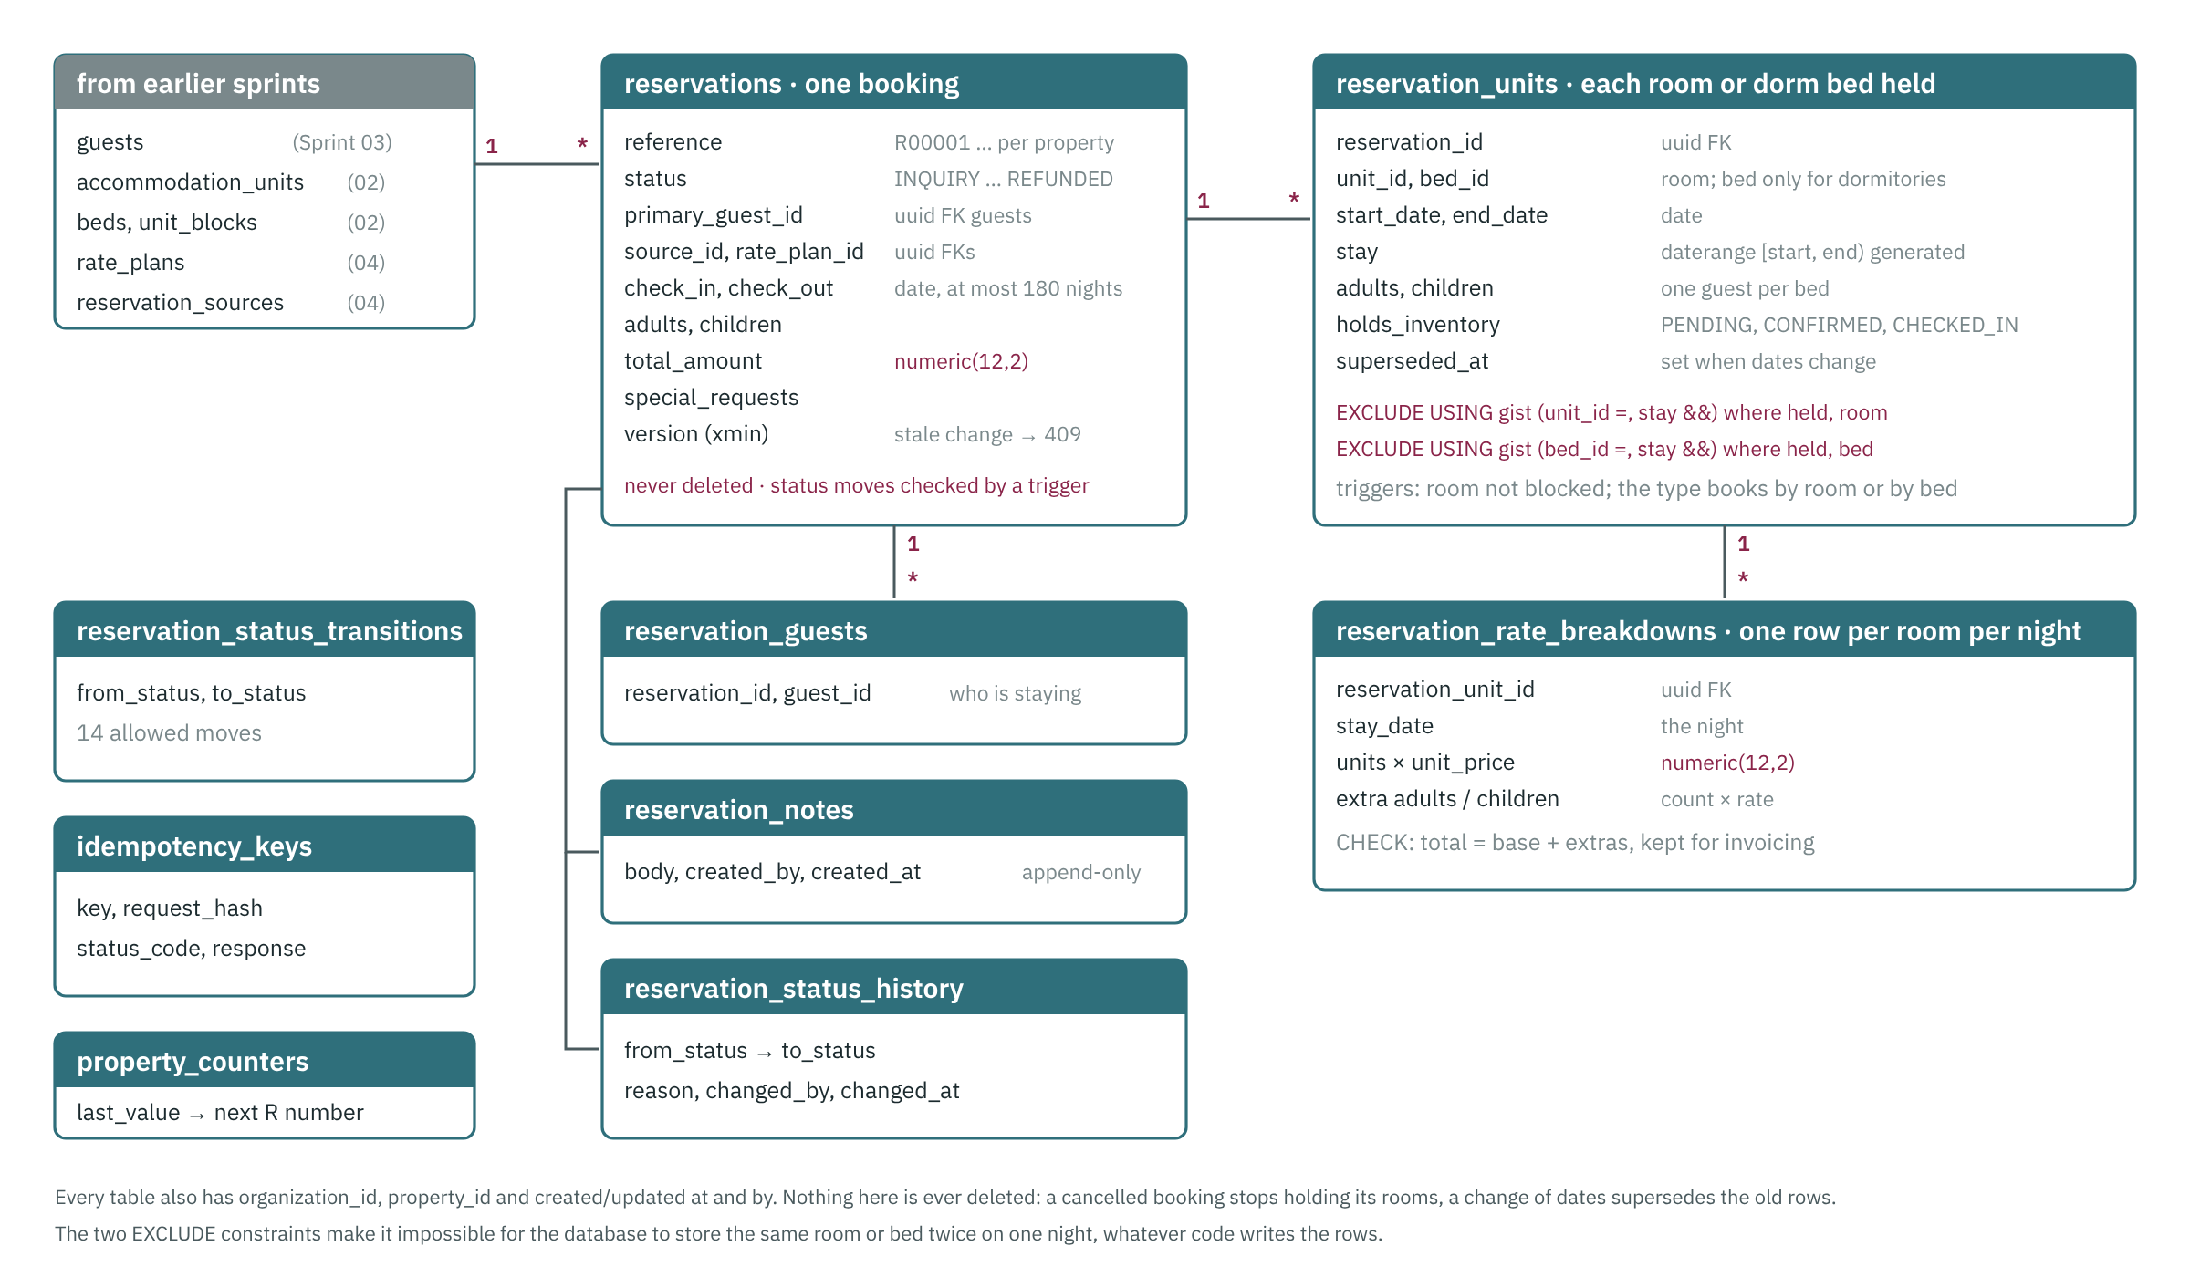
Reservation tables and how they relate
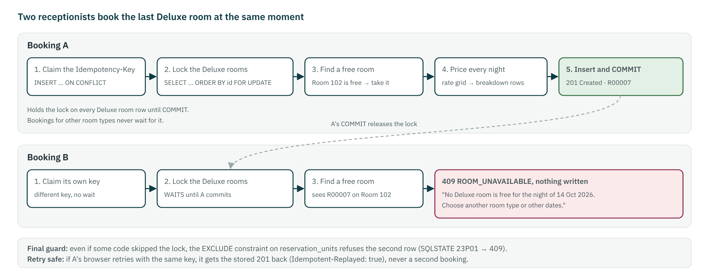
Two people book the last room at once: one gets it, the other is told why

10.5.5 Code changed
Files and folders
database/migrations/V007__reservations.sql; database/seed/dev/S004__reservations.sql; database/queries/check-sprint-05.sql
backend/Resort.Domain/Reservations/Reservations.cs, Reservations/Availability.cs
backend/Resort.Contracts/ReservationContracts.cs
backend/Resort.Application/ — Reservations/ReservationService.cs, AvailabilityService.cs, InventoryLoader.cs, Common/Idempotency.cs, Validation/ReservationValidators.cs, Common/Permissions.cs; Accommodation/BlockService.cs and Guests/GuestService.cs (bookings vs blocks, stays, merge)
backend/Resort.Infrastructure/Persistence/AppDbContext.cs; backend/Resort.Api/ — Endpoints/ReservationEndpoints.cs, Program.cs, Infrastructure/Problems.cs
backend/Resort.Tests/ — Integration/ReservationTests.cs, Integration/DevSeedTests.cs, Unit/ReservationUnitTests.cs
frontend/src/app/ — features/reservations/*, features/guests/guest.page.ts, features/audit (labels), core/models.ts, app.routes.ts, layout/shell.ts
frontend/e2e/sprint-05.spec.ts; scripts/check-api.mjs (Sprint 05 checks)
docs/API.md, docs/DATABASE.md, docs/database/schema-sprint-05.md, docs/architecture/booking-algorithm.md, docs/RUN_AND_TEST.md, docs/sprints/REVIEWING.md, sprint-05-screens/
frontend/src/app/core/dates.ts (date fields); docs/architecture/system-design.md; tools/handbooks/diagrams (er-reservations, booking-flow)

10.5.6 Tests and results
Required test
Concurrency — two simultaneous bookings for the last room → exactly one SUCCESS, one ROOM_UNAVAILABLE (run 50×)
Concurrency — dorm with 1 bed left, 5 parallel requests → 1 success
Idempotency — same request retried → one reservation, identical response
Integration — cancelled reservation frees inventory
Integration — status transitions outside the allowed graph → 422

Results
Backend: 173 passed, 0 failed on real PostgreSQL 16 (35 new: 34 for Sprint 05 including the last room raced 50 times, the last dorm bed with 5 parallel requests, the database guard and idempotency, plus the demo-booking seed check)
Frontend: 44 of 44 unit tests passed; ESLint clean; production build OK
Browser tests: 52 of 52 passed (Sprints 01–04 plus the 7 new Sprint 05 steps, including the last room booked from two browsers); screenshots in docs/sprints/sprint-05-screens
API checks: 0 failed (12 new Sprint 05 checks: idempotent replay, key reuse, room taken, cancel with reason, status graph); database checks: no room or bed held twice

10.5.7 Acceptance criteria
- Brief §16 scenario passes reliably in CI

10.5.8 Behaviours to know when debugging
- Reproduce races locally with tests/…/ConcurrencyTests using Task.WhenAll + a Barrier; never with sleeps.
- Look at pg_locks while a test is paused to see who holds what.

10.6 Sprint 06 — Reservation calendar (in progress)
Goal | Day/week/month calendar showing room, guest, dates, status, source and payment status; safe drag-and-drop reassignment.
In plain words | A calendar shows every room and bed with its bookings by day, week or month; bookings can be moved by drag-and-drop with safety checks.
Phase / size | 2 — Guests, reservations, availability, calendar, front desk · M
Depends on | Sprint 05

10.6.1 Planned scope
Tables
Endpoints | GET /api/v1/properties/{propertyId}/calendar?from&to · POST /api/v1/properties/{propertyId}/reservations/{id}/reassign (reason required)
Screens | /reservations/calendar

10.6.2 Tasks
- API: calendar read model (single query, indexed) including blocks and maintenance blocks
- API: reassign room — same locking as booking; audited with reason (brief §58)
- UI: calendar component (CDK drag-drop); optimistic UI only after server confirms; conflicts shown inline
- UI: mobile view = list by day

10.6.3 Required tests
- Concurrency — two users reassigning into the same room → one wins
- Frontend — calendar renders 7 rooms × 31 days under 200 ms

10.6.4 Acceptance criteria
- Reception moves a guest from 102 to 103 in two actions; the audit trail shows who/why

11 Quality report
Results as recorded for Sprint 05 (done), and the test inventory in the repository at commit 5e821f9.
Kind | Where | Tool | Count | Runs
Backend unit + integration | backend/Resort.Tests | xUnit, real PostgreSQL 16 | 129 methods | CI on Linux and Windows; scripts/test
Frontend unit | frontend/src/**/*.spec.ts | Jasmine + Karma | 44 specs | CI; npm test
Browser (end to end) | frontend/e2e | Playwright, Chromium | 52 steps | CI; npm run e2e:headed to watch
API checks | scripts/check-api.mjs | Node | 68 checks | By hand against a running API
Database checks | database/queries/check-sprint-01-02.sql | psql / any SQL client | 16 queries | By hand, read-only
Database checks | database/queries/check-sprint-03.sql | psql / any SQL client | 14 queries | By hand, read-only
Database checks | database/queries/check-sprint-04.sql | psql / any SQL client | 9 queries | By hand, read-only
Database checks | database/queries/check-sprint-05.sql | psql / any SQL client | 12 queries | By hand, read-only

11.1 Latest recorded results (Sprint 05)
- Backend: 173 passed, 0 failed on real PostgreSQL 16 (35 new: 34 for Sprint 05 including the last room raced 50 times, the last dorm bed with 5 parallel requests, the database guard and idempotency, plus the demo-booking seed check)
- Frontend: 44 of 44 unit tests passed; ESLint clean; production build OK
- Browser tests: 52 of 52 passed (Sprints 01–04 plus the 7 new Sprint 05 steps, including the last room booked from two browsers); screenshots in docs/sprints/sprint-05-screens
- API checks: 0 failed (12 new Sprint 05 checks: idempotent replay, key reuse, room taken, cancel with reason, status graph); database checks: no room or bed held twice

11.2 Code size
Area | Files | Lines
Backend application code (C#) | 65 | 7,824
Backend tests (C#) | 13 | 3,158
Frontend application code (TS, HTML, SCSS) | 49 | 6,725
Frontend unit tests | 7 | 468
Browser tests and helpers | 8 | 1,079
SQL (migrations, seeds, checks) | 15 | 2,422
Documentation (Markdown) | 69 | 9,404
Line counts include blank lines and comments.

12 Roadmap
All sprints in the plan with their goal, size (S ≈ 1, M ≈ 2, L ≈ 3–4 developer-weeks), dependencies and status. Each has a guide in docs/sprints with tasks, required tests, acceptance criteria and debugging notes.
# | Sprint and goal | Phase | Size | Needs | Status
00 | Architecture and requirements  Agree the architecture, data model, permission model, API conventions and delivery plan before more code is written. | 0 | M | — | In review
01 | Foundation — identity, RBAC, organisation, properties, audit  A secure, multi-tenant base that every later module plugs into. | 1 | L | 00 | Done
02 | Accommodation — room types, rooms, dormitory beds, blocks  Model the 6 rooms and the dormitory correctly (room-based vs bed-based inventory) and let managers block units. | 1 | M | 01 | Done
03 | Guests  Guest profiles with only the data that is needed, encrypted sensitive fields, de-duplication and retention. | 2 | M | 01 | Done
04 | Rate plans and packages  Configurable prices per type/date and packages whose revenue is split into room/food/transport/activity. | 2 | M | 02 | Done
05 | Availability engine and reservations core  Race-free booking of rooms and dorm beds with idempotent create and full status history (brief §14–16). | 2 | L | 02, 03, 04 | Done
06 | Reservation calendar  Day/week/month calendar showing room, guest, dates, status, source and payment status; safe drag-and-drop reassignment. | 2 | M | 05 | In progress
07 | Front desk — arrivals, departures, in-house, check-in/out  Reception completes check-in and check-out in very few clicks. | 2 | M | 05 | Planned
08 | Folio  The folio is the central financial object for a stay (brief §20). | 3 | M | 07 | Planned
09 | GST configuration and tax engine  GST as a first-class, versioned, configurable domain (brief §23, §86). | 3 | M | 08 | Planned
10 | Payments, refunds, cash drawer  Record cash/UPI/card/bank payments, allocate them to folios, refund safely, reconcile the cash drawer (brief §21, §39). | 3 | M | 08 | Planned
11 | Razorpay  Online payments where the server-verified webhook is authoritative (brief §22). | 3 | M | 10 | Planned
12 | GST invoices, credit/debit notes, receipts  Legally-numbered GST invoices from folios; cancellations only via credit notes (brief §24, §25). | 3 | L | 09, 10 | Planned
13 | Housekeeping and maintenance (mobile-first)  Room status workflow and maintenance tickets that staff use on phones (brief §33, §34, §53). | 4 | M | 07 | Planned
14 | Menu, restaurant POS and KOT  Orders, kitchen tickets, and charging to a room folio (brief §35, §55). | 5 | L | 08, 09 | Planned
15 | Inventory and recipe costing  Stock ledger, consumption from recipes, wastage, and food-cost reporting (brief §36, §37). | 5 | M | 14 | Planned
16 | Suppliers and purchasing  Purchase request → PO → goods received → supplier invoice → payment (brief §38). | 5 | M | 15 | Planned
17 | Employees and roster  Employee records (salary restricted) and shift rosters with clash detection (brief §42, §46). | 6 | M | 01 | Planned
18 | Attendance and timesheets (PWA)  Mobile clock-in/out with geofence, breaks, timesheets with approval and locked corrections (brief §43, §44, §74). | 6 | L | 17 | Planned
19 | Leave, holidays and payroll export  Leave requests with balance/overlap/coverage checks feeding roster and payroll (brief §45). | 6 | M | 18 | Planned
20 | Activities and equipment  Capacity-safe activity bookings and equipment issue/return (brief §48, §49). | 7 | M | 08 | Planned
21 | Beach transport  Vehicles, drivers, trips, capacity and manifests for the 8 km beach run (brief §47). | 7 | S | 20 | Planned
22 | Expenses and budgets  Expense capture with approval and budget vs actual (brief §40, §41). | 8 | M | 10 | Planned
23 | Reports and dashboards  Owner and role dashboards plus the report list in brief §50–55, Power-BI-ready. | 8 | L | 12, 15, 19, 22 | Planned
24 | Notification engine, WhatsApp, email, background jobs  Configurable templates, delivery tracking and idempotent scheduled jobs (brief §32, §69, §70). | 9 | L | 05 | Planned
25 | Zoho Books, Tally export, e-invoice reconciliation  Sync accounting without duplicates on retry (brief §26, §27, §25). | 9 | L | 12, 24 | Planned
26 | OTA / channel manager  One channel manager integration with idempotent import/modify/cancel (brief §28, §29, §75). | 9 | L | 05, 24 | Planned
27 | Direct booking website  Public booking site with live availability and Razorpay (brief §30). | 9 | L | 11, 24 | Planned
28 | Offline PWA and security hardening  Work through poor connectivity safely; MFA and OWASP verification (brief §56, §57, §68). | 10 | L | 13, 18 | Planned
29 | Backups, monitoring, CI/CD to production, acceptance  Production-ready operations and the three acceptance tests (brief §60, §61, §73–75, §77, §78). | 10 | L | 28 | Planned
Phases: 0 Requirements and architecture · 1 Foundation, property, rooms, beds · 2 Guests, reservations, availability, calendar, front desk · 3 Folio, payments, Razorpay, GST, invoices · 4 Housekeeping and maintenance · 5 Restaurant, kitchen, menu, inventory, purchasing · 6 Employees, attendance, timesheets, leave, roster · 7 Activities, transport, equipment · 8 Expenses, budgets, reports · 9 Notifications, accounting, OTA, booking website · 10 Offline use, security hardening, go-live.

13 Appendices

13.1 A. Roles
Code | Name | Purpose
OWNER | Owner | Full access to the organisation
GENERAL_MANAGER | General Manager | Runs the property; no platform/integration settings
MANAGER | Manager | Duty manager across front office and operations
RECEPTIONIST | Receptionist | Front desk: bookings, check-in/out, payments
HOUSEKEEPING_SUPERVISOR | Housekeeping Supervisor | Assigns and inspects housekeeping
HOUSEKEEPER | Housekeeper | Cleans rooms, reports issues
RESTAURANT_MANAGER | Restaurant Manager | Menu, POS, kitchen, F&B stock
WAITER | Waiter | Takes orders, posts room charges
KITCHEN | Kitchen | Kitchen display / KOT
INVENTORY_MANAGER | Inventory Manager | Stock control
PURCHASING | Purchasing | Suppliers and purchase orders
ACCOUNTANT | Accountant | Invoices, payments, expenses, financial reports
HR | HR | Employees, attendance, leave, roster
MAINTENANCE | Maintenance | Works maintenance tickets
DRIVER | Driver | Operates beach transfers
ACTIVITY_MANAGER | Activity Manager | Activities and equipment
EMPLOYEE | Employee | Self-service only

13.2 B. Permissions by module
Module | Count | Permission codes (sensitive in bold)
identity | 6 | user.read, user.create, user.update, user.deactivate, role.read, role.manage
property | 6 | organization.read, organization.update, property.read, property.create, property.update, property_settings.update
system | 1 | system.settings
audit | 1 | audit.read
accommodation | 3 | accommodation.read, accommodation.manage, unit_block.manage
rates | 2 | rate.read, rate.manage
gst | 6 | tax.read, tax.manage, invoice.read, invoice.create, invoice.cancel, credit_note.create
guests | 5 | guest.read, guest.create, guest.update, guest.delete, guest_document.read
reservations | 6 | reservation.read, reservation.create, reservation.update, reservation.cancel, reservation.delete, reservation.override_rate
frontdesk | 2 | frontdesk.checkin, frontdesk.checkout
folio | 3 | folio.read, folio.post_charge, folio.adjust
payments | 6 | payment.read, payment.create, payment.refund, payment.void, cash_drawer.operate, cash_drawer.approve_variance
housekeeping | 4 | housekeeping.read, housekeeping.update, housekeeping.assign, housekeeping.inspect
maintenance | 4 | maintenance.read, maintenance.create, maintenance.update, maintenance.assign
menu | 3 | menu.read, menu.create, menu.update
pos | 7 | pos_order.read, pos_order.create, pos_order.update, pos_order.void, pos.discount, kot.read, kot.update
inventory | 5 | inventory.read, inventory.adjust, inventory.manage, recipe.read, recipe.manage
purchasing | 7 | supplier.read, supplier.manage, purchase.read, purchase.create, purchase.approve, grn.create, supplier_invoice.manage
employees | 5 | employee.read, employee.create, employee.update, employee_salary.read, employee_document.read
attendance | 5 | attendance.self, attendance.read, attendance.update, timesheet.self, timesheet.approve
roster | 3 | roster.self, roster.read, roster.manage
leave | 5 | leave.create, leave.read, leave.approve, leave.reject, leave.manage_balances
activities | 3 | activity.read, activity.manage, activity_booking.create
transport | 4 | transport.read, transport.manage, transport_booking.create, transport.trip_operate
equipment | 3 | equipment.read, equipment.manage, equipment.issue
expenses | 3 | expense.read, expense.create, expense.approve
budgeting | 2 | budget.read, budget.manage
reports | 2 | report.operational.read, financial_report.read
integrations | 3 | integration.manage, ota.read, ota.manage
communication | 2 | message.read, message.send
Which role holds which permission: docs/security/permission-matrix.md, or the Roles & permissions screen in the app.

13.3 C. Glossary
Term | Meaning
Accommodation type | What is sold: a room type (UNIT, sold whole) or a dormitory type (BED, sold per bed)
Block | A room or bed out of sale for [start, end) nights; released, never deleted
Correlation id | An id that follows a request through logs and the audit trail
EXCLUDE constraint | A PostgreSQL constraint that forbids overlapping ranges for the same key
Folio | The running bill of a stay
Idempotency key | A client-chosen id that makes a retried request safe
Security stamp | A per-user value in every token; changing it signs the user out everywhere
Tenant | An organisation; its rows are invisible to every other organisation
UUIDv7 | A time-ordered UUID, good for index locality
xmin | PostgreSQL's row version, exposed by the API as version for optimistic concurrency

13.4 D. Rebuilding this document
- When a sprint is accepted, update its entry in docs/sprints/sprints.yml: status done, progress (done, files, results, outcome) and the handbook block (highlights, design notes for UI, API and database, screenshots).
- Add a line to tools/handbooks/history.yml with the new version (1.<sprint number>) and date.
- If a diagram changed (new module status, new tables), edit tools/handbooks/diagrams/diagrams.html and run npm run diagrams.
- Run npm ci once and then npm run build in tools/handbooks. Both Word files are written to docs/handbooks/.
- Open both files, check them, and commit them with the sprint's closing pull request.

