Freight Rate Prediction - Solution Report
Spotter.AI | Machine Learning Engineer Assessment
This report describes what I did, why I did it, and what came out. It covers the data split and validation approach, and includes the December prediction chart from score.py as required.

1. Objective in plain words
Each row is one truck load someone wants to move. The job is to predict the price (posted_rate, in dollars) before the truck is booked. I trained on 48,000 old loads from Jan to Oct 2025, then predicted 12,000 new loads from Nov to Dec 2025, plus a fixed 31-day December lane (Lexington to Fort Wayne) that tests whether the model understands time when nothing else changes.

2. Dataset
- Train (Data/train-test.csv): 48,000 rows, 14 columns, dates 2025-01-01 to 2025-10-31. Has the target posted_rate.
- Validation (Data/validation.csv): 12,000 rows, 13 columns (no target), dates 2025-11-01 to 2025-12-31. IDs TE-000001 to TE-012000.
- Template (Data/validation-predictions-template.csv): 12,000 IDs to fill.
- December probe (Data/december-chart-inputs.csv): 31 rows, Dec 1-31, fixed lane Lexington to Fort Wayne, 360 miles, Dry Van, 32,000 lb. Only date changes.
- Target stats: mean $2,373.98, median $2,030.76, std $1,486.49, min $57.22, max $25,533, skew 1.90. Strongly right-skewed.
- Columns: load_id (ID only, never a feature), pickup/delivery cities (64 each, 4,014 routes), pickup/delivery lat-lon, distance, equipment (Dry Van / Reefer / Flatbed), weight, date, market_index, quote_signal.

3. Data quality issues and how I fixed them
I checked missing values, duplicates, negatives, and impossible values before modelling anything. No duplicate rows or IDs in either file. Coordinates, distance, dates were complete.
- Negative weights: 292 in train, 145 in validation. These looked like sign-entry mistakes (magnitude normal, e.g. -30,000 lb), so I took absolute values instead of deleting them.
- Missing weight: 300 train, 165 validation. Fixed with equipment-specific median (Dry Van / Reefer / Flatbed separately), because truck types carry different typical weights. Fallback to global median if a group were empty.
- Missing market_index: 374 train, 249 validation. Fixed with the training median. I did not use validation rows to compute any imputation value.
- quote_signal, distance, equipment, dates: complete, no fix needed. No zero or negative distances.
- Outliers: a small tail above $12,000 (0.1%) up to $25,533. I kept them - they are long-haul Reefer loads, valid but rare. This is why RMSE (~$640) is much bigger than MAE (~$130): RMSE squares the big misses.
Rule I followed everywhere: every cleaning number (medians, means, encodings) is computed on the training part of each fold only, then applied to validation. Nothing is ever computed on validation targets.

4. EDA - key findings
- Price grows almost linearly with distance. Distance is by far the strongest signal.
- Weight alone is nearly flat against price, but weight-per-mile and distance x weight matter (heavy + short is a hard load).
- Equipment matters: Reefer avg $2,553 > Flatbed $2,445 > Dry Van $2,271. Reefer (refrigerated) costs most.
- market_index (fuel/market level) and quote_signal (demand for that load) both push prices up, especially in combination (market x quote) and on long trips (distance x market, distance x quote).
- Lexington to Fort Wayne appears 32 times in training, so the December lane is not completely unseen.

5. Feature engineering (28 features)
Everything here is business logic, no target involved, so it is leakage-free:
- Geography: lat_diff, lon_diff, haversine distance (R = 3958.8 miles, standard formula), road/haversine ratio and difference. The gap between road distance and straight-line distance captures detours and terrain.
- Time from date: day_of_week, day_of_month, month, quarter, week_of_year, is_weekend. Trees use these to learn weekday and seasonal effects - this is the only thing that varies in the December probe.
- Weight/distance: log_distance, log_weight (compress the long tail), weight_per_mile, distance x weight (total work). Divisions clip distance at 1 to avoid divide-by-zero.
- Market interactions: distance x market, market x quote, distance x quote.
- Categorical: route built from pickup and delivery, route_popularity (count, train-only), smoothed target encodings pickup_enc / delivery_enc / route_enc (see next section), equipment one-hot (2 columns). Raw lat/lon, city names, route strings, date, and load_id are dropped after encoding.

6. Target encoding - leakage-safe (important)
The old notebook computed city/route average rates on the full 48,000 rows before splitting. That leaks future prices into training and makes validation look better than it is (old CatBoost MAE $122.71 was optimistic). I fixed it:
- Per fold: group means and counts are computed on the training part only, then mapped onto validation. Unseen cities/routes get the training global mean.
- Smoothing: (count x category_mean + 100 x global_mean) / (count + 100). Smoothing 100 means a route with 2 loads barely moves the global mean, while a route with 500 loads keeps its own average. This stops rare lanes from overfitting.
- Final model: encodings recomputed on all 48,000 rows, applied to the 12,000 validation rows the same way.

7. Validation and split approach
The real test is future data (November/December), so random splitting would cheat - it would let October predict September. I used temporal splits:
- PRIMARY: train Jan 1 - Aug 31 (38,477 rows) -> validate Sep 1 - Oct 31 (9,523 rows). This is the model-selection fold.
- ROLL1: train Jan - Jun (28,806) -> validate July (4,912).
- ROLL2: train Jan - Jul (33,718) -> validate August (4,759).
- Every fold refits cleaning, features, and encodings on train only. Metrics are MAE (primary, in dollars - average miss), RMSE (punishes big misses), R-squared (variance explained).
Why this way: it mimics the actual task (past predicts future), respects how market/quote/route prices drift over time, and the rolling folds prove the winner is stable, not lucky on one window.

Model comparison (primary fold)
Model | Target | MAE ($) | RMSE ($) | R2
CatBoost | log1p | 130.30 | 639.63 | 0.8243
CatBoost | raw | 134.08 | 638.29 | 0.8251
LightGBM | log1p | 136.09 | 642.49 | 0.8227
LightGBM | raw | 148.14 | 647.70 | 0.8199
XGBoost | log1p | 151.85 | 652.01 | 0.8175
XGBoost | raw | 164.87 | 661.44 | 0.8121
Base $/mile | - | 256.95 | 684.25 | 0.7990
Base median | - | 1148.92 | 1569.42 | -0.058
Rolling (raw target): ROLL1 July - CatBoost $154.25 / LightGBM $167.67 / XGBoost $240.77. ROLL2 August - CatBoost $143.53 / LightGBM $177.42 / XGBoost $256.56. CatBoost is the most stable; XGBoost overfits the early months.
Target experiment: log1p(target) with expm1 back-conversion beats raw on MAE for all three models (evaluated on the original dollar scale), so the winner uses log1p. Baselines show the ML models add real value: median/mean baselines miss by about $1,150, distance-only by $257.

8. Why CatBoost won
- Lowest primary MAE ($130.30 with log1p) and best rolling stability.
- Handles the skewed target and categorical/encoded mix well without extra tuning.
- Hyperparameters (kept modest on purpose): iterations=1500, learning_rate=0.03, depth=7, RMSE loss, seed 42, early stopping 50. LightGBM (leaves 63, depth 7) and XGBoost (depth 7, same schedule; early_stopping_rounds in the constructor for v3.x) used comparable budgets.

9. Feature importance (best model)
Top 15 by CatBoost importance: distance (21.2), log_distance (17.2), haversine_dist (13.8), distance_x_market (8.3), route_enc (7.6), distance_x_quote (7.5), lon_diff (5.6), distance_x_weight (3.7), road_hav_diff (3.4), equipment_Reefer (2.7), weight_per_mile (1.3), quote_signal (1.1), equipment_Flatbed (1.0), route_popularity (0.7), week_of_year (0.6). Reading: price is distance first, market/demand interaction second, lane premium (route_enc) third, truck type fourth. The encodings are disclosed here - they carry city/lane price levels.
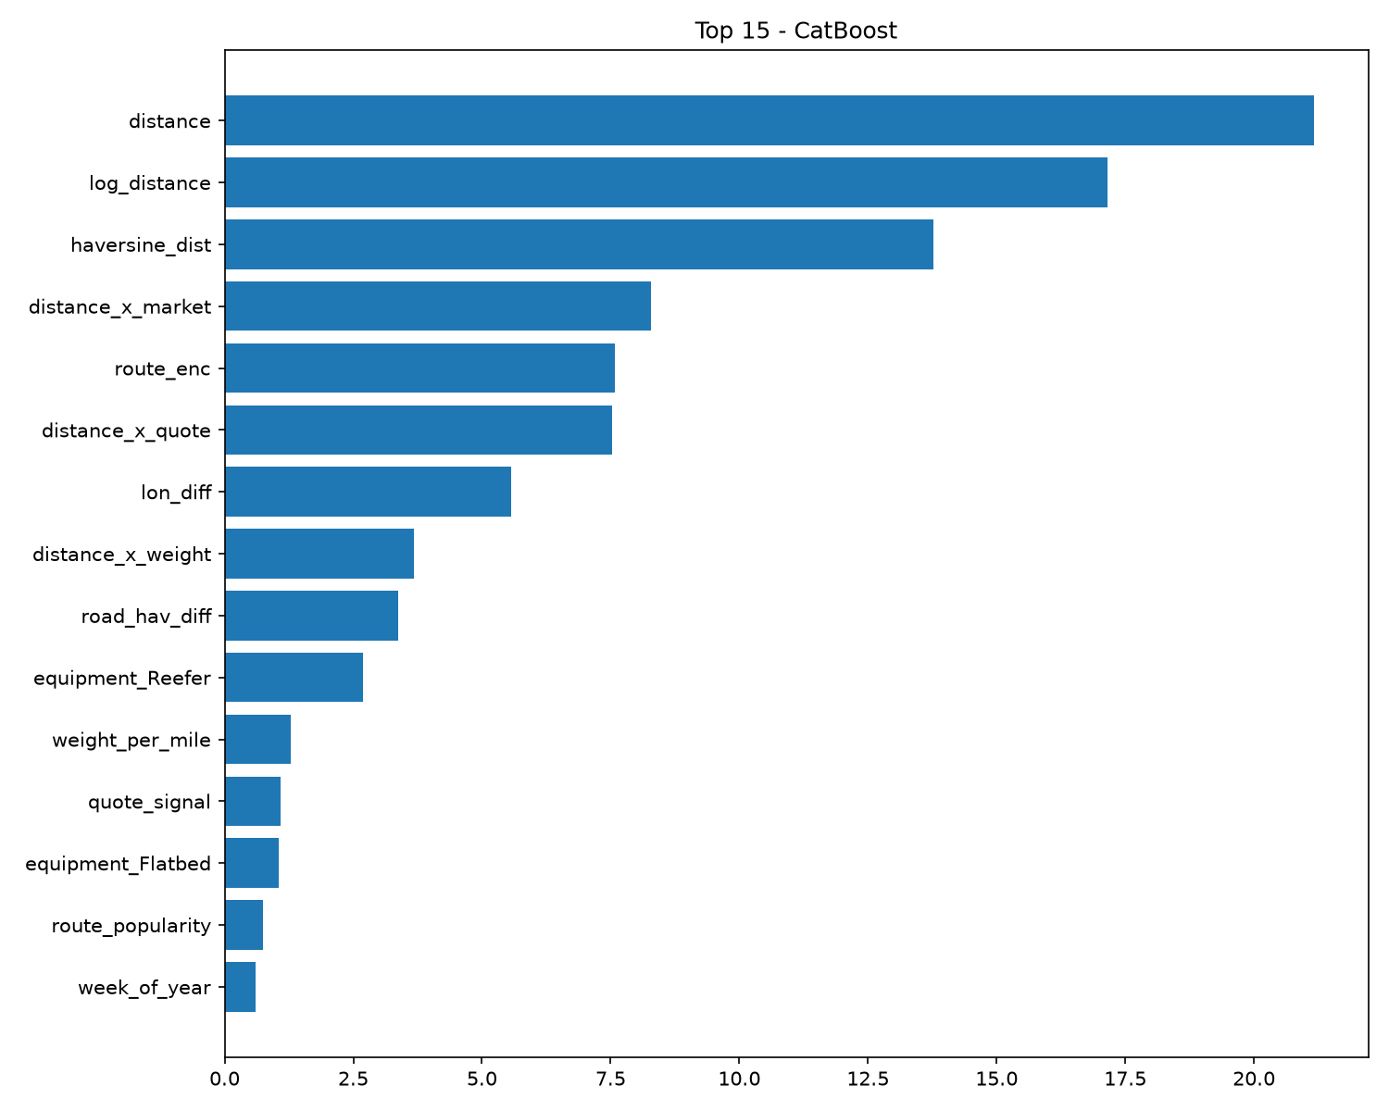

10. December fixed-lane predictions
Problem: the December file has no lat/lon, market_index, or quote_signal - only city names, distance, equipment, weight, date. I did not invent flat placeholders. Method: real Lexington pickup (36.99152, -84.99876) and Fort Wayne delivery (41.31561, -85.36206) medians from training; market_index 0.9281 and Dry-Van quote_signal 2.0538 from the Sep-Oct trailing median (no December market is observed in training, so last-60-day median is the defensible forward fill); route/city encodings from the full 48k training; date features vary naturally. Range $809.61-$833.66 - gentle weekly movement with a small year-end dip, which is what the date-only variation should produce. The old notebook jump ($799 to $1,810 on Dec 26) is gone.
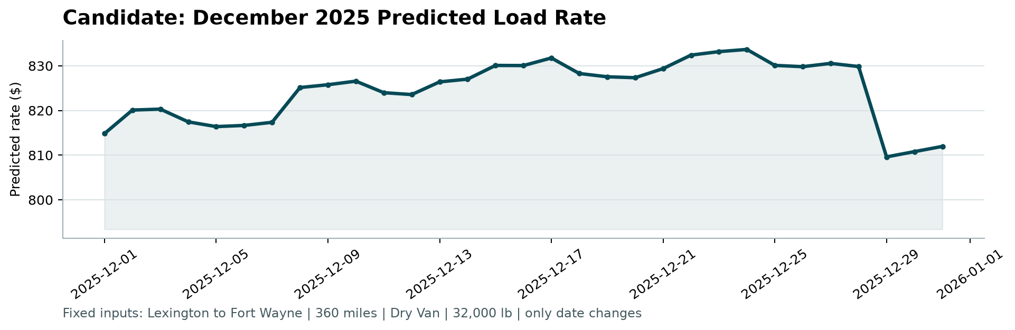
Figure: scorer_results/candidate_december.png from score.py (31 days, Lexington to Fort Wayne, 360 mi, Dry Van, 32,000 lb).

11. Submission files and reproducibility
- validation_predictions.csv: 12,000 rows, load_id,predicted_rate, IDs match template, no duplicates/NaN, all positive. Range $163.90-$7,912.33, mean $2,336.21 (vs train mean $2,373.98 - sensible).
- Data/december-chart-inputs.csv: 31 rows, 7 original columns, fixed lane values untouched, predicted_rate filled.
- scorer_results/candidate_december.png: generated by score.py, passes validation.
- Run: pip install -r requirements.txt (plus lightgbm xgboost catboost scikit-learn seaborn), then python train.py, then python score.py --predictions validation_predictions.csv --december-predictions Data/december-chart-inputs.csv. Seeds fixed, relative paths, no notebook state needed. Code: train.py; notebook kept for exploration.

12. Limitations and next steps
- RMSE near $640 stays high because I kept the rare $15k+ loads. Clipping or a separate long-haul model could lower RMSE but would hide real risk.
- December market/quote is a proxy (Sep-Oct median). If Spotter provides December fuel/demand indices, plug them in directly.
- Next: light tuning of depth/learning-rate, quantile loss for the tail, and a distance-banded error check.
Bottom line: honest temporal validation, leakage fixed, CatBoost-log at $130 MAE (about 6% error), all submission files generated and scorer passes.

