Infrastructure as Code (IaC) Security Scanning with Checkov

Introduction
As organizations increasingly adopt cloud-native architectures, Infrastructure as Code (IaC) has become the standard approach for provisioning and managing cloud resources. Technologies such as Terraform, Kubernetes, CloudFormation, Helm, and ARM templates enable teams to automate infrastructure deployment, improve consistency, and accelerate software delivery.

Insecure IAC TEMPLATE RESULTS
- Publicly exposed cloud storage
- Excessive IAM permissions
- Internet-facing databases
- Missing encryption controls
- Compliance violations
- Expanded attack surface

What is Checkov?
Checkov is an Infrastructure as Code (IaC) static analysis tool developed by Bridgecrew that scans cloud infrastructure definitions for security, compliance, and operational best-practice violations before deployment.
Instead of identifying security issues after cloud resources are created, Checkov enables organizations to detect and remediate risks during development and CI/CD stages.

Core Objectives:
- Prevent insecure infrastructure deployments
- Enforce cloud security standards
- Improve compliance posture
- Reduce remediation costs
- Enable DevSecOps adoption

Why IaC Security Scanning Matters
Infrastructure as Code (IaC) security scanning is the practice of statically analysing infrastructure templates — such as Terraform, AWS CloudFormation, Kubernetes manifests, Helm charts, and Bicep files — for misconfigurations, policy violations, and security weaknesses before those templates are applied to any cloud environment.

Rather than waiting for a CSPM tool to detect a misconfigured S3 bucket or over-privileged IAM role after deployment, IaC scanning catches these issues at the source: in the developer's pull request, in the CI/CD pipeline, or even in the IDE.
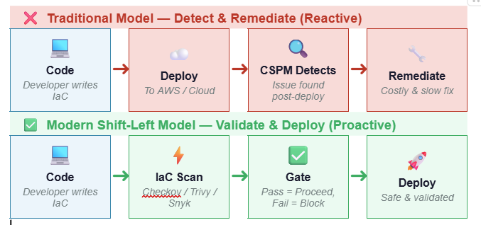

Why It Matters: The Five Core Benefits

Benefit | Description | Business Impact
🔍 Earlier Detection | Security issues are identified before deployment at the IaC stage — in PR reviews or CI pipelines. | Reduces mean time to detect (MTTD) from days to minutes
💰 Reduced Costs | Fixing a misconfiguration in code costs ~$80. Post-production remediation can cost $7,000+ (IBM Cost of Data Breach Report). | Up to 100x cost reduction vs post-breach remediation
📋 Faster Compliance | Continuously validate IaC templates against PCI-DSS, ISO 27001, SOC 2, and CIS benchmarks automatically. | Audit-ready posture; eliminates manual compliance checks
👩‍💻 Developer Awareness | Security feedback is embedded in the developer IDE or Git PR pipeline — making security frictionless and educational. | Builds security culture; reduces repeat misconfigurations
🛡️ Reduced Risk | Misconfigurations are blocked before they reach staging or production cloud environments, eliminating exposure windows. | Zero misconfiguration drift; strong production posture

Benefit Deep-Dive: Faster Compliance
Continuous IaC scanning against compliance frameworks eliminates the "crunch" that occurs before a PCI-DSS or ISO 27001 audit. The following frameworks are natively supported by leading IaC scanning tools:

Framework | Open Source | Enterprise | Other | Key Controls
PCI-DSS v4.0 | ✅ Checkov | ✅ Prisma Cloud | ✅ Trivy | Req 1, 6, 7, 8, 10
ISO 27001:2022 | ✅ Checkov | ✅ Prisma Cloud | ✅ kics | A.12, A.13, A.14
SOC 2 Type II | ✅ Checkov | ✅ Prisma Cloud | ✅ Snyk | CC6, CC7, CC8
CIS AWS Benchmark | ✅ All Tools | ✅ All Tools | ✅ All Tools | All CIS controls
NIST CSF 2.0 | ✅ Checkov | ✅ Prisma Cloud | ⚠️ Partial | ID, PR, DE, RS
AWS Well-Architected | ✅ Checkov | ✅ Prisma Cloud | ✅ Trivy | Security Pillar

Where IaC Scanning Fits in the DevSecOps SDLC

Phase |  | Security Activities | Outputs
Plan | 📋 | Threat modelling; security requirements definition | Threat models; security user stories
Code | 💻 | IDE plugins (Checkov, Snyk); pre-commit hooks; linting | Security linting reports; policy violation blocks
Build | 🔨 | SAST; SCA; IaC scanning in CI (Checkov, Trivy, kics) | Vulnerability reports; policy gate pass/fail
Test | 🧪 | DAST; container image scanning; compliance checks | Security test results; compliance status
Release | 🚀 | Final security gate; sign-off; artefact signing | Signed artefacts; approval records
Deploy | ☁️ | Immutable infrastructure; drift detection; zero-touch deploy | Deployment audit logs; change records
Operate | ⚙️ | CSPM (Prisma Cloud); runtime security (Wazuh, GuardDuty) | Posture dashboards; alert tickets
Monitor | 📊 | SIEM correlation; threat intelligence; IR playbooks | Incident reports; trend analytics

IaC Security Scanning Tools Landscape

Tool | Vendor | Supported Formats | License | Fit
Checkov | Bridgecrew/Palo Alto | Terraform, CloudFormation, ARM, Kubernetes | Free / Enterprise | 🟢 Best Overall
Trivy | Aqua Security | Terraform, K8s, Dockerfiles, SBOM | Open Source | 🟢 Excellent for DevSecOps
tfsec | Aqua Security | Terraform | Open Source | 🟡 Terraform-focused
kics | Checkmarx | Multi-cloud IaC + Dockerfiles | Open Source | 🟢 Broad coverage
Terrascan | Tenable | Terraform, CloudFormation, K8s | Open Source | 🟡 Good compliance rules
Snyk IaC | Snyk | Terraform, K8s, Helm, ARM | Freemium | 🟢 Developer-friendly
Prisma Cloud | Palo Alto Networks | All major IaC + runtime | Enterprise | 🔵 Full CNAPP suite

IMPLEMENTATION

Prerequisite
- Setup Your AWS CLI with respective account
- Install Terraform Latest version
- Install Python 3.8.1 < 3.13.8

Recommended setup for learning Checkov
- pip install Checkov or pip3 install Checkov
- Create and Activate Virtual Environment:.
  - python3 -m venv /path/to/venv/checkov
  - cd /path/to/venv/checkov
  - source ./bin/activate
- Install Checkov: pip install Checkov
- Upgrading Checkov : pip3 install -U Checkov
- Configure a folder: checkov --directory /home/prathamesh/checkov
- Configure a specific file: checkov --file /user/tf/example.tf

Checkov Naming Nomenclature Explained
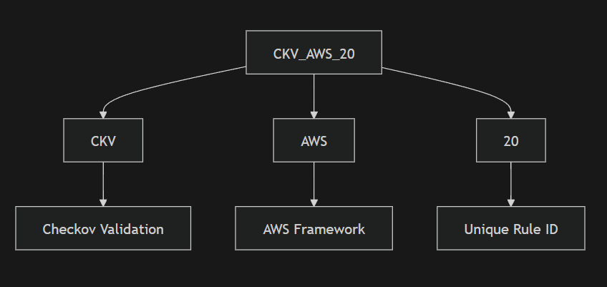.

CI/CD Integration
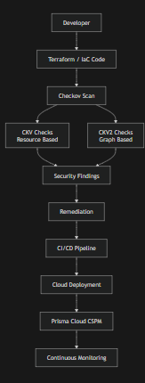

Checkov Security Checks: CKV vs CKV2

Introduction
Checkov is an open-source Infrastructure as Code (IaC) security scanning tool that helps identify security misconfigurations, compliance violations, and architectural risks before cloud infrastructure is deployed. It supports Terraform, Kubernetes, CloudFormation, Docker, CI/CD pipelines, and other cloud-native technologies.
To perform security validation, Checkov uses two primary types of checks:
- CKV (Resource-Based Checks)
- CKV2 (Graph-Based Checks)
Together, these checks provide comprehensive security coverage by validating both individual resources and the relationships between resources.

Definition
CKV (Checkov Validation)
- Resource-based security checks that evaluate a single resource independently.
- Focuses on configuration-level security and compliance validation.
CKV2 (Checkov Validation Version 2)
- Graph-based security checks that analyze relationships between multiple resources.
- Focuses on architectural security, attack paths, and infrastructure connectivity.
Feature | CKV | CKV2
Check Type | Resource-Based | Graph-Based
Scope | Single Resource | Multiple Related Resources
Purpose | Configuration Validation | Architecture & Relationship Validation
Analysis | Individual Resource | Entire Infrastructure Graph
Example | S3 Encryption Enabled | EC2 Reachable from Internet

IMplementing in a actual environment

Installing
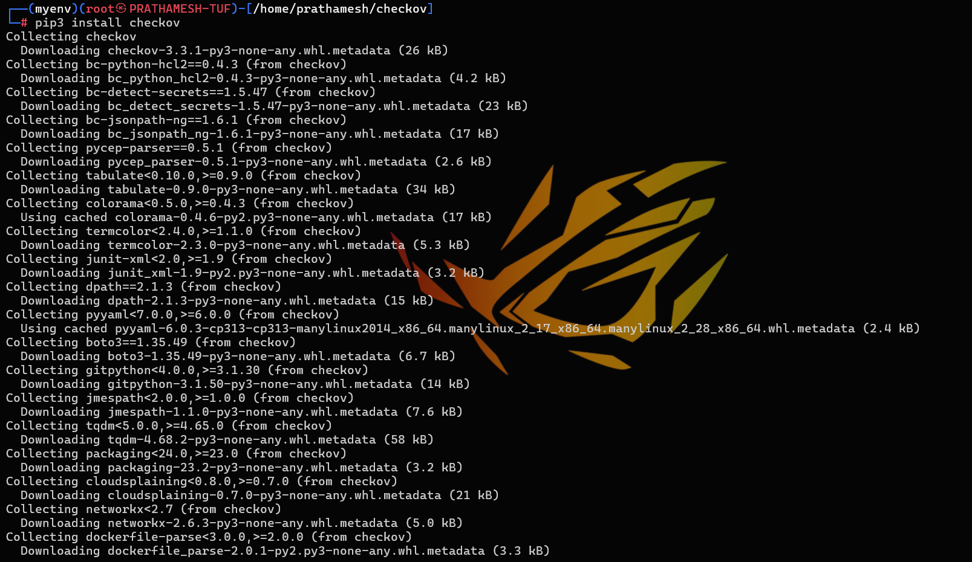

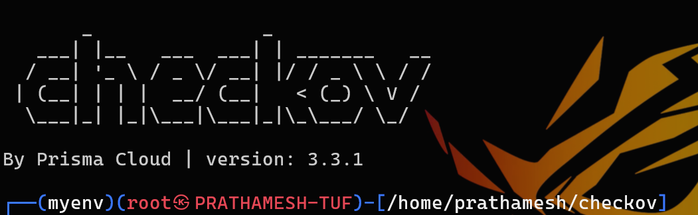

Cloning a repo or a Readymade Project
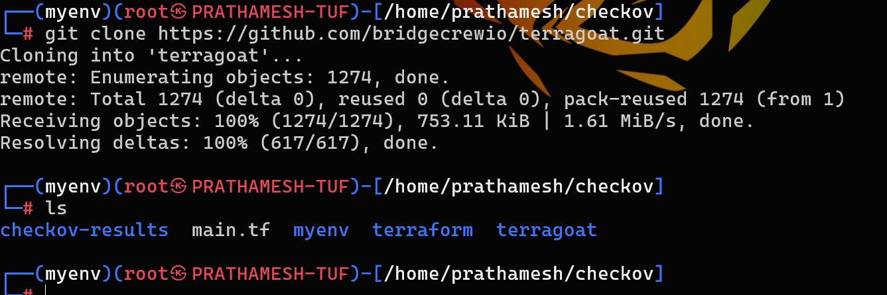

We have downloaded a project containg terraform files
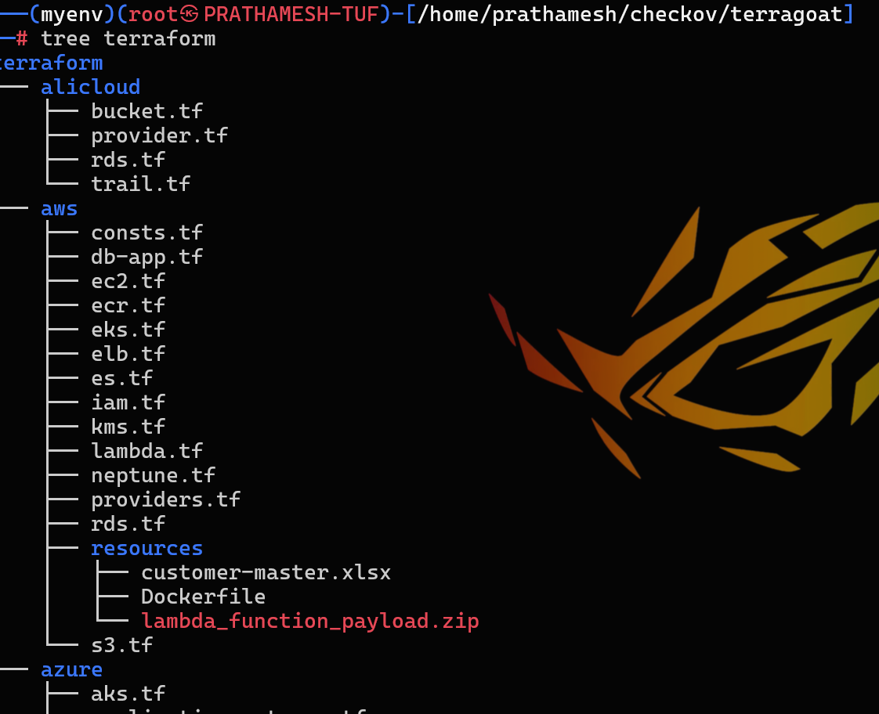

Creating a own branch for it
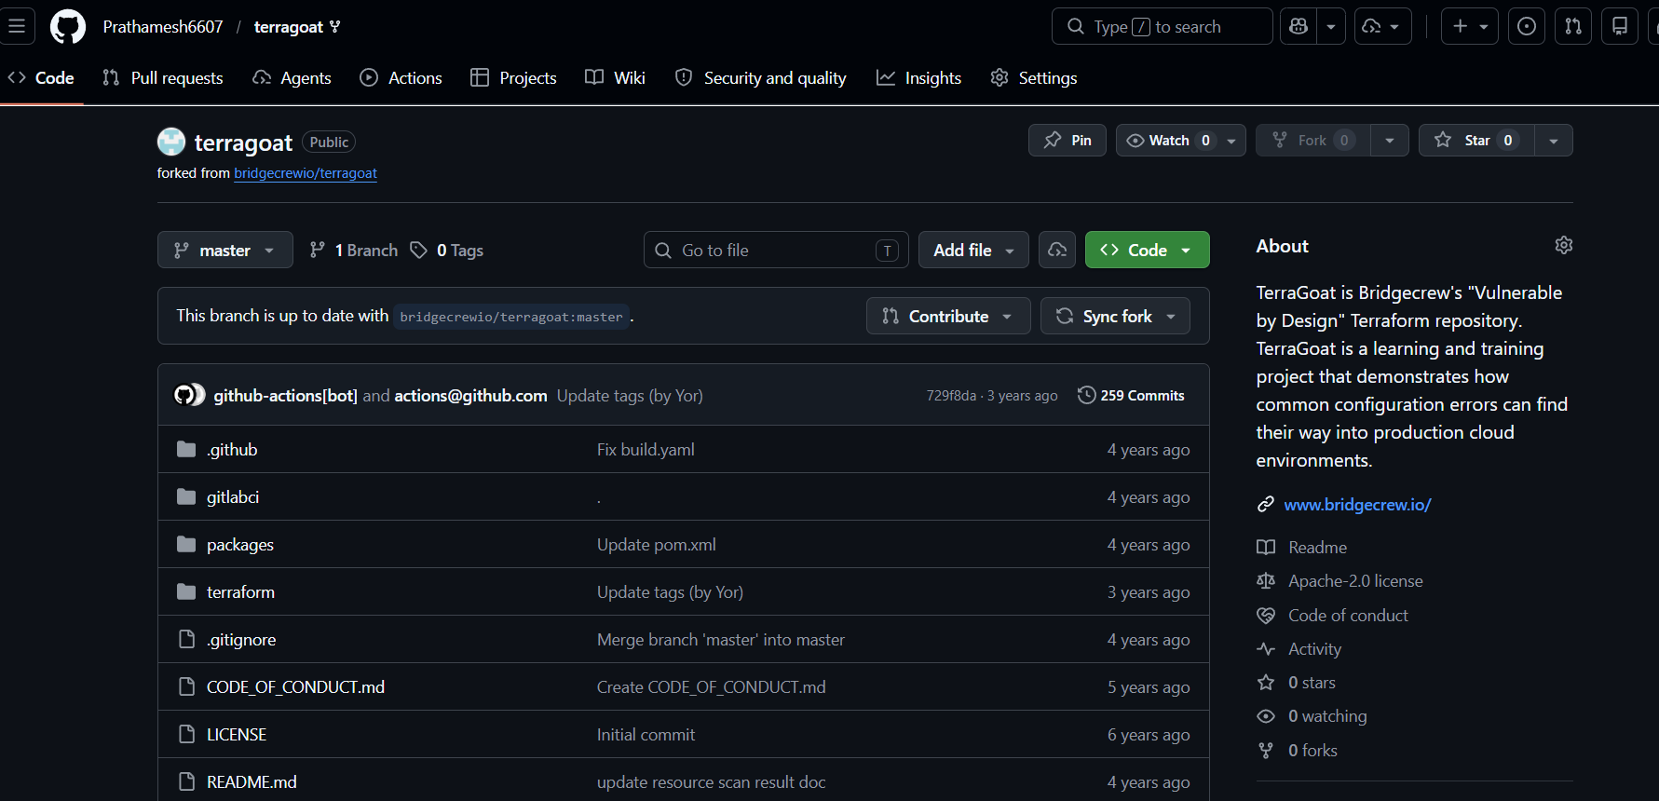

Create a .checkov.yaml config
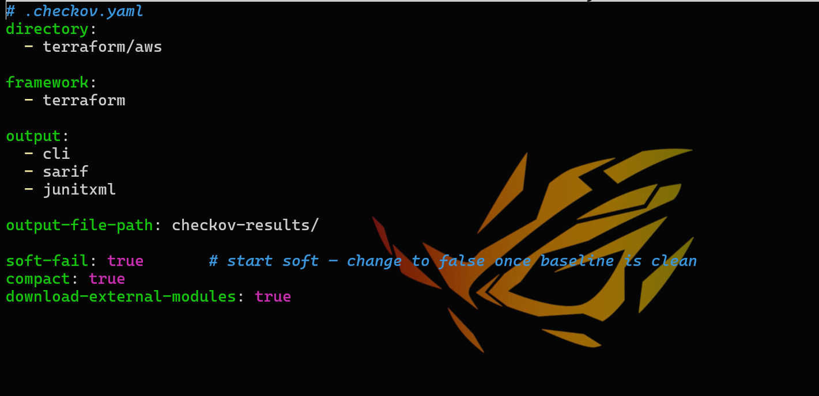
Can be done manually too

Run your first scan
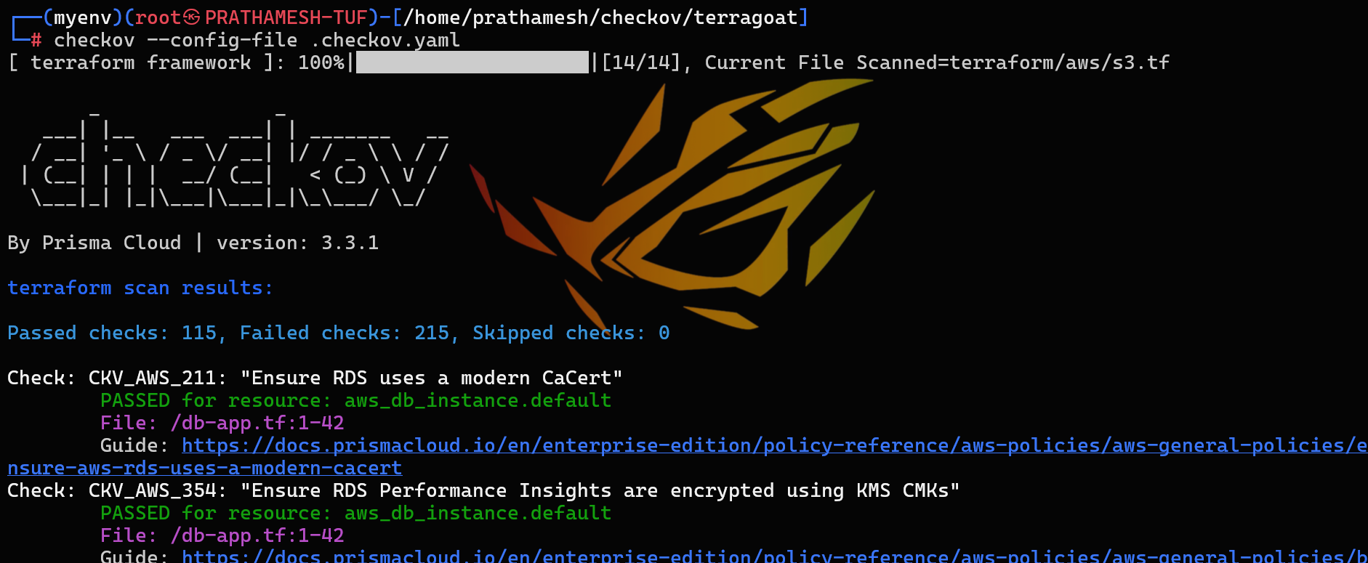

can be done manually
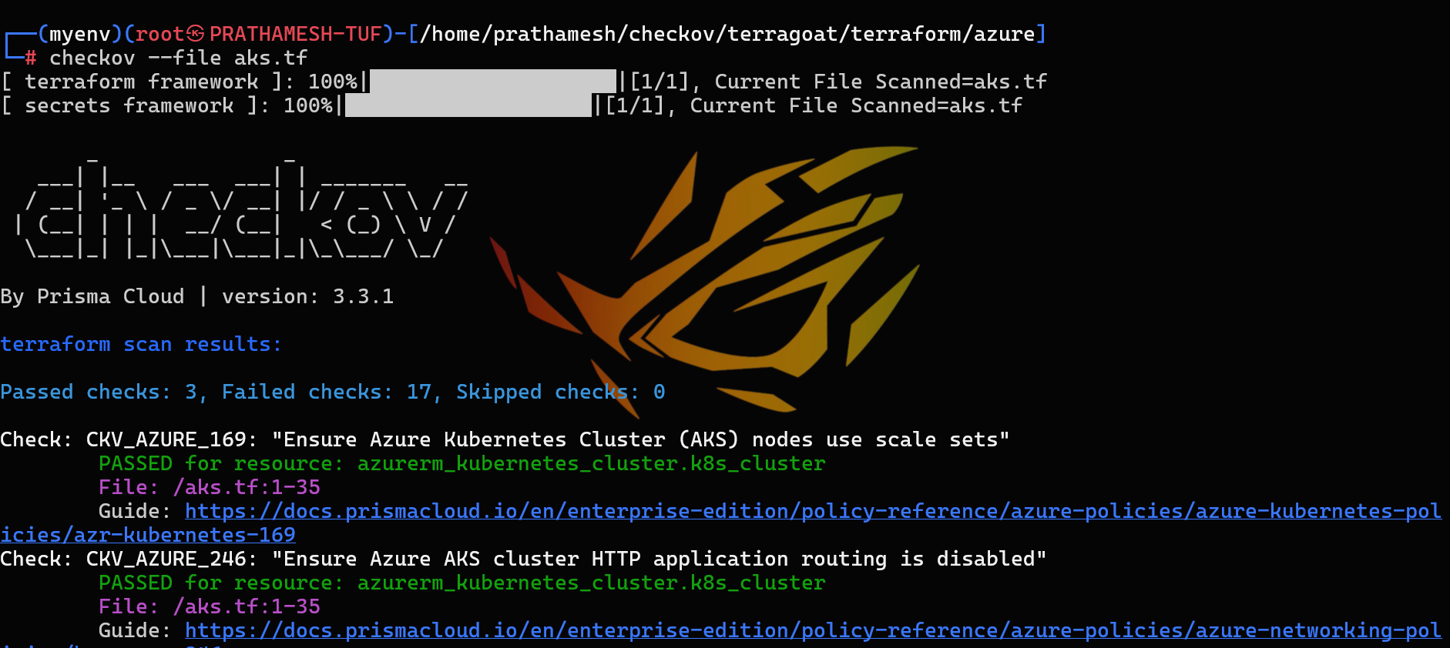.

Run with SARIF output for GitHub
SARIF (Static Analysis Results Interchange Format) is a standardized JSON format used by security and code scanning tools. It is commonly integrated with GitHub Code Scanning, Azure DevOps, and other security platforms.
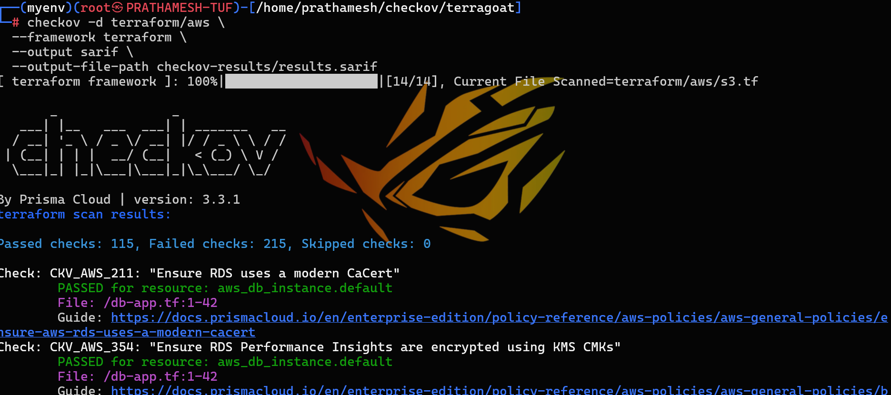

GITHUB ACTION FLOW
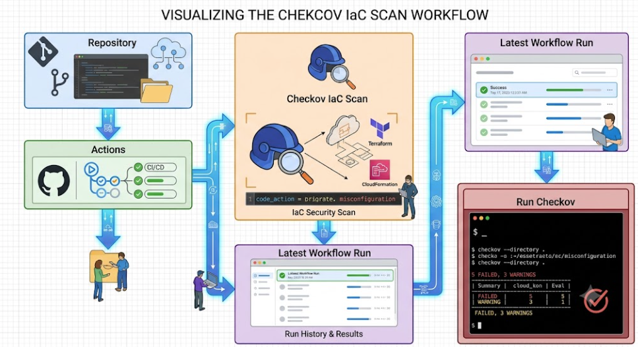
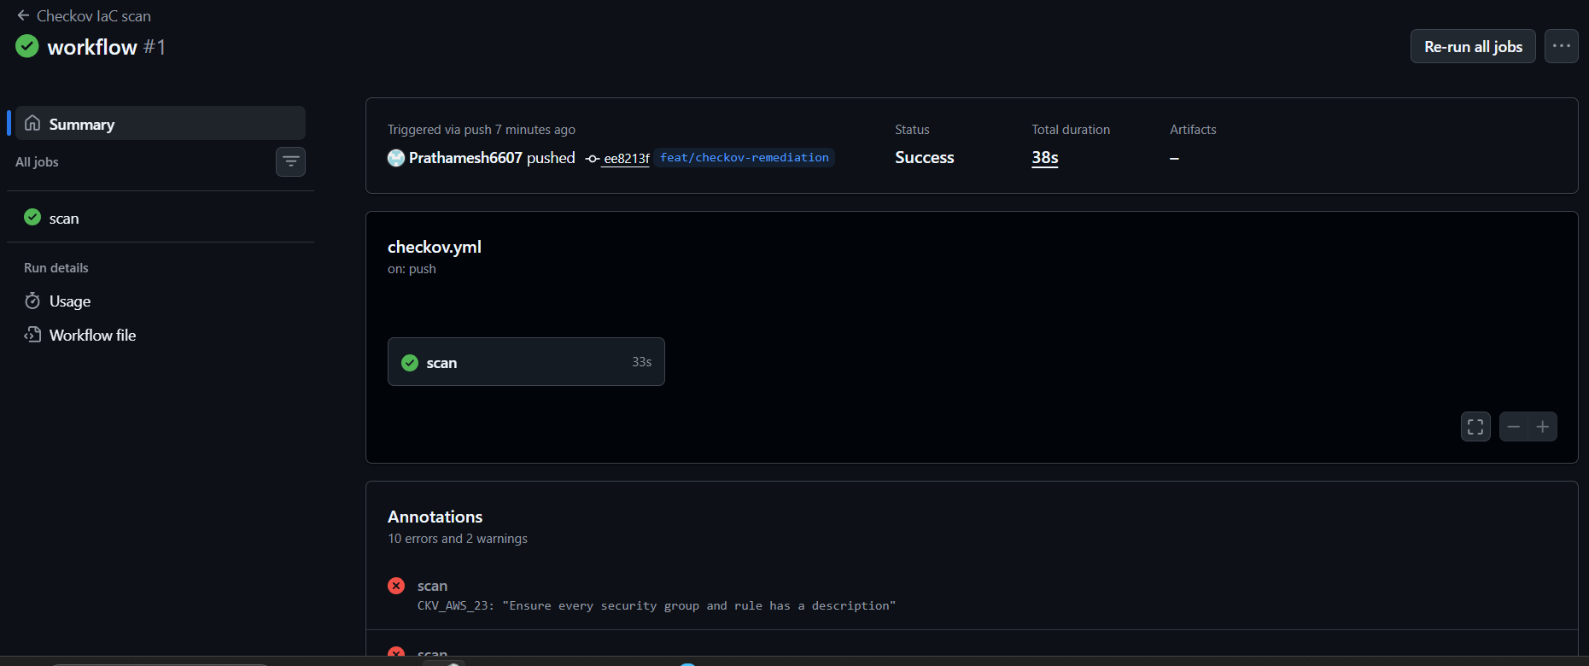

Fail the pipeline when critical S3 policies fail & Upload SARIF to GitHub Security Dashboard.
- Created a insecure s3_failed.tf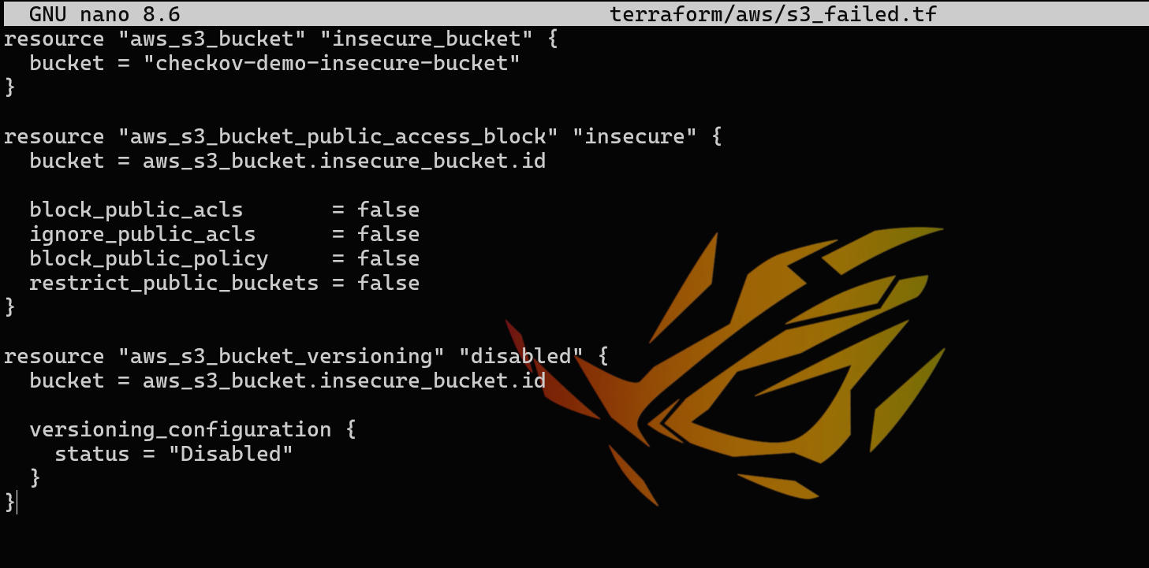
- Manually scanning iac failed file 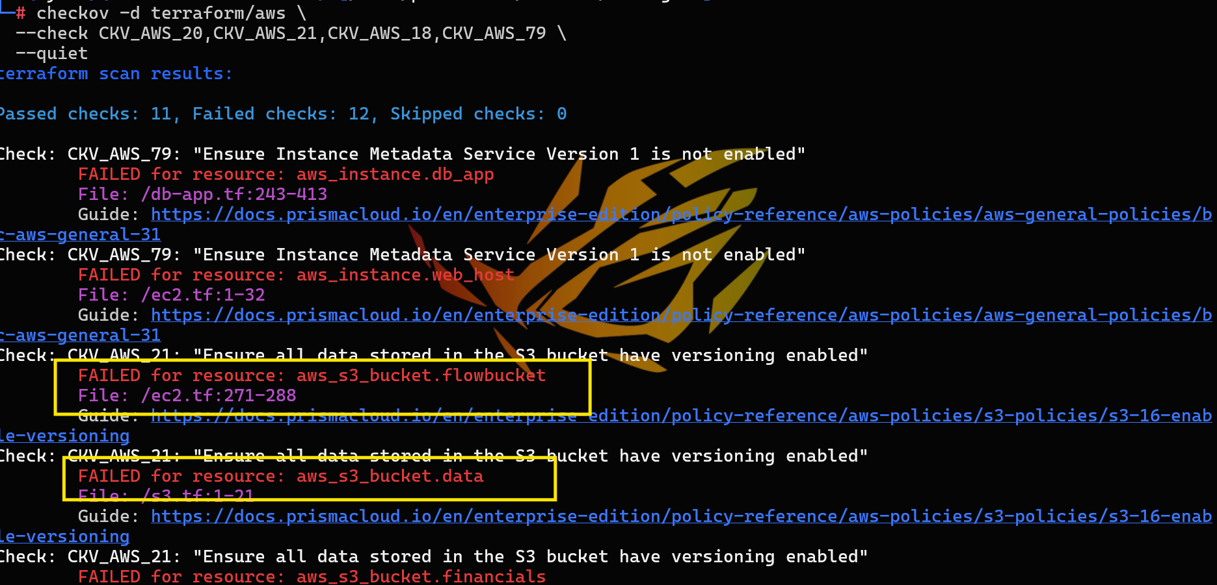
- As we can see specific findings of s3 