**Name: Somesh Somani**

**Enrolment No: 1906124**

**Division: H2**

**Practical No: 03**

**Practical 03-A**

**Problem Statement:** Write a program to insert a element at beginning, end and at given position of a array using menu driven program

**Code:**

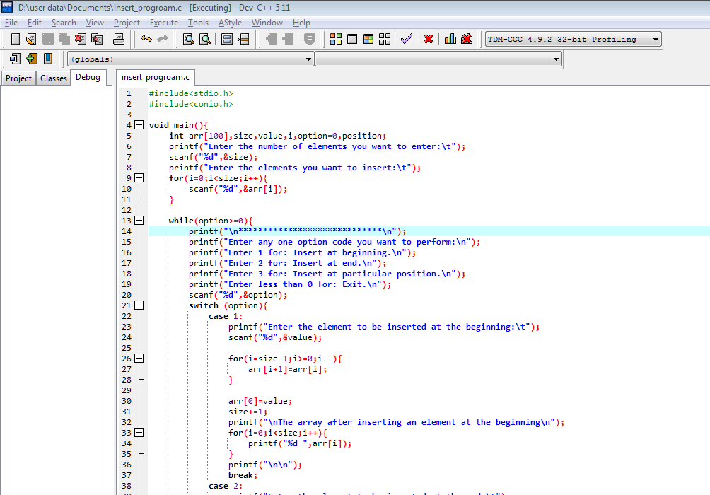

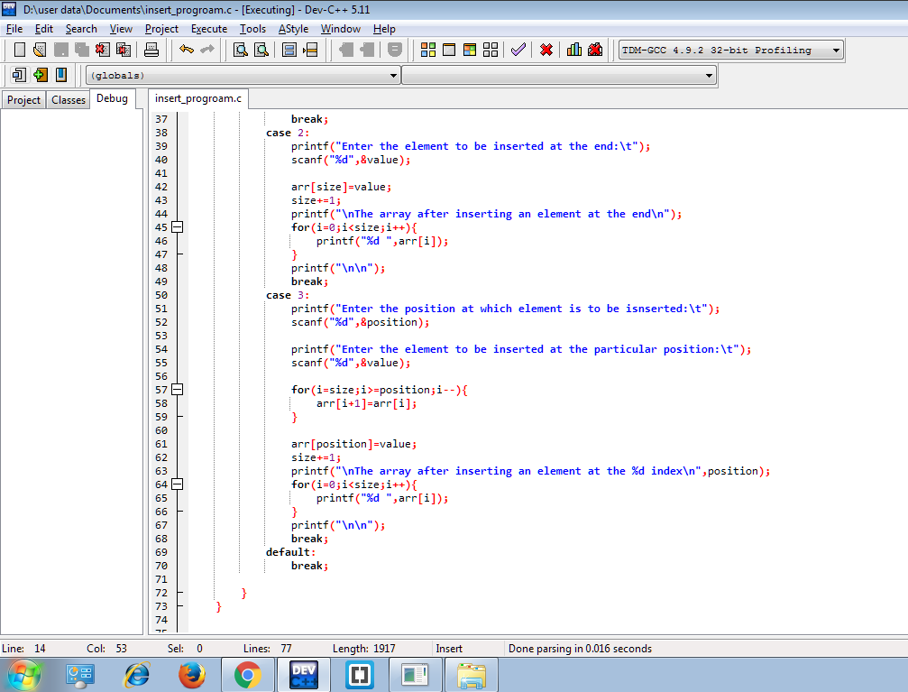

**Output:**

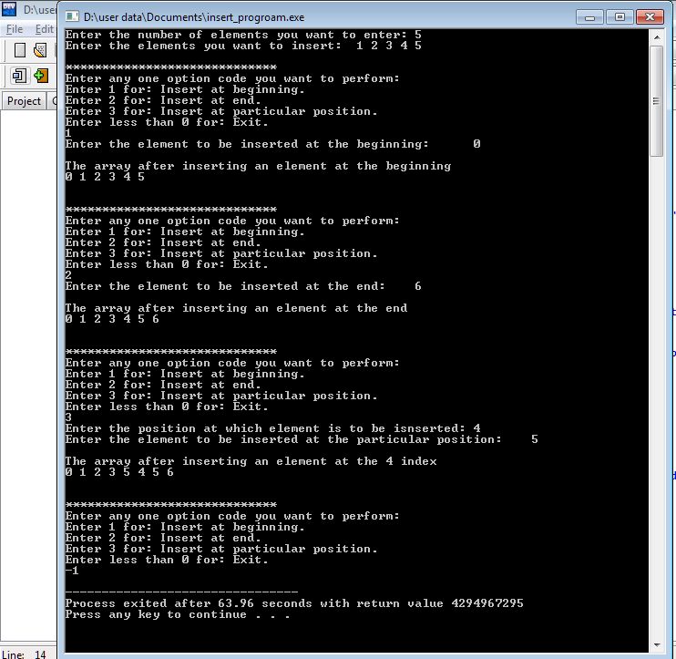

**Practical 03-B**

**Problem Statement:** Write a program to delete a element at beginning, end and at given position of a array using menu driven program

**Code:**

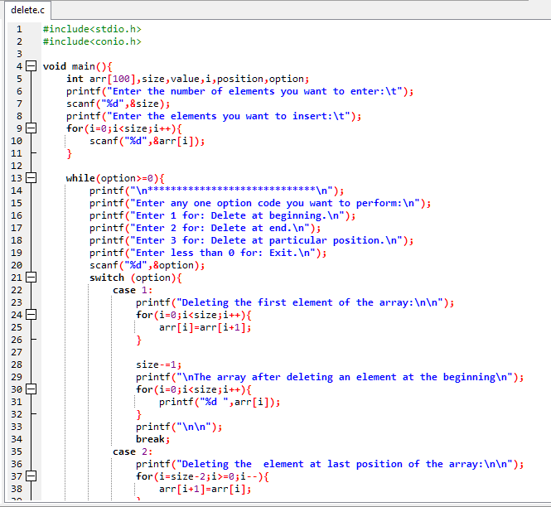

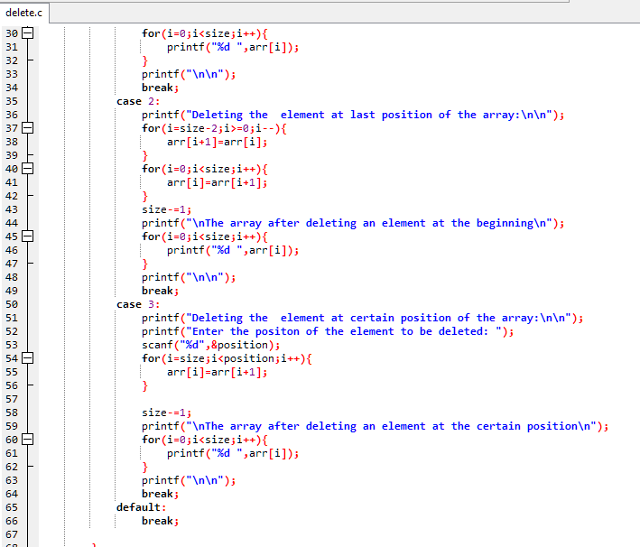

**Output:**

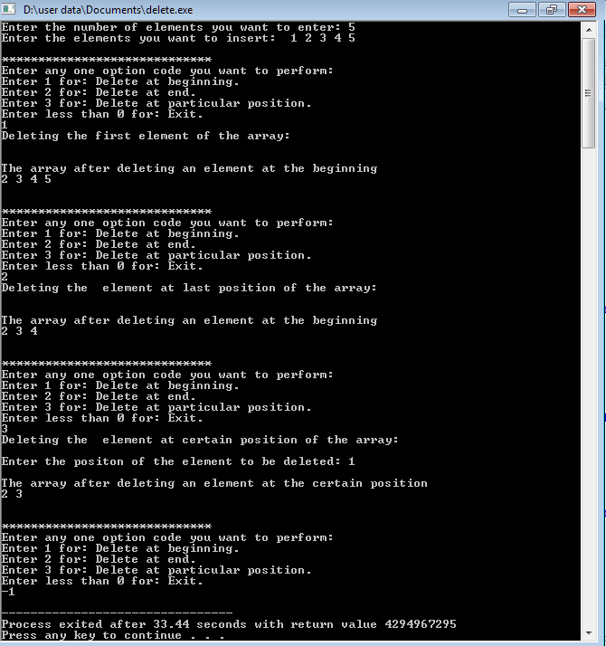

**Conclusion:** In this practical we learnt how insert element at at beginning, end and at given position of a array using menu driven program and also, delete element at at beginning, end and at given position of a array