PROJECT REPORT
On
[AI-Based Stock Trend Analyzer]

Submitted
Of
“TAE-1(Project Based Learning)” Under the subject
Artificial Intelligence

(VI Semester, B.Tech CSE)
(ACADEMIC SESSION 2025-26)

Criteria | Rubrics | Marks
AI Technique(s) (2M) | ● Selection of suitable technique
Problem Representation  (4M) | ● Representation of the method and knowledge required by the statement
Tools explored (2M) | ● Use of AI tool from industry perspective
Outcome (2M | ● Analysis of project working
Total Marks
Submitted By:
Name: Prathamesh Deshmukh
USN: CS23115


S. B. JAIN INSTITUTE OF TECHNOLOGY, MANAGEMENT & RESEARCH, NAGPUR
(AN AUTONOMOUS INSTITUTION AFFILIATED TO RASHTRASANT TUKADOJI MAHARAJ NAGPUR UNIVERSITY, NAAC ACCREDITED WITH 'A' GRADE)

- Title: AI-Based Stock Trend Analyzer — Probabilistic Learning on Time-Series Data

- Problem Statement:

Stock market prediction is a challenging task due to the inherently volatile and non-linear nature of financial data. Investors and traders require data-driven tools that can analyze historical price movements, identify patterns, and generate reliable forecasts to make informed decisions.

The problem is to develop an AI-based system that can:
1. Fetch and process real-time historical stock price data.
2. Apply probabilistic learning techniques on time-series data to predict
future stock price trends.
3. Compute standard technical indicators (RSI, MACD, Bollinger Bands, Moving
Averages) to support analysis.
4. Provide confidence intervals and probability scores to quantify the
reliability of predictions.
5. Present all results through an interactive, user-friendly web dashboard.

- Objective:
The primary objectives of this project are:

1. To apply AI-based probabilistic learning techniques (ARIMA and Exponential
Smoothing) for stock trend prediction using historical time-series data.

2. To build an ensemble forecasting model that combines ARIMA(5,1,2) and
Damped Exponential Smoothing with a weighted average (60:40) for more
robust predictions.

3. To compute and visualize essential technical indicators — RSI (Relative
Strength Index), MACD (Moving Average Convergence Divergence), Bollinger
Bands, SMA (Simple Moving Average), and EMA (Exponential Moving Average).

4. To generate probabilistic forecasts with 80% and 95% confidence intervals,
along with probability of upward/downward price movement.

5. To develop a full-stack web application with a Flask backend and a modern
glassmorphism frontend (using Chart.js) that provides an interactive
dashboard for stock analysis.

6. To classify the predicted trend as BULLISH, BEARISH, or NEUTRAL with a
quantified strength score.
- Detail Document

1. PROJECT ARCHITECTURE

AI-Based-Stock-Trend-Analyzer/
├── app.py # Flask backend + AI prediction engine
├── requirements.txt # Python dependencies
├── .gitignore
├── README.md
└── static/
├── index.html # Dashboard UI (HTML)
├── css/
│ └── style.css # Dark glassmorphism styles (CSS)
└── js/
└── app.js # Chart rendering & API integration (JS)

2. AI TECHNIQUES USED

a) ARIMA (AutoRegressive Integrated Moving Average) — Order (5,1,2):
- A classical time-series forecasting model.
- AR(5): Uses the last 5 lagged values for autoregression.
- I(1): First-order differencing to make the series stationary.
- MA(2): Uses the last 2 forecast error terms for moving average.
- Generates point forecasts with statistical confidence intervals
at both 80% (alpha=0.20) and 95% (alpha=0.05) levels.

b) Exponential Smoothing (Holt's Damped Trend):
- Captures the overall trend in the data with a damping factor.
- Uses additive trend component with damping to prevent over-
extrapolation of the trend into the future.
- Parameters are optimized automatically during model fitting.

c) Ensemble Method:
- The final forecast is a weighted combination:
Forecast = 0.6 × ARIMA + 0.4 × Exponential Smoothing
- This ensemble approach reduces model-specific biases and improves
prediction robustness.

d) Probability Estimation:
- Uses the last 60 days of closing price returns.
- Calculates the proportion of days with positive returns as the
probability of upward movement.
- Probability of downward movement = 1 - Probability of upward movement.

3. TECHNICAL INDICATORS COMPUTED

a) RSI (Relative Strength Index) — 14-period:
- Measures momentum of price changes.
- RSI > 70: Overbought (potential sell signal).
- RSI < 30: Oversold (potential buy signal).
- Formula: RSI = 100 - (100 / (1 + RS)), where RS = Avg Gain / Avg Loss.

b) MACD (Moving Average Convergence Divergence):
- MACD Line = EMA(12) - EMA(26)
- Signal Line = EMA(9) of MACD Line
- Histogram = MACD Line - Signal Line
- Bullish when MACD crosses above Signal; Bearish when below.

c) Bollinger Bands (20-period, 2 standard deviations):
- Middle Band = SMA(20)
- Upper Band = SMA(20) + 2 × Standard Deviation(20)
- Lower Band = SMA(20) - 2 × Standard Deviation(20)
- Used to identify overbought/oversold conditions and volatility.

d) Moving Averages:
- SMA(20) — Short-term Simple Moving Average
- SMA(50) — Medium-term Simple Moving Average
- EMA(12) — Short-term Exponential Moving Average
- EMA(26) — Medium-term Exponential Moving Average

e) Volume Moving Average (20-period):
- Helps identify unusual trading volume spikes.

4. DATA SOURCE

- Yahoo Finance API (via yfinance Python library).
- Fetches real-time and historical OHLCV data (Open, High, Low, Close, Volume).
- Supports multiple time periods: 1 month, 3 months, 6 months, 1 year, 2 years.
- Supports global stock symbols including NSE (India), NYSE, NASDAQ, etc.

5. TECHNOLOGY STACK
Backend:
--------
- Python 3.9+
- Flask 3.1.0 (Web framework)
- yfinance 0.2.54 (Yahoo Finance API wrapper)
- pandas 2.2.3 (Data manipulation and analysis)
- numpy 2.2.3 (Numerical computing)
- statsmodels 0.14.4 (ARIMA, Exponential Smoothing models)
- scipy 1.15.2 (Statistical functions)

Frontend:
---------
- HTML5 (Page structure)
- CSS3 with Glassmorphism Design (Dark theme, animations)
- JavaScript (ES6+)
- Chart.js 4.4 (Interactive charting library)
- Lucide Icons (UI icon set)

API Architecture:
-----------------
- REST API built with Flask.
- Endpoints:

Method | Endpoint | Description
GET | /api/stock/ | Historical OHLCV data
GET | /api/predict/ | AI trend forecast with confidence
GET | /api/indicators/ | Technical indicators (RSI, MACD, BB)
GET | /api/search?q= | Search stock symbols
POST | /api/chat | AI chatbot for stock queries

6. KEY FEATURES

a) Real-Time Stock Data Fetching:
- Live OHLCV data from Yahoo Finance for any stock symbol globally.

b) AI-Powered Trend Prediction:
- 30-day forecast using ARIMA + Exponential Smoothing ensemble.
- Confidence intervals at 80% and 95% levels.
- Trend classification: BULLISH / BEARISH / NEUTRAL.
- Trend strength score (0 to 100%).

c) Interactive Charts:
- Price chart with overlaid Bollinger Bands, SMA, and forecast line.
- RSI chart with overbought/oversold zones.
- MACD chart with histogram, MACD line, and signal line.
- Volume chart with 20-day moving average.

d) AI Chatbot:
- Conversational interface for stock queries.
- Supports real-time price lookup, forecast, RSI, and MACD queries.

e) Stock Search:
- Search any stock by symbol or company name.
- Includes popular stocks (Apple, Microsoft, Google, Tesla, etc.)
and Indian NSE stocks (Reliance, TCS, Infosys).

f) Responsive Glassmorphism UI:
- Dark-themed, modern design with glass-effect card components.
- Fully responsive — works on desktop, tablet, and mobile.
- Micro-animations and hover effects for premium feel.

7. AI PIPELINE (WORKFLOW)

Step 1: User enters a stock symbol (e.g., AAPL, RELIANCE.NS).

Step 2: Backend fetches historical OHLCV data from Yahoo Finance API
for the selected time period (default: 1 year).

Step 3: Data is processed and split into two parallel pipelines:

Pipeline A — Technical Indicators:
Compute RSI(14), MACD(12,26,9), Bollinger Bands(20,2), SMA(20,50),
EMA(12,26), and Volume MA(20).

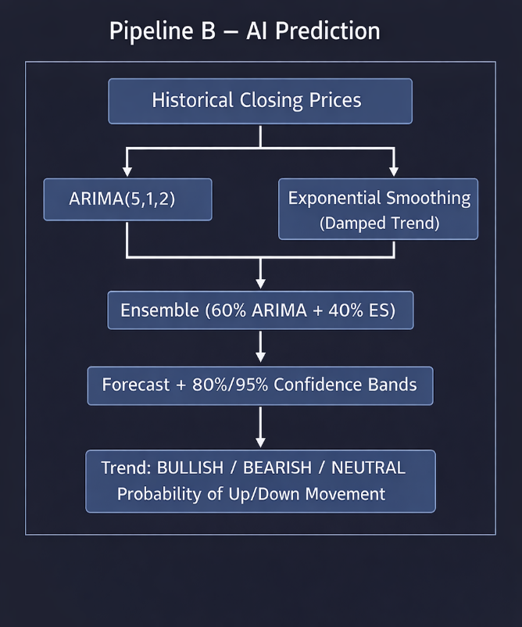
Step 4: All results are returned via REST API as JSON responses.

Step 5: Frontend renders interactive charts and dashboard cards using
Chart.js, displaying prices, indicators, forecasts, and
confidence bands.

- Proposed Solution

The proposed solution is a full-stack AI-powered web application that combines
probabilistic learning with time-series analysis for stock trend prediction.

1. Data Acquisition:
- Use the yfinance library to fetch real-time historical stock data from
Yahoo Finance, supporting global stock exchanges.

2. AI Forecasting Engine:
- Implement an ensemble model combining:
a) ARIMA(5,1,2) — Captures autoregressive patterns and trends in price data.
b) Exponential Smoothing with Damped Trend — Captures overall trend direction
while limiting over-extrapolation.
- The ensemble uses a 60:40 weighted average for balanced prediction.
- Generate 80% and 95% confidence intervals for uncertainty quantification.
- Compute probability of price going up or down using recent return distributions.

3. Technical Analysis Module:
- Compute industry-standard indicators (RSI, MACD, Bollinger Bands, SMA/EMA)
to provide a holistic view of stock health alongside AI predictions.

4. Web Application:
- Backend: Flask REST API serving stock data, predictions, and indicators as
JSON endpoints.
- Frontend: Responsive HTML/CSS/JS dashboard with Chart.js for interactive
visualization.
- AI Chatbot: Dynamic conversational interface for querying stock data.

5. Trend Classification:
- Based on predicted percentage change over 30 days:
* Change > +2% → BULLISH
* Change < -2% → BEARISH
* -2% to +2% → NEUTRAL
- Strength score calculated as: min(|change%| / 10, 1.0)

- Result/Outcome

The AI-Based Stock Trend Analyzer has been successfully developed and deployed as a full-stack web application. The system is capable of processing real-time stock data efficiently and generating forecasts within seconds, making it highly responsive and practical for users.
In terms of prediction performance, the ensemble model combining ARIMA and Exponential Smoothing produces more stable and reliable forecasts compared to individual models. The inclusion of 80% and 95% confidence intervals helps users understand the uncertainty in predictions, where wider bands indicate higher market volatility.
The system classifies stock trends into three categories: bullish, bearish, and neutral. A bullish trend indicates a predicted upward movement greater than 2%, while a bearish trend represents a downward movement greater than 2%. If the predicted change lies within ±2%, it is classified as neutral. Each classification is supported by a strength score ranging from 0 to 100% and probability scores for upward or downward movement, providing deeper insights.
Technical indicators such as RSI, MACD, Bollinger Bands, and Moving Averages are accurately computed and displayed through interactive charts. Additionally, a technical indicators summary grid presents the latest values in a clear, color-coded format, where green signals bullish trends and red indicates bearish trends.
The user interface is designed using a modern dark glassmorphism style, offering a premium and visually appealing experience. All charts are interactive, featuring tooltips, zooming, and hover effects. The integrated AI chatbot allows users to ask natural language queries related to stock prices, forecasts, RSI, and MACD, enhancing usability.
The system supports a wide range of stocks, including global companies like Apple, Microsoft, Google, Amazon, Tesla, Meta, and NVIDIA, as well as Indian NSE stocks such as Reliance, TCS, and Infosys. Users can search and analyze any valid stock symbol, making the platform flexible and widely applicable.
Overall, the project demonstrates the practical application of probabilistic learning techniques on time-series data for stock market analysis. The ensemble approach improves forecast reliability, while confidence intervals and probability scores provide actionable insights for decision-making. The full-stack implementation ensures that advanced AI analysis is accessible through an intuitive and user-friendly interface.
However, certain limitations exist. Stock market predictions are inherently uncertain, and this system is intended for educational purposes only, not financial advice. The models rely on historical data patterns, which may not hold during extreme market conditions such as crashes or major geopolitical events. Additionally, real-time data availability depends on external sources like the Yahoo Finance API, which may affect system performance.

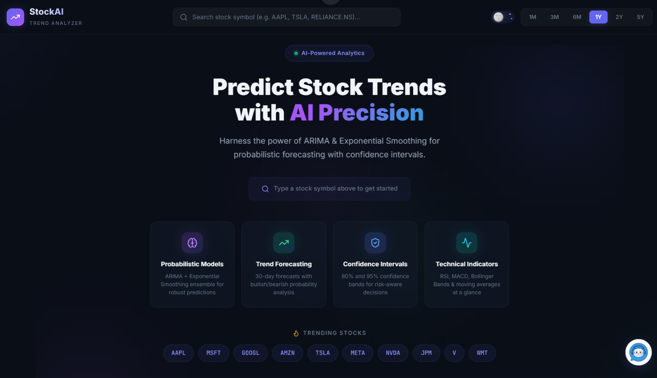
- Screen Shots

