==========github server=============

Why did the incorrect username crash with KeyError?
When the user doesn't exist, GitHub returns a completely different JSON structure:
# Valid user → has 'name', 'public_repos', 'followers'
{'login': 'PrathameshDevkar', 'name': None, 'public_repos': 36, ...}

# Invalid user → completely different keys
{'message': 'Not Found', 'documentation_url': '...', 'status': '404'}
Your code blindly did user['name'] without checking if the call even succeeded. This is the #1 real-world mistake — always check the status code before reading the body. We'll fix this properly in Step 4 (error handling), but keep this lesson in mind.

Core Concepts You Must Understand

Concept 1 — HTTP Request/Response Cycle
Every API call is a conversation between your code (client) and the server:
CLIENT (your Python code) SERVER (GitHub)
───────────────────────── ───────────────
1. You build a REQUEST:
- Method : GET
- URL : https://api.github.com/users/torvalds
- Headers : Accept: application/json
- Body : (empty for GET)
──── REQUEST ────────────────►
2. Server receives it
3. Finds the user data
4. Builds a RESPONSE:
- Status : 200
- Headers: Content-Type, RateLimit...
- Body : JSON data
◄─── RESPONSE ───────────────
5. You read the RESPONSE:
- response.status_code → 200
- response.headers → metadata
- response.json() → parsed dict
Three parts to every response — status code, headers, body. Never skip checking the status code.

Concept 2 — HTTP Status Codes (the language of APIs)
Status codes are grouped into families:
1xx → Informational (rare, you usually don't see these)
2xx → Success
3xx → Redirection
4xx → YOUR fault (bad request, wrong auth, not found)
5xx → SERVER's fault (their backend crashed, overloaded)
The ones you'll encounter most:
Code | Name | Meaning | Should you retry?
200 | OK | All good | —
201 | Created | POST succeeded, resource created | —
400 | Bad Request | You sent invalid data | ❌ Fix your request
401 | Unauthorized | Missing/wrong auth token | ❌ Fix your token
403 | Forbidden | Token valid but no permission | ❌ Need different scope
404 | Not Found | Resource doesn't exist | ❌ Check your URL
422 | Unprocessable | Validation failed | ❌ Fix your payload
429 | Too Many Requests | Rate limited | ✅ Wait, then retry
500 | Internal Server Error | Their server crashed | ✅ Retry later
503 | Service Unavailable | Their server is down | ✅ Retry later
Rule of thumb: 4xx = you need to fix something. 5xx = wait and retry.

Concept 3 — HTTP Headers (metadata layer)
Headers are key-value pairs that travel alongside the request/response. They carry metadata — not the actual data you asked for, but information about the request/response.
Request headers (you send these):
Authorization: Bearer ghp_xxxxxxxxxxxx ← your identity
Content-Type: application/json ← "I'm sending JSON"
Accept: application/json ← "Please reply in JSON"
User-Agent: MyApp/1.0 ← who you are
Response headers (GitHub sends these back):
Content-Type: application/json ← "My reply is JSON"
X-RateLimit-Limit: 60 ← max requests/hour
X-RateLimit-Remaining: 51 ← you have 51 left
X-RateLimit-Reset: 1789834344 ← resets at this Unix timestamp
X-RateLimit-Used: 9 ← you've used 9
Convert that reset timestamp to see it clearly:
import datetime
reset_ts = 1789834344
print(datetime.datetime.fromtimestamp(reset_ts))
# → 2026-09-19 21:02:24 (your local time)

Concept 4 — Rate Limiting (the most important concept for production)
GitHub gives you 60 requests/hour without auth, 5000/hour with auth.
From your output, I can see you already used 14 requests across your tests:
X-RateLimit-Remaining: 46
X-RateLimit-Used : 14
How rate limiting works in practice:
Hour starts
│
├── Request 1 → Remaining: 59
├── Request 2 → Remaining: 58
├── ...
├── Request 60 → Remaining: 0
│
├── Request 61 → Status: 429 (Too Many Requests)
│ Header: Retry-After: 3542 (seconds until reset)
│ Body: {"message": "API rate limit exceeded"}
│
Reset timestamp hits → Counter resets back to 60
The right way to handle this is:
- Check X-RateLimit-Remaining before making calls
- When you get a 429 — read Retry-After header and sleep that long
- Never hammer the API with retries — that makes it worse

Concept 5 — What requests.Session() does (vs plain requests.get)
Right now you're using requests.get() directly. That's fine for learning, but in production you use a Session:
# What you're doing now — creates and destroys connection each time
requests.get(url1) # opens TCP connection, makes call, closes connection
requests.get(url2) # opens NEW TCP connection again — wasteful

# What Session does — reuses the connection
session = requests.Session()
session.get(url1) # opens TCP connection
session.get(url2) # REUSES the same connection (much faster)
session.get(url3) # REUSES again

# Session also lets you set default headers once
session.headers.update({"Authorization": "Bearer token123"})
# Now ALL calls automatically include that header
Opening a TCP connection has overhead (DNS lookup, TLS handshake). A Session eliminates that cost for every call after the first.

============http errors handling===========
This is actually the most important OOP concept in API integrations. You're not confused about exceptions—you’re confused about how control flow jumps between classes.
The key idea is:
GitHubClient never handles errors. BaseAPIClient detects and raises them. main.py catches them. exceptions.py only defines what those errors look like.
Let's connect every class with your actual execution log.

First, the responsibility of each file
exceptions.py
Defines the error classes only. It never makes requests and never catches anything.
exceptions.py
base_client.py
Makes the HTTP request, checks the status code, and raises the correct exception.
base_client.py
github_client.py
Adds GitHub headers and GitHub-specific methods. It inherits all HTTP and error behavior from BaseAPIClient.
github_client.py
main.py
Calls the client and catches exceptions with try/except.
main.py

The complete execution flow
Let's follow one real example:
Python
Run
client.get_repo("PrathameshDevkar", "test_repo")
This looks like one line, but internally it becomes 7 function calls.
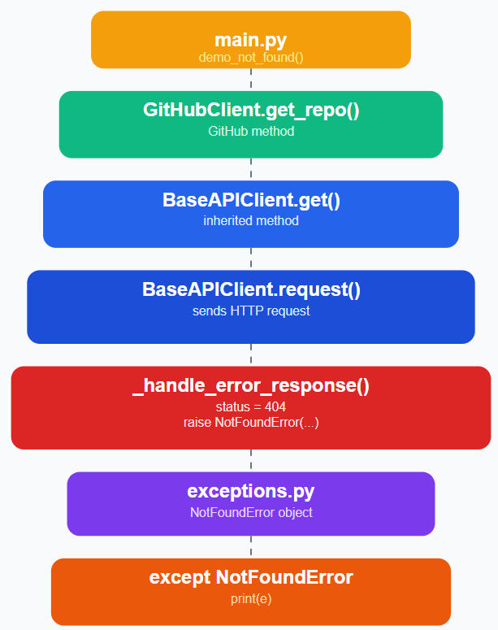
Notice something important:
The exception travels upward automatically.
No code explicitly passes it from BaseAPIClient to GitHubClient.
Python does that.

Let's trace your 404 example line by line

Step 1 — main.py
You wrote:
Python
Run
try:
client.get_repo("PrathameshDevkar", "test_repo")
except NotFoundError as e:
print(e)
At this moment:

client is a GitHubClient

get_repo() is called

main.py

Step 2 — GitHubClient.get_repo()
Your method is:
Python
Run
def get_repo(self, owner, repo):
response = self.get(f"/repos/{owner}/{repo}")
return response.json()
Very important:
self.get() is not inside GitHubClient.
Where does it come from?
It is inherited from BaseAPIClient.
github_client.py
Think of inheritance like this:
GitHubClient
│
│ inherits
▼
BaseAPIClient
So Python says:
"GitHubClient doesn't have get()? I'll use the parent's get()."

Step 3 — BaseAPIClient.get()
This method is tiny:
Python
Run
def get(...):
return self.request(...)
base_client.py
It immediately calls request().

Step 4 — request()
Now we're inside the parent class.
This executes:
Python
Run
response = self.session.request(...)
This is the real HTTP call.
Your log:
Making request ...
GET https://api.github.com/repos/PrathameshDevkar/test_repo

Response received | status = 404
That log comes from here.
base_client.py

Step 5 — Why _handle_error_response() is called
Your code says:
Python
Run
if not response.ok:
self._handle_error_response(response)
Since GitHub returned 404, response.ok is False.
So Python enters _handle_error_response().
base_client.py

Step 6 — The exception is CREATED
Inside _handle_error_response():
Python
Run
elif status == 404:
raise NotFoundError(
f"Resource not found: {api_message}",
status_code=status,
response_body=response.text
)
base_client.py
This is where the object is created.
Internally it's almost like:
Python
Run
e = NotFoundError(...)
raise e
The raise keyword does two things:

Creates the exception object.

Immediately stops the current function.

Nothing below raise executes.

What happens after raise?
This is the part most people miss.
Imagine the call stack.
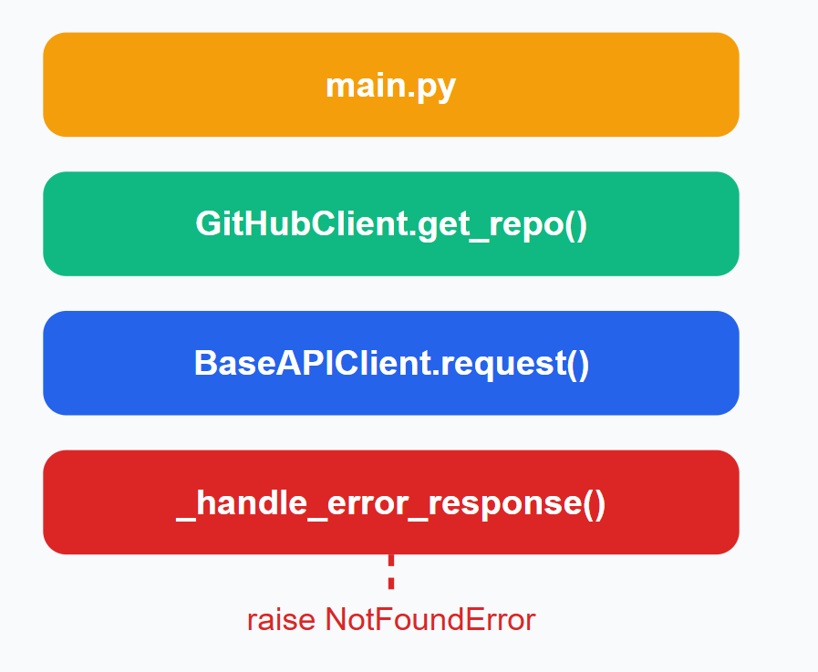
The exception climbs back up.
It leaves _handle_error_response.
It skips request().
It skips get().
It skips get_repo().
Until it finds:
Python
Run
except NotFoundError:
That's why GitHubClient never catches anything.
It simply gets interrupted.

Now your biggest question
Why is the final message coming from APIError.__str__() instead of the message passed in raise?
Excellent question.
Let's separate two different things.

When you raised it
You wrote:
Python
Run
raise NotFoundError(
"Resource not found: Not Found",
status_code=404
)
The message is stored inside the object.
APIError.__init__() does this:
Python
Run
super().__init__(message)
exceptions.py
So now the object contains:
|
Property
|
Value
|
| --- | --- |
|
message
|
"Resource not found: Not Found"
|
|
status_code
|
404
|
Nothing has been printed yet.

When you do print(e)
Python automatically calls:
Python
Run
str(e)
Since NotFoundError does not define __str__, it inherits from APIError.
APIError.__str__() returns:
Python
Run
return (
f"{self.__class__.__name__} | "
f"status={self.status_code} | "
f"message={super().__str__()}"
)
exceptions.py
So:
Python
Run
print(e)
becomes:
Python
Run
print(e.__str__())
which returns:
NotFoundError | status=404 | message=Resource not found: Not Found
Notice:
The raised message is still there.
It's just being formatted by __str__().

Think of it like a parcel
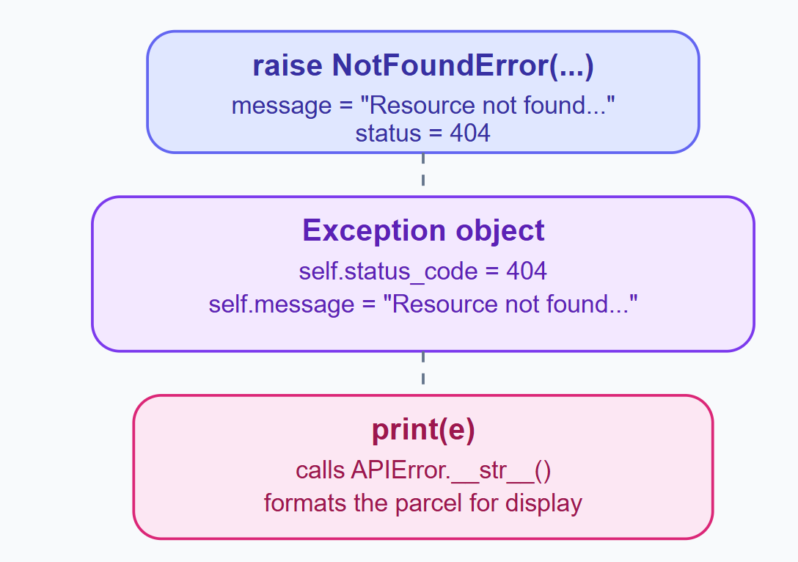
The raise puts data into the parcel.
The __str__ decides how the parcel is displayed.
Those are two completely different responsibilities.

Why doesn't _handle_error_response() print the raised message?
Because it never calls print().
It only does:
Python
Run
raise NotFoundError(...)
raise does not display anything.
It only throws the object.
The only output inside _handle_error_response() is this logger:
Python
Run
logging.error(
"API error | status=%s | error_message=%s",
status,
api_message
)
base_client.py
That's why your log shows:
ERROR | API error | status=404 | error_message=Not Found
This is a log message.
Completely separate from the exception.
Then later:
Python
Run
except NotFoundError as e:
print(e)
prints:
NotFoundError | status=404 | message=Resource not found: Not Found
Two different outputs from two different mechanisms.

Why except APIError catches everything
Look at your inheritance.
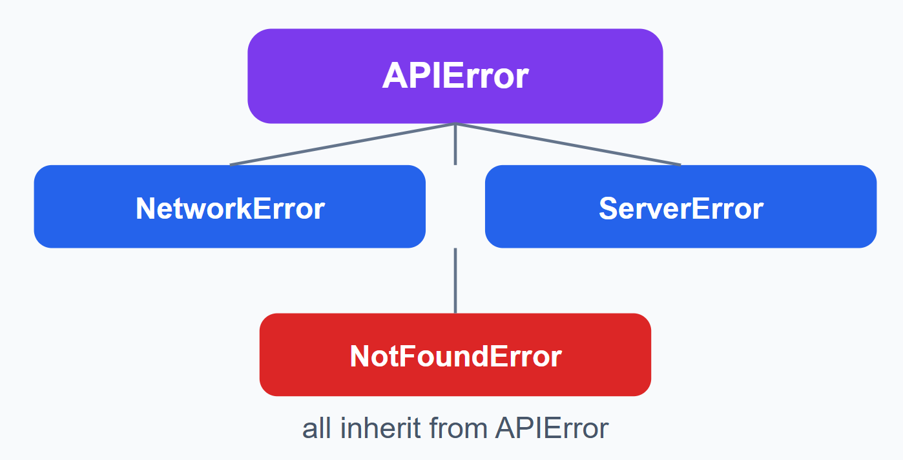
Python checks from top to bottom:
Python
Run
try:
...
except NotFoundError:
...
except APIError:
...
If the object is a NotFoundError, Python uses the first matching block.
If you reversed them:
Python
Run
except APIError:
...
except NotFoundError:
the second block would never execute, because NotFoundError is already an APIError.
This is standard polymorphism.

One bug in your code
I noticed this in main.py:
Python
Run
print(f"Caught NotFoundError : {e}")
Your output showed:
Caught NotFoundError : {e}
If it literally prints {e}, then the f string was probably missing when you ran it, or the file differs from the uploaded version. The uploaded file correctly uses an f-string.
main.py

The mental model you should remember
|
File
|
Responsibility
|
Does it know about GitHub?
|
| --- | --- | --- |
|
exceptions.py
|
Defines exception objects
|
❌ No
|
|
BaseAPIClient
|
Sends requests & raises exceptions
|
❌ No
|
|
GitHubClient
|
GitHub endpoints & headers
|
✅ Yes
|
|
main.py
|
Uses the client & catches exceptions
|
✅ Yes
|
And the execution order is always:
main.py
│
▼
GitHubClient.get_repo()
│
▼
BaseAPIClient.get()
│
▼
BaseAPIClient.request()
│
▼
GitHub API
│
▼
_handle_error_response()
│
▼
raise NotFoundError(...)
│
▼
except NotFoundError
│
▼
print(e) → APIError.__str__()
Once this control flow clicks, you'll understand almost every production Python integration—Salesforce, GitHub, Slack, Stripe, BRICKS, or any REST API follows the same pattern.

============step 5- Pydantic models===========

Yes — and there is an important distinction here:
Pydantic gives you runtime validation and Python type information, but Pydantic itself does not make VS Code/PyCharm underline every typo. The editor's type checker/language server does that.
Your Pydantic models are actually providing the information needed for this, but we need to make sure your editor's type checking is enabled and that your client methods have the correct return type annotations.
There is also one issue in your current github_client.py that is particularly relevant.

1. First, look at what you've currently done
In your github_client.py, you have:
def get_repo(self, owner: str, repo: str) -> dict:
response = self.get(f"/repos/{owner}/{repo}")
return RepoModel.model_validate(response.json())
This is the problem.
You are actually returning a RepoModel, but you have told the editor:
-> dict
So your editor thinks:
get_repo()
↓
returns dict
rather than:
get_repo()
↓
returns RepoModel
That's why your IDE may not be giving you the autocomplete/type checking you expect.

2. Change the return type
Change:
def get_repo(
self,
owner: str,
repo: str
) -> dict:
to:
def get_repo(
self,
owner: str,
repo: str
) -> RepoModel:
So:
def get_repo(self, owner: str, repo: str) -> RepoModel:
response = self.get(f"/repos/{owner}/{repo}")
return RepoModel.model_validate(response.json())
Now the type information flows correctly:
GitHubClient.get_repo()
│
│ -> RepoModel
▼
repo
│
├── repo.name
├── repo.owner
├── repo.private
├── repo.created_at
└── repo.summary()
And your editor can understand that.

3. You have the same problem with other methods
For example:
def get_authenticated_user(self) -> dict:
but you actually return:
GitHubUserModel.model_validate(...)
Change it to:
def get_authenticated_user(self) -> GitHubUserModel:
response = self.get("/user")
return GitHubUserModel.model_validate(response.json())
Similarly:
def get_user(self, username: str) -> GitHubUserModel:
response = self.get(f"/users/{username}")
return GitHubUserModel.model_validate(response.json())
And:
def get_my_repos(
self,
sort: str = "updated",
per_page: int = 5
) -> list[RepoModel]:

response = self.get(
"/user/repos",
params={
"sort": sort,
"per_page": per_page,
"visibility": "all"
}
)

return [
RepoModel.model_validate(r)
for r in response.json()
]
You already correctly annotated:
def get_repo_languages(...) -> RepoLanguagesModel:
So that's good.

4. Now the editor can actually understand your code
After changing the annotations, this:
repo = client.get_repo(
"PrathameshDevkar",
"mcp_a2a_multiagent"
)
has a known type:
repo: RepoModel
because:
client.get_repo()
│
▼
RepoModel
And your RepoModel declares:
class RepoModel(BaseModel):

id: int
name: str
full_name: str
html_url: str
private: bool
stargazers_count: int
...
owner: RepoOwnerModel
Therefore the type checker knows:
repo.name
repo.owner
repo.private
repo.created_at
repo.summary()
are valid.

5. Then try your typo
You currently have:
_ = repo.naem
Your comment says:
# Pydantic: repo.naem → AttributeError immediately
That statement is only about runtime behavior.
Pydantic doesn't inspect your source code and tell your editor:
"Hey, naem doesn't exist."
Instead, the chain is:
Pydantic model
│
│ defines fields
▼
Python type information
│
▼
Pyright / Pylance / mypy
│
▼
VS Code
│
▼
red underline / warning
So there are two separate safety mechanisms.

6. Runtime safety vs static checking
This distinction is extremely important.

Runtime
Suppose:
repo.naem
Python runs the program.
RepoModel doesn't have naem.
You get:
AttributeError
That's runtime checking.

Static checking
Your editor looks at:
repo.naem
and knows:
repo → RepoModel

RepoModel has:
name
full_name
html_url
...

RepoModel does NOT have:
naem
So a type checker such as Pylance/Pyright can warn you before running the program.
That's static checking.

7. Pydantic and Pylance have different jobs
This is probably the biggest conceptual point.

Pydantic
Deals with:
external/untrusted data
↓
Python object
For example GitHub sends:
{
"id": 123,
"name": "my-repo",
"private": false
}
Pydantic validates:
RepoModel.model_validate(response.json())
It checks things such as:
id → int
name → str
private → bool
owner → RepoOwnerModel
created_at → datetime

Pylance/Pyright
Deals with:
your Python source code
↓
potential programming mistakes
For example:
repo.naem

8. Your model is already giving the editor the information
Your model has:
class RepoModel(BaseModel):

id: int
name: str
full_name: str
html_url: str
private: bool
Those type annotations are exactly what tools such as Pylance/Pyright inspect.
So the model itself is fine.
The missing piece is that your client method currently tells the editor the wrong return type.

9. This is why -> dict is actually harmful here
Consider:
def get_repo(...) -> dict:
Then:
repo = client.get_repo(...)
The editor thinks:
repo: dict
So it may suggest dictionary operations such as:
repo.keys()
repo.items()
repo["name"]
rather than:
repo.name
repo.owner.login
repo.summary()
But at runtime you actually have:
RepoModel
So your type annotation and your actual object disagree.
That's called a type annotation mismatch.

10. Your methods should look like this
I'd change your github_client.py to:
def get_authenticated_user(self) -> GitHubUserModel:
response = self.get("/user")
return GitHubUserModel.model_validate(response.json())

def get_user(self, username: str) -> GitHubUserModel:
response = self.get(f"/users/{username}")
return GitHubUserModel.model_validate(response.json())

def get_my_repos(
self,
sort: str = "updated",
per_page: int = 5
) -> list[RepoModel]:

response = self.get(
"/user/repos",
params={
"sort": sort,
"per_page": per_page,
"visibility": "all"
}
)

return [
RepoModel.model_validate(repo)
for repo in response.json()
]

def get_repo(
self,
owner: str,
repo: str
) -> RepoModel:

response = self.get(
f"/repos/{owner}/{repo}"
)

return RepoModel.model_validate(response.json())

def get_repo_languages(
self,
owner: str,
repo: str
) -> RepoLanguagesModel:

response = self.get(
f"/repos/{owner}/{repo}/languages"
)

return RepoLanguagesModel.from_response(
response.json()
)
This creates a clean type chain:
GitHub API
│
│ JSON
▼
response.json()
│
▼
Pydantic
│
▼
GitHubUserModel / RepoModel / RepoLanguagesModel
│
▼
GitHubClient method
│
│ return type annotation
▼
IDE / Pylance knows the type

11. What should happen in VS Code now?
Suppose:
repo = client.get_repo(
"PrathameshDevkar",
"mcp_a2a_multiagent"
)
When you type:
repo.
you should get suggestions such as:
created_at
default_branch
description
forks_count
full_name
html_url
id
is_active()
language
name
open_issues_count
owner
private
pushed_at
size
stargazers_count
summary()
updated_at
watchers_count
Because repo is known to be:
RepoModel

12. And now this should be detected
repo.naem
You should get something similar to:
"RepoModel" has no attribute "naem"
before running the code, assuming Pylance/Pyright type checking is enabled.

13. If you still don't get the warning
Then the issue is probably your editor configuration, not Pydantic.
If you're using VS Code, check that the Python extension and Pylance are installed/enabled.
Then check:
Settings
↓
Python › Analysis: Type Checking Mode
Set it to:
basic
or, while learning:
strict
I'd recommend basic first.
You can also put this in your VS Code settings:
{
"python.analysis.typeCheckingMode": "basic"
}
Then restart/reload VS Code.

14. You can also use pyright
For a more explicit type-checking workflow, you can install:
pip install pyright
Then:
pyright
It can analyze your project without actually executing your program.
For example, it could identify:
error: Cannot access attribute "naem" for class "RepoModel"
This is different from:
python main.py
which actually executes your code.

15. One more issue I noticed in your model
You have:
hoempage: Optional[str] = None
in RepoModel.
I suspect this is a typo for:
homepage: Optional[str] = None
This is a different kind of typo.
If GitHub returns:
{
"homepage": "https://example.com"
}
and your Pydantic model says:
hoempage: Optional[str] = None
you have:
GitHub
│
│ homepage
▼
Pydantic
│
│ doesn't recognize homepage
▼
extra="ignore"
│
▼
homepage is silently discarded
because you configured:
model_config = {
"extra": "ignore"
}
So this is actually a useful learning point:

Your extra="ignore" has a tradeoff.
It protects you from GitHub adding new fields:
GitHub adds new field
↓
Pydantic doesn't know it
↓
ignore it
↓
application continues
But it can also hide a typo in your model field name.
For example:
hoempage
instead of:
homepage
means you won't necessarily notice that you're failing to model a field you intended to model.
For a learning project, I'd consider temporarily using:
model_config = {
"extra": "forbid"
}
Then unexpected fields cause a Pydantic validation error.
But we'll discuss ignore vs forbid vs allow properly when we get to designing the production model layer.

The key thing to fix right now
Your Pydantic models are fine. The main thing I'd change is your return type annotations.
Currently:
def get_repo(...) -> dict:
but actually:
return RepoModel.model_validate(...)
Change it to:
def get_repo(...) -> RepoModel:
Likewise:
get_authenticated_user → GitHubUserModel
get_user → GitHubUserModel
get_my_repos → list[RepoModel]
get_repo → RepoModel
get_repo_languages → RepoLanguagesModel
Then make sure Pylance/Pyright type checking is enabled.
The important mental model is:
PYDANTIC
│
validates external JSON
│
▼
RepoModel object
│
│
TYPE ANNOTATION
│
▼
Pylance / Pyright
│
▼
VS Code understands:
repo: RepoModel
│
┌────────┴────────┐
▼ ▼
autocomplete typo warning
So Pydantic and the editor are working together, but they are not the same thing. Pydantic protects you at runtime; the type checker protects you while writing the code.
==================Pagination===================

Step 6 — Pagination
Right now when you call get_my_repos(per_page=5) you only get 5 repos. You have 37. The other 32 are silently ignored. In production that's a serious bug — imagine fetching orders from Salesforce and only processing the first 30 out of 10,000.

Why APIs Paginate
Your request: GET /user/repos
Your repos : 37 total

Without pagination: With pagination:
────────────────── ────────────────
GitHub sends all 37 GitHub sends page 1 → 10 repos
in one response GitHub sends page 2 → 10 repos
GitHub sends page 3 → 10 repos
GitHub sends page 4 → 7 repos
Total: 37 repos ✓

Why paginate?
- Protects server from sending huge responses
- Protects client from receiving huge responses
- Allows you to stop early if you found what you need

Two Types of Pagination in the Wild
1. OFFSET-BASED (GitHub, most REST APIs)
─────────────────────────────────────
GET /repos?page=1&per_page=10 → items 1-10
GET /repos?page=2&per_page=10 → items 11-20
GET /repos?page=3&per_page=10 → items 21-30

Simple. But if someone adds a repo while you're paginating,
you might skip one or see a duplicate.

2. CURSOR-BASED (Twitter/X, Slack, GraphQL APIs)
───────────────────────────────────────────────
GET /messages?limit=10
→ returns items + "next_cursor": "eyJpZCI6MTIzfQ"

GET /messages?limit=10&cursor=eyJpZCI6MTIzfQ
→ returns next batch + new cursor

More reliable — cursor points to exact position in dataset.
You'll see this in Salesforce (nextRecordsUrl) and Databricks.
GitHub uses offset-based with the Link header to signal next/prev/last pages.

How GitHub Signals Pagination — The Link Header
This is the key thing to understand. GitHub tells you about other pages through a response header:
Link: <https://api.github.com/user/repos?page=2&per_page=10>; rel="next",
<https://api.github.com/user/repos?page=4&per_page=10>; rel="last"
rel value | Meaning
next | URL for the next page
prev | URL for the previous page
first | URL for the first page
last | URL for the last page
If there is no Link header, or no rel="next" in it — you're on the last page.

6.1 Updated folder structure
github-api-client/
├── src/
│ └── github/
│ ├── __init__.py
│ ├── base_client.py ← add pagination here
│ ├── exceptions.py
│ ├── github_client.py ← add paginated methods
│ └── models.py
├── main.py ← updated
├── .env
└── requirements.txt
Regular function — runs to completion, returns everything:
call → run everything → return all data → done
Generator function — runs in steps:
call → run until yield → pause → caller processes
→ caller asks for next → resume from yield → run until next yield → pause
→ ... until break or end of function

How this maps to other APIs
The pattern you just built is identical for every paginated API — only the details change:
GitHub (Link header)
────────────────────
GET /user/repos?page=1&per_page=10
Response header: Link: <...?page=2>; rel="next"
→ extract next URL from Link header

Salesforce (nextRecordsUrl in body)
────────────────────────────────────
GET /query?q=SELECT+Id+FROM+Account
Response body: {"records": [...], "nextRecordsUrl": "/query/01g..."}
→ extract next URL from response body

Databricks (next_page_token in body)
──────────────────────────────────────
GET /api/2.1/jobs/list?limit=20
Response body: {"jobs": [...], "next_page_token": "eyJqb2JJ..."}
→ send token as param in next request: ?page_token=eyJqb2JJ...
When you build those clients later, you'll override _parse_next_url() or write a similar helper — the paginate() generator loop itself barely changes.

Step 6 Summary
✅ Why APIs paginate and the two main strategies
✅ How GitHub's Link header signals next/prev pages
✅ Regex to parse the Link header
✅ Building a reusable paginate() generator in BaseAPIClient
✅ yield — how generators pause and resume
✅ Eager pagination (get_all_my_repos) vs lazy (get_repos_lazy)
✅ Early exit — stop fetching once you have what you need
✅ How this pattern maps to Salesforce and Databricks

Both excellent observations — question 2 shows you're reading the code very carefully. Let me address both precisely.

Question 1 — Yes, you're exactly right
# paginate() is the generator (producer)
def paginate(self, path, params, max_pages):
while True:
response = self.request(...)
yield data # ← gives ONE page, then pauses

# "for page in self.paginate()" is the caller (consumer)
for page_data in self.paginate(...): # asks paginate() for next page each iteration
for item in page_data: # processes all items in that page
yield RepoModel.model_validate(item)
Yes — each loop iteration of for page_data in self.paginate() gets exactly one page (a list of items). Perfect understanding.

Question 2 — This is the most important generator concept
You're right that it looks like it would yield only one repo. But here's the key thing you're missing:
get_repos_lazy is ALSO a generator — because it contains yield inside it.
def get_repos_lazy(self, ...):
for page_data in self.paginate(...): # loop over pages
for item in page_data: # loop over items in page
yield RepoModel.model_validate(item) # ← yield makes THIS a generator too
Any function that contains yield anywhere in it becomes a generator function. It does not run to completion when called — it pauses at each yield and resumes when the caller asks for the next item.
So let's trace exactly what happens:
client.get_repos_lazy(per_page=10) called
│
│ Does NOT execute the function body yet
│ Just returns a generator object
▼
repo_generator = <generator object>

─────────────────────────────────────────────────────────────
for repo in repo_generator: ← asks for item 1
│
│ Resumes get_repos_lazy body:
│ → for page_data in self.paginate(...) ← asks paginate for page 1
│ → paginate fetches page 1 (10 repos), yields it, pauses
│ → page_data = [repo1, repo2, ... repo10]
│ → for item in page_data: ← takes repo1
│ → yield RepoModel(repo1) ← PAUSES here, sends repo1 to caller
│
repo = RepoModel(repo1) ← caller gets repo1
print(repo.name)

─────────────────────────────────────────────────────────────
for repo in repo_generator: ← asks for item 2
│
│ Resumes get_repos_lazy body RIGHT WHERE IT PAUSED:
│ → still inside "for item in page_data" loop
│ → takes repo2 (still on page 1, no new API call needed)
│ → yield RepoModel(repo2) ← PAUSES again
│
repo = RepoModel(repo2) ← caller gets repo2

─────────────────────────────────────────────────────────────
... items 3-10 work exactly the same way, still on page 1 ...

─────────────────────────────────────────────────────────────
for repo in repo_generator: ← asks for item 11
│
│ Resumes get_repos_lazy body:
│ → "for item in page_data" loop is exhausted (page 1 done)
│ → outer "for page_data in self.paginate()" asks for next page
│ → paginate resumes, fetches page 2 (10 more repos), yields it
│ → page_data = [repo11, repo12, ... repo20]
│ → for item in page_data: takes repo11
│ → yield RepoModel(repo11) ← PAUSES
│
repo = RepoModel(repo11) ← caller gets repo11

─────────────────────────────────────────────────────────────
... continues until all 37 repos are yielded ...
So it yields all 37 repos, one at a time, fetching a new page only when the current page is exhausted.

About your second point — you're also right
You noticed that demo_lazy_pagination should use for repo in client.get_repos_lazy(per_page=10) — and if you look at the code I gave, that's exactly what it does:
def demo_lazy_pagination(client):
repo_generator = client.get_repos_lazy(per_page=10) # ← get the generator
for repo in repo_generator: # ← iterate it
print(repo.name)

# These two are 100% identical:
for repo in repo_generator: # via variable
for repo in client.get_repos_lazy(per_page=10): # direct — same thing
Storing it in repo_generator first vs iterating directly is just a style choice — both work identically.

The mental model for nested generators
paginate() → yields one PAGE (list of 10 dicts) per iteration
get_repos_lazy() → yields one REPO (RepoModel) per iteration
↑
unpacks each page into individual items
paginate yields: [r1,r2,...r10] [r11,...r20] [r21,...r30] [r31,...r37]
↓
get_repos_lazy yields: r1, r2, r3, r4 ... r10, r11, r12 ... r37
↓
demo_lazy_pagination: prints each one as it arrives
The nested generator is a very common Python pattern — you'll see it in FastAPI streaming responses, LangChain token streaming, and anywhere you want to process large datasets without loading everything into memory at once.
Clear now? Reply when ready and we move to Step 7 — Retry Logic with Exponential Backoff, where the client automatically recovers from rate limits and server errors without any manual intervention.
Output of the main file for the pagination -
26-09-27 14:41:20,555 | DEBUG | root | BaseAPIClient initialized | base_url= https://api.github.com | timeout= 30
2026-09-27 14:41:20,555 | INFO | github_api_client.src.github.github_client | Github client is ready | base_url = https://api.github.com

==================================================
RAW PAGINATION — SEE THE LINK HEADER
==================================================
2026-09-27 14:41:20,560 | DEBUG | urllib3.connectionpool | Starting new HTTPS connection (1): api.github.com:443
2026-09-27 14:41:21,105 | DEBUG | urllib3.connectionpool | https://api.github.com:443 "GET /user/repos?per_page=5&visibility=all HTTP/1.1" 200 None
Link Header:
<https://api.github.com/user/repos?per_page=5&visibility=all&page=2>; rel="next", <https://api.github.com/user/repos?per_page=5&visibility=all&page=8>; rel="last"

Items on this page : 5
Next page URL : https://api.github.com/user/repos?per_page=5&visibility=all&page=2
==================================================
ALL REPOS — MULTI-PAGE FETCH
==================================================
2026-09-27 14:41:21,109 | DEBUG | github_api_client.src.github.base_client | Making request | method= GET | url= https://api.github.com/user/repos | params= {'sort': 'updated', 'per_page': 10, 'visibility': 'all'}
2026-09-27 14:41:21,469 | DEBUG | urllib3.connectionpool | https://api.github.com:443 "GET /user/repos?sort=updated&per_page=10&visibility=all HTTP/1.1" 200 None
2026-09-27 14:41:21,471 | DEBUG | github_api_client.src.github.base_client | Response received | status= 200 | duration= 0.360146
2026-09-27 14:41:21,472 | DEBUG | github_api_client.src.github.base_client | Pages fetched= 1 | items= 10 | has_next=yes
2026-09-27 14:41:21,473 | DEBUG | github_api_client.src.github.github_client | Fetched page with 10 repos, total so far 10 repos
2026-09-27 14:41:21,473 | DEBUG | github_api_client.src.github.base_client | Fetching the next page | page=2 | URL=https://api.github.com/user/repos?sort=updated&per_page=10&visibility=all&page=2
2026-09-27 14:41:21,849 | DEBUG | urllib3.connectionpool | https://api.github.com:443 "GET /user/repos?sort=updated&per_page=10&visibility=all&page=2 HTTP/1.1" 200 None
2026-09-27 14:41:21,851 | DEBUG | github_api_client.src.github.base_client | Pages fetched= 2 | items= 10 | has_next=yes
2026-09-27 14:41:21,852 | DEBUG | github_api_client.src.github.github_client | Fetched page with 10 repos, total so far 20 repos
2026-09-27 14:41:21,852 | DEBUG | github_api_client.src.github.base_client | Fetching the next page | page=3 | URL=https://api.github.com/user/repos?sort=updated&per_page=10&visibility=all&page=3
2026-09-27 14:41:22,252 | DEBUG | urllib3.connectionpool | https://api.github.com:443 "GET /user/repos?sort=updated&per_page=10&visibility=all&page=3 HTTP/1.1" 200 None
2026-09-27 14:41:22,254 | DEBUG | github_api_client.src.github.base_client | Pages fetched= 3 | items= 10 | has_next=yes
2026-09-27 14:41:22,255 | DEBUG | github_api_client.src.github.github_client | Fetched page with 10 repos, total so far 30 repos
2026-09-27 14:41:22,255 | DEBUG | github_api_client.src.github.base_client | Fetching the next page | page=4 | URL=https://api.github.com/user/repos?sort=updated&per_page=10&visibility=all&page=4
2026-09-27 14:41:22,619 | DEBUG | urllib3.connectionpool | https://api.github.com:443 "GET /user/repos?sort=updated&per_page=10&visibility=all&page=4 HTTP/1.1" 200 None
2026-09-27 14:41:22,621 | DEBUG | github_api_client.src.github.base_client | Pages fetched= 4 | items= 7 | has_next=no
2026-09-27 14:41:22,622 | DEBUG | github_api_client.src.github.github_client | Fetched page with 7 repos, total so far 37 repos
2026-09-27 14:41:22,622 | DEBUG | github_api_client.src.github.base_client | No more pages after page 4

Total repos fetched: 37

All repos:
→ third_party_rest_api
→ mcp_a2a_multiagent
→ Graph_Rag_agent
→ rag_llmops
→ agentic_rag
→ Production_ready_RAG
→ ADK_1
→ mlops_project_1
→ mlops_capstone_project_movie_recommender_system
→ multiuser_article-pdf_rag_chatbot
→ prometheus_grapahana_sample_project
→ kubernetes_practice
→ docker_class
→ MLops_CI_project
→ DVC_pipeline
→ MLFLOW
→ ML_OPS_DVC
→ pulling_repo
→ C-dac-Final-Project-Deep-Fake-Detection
→ CDAC_project
→ code
→ pycode
→ code1
→ lab
→ jenkins-demo4
→ pipeline2
→ pipeline
→ jen-demo3
→ jenkins-demo2
→ jenkins-demo
→ AI_trends_assignment_3
→ AI_trends_assignment_2
→ AI_trends_assignment_1
→ git-demo2
→ git
→ Machine-learning-project
→ PrathameshDevkar

==================================================
LAZY PAGINATION — PROCESS AS THEY ARRIVE
==================================================
Processing repos one by one:
2026-09-27 14:41:22,626 | DEBUG | github_api_client.src.github.base_client | Making request | method= GET | url= https://api.github.com/user/repos | params= {'sort': 'updated', 'per_page': 10, 'visibility': 'all'}
2026-09-27 14:41:22,982 | DEBUG | urllib3.connectionpool | https://api.github.com:443 "GET /user/repos?sort=updated&per_page=10&visibility=all HTTP/1.1" 200 None
2026-09-27 14:41:22,984 | DEBUG | github_api_client.src.github.base_client | Response received | status= 200 | duration= 0.354004
2026-09-27 14:41:22,984 | DEBUG | github_api_client.src.github.base_client | Pages fetched= 1 | items= 10 | has_next=yes
[1] third_party_rest_api | active: True
[2] mcp_a2a_multiagent | active: True
[3] Graph_Rag_agent | active: True
[4] rag_llmops | active: True
[5] agentic_rag | active: True
[6] Production_ready_RAG | active: False
[7] ADK_1 | active: False
[8] mlops_project_1 | active: False
[9] mlops_capstone_project_movie_recommender_system | active: False
[10] multiuser_article-pdf_rag_chatbot | active: False
2026-09-27 14:41:22,986 | DEBUG | github_api_client.src.github.base_client | Fetching the next page | page=2 | URL=https://api.github.com/user/repos?sort=updated&per_page=10&visibility=all&page=2
2026-09-27 14:41:23,346 | DEBUG | urllib3.connectionpool | https://api.github.com:443 "GET /user/repos?sort=updated&per_page=10&visibility=all&page=2 HTTP/1.1" 200 None
2026-09-27 14:41:23,348 | DEBUG | github_api_client.src.github.base_client | Pages fetched= 2 | items= 10 | has_next=yes
[11] prometheus_grapahana_sample_project | active: False
[12] kubernetes_practice | active: False
[13] docker_class | active: False
[14] MLops_CI_project | active: False
[15] DVC_pipeline | active: False
[16] MLFLOW | active: False
[17] ML_OPS_DVC | active: False
[18] pulling_repo | active: False
[19] C-dac-Final-Project-Deep-Fake-Detection | active: False
[20] CDAC_project | active: False
2026-09-27 14:41:23,351 | DEBUG | github_api_client.src.github.base_client | Fetching the next page | page=3 | URL=https://api.github.com/user/repos?sort=updated&per_page=10&visibility=all&page=3
2026-09-27 14:41:23,711 | DEBUG | urllib3.connectionpool | https://api.github.com:443 "GET /user/repos?sort=updated&per_page=10&visibility=all&page=3 HTTP/1.1" 200 None
2026-09-27 14:41:23,713 | DEBUG | github_api_client.src.github.base_client | Pages fetched= 3 | items= 10 | has_next=yes
[21] code | active: False
[22] pycode | active: False
[23] code1 | active: False
[24] lab | active: False
[25] jenkins-demo4 | active: False
[26] pipeline2 | active: False
[27] pipeline | active: False
[28] jen-demo3 | active: False
[29] jenkins-demo2 | active: False
[30] jenkins-demo | active: False
2026-09-27 14:41:23,715 | DEBUG | github_api_client.src.github.base_client | Fetching the next page | page=4 | URL=https://api.github.com/user/repos?sort=updated&per_page=10&visibility=all&page=4
2026-09-27 14:41:24,117 | DEBUG | urllib3.connectionpool | https://api.github.com:443 "GET /user/repos?sort=updated&per_page=10&visibility=all&page=4 HTTP/1.1" 200 None
2026-09-27 14:41:24,119 | DEBUG | github_api_client.src.github.base_client | Pages fetched= 4 | items= 7 | has_next=no
[31] AI_trends_assignment_3 | active: False
[32] AI_trends_assignment_2 | active: False
[33] AI_trends_assignment_1 | active: False
[34] git-demo2 | active: False
[35] git | active: False
[36] Machine-learning-project | active: False
[37] PrathameshDevkar | active: False
2026-09-27 14:41:24,121 | DEBUG | github_api_client.src.github.base_client | No more pages after page 4

==================================================
EARLY EXIT — STOP WHEN FOUND
==================================================
Looking for repos containing 'rag'...
2026-09-27 14:41:24,122 | DEBUG | github_api_client.src.github.base_client | Making request | method= GET | url= https://api.github.com/user/repos | params= {'per_page': 10, 'visibility': 'all'}
2026-09-27 14:41:24,471 | DEBUG | urllib3.connectionpool | https://api.github.com:443 "GET /user/repos?per_page=10&visibility=all HTTP/1.1" 200 None
2026-09-27 14:41:24,472 | DEBUG | github_api_client.src.github.base_client | Response received | status= 200 | duration= 0.348224
2026-09-27 14:41:24,473 | DEBUG | github_api_client.src.github.base_client | Pages fetched= 1 | items= 10 | has_next=yes
2026-09-27 14:41:24,473 | DEBUG | github_api_client.src.github.base_client | Fetching the next page | page=2 | URL=https://api.github.com/user/repos?per_page=10&visibility=all&page=2
2026-09-27 14:41:24,838 | DEBUG | urllib3.connectionpool | https://api.github.com:443 "GET /user/repos?per_page=10&visibility=all&page=2 HTTP/1.1" 200 None
2026-09-27 14:41:24,840 | DEBUG | github_api_client.src.github.base_client | Pages fetched= 2 | items= 10 | has_next=yes
Found enough results after 2 page(s). Stopping.

Matching repos:
→ agentic_rag
→ Graph_Rag_agent

==================================================
SEARCH ACROSS ALL REPOS
==================================================
2026-09-27 14:41:24,842 | DEBUG | github_api_client.src.github.base_client | Making request | method= GET | url= https://api.github.com/user/repos | params= {'sort': 'updated', 'per_page': 10, 'visibility': 'all'}
2026-09-27 14:41:25,211 | DEBUG | urllib3.connectionpool | https://api.github.com:443 "GET /user/repos?sort=updated&per_page=10&visibility=all HTTP/1.1" 200 None
2026-09-27 14:41:25,213 | DEBUG | github_api_client.src.github.base_client | Response received | status= 200 | duration= 0.368087
2026-09-27 14:41:25,213 | DEBUG | github_api_client.src.github.base_client | Pages fetched= 1 | items= 10 | has_next=yes
2026-09-27 14:41:25,214 | DEBUG | github_api_client.src.github.base_client | Fetching the next page | page=2 | URL=https://api.github.com/user/repos?sort=updated&per_page=10&visibility=all&page=2
2026-09-27 14:41:25,602 | DEBUG | urllib3.connectionpool | https://api.github.com:443 "GET /user/repos?sort=updated&per_page=10&visibility=all&page=2 HTTP/1.1" 200 None
2026-09-27 14:41:25,605 | DEBUG | github_api_client.src.github.base_client | Pages fetched= 2 | items= 10 | has_next=yes
2026-09-27 14:41:25,605 | DEBUG | github_api_client.src.github.base_client | Fetching the next page | page=3 | URL=https://api.github.com/user/repos?sort=updated&per_page=10&visibility=all&page=3
2026-09-27 14:41:25,977 | DEBUG | urllib3.connectionpool | https://api.github.com:443 "GET /user/repos?sort=updated&per_page=10&visibility=all&page=3 HTTP/1.1" 200 None
2026-09-27 14:41:25,979 | DEBUG | github_api_client.src.github.base_client | Pages fetched= 3 | items= 10 | has_next=yes
2026-09-27 14:41:25,980 | DEBUG | github_api_client.src.github.base_client | Fetching the next page | page=4 | URL=https://api.github.com/user/repos?sort=updated&per_page=10&visibility=all&page=4
2026-09-27 14:41:26,346 | DEBUG | urllib3.connectionpool | https://api.github.com:443 "GET /user/repos?sort=updated&per_page=10&visibility=all&page=4 HTTP/1.1" 200 None
2026-09-27 14:41:26,347 | DEBUG | github_api_client.src.github.base_client | Pages fetched= 4 | items= 7 | has_next=no
2026-09-27 14:41:26,348 | DEBUG | github_api_client.src.github.base_client | No more pages after page 4
Repos matching 'rag': 5
→ Graph_Rag_agent | name: PrathameshDevkar/Graph_Rag_agent | stagazers count: 0 | forks count: 0 | status: active
→ rag_llmops | name: PrathameshDevkar/rag_llmops | stagazers count: 0 | forks count: 0 | status: active
→ agentic_rag | name: PrathameshDevkar/agentic_rag | stagazers count: 0 | forks count: 0 | status: active
→ Production_ready_RAG | name: PrathameshDevkar/Production_ready_RAG | stagazers count: 0 | forks count: 0 | status: inactive
→ multiuser_article-pdf_rag_chatbot | name: PrathameshDevkar/multiuser_article-pdf_rag_chatbot | stagazers count: 1 | forks count: 1 | status: inactive

=====Step 7 — Retry Logic with Exponential Backoff=====
Great questions — these are the exact things that trip people up. Let me answer each one precisely.

Question 1 — How does Retry-After actually get used?
The value travels from the response header → exception object → wait time calculation. Trace it step by step:
GitHub responds with:
HTTP 429
Header: Retry-After: 5
Body: {"message": "API rate limit exceeded"}

STEP 1: _handle_error_response() reads the header
─────────────────────────────────────────────────
elif status == 429:
retry_after = response.headers.get("Retry-After") # → "5" (a string)
retry_after = float(retry_after) # → 5.0 (a float)

raise RateLimitError(
message="Rate limit exceeded. Retry after 5.0s",
retry_after=5.0, # ← value STORED on the exception object
status_code=429,
)

STEP 2: request() catches that exception
────────────────────────────────────────
except Exception as e:
last_exception = e # e is the RateLimitError with retry_after=5.0

if not self._should_retry(e): # RateLimitError IS retryable → continue
raise

wait = self._get_wait_time(e, attempt) # ← passes the exception in

STEP 3: _get_wait_time() reads retry_after from the exception
──────────────────────────────────────────────────────────────
def _get_wait_time(self, exception, attempt):
if isinstance(exception, RateLimitError) and exception.retry_after:
# ↑
# reads the value stored in Step 1
wait = exception.retry_after + random.uniform(0, 1)
# 5.0 + ~0.3 = ~5.3s
return wait

STEP 4: back in request() — sleep that long
─────────────────────────────────────────────
time.sleep(5.3) # actually waits 5.3 seconds
# then the loop continues to next attempt
Key insight: the Retry-After value moves from the header → stored on the exception → read in _get_wait_time. The exception is the carrier between those two functions.

Question 2 — Why +1, and why start from 0?

Part A — Why +1
max_retries=3 means you want 3 retries after the first attempt — 4 total attempts.
range(self.max_retries) # range(3) = [0, 1, 2] → 3 total attempts (wrong)
range(self.max_retries + 1) # range(4) = [0, 1, 2, 3] → 4 total attempts (correct)
max_retries = 3

range(4) gives: 0 1 2 3
│ │ │ │
│ │ │ └── attempt 3 = 4th attempt = last retry
│ │ └─────── attempt 2 = 3rd attempt = retry 2
│ └──────────── attempt 1 = 2nd attempt = retry 1
└───────────────── attempt 0 = 1st attempt = initial try

is_last_attempt = (attempt == self.max_retries)
= (attempt == 3)
→ True only on attempt 3 ✓
The +1 only affects range() and is_last_attempt. Everywhere else in the code you use self.max_retries directly, not +1.

Part B — Why start from 0, not 1?
Because attempt is also passed into _calculate_backoff as the exponent. Starting from 0 gives you a gentle first wait:
# Starting from 0 (what we do) # Starting from 1 (what you suggested)
attempt 0 → 2^0 = 1 → ~1-2s wait attempt 1 → 2^1 = 2 → ~2-3s wait
attempt 1 → 2^1 = 2 → ~2-3s wait attempt 2 → 2^2 = 4 → ~4-5s wait
attempt 2 → 2^2 = 4 → ~4-5s wait attempt 3 → 2^3 = 8 → ~8-9s wait
attempt 3 → 2^3 = 8 → ~8-9s wait
Starting from 0 means your first retry waits only ~1s. Starting from 1 skips that gentle first wait and jumps straight to ~2s. For a brief server blip, 1s is usually enough. Starting from 1 would be unnecessarily slow.
And if you started from 1 with range(1, self.max_retries + 1):
range(1, 4) = [1, 2, 3] # only 3 iterations
# attempt 3 would never equal self.max_retries (3)
# because is_last_attempt = (attempt == 3) on the last item
# actually this would work but you'd only get 3 attempts total
# instead of 4 (initial + 3 retries)
Bottom line — starting from 0 is the right choice both for the backoff math and the attempt count.

Question 3 — How does base_delay increase each retry?
The formula is:
delay = min(base_delay * (2 ** attempt) + jitter, max_delay)
2 ** attempt is the key — it doubles every time because 2 raised to a higher power grows exponentially:
2^0 = 1
2^1 = 2
2^2 = 4
2^3 = 8
2^4 = 16
2^5 = 32
With base_delay=1.0 and max_delay=60:
attempt 0: 1.0 * (2^0) + jitter = 1.0 * 1 + ~0.5 = ~1.5s
attempt 1: 1.0 * (2^1) + jitter = 1.0 * 2 + ~0.3 = ~2.3s
attempt 2: 1.0 * (2^2) + jitter = 1.0 * 4 + ~0.7 = ~4.7s
attempt 3: 1.0 * (2^3) + jitter = 1.0 * 8 + ~0.2 = ~8.2s
attempt 4: 1.0 * (2^4) + jitter = 1.0 * 16 + ~0.9 = ~16.9s
attempt 5: 1.0 * (2^5) + jitter = 1.0 * 32 + ~0.4 = ~32.4s
attempt 6: 1.0 * (2^6) + jitter = 1.0 * 64 + ~0.6 → min(64.6, 60) = 60s ← capped
min(..., max_delay) caps the wait at 60s so you never wait longer than 1 minute no matter how many retries.
base_delay itself never changes — it's fixed at 1.0. What changes is 2 ** attempt. So base_delay is just the multiplier that scales the whole curve up or down. Set base_delay=2.0 and all waits double.

Question 4 — Full retry logic walkthrough with real examples
Let me trace through the complete request() loop for 3 different scenarios with max_retries=3:

Scenario A — Server error twice, then succeeds
client.get_authenticated_user() called
↓
request("GET", "/user") called

━━━ LOOP ITERATION: attempt=0 ━━━━━━━━━━━━━━━━━━━━━━━━━━━
make HTTP call → GitHub returns 500
_handle_error_response(response) called
→ raises ServerError("Server error 500")
except Exception as e:
last_exception = ServerError(...)
_should_retry(ServerError) → True (ServerError is in RETRYABLE_EXCEPTIONS)
is_last_attempt = (0 == 3) → False
_get_wait_time(ServerError, attempt=0)
→ not RateLimitError → use backoff
→ 1.0 * (2^0) + jitter = ~1.5s
logger: "Retryable error | attempt=1/4 | waiting=1.5s"
time.sleep(1.5)

━━━ LOOP ITERATION: attempt=1 ━━━━━━━━━━━━━━━━━━━━━━━━━━━
make HTTP call → GitHub returns 500 again
_handle_error_response(response) called
→ raises ServerError("Server error 500")
except Exception as e:
last_exception = ServerError(...)
_should_retry(ServerError) → True
is_last_attempt = (1 == 3) → False
_get_wait_time(ServerError, attempt=1)
→ 1.0 * (2^1) + jitter = ~2.3s
logger: "Retryable error | attempt=2/4 | waiting=2.3s"
time.sleep(2.3)

━━━ LOOP ITERATION: attempt=2 ━━━━━━━━━━━━━━━━━━━━━━━━━━━
make HTTP call → GitHub returns 200 ✓
response.ok = True → skip _handle_error_response
attempt > 0 → logger: "Request succeeded after 2 retries"
return response ← exits the loop, caller gets the response

Scenario B — Rate limited, then succeeds
━━━ LOOP ITERATION: attempt=0 ━━━━━━━━━━━━━━━━━━━━━━━━━━━
make HTTP call → GitHub returns 429
response headers: {"Retry-After": "5"}
_handle_error_response(response) called
retry_after = float("5") = 5.0
→ raises RateLimitError("Rate limit exceeded", retry_after=5.0)
except Exception as e:
last_exception = RateLimitError(retry_after=5.0)
_should_retry(RateLimitError) → True
is_last_attempt = (0 == 3) → False
_get_wait_time(RateLimitError, attempt=0)
→ isinstance(e, RateLimitError) AND e.retry_after=5.0 → True
→ return 5.0 + random(0,1) = ~5.3s ← uses Retry-After, NOT backoff formula
logger: "Rate limit hit — using Retry-After header | wait=5.3s"
time.sleep(5.3)

━━━ LOOP ITERATION: attempt=1 ━━━━━━━━━━━━━━━━━━━━━━━━━━━
make HTTP call → GitHub returns 200 ✓
return response ✓

Scenario C — All attempts fail → give up
━━━ attempts 0, 1, 2 all fail with 500 (same as Scenario A) ━━━

━━━ LOOP ITERATION: attempt=3 ━━━━━━━━━━━━━━━━━━━━━━━━━━━
make HTTP call → GitHub returns 500 again
→ raises ServerError(...)
except Exception as e:
last_exception = ServerError(...)
_should_retry(ServerError) → True
is_last_attempt = (3 == 3) → True ← this triggers the give-up path
logger: "All 4 attempts failed | url=..."
raise MaxRetriesExceededError(
message="Request failed after 4 attempts",
attempts=4,
last_exception=ServerError(...) ← preserves what actually went wrong
)

Caller receives MaxRetriesExceededError
Can inspect .last_exception to see it was a ServerError

Scenario D — 404, fails immediately with no retry
━━━ LOOP ITERATION: attempt=0 ━━━━━━━━━━━━━━━━━━━━━━━━━━━
make HTTP call → GitHub returns 404
_handle_error_response(response) called
→ raises NotFoundError("Resource not found")
except Exception as e:
last_exception = NotFoundError(...)
_should_retry(NotFoundError) → False ← NotFoundError NOT in RETRYABLE_EXCEPTIONS
logger: "Non-retryable error | type=NotFoundError"
raise ← re-raises immediately, exits the loop entirely

Caller receives NotFoundError
loop never reached attempt=1

Now the test functions in main.py explained
The tests use unittest.mock to fake GitHub's server so you can test retry behaviour without needing a real failing server.

What MagicMock() does
fake_500 = MagicMock()
MagicMock creates a fake object that pretends to be a real requests.Response. You set its attributes manually:
fake_500.ok = False # makes response.ok return False
fake_500.status_code = 500 # makes response.status_code return 500
fake_500.json.return_value = {"message": "Internal Server Error"}
# ↑
# .json() is a method — .return_value sets what it returns when called
fake_500.elapsed.total_seconds.return_value = 0.1
fake_500.headers = {} # no Retry-After header

What patch.object does
with patch.object(client.session, "request", side_effect=[fake_500, fake_500, fake_200]):
This temporarily replaces client.session.request (the real HTTP call) with a fake function. side_effect=[fake_500, fake_500, fake_200] means:
1st call to session.request → returns fake_500
2nd call to session.request → returns fake_500
3rd call to session.request → returns fake_200
So your retry loop runs 3 times, getting two 500s then a 200 — exactly simulating a flaky server recovering.

What patch("time.sleep") does
with patch("time.sleep") as mock_sleep:
user = client.get_authenticated_user()
print(f"Slept {mock_sleep.call_count} times")
print(f"Wait 1: {mock_sleep.call_args_list[0].args[0]:.2f}s")
This replaces time.sleep with a fake that records calls but doesn't actually wait. Without this, your test would actually wait 1.5s + 2.3s before completing. With it, the test runs instantly but you can still inspect how many times sleep was called and what values were passed.

What nonlocal does
call_count = 0

def counting_request(*args, **kwargs):
nonlocal call_count # ← tells Python: use the call_count from the outer function
call_count += 1 # without nonlocal this would create a NEW local variable
return fake_404 # and the outer call_count would never change
Without nonlocal, call_count += 1 would fail because Python would try to create a new local variable call_count inside counting_request instead of modifying the outer one.

Full picture in one diagram
request() loop
│
for attempt in [0, 1, 2, 3]: ← 4 iterations (max_retries=3)
│
├── make HTTP call
│ ├── SUCCESS (2xx) → return immediately ✓
│ └── FAILURE → exception raised
│ │
│ ├── _should_retry(e)?
│ │ ├── False (404, 401, 403, 400)
│ │ │ └── raise immediately — no retry
│ │ │
│ │ └── True (429, 5xx, NetworkError)
│ │ │
│ │ ├── is_last_attempt?
│ │ │ └── True → raise MaxRetriesExceededError
│ │ │
│ │ └── False → _get_wait_time(e, attempt)
│ │ ├── RateLimitError → use Retry-After header
│ │ └── others → 1.0 * 2^attempt + jitter
│ │ └── time.sleep(wait)
│ │ └── loop continues to next attempt
Does everything click now? Reply and we move to Step 8 — Async with httpx, where instead of making API calls one at a time, you'll make them simultaneously — which matters a lot in your RAG pipelines when you're hitting multiple APIs in parallel.

=======output-

2026-10-02 17:30:57,806 | DEBUG | root | BaseAPIClient initialized | base_url= https://api.github.com | timeout= 30 | max_retries= 3
2026-10-02 17:30:57,807 | INFO | github_api_client.src.github.github_client | Github client is ready | base_url = https://api.github.com
==================================================
NORMAL REQUEST (no retry needed)
==================================================
2026-10-02 17:30:57,807 | DEBUG | github_api_client.src.github.base_client | Making request | method=GET | url=https://api.github.com/user | params=None | attempt=1/4
2026-10-02 17:30:57,811 | DEBUG | urllib3.connectionpool | Starting new HTTPS connection (1): api.github.com:443
2026-10-02 17:30:58,344 | DEBUG | urllib3.connectionpool | https://api.github.com:443 "GET /user HTTP/1.1" 200 None
2026-10-02 17:30:58,345 | DEBUG | github_api_client.src.github.base_client | Response received | status= 200 | duration= 0.534s
Success: PrathameshDevkar

==================================================
BACKOFF CALCULATION PREVIEW
==================================================
Exponential backoff wait times (base_delay=1.0, max_delay=60):
(jitter varies — shown as a range)
Attempt 1: 1.13s – 1.91s
Attempt 2: 2.14s – 2.81s
Attempt 3: 4.52s – 4.91s
Attempt 4: 8.32s – 8.80s
Attempt 5: 16.20s – 16.82s
Attempt 6: 32.03s – 32.86s

==================================================
RETRY ON 500 SERVER ERROR
==================================================
2026-10-02 17:30:58,351 | DEBUG | github_api_client.src.github.base_client | Making request | method=GET | url=https://api.github.com/user | params=None | attempt=1/4
2026-10-02 17:30:58,352 | DEBUG | github_api_client.src.github.base_client | Response received | status= 500 | duration= 0.100s
2026-10-02 17:30:58,352 | ERROR | root | API error | status= 500 | error_message= Internal Server Error
2026-10-02 17:30:58,352 | WARNING | github_api_client.src.github.base_client | Retryable error | type= ServerError | status=500 | message=Server error {status}: {api_message} | attempt= 1/4 | waiting= 1.25s | url= https://api.github.com/user
2026-10-02 17:30:58,353 | DEBUG | github_api_client.src.github.base_client | Making request | method=GET | url=https://api.github.com/user | params=None | attempt=2/4
2026-10-02 17:30:58,353 | DEBUG | github_api_client.src.github.base_client | Response received | status= 500 | duration= 0.100s
2026-10-02 17:30:58,354 | ERROR | root | API error | status= 500 | error_message= Internal Server Error
2026-10-02 17:30:58,354 | WARNING | github_api_client.src.github.base_client | Retryable error | type= ServerError | status=500 | message=Server error {status}: {api_message} | attempt= 2/4 | waiting= 2.89s | url= https://api.github.com/user
2026-10-02 17:30:58,354 | DEBUG | github_api_client.src.github.base_client | Making request | method=GET | url=https://api.github.com/user | params=None | attempt=3/4
2026-10-02 17:30:58,355 | DEBUG | github_api_client.src.github.base_client | Response received | status= 200 | duration= 0.300s
2026-10-02 17:30:58,355 | INFO | github_api_client.src.github.base_client | Request succeeded after 2 retries | url= https://api.github.com/user
Eventually succeeded: PrathameshDevkar
Slept 2 time(s) during retries
Wait 1: 1.25s
Wait 2: 2.89s

==================================================
RETRY ON 429 RATE LIMIT
==================================================
2026-10-02 17:30:58,371 | DEBUG | github_api_client.src.github.base_client | Making request | method=GET | url=https://api.github.com/user | params=None | attempt=1/4
2026-10-02 17:30:58,372 | DEBUG | github_api_client.src.github.base_client | Response received | status= 429 | duration= 0.100s
2026-10-02 17:30:58,372 | ERROR | root | API error | status= 429 | error_message= API rate limit exceeded
2026-10-02 17:30:58,372 | INFO | github_api_client.src.github.base_client | Rate limit hit - Using Retry-After header | wait= 5.56s
2026-10-02 17:30:58,373 | WARNING | github_api_client.src.github.base_client | Retryable error | type= RateLimitError | status=429 | message=Rate limit exceeded. retry after 5.0 | retry _after=5.0 | | attempt= 1/4 | waiting= 5.56s | url= https://api.github.com/user
2026-10-02 17:30:58,374 | DEBUG | github_api_client.src.github.base_client | Making request | method=GET | url=https://api.github.com/user | params=None | attempt=2/4
2026-10-02 17:30:58,375 | DEBUG | github_api_client.src.github.base_client | Response received | status= 200 | duration= 0.200s
2026-10-02 17:30:58,375 | INFO | github_api_client.src.github.base_client | Request succeeded after 1 retries | url= https://api.github.com/user
Got rate limited → waited 5.56s (Retry-After=5 + jitter)
Then succeeded → PrathameshDevkar

==================================================
MAX RETRIES EXCEEDED
==================================================
2026-10-02 17:30:58,381 | DEBUG | github_api_client.src.github.base_client | Making request | method=GET | url=https://api.github.com/user | params=None | attempt=1/4
2026-10-02 17:30:58,381 | DEBUG | github_api_client.src.github.base_client | Response received | status= 500 | duration= 0.100s
2026-10-02 17:30:58,382 | ERROR | root | API error | status= 500 | error_message= Internal Server Error
2026-10-02 17:30:58,382 | WARNING | github_api_client.src.github.base_client | Retryable error | type= ServerError | status=500 | message=Server error {status}: {api_message} | attempt= 1/4 | waiting= 1.94s | url= https://api.github.com/user
2026-10-02 17:30:58,382 | DEBUG | github_api_client.src.github.base_client | Making request | method=GET | url=https://api.github.com/user | params=None | attempt=2/4
2026-10-02 17:30:58,384 | DEBUG | github_api_client.src.github.base_client | Response received | status= 500 | duration= 0.100s
2026-10-02 17:30:58,384 | ERROR | root | API error | status= 500 | error_message= Internal Server Error
2026-10-02 17:30:58,384 | WARNING | github_api_client.src.github.base_client | Retryable error | type= ServerError | status=500 | message=Server error {status}: {api_message} | attempt= 2/4 | waiting= 2.62s | url= https://api.github.com/user
2026-10-02 17:30:58,385 | DEBUG | github_api_client.src.github.base_client | Making request | method=GET | url=https://api.github.com/user | params=None | attempt=3/4
2026-10-02 17:30:58,385 | DEBUG | github_api_client.src.github.base_client | Response received | status= 500 | duration= 0.100s
2026-10-02 17:30:58,385 | ERROR | root | API error | status= 500 | error_message= Internal Server Error
2026-10-02 17:30:58,385 | WARNING | github_api_client.src.github.base_client | Retryable error | type= ServerError | status=500 | message=Server error {status}: {api_message} | attempt= 3/4 | waiting= 4.45s | url= https://api.github.com/user
2026-10-02 17:30:58,387 | DEBUG | github_api_client.src.github.base_client | Making request | method=GET | url=https://api.github.com/user | params=None | attempt=4/4
2026-10-02 17:30:58,387 | DEBUG | github_api_client.src.github.base_client | Response received | status= 500 | duration= 0.100s
2026-10-02 17:30:58,388 | ERROR | root | API error | status= 500 | error_message= Internal Server Error
2026-10-02 17:30:58,388 | ERROR | github_api_client.src.github.base_client | All 4 attempts failed | url= https://api.github.com/user | last_error= ServerError | status=500 | message=Server error {status}: {api_message}
Gave up after 4 attempts
Last error type : ServerError
Last error : ServerError | status=500 | message=Server error {status}: {api_message}

==================================================
NO RETRY ON 404 (fail fast)
==================================================
2026-10-02 17:30:58,391 | DEBUG | github_api_client.src.github.base_client | Making request | method=GET | url=https://api.github.com/repos/nobody/nothing | params=None | attempt=1/4
2026-10-02 17:30:58,392 | DEBUG | github_api_client.src.github.base_client | Response received | status= 404 | duration= 0.100s
2026-10-02 17:30:58,392 | ERROR | root | API error | status= 404 | error_message= Not Found
2026-10-02 17:30:58,393 | ERROR | github_api_client.src.github.base_client | Non-retryable error | type= NotFoundError | url= https://api.github.com/repos/nobody/nothing
Failed immediately with NotFoundError: NotFoundError | status=404 | message=Resource not found: Not Found
API was called exactly 1 time(s) — no retries wasted

