AWS INSTANCES

launch instances

write name for instances

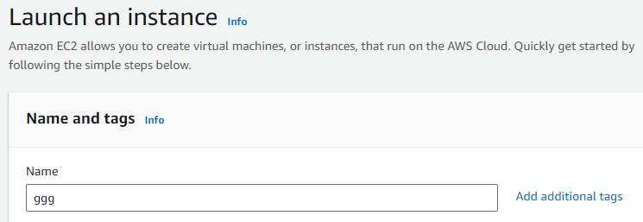

quick start

select UBUNTU

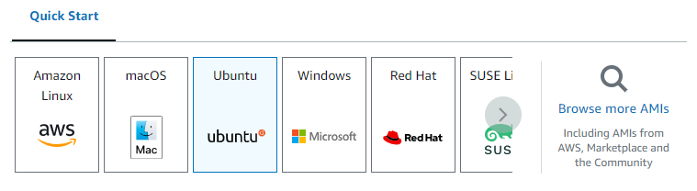

**Key pair (login)**

create new key pair

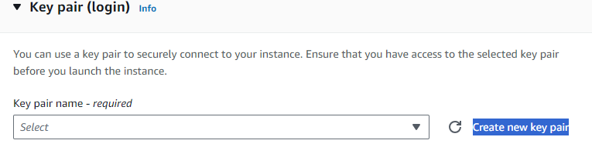

key pair name

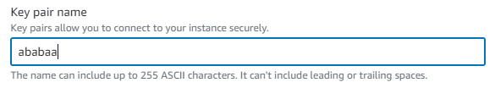

select .ppk for

private key file format

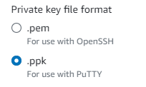

click on create key pair

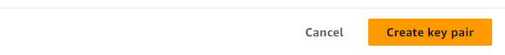

launch instance

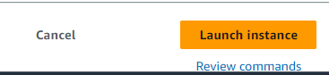

now check box for new instance

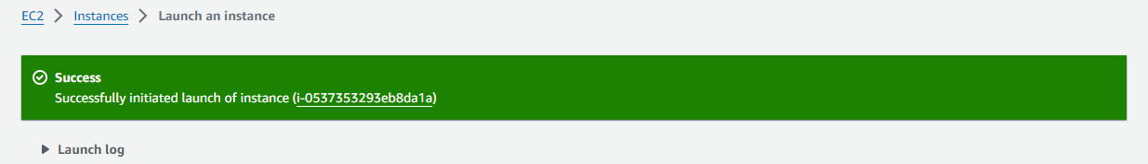

click security

click security groups blue link

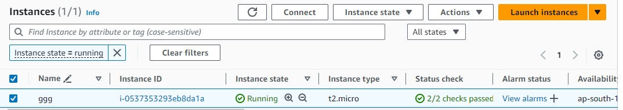

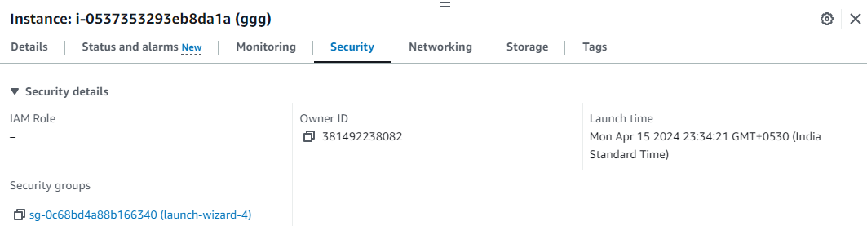

inbound rules

click on edit inbound rules

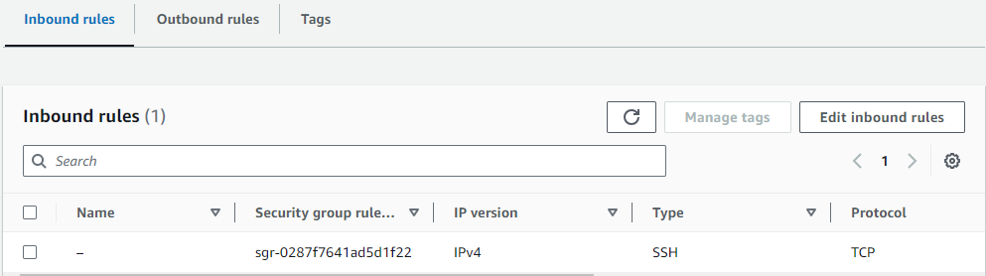

inbound rules

type - all traffic

source- anywhere ipv4

click save rules

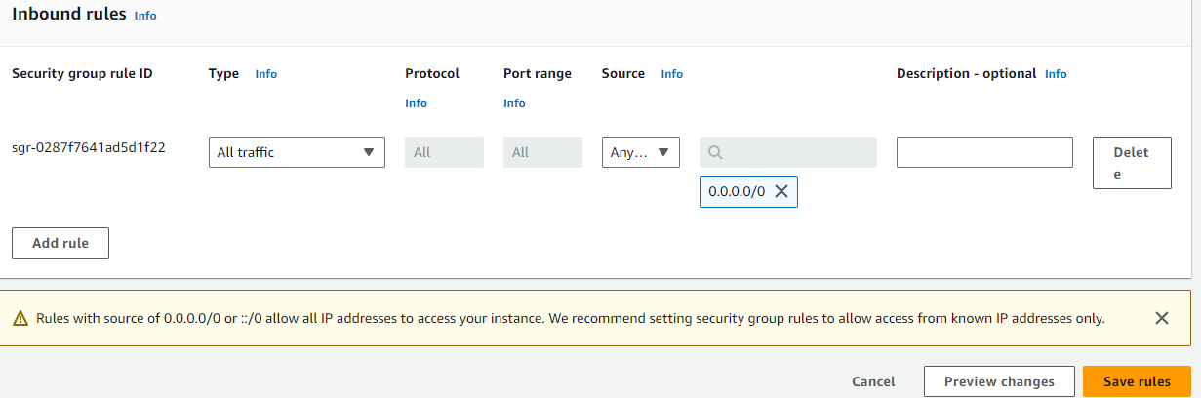

click instance

click connect

click connect

tab will open with linux shell

perform linux commands to open website from github

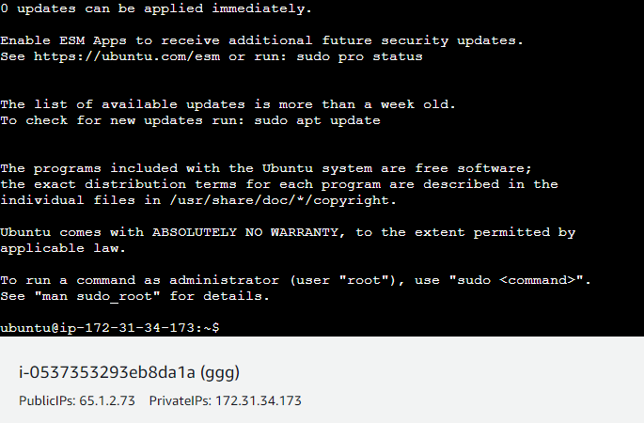

$ git clone <github link>

$ sudo apt update

$ sudo apt install nodejs

$ sudo apt install npm

$ cd <file name>

$ npm install

$ node server.js

copy port no and ips in newtab

website will be open