Write a program to implement wordcount using Pig. Share the screenshots of the commands used with its associated output.

Dataset:

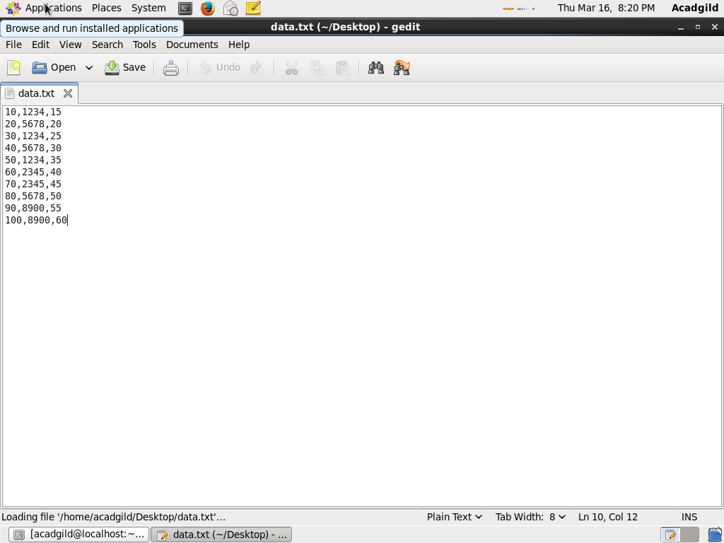

Commands:

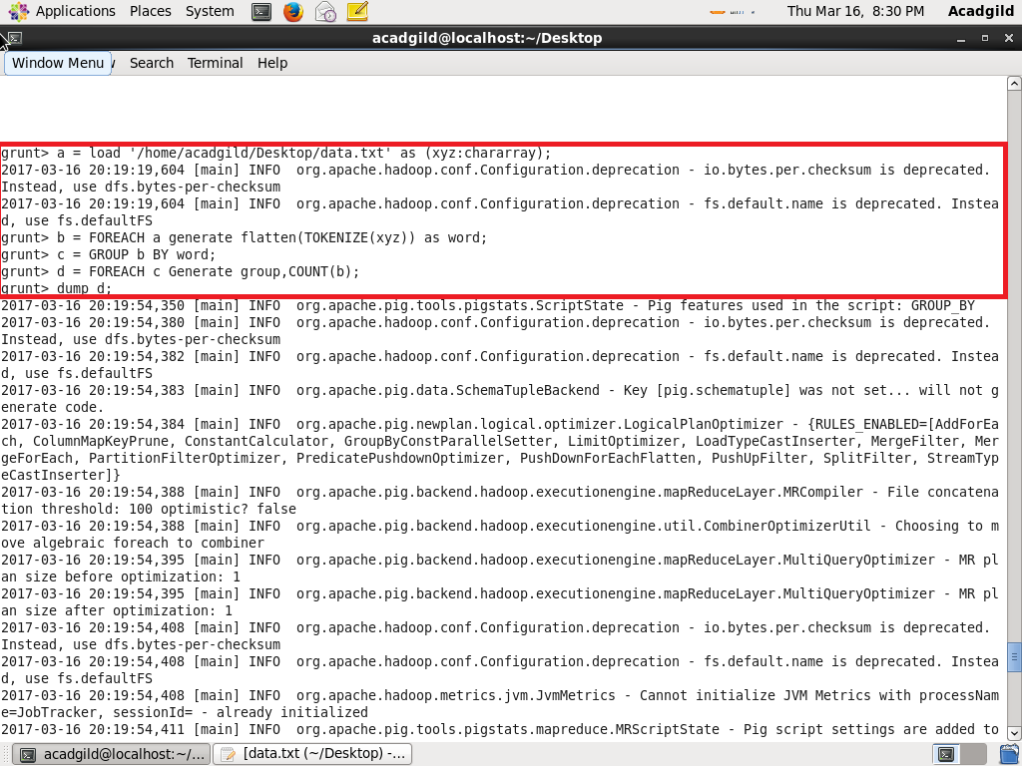

Output:

