Travel_Data

Travel Sector Dataset Description

Column 1: City pair (Combination of from and to): String

Column 2: From location: String

Column 3: To Location: String

Column 4: Product type: Integer (1=Air, 2=Car, 3 =Air+Car, 4 =Hotel, 5=Air+Hotel, 6=Hotel +Car, 7 =Air+Hotel+Car)

Column 5: Adults traveling: Integer

Column 6: Seniors traveling: Integer

Column 7: Children traveling: Integer

Column 8: Youth traveling: Integer

Column 9: Infant traveling: Integer

Column 10: Date of travel: String

Column 11: Time of travel: String

Column 12: Date of Return: String

Column 13: Time of Return: String

Column 14: Price of booking: Float

Column 15: Hotel name: String

1.Write a pig script to find the top 20 destination people travel the most: Based on the given data

Commands:

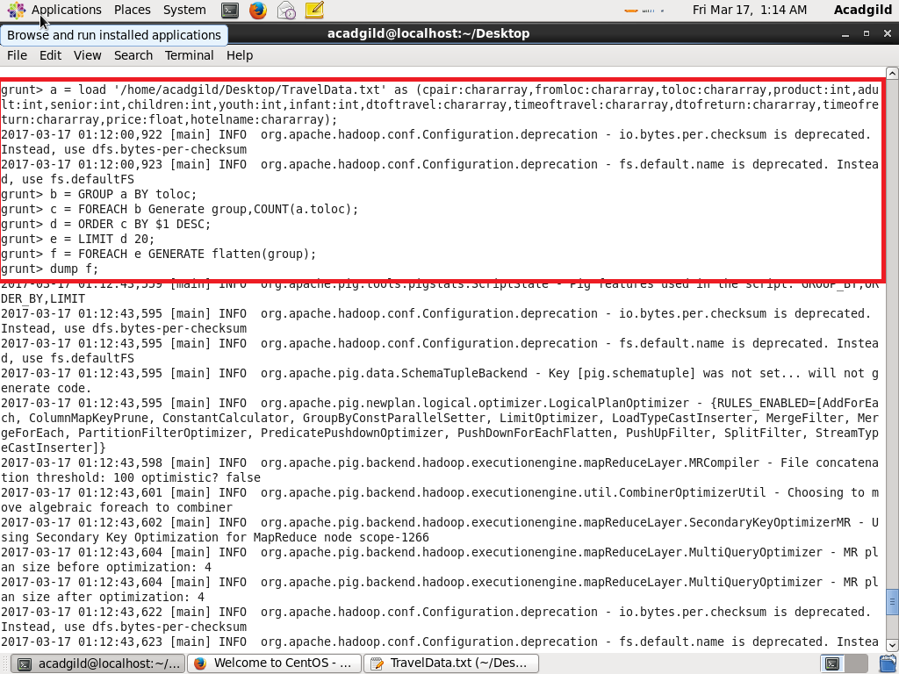

Output:

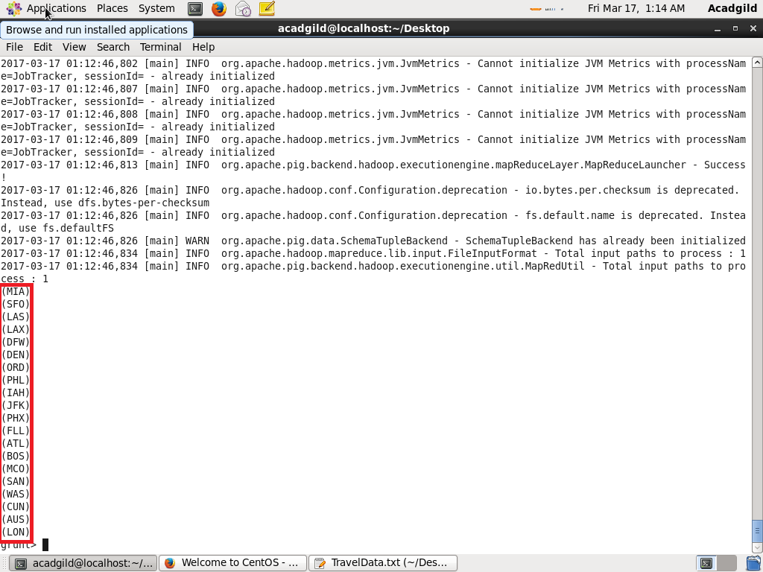

2. Write a pig script to find the top 20 locations from where people travel the most

Commands:

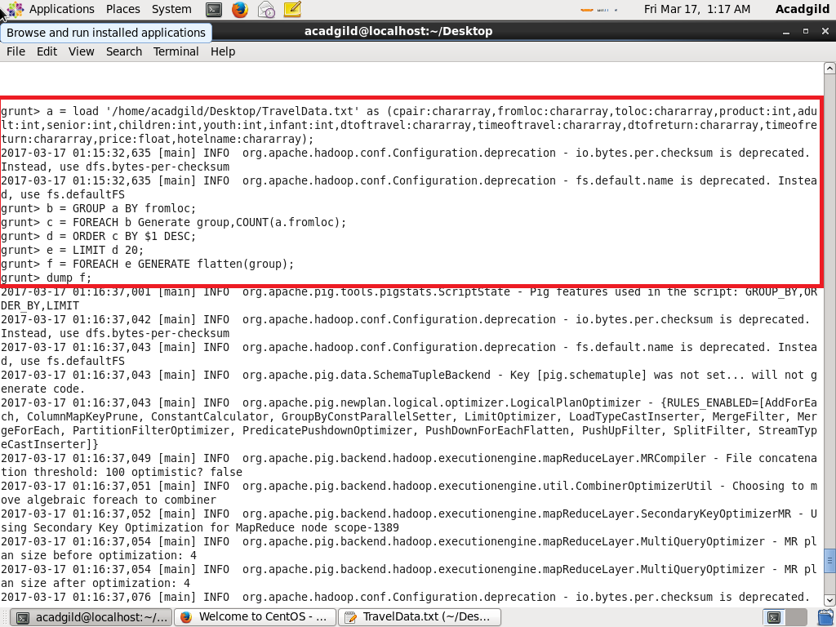

Output:

