Temperature_Data

Data Definition:

Column 1: Weather Station

Column 2: Date(year/Month/Day)

Column 3: Observation Type

Column 4: Temperature

1. Write a pig script to find the minimum temperature observed in a given weather station in a particular year.

Commands:

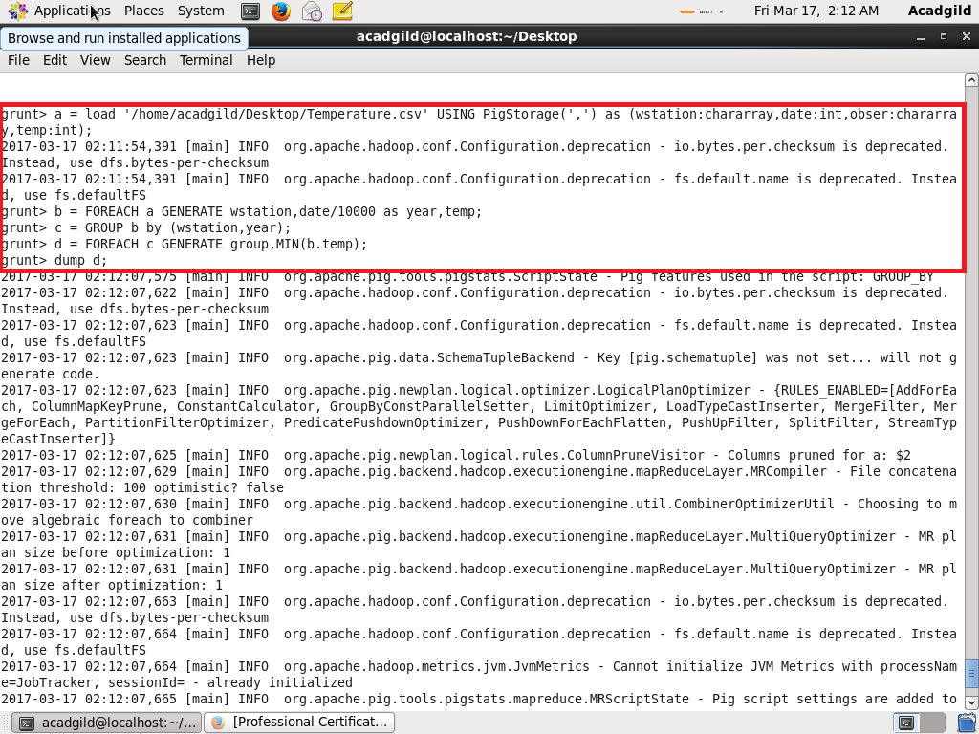

Output:

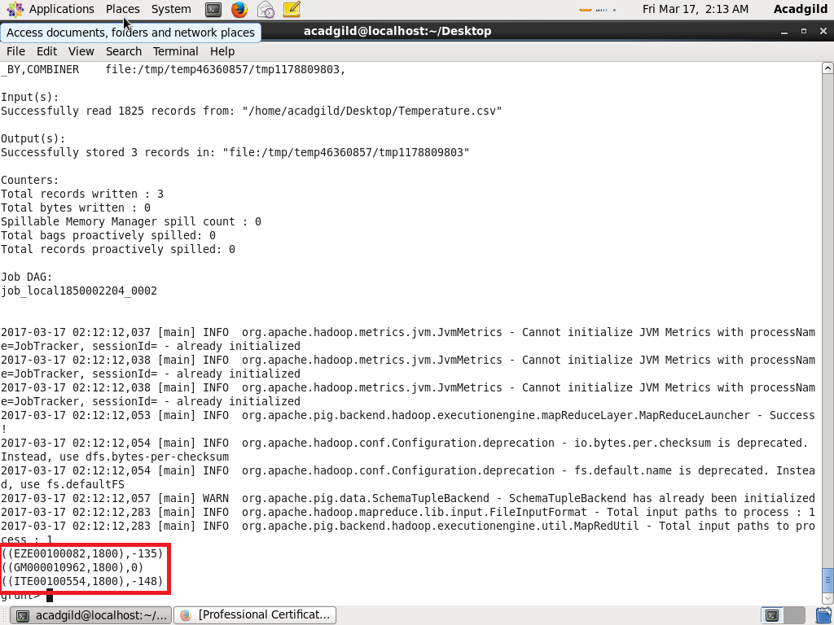

1. Write a pig script to find the maximum temperature observed in a given weather station in a particular year.

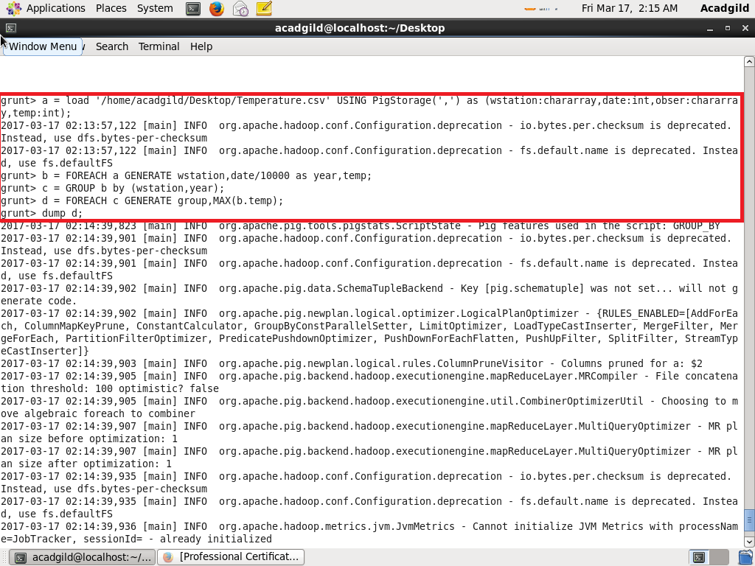

Output:

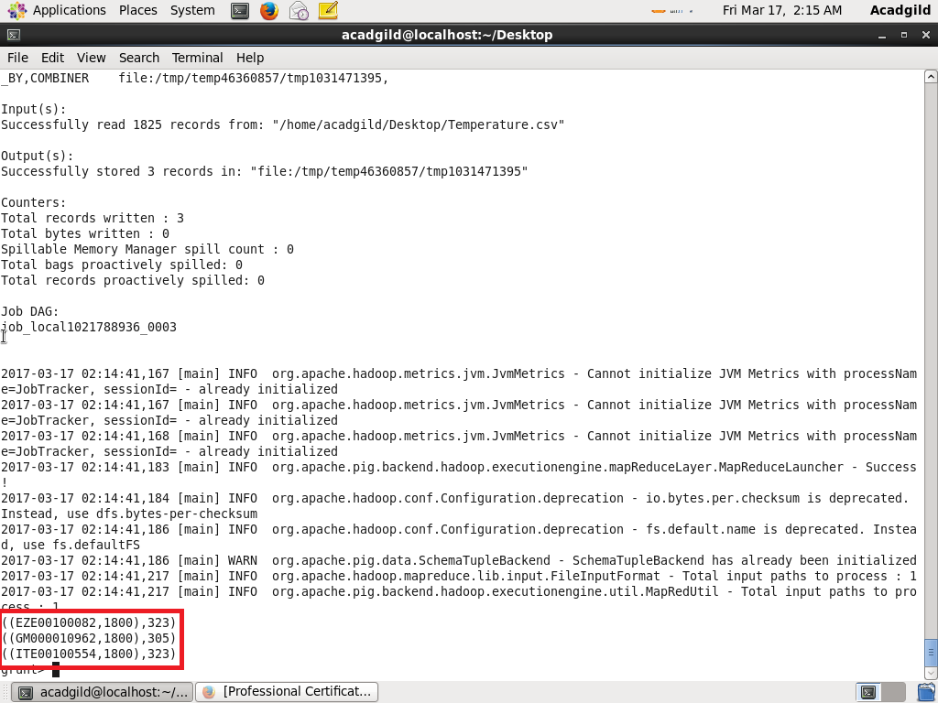

1. Write a pig script to find the number of readings given by each weather station according to the dataset.

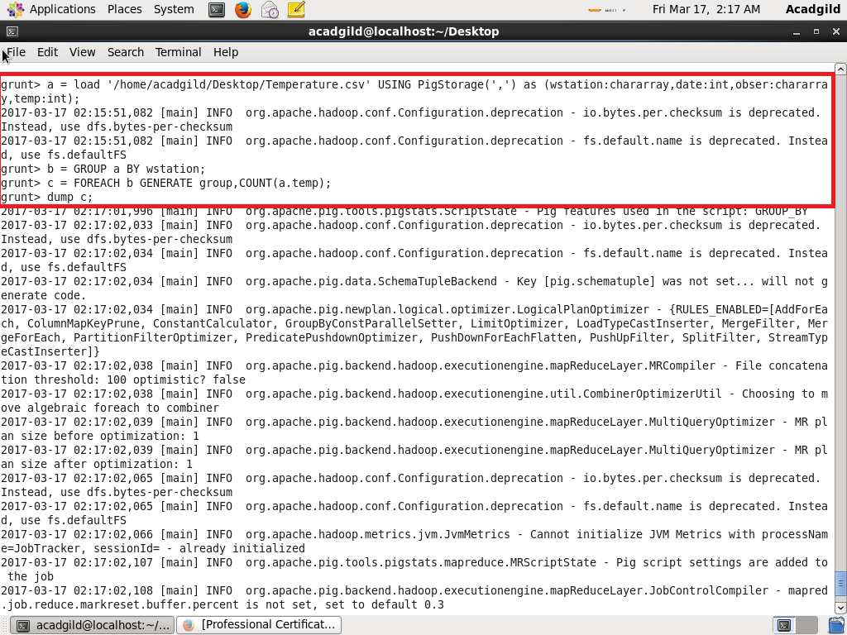

Output:

