DATA SET DESCRIPTION

Column 1: District ID I4N 1M1 varchar

Column 2: Distributor name shell varchar

Column 3: Buy rate (million) $957.70 varchar

Column 4: Sell rate(million) $5779.92 varchar

Column 5: volume IN(million cubic litre) 933, int

Column 6: volume OUT(million cubic litre) 843, int

Column 7: Year 1624 int

1. What is the total amount of petrol in volume sold by every distributor?

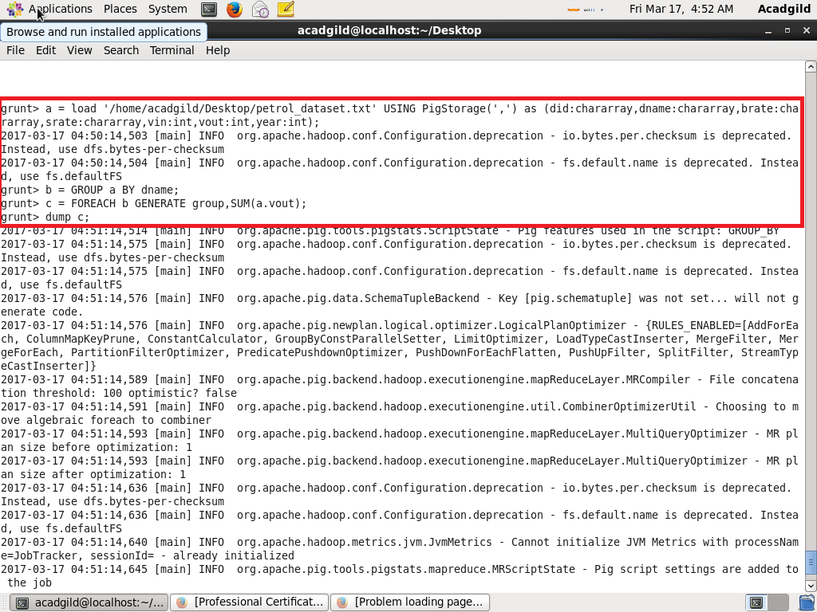

Output:

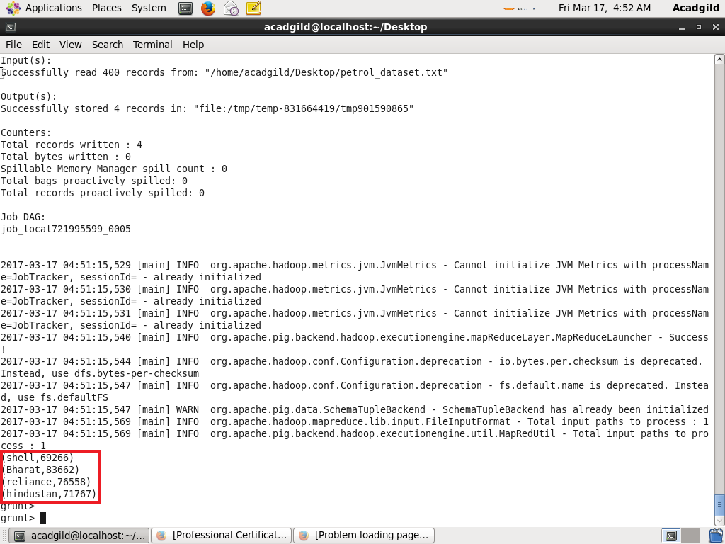

1. Which are the top 10 distributors ID's for selling petrol? Also display the amount of petrol sold in volume.

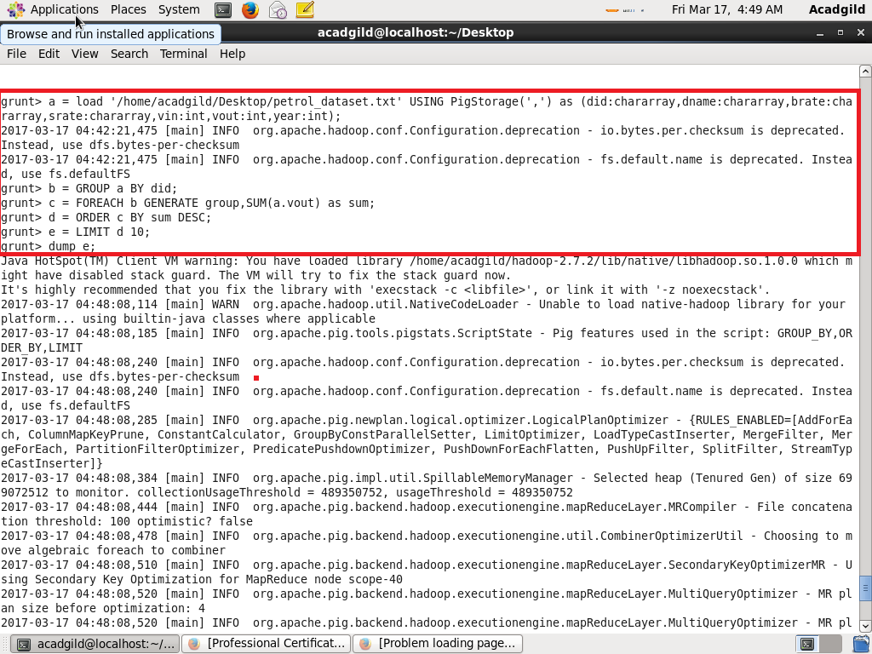

Output:

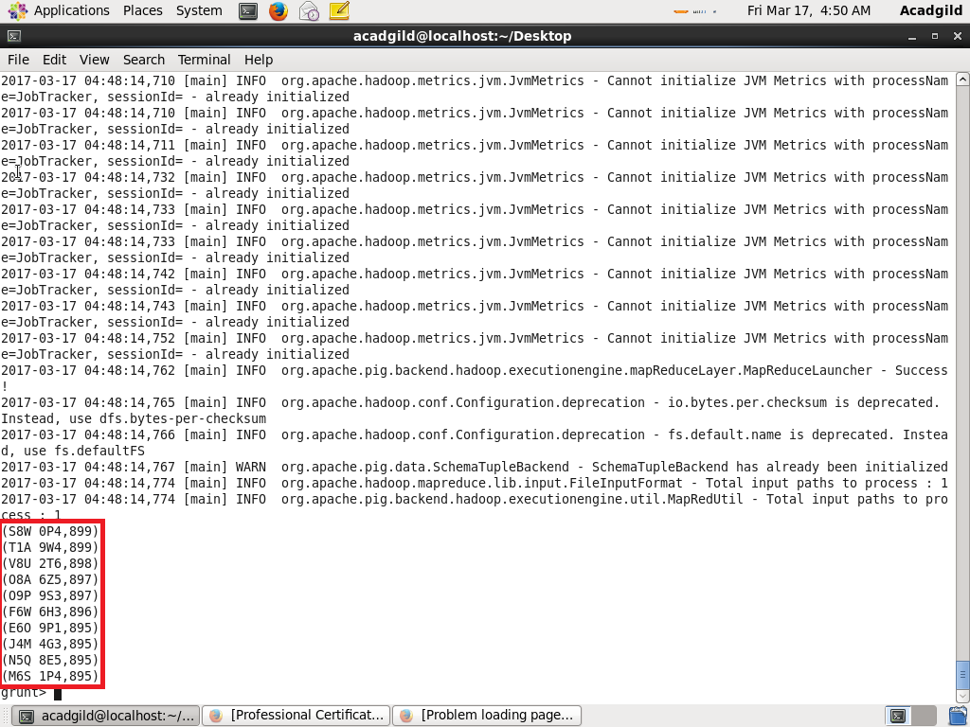

1. List 10 years where consumption of petrol is more with the distributer id who sold it.

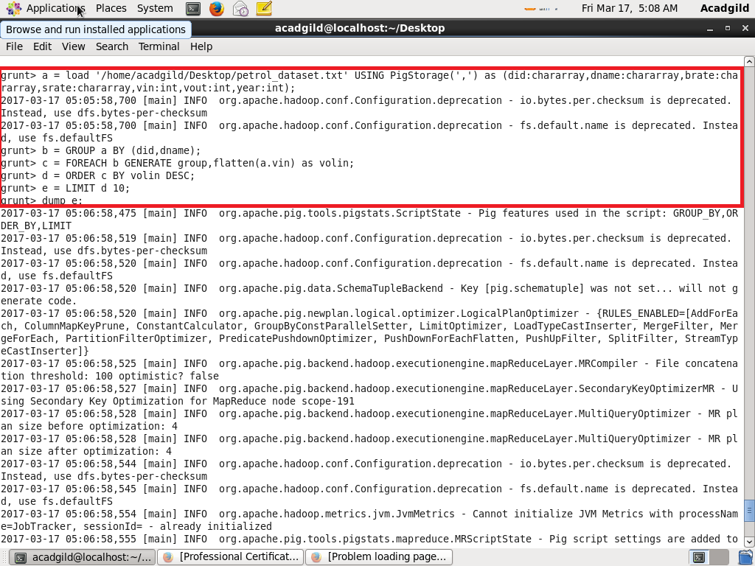

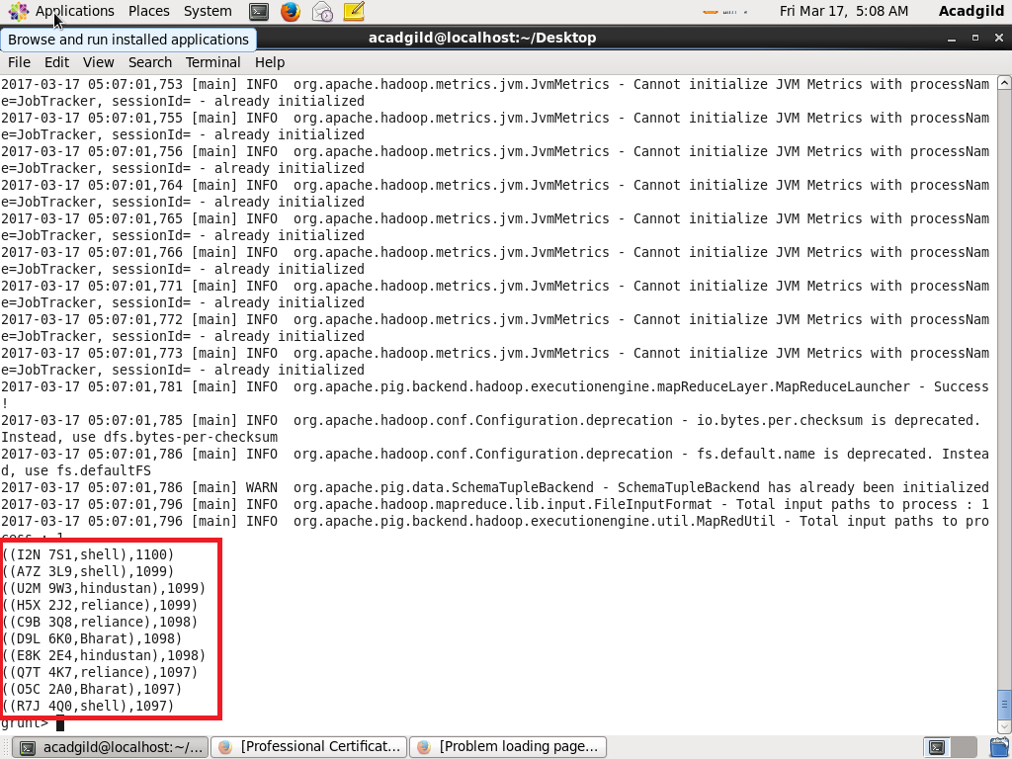

1. Find the distributer name who sold petrol in least amount.

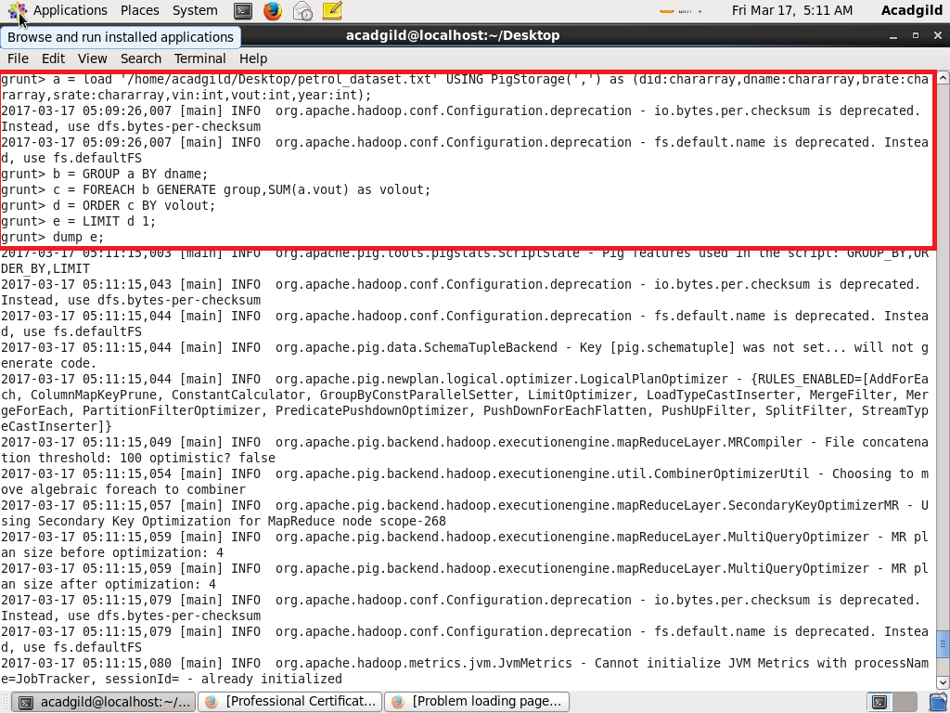

Output:

