Problem Statement:

Create a flume agent that streams data from Twitter and stores it in the HDFS cluster. You can refer the below link document steps to perform the above task :

<https://github.com/prateekATacadgild/Flume.git>

Solution:

* Consumer Key & Consumer Secret Key

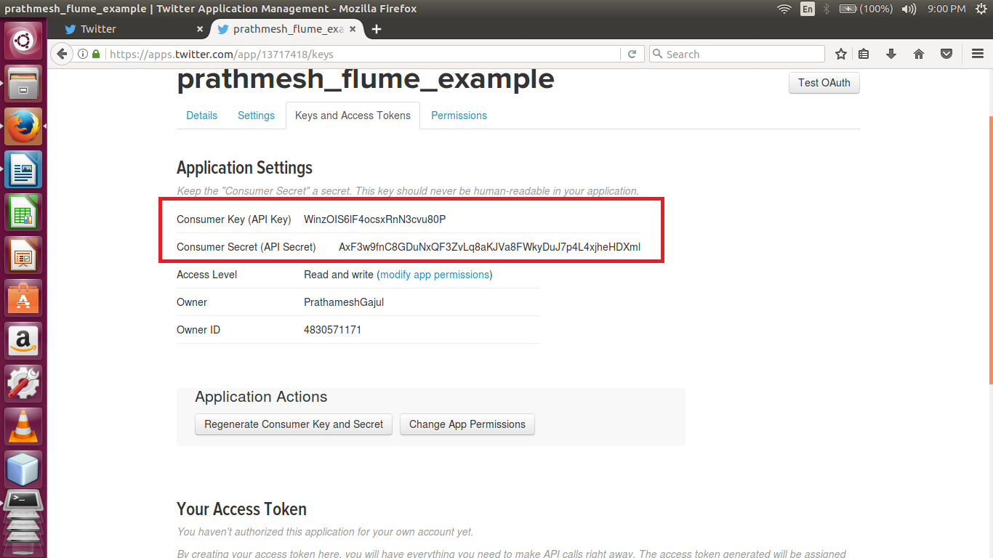

* Access Token & Access Token Secret

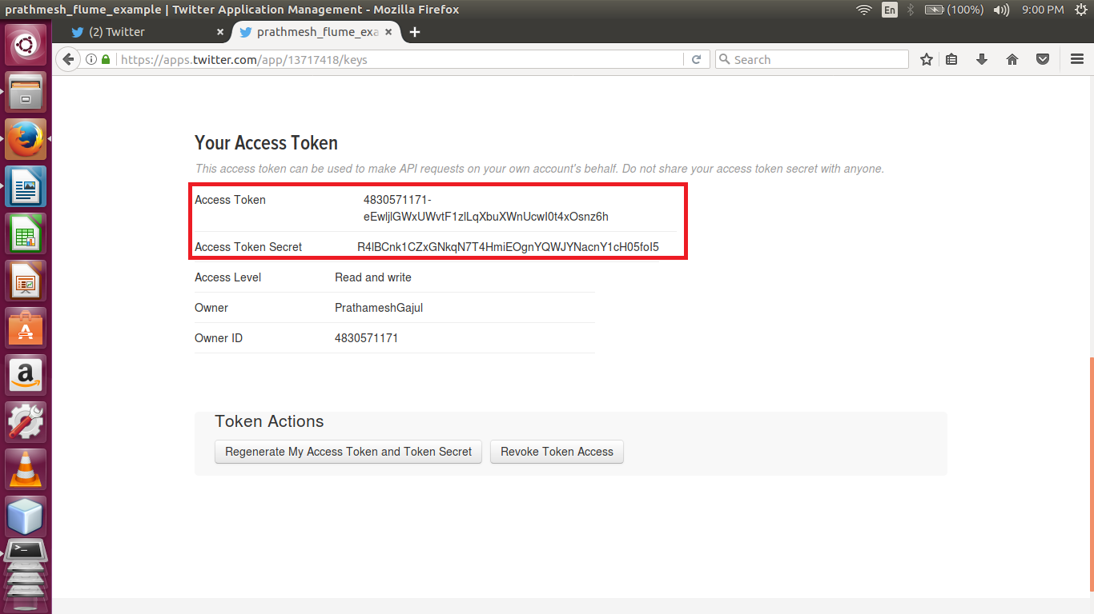

* Flume Configuration file

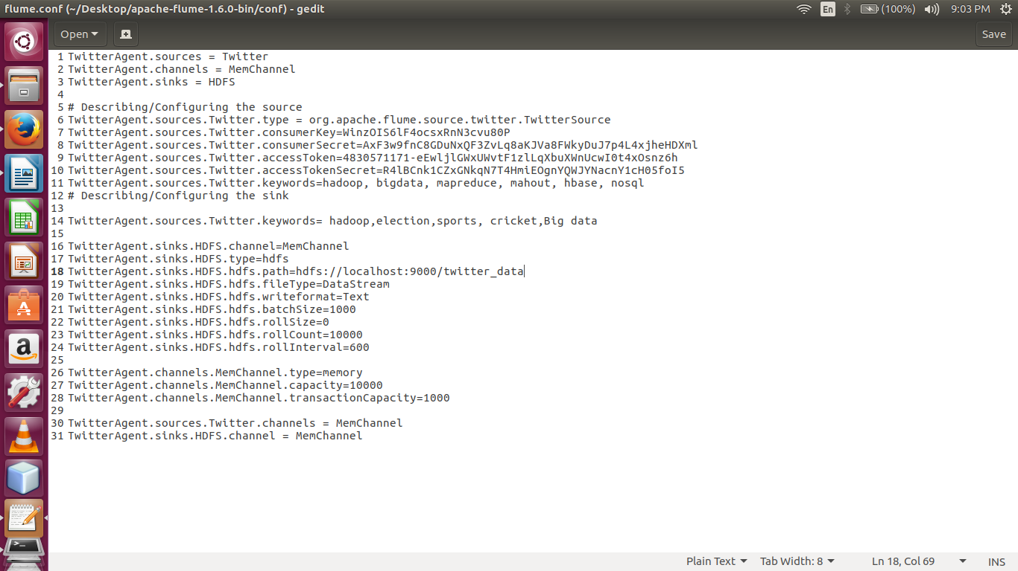

* Stream Twitter data using flume –ng command

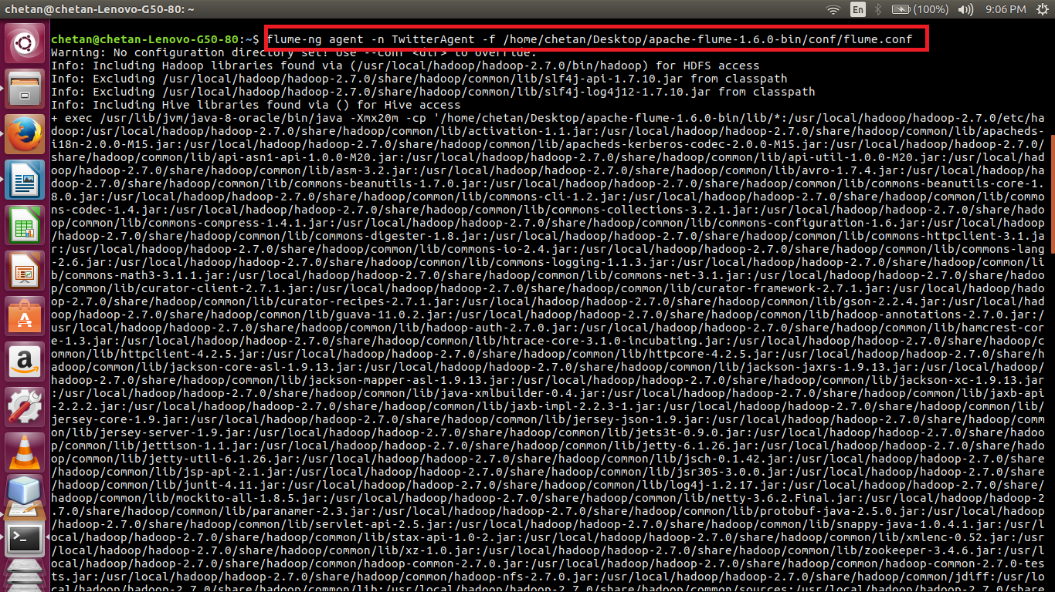

* display the contents of the directory twitter_data

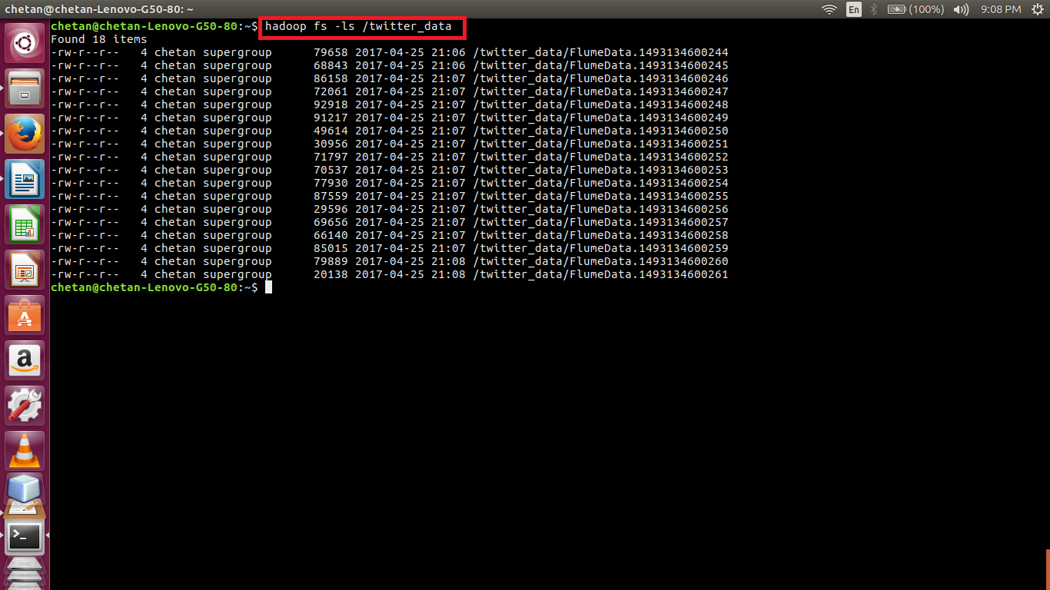

* display the contents of the file

