**Problem Statement:**

Perform wordcount operation in local mode (In windows environment). Share the code, explain the execution steps, and attach the output screenshot.

**Solution:**

**Program:**

**Driver Class:**

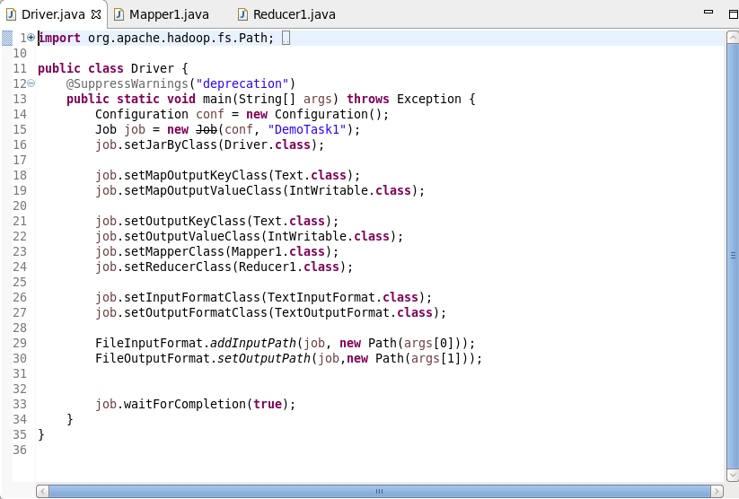

**Mapper Class:**

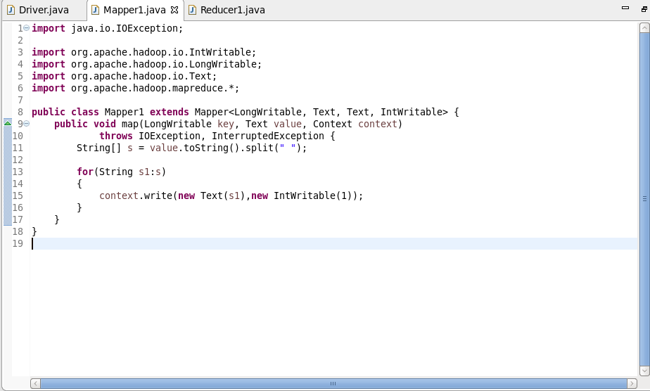

**Reducer Class:**

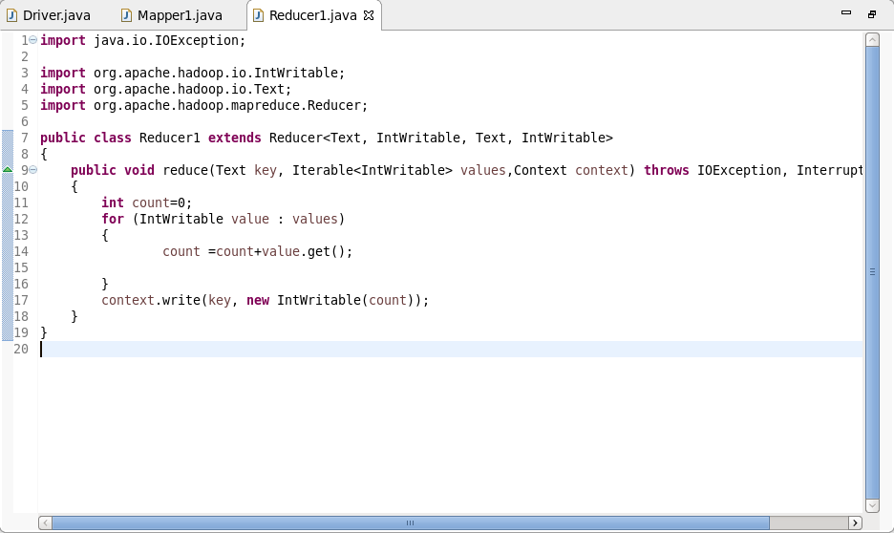

**Dataset (test.txt file)**

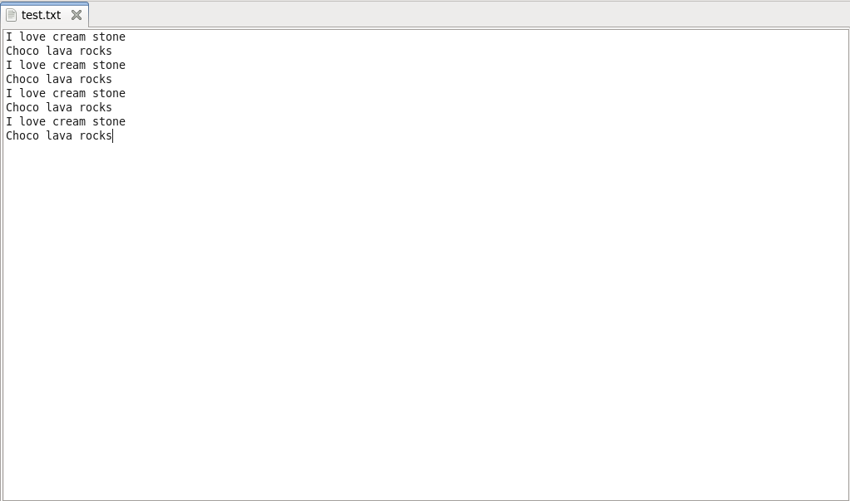

**Eclipse Console:**

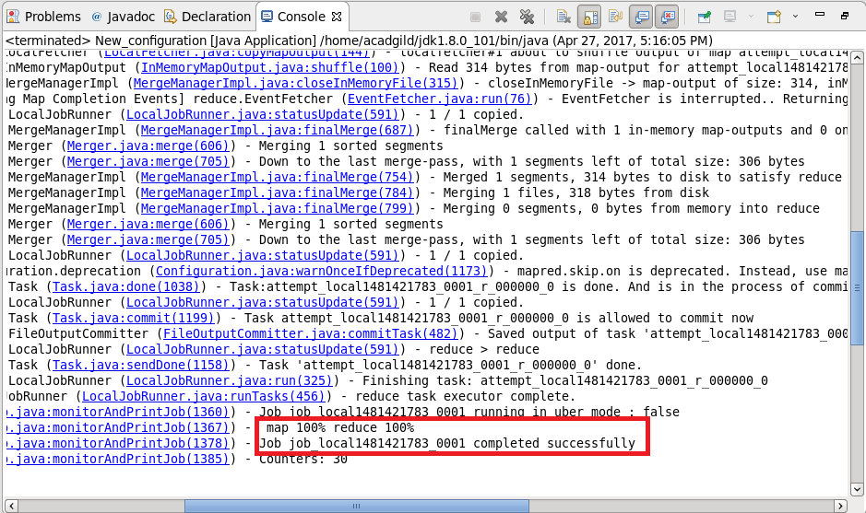

**Output:**

